Logo: Australian Government, Department of Communications and the Arts.

Bureau of  
Communications  
and Arts Research

# Trends and drivers in the affordability of communications services for Australian households

July 2017

Working paper

BCAR logo design image

communications.gov.au/BCAR

#CommAuBCAR

Disclaimer

The material in this paper is of a general nature and should not be regarded as legal advice or relied on for assistance in any particular circumstance or emergency situation. In any important matter, you should seek appropriate independent professional advice in relation to your own circumstances.

The Commonwealth accepts no responsibility or liability for any damage, loss or expense incurred as a result of the reliance on information contained in this discussion paper.

This paper has been prepared as a working paper only and does not indicate the Commonwealth’s commitment to a particular course of action. Additionally, any third party views or recommendations included in this working paper do not reflect the views of the Commonwealth, or indicate its commitment to a particular course of action.

Copyright

© Commonwealth of Australia 2017

Logo:  Creative Commons. The material in this discussion paper is licensed under a Creative Commons Attribution—3.0 Australia license, with the exception of:

* the Commonwealth Coat of Arms
* this Department’s logo
* any third party material
* any material protected by a trademark, and
* any images and/or photographs.

More information on this CC BY license is set out at the creative commons website: [www.creativecommons.org/licenses/by/3.0/au/](http://www.creativecommons.org/licenses/by/3.0/au/). Enquiries about this license and any use of this paper can be sent to: Bureau of Communications and Arts Research, Department of Communications and the Arts, GPO Box 2154, Canberra, ACT, 2601.

Attribution

Use of all or part of this discussion paper must include the following attribution:

© Commonwealth of Australia 2017

Using the Commonwealth Coat of Arms

The terms of use for the Coat of Arms are available from the It’s an Honour website (see [www.itsanhonour.gov.au](http://www.itsanhonour.gov.au/) and click ‘Commonwealth Coat of Arms’).

Contents

Introduction 6

Why look at affordability? 6

Key findings 6

Overall affordability has improved 6

Households are spending less 7

…and are accessing more services 8

Households are getting better value from lower prices and more data 11

Affordability of home broadband 12

Regional ADSL customers will benefit from the NBN 12

Box 1. On-net and off-net ADSL services 14

…as data allowances increase 18

Prices of entry-level broadband bundle plans are stable, but with increased data inclusions for some plans 20

Affordability of mobile services 22

There is a wide range of options for mobile customers, including at lower price points 22

…providing regional consumers with more choice 24

Box 2: MNOs vs MVNOs 24

The range of both post-paid and prepaid plans has increased… 27

…including for mobile wireless broadband 28

Affordability outcomes for particular households 30

Lower-income households spend a larger proportion of their income on communications services 30

International comparisons 34

Outlook for affordability 34

Appendix. Price collection methodology 35

Endnotes 40

List of figures

Figure 1. Average share of household disposable income spent on mobile and fixed-line telephone rent, calls and internet charges 7

Figure 2. Average annual household expenditure on mobile and fixed-line telephone rent, calls and internet charges and average annual household disposable income 8

Figure 3. Growth in real household consumption of communications goods and services 9

Figure 4. Essential and non-essential communications services, 1970s to 2010s 9

Figure 5. Australians’ access to communications technologies, 2006 to 2016 10

Figure 6. Volume of data downloaded, Australia, December 2012–16 11

Figure 7. Telecommunications services price indices 12

Figure 8. Number of fixed broadband bundle plans at price points (selected providers) by technology, May 2017 13

Figure 9. ADSL connections by equipment, 2016 14

Figure 10. Distribution of fixed broadband bundle plans by price and included data for selected providers, May 2017 15

Figure 11. Distribution of NBN satellite plans and low data fixed NBN plans by price and included on-peak data allowance for selected providers, May 2017 16

Figure 12. Distribution of NBN satellite plans and off-net ADSL plans by price and included on-peak data allowance for selected providers May 2017 17

Figure 13. Average bundle prices for on-net ADSL, off-net ADSL and fixed NBN plans (selected providers) over the period June 2014 to June 2016 18

Figure 14. Average monthly data included with on-net ADSL, off-net ADSL and fixed NBN plans (selected providers) over the period June 2014 to June 2016 19

Figure 15. Proportion of advertised plans including more than 500GB per month (selected providers), by technology 20

Figure 16. Average price and price range for entry-level fixed broadband bundles (selected providers) over the period June 2014 to June 2016, by technology 21

Figure 17. Price vs included data, by limited or unlimited calls 22

Figure 18. Price vs Included data, by payment type 23

Figure 19. Price vs included data, by Telstra or non-Telstra network 25

Figure 20. Price vs included data for plans on the Telstra network, by Telstra or MVNOs 26

Figure 21. MNO post-paid plans, 2014–16 27

Figure 22. MNO prepaid plans, 2014–16 28

Figure 23. Mobile Wireless Broadband Price vs Included data, by payment type 29

Figure 24. Mobile Handset vs Mobile Wireless Broadband data downloaded per connection 30

Figure 25. Average share of household disposable income spent on mobile and fixed-line telephone rent, calls and internet charges, by household disposable income decile, 2015 31

Figure 26 and Figure 27. Average share of household disposable income spent on mobile and fixed-line telephone rent, calls and internet charges, by vulnerable groups and rural households over time 32

Figure 28 and Figure 29. Average annual household expenditure on mobile and fixed-line telephone rent, calls and internet charges, all households and rural areas. Average annual household disposable income, all households and rural areas. 32

Figure 30 and Figure 31. Percentage of low-income and high spending households, vulnerable groups and rural households, 2006–2015 33

List of tables

Table 1. Mobile coverage, percentage of the Australian population, 2016 25

Table 2. Selected long-life prepaid plans, call and data costs, May 2017 27

## Introduction

### Why look at affordability?

Communications services are increasingly essential for household access to information, employment, markets and key services. Consumer demand for communications services has grown rapidly. In response, competitive markets should be providing services that are affordable, including for vulnerable groups.

While the Productivity Commission looked at the affordability of communications services as part of its inquiry into the Telecommunications Universal Service Obligation, this paper provides a deeper and more targeted examination of trends in affordability for particular household types, focusing on mobile and internet services.

While this working paper examines pricing as part of the analysis, price itself does not provide a complete picture of the extent to which households are able to afford to access the communications services necessary to engage with society and the economy. Affordability, which takes into account incomes, prices and quantity consumed, is typically measured at the household level as the proportion of total household income spent on a good or service by all members of a household.

Average measures of affordability for all households are also useful to determine trends over time. However, these measures provide little information on outcomes of particular groups. This paper examines trends in affordability for all households, as well as for vulnerable groups and those in rural and regional areas. Affordability in Australia relative to other countries is also assessed using a range of international metrics.

### Key findings

* The affordability of communications services for households has improved in aggregate and for most vulnerable groups over recent years. Consumers are getting better value as prices stay the same or fall, while product inclusions (such as data) increase.
* Markets for communications services are responding to strong consumer demand and different tastes by providing greater choice and products at a range of price points. Mobile customers are generally well served with significant choice and options.
* For home broadband services, the roll out of the NBN is improving choice and reducing prices for regional consumers.
* Australia compares well internationally on affordability measures for mobile services and is improving for fixed broadband. However, better data and comparable methodology are needed for a robust cross-country comparison of the affordability of broadband services.
* Strong consumer demand for communications services is anticipated to continue well into the future. The outlook for affordability will depend on a number of factors including regulatory settings, competitive pressures and broader income growth.

## Overall affordability has improved

Aggregate household affordability of communications services has improved since 2008. This indicates a healthy degree of competition in the market and suggests most households are able to benefit from the digital economy.

### Households are spending less

The average household saw its expenditure on communications services as a share of household disposable income fall in recent years. Average household expenditure on fixed-line telephone, mobile and internet services declined from 4.1 per cent of household disposable income in 2008 to 3.5 per cent in 2015 (Figure 1).

Figure . Average share of household disposable income spent on mobile and fixed-line telephone rent, calls and internet charges

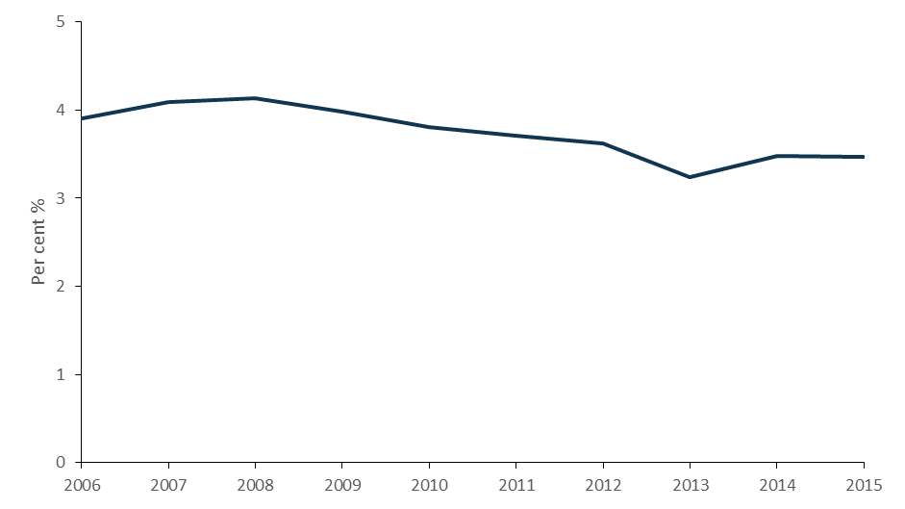

Source. The Household Income and Labour Dynamics in Australia (HILDA) Survey, Release 15.[1]

Notes. Telephone rent and calls includes rent and charges on both fixed-line and mobile phones including the cost of buying a mobile handset that is included in a service bundle (but excluding the cost of buying a handset outright). Internet charges capture both fixed and mobile internet expenses. This data series tracks expenditure share by the average household. While households vary in size, average household size in Australia has remained constant at 2.6 people per household between 2006 and 2011, and is projected to stay between 2.5 and 2.6 people per household in 2036.[2] Household disposable (regular) income is equal to the sum of regular private income, Australian Government public transfers, other regular public transfers and foreign pensions minus estimated taxes on regular income. A small number of households with an expenditure share equal to zero or equal to 100 per cent or greater have been excluded from the analysis. Figures have not been adjusted for inflation.

This has largely resulted from increases in disposable income rather than reduced expenditure on communications services, which has been relatively flat (at approximately $2000 a year, Figure 2). The net result is a decline in communications services share in spending.

Figure . Average annual household expenditure on mobile and fixed-line telephone rent, calls and internet charges and average annual household disposable income

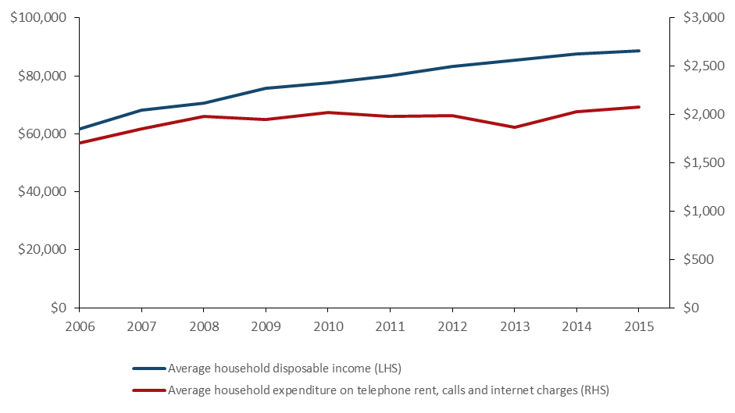

Source. The Household Income and Labour Dynamics in Australia (HILDA) Survey, Release 15.

Notes. Telephone rent and calls includes rent and charges on both fixed-line and mobile phones including the cost of buying a mobile handset that is included in a service bundle (but excluding the cost of buying a handset outright). Internet charges capture both fixed and mobile internet expenses. This data series tracks expenditure share by the average household. While households vary in size, average household size in Australia has remained constant at 2.6 people per household between 2006 and 2011, and is projected to stay between 2.5 and 2.6 people per household in 2036.[3] Household disposable (regular) income is equal to the sum of regular private income, Australian Government public transfers, other regular public transfers and foreign pensions minus estimated taxes on regular income. A small number of households with an expenditure share equal to zero or equal to 100 per cent or greater have been excluded from the analysis. Figures have not been adjusted for inflation.

In addition, once quality is taken into account, households are getting better value for money from communications services. Data suggests that as well as benefiting from falling real prices for communications services, the quantity consumed has grown robustly in line with strong demand for these services and increased product inclusions (largely data allowances).

### …and are accessing more services

Households have ramped up their consumption of communications services to take advantage of greater connectivity, mobility and choice of content. Demand for communications goods and services is growing faster than that of other goods and services in the economy (Figure 3).

Figure 3. Growth in real household consumption of communications goods and services

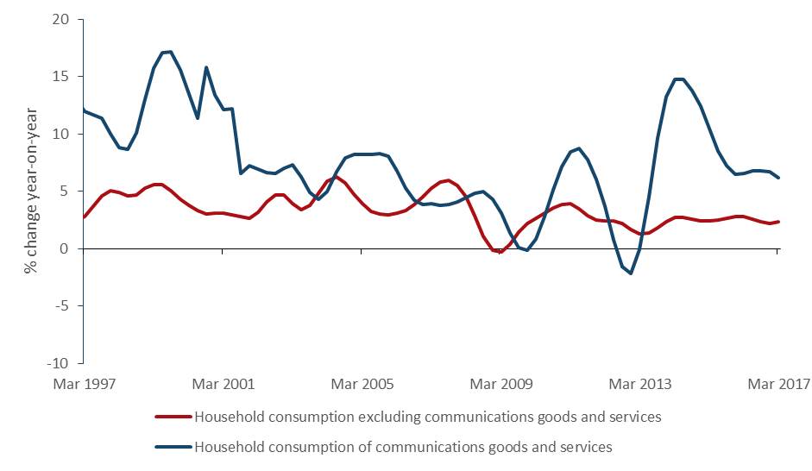

Source. ABS (2017), 5206.0—Australian National Accounts: National Income, Expenditure and Product, Mar 2017.

Note: Communications goods and services include telecommunication equipment and services and postal services.

Consumers’ preferences for different types of communications services have also changed rapidly with the emergence of new technologies. Services once viewed as luxuries, for example mobile phones, are increasingly considered essential (Figure 4).

Figure . Essential and non-essential communications services, 1970s to 2010s

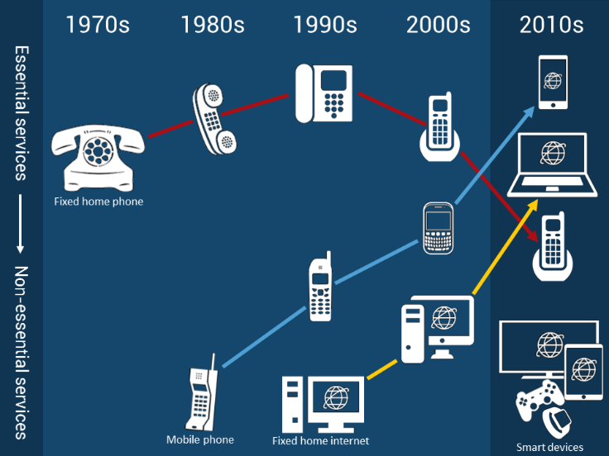

Source. BCAR (2017)

As a consequence consumers are using more communications services than ever before, with more than half of Australians (58 per cent) using five or more different types of communications services in the six months to June 2016.[4] In particular, a home broadband connection and internet-enabled mobile service are now used by the majority of Australians. Australians’ access to internet-enabled mobile phones has grown rapidly, from 8 per cent in 2006 to 76 per cent in 2016 (Figure 5).

Figure . Percentage of Australians accessing communications technologies, 2006 to 2016

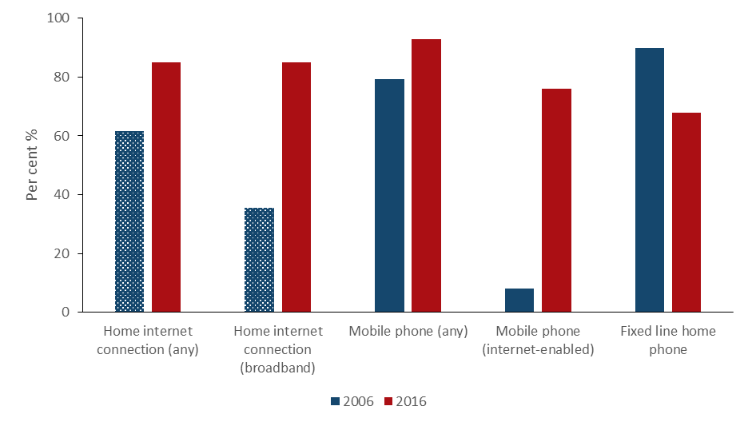

Source. ACMA (2016), Communications report 2015–16; 2005–06

Notes. Access to home internet and broadband connections is reported at the household level (percentage of Australian households) in 2005–06 (shaded bars) and at the population level (percentage of Australians) in 2015–16. In 2005–06 the ACMA reported that around 90 per cent of Australians had a fixed-line home phone. In 2015–16 the fixed-line home phone category includes managed VoIP services.

Similarly, consumer demand for data in Australia has grown rapidly over the past four years (Figure 6). The volume of broadband data downloaded over the last quarter of 2016 exceeded 2.5 million terabytes (TB). This was a 51 per cent higher than the 2015 December quarter, and 366 per cent higher than for the same period in 2012.[5]

While demand for mobile handset data is much lower, it has grown at a much faster rate. Driven by the ubiquity of smart phones, mobile handset data grew from 14,000TB to 146,000TB over the same four year period; an impressive tenfold increase*.*

Figure . Volume of data downloaded, Australia, December 2012–16

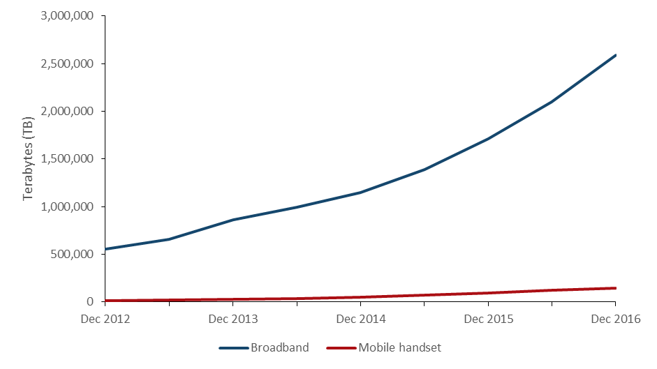

Source. ABS (2017), 8153.0—Internet Activity, December 2016.

Notes. Data downloaded is reported for the three month period prior to the reference date.

This means the average mobile handset customer downloads 1.9GB per month, compared with 2.9GB downloaded on dedicated wireless (fixed, mobile and satellite) connections and 117GB on fixed-line broadband connections.[6] This has shown rapid growth compared in four years—in December 2012, these figures were 0.2GB, 1.5GB and 30.6GB respectively.

### Households are getting better value from lower prices and more data

Real prices for mobile, internet and residential fixed-line voice services have fallen consistently over the past decade, most significantly for fixed-line voice services (Figure 7). For internet and mobile services, real prices have fallen since 2012–13, while nominal prices (that is, not adjusted for inflation) have largely remained stable.

Figure . Telecommunications services price indices

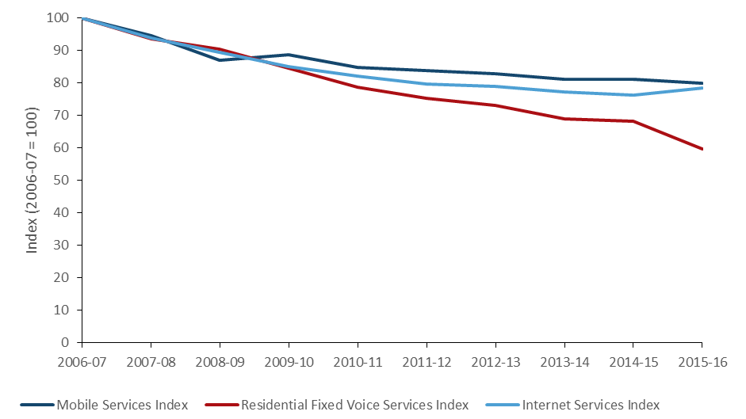

Source. ACCC (2017), Competition in the Australian telecommunications sector: Price changes for telecommunications services in Australia, p. 108, 110.

Notes. These indices capture movements in the cost of plans and are adjusted by the ACCC for inflation using the Consumer Price Index. They do not directly account for changes in product inclusions such as data allowances for mobile and internet services.[7] Fixed-line services do not include residential VOIP.

Since 2012–13, product inclusions have also increased significantly. For example:

* ADSL data quotas grew by 32 per cent during 2015–16 following a 73 per cent increase in 2014–15 and a 47 per cent increase in 2013–14.[8].
* Data quotas for post-paid mobile services increased by an average of 30 per cent during 2015–16, following significant increases of 119 per cent in 2014–15 and 78 per cent in 2013–14.[9].
* A number of internet and mobile service providers have also started bundling content and entertainment offers into their plans at a discounted rate or for free where access to specific content services is not included against data quotas.

Once these inclusions are taken into account, consumers are getting significantly greater value from their communication services.

## Affordability of home broadband

### Regional ADSL customers will benefit from the NBN

The NBN rollout is increasing the range of products available and providing more affordable alternatives for some consumers, particularly in regional areas.

Based on currently advertised prices, regional ADSL customers switching to fixed-line and fixed wireless NBN will be able to access a similar level of service at lower prices and have access to a wider choice of plans. The BCAR compared fixed NBN plans (both fixed-line and fixed wireless NBN[10]), as well as ADSL retail bundled plans, covering the advertised prices of select retail service providers representing approximately 90 per cent of the fixed broadband market.[11]

Figure 8 shows that bundled plans offered by service providers over Telstra’s wholesale ADSL network (off-net) are at higher price points than those offered by service providers on their own infrastructure (on‑net) and fixed NBN plans.[12] In general, on-net plans are more widely available in metropolitan areas, while off-net plans are mostly available in regional areas (see Box 1).

Figure . Number of fixed broadband bundle plans at price points (selected providers) by technology, May 2017

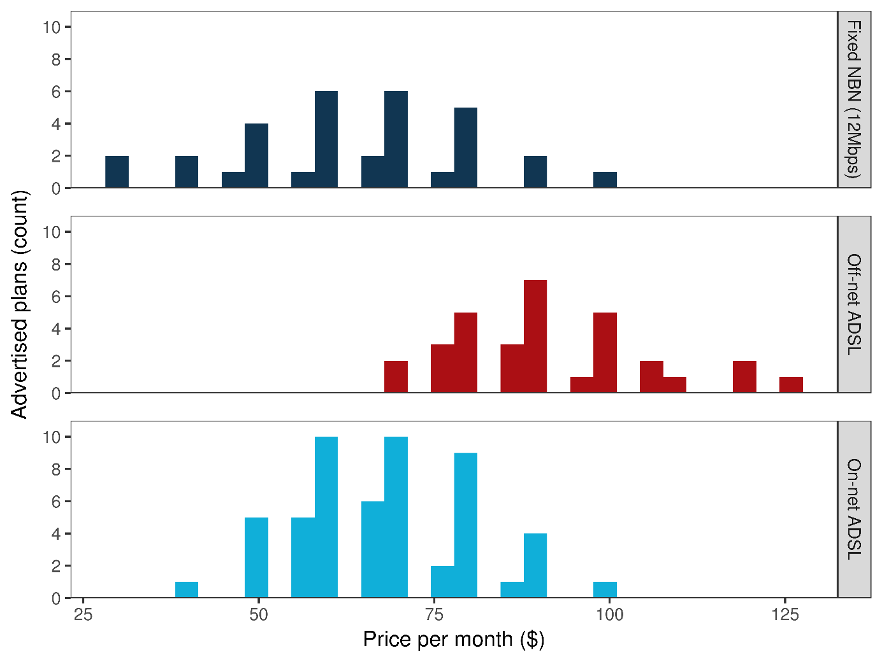

Source. BCAR survey of advertised ADSL and NBN bundle plans offered by Telstra, Optus, iiNet, Internode, iPrimus, Belong, TPG and Dodo.

Notes. Includes plans advertised on provider websites as at 17 and 18 May 2017. Includes ADSL2+/fixed NBN broadband connections and bundles. Where an active phone line is required, $25.95 (price of Telstra Home Phone Basic) is added to the monthly price of the plan. Where contract length or bundled hardware affect the monthly connection fee, the option with the cheapest monthly fee is selected. Off-net plans identified using known Telstra-only addresses and details from Critical Information Summaries. It is unknown if providers vary pricing regionally (outside of technology type).

### 

#### Box 1. On-net and off-net ADSL services

ADSL connections require specialised networking equipment installed at the exchange. Internet service providers (ISPs) can purchase and install this equipment (an ‘on-net’ connection) or purchase wholesale ADSL connections from Telstra (an ‘off-net’ connection). On-net connections are common at larger exchanges, typically in metropolitan areas or regional centres. Elsewhere, most connections are off-net. Figure 9 shows that the vast majority of ADSL connections in exchanges located primarily in regional areas (Bands 3 and 4)—are provided using Telstra’s equipment, either by Telstra or off-net. In exchanges located primarily in metropolitan areas (in Bands 1 and 2), just over half of ADSL connections are provided using non-Telstra infrastructure (on-net).

ISPs offer different ADSL products to on-net and off-net customers. As a result, there are significant regional differences in the cost of ADSL.

Figure . ADSL connections by equipment, 2016

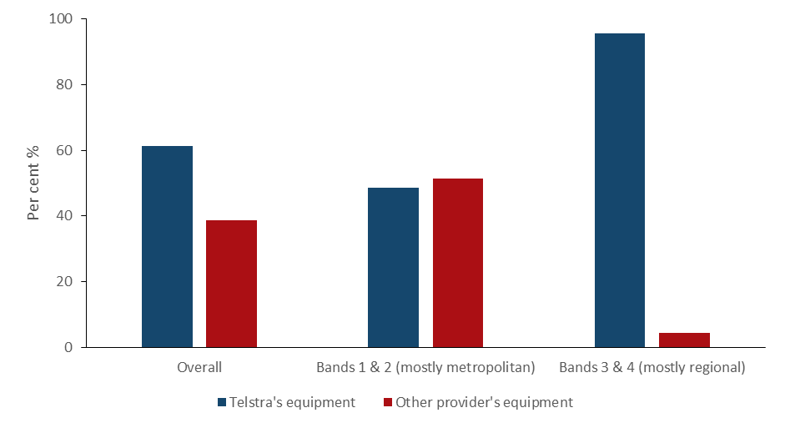

Source. ACCC (2016), Wholesale ADSL service declaration inquiry—discussion paper, p. 22.

Notes. includes both wholesale and retail connections. Non-Telstra connections are predominantly retail, with the ACCC commenting that as at June 2015, ADSL resale competition was extremely limited. Precise figures are commercial-in-confidence.

Off-net ADSL bundle plans are generally more expensive than on-net ADSL and NBN plans (excluding satellite) offering equivalent data allowances (Figure 10). Off-peak data inclusions are essentially offered by one provider (TPG) on their ADSL plans and have been excluded from the analysis.

Figure . Distribution of fixed broadband bundle plans by price and included data for selected providers, May 2017

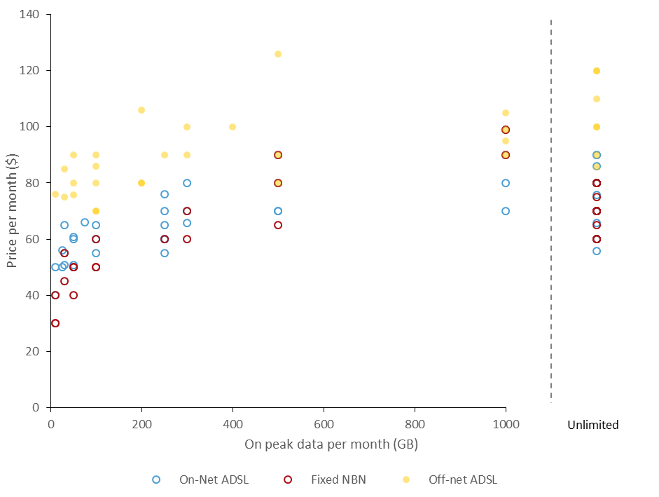

Source. BCAR survey of advertised ADSL and NBN bundle plans offered by Telstra, Optus, iiNet, Internode, iPrimus, TPG, Belong and Dodo.

Notes. Includes plans advertised on provider websites as of 17 and 18 May 2017. Includes ADSL2+/Fixed-line NBN broadband connections and bundles. Where an active phone line is required, $25.95 (price of Telstra Home Phone Basic) is added to the monthly price of the plan. Where contract length or bundled hardware affect the monthly connection fee, the option with the cheapest monthly fee is selected. Off‑net plans identified using known Telstra-only addresses and details from Critical Information Summaries. It is unknown if providers vary pricing regionally (outside of technology type).

Metropolitan ADSL customers who switch to the NBN will be at least as well off, as the advertised prices of plans and included data are broadly comparable to those offered on the NBN at the basic speed tier (12/1 Mbps).[13] On-net ADSL and fixed NBN broadband connections and broadband-voice bundle plans are available at similar price points, and the price of plans appears to be similar when data allowances are taken into account.

NBN Co Limited (nbn) aims to activate 8.1 million premises by 2020, with 7.6 million of these premises (93.8 per cent) connected to the NBN using fixed-line technology. A further 300,000 active premises (3.7 per cent) will have their broadband delivered on fixed wireless technology, with the remaining 200,000 premises (2.5 per cent) connected through the NBN satellite.[14]

For many households without access to fixed broadband, NBN satellite is able to provide access to high-speed broadband services with an on-peak data allowance of less than 40GB per month at a price that is only marginally more expensive than comparable fixed-line or fixed wireless NBN plans (Figure 11). Above 40GB per month, however, ADSL and NBN fixed-line and fixed wireless plans are cheaper than NBN satellite plans (Figure 12). Notwithstanding this, prior to the rollout of the Sky Muster satellite, there were in practice no broadband options (such as ADSL) available for some locations due to their remoteness. As such, caution should be taken when comparing ADSL affordability with the affordability of the satellite. In addition, there have been recent changes to the Sky Muster service that should improve the affordability of the satellite service—in particular nbn’s recent announcement that it has changed its Fair Use Policy to increase the wholesale average peak download usage by 50 per cent and doubled the maximum usage allowed per customer, and kept wholesale prices the same.

This analysis does not include satellite plans delivered as part of the ‘Sky Muster Education Port’ service, which provides existing satellite households with an additional 50GB per student using the internet as their primary means of education.

Figure . Distribution of NBN satellite plans and low data fixed NBN plans by price and included on-peak data allowance for selected providers, May 2017

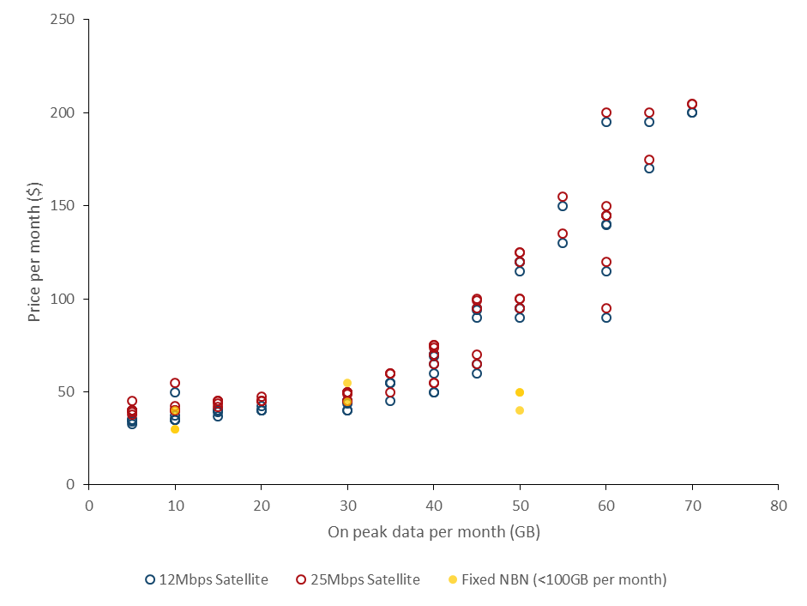

Source. BCAR survey of advertised NBN satellite plans offered by Activ8me, SkyMesh, Harbour ISP, IPSTAR, iiNet, reachnet, Ant Communications, BorderNET, Clear Networks; and fixed NBN bundle plans offered by Telstra, Optus, iiNet, Internode, iPrimus, TPG, Belong and Dodo (only those plans with a data allowance under 100GB charted).

Notes. Off-peak data has been excluded from the analysis. Satellite-voice bundles and ‘night-owl’ satellite plans, which combine small on-peak inclusions with larger off-peak inclusions, have also been excluded. Contract term for each of the advertised NBN satellite plans included in the analysis is one month or less. There is no connection fee associated with these plans, with the exception of iiNet plans which have a $99.95 activation fee (this fee is not applicable if consumers choose to sign-up for a 24 month contract term). NBN satellite connections are available at either a 12/1 Mbps or 25/5 Mbps speed tier. At the end of Q4 2016, two-thirds of NBN satellite services in operation (AVCs) were at the 25/5 speed tier with the remaining third at the 12/1 speed tier (NBN Wholesale Market Indicators Report 31 December 2016). All of the providers surveyed charge an additional $5 per month to upgrade to the 25/5 Mbps speed tier.

Figure . Distribution of NBN satellite plans and off-net ADSL plans by price and included on-peak data allowance for selected providers May 2017

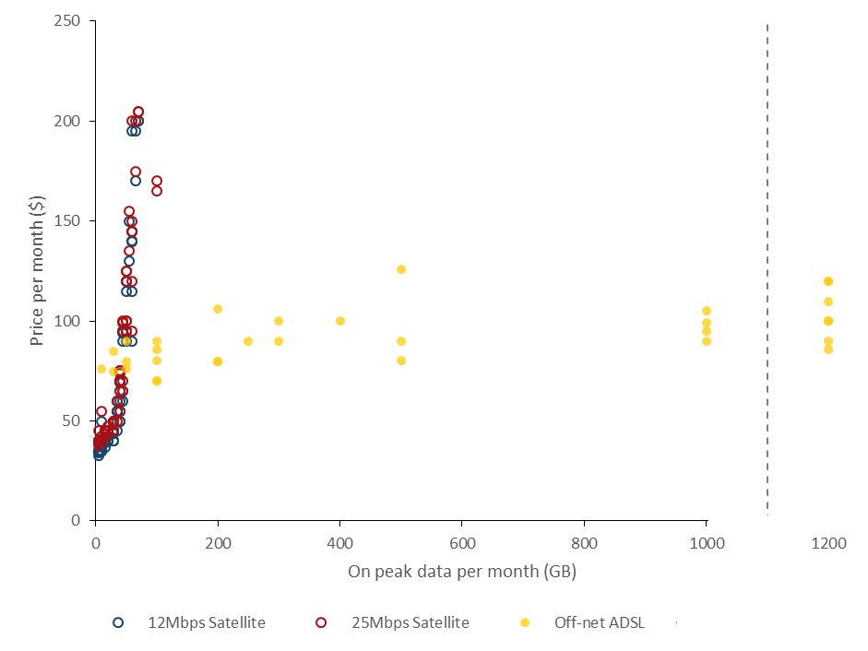

Source. BCAR survey of advertised NBN satellite plans offered by Activ8me, SkyMesh, Harbour ISP, IPSTAR, iiNet, reachnet, Ant Communications, BorderNET, Clear Networks; and off-net bundle plans offered by Telstra, Optus, iiNet, Internode, iPrimus, TPG, Belong and Dodo.

Notes. Off-peak data has been excluded from the analysis. Satellite-voice bundles and ‘night-owl’ satellite plans, which combine small on-peak inclusions with larger off-peak inclusions, have also been excluded. Contract term for each of the advertised NBN satellite plans included in the analysis is one month or less. There is no connection fee associated with these plans, with the exception of iiNet plans which have a $99.95 activation fee (this fee is not applicable if consumers choose to sign-up for a 24 month contract term). NBN satellite connections are available at either a 12/1 Mbps or 25/5 Mbps speed tier. At the end of Q4 2016, two-thirds of NBN satellite services in operation (AVCs) were at the 25/5 speed tier with the remaining third at the 12/1 speed tier (NBN Wholesale Market Indicators Report 31 December 2016). All of the providers surveyed charge an additional $5 per month to upgrade to the 25/5 Mbps speed tier.

With home broadband increasingly regarded as an essential service, there is good news for households given real prices have fallen in recent years, including for some entry-level plans.

Data collected by the ACCC on the prices of broadband bundles including fixed bundles advertised on the websites of selected retail service providers (such as Telstra, Belong, Optus, iiNet and iPrimus) suggests that average prices for fixed-line and fixed wireless NBN, on-net ADSL and off-net ADSL bundles remained broadly constant between June 2014 and June 2016 (Figure 13). Once accounting for the rate of inflation in the rest of the economy, the real price of fixed broadband bundles offered by the included providers has declined in recent years.

Figure . Average bundle prices for on-net ADSL, off-net ADSL and fixed NBN plans (selected providers) over the period June 2014 to June 2016

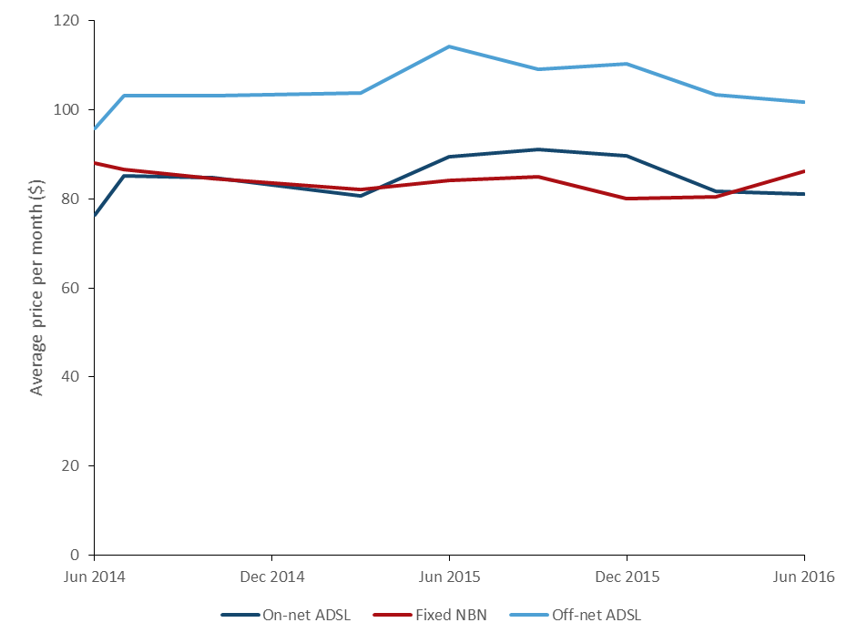

Source. Advertised service plan data compiled by the ACCC. Includes fixed bundles (phone and internet) advertised by the following retail service providers: Telstra, Belong, Optus, TPG, iiNet and iPrimus.

Notes. Prices have not been adjusted for inflation. Off-net plans include connections at Zone 2 and 3 exchanges for Telstra and Belong. Some providers are not available on all types of connection.

### …as data allowances increase

Providers are increasing their data allowances in response to growing consumer demand. Between 2014 and 2016 the average amount of data included in plans increased significantly, particularly for fixed NBN and on-net ADSL plans (Figure 14).

Figure . Average monthly data included with on-net ADSL, off-net ADSL and fixed NBN plans (selected providers) over the period June 2014 to June 2016

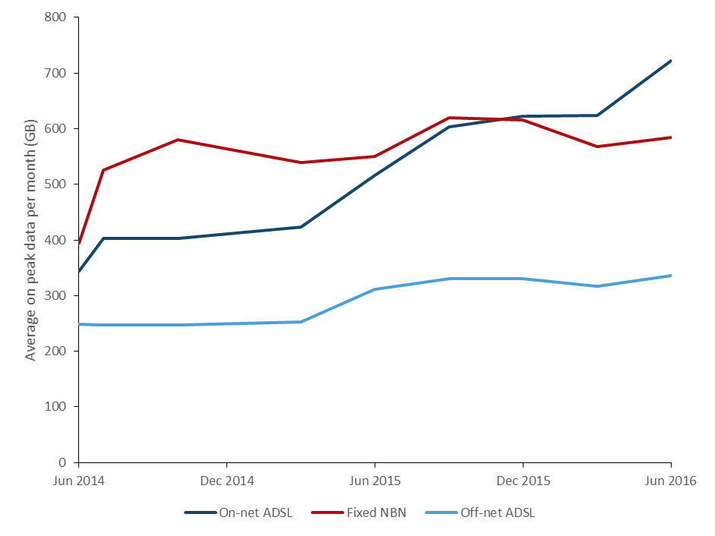

Source. Advertised service plan data compiled by the ACCC. Includes fixed bundles (phone and internet) advertised by the following retail service providers: Telstra, Belong, Optus, TPG, iiNet and iPrimus.

Notes. Unlimited plans recorded as 1500GB. Off-net plans include connections at Zone 2 and 3 exchanges for Telstra and Belong. Off-peak data was excluded from the analysis. Some providers are not available on all types of connection.

In general, providers increasingly offered more plans with on-peak data inclusions in excess of 500GB per month, with only a marginal increase in monthly prices.

This shift to plans with larger data allowances has contributed to the increase in average data downloads, as providers have removed smaller plans. However, increases to data inclusions are not uniform across different retail service providers and market segments (Figure 15).

Figure . Proportion of advertised plans including more than 500GB per month (selected providers), by technology

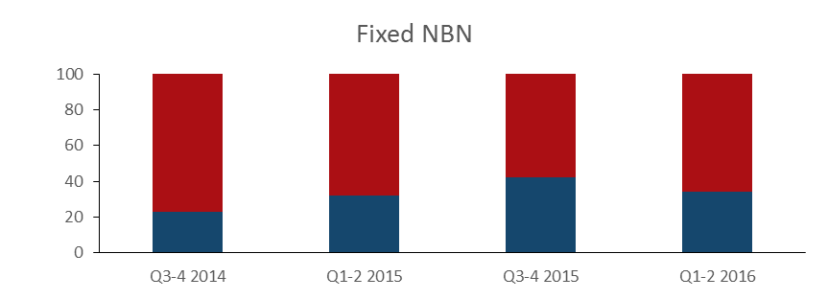

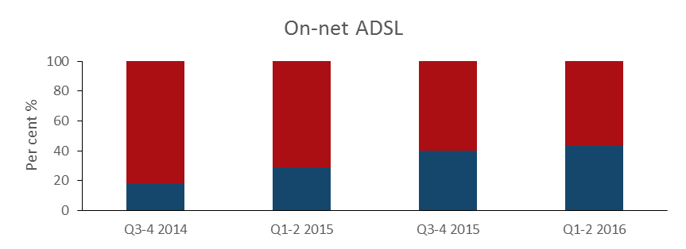

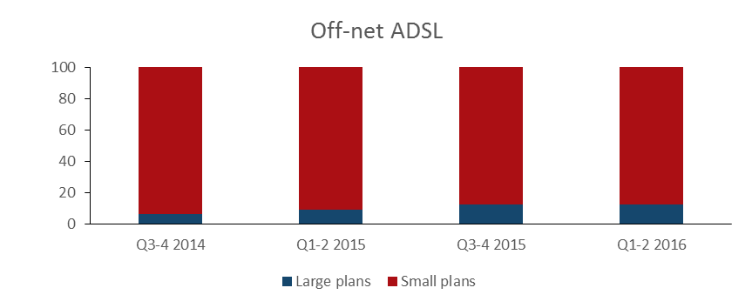

Source. Advertised service plan data compiled by the ACCC. Includes fixed bundles (phone and internet) advertised by the following retail service providers: Telstra, Belong, Optus, TPG, iiNet and iPrimus.

Notes. Large plans included more than 500GB per month of on-peak data, or unlimited data. Off-net plans include price of Telstra connection at Zone 2 and 3 exchange. Some providers are not available on all types of connection.

### Prices of entry-level broadband bundle plans are stable, but with increased data inclusions for some plans

Low-income or low-demand consumers have seen the price of entry-level plans fall in real terms. Entry‑level broadband bundles are defined as the cheapest plan including at least 40GB per month offered by each provider included in the survey.

Monthly nominal prices for entry-level plans remained relatively constant over the period from June 2014 to June 2016 (Figure 16), which means prices have declined when adjusted for inflation. In terms of data inclusions, some of these consumers are better off as some providers have increased data allowances for entry-level plans over the period.

Off-net ADSL entry-level plans were generally more expensive than on-net ADSL and fixed NBN plans over this period.

Figure . Average price and price range for entry-level fixed broadband bundles (selected providers) over the period June 2014 to June 2016, by technology

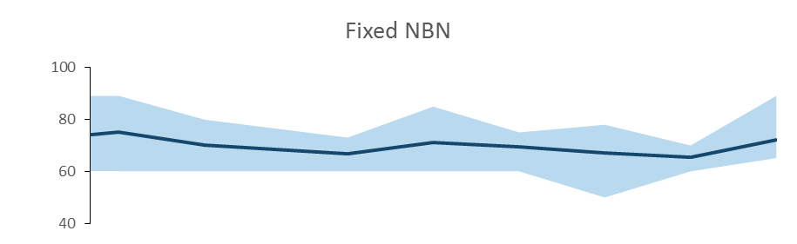

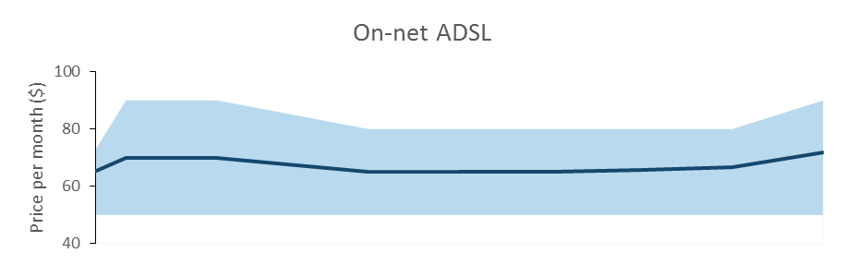

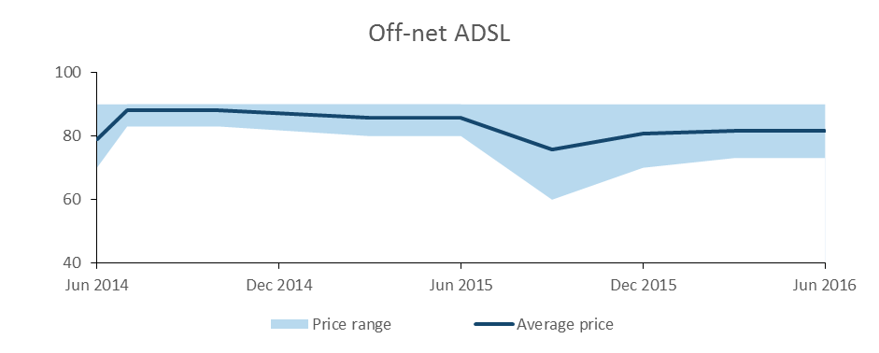

Source. Advertised service plan data compiled by the ACCC. Includes fixed bundles (phone and internet) advertised by the following retail service providers: Telstra, Belong, Optus, TPG, iiNet and iPrimus.

Notes. Entry-level plans defined as the cheapest bundle including at least 40GB data per month of on-peak data for each provider. Prices have not been adjusted for inflation. Off-net plans include connections at Zone 2 and 3 exchanges for Telstra and Belong. Some providers are not available on all types of connection.

## Affordability of mobile services

### There is a wide range of options for mobile customers, including at lower price points

Most mobile customers enjoy substantial choice when selecting a mobile plan. As at May 2017, the range of mobile services included pre and post-paid plans, at various price points, and with a range of data and voice inclusions. Customers who can access services from multiple mobile networks are better placed to tailor their choice of plan to suit their particular data and call needs.

The amount of data included in a plan tends to drive its price, with a strong positive relationship between price and data inclusions (Figure 17). There is also a strong relationship between data inclusions and the number of plans available to consumers. For instance, consumers with average data requirements–around 2GB per month–have the greatest choice, with a number of products offered at lower price points.[15] Large data users have more limited choice, with fewer plans available providing more than 12GB per month.

The relationship between a plan’s monthly price and its call inclusions is less clear. Unlimited calls are common, being included in more than half of the plans surveyed. Unlimited calls are a standard feature of plans with large data inclusions, but are also available at lower monthly costs ($25) (Figure 17). This suggests customers can cheaply access unlimited calls, irrespective of their data use.

Figure . Price vs included data, by limited or unlimited calls

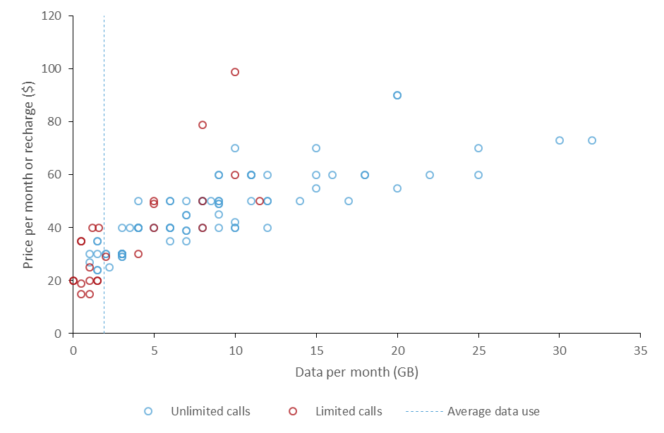

Source. BCAR survey of advertised mobile plans offered by Telstra, Optus, Vodafone, Amaysim, Virgin, Aldi, Boost, TPG. Excludes 32 prepaid plans with an expiry period of more than 1 month.

Notes. Plans advertised on provider websites in May. Blue circles are plans that include unlimited calls, other plans are red circles. Darker circles indicate numerous plans at the same data point. Plans closest to the bottom of the chart are the cheapest option for each amount of included data. The vertical blue line is the average Australian mobile consumption as at December 2016 (ABS 8153.0 Internet Activity, Australia, December 2016). Excludes plans with bundled hardware, such as an included handset.

Both the price and availability of prepaid plans are crucial to the affordability of mobile services, as prepaid services are heavily used by more vulnerable groups. For example, prepaid plans are often favoured by low income customers,[16] often as a way to control their expenditure,[17] and are also accessible to customers with limited access to credit or banking services.

Consumers who require prepaid services are generally well served in terms of price and choice. In particular, prepaid products dominate the cheapest end of the market (less than $25 a month and 2GB of included data), while post-paid offers are generally only available for $25 a month or more. Consumers can also access unlimited calls on prepaid plans at a lower monthly cost (around $30).

Many prepaid plans are available with up to 12–15GB per month (Figure 18) at comparable prices to post-paid services. However, prepaid plans tend not to be available with large amounts of data (inclusions greater than 15GB). Large mobile data users are therefore limited to post-paid products.

A number of prepaid plans offered longer expiry periods (typically 12 months), but with more limited data and call inclusions. Despite offering significantly worse value on a per-call or per-GB basis, these plans may represent a cost effective solution for extremely low use customers, as they can be used over an extended period. An analysis of some of these plans by carrier is at Table 2.

Figure . Price vs Included data, by payment type

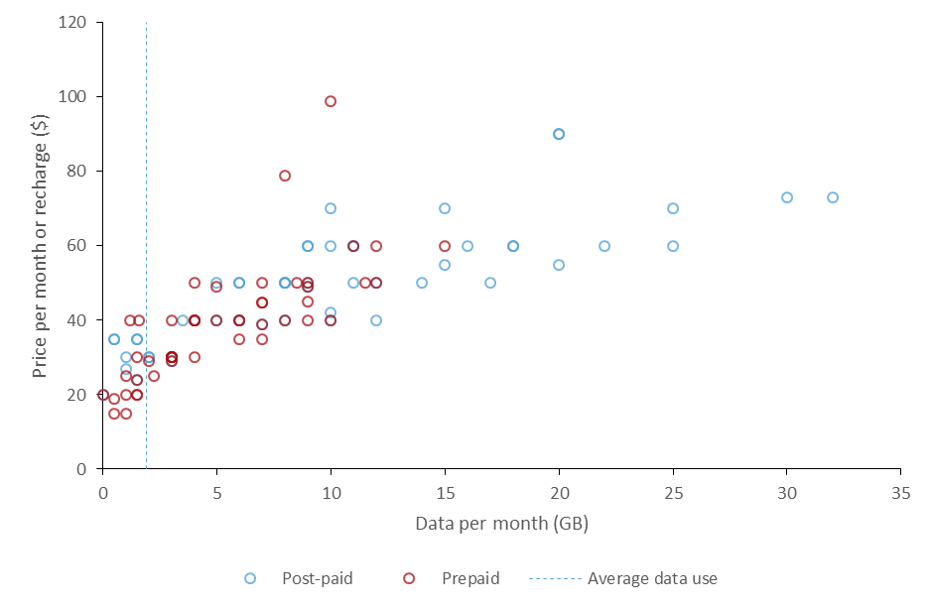

Source. BCAR survey of advertised mobile plans offered by Telstra, Optus, Vodafone, Amaysim, Virgin, Aldi, Boost, TPG. Excludes 32 prepaid plans with an expiry period of more than 1 month.

Notes. Plans advertised on provider websites in May. Blue circles are post-paid plans, prepaid plans are red circles. Darker circles indicate numerous plans at the same data point. Plans closest to the bottom of the chart are the cheapest option for each amount of included data. The vertical blue line is the average Australian mobile consumption as at December 2016 (ABS 8153.0 Internet Activity, Australia, December 2016). Excludes plans with bundled hardware, such as an included handset.

### …providing regional consumers with more choice

Although carriers apply nationally consistent pricing, the range of mobile products on offer varies across locations due to differences in the coverage of both mobile network operators (MNOs) and mobile virtual network operators (MVNOs) (Box 2). This variation can impact choice and affordability, particularly for regional and remote areas.

Telstra has the largest footprint of any mobile carrier, both in terms of population reach (Table 1) and geographic coverage. For approximately 1 million km2 (around 13 per cent of Australia), Telstra is the only available mobile network, although this area includes less than 1 per cent of the Australian population.[18] This means that some regional customers only access mobile plans provided on the Telstra network.

Table . Mobile coverage, percentage of the Australian population, 2016

|  | 3G coverage  (% of population) | 4G coverage  (% of population) |
| --- | --- | --- |
| Telstra | 99.3 | 98 |
| Optus | 98.5 | 95 |
| VHA (Vodafone) | 97 | 96.9 |

Source. ACCC (2016), Domestic Mobile Roaming Declaration Inquiry 2016—Discussion Paper

As with other MNOs, Telstra resells large sections of its network to MVNOs such as Boost and Aldi. The addition of these MVNOs has increased the choice of products available to regional areas. When taking into account the plans offered by these resellers, services offered over the Telstra network were broadly comparable to other networks in terms of price. For plans with large data inclusions (i.e. greater than 10GB), there tended to be fewer available on the Telstra network and they tended to be more expensive.

#### Box 2: MNOs vs MVNOs

Mobile network operators (MNOs) build and operate the physical equipment that provides mobile services. There are three MNOs currently operating in Australian (Telstra, Optus and Vodafone), with a fourth (TPG) set to enter the market in 2018.

As well as selling mobile services directly to customers, MNOs also offer provision services for resellers, or mobile virtual network operators (MVNOs), on a wholesale basis. An MNO can sell access to some or all of its network, and to a subset of technologies (i.e. 3G/4G, and at differing speeds).

Desktop research was conducted in May 2017, and recorded mobile plans advertised on MNO and MNVO websites. Both prepaid and post-paid plans were recorded. Post-paid plans that included a handset were excluded, to allow for immediate comparison with prepaid plans.

Figure 19. Price versus included data, by Telstra or non-Telstra network

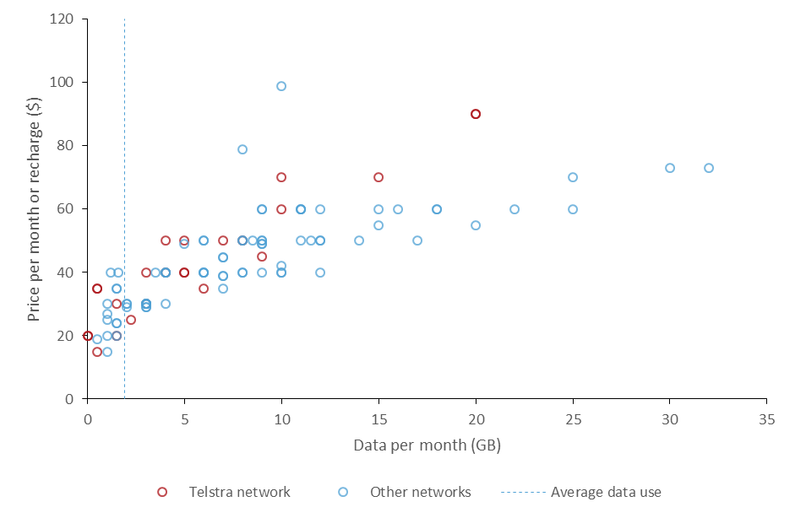

Source. BCAR survey of advertised mobile plans offered by Telstra, Optus, Vodafone, Amaysim, Virgin, Aldi, Boost, TPG. Excludes 32 prepaid plans with an expiry period of more than 1 month.

Notes. Plans advertised on provider websites in May 2017. Red circles are plans available on the Telstra network, other plans are blue circles. Darker circles indicate numerous plans at the same data point. Plans closest to the bottom of the chart are the cheapest option for each amount of included data. The vertical blue line is the average Australian mobile consumption as at December 2016 (ABS 8153.0 Internet Activity, Australia, December 2016). Excludes plans with bundled hardware, such as an included handset.

The overall picture for Telstra’s resale of access to its mobile network is unclear. Boost appears to have access to the entire network, whilst Aldi appears to access a large proportion of the network, particularly in eastern Australia. Customers who are only able to access Telstra’s retail mobile services (and not those from MVNOs) would have a more limited range of offers and generally higher prices (Figure 20).

Figure . Price vs included data for plans on the Telstra network, by Telstra or MVNOs

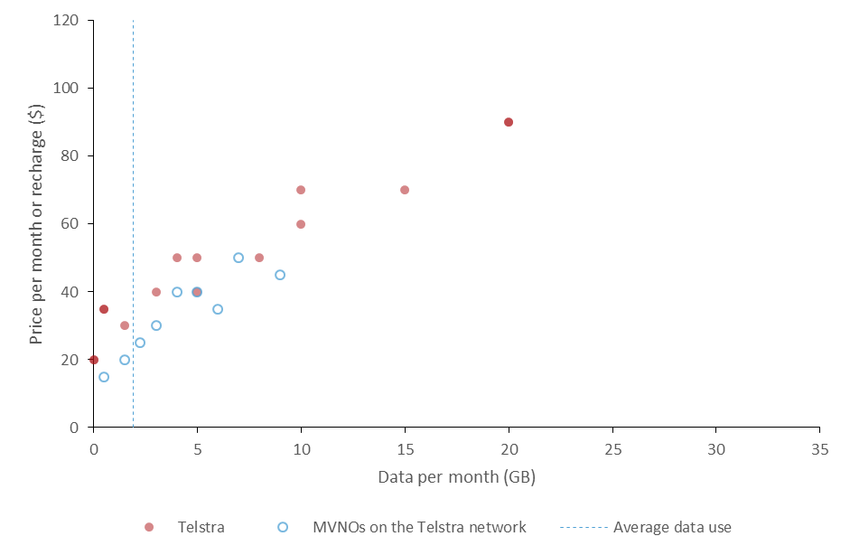

Source. BCAR survey of advertised mobile plans offered by Telstra, Aldi, and Boost. Excludes 32 prepaid plans with an expiry period of more than 1 month.

Notes. Plans advertised on provider websites in May 2017. Red circles are plans provided directly by Telstra, while MVNO plans provided on the Telstra network are blue circles. Darker circles indicate numerous plans at the same data point. Plans closest to the bottom of the chart are the cheapest option for each amount of included data. The vertical blue line is the average Australian mobile consumption as at December 2016 (ABS 8153.0 Internet Activity, Australia, December 2016). Excludes plans with bundled hardware, such as an included handset.

Telstra’s prepaid cap plans are broadly comparable to competitor offers in terms of price and inclusions, while its sim-only post-paid plans offer slightly less value. Telstra’s long-life prepaid plans appear to offer significantly less value, in terms of both voice and data, than the other providers surveyed, with the exception of Virgin (Table 2). However, there are some more cost effective long-life plans offered on the Telstra network, such as those through ALDI.

Table . Selected long-life prepaid plans, call and data costs, May 2017

| Plan (provider) | Expiry period | Price per Mb ($) | Price of a two-minute call |
| --- | --- | --- | --- |
| Prepaid Long Life (Telstra) | 2–12 Months[19] | 2 | 1.95 |
| Prepaid Long Life (Virgin) | 6–12 Months[20] | 0.12 | 1.96 |
| Pay As You Go (ALDI) | 12 Months | 0.05 | 0.24 |
| Pay As You Go (Amaysim) | 12 Months | 0.072 | 0.24 |
| Pay As You Go Plus (Vodafone) | 12 Months | 0.02 | 0.4 |

### The range of both post-paid and prepaid plans has increased…

Over the past three years there appears to have been a significant increase in the range of post-paid products on offer to consumers. Over this period, data and voice inclusions have increased significantly, particularly for more expensive plans offered by Optus and Vodafone (Figure 21). By contrast, the price of existing advertised plans appears to have remained relatively constant, though some expensive plans with higher data inclusions have been introduced.

Figure 21. MNO post-paid plans, 2014–16

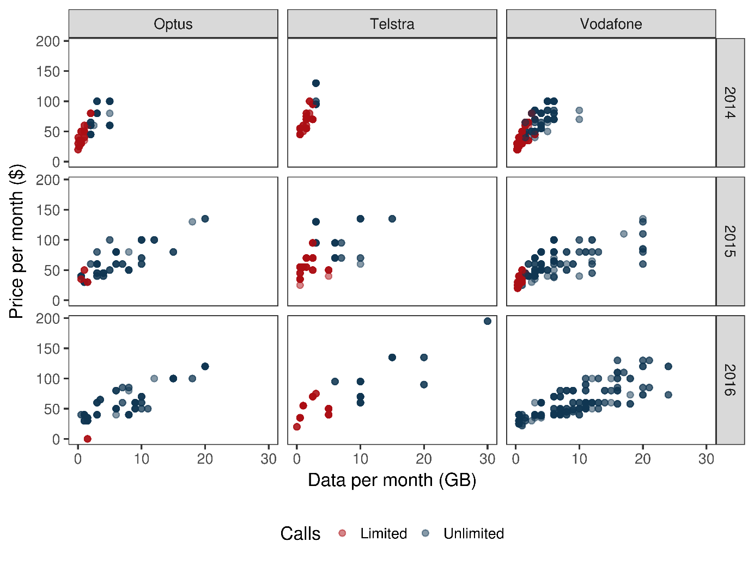

Source. Advertised service plan data compiled by the ACCC. Includes post-paid plans offered by Mobile Network Operators (MNOs).

Notes. Plans advertised by the following providers: Telstra, Optus, Vodafone. Collected on a monthly basis by the ACCC from January 2014 to November 2016. Blue circles are plans that include unlimited calls, other plans are red circles. Darker circles indicate numerous plans at the same data point. Plans closest to the bottom of the chart are the cheapest option for each amount of included data. Prices have not been adjusted for inflation.

There is a similar story for prepaid plans, where a broader range of prepaid products have become available over the past three years. Similar to the trends observed in post-paid, many plans included greater data and voice allowances in 2016 than 2014 without substantial increases in monthly costs, particularly from Optus and Vodafone. However, data and voice allowances offered by Telstra have lagged behind offerings from Optus and Vodafone. Prepaid plans have continued to offer more limited inclusions at a lower monthly price than post-paid plans.

Figure 22. MNO prepaid plans, 2014–16

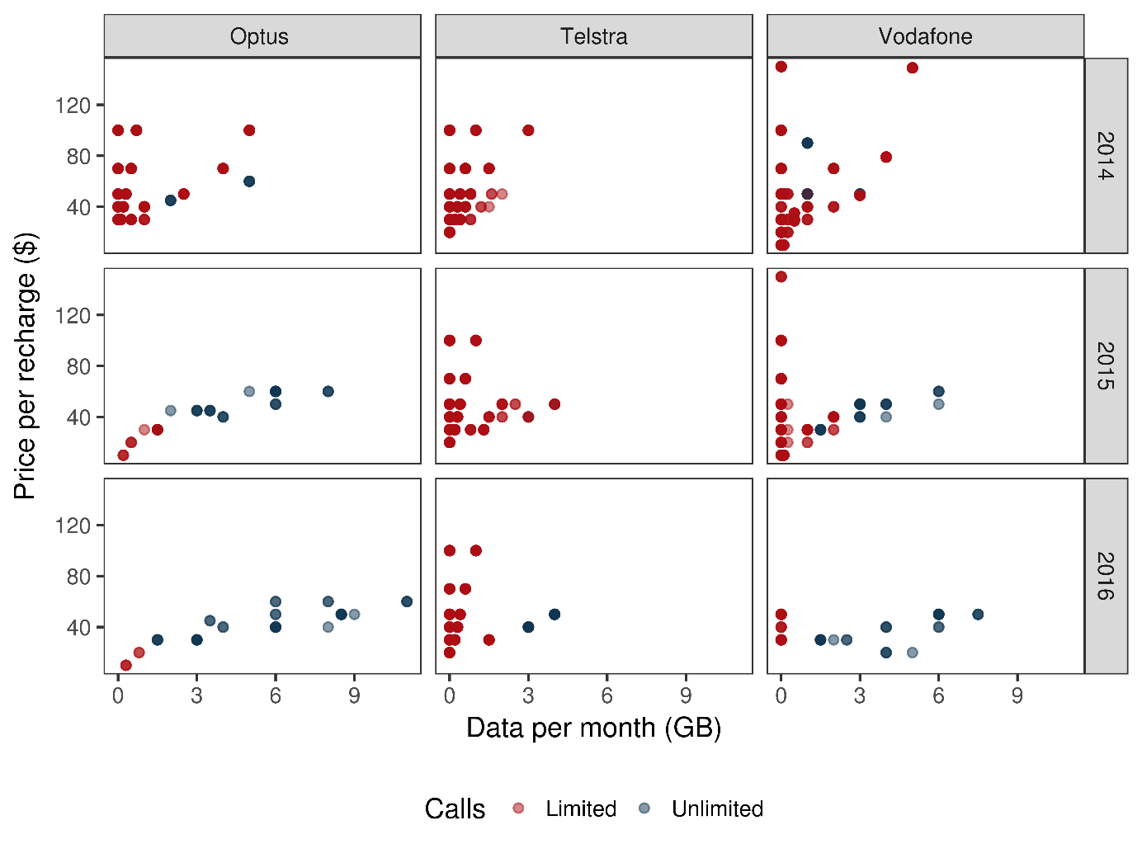

Source. Advertised service plan data compiled by the ACCC. Includes prepaid plans offered by Mobile Network Operators (MNOs).

Notes. Plans advertised by the following providers: Telstra, Optus, Vodafone. Collected on a monthly basis by the ACCC from March 2014 to November 2016. Blue circles are plans that include unlimited calls, other plans are red circles. Darker circles indicate numerous plans at the same data point. Plans closest to the bottom of the chart are the cheapest option for each amount of included data. Prices have not been adjusted for inflation.

Consumers appear to be better off because of lower real prices and the inclusion of more data. With prices broadly constant in nominal terms for prepaid and post‑paid plans over the past three years both prepaid and post-paid prices have declined in real terms. Additionally, some customers are likely to be receiving significantly more calls and data with their mobile plans.

### …including for mobile wireless broadband

Similar to mobile services, research of advertised prices for mobile wireless broadband services (wireless services) indicates that most consumers have access to a range of products across a range of price points (for both prepaid and post-paid plans).

As with mobile handset plans, data is a driver of the price of wireless products. Consumers have a considerable choice of wireless products below 12–15GB, especially for those with average data requirements of around 3GB per month (Figure 23).[21]

Figure . Mobile Wireless Broadband Price vs Included data, by payment type

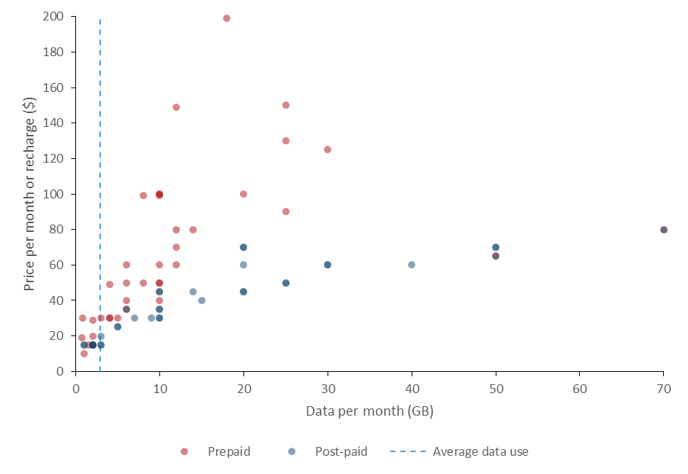

Source. BCAR desktop research of advertised mobile wireless broadband plans offered by Telstra, Optus, Vodafone, Amaysim, Virgin and Aldi (TPG and Boost did not offer data-only mobile broadband plans).

Notes. Plans advertised on provider websites in May 2017. Blue dots are post-paid plans, red dots are prepaid plans. Darker circles indicate numerous plans at the same data point. Plans closest to the bottom of the chart are the cheapest option for each amount of included data. A number of plans had expiry periods of less than one month. These have been adjusted to reflect the cost and data available if a customer was to maintain service over a one month period. The vertical blue line is the average Australian mobile wireless broadband consumption as at December 2016 (ABS 8153.0 Internet Activity, Australia, December 2016). Plans which bundle hardware (i.e. mobile broadband dongles) have been excluded.

In terms of data inclusions, there are more plans with larger data inclusions (12GB and over) offered for post-paid wireless compared to prepaid. With the exception of a few plans, these larger prepaid plans are more expensive than post-paid plans with the same data inclusions.

While most low-end post-paid and prepaid mobile plans are fairly comparable in terms of data included, the amount of data included for wireless services varies significantly. For example a number of prepaid plans with data inclusions up to 20–30GB are offered at higher price points. This could be due to the large difference in expiry dates for products (one week up to two years).[22]

Prices could also be influenced by the degree of competition in wireless services compared to mobile services. As at June 2016, Telstra’s retail share of the market for mobile wireless services (65 per cent) was much higher than its share of the market for mobile handset services (45 per cent). The wireless market share of the other MNOs was just 20 per cent; 13 per cent for Optus and 7 per cent for Vodafone.[23]

The ACCC reports that prices paid for wireless services increased by 6.4 per cent during 2015–16 and average data inclusions also increased significantly by 91 per cent.[24] This increase is a result of average and higher spending consumer groups spending significantly more on wireless services.

The volume of mobile and wireless data downloaded by users has increased significantly in recent years, especially from 2015 onwards (Figure 24).

Figure . Mobile handset versus mobile wireless broadband data downloaded per connection

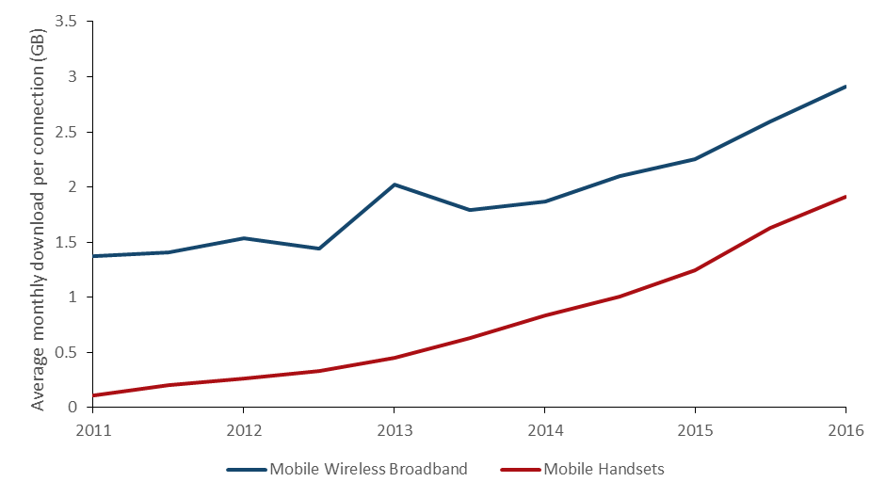

Source. ABS (2017), 8153.0—Internet Activity, Australia, December 2016

## Affordability outcomes for particular households

Aggregate affordability measures, which reflect the outcome for the ‘average’ household, are not sufficient to draw inferences of affordability for some groups. This is because costs and products vary across different communications services, market segments and geographic regions.

This variance may disproportionately impact on low income, vulnerable groups—which includes households where at least one member is not employed, has a long term health condition, is aged 65 years and over, or is Aboriginal or Torres Strait Islander, as well as rural households.

### Lower-income households spend a larger proportion of their income on communications services

In 2015, the bottom 10 per cent of households by income spent almost 10 per cent of their disposable income on communications services, compared with the top 10 per cent of households, who spent approximately 1 per cent of their disposable income. The average spend was 3.5 per cent of disposable income across all households (Figure 25).

Figure . Average share of household disposable income spent on mobile and fixed-line telephone rent, calls and internet charges, by household disposable income decile, 2015

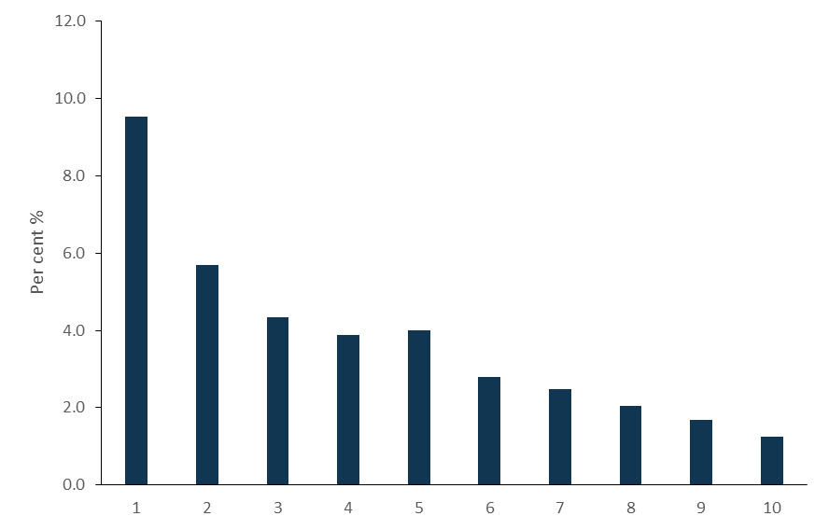

Source. The Household Income and Labour Dynamics in Australia (HILDA) Survey, Release 15.

Notes. Analysis excludes a small number of households with an expenditure share equal to zero or equal to 100 per cent or greater.

However, the amount most vulnerable groups (as defined above) spend on key communications services has been falling as a share of their income since around 2009 (Figure 26). This share fell for rural households until 2013 but slightly increased more recently (Figure 27).

Rural households tend to spend a slightly higher proportion of their income on key communications services compared to households overall. Figure 28 and Figure 29 suggest that the recent increase in the expenditure share for rural households was largely driven by relatively weaker growth in disposable income in rural areas at the same time that expenditure continued to track the average for all households. However, this analysis is based on data up to 2015 and pre‑dates the take-up of NBN services in many of these areas.

Figure and Figure . Average share of household disposable income spent on mobile and fixed-line telephone rent, calls and internet charges, by vulnerable groups and rural households over time

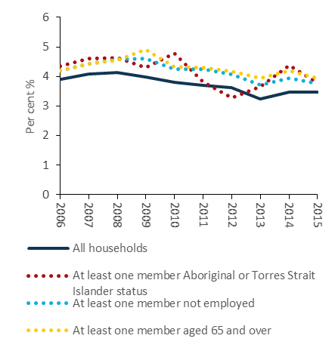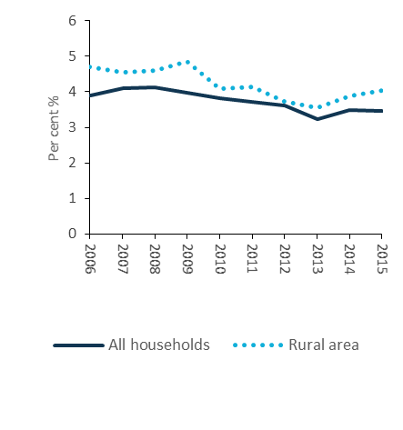

Source. The Household, Income and Labour Dynamics in Australia (HILDA) Survey, Release 15.

Notes. Analysis excludes a small number of households with an expenditure share equal to zero or equal to 100% or greater. Due to small sample sizes, results for Aboriginal or Torres Strait Islander status should be treated with caution. The definition of rural areas is consistent with the Section of State structure in the Australian Statistical Geographical Standard.

Figure and Figure . Average annual household expenditure on mobile and fixed-line telephone rent, calls and internet charges, all households and rural areas. Average annual household disposable income, all households and rural areas.

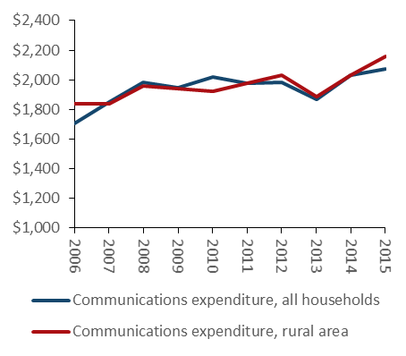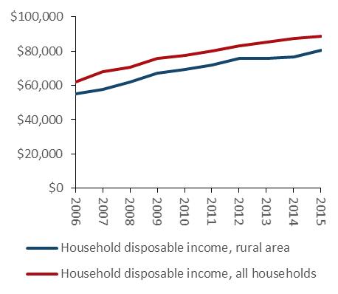

Source. Household, Income and Labour Dynamics in Australia (HILDA) Survey, Release 15.

Notes. Analysis excludes a small number of households with an expenditure share equal to zero or equal to 100% or greater. Due to small sample sizes, results for Aboriginal or Torres Strait Islander status should be treated with caution. The definition of rural areas is consistent with the Section of State structure in the Australian Statistical Geographical Standard.

The proportion of low-income households which spend a relatively larger proportion of their income on communication services has also been declining. These ‘low-income, high spending’ households are defined as those:

* with less than half the median household income, and
* whose share of expenditure on communications services is more than three times the median.[25]

While this group may include households experiencing affordability issues, it may also include households that choose to spend a high share of disposable income on communication services due to tastes or preferences. These households tend to have younger members, who are more likely to access data‑intensive online content such as audio and video streaming.[26]

Overall, the share of ‘low-income, high spending’ households increased from 5.9 per cent in 2006 to 7.9 per cent in 2009 but has since fallen to approximately 7.0 per cent in 2015. The proportion of vulnerable groups who are ‘low-income, high spending’ has declined over this period, though there has been a slight increase for rural households (Figure 30). This could be due to a number of factors, including volatility in the data and lower income growth in rural areas in this period. Once again, this analysis is based on data up to 2015 and thus pre‑dates the take-up of NBN services in many of these areas.

Figure and Figure . Percentage of low-income and high spending households, vulnerable groups and rural households, 2006–2015

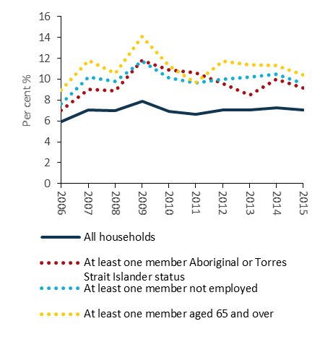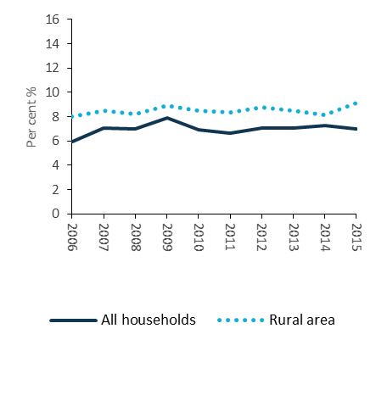

Source. The Household, Income and Labour Dynamics in Australia (HILDA) Survey, Release 15.

Notes. Analysis excludes a small number of households with an expenditure share equal to zero or equal to 100 per cent or greater. Due to small sample sizes, results for Aboriginal or Torres Strait Islander status should be treated with caution.

Aside from spending a relatively larger proportion of their income on communication services, some vulnerable groups may also be under-utilising communications services. Compared to other households on similar incomes, households with members who are not employed, aged 65 years or older or who are Aboriginal or Torres Strait Islander tend to spend less on communications services.

A significant minority of Australian households (14 per cent) are not connected to the internet at home, with most falling within the lowest and second-lowest income quintiles. However it appears that cost is not the main reason, with respondents from these income brackets more likely to cite a lack of need (65 per cent) or a lack of confidence or knowledge (24 per cent) as reasons why they do not have a home internet connection, rather than the cost of access (16 per cent).[27]

## International comparisons

A number of international organisations attempt to compare affordability of ICT services between countries. These include the International Telecommunications Union (ITU) in its ‘Measuring the Information Society’ series, the World Economic Forum (WEF) in its ‘Global Information Technology’ report, and the Groupe Speciale Mobile Association (GSMA) in its ‘Mobile Connectivity Index’.

Australian mobile services typically perform well against these international measures. The GSMA, for example, ranked Australia fifth in the world for mobile internet affordability in 2016.[28] Adopting different methodologies for assessing and compared prices, the ITU ranked Australia as the 12th most affordable mobile-cellular services in its 2016 report,[29] and the WEF ranked Australia’s mobile tariffs as 19th most affordable out of the 139 countries it assessed.[30]

By contrast, Australia has traditionally not performed as well on the affordability of its fixed-line broadband services. The WEF, for example, ranked Australia 100th in the world on fixed broadband prices in 2016, behind comparable countries in terms of income and population density such as Canada (81st).[31] The ITU was more favourable; ranking Australia’s fixed-broadband as 16th most affordable in 2016. [32] This was a considerable improvement on its 2015 ranking of 40th in the world.[33]

As these broadband measures do not account for differences in product inclusions such as data allowances and speed, better data and comparable methodologies are needed for a more robust cross-country comparison of the affordability of broadband and mobile services. As such, caution should be applied when relying on these international measures.

## Outlook for affordability

Strong consumer demand for communications services is anticipated to continue well into the future, driven by new digital services and technological innovations, the proliferation of content markets, and greater access to high-speed internet.

For home broadband users, the NBN will be key to delivering services that can meet this growing demand. The average NBN user downloaded 150GB per month in December 2016.[34] While this is already considerably higher than the national average for fixed-line broadband services,[35] nbn anticipates average monthly data downloads to more than double by 2020.

The affordability outlook for NBN or other fixed-line broadband services depends on a number of factors, including regulatory settings, competitive pressures and broader income growth. A key objective of the NBN is to deliver fast broadband for affordable prices, by providing wholesale services to access seekers on a level playing field. Regulatory measures ensure that most price sensitive consumers can currently access entry-level (12/1 Mbps) NBN services at a comparable price to their existing ADSL services.

A highly competitive mobile sector is likely to ensure ongoing access to affordable mobile services with growing data allowances. As existing carriers continue to make significant investments in their mobile networks,[36] and TPG launches its own network in 2018 with aggressively priced plans, competition will focus on retention and growth of market share. Building on these developments, the ACCC found price competition to be reasonably dynamic within the sector, and mobile prices low compared to similar countries.[37] These were factors in its draft decision not to declare a mobile roaming service, suggesting the ACCC views robust competition as a long-term feature of the national mobile market in Australia.

## Appendix. Price collection methodology

To obtain detailed information on the prices and product inclusions of currently available communications services, the BCAR recorded details of products advertised on the websites of a range of providers. Information was collected for fixed broadband, mobile voice, and mobile wireless broadband offers on 17 and 18 May 2017.

Due to the complexity and variability of communication service offerings, drawing meaningful comparisons between providers or plans can be challenging. Where appropriate, adjustments have been made to the sample to enable meaningful comparisons between plans.

The data collection and research aims to:

* **Provide an overview of the products purchased by most consumers** by recording plans offered by the largest three or four providers in each market (fixed broadband, mobile voice and mobile wireless broadband), generally accounting for around 90 per cent of connections.
* **Provide an overview of the products available to consumers** by recording plans offered by smaller providers, particularly MVNOs. This gives a more complete picture of the choices available to consumers.
* **Explore the pricing and inclusions of products most relevant to price sensitive consumers and vulnerable groups** by analysing plans at lower price points, and considering a range of prepaid mobile plans alongside post-paid offers.
* **Explore differences between pricing and affordability in metropolitan and regional areas** using products offered via off-net ADSL, nbn satellite and fixed wireless, and mobile services available on the Telstra network as indicators of the products available to regional customers.
* **Develop an efficient, transparent and reproducible collection methodology.**

This Appendix documents the collection and adjustment process, along with key assumptions and excluded plans. It is intended to identify the boundaries of the analysis, and improve the reproducibility of the research.

### Fixed broadband products

#### Providers

Broadband services from the following providers were collected: Telstra and its brand Belong, Optus, TPG and its brands iiNet and Internode, and the Vocus brands iPrimus and Dodo. These four fixed broadband retailers and their major brands, account for around 90 per cent of the fixed broadband services market, as at June 2016.

#### Plans

Where possible, only products advertised on websites were included.

#### Connection types/technology

The following connection types were recorded:

* ADSL (on- and off-net)
* Fixed NBN connections, including:
* Fibre to the Premise (FTTP)
* Fibre to the Basement (FTTB)
* Fibre to the Node (FTTN)
* Hybrid fibre-coax (HFC)
* Fixed wireless NBN
* Satellite NBN.

With the exception of TPG, all providers offered identical pricing across fixed-line and fixed wireless NBN connection types. The pricing of TPG’s NBN fixed wireless differed from its other NBN plans. As a result, TPG’s fixed wireless plans were excluded from the analysis. For all other providers, a single ‘fixed NBN’ price was recorded for each plan.

All other connection types, including non-NBN HFC/FTTP/FTTB/FTTN and fixed wireless, were excluded from the analysis.

A key assumption was that these providers will eventually offer plans across the entire NBN (all 121 points of interconnection (POIs)). As at 31 March, the ACCC reports that at least four access seeker groups are connecting to each POI. Additionally, Telstra, Optus and Vocus offer wholesale broadband products to all NBN-enabled premises. As a result, it is likely that the fixed broadband providers surveyed are, or will be, widely available across the NBN. This may not apply to smaller providers.

#### Voice and calling packs

Some providers offered optional voice add-ons which increased the monthly broadband access fee. For example, Belong offers unlimited calls to Australian numbers on all its plans, for an additional $10 per month. In these cases, the original plan and the plan with the calling pack were recorded separately. International call packs were not included in the analysis.

#### Speed tiers

Most providers offered optional speed add-ons for their NBN plans, where customers could upgrade to a higher speed tier for an additional monthly cost. All NBN plans were recorded at the lowest speed tier (12/1Mbps), with two exceptions:

* Telstra does not offer 12/1Mbps plans. Plans from its lowest speed tier (25/5Mbps) have been included instead.
* Optus offers three broadband plans. Plans from its lowest speed tier (25/5Mbps) have been included.
* Satellite plans were collected at both the 12/1Mbps and 25/5Mbps speed tiers.

#### Unlimited data

Where providers offered unlimited data, an allowance of 1500GB was used for comparison purposes.

#### Off-Peak data

Plans including off-peak data were relatively rare, except for NBN-Satellite plans. Some NBN satellite plans included a small amount of on‑peak data with a much larger (more than ten times) amount of off‑peak data. These night-owl plans were excluded from the analysis. Otherwise, off-peak data inclusions were not analysed in detail.

#### Foxtel

Several Telstra plans were bundled with a Foxtel service. These plans, which were more expensive than comparable broadband plans, were excluded from the analysis.

#### Phone line rental

Both standalone broadband and broadband-voice bundles were included in the analysis. Where a plan required an active phone line, the price of Telstra Home Phone Basic ($25.95) was added to the monthly cost. Some providers offered a broadband-voice bundle at the same price as a standalone ADSL2+ connection. In these cases, only the bundle price was included. NBN-Satellite voice bundles were not considered in the analysis.

#### Other product inclusions

For all other optional inclusions that affect price (i.e. apart from calls or speed tier), the option with the *cheapest monthly price* is selected. For example, some providers offer month-to-month plans with no minimum contract length but an increased monthly cost. These plans were excluded from the analysis.

A range of other product inclusions may differentiate the quality of fixed broadband services, but were not analysed in depth. This includes contract length, voice inclusions, streaming/video on demand, and zero rated data inclusions.

#### Setup costs

Equipment, installation and other setup costs were not considered in the analysis.

#### Connection type

Most provider websites do not present customers with all the plans available in their area up front. Instead, customers are asked to input their address and a range of options and prices is presented, based on the type of broadband connections available.

To determine prices for different technology types, a list of addresses with access to specific connection types was developed internally. These addresses were then entered into each provider website to determine pricing for each service.

For example, an address that could only access Telstra ADSL (wholesale or retail) was used to determine the off-net ADSL pricing of each provider. Similarly, an address that could only access NBN fixed wireless was used to determine prices and offers over the NBN fixed wireless footprint.

It was not able to be determined if each of the providers examined offer products across the entire NBN. As at March 2017, at least four access seeker groups were present at each NBN point of interconnect, suggesting that many providers are widely available on the NBN.

It is unclear if providers vary pricing based on location, outside of connection type.

Where providers offer a range of off-net or regional products (i.e. resell a non-Telstra ADSL network) off-net pricing was taken to be the price of a connection at a Zone 2 Telstra-only exchange.

### Mobile handset and mobile wireless broadband products

#### Providers

Mobile voice services from the following providers were collected: Telstra and its resellers Boost and Aldi, Optus and its resellers Amaysim and Virgin, and Vodafone and its reseller TPG. The three MNOs account for 90 per cent of the retail mobile handset services market and 85 per cent of the wireless broadband services market, as at June 20.

#### Plans

The analysis covered products advertised on websites. The analysis does not include products offered to customers over other media such as telemarketing and in store.

#### Mobile wireless broadband

Plans that were advertised as mobile broadband, or did not offer voice inclusions, were analysed separately as mobile wireless broadband.

#### Plan type

Both pre and post-paid mobile plans were collected. The recharge price and data included with prepaid plans with an expiry period of less than a month was adjusted to one month on a pro-rata basis, with the exception of daily prepaid plans which were excluded from all analysis. Prepaid voice plans with expiry periods of more than one month (long-life) were collected but analysed separately.

Due to the smaller number of plans, long-life mobile wireless broadband plans were included in the analysis. A single daily plan was excluded.

#### Bundled hardware

Plans that included subsidised hardware (i.e. a phone/wireless modem at reduced/no up-front cost) were not included in the analysis. Plans that include a free sim card were included.

#### Contract length

Unlike with fixed-line services, where contract length affected plan price, all options were recorded. This is because the pricing structure of contracted plans appears to be substantively different from uncontracted plans.

#### Bonus data

Some providers offered significant additional monthly data, badged as ‘bonus data.’ Where this is available over the course of the plan, it is added to standard data inclusions.

#### Other product inclusions

A range of other product inclusions may differentiate the quality of fixed broadband services, but were not analysed in depth. This includes international call inclusions, streaming/video on demand, and zero rated data inclusions.

## Endnotes

1. This paper uses unit record data from the Household, Income and Labour Dynamics in Australia (HILDA) Survey. The HILDA Project was initiated and is funded by the Australian Government Department of Social Services (DSS) and is managed by the Melbourne Institute of Applied Economic and Social Research (Melbourne Institute). The findings and views reported in this paper, however, are those of the author and should not be attributed to either DSS or the Melbourne Institute.
2. ABS (2015), Household and Family Projections, Australia, 2011 to 2036.
3. Ibid.
4. ACMA (2016), Communications report 2015-16, p.60.
5. ABS (2017), 8153.0—Internet Activity, Australia, December 2016.
6. Ibid.
7. The ACCC produces an annual index of communications prices to indicate movements in prices for a basket of telecommunications services. The fixed-line voice services index is calculated using a unit value approach based on company level revenue and usage data and takes into account changes in product inclusions. The internet and mobile services indices are created using consumer ‘profiles’ generated from a sample of internet or mobile bills. The profiles are based on expenditure quintile (i.e. average consumption from the lowest spending fifth through to average consumption by the highest spending fifth). The most appropriate plan is selected for each group, and price compared with previous periods. Price change is averaged over each group (for the mobile index) or over each group for each provider, weighted by expenditure (for the internet index). These indices do not directly account for changes in product inclusions and are currently being reviewed by the ACCC. All three indices are adjusted for inflation; ACCC (2017), Competition in the Australian telecommunications sector: Price changes for telecommunications services in Australia, pp.108, 110.
8. ACCC (2017), Competition in the Australian telecommunications sector: Price changes for telecommunications services in Australia, p.105.
9. ACCC (2017), Competition in the Australian telecommunications sector: Price changes for telecommunications services in Australia, p.99.
10. With the exception of TPG, providers offered identical plans over fixed-line NBN (FTTP, FTTB, FTTB and HFC) and fixed wireless NBN. Consequently, these groups have been merged in the analysis with TPG’s fixed wireless plans excluded.
11. Data on advertised plans was collected directly from provider websites in May 2017 for the following retail service providers: Telstra, Optus, iiNet, TPG, Internode, iPrimus, Belong and Dodo. The ACCC reports that Telstra, Optus, TPG group (TPG, iiNet, Internode) and Vocus (Dodo and iPrimus) provided 94% of wholesale NBN connections, and 90% of retail fixed broadband services overall, as at June 2016; Competition in the Australian telecommunications sector: Price changes for telecommunications services in Australia, pp. 16-25.
12. The analysis includes both fixed-line and fixed wireless NBN plans. All of the providers surveyed offered identical plans across these technologies with the exception of TPG which charges slightly more for fixed wireless plans.
13. The analysis has focused on fixed NBN plans available at the 12/1 Mbps speed tier, except where providers do not offer plans at this speed tier (i.e. Telstra and Optus). In general providers charge extra for higher speed tiers.
14. nbn (2016), nbn Corporate Plan 2017.
15. ABS (2017), 8153.0 Internet Activity, December 2016.
16. ACCAN (2013), Wise, Trying to connect—Telecommunications access and affordability among people experiencing financial hardship.
17. Ogle & Musolino (2016), Connectivity Costs, South Australian Council of Social Services.
18. ACCC (2016), Domestic Mobile Roaming Declaration Inquiry 2016—Discussion Paper, p. 14.
19. Expiry period increases with recharge value.
20. Expiry period increases with recharge value. Call rates to other Virgin services are lower. Data price on the Optus APN, with the Virgin APN being significantly more expensive.
21. ABS (2017), 8153.0 Internet Activity, December 2016.
22. Mobile wireless broadband is defined by the ABS as an internet connection which provides short range, high data rate connections between mobile data devices and access points connected to a network e.g. mobile WiMax and 3G/4G accessed through a datacard, USB modem, tablet SIM card or any other device used to connect a computer to a cellular network (excluding a mobile handset); ABS (2017), 8153.0 Internet Activity, December 2016.
23. ACCC (2017), Competition in the Australian telecommunications sector: Price changes for telecommunications services in Australia, p. 29-30.
24. ACCC (2017), Competition in the Australian telecommunications sector: Price changes for telecommunications services in Australia, p. 102.
25. Half the median income is a standard measure of income poverty which has been used by the OECD and in previous Australian research to calculate poverty rates. https://data.oecd.org/inequality/poverty-rate.htm <http://www.acoss.org.au/wp-content/uploads/2016/10/PovertyMethods2016.pdf>. Based on analysis of the HILDA data, three times the median share was the most appropriate metric to capture those households spending an unusually large share of their income on communications services. A multiple other than three could also be chosen.
26. ACMA (2016), Communications report 2015-16, p. 64.
27. ABS (2016), Household use of information technology, Australia, 2014–15, Table 1: Persons, by internet use; Table 5: Households without internet access, by reasons for no internet access at home
28. The affordability measure takes into account the cost of entry-level data plans, entry-level handset prices, average income, degree of inequality and taxation; GSMA (2016), [Mobile Connectivity Index: Australia](http://www.mobileconnectivityindex.com/).
29. The mobile-cellular sub-basket of ICT prices refers to the price of a standard basket of 30 outgoing calls per month (on-net/off-net to a fixed-line and for peak and off-peak times, in predetermined ratios), plus 100 SMS messages. ITU (2016), [Measuring the Information Society Report 2016](http://www.itu.int/en/ITU-D/Statistics/Documents/publications/misr2016/MISR2016-w4.pdf), pp. 105, 107.
30. World Economic Forum (2016), [Global Information Technology Report 2016](http://www3.weforum.org/docs/GITR2016/WEF_GITR_Full_Report.pdf), p. 60.
31. Ibid.
32. ITU (2016), [Measuring the Information Society Report 2016](http://www.itu.int/en/ITU-D/Statistics/Documents/publications/misr2016/MISR2016-w4.pdf), p. 120.
33. Noting that this score is derived from the price of a single plan from a single provider, and therefore may not be representative of the affordability of the wider market.
34. nbn (2017), Aussie OTT subscribers set to treble [media release], 28 March.
35. The average fixed-line broadband subscriber downloaded 117GB of monthly data in December 2016; ABS (2017), 8153.0 - Internet Activity, Australia, December 2012-2016.
36. ACCC, Telecommunications reports 2014–15, p. 7.
37. ACCC (2017), Domestic mobile roaming declaration inquiry: draft decision, May.