Commonwealth of Australia

Telecommunications Act 1997

Telecommunications (Network Exemption—TransACT Very Small Scale Networks) Instrument 2012 (Amendment No.1 of 2020)

I, PAUL FLETCHER, Minister for Communications, Cyber Safety and the Arts make the following Instrument under subitem 27(1) of Schedule 1 to the Telecommunications Legislation Amendment (Competition and Consumer) Act 2020 and subsection 144(1) of the Telecommunications Act 1997.

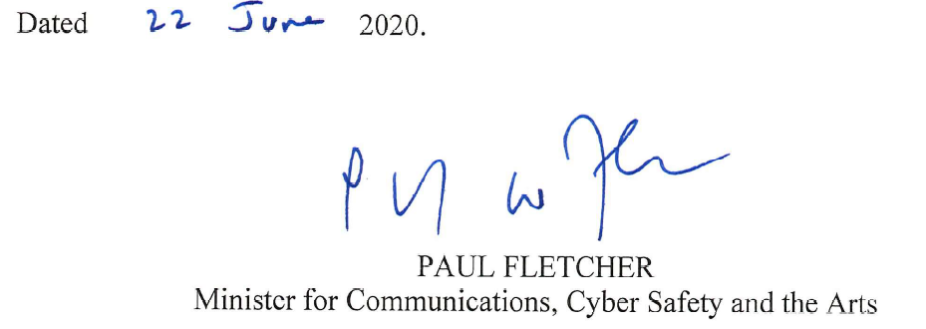_________________________________________________________________
- Name of Exemption Instrument
This Instrument is the Telecommunications (Network Exemption—TransACT Very Small Scale Networks) Instrument 2012 (Amendment No.1 of 2020).
- Commencement

This Instrument commences on the day it is signed.
- Amendment

The Telecommunications (Network Exemption—TransACT Very Small Scale Networks) Instrument 2012 (incorporating amendments up to 9 November 2012) is amended as set out in the Schedule to this Instrument.
- Schedule—Amendments

Telecommunications (Network Exemption—TransACT Very Small Scale Networks) Instrument 2012 (Amendment No.1 of 2020)

1 Cause 2 (Cessation)

Omit the clause in its entirety, substitute:

This Instrument ceases on the earlier of:
a. the day after:
i. a functional separation undertaking; or
ii. a deemed standard functional separation undertaking
relating to local access lines forming part of a Victorian Very Small Scale Network or an ACT Very Small Scale Network first comes into force for the purposes of Part 8 of the Act; and
b. the day that is the second anniversary of the day on which the Telecommunications Legislation Amendment (Competition and Consumer) Act 2020 (Cth) received the Royal Assent.

2 Cause 3 (Definitions)
Insert:

deemed standard functional separation undertaking means a functional separation undertaking covered by a determination under subsection 151B(1) of the Act, as amended by Schedule 2 to the Telecommunications Legislation Amendment (Competition and Consumer) Act 2020 (Cth).

functional separation undertaking has the same meaning as in section 142A of the Act, as amended by Schedule 2 to the Telecommunications Legislation Amendment (Competition and Consumer) Act 2020 (Cth).

