Commonwealth of Australia

Telecommunications Act 1997

Telecommunications (Network Exemption—TransACT Very Small Scale Networks) Instrument 2012

as amended

Made under the Telecommunications Act 1997 as in force at 22 June 2020.

This compilation was prepared on 25 June 2020 taking into account amendments made on 22 June 2020.

Prepared by the Department of Broadband, Communications and the Digital Economy _________________________________________________________________
- Name of Instrument
This Instrument is the Telecommunications (Network Exemption—TransACT Very Small Scale Networks) Instrument 2012.
- Commencement and cessation
This Instrument ceases on the earlier of:
    - the day after:
      - a functional separation undertaking; or
      - a deemed standard functional separation undertaking
relating to local access lines forming part of a Victorian Very Small Scale Network or an ACT Very Small Scale Network first comes into force for the purposes of Part 8 of the Act; and
    - the day that is the second anniversary of the day on which the Telecommunications Legislation Amendment (Competition and Consumer) Act 2020 (Cth) received the Royal Assent.

- Definitions
  - In this Instrument:
access seeker has the same meaning as in Part XIC of the Competition and Consumer Act 2010.
Act means the Telecommunications Act 1997.
ACT Very Small Scale Network means a fixed line telecommunications network:
    - that is owned by TransACT; and
    - which comprises:
      - an extension to a specified relevant network, where that extension;
- is located in a real estate development project within the network footprint of that specified relevant network; and
- is constructed on or after 1 January 2011; and
- extends further than 1 kilometre from a point of the infrastructure of that specified relevant network; and
- connects no more than 100 premises in the real estate development project; or
      - a relevant network which:
- is constructed on or after 1 January 2011: and
- is located in a new real estate development project within the network footprint of a specified relevant network; and
- connects no more than 100 premises in the real estate development project.
declared service has the same meaning as in Part XIC of the Competition and Consumer Act 2010.
deemed standard functional separation undertaking means a functional separation undertaking covered by a determination under subsection 151B(1) of the Act, as amended by Schedule 2 to the Telecommunications Legislation Amendment (Competition and Consumer) Act 2020 (Cth).
designated day has the same meaning as in section 577A of the Act.
FTTP network means fibre-to-the-premises network.
functional separation undertaking has the same meaning as in section 142A of the Act, as amended by Schedule 2 to the Telecommunications Legislation Amendment (Competition and Consumer) Act 2020 (Cth).
HFC network means a telecommunications network the line component of which consists of optical fibre to connecting nodes, supplemented by coaxial cable connections from the nodes to the premises of end-users.
Layer 2 has the same meaning as in the Open System Interconnection (OSI) Reference Model for data exchange.
Layer 3 has the same meaning as in the Open System Interconnection (OSI) Reference Model for data exchange.
relevant network means a HFC network, an FTTP network or a VDSL network.
TransACT means TransACT Capital Communications Pty Ltd (ACN 093 966 888), a company incorporated in the Australian Capital Territory.
TransACT Layer 3 Wholesale Interconnection Service means a carriage service that:
    - is offered to be supplied on a wholesale basis; and
    - is supplied to internet service providers for connectivity to end customers; and
    - is supplied by means of either an optic fibre line or a copper line; and
    - where supplied:
      - using a VDSL network, is offered as an aggregation service to support the aggregation of access services at a maximum download transmission speed of at least 60 Mbps and upload transmission speed of at least 15 Mbps;
      - using an FTTP network, is offered as an aggregation service to support the aggregation of access services at each of the following maximum transmission speeds:
        - download transmission speed of at least 10 Mbps but less than 25 Mbps and upload transmission speed of at least 1 Mbps;
        - download transmission speed of at least 25 Mbps but less than 100 Mbps and upload transmission speed of at least 5 Mbps;
        - download transmission speed of at least 100 Mbps and upload transmission speed of at least 20 Mbps; and
    - is configured as a best effort or non-prioritised service; and
    - has connectivity made either:
      - via Layer 3 interconnect with:
        - Internet Protocol version 4 (IPv4) connectivity provided to end user sessions; and
        - end-user sessions terminated in the TransACT network via Point to Point Protocol over Ethernet and supplied as IPv4 over Ethernet; or
      - via Layer 2 Tunnelling Protocol (L2TP) interconnect with:
        - direct access to end user sessions via L2TP; and
        - end-user sessions aggregated together in either a TransACT or TransACT Victoria network via static L2TP tunnels supplied over the Ethernet.
TransACT Victoria means TransACT Victoria Communications Pty Ltd (ACN 063 024 475), a company incorporated in the State of Victoria.
VDSL network means a very high speed digital subscriber line network.
Very Small Scale Network means either an ACT Very Small Scale Network or a Victorian Very Small Scale Network.
Victorian Very Small Scale Network means a fixed line telecommunications network:
    - that is owned by TransACT Victoria; and
    - which comprises:
      - an extension to a specified relevant network where that extension;
- is located in a real estate development project within the network footprint of that a specified relevant network; and
- is constructed on or after 1 January 2011; and
- extends further than 1 kilometre from a point of the infrastructure of the specified relevant network; and
- connects no more than 100 premises in the real estate development project; or
      - a relevant network which:
- is constructed on or after 1 January 2011: and
- is located in a new real estate development project within the network footprint of a specified relevant network; and
- connects no more than 100 premises in the real estate development project.

  - The specified relevant networks:
    - for TransACT—are set out at column 1 (items 1 and 2) of the table at Schedule 1; and
    - for TransACT Victoria—are set out at column 1 (items 3, 4 and 5) of the table at Schedule 1.

  - The network footprints of the specified relevant networks are those areas that were covered by the specified relevant networks.

  - For the specified relevant networks specified in items 1 and 2 of the table, the network footprints fall entirely within the areas identified in maps 1 and 2 at Annexure A to Schedule 1.

  - For the specified relevant networks specified in items 3, 4 and 5 of the table, the network footprints are shown in maps 3, 4 and 5 at Annexure A to Schedule 1.
Note By virtue of paragraph 46(1)(b) of the Acts Interpretation Act 1901, expressions used in this Instrument that are also used in the Act have the same meaning as in the Act.

- Exemptions
  - Subject to the conditions set out in subclauses (3), (4) and (5), and pursuant to subsections 141A(1) and 144(1) of the Act, each ACT Very Small Scale Network and each Victorian Very Small Scale Network that is a FTTP network or a VDSL network, is exempt from sections 141 and 143 of the Act.

  - Subject to the conditions set out in subclauses (4) and (5), and pursuant to subsections 141A(1) and 144(1) of the Act, each Victorian Very Small Scale Network that is a HFC network is exempt from sections 141 and 143 of the Act.

  - The exemptions are subject to the conditions that, if a TransACT Layer 3 Wholesale Interconnection Service is not a declared service:
    - TransACT must offer and supply to access seekers, upon reasonable request, a TransACT Layer 3 Wholesale Interconnection Service over each:
      - ACT Very Small Scale Network; and
      - Victorian Very Small Scale Network that is an FTTP network or a VDSL network; and
    - TransACT must:
      - publish on the wholesale section of its website, the terms and conditions (price and non-price) on which it offers to supply the TransACT Layer 3 Wholesale Interconnection Service on each ACT Very Small Scale Network and each Victorian Very Small Scale Network that is an FTTP network or a VDSL network (TL3WIS reference offer); and
      - each time it enters into an agreement with an access seeker, where the terms and conditions are not the same as those set out in the TL3WIS reference offer, provide the following information to the ACCC within 14 days of entering into the agreement:
(A) the identity of the parties to the agreement; and
(B) the differences between the terms and conditions set out in the agreement and the terms and conditions set out in the TL3WIS reference offer; and
      - each time it implements a material change to either the TL3WIS reference offer or the product definition of the TransACT Layer 3 Wholesale Interconnection Service, provide the following information to the ACCC within 14 days of implementing the change:
(A) the nature of the change; and
(B) the date the change took effect.

  - The exemptions are subject to the conditions that TransACT must:
    - provide to the ACMA or the ACCC (as applicable), within the period specified in a written request from either the ACCC or the ACMA, such additional information as reasonably requested to ascertain the extent of the network footprints of the specified relevant networks that are set out in items 1 and 2 of column 1 at the table in Schedule 1; and
    - provide to the ACMA and ACCC:
      - every three months after the commencement of this Instrument, details of each Very Small Scale Network that has come into existence during that three-month period; and
      - within 14 days of receipt of a written request from either the ACMA or the ACCC, details of each Very Small Scale Network that has come into existence during the period specified in the request; and
    - publish on its website the details of each Very Small Scale Network within 14 days of each respective network coming into existence.

Note Subclause 3(2) provides that column 1 of the table at Schedule 1 sets out the specified relevant networks for TransACT and TransACT Victoria.

  - The exemption is subject to the condition that, upon reasonable request by an end-user:
    - where the premises of the end-user are:
      - passed by a Very Small Scale Network; and
      - not passed by a fixed-line telecommunications network that is owned by Telstra;
TransACT must offer and supply to that end-user, a standard telephone service over the Very Small Scale Network.

Note 1 Paragraph 141A(4)(b) provides that an instrument made under subsection 141A(1) may be subject to such conditions as are specified in the instrument.

Note 2 Paragraph 144(4)(b) provides that an instrument made under subsection 144(1) may be subject to such conditions as are specified in the instrument.

SCHEDULE 1 – SPECIFIED RELEVANT NETWORKS AND NETWORK FOOTPRINTS

Item | Column 1  Specified Relevant Networks | Column 2  Area of Network Footprint  (Map Number)
1 | VDSL Networks, Canberra, Australian Capital Territory | The area identified as ‘VDSL cable’ in map 2 Map 1 at Annexure A
2 | FTTP Network, Canberra, Australian Capital Territory | The area identified as ‘FTTH’ in  map 2 at Annexure A
3 | Ballarat, Victoria | Map 3 at Annexure A
4 | Geelong, Victoria | Map 4 at Annexure A
5 | Mildura, Victoria | Map 5 at Annexure A
ANNEXURE A TO SCHEDULE 1
Map 1
VDSL Networks (in yellow)
Canberra, Australian Capital Territory
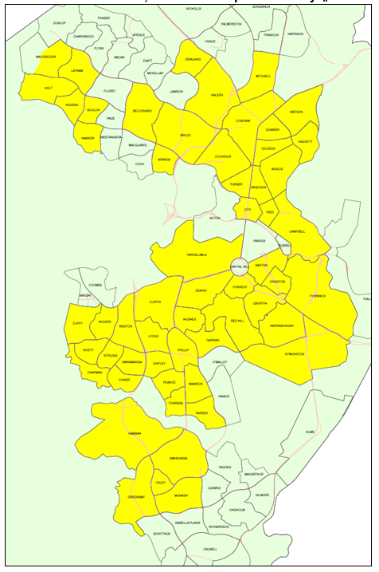

Map 2
FTTP Networks (in turquoise)
Canberra, Australian Capital Territory

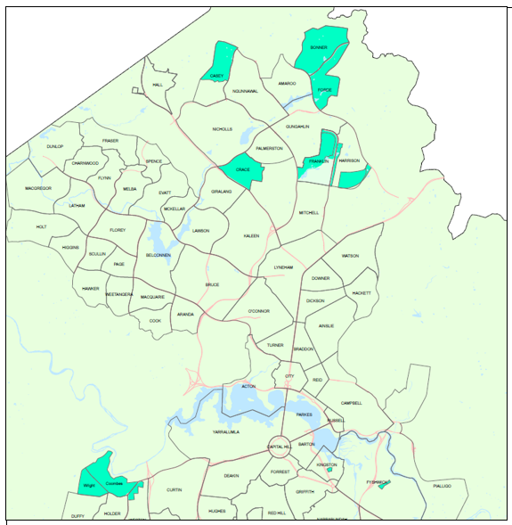

Map 3
TransACT VIC Networks, Ballarat, Victoria
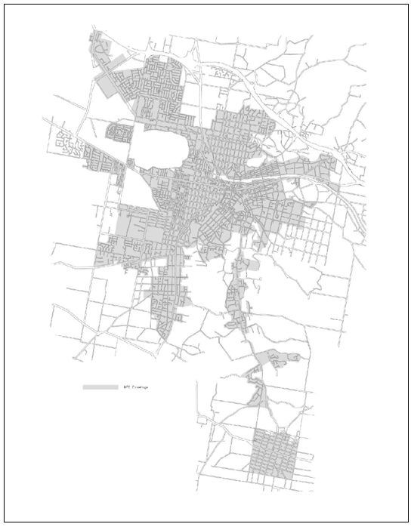

Map 4
TRANSACT VIC Networks, Geelong, Victoria
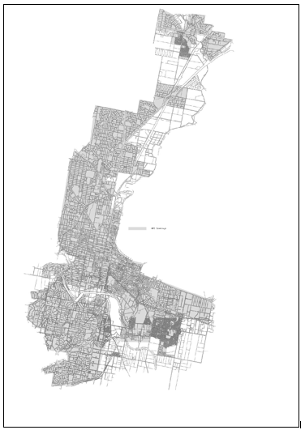

Map 5
TransACT VIC Networks, Mildura, Victoria
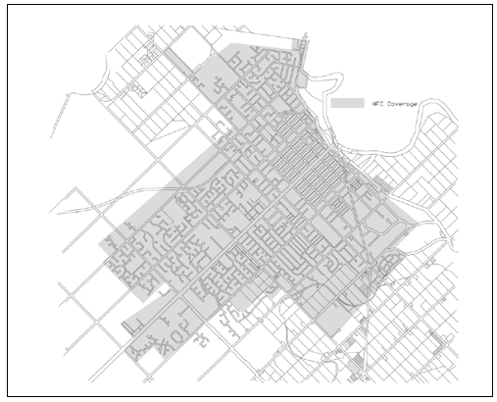
Table of Amendments
ad. = added or inserted am. = amended rep. = repealed rs. = repealed and substituted
Provision affected | How affected
Clause 3(1)(d)(ii), definition of TransACT Layer 3 Wholesale Interconnection Service | rs. by Telecommunications (Network Exemption—TransACT Very Small Scale Networks) Instrument 2012 (Amendment No.1 of 2012)
Clause 3(1)(b)(i)(C), definition of Victorian Very Small Scale Network | am.by Telecommunications (Network Exemption—TransACT Very Small Scale Networks) Instrument 2012 (Amendment No.1 of 2012)

