Commonwealth of Australia

Telecommunications Act 1997

Telecommunications (Network Exemption—Specified Velocity Networks) Instrument 2012 (Amendment No.1 of 2020)

I, PAUL FLETCHER, Minister for Communications, Cyber Safety and the Arts make the following Instrument under subitem 27(1) of Schedule 1 to the Telecommunications Legislation Amendment (Competition and Consumer) Act 2020 and subsection 144(1) of the Telecommunications Act 1997.

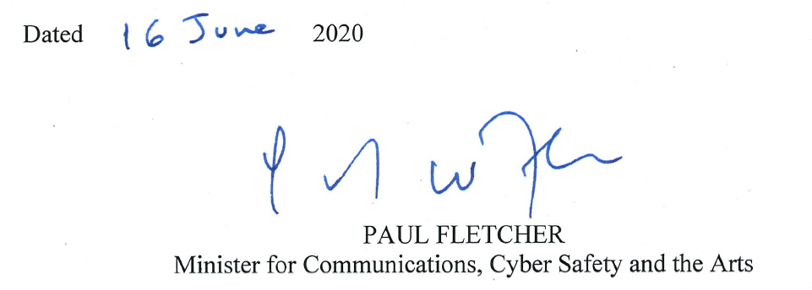_________________________________________________________________
- Name of Exemption Instrument
This Instrument is the Telecommunications (Network Exemption—Specified Velocity Networks) Instrument 2012 (Amendment No.1 of 2020).
- Commencement

This Instrument commences on the day it is signed.
- Amendment

The Telecommunications (Network Exemption—Specified Velocity Networks) Instrument 2012 is amended as set out in the Schedule to this Instrument.

Schedule—Amendments
Telecommunications (Network Exemption—Specified Velocity Networks) Instrument 2012

1 Clause 2 (Cessation)

Omit
This Instrument ceases to have effect on the designated day.

Substitute:

This Instrument ceases to have effect on the earlier of:

(a) the day which is 90 days after the last of the customer transition completion dates of the Specified Velocity Networks; and
(b) 1 July 2022, if Telstra owns any Specified Velocity Networks on that day.

2 Clause 2 (Notes)

Omit Note 1 and Note 2, substitute:

Note This instrument commenced on 12 April 2012.

3 Clause 3 (subparagraph (a) of the definition, Specified Velocity Network)
Omit:
(a) that is owned by Telstra; and

Substitute:
(a) that is owned by Telstra or over which Telstra is in a position to exercise control; and

4 Clause 3 (Definitions)
Insert:

customer transition completion date means, in respect of a Specified Velocity Network, the day on which Telstra completes disconnection of all Telstra-Equipped Services supplied to premises connected to that Specified Velocity Network.

Telstra-Equipped Services means carriage services which Telstra, while it is in a position to exercise control of a Specified Velocity Network, supplies to itself or to access seekers at premises connected to that Specified Velocity Network, including the Fibre Access Broadband Service.

5 At the Note immediately after Clause 3
Omit “designated day”, substitute “a person being in a position to exercise control over a network”

6 At Subclause 4(1) (Exemptions)
Omit “condition set out in subclause (2)”, substitute “conditions set out in subclauses (2) and (3)”

7 Immediately after Subclause 4(2) (Exemptions)
Insert:

(3) Telstra must provide a written report to the ACCC and the Minister:
(a) every six months commencing on 15 July 2020 until the
cessation of this Instrument; and
(b) within 30 days of a written request by the ACCC pursuant to this paragraph;
detailing the progress of the sale of each Specified Velocity Network, including:
(c) a summary of the legal arrangement(s) for the transfer of ownership of each Specified Velocity Network (including the name of the purchaser and date of transfer);
(d) if, as at the date of the report, legally binding arrangement(s) are in place for the transfer of ownership of any Specified Velocity Network, the following information about the customer transfer process:
(i) details of the work arrangements (including physical work) required to be undertaken (or being undertaken) by Telstra to effect the transfer of the local access line to the network purchaser;
(ii) the number of local access lines where physical work has been initiated (but not yet complete) to transfer the lines to the network purchaser;
(iii) the timeframes for the completion of the transfer of ownership of the local access lines and associated work, on a per area basis (if known);
(iv) the number and location of the local access lines that, as at the date of the report, have been fully transferred to the network purchaser; and
(v) a summary of the information disseminated to retail customers and end-user customers regarding the transfer of the local access lines and any related service or network disruption.

