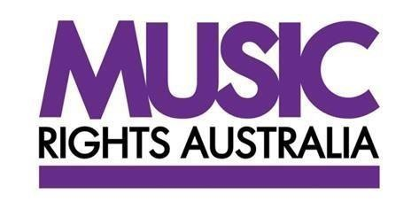

Music Rights Australia’s Submission in Response to the Review of Copyright Online Infringement Amendment

**16 March 2018**

**Contents**

**1. About Music Rights Australia** **2**

**2. Summary**  **2**

**3. Responding to the Copyright Online Infringement Amendment 5**

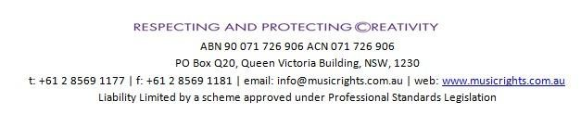

Music Rights Australia thanks the Department of Communication and the Arts (the **Department**) for the opportunity to make a submission in response to the Copyright Online Infringement Amendment.

1. **About Music Rights Australia**

Music Rights Australia (**MRA**) is an organisation that protects the creative interest of artists within the Australian music community. MRA represents over 90,000 songwriters and music publishers through their association with the Australasian Mechanical Copyright Owners’ Society (**AMCOS**) and the Australasian Performing Right Association (**APRA**)[1], and more than 125 record labels – both independent and major – through the Australian Recording Industry Association (**ARIA**).[2]

1. **Summary**

* Section 115A of the Copyright Act 1968 (the **Act**) gives copyright owners the ability to apply to the Federal Court of Australia for no fault injunctions against ISPs to block off shore sites whose primary purpose is copyright infringement or the facilitation of copyright infringement.
* The music industry has filed one s115A case. Its objective in filing site blocking cases here and in other jurisdictions is to disrupt the operation and proliferation of illegal sites in a particular jurisdiction. Disruption of piracy cannot be achieved through one action. Evidence from the UK and other jurisdictions shows that sustained action against multiple websites over a period of time will have a lasting impact.
* Data indicates s115A cases (including those filed by the film industry and Foxtel[3]) have disrupted access to the sites against which site blocking orders have been made. However, if this trend is to continue copyright owners will need to take more actions over a longer period. It is only after a series of actions over a period of time that we can be confident that the trend is meaningful and the s115A site blocking remedy is operating as it was intended to operate.
* The current imposition of costs orders for both compliance costs and legal costs of the proceedings have the potential to hamper copyright owners’ capacity to bring a large number of cases.
* In the music case, the Applicants were ordered to pay some aspects of the Respondents’ legal costs. The risk of adverse costs orders will impact copyright owners in the future should they seek to file Applications which the ISPs choose to oppose.
* Costs orders which require copyright owners to pay ISPs’ compliance costs are out of step with international precedent and will impact the efficiency and efficacy of the s115A regime.
* At this time, despite serious concerns about the costs orders made in the music case, it is too early to make specific recommendations to amend the s115A regime.
* MRA recommends the Government conduct a formal review of all aspects of copyright enforcement within eighteen months. Such a review will ensure s115A is an effective and efficient mechanism in the context of the overall rights protection environment.

**Background**

* + There are over 20 online licensed music services in Australia which make music available to consumers across platforms and devices at a range of price points including free on some advertising supported services: see www.digitalcontentguide.com.au; www.promusic.org.
  + Music industry copyright owners have filed one s115A case. The case[4] (the **music case**) was filed against Kick Ass Torrents (**KAT**) and a number of KAT proxy sites. During the preparation of the music case, but after the Application had been filed, US authorities shut down the KAT site and the music case proceeded against KAT proxy sites only.
  + In order to narrow the issues between the parties, MRA met with representatives of some of the ISPs. Other ISPs did not agree to these pre-application discussions. These discussions continued between the parties’ legal representatives up to the hearing in October 2016.
  + Most issues were agreed between the parties prior to the hearing.
  + The ISPs took the position that as this was a no fault remedy they would not contest evidentiary matters as it was for the Applicants to prove their case and satisfy the Court they had met the evidentiary threshold to obtain the blocking orders.
* The Applicants led substantial evidence:
  + Of subsistence of copyright;
  + That the carriage service providers provide access to online locations outside Australia;
  + That the KAT proxy sites were online locations outside Australia;
  + That the Applicants had notified the carriage service providers and the operators of the KAT proxy sites of the Application;
  + Of flagrancy of copyright infringement; instances of facilitation of copyright infringement; demonstrated disregard of copyright by the operator of the KAT proxy sites; examples of orders made in other jurisdictions against the KAT site; and
  + Of the negative impact which online copyright infringement had on the copyright owners and the music industry generally.
* The Applicants’ evidence was accepted by the Court.
* In the music case, the parties had agreed the blocking technology which ISPs could use prior to the Court making the orders.
* The issues between the parties at the hearing centred on:
  + Costs of implementing the site blocking (referred to in the cases as “**compliance costs"**);
  + The wording of some aspects of the orders, including wording to be used on a landing page and use of a single landing page; and
  + Legal costs of the proceedings (**legal costs**).
* The ISPs did not have a single position on the compliance costs or the landing page issues.
* The matter ran for one and a half days from 25 October 2016.
* Judgment was delivered on 28 April 2017.
* The ISPs implemented the blocks within the time period set out in the orders and they remain in place.
* Immediately after the film industry and Foxtel cases were filed, MRA worked with the other copyright owners to appoint a third party to develop and manage a landing page which ISPs could use when they blocked sites (the **Copyright Landing Page**).
* At present it appears only Optus and Foxtel are using the Copyright Landing Page. The other ISPs have chosen to implement their own landing pages.
* The Applicants have paid the compliance costs to each ISP for each domain name which has been blocked.
* Prior to the hearing, the Applicants and the Respondents had agreed a process to apply to the Court to add proxy sites to the existing orders.
* In effect the music case was against proxy sites because the KAT site had been closed down. Therefore, the Applicants have not filed any applications to add proxy sites.
* The Applicants have not filed further cases because of an ongoing issue about the legal costs of two ISPs. One of these matters was resolved in late February 2018, the other is still ongoing.

1. **Responding to the Copyright Online Infringement Amendment**

**Question 1: *How effective and efficient is the mechanism introduced by the Online Infringement Amendment?***

MRA‘s comments are based on its experience in developing and managing one s115A case and consultation with international associations on the operation of site blocking legislation in other jurisdictions.

The music industry’s goals when applying for site blocking orders are: as efficiently and effectively as possible to decrease access to a site with the aim of changing users’ behaviour; and to disrupt the business model of the illegal site in that jurisdiction.

Preliminary data indicates that s115A blocks are achieving those goals with respect to the sites which are the targets of the orders. The real impact of the site blocking[5] will only be shown over a period of sustained action and while the early data is encouraging it is too early to say conclusively that this impact will be sustained.

The music industry has not brought a second s115A case because until March of this year it was still dealing with the legal costs claimed by two ISPs, one of which recently settled.

It has always been the music industry’s position that no fault injunctions which allow copyright owners to obtain orders to block illegal sites are an efficient and effective mechanism to address the threat such sites pose to copyright owners’ interests.

In its submission on the draft legislation MRA advocated for a less prescriptive model than that adopted by the Australian Government. It proposed a site blocking remedy which mirrored the UK legislation[6] and continues to support this model as it has the capacity to more readily address changes in the illegal online environment.

However, despite the issues which are highlighted in this submission, the music industry suggests that it is too early to call for amendments to the site blocking regime established under s115A. MRA suggests that some reform may be necessary in the future, particularly with respect to the issue of costs, but all aspects of s115A should be assessed in a full review of copyright enforcement in eighteen months.

Such a review would allow the affected parties to consider s115A in the overall rights protection environment and allow them to make evidence-based recommendations to ensure s115A is an effective and efficient mechanism which addresses online copyright infringement.

**Developing the music case**

MRA met with representatives of some ISPs prior to filing the music case. The meetings were productive and the parties continued to engage to narrow the issues prior to the hearing through their counsel.

The Respondents adopted the position that as s115A was a no fault remedy, they would not comment on of the Applicants’ evidence. This approach assisted the Applicants in the preparation and conduct of the matter. MRA anticipates ISPs will maintain this position in future cases. This should mean s115A cases can become more streamlined and that orders, including orders to add proxy sites, can be delivered in a timely way. However, MRA does not anticipate Applicants’ costs to prepare and prove s115A cases will reduce significantly over time as they are required to prove the elements in subsections 1, 4 and 5 in each case.

The problem which s115A is designed to address requires swift action. Judgment in the music case was delivered on 28 April 2017. The hearing was held over one and half days from 25 October 2016. Similarly, judgment in the first film and Foxtel cases was delivered six months after the hearings concluded. While the music industry appreciates that these were the first cases under s115A, it is hoped that as the case law develops and the processes become more streamlined judgments in future cases will be delivered much more expeditiously.

***Conditions Precedent: section 115A (1) (a), (b) and (c)***

The Australian Government adopted a prescriptive model in s115A. This model places additional evidentiary burdens on copyright owners which site blocking legislation in other jurisdictions does not require[7]. For example: the requirement to prove the illegal site is an online location outside Australia. It was a challenge to discharge the evidentiary burden to establish this element. While the Applicants’ evidence was accepted by the Court, in the future it may become a barrier to legitimate applications particularly as the illegal sites adapt to avoid site blocking legislation here and in other jurisdictions.

At this time, MRA does not wish to recommend changes to subsection (1) but suggests all the conditions precedent should be reviewed in the future to ensure s115A is an effective and efficient mechanism to address online copyright infringement.

**Notices: section 115A (4)**

The site operators are difficult to contact. The sites are structured to make contact difficult if not impossible. The Court took a pragmatic approach to this condition. MRA does not anticipate this will change and does not consider this condition problematic.

**The eleven factors which the Court may take into account: section 115A (5)**

As this was the first music case, the Applicants lead evidence which went to each of the 11 factors. The Applicants’ evidence was accepted by the Court.

At this time, MRA does not have any specific comments on this subsection. Over time MRA anticipates that some factors may become redundant, for example s115A (5) (d). However, as the Court has discretion about which factors it may take into account this should not be an issue.

MRA recommends the eleven factors are reviewed as part of a full review of copyright enforcement to ensure s115A is an effective and efficient mechanism to address online copyright infringement.

**Rescinding and varying injunctions: section 115A (7)**

The orders in the music case were made against proxy sites because the KAT site had been closed down. Prior to the hearing, the Applicants and Respondents had agreed a process to add proxy sites to the existing orders. The Court made orders reflecting that process.

As the Applicants have not made an application under this process MRA is unable to comment on its efficiency or efficacy at this time.

As it is imperative that this process works effectively and efficiently to suppress proxy sites before they can attract significant traffic, MRA recommends the proxy application process is reviewed in a full review of copyright enforcement to ensure s115A is an effective and efficient mechanism which can address online copyright infringement.

**Costs: section 115A (9)**

Under s115A (9), an ISP is not liable for any costs in relation to s115A proceedings unless it enters an appearance and takes part in the proceedings. The Explanatory Memorandum states that this was "intended to ensure that a party will not be penalised and required to bear unnecessary costs where it is fully cooperating, or not frustrating proceedings. Each of the ISPs in the music case entered an appearance and took part in the proceedings. Without criticising them for doing so, the Applicants submitted that the most equitable outcome would be for each party to pay its own costs of the proceedings. The Respondents all sought orders requiring the Applicants to pay all of their legal costs. Consistent with the costs orders made in the first film industry and Foxtel cases, the Applicants were ordered to pay "the Respondents' costs (as agreed or taxed) of and incidental to the preparation of evidence and submissions and the making of oral submissions, in relation to the issue of compliance costs (excluding set-up costs)" on the basis that the Respondents "were successful on the question of principle as to whether or not the Applicants should pay the compliance costs"[8]. As noted above, the quantum of costs payable under the order could not be agreed with two of the ISPs, leading to a lengthy and expensive taxation process which, in one case, is still ongoing.

In the first music case, each of the ISPs sought different amounts for their compliance costs, and led evidence and made submissions in support of their claimed amount, which added to the length and cost of the hearing. Ultimately, the Judge followed the approach taken in the first film industry and Foxtel cases and adopted what was described as "a uniform approach to fixing a "tariff" for the grant of such orders".[9]

Given that the $50 figure did not reflect the actual compliance costs of the individual ISPs, and it has now been ordered in multiple proceedings, MRA is concerned that this figure will be difficult to challenge in future cases, even though it could be expected that the actual costs to ISPs will decrease over time as technology advances. Further, the risk of an adverse costs order may deter copyright owners from agitating this issue again. Unlike legislatively imposed tariffs, there is no mechanism in s115A for copyright owners or ISPs to seek to have the "tariff" reviewed in an efficient and cost effective manner.

Further, while a tariff amount of $50 may appear to be minimal, it is imposed on a 'per ISP, per domain name' basis. There are hundreds of different ISPs in Australia and a pirate website may be available from tens, or hundreds, of proxy websites. In order to have maximum effect, the orders should cover all Australian ISPs and all relevant domain names, but the cost of doing so would be prohibitive.

***International experience***

The requirement that the Applicants pay compliance costs is also out of step with international precedent. Internet Service Providers in over 27 countries have been ordered to implement site blocking in relation to approximately 2,800 individual URLs and in most cases they have done so without seeking costs of implementing the site blocking. In the overwhelming majority of cases, where the issue has been considered by a court, ISPs have been ordered to bear the compliance costs and their own legal costs, even though it was acknowledged they were not responsible for the copyright infringements. These costs have been characterised as “a cost of doing business” for the ISPs.

Section 115A(9) and the issue of compliance costs must be reviewed as part a full review of copyright enforcement to ensure s115A is an effective and efficient mechanism to address online copyright infringement.

**Question 2: *Is the application process working well for all parties and are the injunctions operating well once granted?***

The parties had agreed the blocking technology issues prior to the hearing. Once the orders were made the Respondents implemented the site blocking within the time frame set out in the orders.

The blocks remain in place and MRA is not aware of any instance or allegation of “over blocking” with respect to the orders made in the music case.

All the s115A cases have included orders that the ISPs either direct their subscribers to the Copyright Landing Page or to another site of their choice.

The graph below shows traffic to the Copyright Landing Page (including from the period when the orders were made in the film industry and Foxtel cases).

It is our understanding that only Optus and Foxtel are using the Copyright Landing Page. The graph below only captures the traffic to the Copyright Landing Page from those two carriage service providers.

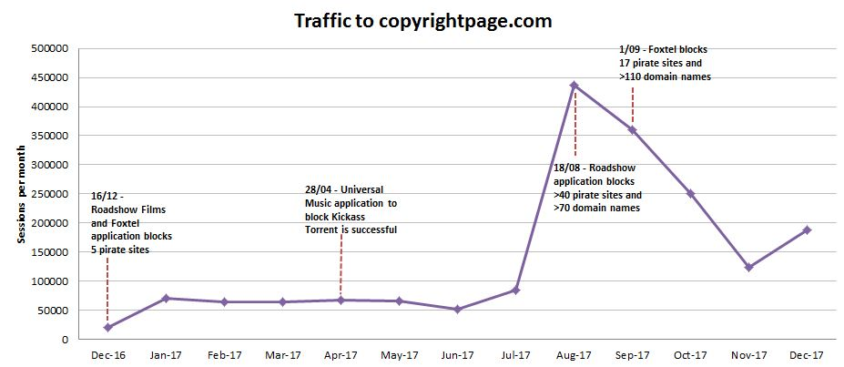



This graph shows traffic to the KAT site after the US action and the traffic to the KAT proxy sites once the ISPs implemented the site blocks.



This graph shows traffic to the four sites which were subject to blocking orders in the Foxtel case in December 2016.



This graph shows there has been an overall decline in bittorrrent activity during the period when the site blocking orders have been in place.



This graph shows the growth of unique Spotify users over the period September 2016 to December 2017

This data shows the site blocking orders are effective. However, while the preliminary data is positive and promising, MRA recommends the Government undertake a full review of copyright enforcement within eighteen months. The review should include a full review of s115A to ensure it is an effective and efficient mechanism to address online copyright infringement.

**Question 3: *Are any amendments required to improve the operation of the Online Infringement Amendment?***

Despite serious concerns about the implications of the compliance costs orders which require copyright owners to pay $50 per domain name per ISP and legal costs orders which required the Applicants to pay some aspects of the ISPs’ legal costs of the proceedings, MRA and its stakeholders do not recommend amendments to s115A at this time.

MRA recommends the Government undertake a full review of copyright enforcement within eighteen months. The review should include a review of s115A to ensure it is an effective and efficient mechanism to address online copyright infringement.

Should the Department have any questions about the MRA submission, please contact Vanessa Hutley General Manager MRA at [vhutley@musicrights.com.au](mailto:vhutley@musicrights.com.au).

1. See [www.apraamcos.com.au](http://www.apraamcos.com.au)
2. See [www.aria.com.au](http://www.aria.com.au)
3. Roadshow Films Pty Ltd v Telstra Corporation Ltd [2016]FCA1503; Roadshow Films Pty Ltd v Telstra Corporation Ltd [2017] FCA 965; Foxtel Management v TPG Internet Pty Ltd [2017] FCA 1041
4. Universal Music Pty Limited and Ors v TPG Internet Pty Ltd and Ors [2017]FCA 435
5. Evidence from the UK Andrew Forces, The Music, (July 30th 2014) ‘Does Illegal Website Blocking Break the Internet’, http://themusic.com.au/opinion/music/2014/07/30/does-blocking-illegal-websites-break-the-internet/
6. Copyright, Designs and Patents Act 1988 (Cth) section 97A
7. See: Copyright, Designs and Patents Act 1988 (Cth) section 97A
8. Universal Music Pty Limited and Ors v TPG Internet Pty Ltd and Ors[2017] FCA 435 at [108]
9. Universal Music Pty Limited and Ors v TPG Internet Pty Ltd and Ors[2017] FCA 435 at [105]