

**Australian Computer Society Inc. (ACT)** ARBN 160 325 931

Level 11, 50 Carrington Street

Sydney, NSW 2000

T02 9299 3666

The Manager

Services and Regulation Section

Media Branch

Department of Communications

GPO Box 2154 CANBERRA ACT 2601

dtreview@communications.gov.au

# ACS Response to Federal Governments Consultation Paper on Digital Television Regulation

31 March 2015

Dear Sir/Madam

The ACS is delighted to have the opportunity to respond to the Federal Government’s Consultation Paper on Digital Television Regulation. The ACS response is limited to technical considerations.

The 2013 switch to digital‐only television marked a major change in the television broadcasting sector and an opportunity to review the nature of the digital television regulatory framework. Any potential reform of digital television regulation must be placed in the context of a rapidly changing communications environment, the increasing use of high‐speed broadband and mobile devices, changes in consumer behaviour and the growth of online content providers.

The growth of online content providers and the availability of “catch‐up” television have fundamentally changed the experience of television from being a time bounded appointment with passive consumption of predetermined content, to an interactive experience with extraordinary choice which can be experienced in many different formats.

The great differentiators of broadcast television compared to online delivery of content remain

* the access of broadcasters to a limited national resource in the form of radio spectrum,
* the need for careful radio / interference planning for broadcast transmitters,
* the predominance of one directional data flow.

With the move to digital transmission, television can also be relevantly compared to mobile communications systems. The major differentiators of broadcast television compared to mobile communications systems include

* the much greater transmit power of the television broadcasters (kW versus W),
* the much greater reach of individual television broadcast towers,
* fixed (or limited) mobility of the television receiver,
* the ability for all receivers within the coverage area to decode and access free‐to‐air channels
* the predominance of one directional data flow.

The allocation of dedicated spectrum must be considered in light of alternate uses which generate greater economic or social value.

ACS Response to Consultation Paper on Digital Television Regulation Page 1

March 2015 Final

The rapidly increasing demand for mobile communications services has motivated mobile operators in all countries to invest heavily in new spectrally efficient technology and to acquire new blocks of radio spectrum. With the television spectrum restacking, Australian operators paid substantial sums for access to spectrum released for new mobile services, and invested heavily in new network infrastructure to make use of the spectrum acquired. Television spectrum clearly has economic value and alternative uses. Recognising this economic value, a requirement must exist for broadcasters to offer a set of freeto‐air services. Recognising the change to digital television format, the offering from broadcasters need not be limited to traditional television content, but may include other digital content.

The ACS broadly, but not unreservedly, agrees with the Government position that

* It is important to continue to reserve spectrum for commercial and national television services;
* The current restriction on the number of commercial television licences that can be allocated for each licence area should be retained;
* Commercial and national broadcasters should be free to determine the most appropriate mix of services and formats for their audience. Regulation should however mandate that commercial and national broadcasters provide minimum numbers of free‐to‐air content;
* Commercial and national broadcasters should be increasingly permitted to use spectrum more flexibly and allow third party access to their spectrum. The type of services commercial and national broadcasters offer should not be constrained by regulation apart from retaining the restriction on subscription services; and
* Commercial and national broadcasters should deliver their services through spectrally efficient mechanisms

The scarce nature of spectrum leads the ACS to the strong view that the Federal Government should encourage broadcasters to move to more spectrally efficient mechanisms and provide encouragement for broadcasters to use spectrum more flexibly and allow third party access to their spectrum.

The ability to create a reverse link, taking real time input from an individual viewer back to the broadcaster, has the potential to dramatically change the nature of services delivered by broadcasters. The use of such hybrid technology opens up the potential for broadcasters to deliver individually tailored content within the broadcast area. This could range from collective viewer voting to identify most popular free‐to‐air content, to scheduling a preload of video content for later viewing, to delivering a refresh of an internet cache. This “batched” broadcast ability may not directly match those of dedicated on‐line delivery via internet, but may offer new services for viewers in remote parts of Australia.

ACS’ detailed responses to the questions posed in the Consultation Paper are in the Attachment to this document.

The summary of ACS recommendations is as follows:

# Section 1

1. That the Federal Government require broadcasters to offer a minimum set of Free to Air services.
2. That the Federal Government should encourage broadcasters to move to more spectrally efficient mechanisms and to use spectrum more flexibly.

1. That the Federal Government should require that any changes in technologies and services not reduce the existing primary or secondary broadcast coverage areas.

# Section 2

1. That future regulatory framework for broadcasters be shaped to be similar to that which applies to internet service providers.
2. That offerings from broadcasters need not be limited to traditional television content, but may include any other digital content.
3. That any regulatory framework for broadcasters should have the regulatory flexibility to make greater use of new technologies however new technologies should only be adopted if there is a clearly defined (backwards) compatibility pathway.

# Section 3

1. A roadmap for migration, developed in conjunction with industry and communities, should be developed and communicated.
2. The application of national standards is recommended to ensure compatibility between equipment vendors and broadcasters.

The ACS commends the Government’s focus on reform of Digital Television Regulation. If you require any further information regarding this submission, please contact Athol Chalmers, ACS Director, Policy and Public Affairs.

Yours Sincerely



Andrew Johnson

Chief Executive Officer, ACS

**ATTACHMENT**

# Section 1 ‐ Commercial and National Broadcasters Should Be Free To Determine the Most Appropriate Mix of Services and Formats for Their Audience

In this section, a number of preliminary positions of government were laid out.

Preliminary Government position:

* No new regulation limiting the number of services provided by broadcasters will be introduced. The Government will not seek to regulate the number of services provided by commercial or national broadcasters in addition to their primary channel. It considers that there are sufficient commercial incentives in the market to mitigate the likelihood of broadcasters significantly reducing the number of services they provide.

* Remove the provisions in the BSA that specify if a terrestrial regional commercial broadcaster provides fewer services in its licence area than is provided on VAST, the ACMA can declare the area to be ‘service deficient’. Consistent with its deregulation agenda, the Government will remove the regulation of the number of services provided across regional and remote licence areas. The provisions intended to allow viewers in regional licence areas access to the VAST service where the ACMA declare the area to be ‘service deficient’ will be removed.

* The requirement for the primary channel to be provided in standard definition will be removed The Government intends to remove the requirement for the primary channel to be provided in standard definition. Given the widespread availability of HD receivers, there is no longer any reason to restrict the format of the primary channel.

* No reintroduction of a quota requiring a specified amount of HD content. The Government will not reintroduce a quota requiring a specified amount of HD content. This will provide broadcasters with greater flexibility to choose the format of services they provide.

**Question 1**. *What factors will influence the decision to increase or reduce the number of services a broadcaster chooses to provide?*

**ACS Response**: The ability to create a reverse link, taking real time input from an individual viewer back to the broadcaster, has the potential to dramatically change the nature of services delivered by broadcasters. The use of such hybrid technology opens up the potential for broadcasters to deliver individually tailored content within the broadcast area. This could range from collective viewer voting to identify most popular free‐to‐air content, to scheduling a preload of video content for later viewing, to delivering a refresh of an internet cache. This “batched” broadcast ability may not directly match those of dedicated on‐line delivery via internet, but may offer new services for viewers in remote parts of Australia.

**Question 2.***What safeguards, if any, should the Government put in place to make sure that an appropriate balance is maintained between giving broadcasters the freedom to use their spectrum how they see fit, providing audiences with a diverse range of television services and the appropriate and efficient use of spectrum?*

ACS Response: Recognising the economic value of spectrum, a requirement must exist for broadcasters to offer a set of free‐to‐air services. Recognising the change to digital television format, the offering from broadcasters need not be limited to traditional television content, but may include other digital content.

**Question 3**. *What consequences, if any, could the removal of ‘service deficient’ declarations have on the content delivered to viewers in smaller regional and remote areas?*

**ACS Response**: The removal of service deficient declarations may remove the incentive for broadcasters to provide a minimum set of free‐to‐air services.

**Question 4**. *What impact, if any, will the removal of the requirement for the primary channel to be provided in SD have on viewers?*

**ACS Response**: The removal of this requirement may lead to a reduced coverage for a given broadcast tower.

Delivery of HD content requires the broadcaster to deliver fewer channels (compared to SD) or to increase the data rate delivered in a broadcast area. Any desire for broadcasters to increase data rates can consequently lead to reduced effective coverage area.

Current planning is based on the minimum signal strengths and relevant protection ratios for transmissions using a digital modulation scheme of 64 QAM with forward error correction (FEC) rates of 2/3 (an average of 1 redundant symbol for every 2 data symbols)[1]. Without building new infrastructure, or increasing transmit power levels, higher data rates are achieved by reducing the FEC rates (fewer redundant symbols data symbol) or by increasing the complexity of the digital modulation scheme (for example, 128 QAM, 256 QAM). Both of these approaches increase the minimum signal level (Field Strength) required at the receiver for a given quality of reception. As shown in Figure 1[2], the coverage area reduces rapidly as the minimum required field strength increases. The figure shows the coverage of digital television (required field strength of 44 dBuV/m) versus the coverage for much less demanding requirement for digital radio (required field strength of 22.5 dBuV/m). The impact is potentially most significant in regional or remote areas of Australia where an increased minimum required field strength may lead to dramatic reduction in received quality, or a complete loss of coverage. As an example, Figure 2 shows the estimated coverage for different quality levels for ABC Digital TV around Alice Springs in the NT[3]. The figure shows estimated Primary[4], Secondary[5] and Tertiary[6] coverage.

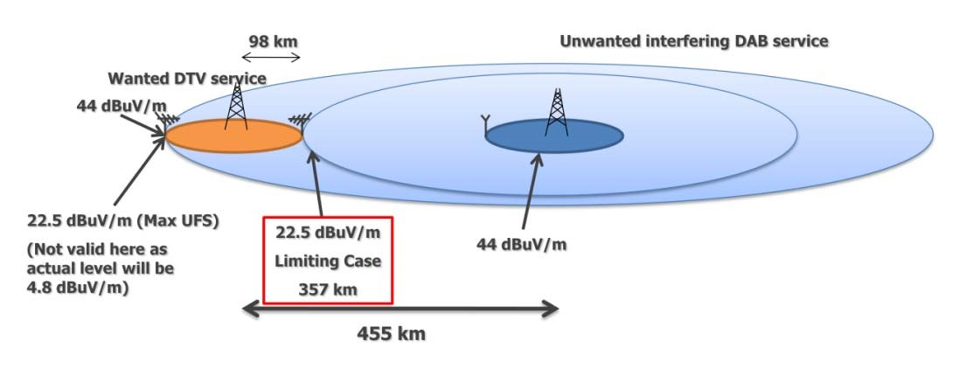

**Figure 1. Example of broadcast coverage area versus received Field Strength**

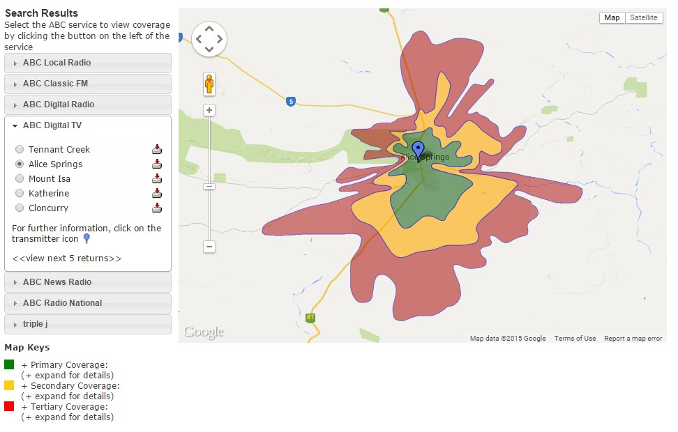

**Figure 2. Example of ABC Digital TV coverage in Alice Springs**

**Question 5**. *What factors will influence a television broadcaster’s decision to continue to offer HD content?*

**ACS Response**: Delivery of HD content has the potential to reduce coverage

As for question 4, the delivery of higher data rate services potentially reduces the broadcast coverage area compared to lower data rate services.

**Recommendations:**

1. That the Federal Government require broadcasters to offer a minimum set of Free to Air services.
2. That the Federal Government should encourage broadcasters to move to more spectrally efficient mechanisms and to use spectrum more flexibly.
3. That the Federal Government should require that any changes in technologies and services not reduce the existing primary or secondary broadcast coverage areas.

# Section 2 ‐ Commercial and National Broadcasters Should Be Increasingly Permitted To Use Spectrum More Flexibly

In this section, a number of preliminary positions of government were laid out.

Preliminary Government position:

* Remove the datacasting regime in relation to television and remove the current restriction on providing narrowcasting services on digital multiplexes. The Government intends to remove datacasting provisions related to television in Schedule 6 to the BSA and corresponding provisions in the Radcomms Act. It is anticipated that arrangements will need to be put in place to allow the established datacasting services provided by commercial broadcasters to continue where necessary. The Government also intends to remove the current restriction on commercial and national broadcasters providing narrowcasting services on their digital multiplexes. This will provide broadcasters with greater flexibility as to the types of services they provide. The Government will monitor the industry’s response to this increased flexibility with a view to ensuring that services offered by broadcasters continue to meet the objectives of broadcasting legislation.

* Maintain the current arrangements for third‐party content while considering alternative frameworks. The Government will maintain the current arrangements for third‐party content in the near term. However, the Government is interested in other options for the provision of third‐party content by commercial broadcasters and their implications for licensing, regulation and spectrum use.

* No change to the restriction on broadcasters providing subscription services. The Government intends to retain the current restriction on commercial and national broadcasters providing subscription television services on their digital television multiplex. Broadcasters are provided with spectrum on the expectation that their services are available to the public free of charge. Allowing broadcasters to provide subscription services would represent a significant cultural and policy shift.

* Further work should be undertaken in 2015 on the commercial and regulatory implications of free‐to‐air television services being delivered using online platforms, in the context of the Government’s deregulation agenda. The Government considers that developments in the online delivery of free‐to‐air television services may offer opportunities to the broadcasting industry to provide new and diverse services to their viewers. The Government is interested in getting feedback on the potential use of alternative technologies which do not use BSB spectrum for the delivery of television services and the impact this could have both on the regulatory framework and on broadcasters’ business models in the future.

**Question 6**. *What form of regulation should there be for services that are indistinguishable to viewers from more regulated services and accessed with common equipment, such as HbbTV?*

**ACS Response**: Recognising the economic value of spectrum, a requirement must exist for broadcasters to offer a set of free‐to‐air services. Recognising the change to digital television format, the offering from broadcasters need not be limited to traditional television content, but may include other digital content. The regulatory framework should be similar to that which applies to internet service providers.

**Question 7.***What arrangements may be required to allow currently established datacasting services provided by commercial broadcasters to continue where necessary after the repeal of the datacasting provisions in the BSA and Radcomms Act?*

ACS Response: No response

**Question 8**. *Other than narrowcasting services, are there any other types of services which broadcasters should offer on their television multiplexes?*

**ACS Response**: Recognising the change to digital television format, the offering from broadcasters need not be limited to traditional television content, but may include any other digital content.

The ability to create a reverse link, taking real time input from an individual viewer back to the broadcaster, has the potential to dramatically change the nature of services delivered by broadcasters. The use of such hybrid technology opens up the potential for broadcasters to deliver individually tailored content within the broadcast area. This could range from collective viewer voting to identify the most popular free‐to‐air content, to scheduling a preload of video content for later viewing, to delivering a refresh of an internet cache. The broadcast nature of transmission would mean that this tailored content would be available to everyone in the coverage area, but may not be taken up by everyone. Such services may not directly match those of dedicated on‐line delivery via internet, but may offer new services for people in regional and remote parts of Australia.

**Question 9**. *Is it likely that commercial television broadcasters will want to use their multiplexes and hence spectrum to offer third party content that they are not responsible for under the relevant broadcasting legislation? If so, what form of regulation would be appropriate to ensure such content was provided in a manner consistent with commercial broadcaster provided content?*

**ACS Response**: It is likely that broadcasters will want to use their spectrum to offer third party content that they are not responsible for.

Recognising the change to digital television format, the offering from broadcasters need not be limited to traditional television content, but may include other digital content. The regulatory framework should be similar to that which applies to internet service providers.

**Question 10**. *How important is it that broadcasters have the regulatory flexibility to make greater use of new technologies to deliver their television services to viewers?*

**ACS Response**: Recognising the economic value of spectrum, broadcasters should have the regulatory flexibility to make greater use of new technologies. The requirement on broadcasters must however be that any changes in technologies be backwardly compatible and that services not reduce the existing primary or secondary broadcast coverage areas for people in regional or remote Australia.

As an example of backward compatibility of technologies, MPEG‐4 receivers are backwards compatible, able to also receive MPEG‐2 services.

**Recommendations:**

1. That future regulatory framework for broadcasters be shaped to be similar to that which applies to internet service providers.
2. That offerings from broadcasters need not be limited to traditional television content, but may include any other digital content.
3. That any regulatory framework for broadcasters should have the regulatory flexibility to make greater use of new technologies however new technologies should only be adopted if there is a clearly defined (backwards) compatibility pathway.

# Section 3 ‐ Commercial and National Broadcasters Should Deliver Their Services Through Spectrally Efficient Mechanisms

In this section, a number of preliminary positions of government were laid out.

Preliminary Government position:

* Broadcasters should commence the transition process to transmit their services in MPEG‐4 The Government will consult with and encourage television broadcasters to commence their transition to using MPEG‐4 technologies. Subject to the extent of the roll‐out of such services, the Government may consider setting a deadline by which broadcasters are required to transmit MPEG‐4 only services following consultation with industry. The Government also encourages the broadcasting and manufacturing industries to explore adopting additional spectrum efficient technologies in the future.

* Digital television multiplex licensing will be introduced The Government will commence discussions with the national broadcasters to develop a spectrum sharing arrangement for the terrestrial delivery of their television services. The Government will also commence consultation and planning for introducing alternative digital multiplex licensing arrangements, including the potential to share digital television multiplexes for commercial broadcasters.

**Question 11**. *How can the Government support the broadcasting and manufacturing industry in managing a transition to MPEG‐4 only television?*

**ACS Response**: A roadmap for migration, developed in conjunction with industry and communities, should be developed and communicated. The roadmap should include phased transitions to new technologies and clear cut off dates for older technologies.

**Question 12.***Should the Government consider any legislative mechanisms such as technical standards for MPEG‐4 terrestrial transmitters and/or television receivers?*

ACS Response: The application of national standards is recommended to ensure compatibility between equipment vendors and broadcasters.

**Question 13**. *By what date does the broadcasting and manufacturing industry consider that MPEG‐4only television could be achieved?*

**ACS Response**: No response

**Question 14**. *What does the industry consider should be the future standard(s) for broadcast television in*

*Australia? Should a pathway to next generation technologies such as DVB‐T2 or HEVC also be considered?*

**ACS Response**: A roadmap for migration, developed in conjunction with industry and communities, should be developed and communicated. New technology developments should be considered and used as input to periodically update the roadmap.

**Question 15**. *What consumer issues are raised by the transition to new transmission standard such as MPEG‐4?*

**ACS Response**: MPEG‐4 will have some affect on the channel changing performance of the television picture. In some cases the channel changing time may increase and this will have a negative effect on the consumer's experience. Consideration should be given to an acceptable minimum channel changing time. Also, MPEG‐4 will potentially enable the delivery of higher definition video. So as the consumer market sees more 4k and 8k screen sales the ability to deliver this higher quality content should be considered.

**Question 16**. *16. Are there any alternative arrangements to digital television multiplex licensing that the Government should consider?*

**ACS Response**: No response

**Question 17**. *Are there other ways commercial television broadcasters can be encouraged to share or utilise their spectrum more efficiently?*

**ACS Response**: A use it or lose it approach could be taken to encourage the most efficient use.

**Question 18**. *How might national broadcasters implement spectrum sharing while maintaining their distinct television services?*

**ACS Response**: No response

**Recommendations:**

1. A roadmap for migration, developed in conjunction with industry and communities, should be developed and communicated.
2. The application of national standards is recommended to ensure compatibility between equipment vendors and broadcasters.

1. See ACMA document “RPAG 12 Proposals for revised planning parameters for restack”, http://www.acma.gov.au/~/media/Broadcasting%20Spectrum%20Planning/Information/pdf/RPAG%2012%20Proposals%20for%2 0revised%20planning%20parameters%20for%20restack.PDF
2. See ACMA document “RPAG11 Retention of spectrum for digital radio” file:///C:/Users/ioppermann/Documents/Personal/ACS/Digital%20Television%20Regulation%20RFI/Research/RPAG11%20Retenti on%20of%20spectrum%20for%20digital%20radio.PDF
3. See ABC Reception coverage estimator http://reception.abc.net.au/Reception.aspx
4. Primary Coverage: Highest signal level due to close proximity of the transmitter and good terrain conditions. It may be possible to receive a signal with an internal or small outdoor antenna.
5. Secondary Coverage: Good reception in this area is ordinarily possible with the use of an external antenna
6. Tertiary Coverage: Reception in this area will prove difficult and will require the use of a good quality external antenna and possible a low noise amplifier.