# Regional Digital radio technology review

Please read the  
“A Proposal for Australian Digital Radio”  
Which follows, then read  
<http://www.drm.org/uploads/files/drm_30_pres.pdf>  
and  
<http://www.drm.org/uploads/files/drm_plus_pres.pdf>  
Prior to reading the  
“Issues for Comment”

## *Issues for comment*

**My Definition:**

**Full Digital Radio is capable of receiving DAB+/DMB/DRM30 (MF & HF)/DRM+ at profile level 2[1]**

### *Key issues*

**Considerations for consumers**

#### Key issue 1

***What aspect or aspects of digital radio should be given priority in regional areas? (For example, is wide area coverage or additional radio services more important than sound quality?)***

Currently;

* AM suffers from;
* Congestion on the 121 possible MF AM channels.
* Virtually all channels contain 3 transmitters each, however a transmitter straddles a pair of channels. Additionally interference occurs if there is a transmitter in an adjacent channel to the pair of channels used in a licence area.
* poor quality mono sound
* one octave of frequencies is not transmitted and nearly all receivers remove an additional octave to produce near telephone quality sound.
* FM suffers from;
* Congestion on the 103 possible band 2 FM channels.
* a small coverage area unless tall masts on unusually the most inaccessible high ground and high radiated power is used.
* Severe congestion in areas using analog TV channels 3, 4 and 5**[2]** The Riverland and Spencer Gulf North were switched off on 15 December 2010 and the last transmitter at the end of 2013.
* Many country commercial licensees have an AM licence and a supplementary FM licence, this usually gives an unequal coverage area between a licensees' programs.
* There is considerable networking in commercial and national radio in regional and remote areas. There is very little truly local radio, and television is highly networked.
* In remote areas there is no radio coverage at all if you have an AM/FM radio. Whilst the ABC transmits its NT "local" radio service on HF radio, only very short wave specialist radios can receive 2.310, 2.325, 2.485, 4.835, 4.910 and 5.925 MHz.
* The ABC transmits its "local" radio on high powered FM in the eastern states in mono. In the rest of the country they use AM along with the remoter areas of the eastern states. Radio National is on AM when "local" radio is on FM and vice versa. All Radio National transmitters are mono except for the DAB+ transmissions in the mainland state capital cities.
* ABC Classics and JJJ are exclusively transmitted on FM in stereo, but in remote areas community groups have to pay for re-transmitters and a satellite down link.
* In remote areas there are a couple of commercial stations per remote licence areas who transmit their signals to a satellite and mostly community funded re-transmitters relay these programs at low power. This means no coverage between re-transmitters.

Digital priorities;

* Receiver profile 2 should be mandatory <http://www.drm.org/uploads/files/drm_receiver_profiles.pdf> This is to give radios attractive new facilities. (DAB and MPEG-2 not required)
* Since TV in regional and remote areas are completely networked, the ability of digital radio to transmit video and slide shows is a new market for regional broadcasters. They can use it for advertising as well as program support.
* All programs can be FM stereo quality
* DRM+ can even transmit surround sound
* The advantage of DRM+/DRM30 over the DAB+ being used in our major cities is that it is suitable for a single broadcaster, whereas DAB+ is designed for high population densities with lots of broadcasters.

In summary, no priority is required because all the objectives can be met using DRM.

***Would additional digital radio services appeal to you even if compromises, for example in terms of coverage, are required?***

The only "compromise" is that I would have to buy a DRM30/DRM+ radio!

Using these transmission techniques and the appropriate antenna system and power the coverage area will cover the licence area. DRM30 can be used to cover remote areas.

***If several technologies are used for digital radio in Australia (a hybrid model), how important is it for receivers to receive all the technologies used?***

Yes it is important. Just like AM and FM can be used in most places, then digital radios should be able to do the same.

This is particularly important in cars and trucks which can easily drive to the cities and county areas, fly-in/fly-out, seasonal workers as well as swelling numbers of grey nomads. It is also important for the fringes of cities where the signal strength of DAB+ is low and regional radio signals are stronger.

***Would the range and cost of digital radio receivers influence your decision to adopt digital radio?***

* If all radios are full digital radios, most of the electronics will be identical in all types of receiver. This reduces the cost of receivers.
* A range of radios similar to what is available at the moment is required, because these are the styles proven to be popular.
* A full digital radio should be specified as part of the Australian Design standard**[3]** for new vehicles. Part of the specification should include the display, for TPEG and TMC (traffic updates) and emergency warnings. Service following should also be required to reduce the incidence of drivers
* fiddling with the tuning. Slideshow/EPG and video mode needs to be prevented when the vehicle is in motion.. The inclusion of full digital radios in vehicles will reduce the accident rate in cities, reduce congestion, and therefore fuel consumption and greenhouse gas production. In the country emergency warnings can be used for floods, cyclones etc. This will also rapidly expose the population to digital radio.
* An aftermarket radio of the type above should also be available
* Personal portable audio devices (eg Ipod) and mobile phones which contain FM radios, should replace the FM radio with a full digital radio receiver. The display in the device can be used for all the radio's display requirements. Emergency/Warning function must be active.
* Home Theatre amplifiers should contain a surround sound decoder from the DRM+ and DAB+/DMB. An 'F' style antenna socket must be provided. The internal switching should put the graphical and picture data on HDMI output when radio is selected. This will display the pictures.
* A portable sound system with separate detachable speaker(s) is a popular category. An 'F' connector antenna socket must be provided.
* Currently most radios on the market contain the same receiving module from Frontier Silicon, so no variation here.

What needs to happen is that the modules used should be upgraded to be capable of DAB+/DMB to fit European requirements, but with DRM30 and DRM+.

All radios must be capable of DAB+/DMB/DRM30/DRM+ reception at profile level 2. <http://www.drm.org/uploads/files/drm_receiver_profiles.pdf> and <http://www.worlddab.org/public_documents/WorldDMB_Digital_Radio_Receiver_Profiles.pdf>

* This will mean that these radios can work anywhere worldwide (except parts of North and South America where HD Radio® is used). Remember that this multi-standard operation will not add much to the price when mass produced in huge quantities. This is because the profile requirements are virtually identical, all of the above standards use the same sound compression system (HE AAC V2) and use the CSIRO invented COFDM modulation system.
* Receiver range is important.
* The prime requirement is to get full digital radio receivers installed on the production line in new cars. This is where the most listening is done.
* There is now a DAB+ adaptor for the ipod[4]. This all happened after Australia started broadcasting with DAB+ to prove it could be done commercially. Now is the time to extend this to a full digital radio.
* Full digital Clock radio
* Standalone full digital radio tuner with HDMI output containing sound and vision. This receiver must have an 'F' type antenna socket.
* Long distance full digital radio which has an "F' type antenna input and remote antenna tuning (DRM30)
* Caravan antenna system for the above.
* Marine radio
* The prices should be as close to analog prices as possible so that large volumes of sales will bring bigger profits to not only retailers, but broadcasters, manufacturers etc. There is a broadcaster in the USA who is giving away large numbers of free receivers to boost listeners. Discount receiver prices are being provided to the broadcaster by ibiquity the developer of HDRadio[5].

**The potential adoption of DAB+**

#### Key issue 2.1

***If DAB+ cannot match the current analog AM coverage in some regional licence areas, should it be rolled out in these areas in any case?***

DAB+ should only be rolled out in licence areas containing four or more commercial licensees. This would mean for example Lower Hunter Valley (Newcastle), Illawarra (Wollongong) NSW, Gold Coast, Townsville, and Cairns could be candidates. Once the 2011 census population statistics are out their population growth may make it viable for additional commercial licences to be granted in the Central Coast NSW, SW WA (Bunbury), Geelong and any licence area containing 200,000 people and rapidly growing. It is not suitable elsewhere.

Therefore the licensees will need to decide between using DAB+ with an additional competitor (who will have to share the transmission costs) as against owning their own DRM+ transmitters without extra competition for 6 years.

***Can DAB+ economically provide equivalent coverage to existing analog FM and AM radio services in regional licence areas?***

DAB+ cannot compete with AM for coverage area particularly in undulating terrain. Equal or more even coverage can be attained using DRM+ or DRM30 in the 26 MHz band.

As proof of this take the Central Tablelands of NSW. The western side of Mt Canobolas coverage area is "substantially" flat.

* ABCN analog TV channel 1 uses a 16 kW FM sound transmitter and an external receiving antenna up to 10 m above the ground is assumed. (Frequency 62.75 MHz using vertical polarisation). Coverage area: <http://www2b.abc.net.au/reception/frequencyfinder/asp/largemap.asp?transmissionid=1018&presdir>=
* 104.3 2ABCFM is a 80 kW using mixed polarisation. Coverage area: <http://www2b.abc.net.au/reception/frequencyfinder/asp/largemap.asp?transmissionid=968&presdir>=

This shows that the frequency range used by DRM+ (including 62.75 MHz) has a better coverage area than much higher powered transmitter in the FM band.

***What frequencies should be used for DAB+ services in regional areas?***

The only frequencies available are 174 - 230 MHz. Receivers are made for 174 - 240 MHz, however the extra 10 MHz is allocated to non-broadcast use. There are currently 31 vertically polarised DTV transmitters in this band in operation, which will give the most interference to DAB+ radio which is also vertically polarised. Additionally, there are also 119 horizontally polarised DTV transmitters which will also interfere with DAB+ and vice versa. There are already 135 DTV transmitters in the shared DAB+ band already.

Please note that L Band (1.5 GHz) has been broadcast in Canada and is regarded as a failure.

***What are the potential costs for broadcasters of providing DAB+ services in regional licence areas?***

The current cost of a commercial DAB+ transmitter is shared between 8 broadcasters with a community broadcaster tagging along. In regional areas this may be shared between one or two broadcasters.

To get the coverage area it is likely that the transmitter and its antenna will be on the tower for regional TV resulting in hiring costs... This puts sole operators at a disadvantage, For example 2PK, 2ROK, HPON and community 2LVR Parkes/Forbes are in the TV coverage area from Mt Canobolas, which is 80 km away and the reception is patchy.

Their choice is to lose their local identity and join 2EL, 2OAG, 2GZF Orange and may be even 2BS and 2BXS Bathurst in competition or stay local using DRM.

Broadcaster costs will be reduced if they are able to close down their AM and FM transmitters and just transmit on digital.

***If DAB+ in VHF Band III could be introduced to all licence areas in Australia but required compromises (for example, coverage and interference), should it go ahead anyway?***

It would not be a problem provided that DAB channels 10A - 12D (209 - 230 MHz is cleared of analog and digital TV channels 10 - 12).

This will require the restacking of 41 DTV transmitters to other band 3 channels or even replacing some of them with UHF transmitters.

So in short No, use DRM+ or DRM30.

***What measures would encourage the supply of inexpensive DAB+ receivers in Australia?***

The only way to get prices down is to sell huge volumes. To do this you have to make the radios attractive to listeners. This is done by the following methods;

* Encourage the Commercial Radio Australia to continue their "Digital Radio Plus" initiative. This includes their initiative to get the car manufacturers to factory install digital car radios, but extend it to full digital radio.
* Encourage other countries to follow our example, to increase the number of listeners.
* <http://www.worlddab.org/news/document/1263/EBU_backs_digital_radio_switch_over.pdf>
* <http://www.worlddab.org/news/document/1265/Let_s_Just_Get_On_With_It.pdf>
* Legislate a date of an analog radio switchoff as is happening in Europe[6].
* Convince the Federal Communications Commission (USA) to reclassify 216 - 240 MHz from two way radio and amateur band to DAB+ broadcasting. Then the all digital DAB+ can be in competition with the compromise analog/digital HDRadio® which is not successful.
* Problems of HDRadio® include low usable data rates, smaller coverage area due to digital power being 1% of the analog power, interference with other broadcasters particularly AM HDRadio® at night. Interference to other analog broadcasters and to the accompanying analog signal limits the digital signal HDRadio® can be operated in an all digital mode by replacing the analog signal with a digital signal. The result is a pair of independent digital signals. This is not as effective as having a single signal protected by error correction.
* Provide stable reception to where the radio actually is (ie inside using an internal antenna). Eg. Copy the Inband repeaters in 101 Collins St Melbourne example in all DTV translator sites in major cities as well as their CBDs.
* Provide extra wanted facilities eg slide show
* Ensure that all current programs in each licence area are transmitted using the new digital system, as well as new programs the audience wants to hear!

**The potential adoption of DRM30/DRM+**

#### Key issue 2.2

***Can DRM 30 or DRM+ economically provide equivalent coverage to existing analog radio services in regional areas?***

Yes, in fact it can be less expensive, because DRM digital transmitters are more efficient than analog ones. [*http://www.drm.org/uploads/files/broadcast_manual.pdf*](http://www.drm.org/uploads/files/broadcast_manual.pdf)

***What are the potential costs for broadcasters ofproviding DRM30 and/or DRM+ services in regional licence areas?***

[http://www.drm.org/uploads/files/broadcast manual.pdf](http://www.drm.org/uploads/files/broadcast%20manual.pdf). Our MF band is already congested with AM broadcasters, where there are 3 broadcasters per channel. New MF DRM30 transmitters would have to have power restrictions to prevent interference to and from AM broadcasters. Instead it would be better to either;

* Transmit main and supplementary existing programs one or two of DRM+ transmitter(s).
* Transmit the main and supplementary existing programs on a pair of 26 MHz HF DRM30 transmitters.

In these examples both programs will have the same coverage areas and sound quality as each other. This also means that maintenance costs are minimised because both transmitters are on the same site and use common power supply, mast and antennae, studio transmitter link, land and buildings.

For the national broadcasters ABC & SBS, time zone and nationwide coverage can be provided by a single transmitter per program per area time zone or a national coverage. This gives a more even coverage than adding DRM+ or DAB+ transmitters for every licence area.

There is a precedent for this, when the ABC was state based radio in HF from;

* Lyndhurst (near Dandenong Vic) for inland NSW,
* Bald Hills (near Brisbane) for inland Queensland,
* Hamersley (near Perth) one service for the Kimberley and the other for the Pilbara/Northern Goldfields.

These services were shut down in the 1960's and 1970s. The reasons for the shutdown are outlined in "A Proposal for Digital Radio" which is attached.

Costs of providing existing AM and FM broadcasting.

* Survey the age of **all** AM and FM transmitters along with the age of AM transmitting aerials, currently on air. This is to determine;
* Total cost per annum of transmitting each broadcasters' programs. This excludes any studio and program delivery to the transmitter(s).
* The number and location of transmitters which are less than 5 years old.
* The number and location of transmitters and AM aerials which have reached the end of their economic life
* The energy consumption used to provide each program. (This includes the power consumption of the actual transmitter, air conditioning, etc. Energy includes electricity from the grid and the quantity of diesel etc.)
* From the energy consumption above should be used to calculate quantity of greenhouse gasses produced in transmitting programs.
* After planning coverage areas, the predicted costs and greenhouse gas production can be calculated.
* The above figures can be used in the calculation of the duration of digital and analog simulcasting.

The ABC can defray costs of new transmitter installation by;

* Converting some of its high powered "local radio" AM transmitters in country areas to DRM30 in the MF Band, provided the transmitters are relatively new and frequencies are available.
* Closing their AM transmitter sites in the following areas;
* Bald Hills, Qld <http://www.nearmap.com/?ll=-27.311307,153.017664&z=16&t=h&nmd=20100912>
* Area: 50 ha
* Prestons, NSW <http://www.nearmap.com/?ll=-33.942078,150.885458&z=16&t=h&nmd=20100715>
* Area: 31 ha
* Delahey, Vic <http://www.nearmap.com/?ll=-37.718556,144.785686&z=15&t=h&nmd=20101020>
* Area: 81 ha
* Lower Plenty, Vic <http://www.nearmap.com/?ll=-37.744394,145.110619&z=18&t=h&nmd=20101020>
* Area: 4 ha
* Reynella, SA <http://www.nearmap.com/?ll=-35.103198,138.519809&z=17&t=h&nmd=20101020>
* Area: 21 ha
* Hamersley WA <http://www.nearmap.com/?ll=-31.854842,115.81859&z=17&t=h&nmd=20101023>
* Area: 45 ha
* Sandford TAS -42 55'37", 147 29'50" use Google Earth.
* Area: 22 ha
* Beresfield NSW <http://www.nearmap.com/?ll=-32.799234,151.663105&z=17&t=h&nmd=20100619>
* Area: >12 ha
* Brandon Qld -19.5117, 147.3392 use Google Earth Image date 2004
* Area: 38 ha
* Basin View NSW - 35° 5'9.24", 150°33'8.40" use Google Earth Image date 2006
* Area: 20 ha
* Conversions (AM to DRM30 for local radio)
* Wagin, Dalwallinu WA, Crystal Brook & Naracoorte SA, Byrock NSW, Charleville, Emerald, using state capital city AM transmitters provided they have sufficient economic life.
* The size of the conversion

| Broadcaster | ABC Local | Radio National | PNN | ABC Classics | JJJ | SBS | Commercial | UPON |
| --- | --- | --- | --- | --- | --- | --- | --- | --- |
| Studios | 59 | 1 | 1 | 1 | 1 | 2 | ? | ? |
| Regional Transmitters[7] | 55 AM 15 FM | 12 AM 14 FM | 2 AM 21 FM | 43 FM | 42 FM | 1 AM 2 FM | 92 AM 101 FM | 17 AM 12 FM |
| Broadcaster owned low powered Transmitters | 22 AM 42 FM | 8 AM 205 FM | 2 AM 32 FM | 19 FM | 11 FM | 1 FM | 15 AM 297 FM | 8 AM 206 FM |

Mainland state capitals + Canberra omitted as they are using DAB+. Community funded transmitters not included. Community owned repeaters (excluding RN, PNN, ABC Classic, JJJ and SBS) 351

Note 1: Most regional commercial have a subsidiary FM licence to go with their AM licence. Both programs could be transmitted on a single DRM+ transmitter reducing transmission costs.

Note 2: All of the ABC & SBS (except ABC Local) can be transmitted by one high power HF DRM30 transmitter per state or time zone. PNN may only use a single high powered HF DRM30 transmitter and a very low powered HF DRM transmitter in Tasmania.

Note 3: There a number of locations where high powered FM and AM transmitters cover the same coverage area. The most obvious is Wide Bay (855 4QB, Dundowran and 100.1 4ABCRR Mt Goonaneman) and other locations down the eastern coast.

*What frequencies should be used to deliver DRM30 and/or DRM+ digital radio services, and in what circumstances?*

**DRM+**

47 - 68 MHz[8] with the following modifications

* The current 52 - 54 MHz Amateur band be shifted to 45 - 47 MHz
* 54 - 56 MHz is used by the radio-location service for wind profiler radars (see Resolution 217) (WRC-97)) in Australia only. The Bureau of Meteorology should be asked if they could operate the wind profilers at another frequency.
* 68 - 87.5 MHz is reserved for fixed and mobile communications, along with aeronautical radio-navigation
* *This makes 209 channels available for DRM+ (41 less if wind profiler radars stay protected)*

47 - 52 MHz is available now except within 200 km of Darling Downs Qld, SW Slopes & E Riverina NSW, and less stringently Tamworth city*, Narooma and Cooma town* NSW.

* These transmitters have analog alternatives currently.

56 - 63 MHz is available now except within 200 km of SW SA, Upper Murray, Central Tablelands NSW, Central Victoria, and less stringently to Bowen Qld, Walcha, Murrurundi, and Eden NSW.

63 - 68 MHz is available now except within 200 km of Adelaide, Brisbane, Hobart, Melbourne, Murray Valley Vic, Perth, Southern Agricultural WA, SW Slopes/E Riverina, Sydney, Grafton/Kempsey, and less stringently Bombala, Cobar, Inverell, Tamworth city* NSW, Coleraine, Myrtleford, Orbost, Warrnambool Vic, Dysart, Gordonvale, Mission Beach, Mt Garnet, and Shute Harbour Qld.

From the following map you can see that for large areas of Australia, 47 - 52 MHz are available now, and the rest of the band will become progressively available.

Usage of 47 -68 MHz at 16 December 2010

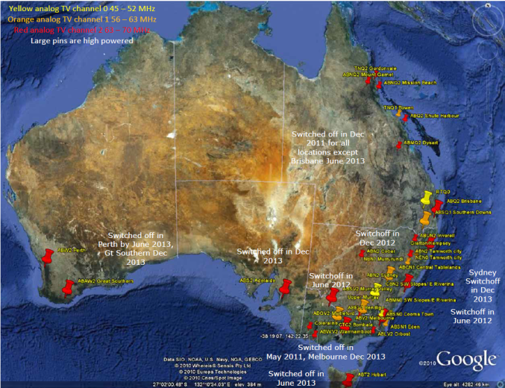

DRM30

| Time zone & National @ night | Time Zone & National @ day | Local coverage |
| --- | --- | --- |
| 5.950 - 6.200 MHz | 11.650 - 12.050 MHz | 25.670 - 26.100 MHz |
| 7.100 - 7.350 MHz | 13.600 - 13.800 MHz | 21 channels are available. There are 124 channels available for DRM30 transmitters in Australia. |
| 9.500 - 9.900 MHz | 15.100 - 15.600 MHz | 21 channels are available. There are 124 channels available for DRM30 transmitters in Australia. |
| — | 17.550 - 17.900 MHz | 21 channels are available. There are 124 channels available for DRM30 transmitters in Australia. |
| — | 21.450 - 21.850 MHz | 21 channels are available. There are 124 channels available for DRM30 transmitters in Australia. |

See the appendix to show which channels are currently in use.

***Considering that DAB+ is currently used in the mainland state capitals, is a DAB+/DRM (either DRM30 or DRM+) hybrid model viable ?***

* To make DAB+ work as a standalone standard it will require more power per transmitter as well as in-band repeaters in valleys. It is particularly poor down the Great Dividing Range from Cape York, Qld through to the Grampian Mountains in Victoria. It also includes a lot of the coastal strip between the Range and the ocean as well as all of Tasmania.
* The areas to the west and north of the Range often require greater coverage areas while containing less people. The radio horizon becomes a problem here. Since the number of broadcasters in each licence area is small and require larger coverage areas, DRM must be used.
* What will be required are reasonable priced receivers which are also Band 3 DAB+ capable.
* To reduce broadcasters' transmission costs a legislated analog switchoff date is required just like for analog TV.
* Provided he steps below happen then the answer is definitely yes.

***What measures would encourage the supply of inexpensive DRM30 and/or DRM+ receivers in Australia?***

* The way to get inexpensive receivers is to create a worldwide demand.
* This requires a single set of standards in all radios
* DAB+/DMB for areas of high population density. (In analog this is equivalent to FM)
* DRM+/DRM30 for areas of low population density. (In analog this is equivalent to AM in both MF and HF forms)
* DRM+/DRM30 for low powered community radio stations. (In analog this is equivalent to low power FM)
* In 1997/8, the Commonwealth Government's Communications Laboratory did a series of side by side tests of DVB-T and ATSC digital TV transmission standard. They proved the superiority of the DVB-T which now transmits to most of the world's population and limited ATSC to North America and Korea. A similar comparison needs to be performed with DAB+, DRM+, DRM30 and HDRadio®, more on that later.
* On the 23rd January 2012 at the ITU-R's World Radio-communications Conference;
* allocate 47 - 68 MHz to DRM+ radio. These frequencies are being released from Band 1 analog TV worldwide.[9] This will produce a "greenfield" frequency range where transmission characteristics are not limited by existing FM and AM radio transmissions.
* Specify that all HF transmissions are limited to the ITU region in which they are situated.[10] This is to allow HF frequencies to be re-used.
* Convert HF AM broadcasts worldwide to DRM30 with 20 kHz bandwidth channels.
* I personally know of one Asian manufacturer who makes portable radios and is interested in making DAB+/DRM radios for the Australian market.
* German Semiconductor manufacturer is about to release to manufacturers a digital signal processing integrated circuits which is capable of decoding all digital radio standards[11].
* Manufacturers are to create the following types profile 2 stereo receivers for;
* Automotive for cars, trucks and 4 wheel drives and installed in all new vehicles
* Portable Audio Devices (eg Ipod), Mobile phones and hence docking stations
* Portable radios containing a pair of speakers along with replay facilities
* Home theatre, surround sound amplifiers and discrete radio tuners.
* Marine receivers
* A broadcast digital radio reception option for HF communications equipment.
* Antenna manufacturers are to make;
* Remote tuned antennas for vehicles for 2.3 - 27 MHz, 47 - 68 MHz, 174 - 230 MHz, vertically polarised. These are used with 2-way radios in remote areas already.
* House mounted antenna for 2.3 - 27 MHz, 47 - 68 MHz, 174 - 230 MHz, vertically polarised.
* Marine radio omnidirectional antenna for 2.3 - 27 MHz, 47 - 68 MHz, 174 - 230 MHz, vertically polarised.
* Masthead amplifier (Variable Gain in each band ) filtered for 2.3 - 27, 47 - 68 MHz, 174 - 230 MHz.
* Convince the regulators, broadcasters, manufacturers and listeners that the above is worthwhile

Following the ABU Digital Broadcasting Symposium to be held from 8 - 11 March 2011.[12], create a symposium in Canberra, following the one in Malaysia.

* To do this a side by side comparison of;
* MF and HF at 170 VCMF on a 70 mast (around 300 W) from Bellenden St, Gungahlin, ACT[13]
* AM, (18 kHz RF bandwidth mono only)
* MF DRM30, (18 kHz RF bandwidth all digital Parametric Stereo)
* HF DRM30 (20 kHz RF bandwidth all digital Parametric Stereo)),
* HD Radio (27 kHz RF bandwidth all digital stereo)
* VHF using 1 kWERP each from an antenna about 170 m above the ground on the Telecom Tower, Black Mountain Canberra ACT[14].
* FM (200 kHz RF bandwidth, stereo 50 is pre-emphasis),
* DAB + (1.54 MHz RF bandwidth, 64 kbit/s/program),
* DRM+ (100 kHz RF bandwidth, surround or stereo),
* HD Radio® (400 kHz digital mode only, stereo sound)
* Surround sound in a car and in a room used for home theatre. May be transmitted on DRM+ and possibly DAB+ and HD Radio®.
* Demonstrate additional facilities
* Service Following. Automatic switching between digital modes which is important in automotive and HF systems.
* Video
* Slide show
* Text based Journal line
* Electronic program guide
* Emergency Warning/alert system
* We need to prove the use of DRM+ and 26 MHz DRM30 which can be transmitted in the USA/Canada because of their Analog TV switchoff. Then DRM+ can demonstrate its superiority over HD Radio. If the USA can be persuaded to take on DRM+ there will be a worldwide market for receivers. This market becomes available as analog TV is switched off.
* Get national coverage as soon as possible from the national broadcasters and through the most populated regional areas for commercial and community broadcasters. A rapid increase in initial sales will give manufacturers, retailers and the automotive industry confidence that the adoption of this format is correct.
* Enlist http://www.digitalradioplus.com.au (Owned by Commercial Radio Australia) to extend use of their marketing model they have used in DAB+ areas to promote DRM to the 9 million people in regional and remote Australia. This model is being copied by quite a few countries because of its success.
* The CRA has been trying to get the automotive manufacturers to install DAB+ radios in new cars. This is just starting to happen in Europe. It is understandable that the local manufacturers and importers would be reticent because they cannot guarantee the radio will work nearly everywhere. The adoption of DRM30/DRM+ along with DAB+/DMB will achieve this aim, particularly if the DRM network is quickly rolled out.
* Licence low powered community broadcasters in DAB+ areas to transmit in DRM+ or 26 MHz DRM30 at low power.
* Encourage other countries to follow our example, to increase the number of listeners.
* [http://www.worlddab.org/news/document/1263/EBU_backs_digital_radio_switch over.pdf](http://www.worlddab.org/news/document/1263/EBU_backs_digital_radio_switch%20over.pdf)
* <http://www.worlddab.org/news/document/1265/Let_s_Just_Get_On_With_It.pdf>
* Convince the International Telecommunications Union (An agency of the United Nations) to prepare "Guidelines for the transition from analog to digital radio broadcasting" in the same format as [http://www.itu.int/dms pub/itu-d/opb/hdb/D-HDB-GUIDELINES.01-2010-R1-PDF-E.pdf](http://www.itu.int/dms%20pub/itu-d/opb/hdb/D-HDB-GUIDELINES.01-2010-R1-PDF-E.pdf)
* Legislate a date for an analog radio switchoff as is happening in Europe.
* This will reduce operating costs for broadcasters (Maintenance & transmitter power)
* This will reduce the generation of greenhouse gasses.
* Broadcast new programs the audience wants to hear,
* Provide stable reception to where the radio actually is (ie inside using an internal antenna)
* Ensure that all current programs in each licence area are transmitted using the new digital system. This is what the CRA, ABC & SBS have done. New programs also have to be added to attract listeners.
* Update "AS 4943.1-2009 Digital radio - Terrestrial broadcasting - Characteristics of terrestrial digital audio broadcasting (T-DAB+) transmissions" to include DRM30 and DRM+. All receivers must comply or have to be prominently marked prior to sale that they are not.
* Update "AS 1417.2-1991 Receiving antennas for radio and television in the frequency range 30 MHz to 1 GHz - Performance " to include antennas for DAB+ (on the frequencies selected after the decision on the Digital Dividend), as well as for the DRM+ and DRM30 frequency ranges mentioned here. The standard should include antennas for fixed and automotive installations.

**Australian Industry**

The Coded Orthogonal Frequency Division Multiplexing (COFDM) system was invented by Dr John O'Sullivan and his CSIRO team.[15] This modulation system is used by all Digital radio systems as well as DVB-T, Wireless LANs and the 3G/4G phone systems.

Australia is capable of producing commercial quantities of Radio Digital Signal Processing chips. It is possible to integrate nearly all the reception and processing functions of DAB/DAB+/DMB/DRM30/DRM+/AM/FM in a single chip. These could be exported to Asia to be included in radios worldwide.[16]

WINRadio of Melbourne has been making DRM30 professional receivers since DRM30 started.[17]

There is a variety of antenna systems manufacturers particularly for HF DRM30[18]

TV antenna manufacturers are quite capable of manufacturing DRM+ antennas for 47 - 68 MHz[19].

**The potential adoption of other technology solutions**

#### Key issue 2.3

***Have other terrestrial technologies sufficiently changed since 2007 that now make them suitable for use in regional areas of Australia?***

**HD Radio®** is only broadcast in the USA[20]. Having commenced in 2003, automotive manufacturers are yet to include HDRadio as standard equipment because of low sales in other styles of radios. Modifications to the standard this year has reduced interference but has not increased the coverage area. Additionally iBiquity[21] Corp has ongoing charges for broadcasters. It is claimed[22] that only 242 stations are on air with MF HDRadio® with less than 83 on air at night. This is limited by interference.

**3G/4G mobile phone network.** The frequency range, used for these networks are similar to L band DAB+ (1.5 GHz). As a result terrain can easily block signals causing patchy reception. To overcome this there are many repeaters. The addition of broadcasting of radio signals will add to the number of transmitters on each site.

"He went on to highlight the point that broadcast radio remains the most efficient and greenest method of reaching a large population and is the only viable solution for delivering radio to listeners in cars and on the move. On the same topic, Simon Mason of Arqiva presented detailed analysis underlining the fact that other mobile communication solutions such as 3G/4G are neither economically, nor technically realistic alternatives for delivering radio on the move."

For further information read; <http://www.worlddab.org/news/document/1285/WorldDMB_Broadcast_radio_not_to_be_replaced_by_Internet_3G.pdf>

Arqiva[23], the communications infrastructure and media services company, operates at the heart of the broadcast, satellite and mobile communications markets.

***Can satellite broadcasting be economically used to provide free-to-air radio services in Australia and what are the implications for consumers in terms of ease of reception and cost?***

Regardless of the costs, satellite signals will not pass through a roof or the floors of multiple floored buildings. The USA has XMSirius satellite [24]pay radio. There are only 11.6 million car subscribers in a population of 310 million people.

Whilst DAB+ can be broadcast from a satellite using 7 DAB+ channels (LQ - LW 1.480.352 - 1.490624 GHz) I do not know of any broadcasters or receivers on the market for satellite reception.

Satellite reception will disappear when driving under bridges, in city CBDs and driving through forests.

The use of satellite radio is not easy. The signals will not penetrate buildings. This would then require an external receiver and WiFi transmitter for inside the dwelling. Multi-unit dwellings will require additions to a Master Antenna TV system for internal signal distribution.

***Are there any other technologies not covered in this paper that may be suitable for digital radio in regional Australia?***

No.

**Addenda part 1**

Conference and workshop suggested details 20

A proposal for Australian Digital Radio 22

**Addenda part 2**

ABC High Strength transmitter sites 56

High Strength 58

Australian HF Broadcast Assignments 67

Region 2 Frequency allocations for the Americas 74

## Addenda part 1

### Conference and workshop suggested details

**Conference and workshop participants should include the following stakeholders**

* Senator Stephen Conroy, Minister for Department of Broadband, Communications and the Digital Economy.
* Regulators;
* DBCDE,
* ACMA
* Overseas (particularly, FCC (USA), Ofcom(UK), Canadian Radio-television and Telecommunications Commission
* A contingent from Digital Radio Mondiale[25]
* WorldDRM[26]
* Receiver manufactures
* Digital Signal Processing Integrated circuit manufacturers
* Ibiquity Corporation
* To demonstrate the all digital modes of MF and VHF HDRadio
* Broadcasters
* Commercial Radio Australia and their members
* Australian Broadcasting Corporation
* Special Broadcasting Service
* Community Broadcast Association Australia and their members
* Retailers
* Australian Radio Equipment Manufacturers
* Automotive manufacturers
* All Australian Automotive manufacturers and importers.
* Society of Indian Automotive Manufacturers
* European Automobile Manufacturers Association
* Association of International Automobile Manufacturers[27] (USA)..
* European Broadcasting Union
* National Association of Broadcasters (USA)
* Ionospheric Prediction Service (To give a paper on covering Australia using DRM30 HF radio at high power)

**Comparison Demonstration which are all on Broadcast Australia properties. The same surround sound original program should be fed to all trial transmitters simultaneously.**

* AM transmitter site at Bellenden St, Gungahlin ACT <http://www.nearmap.com/?!!-35.214069,149.12168&z=16&t=h&nmd=20100707>

### A proposal for Australian Digital Radio

**By Alan Hughes**

[dtvdrb@westnet.com.au](mailto:dtvdrb@westnet.com.au)

"A proposal for Australian Radio" 201011 © to the author

**This Proposal Contains;**

* Objectives
* DAB+ Network, Nov 2010
* The proposal
* Propagation
* Transmission Systems Available
* Characteristics of the different transmission systems
* Finding channels
* Proof of transmission systems to be used
* DAB+ direct broadcast satellite option
* Climate Change Advantages
* HF DRM transmitter locations
* Conclusion

**Objectives**

* Provide digital radio to all Australian citizens regardless of where they live.
* Reduce the CO2 emissions by at least 257,000 t/year
* Provide coverage in the shortest possible time at the lowest setup and maintenance costs.
* This will minimise extra CO2 production during the changeover.
* At the highest sound quality including stereo sound.
* Provide extra facilities.

**Transmission Systems Available**

* Old Analog
* AM
* Short Wave
* FM
* New Digital
* MF DRM30
* HF DRM30
* DRM+
* Band 3 DAB+
* L Band DAB+
* L Band DAB+ from Satellite

DAB+ Network Nov 2010

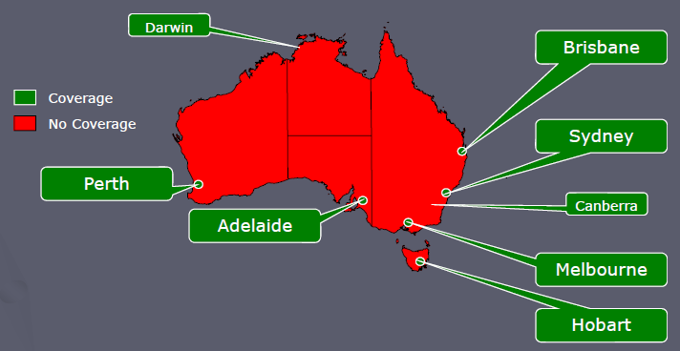

### My Proposal Follows...

Total Coverage

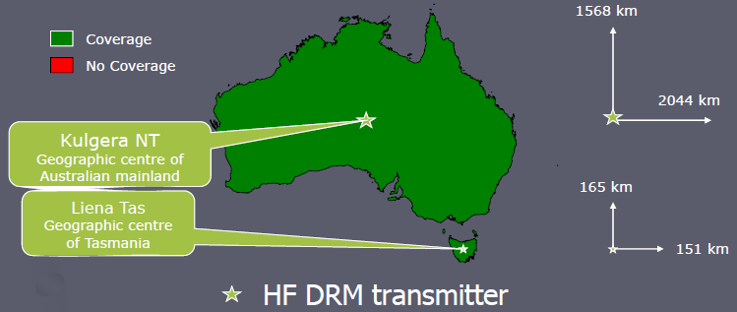

This coverage is suitable for live national coverage such as Parliamentary NewsRadio

**Facilities and opinions**

* Facilities in receivers;
* DAB+ receiver profiles
* <http://www.worlddab.org/public_documents/WorldDMB_Digital_Radio_Receiver_Profiles.pdf>
* DRM Receiver profiles <http://www.drm.org/uploads/files/drm_receiver_profiles.pdf>
* DRM30 it needs few or single transmitters (HF) to cover one large area **HF coverage for Australia needs only ONE 250 kW HF DRM30 transmitter per program.** (Phillippe Charron, [WorldDAB.org](http://WorldDAB.org))
* MF coverage needs more high power DRM transmitters to cover the same area, that's why **HF should be considered as a distance learning cost effective solution** (ie School of the Air)
* Directional transmitting antennae could be designed to transmit to selected areas

Australian Time Zones

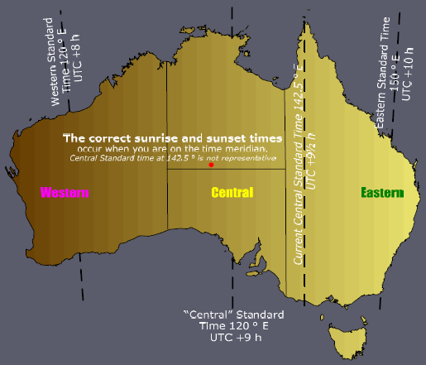

Eastern Time Zone Coverage

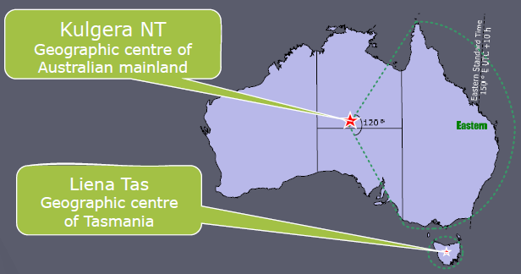

This coverage is suitable for national programs for coverage in Eastern Australia

For example SBS Radio 1 & 2, Radio National, JJJ, ABC Classics, Dig, ABC Jazz, ABC country & Grandstand

No program delays

Central Time Zone Coverage

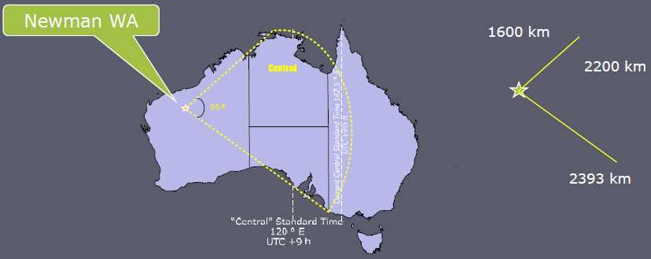

This coverage is suitable for national programs for coverage in Central Australia

For example SBS Radio 1 & 2, Radio National, JJJ, ABC Classics, Dig, ABC Jazz, ABC country & Grandstand

All programs are delayed 1 hour from Eastern Time

Western Time Zone Coverage

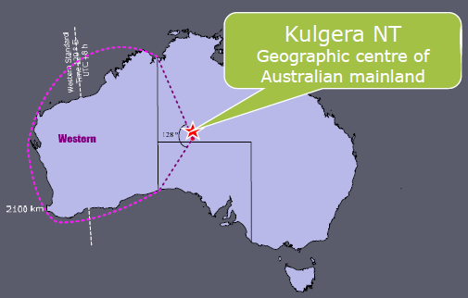

This coverage is suitable for national programs for coverage in Western Australia For example SBS Radio 1 & 2, Radio National, JJJ, ABC Classics, Dig, ABC Jazz, ABC country & Grandstand All programs are delayed 2 or 3 hours from Eastern Time

Propagation

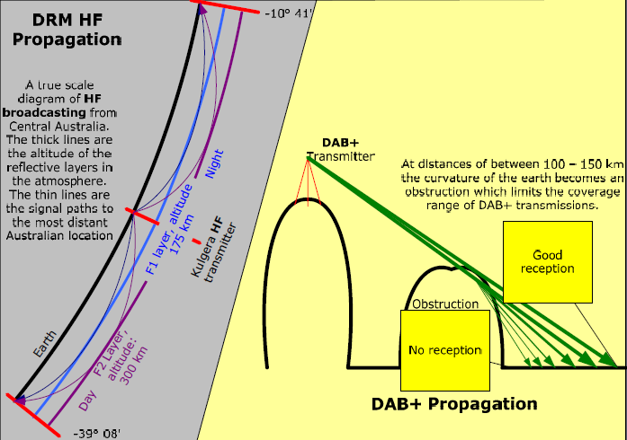

**Remote "Local" Radio**

* An ABC Local Radio program and a pair of commercial radio programs from the nearest station can be received



Eastern Remote "Local" Coverage

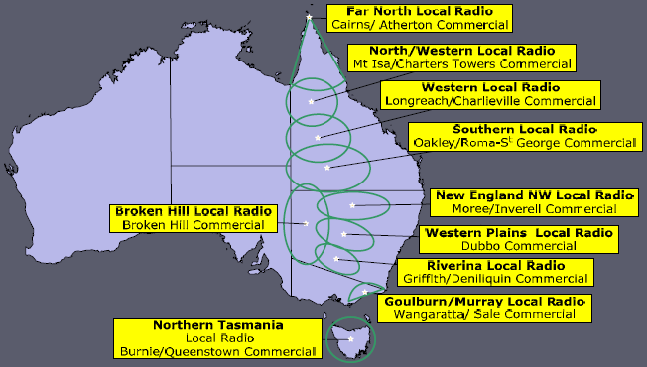

Currently, there are some areas with no coverage. The map shows "local" programs in remote eastern areas. This will provide car coverage anywhere.

26 MHz DRM30 shower transmissions (NVIS) are best for these areas.

Remote "Local" Coverage SA

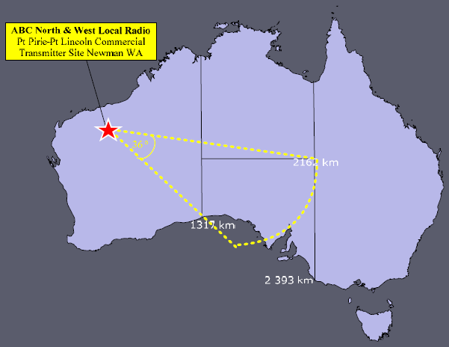

This coverage is suitable for “local” programs for coverage in South Australia. This will provide car coverage anywhere in SA. There are currently large areas with no coverage.

Remote "Local" Coverage NT

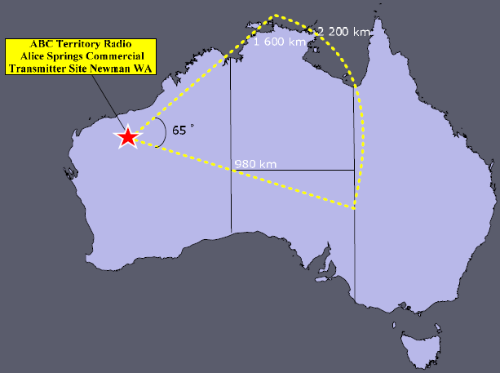

This coverage is suitable for “local” programs for coverage in Northern Territory.

This will provide car coverage anywhere in NT.

Remote "Local" Coverage WA

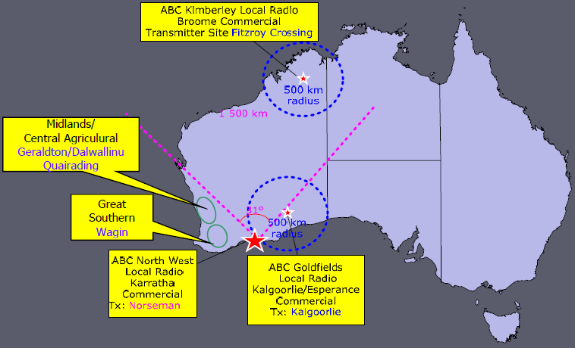

This coverage is suitable for “local” programs for coverage in Western Australia. This will provide car coverage anywhere in WA. There are currently large areas with no coverage.

**Regional Areas**

* Each area should contain
* ABC Local Radio
* 2 or more commercial stations
* 2 or more community stations
* Using either
* A single Band 3 DAB+ channel containing about 9 radio programs or
* 5 DRM+ or (MF or HF DRM) channels
* The choice is controlled by population density & terrain.

**Large Cities**

* Main Transmitters

Band 3 DAB+ for ABC Local Radio, commercials

* Gap fillers

In band repeater

* Community Radio
* DRM +

Spectrum Real Estate – DRM

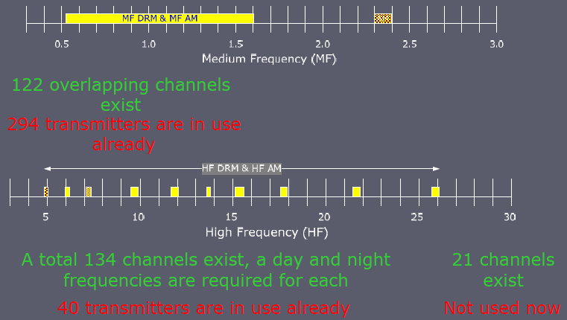

A DRM channel carries one program

Spectrum Real Estate - DAB+/DRM+

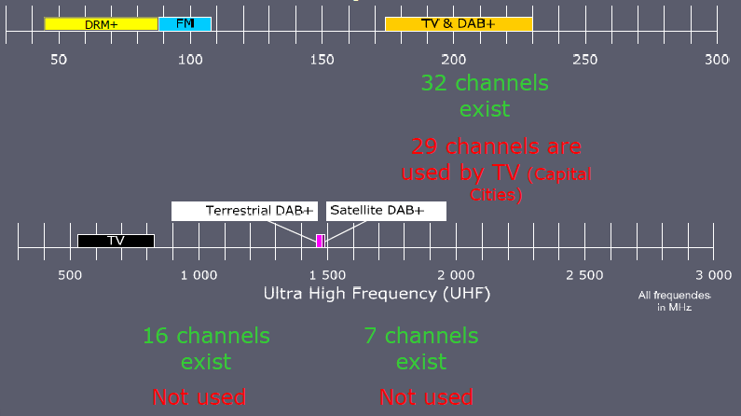

A DAB+ channel carries up to 9 CD quality programs

**AM - Amplitude Modulation**

Invented in 1901

* Poorest quality sound with no stereo.
* MF AM (Medium Wave or "AM"). This band broadcasting covers a region "regardless" of the terrain. eg hills
* HF AM (Short Wave). This band covers large areas including continents and larger.
* A third of the power contains no program information, as a result is inefficient.

**FM - Frequency Modulation**

Invented in 1933

* Generally the stereo sound is either very good, hissy or non existent.
* The Very High Frequency band is used and at high powers the signal can cover a region as effectively as VHF TV. FM is used for sound in analog TV.
* VHF is not very tolerant of the terrain, but this depends on the transmitter power.
* All of the signal is used
* The sound can become fuzzy during city car driving.

**DRM30 - Digital Radio Mondiale**

Invented in 2002

* "Near" FM quality complete with stereo sound
* MF DRM will have to compete for channels in a currently congested "AM" band
* HF DRM has more channels available
* Overcomes the problems with HF AM
* Can cover from communities to continents.

**DAB+ - Digital Audio Broadcasting**

Invented in 1987

* Highest quality sound in stereo but will be either present, breaking up or absent.
* Four DAB+ channels will fit into a standard TV channel
* A DAB+ channel carries 9 CD quality programs
* Only DAB+ channels 9A, 9B, 9C are available in capital cities until analog TV is switched off.
* DAB+ channels LA - LP, giving 16 DAB+ channels are available nationally.
* If high TV receiving antennas are required in a particular area then car/portable radio reception is impossible in that location.

Invented in 2009

* Single broadcaster per transmitter
* Capable of 5.1 surround sound
* 100 kHz per channel (200 kHz for FM broadcast).
* Transmitters on the same site can be on adjacent channels (FM: 3 blank channels in between)
* 210 channels become available when TV channels 0 - 3 are switched off

**Compatibility in receivers**

* A tuning module
* is now being manufactured to receive all broadcast radio standards.
* So receiver manufacturers can then add which facilities they wish.
* Sound Compression systems
* Advanced Audio Coding (ACC+) is being used in DAB+, DRM30 and DRM+.

**Finding Channels - DRM**

* MF
* There are currently 294 AM transmitters sharing 122 overlapping channels. Nearly all AM channels have 3 transmitters on each.
* HF
* The ACMA has embargoed (#44) 155 20 kHz wide channels
* For continuous large area coverage 2 channels are required per program. (One for day and another for night)
* Also used by overseas broadcasters on DRM and AM
* VHF band 1
* 210 x 100 kHz channels

**Finding Channels - DAB+**

* VHF Band 3
* This band is also used by TV channels 6 - 12.
* Only 3 DAB+ channels are available in major cities until analog TV shutdown, afterwards 8 channels including surrounding areas is proposed.
* UHF L Band
* 16 terrestrial channels are available.
* 7 satellite channels are available but there isn't any repeaters on the satellites over Australia. There is none planned presently. (The satellite transmitter power is insufficient for good coverage)

**Reducing Demand**

**Example: Radio National**

* Radio National, a time zone coverage example
* Current capacity
* 24 AM transmitters with a total 300 kW of power, using 2.1 km of tower.
* 292 FM transmitters with a total 2880 kWERPof power, using 11 km of tower.
* HF DRM
* 4 channels, 3 high powered transmitters in Kulgera NT
* 2 channels, 2 high powered transmitters in Newman WA
* 2 channels, 2 low powered transmitters in Liena Tas
* Using only 3 sites will allow the use of solar power for the first 2 and hydro for the Tasmanian site.
* This will provide nationwide coverage very quickly.

53 Transmitters give national coverage of 9 programs

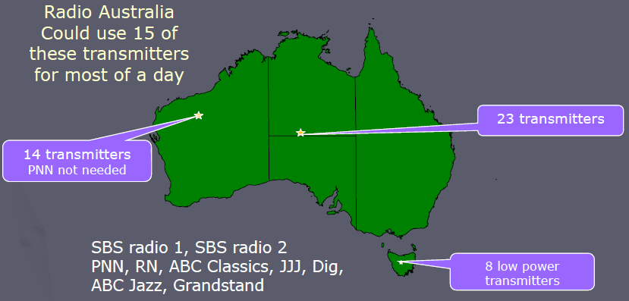

Finding HF DRM Frequencies

| Band | Occupied | All Directions | Free to West | Free to East |
| --- | --- | --- | --- | --- |
| 6 MHz | 4/12 | 8 | 2 | 0 |
| 7 MHz | 2/10 | 9 | 1 | 0 |
| 9 MHz | 7/20 | 13 | 0 | 2 |
| 11 MHz | 4/20 | 17 | 0 | 1 |
| 13 MHz | 5/10 | 6 | 0 | 1 |
| 15 MHz | 12/25 | 17 | 1 | 4 |
| 17 MHz | 5/17 | 17 | 1 | 4 |
| 21 MHz | 1/20 | 17 | 1 | 4 |
| 26 MHz | 0/21 | 21 | 1 | 0 |

Night, Day, Local Change from Day to Night frequencies varies with the season an year. Check this table out with Ionospheric Prediction Service

**The Reasons HF AM Went Out of Favour in Domestic Broadcasting**

* Why domestic HF radio is now reduced to 3 transmitters in this country.
* It is difficult to tune in analog radios, particularly the cheaper ones in the 1970s where, slightly touching the dial would make the radio would go off tune.
* Signals would fade and distort
* Too many signals to choose from
* Broadcasters had to change frequency between day and night so you had to memorise where to find your program. The frequencies are longer series of numbers eg. 26.125 MHz
* No stereo sound.

DRM Improvements

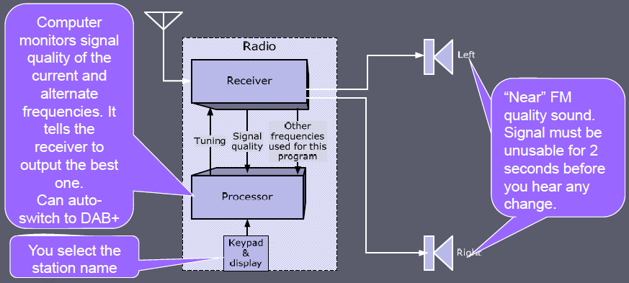

Australia has monitoring stations for space weather, so that the best transmission frequencies and power can be selected for a continuous reception.

[www.IPS.gov.au](http://www.IPS.gov.au)

Working Broadcasts NZRI

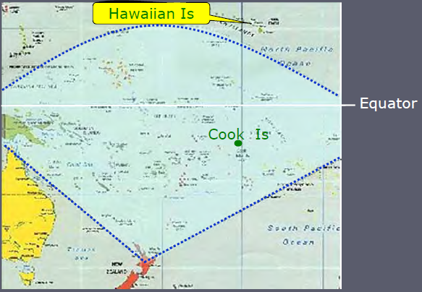

Rangitaiki, NZ to Cook Islands 2500 km. Service covers the whole South Pacific on 50 kW. <http://www.rnzi.com/pages/technical.php>

**DRM Rollouts**

* India
* $Aust 250 million for Analog to DRM30 conversion completed by 2013
* Includes high powered HF and MF transmitters of which 2 are operating already
* AM (MF & HF) switch off in 2015.
* CIS (Russia)
* Changing over to DRM30 between 2009 - 2015.

Demonstration Broadcasts

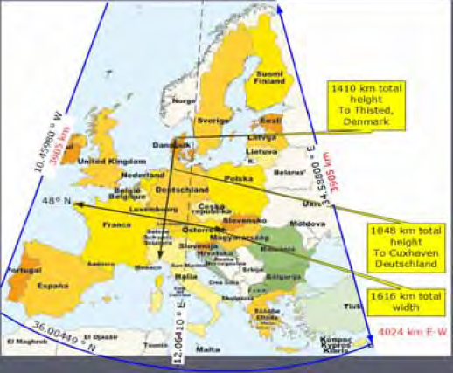

WinRadio G303e  
Connects to a computer

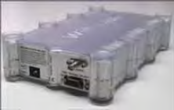

Uniwave Di-Wave 100

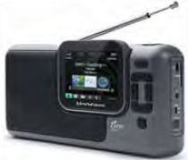

Please listen to these demonstrations from <http://www.drm.org/index.php?p=what_can_i_hear>

| Transmitter Location | Frequency kHz | Power kW | Receiver Location | S km |
| --- | --- | --- | --- | --- |
| Wertachtal Germany | 6180 | 200 | Brussel Belgium | 550 |
| Issoudun France | 6175 | 30 (Beam width 50?) | Bonn Germany | 575 |
| Flevo Netherlands | 5995 | 40 omnidirectional | Köln | 351 |

The DAB+ Satellite Alternative

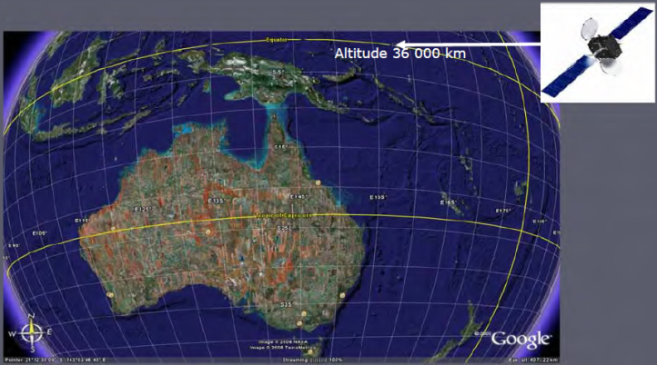

Characteristics of DAB+ Direct Satellite Broadcasting, Australia-wide

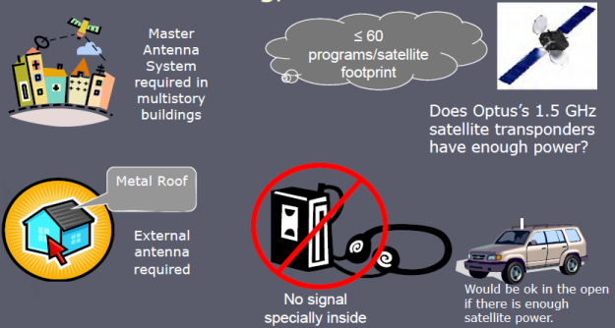

**Possible Data Applications of DRM30, DRM+,DAB+**

* Emergency warnings for cyclones, floods, fires etc.
* Advertising
* Subtitles for the hard of hearing, particularly news
* Rural information such as prices etc.
* Sporting results, etc
* Local weather forecasts
* Traffic conditions including data downloads to navigation computers to modify directions around blockages, fuel prices etc.
* Name, party and perhaps a picture of the politician in the parliamentary broadcasts.
* Program name, music title & credits
* Music downloads
* Webcam images from the studios.

**Climate Change Advantages**

* If HF DRM is used for time zone coverage, far fewer transmitters are required for equivalent coverage.
* The additional transmitters would have to be powered from the grid, which is not as yet pollution free
* The HF DRM proposal allows each time zone its own programs from 3 sites. This makes 24 hour renewable power possible.
* Power sources;
* Kulgera NT: Geothermal power from Paralana SA. Solar, wind & gas
* Newman WA, Solar and gas
* Norseman WA, Wind and sun.
* Liena Tas, hydro-electricity.

**Site Selection for HF DRM**

* This system does not use a satellite owned by a foreign government
* The site must be out of the cyclone zone
* Kulgera NT is as far as possible from the coast which allows maximum time to detect invaders.
* Kulgera NT and Newman WA are;
* close to a railway lines for construction
* close to fibre optic communications for program feeds

**Conclusion**

* This proposal meets the objectives
* Provide digital radio to all Australian citizens regardless of where they live.
* Provide coverage in the shortest possible time at the lowest setup and maintenance costs.
* At the highest sound quality including stereo sound.
* Provide extra facilities.
* It will reduce the number of government funded transmitters dramatically once analog is switched off.
* A saving of at least 257,000 tonnes of CO2 per year once analog radio has been switched off.

**Relevant links**

<http://www.worlddab.org/news/document/1265/Let_s_Just_Get_On_With_It.pdf>

<http://www.telecompaper.com/news/mexican-radio-stations-want-digital-switchover-in-2015>

[www.drm.org](http://www.drm.org)

[www.worlddab.org](http://www.worlddab.org)

[www.Digitalradioplus.com.au](http://www.Digitalradioplus.com.au)

[www.cbaa.org.au](http://www.cbaa.org.au)

<http://www.siliconchip.com.au/cms/search/index.html?scope=&keywords=Digital+Radio&Search=Search> "Digital radio is coming" by this author.

[www.ips.gov.au](http://www.ips.gov.au)

<http://www.climatechange.gov.au/~/media/publications/greenhouse-acctg/national-greenhouse-factors-iuly-2010-pdf.ashx>

<http://www.energy.unimelb.edu.au/uploads/ZCA2020_Stationary_Energy_Report_v1.pdf> part 3 base load thermal.

<http://www.petratherm.com.au/_webapp_117685/Paralana>

### ABC High Strength transmitter sites

Which can be sold and which should be retained for ABC Local Radio. Radio National, JJJ, Classic FM, Dig, Jazz and Country should come from 

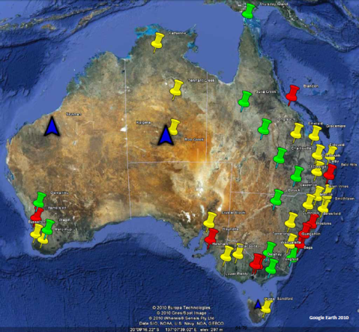



High Strength AM to DAB+ Site Redundant



High Strength AM to DRM+ Site Redundant



High Strength AM to DRM30 Keep Site



New Very High Strength DRM30 Site

### High Strength

| Area Served | Callsign | Frequency (kHz) | Site Name | Location to paste into Google Earth |
| --- | --- | --- | --- | --- |
| Cumnock | 2CR | 549 | Broadcast Site CUMNOCK | -32.9352777777778, 148.710277777778 |
| Horsham | 3WV | 594 | Broadcast Site HORSHAM | -36.6419444444444, 142.254166666667 |
| Emerald | 4QD | 1548 | 4QD Tower EMERALD | -23.4611111111111, 148.148055555556 |
| Grafton | 2NR | 738 | Broadcast Site LAWRENCE | -29.4933333333333, 153.114166666667 |
| Naracoorte | 5PA | 1161 | Broadcast Site NARACOORTE | -36.9408333333333, 140.670555555556 |
| Pialba | 4QB | 855 | Broadcast Site Sorrensons Road DUNDOWRAN | -25.3036111111111, 152.786111111111 |
| Julia Creek | 4JK | 567 | AM Broadcast Site Flinders Hwy JULIA CREEK | -20.6522222222222, 141.820555555556 |
| Manjimup | 6RN | 1152 | Broadcast Site 8 km S of MANJIMUP | -34.3219444444444, 116.143333333333 |
| Hobart | 7ZR | 936 | Broadcast Site RALPHS BAY | -42.9269444444444, 147.497222222222 |
| Wangaratta | 3RN | 756 | Broadcast Site cnr Boorhaman Rd & Richards St | -36.3161111111111, 146.369722222222 |
| Busselton | 6PNN | 1152 | Broadcast Site BUSSELTON | -33.6608333333333, 115.2275 |
| Glen Innes | 2GL | 819 | Broadcast Site 1 GLEN INNES | -29.7919444444444, 151.764444444444 |
| Rockhampton | 4RK | 837 | Broadcast site 1.2 km S of Gracemere | -23.4530555555556, 150.455833333333 |
| Canberra | 2RN | 846 | Broadcast Site Barton Hwy GUNGAHLIN | -35.2191666666667, 149.122222222222 |
| Kempsey | 2KP | 684 | Broadcast Site SMITHTOWN | -31.0072222222222, 152.946944444444 |
| Port Pirie | 5CK | 639 | Telstra Site CRYSTAL BROOK | -33.3463888888889, 138.2525 |
| Toowoomba | 4QS | 747 | 4QS Broadcast Site 3 km NE of DALBY | -27.1463888888889, 151.300555555556 |
| Tamworth | 2NU | 648 | Broadcast Site MANILLA | -30.7830555555556, 150.744722222222 |
| Eidsvold | 4QO | 855 | 4QO AM Tx Site EIDSVOLD | -25.4094444444444, 151.121111111111 |

Retain

| Area Served | Callsign | Frequency (kHz) | Site Name | Location to paste into Google Earth |
| --- | --- | --- | --- | --- |
| Dalwallinu | 6DL | 531 | Broadcast Site DALWALLINU | -30.29, 116.608055555556 |
| Charleville | 4CH | 603 | 4CH Site Mitchell Hwy 19km N of CHARLEVILLE | -26.2555555555556, 146.301944444444 |
| Bega | 2BA | 810 | Broadcast Site BEGA | -36.7127777777778, 149.819444444444 |
| Wagin | 6WA | 558 | Broadcast Site Arthur River Rd WAGIN | -33.3383333333333, 117.091388888889 |
| Byrock | 2BY | 657 | Broadcast Site BYROCK | -30.6511111111111, 146.425833333333 |
| Roma/St George | 4QW | 711 | Broadcast Site 4QW 9 km NE of ST GEORGE | -27.9977777777778, 148.673888888889 |
| Longreach | 4QL | 540 | MF Broadcast Tower 6 km NW of LONGREACH | -23.3905555555556, 144.2225 |
| Sale | 3GI | 828 | 3GI MF Broadcast Tower LONGFORD | -38.1897222222222, 147.093888888889 |
| Torres Strait | 4TI | 1062 | Broadcast Site THURSDAY ISLAND | -10.5819444444444, 142.206944444444 |

Above sites are producing signals of >1000 Vcmf

DAB+

**DAB+ Radio has been on air since August 2009**

| Area Served | Callsign | Frequency( kHz) | Site Name | Comments | Location to paste into Google Earth |
| --- | --- | --- | --- | --- | --- |
| Melbourne | 3LO | 774 | Melbourne Broadcast Site Sydenham Road DELAHEY | — | 144.7825, 37 |
| Melbourne | 3PB | 1026 | Broadcast Site Bonds Rd LOWER PLENTY | Shared site with | 145.110277777778, -37.7427777777778 |
| Sydney | 2BL | 702 | ABC main tower Kurrajong Road PRESTONS | — | 150.884166666667, -33.9436111111111 |
| Adelaide | 5AN | 891 | Broadcast Site Sherriffs Road REYNELLA | — | 138.517222222222, -35.1052777777778 |
| Perth | 6WF | 720 | National Broadcast Transmit Site HAMERSLEY | — | 115.817777777778, -31.8558333333333 |
| Brisbane | 4QR | 612 | 4QR Site BALD HILLS | — | 153.016388888889, -27.3130555555556 |

**DAB+ Radio is viable in these areas**

| Area Served | Callsign | Frequency( kHz) | Site Name | Comments | Location to paste into Google Earth |
| --- | --- | --- | --- | --- | --- |
| Townsville | 4QN | 630 | MF Broadcast Site Jack Rd BRANDON | Shared with ABC's Radio Australia | 147.339166666667, -19.5116666666667 |
| Nowra | 2RN | 603 | Broadcast Site Tomerong 2 km NW of BASIN VIEW | Part of the Illawarra | 150.555555555556, -35.0997222222222 |
| Newcastle | 2NC | 1233 | Broadcast Site BERESFIELD | Part of Hunter Valley | 151.660555555556, -32.8005555555556 |

Lower strength

| Area Served | Callsign | Frequency (kHz) | Purpose | Maximum CMF (V) |
| --- | --- | --- | --- | --- |
| Adelaide | 5PB | 972 | National | 605 |
| Albany | 6AL | 630 | National | 700 |
| Albury/Wodonga | 3RN | 990 | National | 225 |
| Alice Springs | 8AL | 783 | National | 440 |
| Armidale | 2RN | 720 | National | 70 |
| Atherton | 4AT | 720 | National | 715 |
| Bridgetown | 6BR | 1044 | National | 310 |
| Broken Hill | 2NB | 999 | National | 660 |
| Broome | 6BE | 675 | National | 685 |
| Cairns | 4QY | 801 | National | 430 |
| Carnarvon | 6CA | 846 | National | 474 |
| Christmas Island | 6ABCRN | 1422 | Retransmission | 220 |
| Cooma | 2CP | 1602 | National | 70 |
| Corowa | 2CO | 675 | National | 960 |
| Darwin | 8RN | 657 | National | 450 |
| Derby | 6DB | 873 | National | 640 |
| Esperance | 6ED | 837 | National | 670 |
| Exmouth | 6XM | 1188 | National | 484 |
| Fingal | 7FG | 1161 | National | 535 |
| Geraldton | 6GN | 828 | National | 960 |
| Goulburn | 2RN | 1098 | National | 140 |
| Gympie | 4GM | 1566 | National | 140 |
| Hughenden | 4HU | 1485 | National | 70 |
| Jabiru | 8JB | 747 | National | 135 |
| Kalgoorlie | 6GF | 648 | National | 540 |
| Karratha | 6KP | 702 | National | 948 |
| Katherine | 8RN | 639 | National | 450 |
| Kununurra | 6KW | 819 | National | 695 |
| Leigh Creek South | 5LC | 1602 | National | 140 |
| Lithgow (City) | 2LG | 1395 | National | 140 |
| Mossman | 4MS | 639 | National | 305 |
| Mount Gambier | 5MG | 1476 | National | 285 |
| Murwillumbah | 2ML | 720 | National | 190 |
| Muswellbrook | 2UH | 1044 | National | 672 |
| Newman | 6MN | 567 | National | 100 |
| Nhulunbuy | 8GO | 990 | National | 220 |
| Northam | 6NM | 1215 | National | 235 |
| Omeo | 3MT | 720 | National | 755 |
| Pannawonica | 6PN | 567 | National | 100 |
| Paraburdoo | 6PU | 567 | National | 94 |
| Port Hedland | 6PH | 603 | National | 424 |
| Port Lincoln | 5LN | 1485 | National | 140 |
| Queenstown | 7RN | 630 | National | 200 |
| Renmark/Loxton | 5RN | 1305 | National | 565 |
| St Helens | 7SH | 1584 | National | 100 |
| Streaky Bay | 5SY | 693 | National | 850 |
| Taree | 2TR | 756 | National | 672 |
| Tennant Creek | 8RN | 684 | National | 305 |
| Tom Price | 6TP | 567 | National | 94 |
| Warrnambool | 3WL | 1602 | National | 160 |
| Weipa | 4WP | 1044 | National | 220 |
| Wilcannia | 2RN | 1485 | National | 105 |
| Woomera | 5WM | 1584 | National | 70 |
| Wyndham | 6WH | 1017 | National | 215 |

Lower strength

| Site Name | Location to paste into Google Earth |
| --- | --- |
| Broadcasting site South Terrace WINGFIELD | -34.8380555555556, 138.567777777778 |
| Gledhow Rd South ALBANY | -35.0119444444444, 117.819722222222 |
| ABC Radio National Site 2km north of WODONGA | -36.1033333333333, 146.901111111111 |
| Broadcast Site Lot 3697 South Stuart Hwy ALICE SPRINGS | -23.7688888888889, 133.870833333333 |
| Broadcast Site MACPHERSON RANGE | -30.4972222222222, 151.663333333333 |
| Broadcast Site 3.8 km SW of Yungaburra ATHERTON | -17.3113888888889, 145.554444444444 |
| Broadcast Site BRIDGETOWN | -33.9222222222222, 116.12 |
| Broadcast Site BROKEN HILL | -31.93, 141.484722222222 |
| Broadcast Site 8km NNE of BROOME | -17.8891666666667, 122.261666666667 |
| Broadcast Site KAMMA | -17.0541666666667, 145.777222222222 |
| 6CA cnr Lewer Rd and Robinson St CARNARVON | -24.8727777777778, 113.668888888889 |
| Broadcast Site Phosphate Hill CHRISTMAS ISLAND | -10.4333333333333, 105.683333333333 |
| Broadcast Site COOMA | -36.2291666666667, 149.135555555556 |
| Broadcast Site COROWA | -35.9569444444444, 146.418055555556 |
| Broadcast Site Douglas St LUDMILLA | -12.4252777777778, 130.848333333333 |
| Broadcast Site DERBY | -17.3544444444444, 123.668055555556 |
| Broadcast Site Coolgardie Esperance Hwy 13.5 km N of Esperance ESPERANCE | -33.7541666666667, 121.858611111111 |
| Broadcast Site 3 km S of EXMOUTH | -21.9608333333333, 114.128055555556 |
| Broadcast Site Esk Main Rd FINGAL | -41.6902777777778, 147.874166666667 |
| Broadcast Site Fig Tree Crossing 15 km NE of GERALDTON | -28.6619444444444, 114.704722222222 |
| Broadcast Site GOULBURN | -34.7472222222222, 149.695277777778 |
| Broadcast Site 3 km SE of GYMPIE | -26.2116666666667, 152.6875 |
| National MF Broadcast Site Flinders Hwy HUGHENDEN | -26.2116666666667, 152.6875 |
| MF Broadcast Site 2km NE of JABIRU | -12.6572222222222, 132.848055555556 |
| Broadcast Site near Railway KALGOORLIE | -30.7836111111111, 121.402777777778 |
| Broadcast Site NW Coastal Hwy 7 km SE of KARRATHA | -20.7330555555556, 116.833055555556 |
| MF and HF Broadcast Site 13km NE of KATHERINE | -14.3977777777778, 132.178333333333 |
| MF Broadcast Site Lot 2229 Speargrass Road KUNUNURRA | -15.7652777777778, 128.730833333333 |
| Broadcasting site SSE of LEIGH CREEK | -30.6008333333333, 138.402777777778 |
| MF Broadcast Site near Bracys Lookout LITHGOW | -33.4894444444444, 150.159444444444 |
| Broadcast Site 6 km WNW of MOSSMAN | -16.4163888888889, 145.387222222222 |
| Telstra 60 Crouch Street NORTH MOUNT GAMBIER | -37.8258333333333, 140.788611111111 |
| Telstra Radio Terminal Terranora Lodge TERRANORA | -28.2438888888889, 153.510277777778 |
| Broadcast Site MUSWELLBROOK | -32.2358333333333, 150.917777777778 |
| ABC Tower TV Hill Approx 1km NW NEWMAN | -23.3502777777778, 119.723611111111 |
| MF Broadcast Site NHULUNBUY | -31.6769444444444, 116.609722222222 |
| Broadcast Site NORTHAM | -37.1477777777778, 147.656388888889 |
| Broadcast Site OMEO | -37.1477777777778, 147.656388888889 |
| Broadcast Site PANNAWONICA | -21.6630555555556, 116.342222222222 |
| Broadcast Site PARABURDOO | -23.2177777777778, 117.664166666667 |
| Broadcast Site PORT HEDLAND | -20.4002777777778, 118.673611111111 |
| Broadcast/Telstra Site Cardiff Rd PORT LINCOLN | -34.7305555555556, 135.877777777778 |
| Broadcast Site Zeehan Hwy QUEENSTOWN | -42.0466666666667, 145.527777777778 |
| 5MV Broadcast Site RENMARK | -34.2666666666667, 140.621666666667 |
| Broadcast Site North of Airport ST HELENS | -41.335, 148.285833333333 |
| Broadcast Site STREAKY BAY | -32.7577777777778, 134.188611111111 |
| Broadcast Site TAREE | -31.9269444444444, 152.464444444444 |
| Broadcast Site TENNANT CREEK | -19.6686111111111, 134.222777777778 |
| ABC MF Broadcast Site Tom Price Spur Road TOM PRICE | -22.7005555555556, 117.773055555556 |
| Broadcast Site WARRNAMBOOL | -38.3666666666667, 142.499722222222 |
| AM Broadcast Site WEIPA | -12.6219444444444, 141.888888888889 |
| National AM Site Cleaton St WILCANNIA | -31.5588888888889, 143.369444444444 |
| Broadcast Site WOOMERA | -31.2016666666667, 136.825555555556 |
| MF Broadcast Site Great Northern Highway WYNDHAM | -15.4958333333333, 128.135555555556 |

### Australian HF Broadcast Assignments

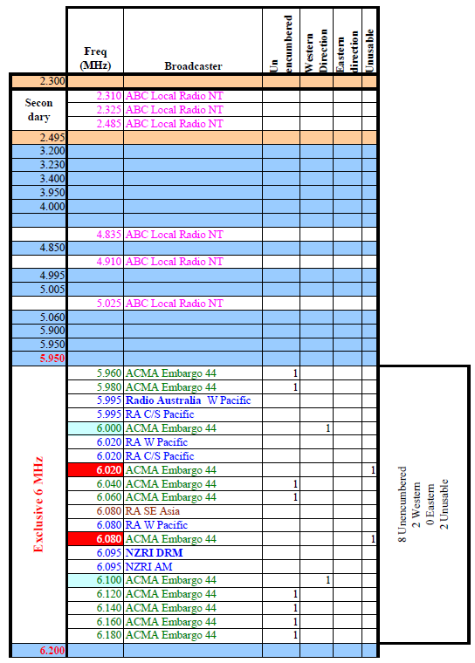

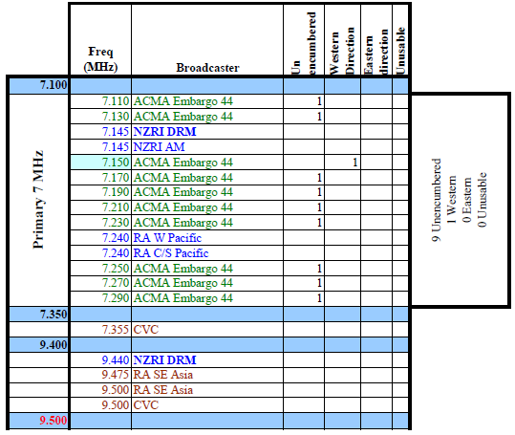

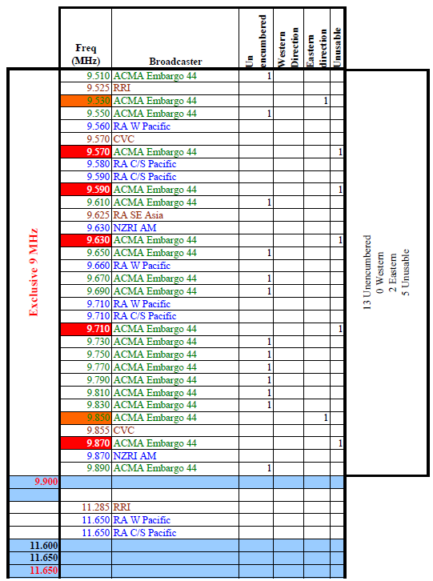

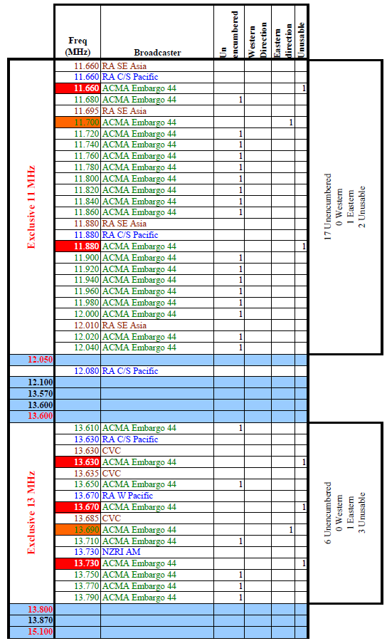

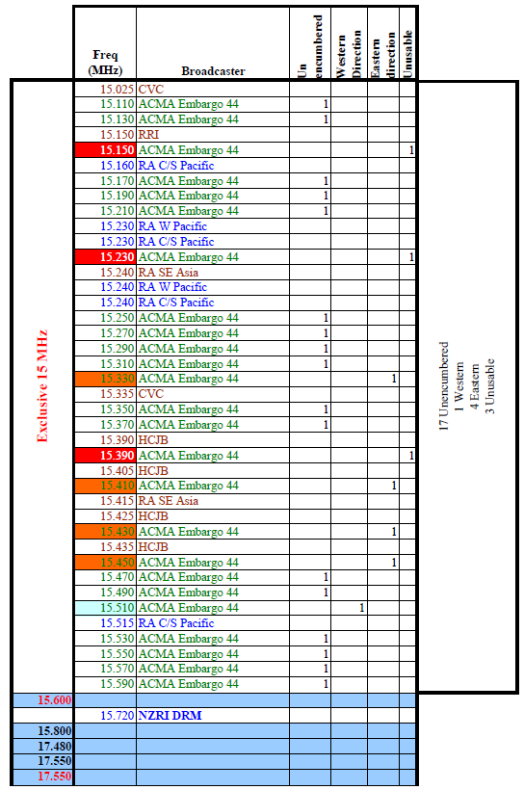

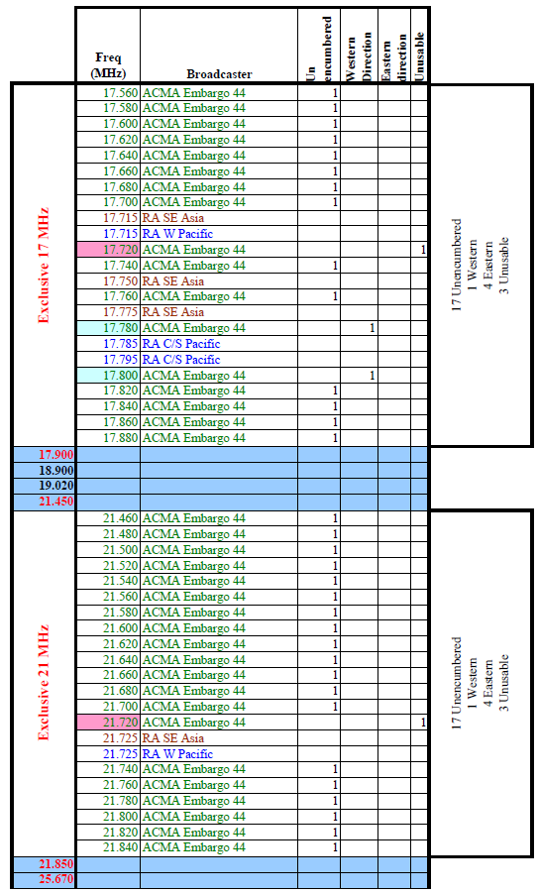

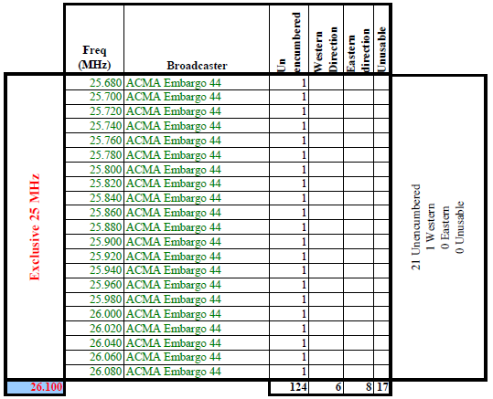

### Region 2 Frequency allocations for the Americas

ITU Region 2 = The Americas Spectrum Plan

Existing Spectrum

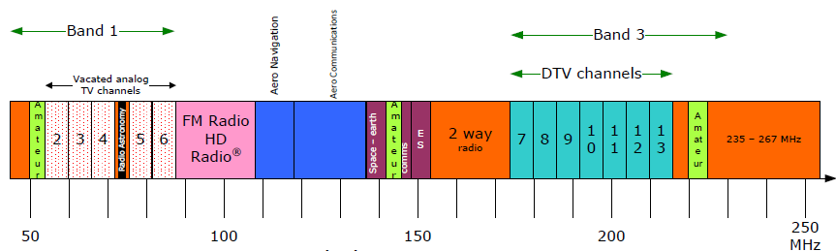

Proposed DAB+/DRM+ Pure Digital Radio

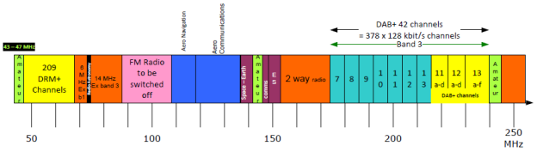

DRM30 & AM - Region 1: Europe & Africa

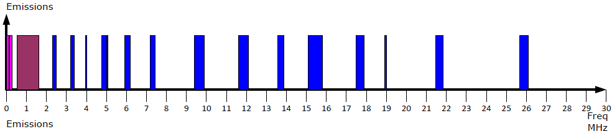

DRM30& AM - Region 2: Americas

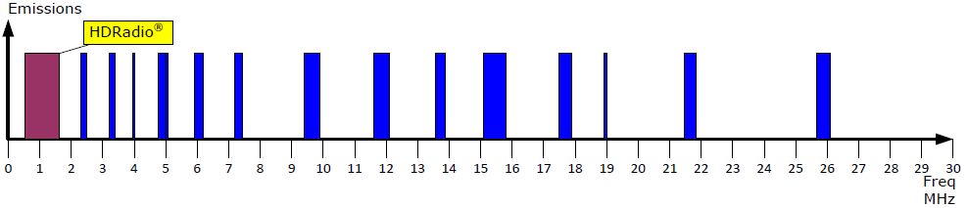

DRM30 & AM - Region 3: Australia, Asia & Pacific

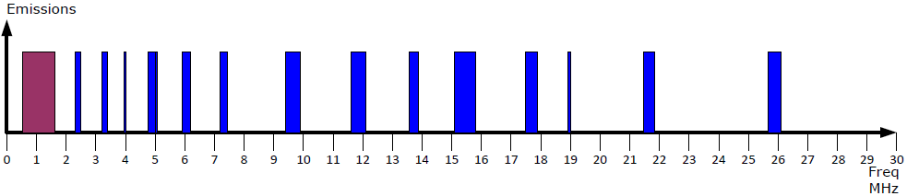

### Appendix for the "A proposal for Australian Digital Radio"

Current Analog Transmitter Statistics 78

Regional & Local Area Coverage 79

Selection of DRM sites for National Broadcasters 80

Remote Local Radio 84

Remote Local Radio - Pilbara 85

Monitoring of Reception Quality 86

Further Information 86

DRM Trial Distances 88

Wave Propagation 89

Transmission Schedule 90

On Air DRM Transmissions 91

#### Current Analog Transmitter Statistics

National Networks with no local content

| Network | # AM | # FM | Power AM kW | Power FM kW ERP | Height AM km | Height FM km |
| --- | --- | --- | --- | --- | --- | --- |
| **RN** | 24 | 296 | 290 | 2879 | 2.9 | 11.5 |
| **PNN** | 7 | 7 | 46 | 330 | 0.5 | 0.4 |
| **JJJ** | 0 | 192 | 0 | 4855 | 0.0 | 8.6 |
| **ABC CL** | 0 | 97 | 0 | 4863 | 0.0 | 6.3 |
| **SBS FM** | 0 | 9 | 0 | 648 | 0.0 | 1.0 |
| **SBS EA** | 5 | 0 | 19 | 0 | 6.2 | 0.0 |
| **Total** | 36 | 601 | 355 | 13575 | — | — |

Most of the above FM transmitters share antenna towers with each other and also TV, however some community funded antenna towers will be shared between ABC Local Radio and RN.

| Network | # AM | # FM | Total Analog | # HF DRM Kulgera NT | # HF DRM Newman WA | # HF DRM Liena Tas |
| --- | --- | --- | --- | --- | --- | --- |
| **RN** | 24 | 296 | 120 | 3 | 2 | 2 |
| **PNN** | 7 | 7 | 14 | 2 | 0 | 2 |
| **JJJ** | 0 | 192 | 192 | 3 | 2 | 2 |
| **ABC CL** | 0 | 97 | 97 | 3 | 2 | 2 |
| **SBS FM** | 0 | 9 | 9 | 3 | 2 | 2 |
| **SBS EA** | 5 | 0 | 5 | 3 | 2 | 2 |
| **Total** | 36 | 601 | 427 | 17 | 10 | 12 |

* All transmitters in Kulgera are to be >100 kW each with PNN >250 kW= 1350 kW with a dusk peak of 2000 kW
* All transmitters in Newman to be about 100 kW each making the power 1 000 kW with a dusk peak of 2000 kW
* All transmitters in Liena to be about 10 kW each making of 120 kW with a peak of 240 kW
* **All power and antenna designs to be subject to engineering assessment.**

#### Regional & Local Area Coverage

| Network | # AM (MF) | # FM | Power AM kW | Power FM kW ERP | Height AM km | Height FM km |
| --- | --- | --- | --- | --- | --- | --- |
| **Local Radio** | 81 | 160 | 846 | 2883 | 8.5 | 6.8 |
| **Commercial** | 130 | 538 | 421 | 5580 | 10.2 | 21.1 |
| **Community** | 14 | 451 | 50 | 1761 | 1.2 | 14.8 |
| **Total** | 225 | 1600 | 1317 | 10224 | — | — |

Some AM Local Radio towers are shared with Radio National.

| Network | # AM (MF) | # FM | Total Analog | # HF DRM | # 26 MHz DRM | DAB |
| --- | --- | --- | --- | --- | --- | --- |
| **Local Radio** | 81 | 160 | 241 | 6 | 12 |  |
| **Commercial** | 130 | 538 | 668 | 6 | 12 |  |
| **Community** | 14 | 451 | 465 | 4 | 2 |  |
| **Total** | 225 | 1600 | 1374 | 16 | 26 | 46 |

**The DAB numbers are an estimate based on the number of Local Radio transmitters as sites with the HF DRM stations removed. Additional city channels will be required.**

#### Selection of DRM sites for National Broadcasters

**Objective**

It is to give all areas of Australia the same signal strength signal and where appropriate in their time zone.

**Kulgera NT[28]** (SW of Alice Springs)

**Function**

* Parliamentary NewsRadio for the whole mainland
* All Government funded broadcasting except for "Local" Radio. Eastern Time Zone except Tasmania
* All Government funded broadcasting except for "Local" Radio. Western Time Zone
* Radiate Radio Australia for 18 h 24 min / day from each program stream. One program stream's allowance will have to be sacrificed for maintenance time. Possible target audience East Asia and Western Pacific

**Antenna Requirements**

* The antenna farms are in the geographic centre of the Australian mainland. This is to give an even signal strength over the whole continent.
* Two antenna farms will be required, to make it safe to perform maintenance, whilst maintaining transmission at full power.
* The antennas must have considerable gain to increase the Effective Radiating Power.
* Each antenna should;
* be an omnidirectional antenna, which is segmented, so that power distribution can be controlled to produce an elliptical footprint.
* allow other signals to be added for other programs destined for different time zones. Eg, Western and Eastern. The beamwidth is on the PowerPoint maps.
* be tuneable to all the frequencies in ACMA's Embargo 44
* be vertical angle steerable, using information provided by Ionospheric Prediction Service.

**Transmitters**

* The transmitter output stages should be broadband, linear and modular. There would be one module for each segment of the antenna. The linear requirement is so that multiple signals can be sent to that antenna segment. Control of the input levels can be used to produce the elliptical coverage area.
* The transmitter building should be underground to reduce;
* the air conditioning load
* human exposure to strong Electromagnetic fields

**Continuity of Transmission**

Kulgera;

* is not in a cyclone or earthquake zone.
* is the furthest from the coast that you can get, thus provides maximum detection time prior to military attack.
* should be fed (in compressed form) by two program circuits;
* A connection to the fibre-optic network from the south to Alice Springs.
* Satellite

**Access for construction and maintenance**

The site is close to the Adelaide - Alice Springs railway, which will greatly assist in construction and maintenance.

**Power Supply**

* Solar energy is in abundance (175 clear days and 64 cloudy days on average per year) and the peak electricity load is at dawn & dusk. This peak does not occur if Radio Australia transmits during the rest of the day. There is an average 9 hours per day of sunshine.
* The average wind speed is 18.5 km/h @ 08:24 and 15.4 km/h @ 14:24 solar time**[29]**. Its monthly average is even through the year. Unfortunately, these values do not represent the dawn, dusk & night figures at the site.
* There is also natural gas in the region. The Commonwealth Government is looking for green power projects at the moment. This would drastically reduce the operating costs.

**Commonwealth Greenhouse Office[30]**

**WA Office of Sustainable Development[31]**

**Liena Tasmania[32]** (Central Tasmania)

**Function**

* Parliamentary NewsRadio for the whole of Tasmania
* All Government funded broadcasting.
* Radiate Radio Australia for 23h 30 min / day from each program stream, if similar frequencies are used to the other sites. One program stream's allowance will have to be sacrificed for maintenance time. Possible target audience is Australians in New Zealand as well as New Zealanders.
* If required additional antennas and transmitters can be added, if noise levels in major southern cities is too high.

**Antenna Requirements**

* The antenna farms are in the geographic centre of Tasmania. This is to give an even signal strength over the island.
* Two antenna farms will be required, to make it safe to perform maintenance, whilst maintaining transmission at full power.
* Each antenna should;
* be an omnidirectional antenna aimed vertically at the ionosphere. This is to give a shower pattern as is currently done in the domestic HF service in the NT.
* be tuned to 25.67 - 26.10 MHz if an adequate coverage can be obtained. Then half the number of transmitters will be required and there will be no spare capacity for New Zealand. An extra transmitter will be required as a spare.
* be tuned to similar frequencies of the other sites, if the 26 MHz option was not feasible. An additional directional antenna will be required for Radio Australia.

**Transmitters**

* This depends on antenna design, however the minimum value will be considerably less than for Kulgera NT.

**Continuity of Transmission**

Liena;

* is not in an cyclone or earthquake zone.
* is the furthest from the coast that you can get, thus provides maximum detection time prior to military attack.
* should be fed (in compressed form) by two program circuits;
* A connection to the fibre-optic network for Tasmania
* Satellite

**Access for construction and maintenance**

The site is already accessible by road.

**Power Supply**

I expect it would be powered by the power grid, which is powered by hydro.

**Newman WA[33]** (Pilbara)

**Function**

* No Parliamentary NewsRadio transmitters on this site
* All Government funded broadcasting for SA & NT including Remote "Local" radio.
* Remote "Local" radio should be strongest in the northern and western areas of SA. This is to reduce the possibility of coverage in more populous parts of SA. This is particularly required for commercial stations.
* Radiate Radio Australia for 21 h 14 min / day from each program stream. One program stream's allowance will have to be sacrificed for maintenance time. Possible target audience Central Asia, including Indonesia, West Asia (Middle East).

**Antenna Requirements**

* Since these signals are bounced off the Ionosphere, there is a zone of no coverage at around 150 km from the transmitters. If the NT services were to be radiated from Kulgera, coverage in Alice Springs would be poor.
* The other objective is that any overspill of signals will not be directed at our northern neighbours but into the largely vacant Pacific Ocean.
* Two antenna farms will be required, to make it safe to perform maintenance, whilst maintaining transmission at full power.
* The antennas must have considerable gain to increase the Effective Radiating Power.
* Each farm should;
* contain a pair of antennas;
* 65 ° width aimed at the NT
* 36 ° width aimed at SA.
* be tuneable to all the frequencies in ACMA's Embargo 44
* be vertical angle steerable, using information provided by Ionospheric Prediction Service.

**Transmitters**

* This depends on antenna design, however the minimum value will be over 100 kW each.

**Continuity of Transmission**

Newman;

* is not in an cyclone or earthquake zone.
* should be fed (in compressed form) by two program circuits;
* A connection to the fiber-optic network to Newman
* Satellite

**Access for construction and maintenance**

* The site is close to the Newman - Port Hedland railway, which will greatly assist in construction and maintenance.

**Power Supply**

* Solar energy is in abundance (181 clear days and 59 cloudy days on average per year) and the peak electricity load is at dawn & dusk. There is an average of 9-10 hours of sunshine/day
* The average wind speed is 14 km/h @ 09:00 and 13.2 km/h @ 15:00 solar time**[34]**. Its monthly average is even through the year. Unfortunately, these values do not represent the dawn, dusk & night figures at the site.
* There is also natural gas in the region. The Commonwealth Government is looking for green power projects at the moment. This would drastically reduce the operating costs.

**Commonwealth Greenhouse Office[35]**

**WA Office of Sustainable Development[36]**

**Radio Australia**'s current HF transmission system.

* Brandon Qld site is in a cyclone prone area.
* Shepparton is 1370 km south of Kulgera making the Asian audience more distant.

#### Remote Local Radio

**Function**

* To provide continuous coverage for ABC Local Radio and a pair of local commercial stations in a Licence Area Planned area up to the edge of the next LAP area.

**Transmitters**

* are to be located in the centre of the coverage area.
* The only difference between these stations and regional stations is the use of HF DRM to extend the coverage area at an economical price.

**Continuity of Transmission**

* The program is to be fed from the local studio to a transmitter by terrestrial means
* WA Locations**[37]**

#### Remote Local Radio - Pilbara

**Function**

* To provide continuous coverage for ABC Local Radio and a pair of local commercial stations to cover all areas excluding, the Kimberley, Goldfields/Esperance and the South West of WA.

**Antennas and Transmitters**

* These transmitters and antennas will be similar to those at Newman.
* The transmitter site should be near Norseman to centre the beam through WA and to ensure the Northern Goldfields gets an adequate coverage.

**Continuity of Transmission**

Norseman**[38]**;

* is not in an cyclone or earthquake zone.
* should be fed (in compressed form) by two program circuits from Karratha;
* A connection to the fibre-optic network to Esperance
* Satellite

**Power Supply**

Solar energy is in abundance (138 clear days and 90 cloudy days on average per year) and the peak electricity load is at dawn & dusk. The average wind speed is 12.1 km/h @ 09:00 and 13.6 km/h @ 15:00 solar time**[39]**. Its monthly average is even through the year. Unfortunately, these values do not represent the dawn, dusk & night figures at the site.

#### Monitoring of Reception Quality

**Function**

* To ensure the most reliable reception at the lowest cost it is essential to have remote unattended receiving stations.
* The reception quality information could be shared between the broadcaster and the Ionospheric Prediction Service to build an accurate model of the Australian Conditions.
* The vertical angle of radiation can be adjusted and monitored using the receivers, live.

**Receivers**

* There are currently available in Australia software decoding receivers using a computer and a receiver board. This software can measure the signal strength and Bit Error Rate (Quality of decoding).
* The receivers can be connected to the internet or the mobile phone network. This would mean that the reception quality could be obtained at any time along with remote control of the receiver.
* Connected to the receiver would be an antenna and it could be solar powered if required.

**Location of Receivers**

* They must be in an electrically quiet location
* At radii or 256, 512, 1024 and 2048 km. For Kulgera, they should be north and south and east of the transmitter site. This is because the ionosphere in tropical zones behaves differently to that in sub tropical zones.

#### Further Information

**All distances and angles were calculated** using **GDA Vincenty Calculation Results (Inverse)[40].** These calculations operate in 3 dimensions, because the earth is a sphere.

**All sunrise & sunset times were calculated using Geoscience Australia[41]**

These calculations were used to calculate sun rise/set on the longest and shortest days of the year. These values vary with latitude and the offset is caused by a change in longitude.

**DRM Website[42]** Please download the demonstrations and listen to them. The trial distances are on the next page.

**DRM Broadcasters' User Manual[43]**

**DRM Technical Standard TS 201 908[44]**

**Radio New Zealand International - Technical[45]**

**EBU Review Technical Oct 2003 DRM Field Tests[46]**

**DRM Radio Broadcast Transmitter Manufacturers[47]**

**TCI » Antenna Systems » HF DRM (Digital Radio Mondiale) Antenna Products[48]**

**WIN Radio Melbourne[49]**

**BBC NEWS | Technology | Fears for new digital radio system[50]**

**BBC NEWS I Technology I Hybrid radios set for take-off[51]**

**Receiver module[52]**

**Philips Integrated Circuit Receiver for Car Radios[53]**

**DRM in Taiwan[54]**

**Isle of Man International Broadcasting (Commercial)[55]**

**DAB organisation website[56]**

**DAB Technical Standard 301 400[57]**

#### DRM Trial Distances

The blue background are the distances for the **DRM demonstrations**

Please download the files prior to viewing.

| Transmitter Location | Frequency kHz | Power kW | Receiver Location | Distance km |
| --- | --- | --- | --- | --- |
| Wertachtal Germany | 6180 | 200 | Brussel Belgium | 550 |
| Issoudun France | 6175 | 30 (Beam width 50°?) | Bonn Germany | 575 |
| Flevo Netherlands | — | 40 omnidirectional | Köln | 351 |
| Flevo Netherlands | — | 40 omnidirectional | Bonn | 201 |
| Orfordness UK | — | — | Erlangern Germany | 726 |
| Sines Portugal | — | — | Kotka Finland | 3538 |
| Sines Portugal | — | — | Limassol Cyprus | 3750 |
| Rampisham UK | — | — | Bockhagen Germany | 774 |
| Issoudun France | — | — | Köln Germany | 732 |
| Radio Sweden ex Sackville Canada current. | — | — | Stockholm | 5451 |

#### Wave Propagation

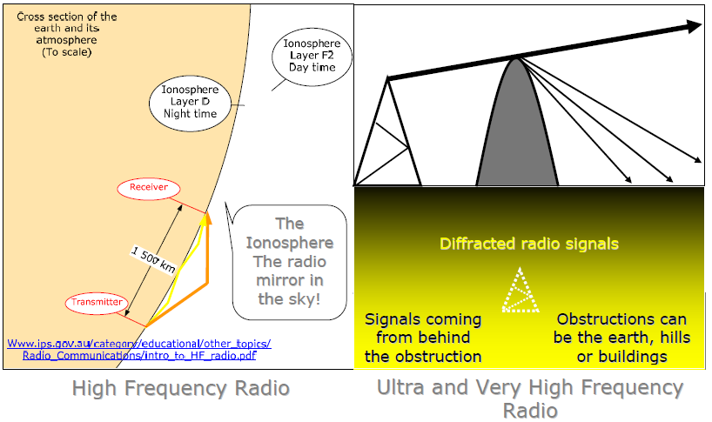

#### Transmission Schedule

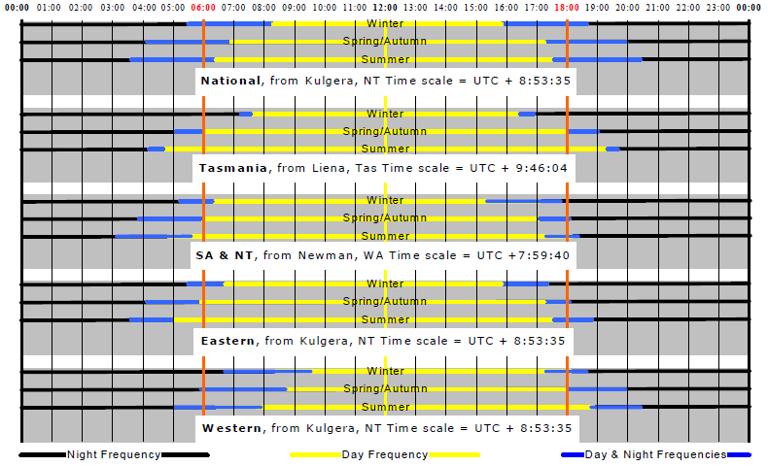

Times are solar time at the site

The blue section needs 2 transmitters per program, the rest of the day only one.

#### On Air DRM Transmissions

| Tx Country | Transmitter Site Name | Programme | Freq­uency kHz | Power kW | Beam ° | Target | Language | Latitude ° | Latitude ‘ | Latitude “ | Longitude ° | Longitude ‘ | Longitude “ | Time UTC | Days | |
| --- | --- | --- | --- | --- | --- | --- | --- | --- | --- | --- | --- | --- | --- | --- | --- | --- |
| Austria | Moosbrunn | CVC | 11815 | 50 | 295 | Great Britain | English | 48 | 0 | 0 | 16 | 28 | 0 | 1000-1100 | daily | |
| Bulgaria | Sofia | WRN | 5820 | 50 | 306 | Europe | English | 42 | 9 | 32 | 23 | 20 | 2 | 1800-2200 | Sat/Sun | |
| Bulgaria | Sofia | WRN | 11540 | 50 | 306 | Europe | English | 42 | 9 | 32 | 23 | 20 | 2 | 1400-1800 | Sat/Sun | |
| Bulgaria | Sofia | WRN | 13865 | 50 | 306 | Europe | English | 42 | 9 | 32 | 23 | 20 | 2 | 0900-1400 | Sat/Sun | |
| Canada | Sackville | Vatican Radio | 9800 | 70 | 268 | NE USA | English | 45 | 53 | 0 | -64 | 19 | 0 | 1945-2030 | daily | |
| Canada | Sackville | RNW | 9800 | 70 | 268 | NE USA | English | 45 | 53 | 0 | -64 | 19 | 0 | 2030-2057 | daily | |
| Canada | Sackville | RCI | 9800 | 70 | 268 | NE USA | English | 45 | 53 | 0 | -64 | 19 | 0 | 2100-2200 | daily | |
| Canada | Sackville | DW | 9800 | 70 | 268 | NE USA | English | 45 | 53 | 0 | -64 | 19 | 0 | 2200-2230 | daily | |
| Canada | Sackville | Radio Sweden | 9800 | 70 | 268 | NE USA | English | 45 | 53 | 0 | -64 | 19 | 0 | 2230-2300 | daily | |
| Canada | Sackville | TDPradio | 11900 | 70 | 240 | NE USA | Dance Music | 45 | 53 | 0 | -64 | 19 | 0 | 1600-1800 | Sat | |
| Chile | Santiago | CVC | 17660 | 15 | 45 | Brazil | Portuguese | -33 | 6 | 8 | -70 | 47 | 15 | 1800-2000 | Mon-Fri | |
| China | Chang Sha | Economic Ch. | 1008 | 4 | ND | Prov. Hunan | Chinese | 28 | 12 | 0 | 112 | 58 | 0 | 0000-2400 | daily | |
| Croatia | Deanovec | Glas Hrvatske | 594 | 10 | ND | Europe | various | 45 | 41 | 0 | 16 | 27 | 0 | 0700-1500 | daily | |
| France | Fontbonne | RMC test | 6175 | 10 | 330 | Europe | French | 43 | 44 | 0 | 7 | 26 | 0 | 0600-1000 | daily | |
| France | Issoudun | TDF | 3965 | 1 | 65 | France | French | 46 | 52 | 0 | 2 | 0 | 0 | 1900-2057 | daily | |
| France | Issoudun | TDF | 3965 | 1 | 65 | France | French | 46 | 52 | 0 | 2 | 0 | 0 | 2300-1757 | daily | |
| France | Meudon | TDF | 25765 | 0.4 | 61 | Paris | French | 48 | 48 | 0 | 2 | 12 | 0 | 0000-2400 | daily | |
| France | Rennes | TDF Radio | 25775 | 0.1 | ND | Rennes | French | 48 | 7 | 0 | -1 | 41 | 0 | 0000-2400 | daily | |
| Germany | Berlin-Britz | DLF | 855 | 10 | ND | Berlin | German | 52 | 28 | 0 | 13 | 35 | 0 | 0000-2400 | daily | |
| Germany | Dillberg | Campus Radio | 26000 | 0.1 | ND | Neumarkt | German | 49 | 19 | 26 | 11 | 22 | 53 | 0000-2400 | daily | |
| Germany | Erlangen | biteXpress | 15896 | 0.1 | ND | Erlangen | German | 49 | 35 | 0 | 11 | 0 | 0 | 0000-2400 | daily | |
| Germany | Hannover | various | 26045 | 0.04 | ND | Hannover | German | 52 | 23 | 0 | 9 | 42 | 0 | 0000-2400 | daily | |
| Germany | Ismaning | BR-B5akt | 6085 | 50 | ND | Europe | German | 48 | 14 | 0 | 11 | 41 | 0 | 0500-2305 | daily | |
| Germany | Juelich | TDPradio | 6015 | 40 | ND | Europe | Dance Music | 50 | 56 | 53 | 6 | 21 | 46 | 1400-1600 | Sat | |
| Germany | Langenberg | WDR Klassik | 1593 | 10 | ND | W Germany | German | ? | — | — | ? | — | — | 0000-2400 | daily | |
| Germany | Mainz-Wolfsheim | SWR Das Ding | 1485 | 0.42 | ND | SW Germany | German | 49 | 27 | 35 | 7 | 46 | 17 | 0000-2400 | daily | |
| Germany | Marnach | RTL Radio | 1440 | **240** | 45 | Europe | German | 48 | 47 | 26 | 2 | 14 | 48 | 0700-1600 | daily | |
| Germany | Marnach | RTL Radio | 1440 | **120** | 320 | Europe | German | 48 | 47 | 26 | 2 | 14 | 48 | 0300-0330 | Sun | |
| Germany | Marnach | RTL Radio | 1440 | **120** | 320 | Europe | German | 48 | 47 | 26 | 2 | 14 | 48 | 2300-0300 | daily | |
| Germany | Nuernberg | Campus Radio | 26012 | 0.1 | ND | Nuernberg | German | 49 | 27 | 4 | 11 | 5 | 28 | 0000-2400 | daily | |
| Germany | Oranienburg | VoR (Simulcast) | 693 | **250** | ND | Berlin | various | 52 | 48 | 0 | 13 | 24 | 0 | 0400-2200 | daily | |
| Germany | Oranienburg | DLR Kultur | 177 | **150** | ND | Germany | German | 52 | 48 | 0 | 13 | 24 | 0 | 0000-0300 | daily | |
| Germany | Putbus | DLF | 729 | 1 | ND | NE Germany | German | 54 | 21 | 0 | 13 | 28 | 0 | 0000-2400 | daily | |
| Germany | SFN Berlin | Oldiestar Radio | 1485 | 1 | ND | Berlin | German | 52 | 25 | 5 | 13 | 7 | 38 | 0000-2400 | daily | |
| Germany | Wertachtal | DW | 3995 | **200** | ND | Europe | German | 48 | 4 | 57 | 10 | 41 | 43 | 1600-0659 | daily | |
| Germany | Wertachtal | DW | 6130 | **200** | ND | Europe | various | 48 | 4 | 57 | 10 | 41 | 43 | 0600-0800 | daily | |
| Germany | Wertachtal | DW | 6130 | **200** | ND | Europe | various | 48 | 4 | 57 | 10 | 41 | 43 | 1200-1559 | daily | |
| Germany | Wertachtal | DW | 6140 | **200** | ND | Europe | various | 48 | 4 | 57 | 10 | 41 | 43 | 1700-1759 | daily | |
| Germany | Wertachtal | DW | 7265 | **200** | ND | Europe | various | 48 | 4 | 57 | 10 | 41 | 43 | 0600-1200 | daily | |
| Holland | Flevo | Radio Sweden | 5955 | 40 | ND | Europe | English | 52 | 21 | 44 | 5 | 27 | 19 | 1700-1730 | daily | |
| Holland |  | Radio Sweden | 5955 | 40 | ND | Europe | German | 52 | 21 | 44 | 5 | 27 | 19 | 1730-1800 | daily | |
| Holland | Flevo | RNW | 6105 | 40 | 230 | SW Europe | Dutch | 52 | 21 | 44 | 5 | 27 | 19 | 0500-0557 | daily | |
| Holland | Flevo | RNW | 7240 | 40 | 123 | Europe | English | 52 | 21 | 44 | 5 | 27 | 19 | 1000-1100 | daily | |
| Holland | Flevo | RNW | 7240 | 40 | 123 | Europe | Dutch | 52 | 21 | 44 | 5 | 27 | 19 | 1100-1200 | daily | |
| Holland | Flevo | RNW | 7240 | 40 | 123 | Europe | English | 52 | 21 | 44 | 5 | 27 | 19 | 1200-1330 | daily | |
| Holland | Flevo | RCI | 7240 | 40 | 123 | Europe | English | 52 | 21 | 44 | 5 | 27 | 19 | 1330-1400 | daily | |
| Holland | Flevo | R. Vatican | 7240 | 40 | 123 | Europe | German | 52 | 21 | 44 | 5 | 27 | 19 | 1400-1415 | daily | |
| Holland | Flevo | RNW | 7240 | 40 | 123 | Europe | Dutch | 52 | 21 | 44 | 5 | 27 | 19 | 1415-1457 | daily | |
| Holland | Flevo | RNW | 7300 | 40 | 191 | SW Europe | Dutch | 52 | 21 | 44 | 5 | 27 | 19 | 0600-0657 | daily | |
| Holland | Flevo | RNW | 9480 | 40 | 123 | SE Europe | Dutch | 52 | 21 | 44 | 5 | 27 | 19 | 2000-2057 | 07/01-08/31 | |
| Holland | Flevo | RNW | 9690 | 40 | 123 | SE Europe | Dutch | 52 | 21 | 44 | 5 | 27 | 19 | 1900-1957 | daily | |
| Holland | Flevo | RNW | 11640 | 40 | 191 | S Europe | Dutch | 52 | 21 | 44 | 5 | 27 | 19 | 1600-1657 | daily | |
| Holland | Flevo | RNW | 11890 | 40 | 191 | S Europe | Dutch | 52 | 21 | 44 | 5 | 27 | 19 | 1500-1557 | daily | |
| Holland | Flevo | RNW | 11895 | 40 | 191 | S Europe | Dutch | 52 | 21 | 44 | 5 | 27 | 19 | 0700-0757 | daily | |
| Holland | Flevo | RNW | 11895 | 40 | 133 | SE Europe | Dutch | 52 | 21 | 44 | 5 | 27 | 19 | 0800-0957 | daily | |
| Italy | Milano | RAI tests | 693 | 30 | ND | Italy | Italian | 45 | 28 | 0 | 9 | 11 | 0 | 0000-2400 | daily | |
| Kuwait | Sulaibiyah | Radio Kuwait | 9880 | **120** | 282 | N Africa | Arabic | 29 | 8 | 25 | 47 | 45 | 40 | 1345-1730 | daily | |
| Kuwait | Sulaibiyah | Radio Kuwait | 11675 | **120** | 350 | NE USA | Arabic | 29 | 8 | 25 | 47 | 45 | 40 | 2200-0200 | daily | |
| Kuwait | Sulaibiyah | Radio Kuwait | 13620 | **120** | 310 | Europe | Arabic | 29 | 8 | 25 | 47 | 45 | 40 | 0930-1330 | daily | |
| Luxembourg | Junglinster | RTL France | 5990 | 50 | ND | Europe | French | 49 | 43 | 8 | 6 | 15 | 38 | 0000-2400 | daily | |
| Luxembourg | Junglinster | RTL Radio | 6095 | 50 | ND | Europe | German | 49 | 43 | 8 | 6 | 15 | 38 | 0000-2400 | daily | |
| Luxembourg | Junglinster | Radio Luxembourg | 25795 | 0.15 | ND | Junglinster | English | 49 | 43 | 8 | 6 | 15 | 38 | 0000-2400 | daily | |
| Luxembourg | Nauen | Radio Luxembourg | 7295 | 40 | 275 | Great Britain | English | 52 | 39 | 2 | 12 | 52 | 19 | 0900-1700 | daily | |
| Netherlands Antilles | Bonaire | RNW | 15195 | 10 | 320 | N America | English | 12 | 6 | 23 | -68 | 17 | 3 | 2200-2300 | daily | |
| **New Zealand** | **Rangitaiki** | **RNZI** | 6095 | **100** | 0 | **Pacific** | **English** | **-38** | **30** | **0** | **176** | **15** | **0** | 0659-1650 | **daily** | |
| New Zealand | Rangitaiki | RNZI | 7145 | **100** | 35 | Pacific | English | -38 | 30 | 0 | 176 | 15 | 0 | 1651-1850 | daily | |
| New Zealand | Rangitaiki | RNZI | 9440 | **100** | 0 | Pacific | English | -38 | 30 | 0 | 176 | 15 | 0 | 0459-0658 | daily | |
| New Zealand | Rangitaiki | RNZI | 9440 | **100** | 0 | Pacific | English | -38 | 30 | 0 | 176 | 15 | 0 | 1851-1950 | daily | |
| New Zealand | Rangitaiki | RNZI | 13730 | **100** | 0 | Pacific | English | -38 | 30 | 0 | 176 | 15 | 0 | 1951-2235 | daily | |
| New Zealand | Rangitaiki | RNZI | 6095 | **100** | 0 | Pacific | English | -38 | 30 | 0 | 176 | 15 | 0 | 0659-1650 | daily | |
| New Zealand | Rangitaiki | RNZI | 7145 | **100** | 35 | Pacific | English | -38 | 30 | 0 | 176 | 15 | 0 | 1651-1850 | daily | |
| New Zealand | Rangitaiki | RNZI | 9440 | **100** | 0 | Pacific | English | -38 | 30 | 0 | 176 | 15 | 0 | 0459-0658 | daily | |
| New Zealand | Rangitaiki | RNZI | 9440 | **100** | 0 | Pacific | English | -38 | 30 | 0 | 176 | 15 | 0 | 1851-1950 | daily | |
| New Zealand | Rangitaiki | RNZI | 13730 | **100** | 0 | Pacific | English | -38 | 30 | 0 | 176 | 15 | 0 | 1951-2235 | daily | |
| New Zealand | Rangitaiki | RNZI | 15720 | **100** | 0 | Pacific | English | -38 | 30 | 0 | 176 | 15 | 0 | 2236-0458 | daily | |
| Norway | Kvitsoy | BBCWS | 7465 | 50 | 190 | Europe | English | 59 | 4 | 0 | 5 | 27 | 0 | 1330-1800 | daily | |
| Norway | Kvitsoy | BBCWS | 7475 | 50 | 190 | Europe | English | 59 | 4 | 0 | 5 | 27 | 0 | 0600-0700 | daily | |
| Norway | Kvitsoy | BBCWS | 9470 | 50 | 190 | Europe | English | 59 | 4 | 0 | 5 | 27 | 0 | 0700-1328 | daily | |
| Portugal | Sines | DW | 3995 | 90 | 40 | Europe | various | 37 | 57 | 15 | -8 | 50 | 26 | 2200-0257 | daily | |
| Portugal | Sines | DW | 5980 | 90 | 40 | Europe | various | 37 | 57 | 15 | -8 | 50 | 26 | 2100-2158 | daily | |
| Portugal | Sines | DW | 11640 | 90 | 30 | Europe | English | 37 | 57 | 15 | -8 | 50 | 26 | 1800-1955 | daily | |
| Portugal | Sines | DW | 13790 | 90 | 40 | Europe | various | 37 | 57 | 15 | -8 | 50 | 26 | 1500-1755 | daily | |
| Portugal | Sines | DW | 13810 | 90 | 30 | Europe | various | 37 | 57 | 15 | -8 | 50 | 26 | 0805-1400 | daily | |
| Portugal | Sines | DW | 15440 | 90 | 35 | Europe | various | 37 | 57 | 15 | -8 | 50 | 26 | 0900-1457 | daily | |
| Portugal | Sines | DW | 15725 | 90 | 30 | Europe | various | 37 | 57 | 15 | -8 | 50 | 26 | 1400-1555 | daily | |
| Russia | Taldom | DW | 7515 | 40 | 261 | Europe | various | 56 | 44 | 49 | 37 | 37 | 32 | 1900-2100 | daily | |
| Russia | Taldom | Dw | 9690 | 40 | 261 | Europe | various | 56 | 44 | 49 | 37 | 37 | 32 | 0400-0600 | daily | |
| Russia | Taldom | VoR | 9450 | 35 | 240 | Europe | Russian | 56 | 44 | 49 | 37 | 37 | 32 | 1300-1400 | daily | |
| Russia | Taldom | VoR | 9450 | 35 | 240 | Europe | English | 56 | 44 | 49 | 37 | 37 | 32 | 1400-1500 | daily | |
| Russia | Taldom | VoR | 9450 | 35 | 240 | Europe | German | 56 | 44 | 49 | 37 | 37 | 32 | 1500-1600 | daily | |
| Russia | Taldom | VoR | 9450 | 35 | 240 | Europe | French | 56 | 44 | 49 | 37 | 37 | 32 | 1600-1700 | daily | |
| Russia | Taldom | VoR | 9810 | 35 | 265 | Europe | German | 56 | 44 | 49 | 37 | 37 | 32 | 1600-1700 | daily | |
| Russia | Taldom | VoR | 9810 | 35 | 265 | Europe | French | 56 | 44 | 49 | 37 | 37 | 32 | 1700-1800 | daily |
| Russia | Taldom | VoR | 12060 | 35 | 265 | Europe | English | 56 | 44 | 49 | 37 | 37 | 32 | 0800-0900 | daily |
| Russia | Taldom | VoR | 12060 | 35 | 265 | Europe | German | 56 | 44 | 49 | 37 | 37 | 32 | 0900-1000 | daily |
| Russia | Taldom | VoR | 15780 | 35 | 240 | Europe | English | 56 | 44 | 49 | 37 | 37 | 32 | 0800-0900 | daily |
| Russia | Taldom | VoR | 15780 | 35 | 240 | Europe | German | 56 | 44 | 49 | 37 | 37 | 32 | 0900-1200 | daily |
| Sri Lanka | Trincomalee | DW | 21820 | 90 | 300 | West Asia | English | 8 | 44 | 45 | 81 | 7 | 48 | 0900-1025 | daily |
| UK | Crystal Palace | various | 25695 | 0.1 | - | London | English | 51 | 25 | 18 | 0 | 5 | 51 | 0000-2400 | daily |
| UK | Hickstead | Tests | 1386 | lp | ND | West Sussex | English | 50 | 58 | 0 | -0 | 12 | 0 | 0000-2400 | daily |
| UK | London-Croydon | WRN Europe | 26000 | 1.7 | North | London | English | 51 | 21 | 42 | 0 | 4 | 35 | 0000-2400 | daily |
| UK | Orfordness | BBCWS | 1296 | 70 | 96 | Europe | English | 54 | 6 | 0 | 1 | 35 | 0 | 0400-2200 | daily |
| UK | Rampisham | RNZI | 9770 | 35 | 95 | Europe | English | 50 | 49 | 0 | -2 | 37 | 0 | 1400-1430 | Sat |
| UK | Rampisham | Radio Korea Int. | 9770 | 35 | 95 | Europe | English | 50 | 49 | 0 | -2 | 37 | 0 | 1430-1500 | Fri |
| UK | Rampisham | **Radio Australia** | 9770 | 35 | 95 | Europe | English | 50 | 49 | 0 | -2 | 37 | 0 | 1430-1500 | Sat |
| UK | Rampisham | Radio Taiwan Int. | 9770 | 35 | 95 | Europe | English | 50 | 49 | 0 | -2 | 37 | 0 | 1500-1600 | Fri |
| UK | Rampisham | NHK | 9770 | 35 | 95 | Europe | English | 50 | 49 | 0 | -2 | 37 | 0 | 1600-1700 | Fri |
| UK | Rampisham | Maeva Digital | 6065 | 33 | 80 | Europe | English/Dutch | 50 | 49 | 0 | -2 | 37 | 0 | 1200-1300 | Sat |
| UK | Rampisham | BBCWS | 7320 | 33 | 80 | Europe | English | 50 | 49 | 0 | -2 | 37 | 0 | 0600-1800 | daily |
| Vatican | Santa Maria | Vatican Radio | 1530 | 60 | ND | Europe | various | 41 | 54 | 0 | 12 | 27 | 0 | 2210-2400 | daily |
| Vatican | Santa Maria | Vatican Radio | 9750 | 60 | 300 | N America | English | 41 | 54 | 0 | 12 | 27 | 0 | 2300-2345 | daily |
| Vatican | Santa Maria | Vatican Radio | 13750 | 60 | 300 | N America | various | 41 | 54 | 0 | 12 | 27 | 0 | 1100-1200 | daily |
| Vatican | Santa Maria | Vatican Radio | 1611 | 25 | ND | Europe | various | 41 | 54 | 0 | 12 | 27 | 0 | 0600-0815 | Mon-Sat |
| Vatican | Santa Maria | Vatican Radio | 1611 | 25 | ND | Europe | various | 41 | 54 | 0 | 12 | 27 | 0 | 0815-1510 | daily |
| Vatican | Santa Maria | Vatican Radio | 1611 | 25 | ND | Europe | various | 41 | 54 | 0 | 12 | 27 | 0 | 2020-2210 | daily |
| — | — | — | MF Band | — | — | — | Not sighted on Google Earth | Not sighted on Google Earth | Not sighted on Google Earth | Not sighted on Google Earth | Not sighted on Google Earth | Not sighted on Google Earth | Not sighted on Google Earth | — | — |

1. <http://www.drm.org/uploads/files/drm_receiver_profiles.pdf>, <http://www.worlddab.org/public_documents/WorldDMB_Digital_Radio_Receiver_Profiles.pdf> (excluding DAB and MPEG-2 decoding)
2. Channel 3 covers 20 FM channels. Newcastle NSW, Townsville, Qld, **SW WA (Bunbury),** Wollongong NSW, Riverland SA, Narooma NSW,  
   Nyngan NSW, Kambalda WA  
   Channel 4 covers 34 FM channels Spencer Gulf North SA, Savage River Tas  
   Channel 5 covers 34 FM channels **SW WA (Bunbury)**
3. <http://www.infrastructure.gov.au/roads/motor/design/index.aspx>
4. <http://www.frontier-silicon.com/media/releases/10/1010_Verona2i.htm>
5. <http://www.hdradioalliance.com/assets/file/broadcaster_discounts_catalog.pdf>
6. http://www.telegraph.co.uk/technology/8073195/Help-make-FM-switchover-happen-Ed-Vaizey-tells-the-BBC.html <http://www.officialdocuments.gov.uk/document/cm76/7650/7650.pdf> pages 91-103 (.pdf page 97-109)
7. Regional taken as a CMF of >300 V for AM and 10 kWERP for FM
8. European TV channels 2 – 4 which are not used for DTV.
9. In Region 2 & 3 will require 50 – 54 Amateur band moved to 43 – 47 MHz
10. Region 1 Europe/Africa, Region 2 Americas, Region 3 Asia/Pacific
11. <http://www.ru.nxp.com/news/content/file_1799.html>
12. <http://www.drm.org/uploads/files/ABU-DBS2011-MR1-9Nov2010.pdf>
13. <http://www.nearmap.com/?ll=-35.21669,149.124298&z=17&t=h&nmd=20100707>
14. <http://www.nearmap.com/?ll=-35.277791,149.097245&z=18&t=s&nmd=20100707>
15. <http://www.abc.net.au/catalyst/stories/2708730.htm>
16. <http://www.silanna.com/index.php?page=ska-receiver-development>
17. <http://www.winradio.com.au/home/drm.htm>
18. <http://www.barrettcommunications.com.au>, <http://www.broadbandpropagation.com>, <http://www.codan.com.au>
19. <http://www.hillsantenna.com.au/.http://www.matchmaster.com.au/,http://www.gme.net.au/>
20. <http://www.ibiquity.com/index.php>
21. <http://www.ibiquity.com/broadcasters/licensing>
22. <http://topazdesigns.com/iboc/station-list.html>
23. <http://www.arqiva.com>
24. <http://files.shareholder.com/downloads/SIRI/1072007520x0x366184/EF741909-023A-4EB8-9F1C-3E8CDA7E2F8A/SIRIUS_XM_Annual_Report_Proxy_2009.pdf>
25. Ruxandra Obreja, DRM Project Office, C/O BBC World Service, Bush House, Aldwych, Strand, London, WC2B 4PH UK +44 207 557 3271 <mailto:projectoffice@drm.org>
26. Yu Sun, Project Manager, Asia Pacific, +44 (0) 20 3206 7849 <mailto:yu.sun@worlddab.org>
27. <http://www.aiam.org/public/aiam/contact_us.aspx>
28. 24° 51' 30" S 133° 23' 30" E, 149 km away from Alice Springs NT@ 71° 12.5 km due west of Alice Springs railway, 96 km north of the Kulgera airstrip
29. Solar time is where the sun rises on average at 06:00, the sun is at its highest in the sky at midday and sets at 18:00.
30. <http://www.greenhouse.gov.au/renewable/government.html>
31. <http://www1.sedo.energy.wa.gov.au/pages/renewable_energy.asp>
32. 42° 8' 28"S 146°31'03" 14 km away Liena Tas @33 °, 3 km from Bronte Park
33. 23° 04' 06"S 119° 54' 57"E Newman is 37 km away at a bearing of 203 °
34. Solar time is where the sun rises on average at 06:00, the sun is at its highest in the sky at midday and sets at 18:00.
35. <http://www.greenhouse.gov.au/renewable/government.html>
36. <http://www1.sedo.energy.wa.gov.au/pages/renewable_energy.asp>
37. Goldfields 30 ° 44' 23 " S 125 ° 15' 0 " E, Kimberley 18° 11 ' 53" S 125 ° 34 ' 01" E near Fitzroy Crossing
38. Transmitter site 32 ° 30' 53" S 122 ° 01' 44" E 150 km north of Esperance
39. Solar time is where the sun rises on average at 06:00, the sun is at its highest in the sky at midday and sets at 18:00.
40. <http://www.ga.gov.au/bin/gda_vincenty.cgi?inverse=1&lat_degrees1=-27&lat_minutes1=27&lat_seconds1=58&NamePoint1=FlindersPeak&lon_degrees1=152&lon_minutes1=56&lon_seconds1=47&lat_degrees2=->
41. <http://www.ga.gov.au/bin/astro/sunrisenset>
42. <http://www.drm.org/videos/receptiondemo.php>
43. <http://www.drm.org/broadcastmanual/broadcastermanual.php>
44. <http://www.etsi.org/services_products/freestandard/home.htm>
45. <http://www.rnzi.com/pages/technical.php>
46. <http://www.ebu.ch/en/technical/trev/trev_frameset-index.html>
47. <http://www.transmitter.be/drm.html>
48. <http://www.tcibr.com/entry.asp?PageID=124>
49. <http://www.winradio.com/home/g303i.htm>
50. <http://news.bbc.co.Uk/2/hi/technology/3652202.stm>
51. <http://news.bbc.co.uk/1/hi/technology/4237010.stm>
52. <http://www.radioscape.com/downloads/RSRed_RD500_Doc_02.pdf#search=%o22digital%20Radio%20mondiale%22>
53. <http://www.radioscape.com/downloads/RSRed_RD500_Doc_02.pdf#search=%22digital%_20Radio%20mondiale%22>
54. <http://www.harris.com/view_pressrelease.asp?act=lookup&pMd=1658>
55. <http://www.iomib.com/index.html>
56. <http://www.worlddab.org/>
57. <http://www.etsi.org/services_products/freestandard/home.htm>