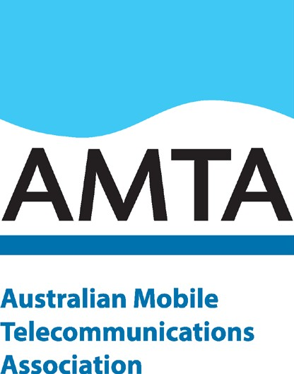20 October 2020

AMTA submission

Designation of spectrum in the 3.4 GHz band

Department of Communications

# Introduction

The Australian Mobile Telecommunications Association (AMTA) welcomes the opportunity to comment on the proposal for the Minister to designate parts of the spectrum in the 3.4 GHz band for the conversion of NBN Co’s PTS apparatus licences to spectrum licences in the specified frequency ranges and areas. This will facilitate the defragmentation activities already underway in the 3.4 GHz band, as well as facilitate opportunity for the release and allocation of additional spectrum in the band following further consultation processes. We also welcome future engagement on these matters at a later stage.

AMTA considers that finalising the licensing arrangements to facilitate the optimisation of the 3.4 GHz band will ensure the efficient use of that spectrum and as well as maximising the public benefit of its use. This will help to deliver key mobile services to Australian consumers.

**Supporting harmonisation across the 3.4 GHz, 3.6 GHz and future 3700-4200 MHz bands** AMTA supports the proposed approach, set out in the consultation paper, to designate the specified geographic areas and frequency ranges, for spectrum licensing.

We believe that the designation would promote efficient and optimised use of the 3.4 GHz spectrum, support the re-stack process, and enable more efficient trading of spectrum licences to occur.

In turn, this will support a timely and efficient roll-out of 5G technology by making appropriate mid- band spectrum available, in contiguous blocks.

AMTA notes that the 3.4 GHz band is suitable for 5G. As the consultation paper notes, the broader 3.3-

3.8 GHz band has been globally identified as a pioneer band for 5G and its use is expected to increase. Addressing the fragmented licensing arrangements in the 3.4 GHz would therefore support deployment of 5G services in Australia by making available wider contiguous bandwidths which are required for 5G.

AMTA estimates that each mobile operator will need a minimum of 100 MHz of contiguous mid-band spectrum for optimal initial 5G deployments (with demand for mid-band spectrum expected to grow rapidly in the medium term).

We submit that this designation will support the Government’s policy to make spectrum available for 5G and will therefore enable industry to deliver the greatest economic and social benefit to Australia as well as meet the continuing demand for 5G services.

We have also submitted to the ACMA that the adjacent 3700-3800 MHz band should be allocated to spectrum licensing for mobile use and that the 3800-4000 MHz band should also be considered for potential allocation under exclusive access in six metro centres plus Hobart to further improve the 5G experience in areas of high demand.

The consultation paper also foreshadows future activities in the 3.4 GHz band relating to urban excise areas and the allocation of additional spectrum that may become vacant following completion of the restack activities. We welcome further investigation of these issues and the opportunity to engage on these matters at a later stage.

We encourage ongoing discussions between government and industry stakeholders to support 5G harmonisation across the 3.4 GHz, 3.6 GHz and any future 3700-4200 MHz bands to ensure the efficient use of spectrum across the entirety of the mid-band frequency ranges, as well as maximising the public benefit of its use. This will help to deliver key mobile services to Australian consumers.

# Next steps: pricing considerations

AMTA notes that the Government is separately considering whether to direct ACMA in relation to the fixing of a charge for spectrum licences to be offered to NBN Co and the terms of any such direction. AMTA submits that charges for spectrum licences should be always based on market pricing principles.

# Background: Demand for 5G continues to grow

In 2020, the demand for mobile technologies continues to be strong and ever increasing, despite the disruption of the global pandemic.

In fact, Ericsson reports that mobile traffic increased during lockdowns due to COVID-19, with mobile traffic patterns reflecting the shift away from working in urban centres to working from home in suburban areas.1 Consumer behaviour has also shifted remarkably during the pandemic with the sudden and widespread take up of video calls with up to 85% of consumers now using video calling to stay in touch with family and colleagues.2

With some markets experiencing accelerated growth in mobile subscriptions during the pandemic, Ericsson now forecast a total of 190 million 5G subscriptions by the end of 2020.3 Ericsson also expects 5G mobile traffic to account for 45% of all global mobile traffic by 2025.4

While the take up of 5G can reflect consumers upgrading from 3G/4G, it is notable that Ericsson also forecast a 33% CAGR in mobile data traffic per smartphone for Australia and our region:

1 [Ericsson Mobility Report,](https://www.ericsson.com/49da93/assets/local/mobility-report/documents/2020/june2020-ericsson-mobility-report.pdf) June 2020, page 5

2 Ibid

3 [Ericsson Mobility Report,](https://www.ericsson.com/en/mobility-report/reports/june-2020) June 2020.

4 Ibid

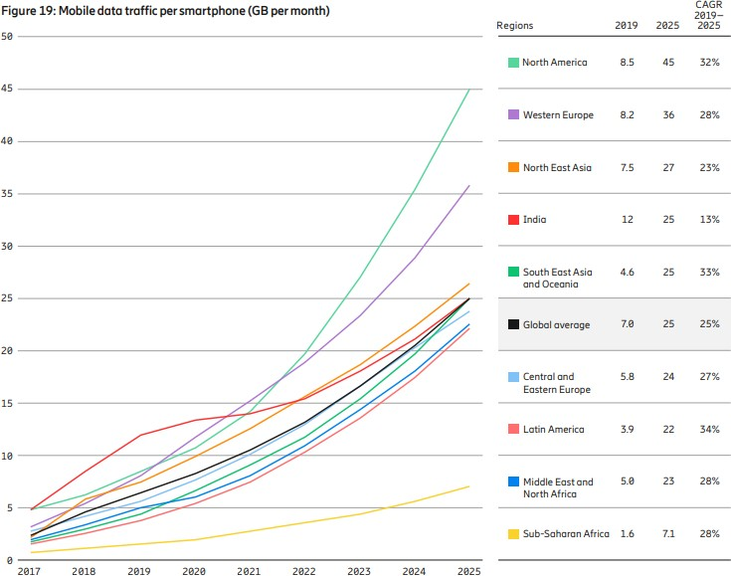5

AMTA also notes that despite the continuing impact of the pandemic on economic certainty; Australia’s mobile network operators continue to deploy 4G and increasingly 5G in 2020 and the pace of deployment has not slowed due to COVID-19.6 This aligns with Ericsson’s global observations that over 75 providers have now announced 5G commercial launches and that uptake in some markets, for example, China, has been faster than expected, although the pace of 5G adoption in the USA and Europe is expected to slow slightly in the short term but still achieve the original forecast results by 2025.7

Mobile telecommunications have historically had an enabling impact on other industries across the economy and society. As the world starts to recover from the impacts of COVID-19, we expect that 5G will continue to drive economic growth and play a key role in Australia’s recovery as it enables service providers to offer cost-effective technology to meet consumer demand for data and new advanced 5G services.8

5 [Ericsson Mobility Report,](https://www.ericsson.com/en/mobility-report/reports/june-2020) June 2020, page 21

6 ChannelNews, [Telstra 5G rollout undeterred by coronavirus,](https://www.channelnews.com.au/telstra-5g-rollout-undeterred-by-coronavirus/) 26 May 2020

7 [Ericsson Mobility Report,](https://www.ericsson.com/en/mobility-report/reports/june-2020) June 2020, page 10

8 Ericsson and Arthur D. Little, [5G for business: a 2030 market compass,](https://www.ericsson.com/en/news/2019/10/ericsson-5g-for-business-a-2030-market-compass) Oct 2019, page 3