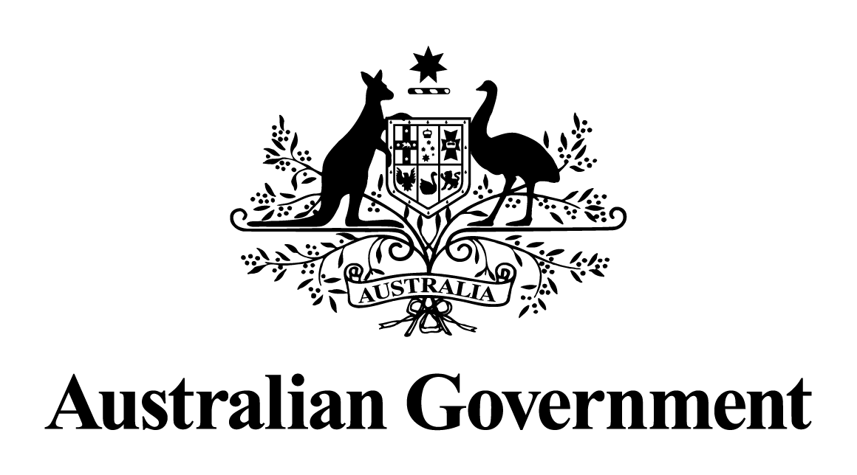

# Australian Government response to the Senate Environment and Communications References Committee report:

Effectiveness of current regulatory arrangements in dealing with radio simulcasts

March 2018

[This page is left intentionally blank.]

Contents

Overview 1

Context 1

Australian Government response 2

Recommendation 1: 2

Recommendation 2: 2

## Overview

The Australian Government notes the report by the Senate Environment and Communications References Committee (the Committee) into the Effectiveness of current regulatory arrangements in dealing with radio simulcasts.

On 21 March 2013, the Senate referred the following matters to the Committee for inquiry and report:

The effectiveness of current regulatory arrangements in dealing (under the *Broadcasting Services Act 1992* and the *Copyright Act 1968*) with the simultaneous transmission of radio programs using the broadcasting services bands and the Internet (‘simulcast’), including:

1. the impact of current regulation on stakeholders, including broadcasters, copyright holders, including both publishing and performance rights holders and the audience; and
2. any related matter.

The Committee received 16 submissions, and a range of additional information from various industry stakeholders and other parties. The Committee made two recommendations, and tabled its report on 12 July 2013.

## Context

The Committee Inquiry stemmed from a dispute concerning the royalties payable for the use of recorded music incorporated in internet simulcasts of radio programs. In 2013, the Federal Court ruled that internet simulcast services are separate services from terrestrial radio services. Under Australian copyright law, this means that broadcasters must pay a separate copyright royalty for music used as part of these internet services.

Commercial negotiations between the Phonographic Performance Company of Australia (PPCA) and Commercial Radio Australia (CRA) failed to resolve the dispute and in March 2015, the PPCA referred a licence scheme to the Copyright Tribunal of Australia (the Tribunal). On 11 July 2016, the Tribunal issued its final (and third) order which confirmed the PPCA Simulcast Licence for Commercial Radio Broadcaster (Final Scheme).

The Final Scheme sought to balance the opposing views of both parties, and incorporated both a percentage of revenue method for determining royalties payable by radio broadcasters (preferred by CRA) and per-stream rate (preferred by the PPCA). On 30 November 2016, CRA launched ‘RadioApp’, which will allows listeners to live stream more than 250 Australian radio stations. The app’s production confirms that commercial relations between the CRA and the PPCA have resumed, as the app would require CRA to pay copyright royalties in line with the Final Scheme confirmed by the Tribunal.

## Australian Government response

The Australian Government’s response to the *Effectiveness of current regulatory arrangements in dealing with radio simulcasts* is set out in detail below.

### Recommendation 1:

2.84 The committee recommends that the Minister for Broadband, Communications and the Digital Economy seek to resolve the ambiguity in the existing determination, either through a new determination, having regard to any other potential consequences of such action, or by negotiating a satisfactory agreement between the two key stakeholders pending a comprehensive response at the earliest opportunity to the findings of the Convergence review, ALRC review and other outstanding issues regarding the interaction of broadcasting and copyright law.

The Government **does not** support this recommendation.

The dispute between the PPCA and CRA, concerning the royalties payable for the use of recorded music incorporated in internet simulcasts of radio programs, has been resolved. On 11 July 2016, the Copyright Tribunal of Australia (the Tribunal) issued its third and final order which confirmed the PPCA Simulcast Licence for Commercial Radio Broadcaster (Final Scheme).The Final Scheme was accepted by both parties, and enabled online simulcasts of radio programs to resume.

Throughout this dispute, the Government maintained the position that it would not consider regulatory or other action until commercial negotiations and (as necessary) consideration of the matter by the Tribunal had run its course. This is precisely what occurred. The Tribunal sought to balance the competing claims and positions of the two parties and, importantly, its Final Scheme allowed for online simulcasts of radio programs to recommence. This is an excellent outcome for copyright owners and radio broadcasters and, ultimately, for radio consumers.

### Recommendation 2:

2.85 The committee recommends that the Minister for Broadband, Communications and the Digital Economy and the Attorney-General fully and urgently address in a comprehensive and long-term manner all of the related broadcasting and copyright issues identified in numerous reviews, and by many stakeholders, following receipt of the ALRC review later this year.

The Government **notes** this recommendation.

This recommendation has been overtaken by events. The Australian Law Reform Commission’s (ALRC) 2013 report ‘*Copyright and the Digital Economy*’ made a number of recommendations that the Government should consider possible changes to the broadcast-related copyright sections of the *Copyright Act 196*8 (the Act) but did not recommend any actual changes. The Productivity Commission (PC) ‘*Intellectual Property Arrangements*’ inquiry conducted in 2015–16 included a broad review of Australia’s copyright framework, which considered the ALRC’s recommendations and stakeholder views on these issues. The PC did not make any specific recommendations to change the broadcast-related sections in the Act.