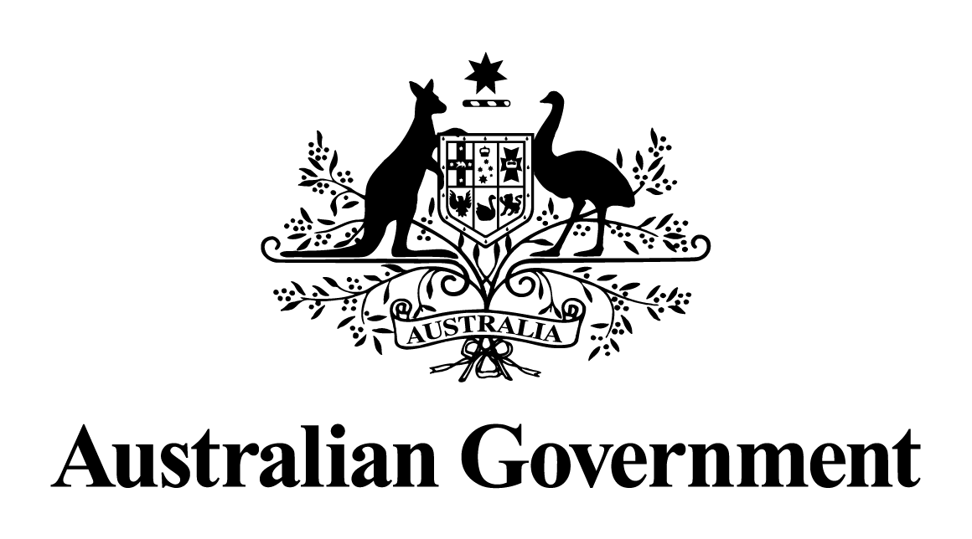

# Australian Government response to the Senate Environment and Communications Legislation Committee report:

Into the Australian Broadcasting Corporation Amendment (Restoring Shortwave Radio) Bill 2017

February 2018

[This page is left intentionally blank.]

Contents

Overview 1

Australian Government response 2

Recommendation 1: 2

## Overview

The Australian Government notes the report by the Senate Environment and Communications legislation Committee (the Committee) into the Australian Broadcasting Corporation Amendment (Restoring Shortwave Radio) Bill 2017 (the Bill).

The Bill was introduced by Senator Nick Xenophon on 13 February 2017. On 16 February 2017, the Senate referred the Bill to the committee for inquiry and report by 10 May 2017. This was later extended to 9 August2017.

The Bill proposes to amend the Australian Broadcasting Corporation Act 1983 (ABC Act) to require the Australian Broadcasting Corporation (ABC) to restore its shortwave transmission services. The ABC ceased shortwave transmission services in the Northern Territory and to international audiences from 31 January2017.

The Bill proposes to require the ABC to maintain three domestic shortwave transmission services providing wide area coverage across the Northern Territory which will broadcast the proximate local radio service. The proposal will also require the ABC to maintain at least three domestic shortwave transmission services which were operating up until the cessation of the domestic shortwave transmission on 31 January 2017.

The Bill would also require the ABC to maintain an international shortwave transmission service for Papua New Guinea and parts of the Pacific which will use at least three transmitters and broadcast the ABC's international service. The proposal will also require the ABC to broadcast in the relevant language of the population that it is broadcasting to.

## Australian Government response

The Australian Government’s response to the inquiry and report into the *Australian Broadcasting Corporation Amendment (Restoring Shortwave Radio) Bill 2017* is set out in detail below.

### Recommendation 1:

2.56 The committee recommends that the Senate not pass the bill.

The Government **supports** this recommendation.

The Government also supports the committee’s view that developments in this area continue to be monitored. With this view in mind, in 2018, the Department of Communications and the Arts in conjunction with the Department of Foreign Affairs and Trade will conduct a review to examine the reach of Australia broadcasting services in the Asia Pacific region, including investigating whether shortwave radio technology should be used.