Leading Indicators

*Second release*

March 2015



# Introduction

The Bureau of Communication Research (BCR) supports the development of good public policy and informed policy discussion for digital technologies, communications networks and services. As part of this, its Leading Indicators project framework is generating snapshots around recent data releases to build insights into the communications sector. In this release we profile:

* Consumption patterns – recent data for public access to government information online provides insights into evolving consumer behaviour patterns including the adoption and use of digital services.
* Industry growth – trends for 457 visa grants and holders in the telecommunications sector against the backdrop of employment trends for the sector indicates how employers are meeting their labour requirements.
* Industry investment – pre-committed investment for construction in the telecommunications sector helps foreshadow further growth, just as low levels of pre-committed funds may pre-empt a downturn in the sector.

# Consumption patterns: open data

Datasets accessed on Australia’s national open data website data.gov.au, show an 18 per cent increase in the number of views of published government data over the twelve months to October 2014, and an increase in public access of data across levels of government.[1]

Of the top 10 datasets, location data for government services is the most popular, in particular Medicare offices (63 per cent) and Centrelink offices (26 per cent) with the Federal Budget 2014-15 (2 per cent) in May representing the top three datasets accessed.

Datasets from state and territory governments – such as ACT Magistrates Court judgements and Victorian school locations – were also reflected in the top ten sites visited together with local government Brisbane City Council parking meter areas.

Table 1: Top 10 datasets visited on data.gov.au

|  |  |
| --- | --- |
| Datasets | Visits |
| Location of Medicare offices, Department of Human Services | 180 815 |
| Location of Centrelink offices, Department of Human Services | 75 757 |
| Federal Budget 2014-15 tables and data, Department of Finance | 6 629 |
| ACT Magistrates Court judgements, ACT Government Justice and Community Safety Directorate | 4 445 |
| Victorian school locations, Victorian Department of Education and Early Childhood Development | 4 277 |
| National public toilet map, Department of Social Services (DSS) | 3 614 |
| DSS payment demographic data, DSS | 3 392 |
| Parking meter areas, Brisbane City Council | 3 383 |
| NSW crime data, NSW Bureau of Crime Statistics and Research | 3 325 |
| Energy rating data for household appliances, Department of Industry and Science | 3 334 |

Source: Data.gov.au, October 2013 – October 2014

# Industry growth

Despite the slower growth rate in information, media and technology sector (IMT) 457 visa employees and approved grants in 2013-14, overall employment in the IMT industry rose by six per cent to 209,100. A comparison between 457 visa holders and industry employment trends may indicate that employers are looking to the skilled domestic market to meet demand in the short to medium term.

The subclass 457 visa program is designed to address labour shortages in industries where employers are unable to find appropriately skilled workers locally. The program is driven by demand from employers and data available reflects workers currently employed in Australia (holders) and approved applications yet to commence (grants).[2]

Between 2009-10 and 2011-12, 457 visa grants in the IMT industry nearly doubled, flowing through to an expansion in the number of 457 visa holders in the industry (40 per cent in the same period). In the IMT industry, grants have since decreased by 22 per cent to 5,820 in 2013-14 and the growth rate in the number of visa holders has slowed to seven per cent for the same time period. [3]

**Figure 2: Number of 457 grants and holders, and total employment in IMT industry**

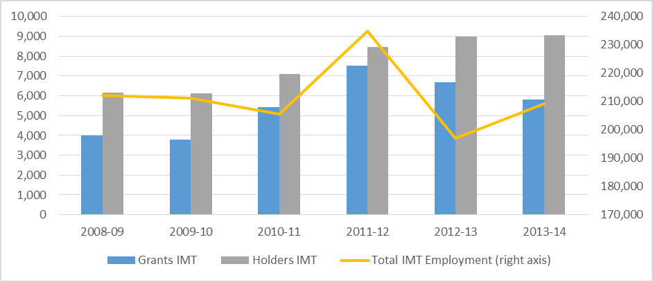Source: Department of Immigration and Border Protection subclass 457 pivot tables, 2014; Australian Bureau of Statistics 6291.004 – Labour Force, Australia, August 2014

# Industry investment

Seasonally adjusted data on Australia’s engineering construction activity combines public and private sector work ‘commenced’, ‘done’, and ‘yet to be done’. Based on engineering construction activity figures released on 1 October 2014, the telecommunications sector has outperformed other sectors in the economy.

However telecommunications work ‘yet to be done’ peaked in the fourth quarter of 2012 for both total engineering construction activity and, more specifically, for engineering construction. The telecommunications industry grew faster than the rest of the economy in the build up to the peak in 2012 and has continued to decline at a steadier rate since.

While the value of the work ‘yet to be done’ for the second quarter of 2014 at $2 billion is trending below the 2012 peak, it remains well above the 2009 -2011 period where quarterly investment was below $0.5 million. This could foreshadow a period of continued growth in the telecommunication sector as work ‘yet to be done’ commences. The value of work commenced at $1.4 billion and work completed at $1.7 billion for the June 2014 quarter also reflects this positive trend. [4]

Figure 1: Telecommunications industry investment – value of work ($ millions)

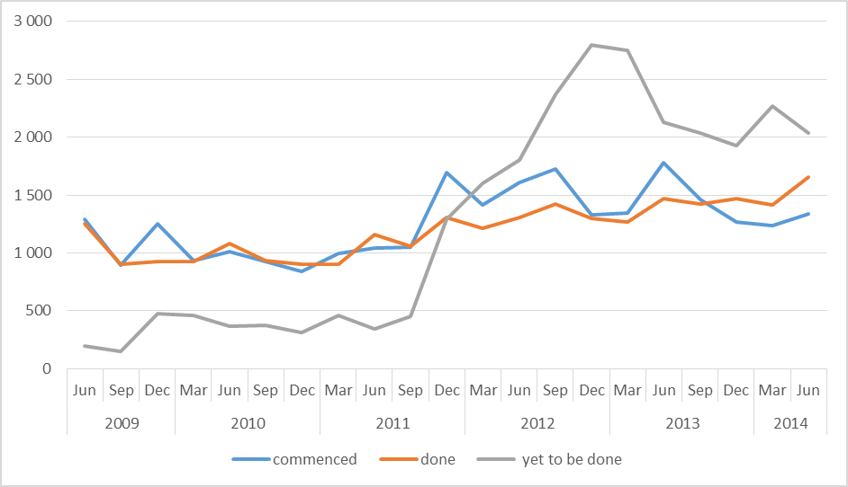

Source: Australian Bureau of Statistics, 8762.0 - Engineering Construction Activity, Australia, Sep 2014

Table 2: Compound Quarterly Growth Rate (CQGR) of engineering work yet to be done in the telecommunications industry and the total economy

|  |  |  |  |
| --- | --- | --- | --- |
| (CQGR) | Value of work yet to be done - Telecom. | Value of work yet to be done - Total. | |
| 4nd Q 2008 – 4th Q 2012 | 16.21% | | 7.08% |
| 1st Q 2013 - 2nd Q 2014 | -5.79% | | -7.44% |

# End note

Using the current set of indicators to gauge investment, growth and consumption patterns provides a snapshot of the industry and could foreshadow future trends. However, the communications sector is dynamic and continually evolving. The value of particular indicators needs to be reassessed and the BCR is seeking new measures to be identified to provide insights into new and emerging areas.

The development of a Leading Indicators framework is an early area of work for the BCR. The framework will continually evolve through engagement with key stakeholders to determine the most effective and relevant indicators for the communications sector.

1. Data.gov.au, October 2013 – October 2014
2. Department of Immigration and Border Protection, Annual Report 2013-14, p.66
3. Department of Immigration and Border Protection, 457 visa holders pivot table 2014
4. Australian Bureau of Statistics, 8762.0 - Engineering Construction Activity, Australia, Sep 2014