# Riding the Digital Wave—Report on COVID-19 Trends and Forward Work Program

**November 2020**

Contents

Executive summary 4

Of particular interest to the ABAC will be: 5

Small and medium-sized enterprises (SMEs) 5

Digital Inclusion 5

Digital skills 5

Sectoral Deep dives 5

ABAC will look broadly at digital infrastructure 6

Australia’s mobile coverage priorities 7

Australia’s 5G Rollout 8

ABAC will look at where it can have the greatest impact 9

COVID-19 and acceleration of digitisation in the economy 10

COVID-19 has brought forward 10 years of growth in data consumption 10

COVID-19 has accelerated four key trends 11

Offline to online acceleration 12

Many organisations have instituted large-scale changes in order to adapt to the offline to online acceleration 12

The Royal Prince Alfred Hospital opened Australia’s first virtual ward 12

Museums Victoria 12

Many organisations have instituted large-scale changes in order to adapt to the offline to online acceleration 13

Woolworths adapted its supply chain to meet increased online demand 13

Gyms started hiring their equipment out to people working out at home 13

Small businesses have the most to do to be competitive 14

Work during COVID-19 15

COVID-19 has changed the nature of work, with 46% of Australians working from home in May 2020 15

Nearly half (46%) of working Australians worked from home in May 2020 15

Remote learning will be critical to COVID-19 recovery 16

Early evidence of increase in demand for adult remote learning 17

Vulnerable groups 18

Quality internet is critical in keeping vulnerable groups from falling behind 18

There are three main drivers to digital inclusion that have been highlighted during COVID-19 18

Leveraging Government Initiatives 19

PLAN NOW: Applying a place-based lens to gaps in digital infrastructure 20

Importance of state-based digital plans 20

Why is this evidence needed? 20

ABAC will work with the Commonwealth to explore the best use of state-based digital plans, digital clusters in regional Australia, and City Deals 20

ACT NOW: Digital Inclusion 21

Common framework to identify gaps 21

Remote learning 21

ACT NOW: Digital Skills 22

Renewed focus on digital skills is urgently needed to realise the economic potential of the shift to online and the impact of digital transformation 22

Role of tertiary education 22

SMEs 23

Greatest productivity potential 24

Sectors with greatest productivity potential if barriers to digitisation are removed 24

ABAC has considered three key factors in determining high opportunity areas 24

Assessment of sectors 25

These criteria were then assessed using a range of public, propriety data and expert information 25

Size of opportunity 27

Digitisation and export opportunities by sector presented by COVID-19 27

STUDY NOW: ABAC’s work program gives early attention to sectors with high economic potential and significant barriers to digitisation 28

Agriculture 28

STUDY NOW: ABAC’s work program gives early attention to sectors with high economic potential and significant barriers to digitisation 29

Health 29

STUDY NOW: ABAC’s work program gives early attention to sectors with high economic potential and significant barriers to digitisation 30

Construction 30

Where to from here? 31

Quarter 4 2020 31

Quarter 1 2021 31

Post-Q1 2021 31

Tables / images

<Table/figure heading> 3

<Table/figure heading> 3

## Executive summary

On 22 July 2020, the Minister for Communications, Cyber Safety and the Arts, the Hon Paul Fletcher MP, announced the Australian Broadband Advisory Council (ABAC) to provide advice to the Government on ways to maximise the economic benefits of increased digital connectivity for Australian businesses and consumers.

This report, which is the first by ABAC, sets out the methodology for analysis of key sectors of the Australian economy during and as part of the COVID-19 recovery.

Access to broadband infrastructure has held up well during COVID-19 by OECD standards. This period coincided with 7.8 million customers now active on the National Broadband Network (NBN). High speed mobile networks have also coped well with the rise in data usage.

This period has dramatically accelerated:

* the move of businesses and consumers from offline to online
* remote working and online collaboration tools
* the shift from face to face to online learning
* a shift to new service delivery models. In particular, the use of telehealth, albeit largely telehealth consultations by phone, has brought into focus the potential to introduce new and better models of care and improved rural and remote delivery of health services.

The last year has also created opportunities to improve productivity and increase the online participation of businesses. The task now is to support Australians as they take advantage of the opportunities of broadband and continue to adopt digital applications.

## Of particular interest to the ABAC will be:

### Small and medium-sized enterprises (SMEs)

The rise of e-commerce and the continuing interest in remote working, offers new opportunities for job creation and economic participation in our regions. ABAC will encourage new planning capabilities to track how SMEs in various regions and sectors make use of broadband and access information to improve digital capabilities.

### Digital Inclusion

The economic disruption of COVID-19, coupled with the move to online, further exposes vulnerable groups who were already struggling to be engaged, especially low income groups. Our initial focus will be on access and affordability packages for remote learners, and the opportunities to use public infrastructure by increasing the capacity of Wi-Fi.

### Digital skills

Digital skills are critical in supporting this shift in economic activity and maintaining the competitiveness of high adopters. Opportunities will exist for both reskilling and upskilling. ABAC will engage on the prioritisation of IT training and apprenticeships, improved digital connectivity standards, and the accessibility of blended TAFE programs throughout Australia.

### Sectoral Deep dives

ABAC has considered the parallel work of the Digital Technology Taskforce in ensuring Australia will be a leading digital economy by 2030. This collaboration and whole-of-government approach will enhance the Government’s role as a digital exemplar and enabler to build business confidence to use online and cloud-based services by improving cyber and critical network security.

ABAC will focus on sectors with high digital potential, but low levels of adoption, such as health and construction. ABAC will also look at sectors such as manufacturing and agriculture, where new technologies need a period of experimentation to adjust business processes and supply chains.

## ABAC will look broadly at digital infrastructure

**Infrastructure needed to support future applications; with broadband connectivity to include NBN, 5G, wide area narrow band and other technologies**

92% of households have access to NBN fibre or cable connections. 8% of Australian households are served by fixed wireless or satellite connections. Connectivity may also be through non-NBN broadband or fixed wireless providers.

**By 2023, NBN Co will make its highest wholesale speed plans available for up to 75% of households and businesses via four initiatives**

* $400m for new capacity in the HFC network
* $2.9b to enhance the FTTN footprint, enabling premises to move to
* FTTP service
* $100m to provide 100Mbps line speeds for premises on the FTTC network
* $50m to improve in-home speeds for customers on the FTTN network

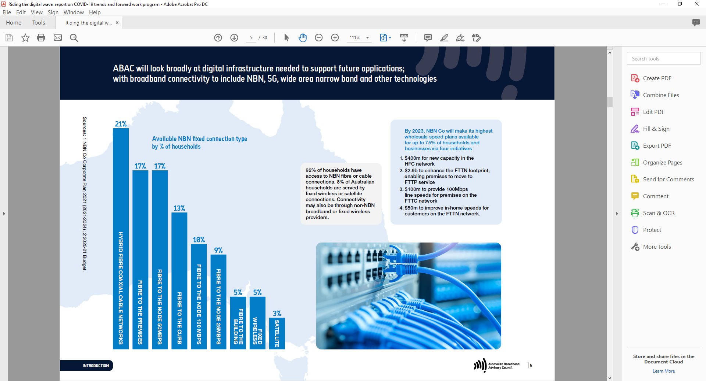

**Sources:** 1 NBN Co Corporate Plan 2021 (2021–2024); 2 2020–21

## Australia’s mobile coverage priorities

**Currently, over 99% of Australian premises have 3G or 4G mobile reception, covering only one-third of total land mass.**

Delivery of mobile coverage has traditionally prioritised high density areas resulting in limited coverage in other areas such as along transport corridors, or in large landholdings away from homes and businesses, such as farms and stations.

Australian national priorities should consider:

* national safety and resilience, such as coverage of major transport links as well as routes in and out of centres at risk of bushfires1
* the physical interdependencies between fixed and wireless broadband infrastructures
* the complementarity and overlapping use of fixed and mobile technologies by most businesses and households
* the dependence on mobile‑only by vulnerable groups for connecting to the internet business reliance on wireless access for particular applications (e.g. for construction and agriculture) which will only intensify with 5G and new technologies.

The graph shows 3G and 4G mobile coverage by percentage of population, and percentage of Australia's land mass.

Telstra covers 99% of population, Optus covers 99% of population, and TPG covers 97% of population.

Telstra covers 31% of Australia's land mass, Optus covers 99% of land mass, and TPG covers 97% of land mass.

**Sources:** 1 Australian Infrastructure Audit 2019; 2 Bureau of Communications and Arts Research

## Australia’s 5G Rollout

* 5G is expected to add up to $2,000 in GDP per person after the first decade of the rollout.1
* 5G can underpin both consumer and enterprise applications. 5G will provide greater network capacity, higher speeds and lower latency, and has been designed to support machine-to-machine communication. Potential uses include smart factories and warehouses, logistics management and real-time decision support.
* Existing efforts by mobile carriers have focused on using 5G to improve 4G mobile capacity to improve consumer experience. The next steps will involve assessing and supporting business uptake of 5G and other new technologies to drive their digital transformation.
* In April 2021, the Government will allocate high band 5G spectrum (in the 26 GHz band), which will enable extremely fast, high-capacity services. In the second half of 2021,the Government will allocate low band 5G spectrum
* (in the 850/900 MHz band), which will be crucial for broader geographic coverage of 5G services. This will enable
* new applications for 5G in the enterprise market that take advantage of 5G’s unique properties like ultra-low latency, high capacity, and advanced functions like network slicing.
* To realise these productivity benefits, businesses not only need to build understanding of the capabilities of 5G across a range of sectors, but new types of collaboration may be needed within ecosystems and supply chains.
* Trialing 5G use cases will benefit adoption, expose regulatory and other barriers, and enable local technology and applications providers to mature their offerings and improve interoperability issues across the ecosystem.

**Note:** 1 Bureau of Communications and Arts Research.

## ABAC will look at where it can have the greatest impact

COVID-19 response: COVID-19 has had a severe impact across the economy and as a consequence, some sectors and issues require immediate action. These include digital skills, digital inclusion and ongoing support for SMEs to adopt digital capabilities.

Leverage government initiatives: ABAC will work to harness government initiatives, including increased infrastructure spending, NBN upgrades and the relaxation of COVID-19 restrictions. ABAC will support the Commonwealth to coordinate planning across all levels of government to optimise the benefits of infrastructure spending.

Sectors with greatest productivity potential if barriers to digitisation are removed: ABAC has identified areas of the economy where there are significant barriers to digitisation but where, with the right support to adopt new technologies, productivity gain can be greatest.

## COVID-19 and acceleration of digitisation in the economy

### COVID-19 has brought forward 10 years of growth in data consumption

COVID-19 resulted in: 76% increase in upstream internet volume per user; 18% increased smart TV use; 32% increased laptop use; 314% increase in off-peak to peak hour traffic; 38% increased mobile phone use; and 23% increased PC use.

Mobile and fixed internet use is converging: 29% of households use both fixed and mobile networks to access the internet, increasing from only 5% in 2017; and 32% of fixed line customers would switch to mobile only internet if they were the same price.

**Sources:** 1 NBN; 2 Centre for International Economics analysis October 2020 for TPG Telecom.

**Note:** 1 Fixed line customers include only customers with <50GB monthly usage and assumes that data allowance is the same.

## COVID-19 has accelerated four key trends

| **Trend** | **Description** | **Opportunities** |
| --- | --- | --- |
| Offline to online | COVID-19 has forced many industries online, accelerating the rate of digitisation across sectors. | * Increased online consumption by consumers across nearly all categories * Increased investment in digital assets such as cloud, stock and supply chain management software * Increased investment in digital skills training |
| Remote work | Australians have moved their workplace from centralised office spaces to their homes in response to COVID-19 health concerns, with many non-essential functions now being conducted virtually. | * Some productivity gains from increased flexible work arrangements and diminished transportation needs * Increased mental wellbeing issues as individuals find it harder to connect with relevant support systems * Increased experimentation as businesses establish alternative collaboration channels * Greater internet capacity requirements as workers virtually collaborate |
| Remote learning | Australians have also moved their learning online in response to restrictions on in-person course attendance. | * Increased investment in transitioning courses online by post-secondary education institutes * Increased disadvantage for students unable to access online education |
| Digital divide | The ability to get online is not the same for all Australians and the online shift has left vulnerable cohorts exposed. | * Decreased access to internet as libraries, co-working spaces and universities closed due to COVID-19 * Increased internet affordability concerns as large number of workers face unemployment * Increased health implications as cohorts with low digital skills face barriers to receiving COVID-19 health advice |

**Source:** 1 AlphaBeta analysis of various available.

## Offline to online acceleration

### Many organisations have instituted large-scale changes in order to adapt to the offline to online acceleration

#### The Royal Prince Alfred Hospital opened Australia’s first virtual ward

**600 patients are registered in the Australia’s first virtual ward at the Royal Prince Alfred Hospital (RPA).**

The RPA virtual ward was launched in February 2020 to care for people with cystic fibrosis and palliative care patients, but was quickly adapted as an alternative channel to care for COVID‑19 patients in an effort to minimise hospitalisations.

Medical grade monitoring equipment is sent out to patients’ homes, where the data is then transmitted via an app on patients’ phones to a virtual ward headquarters. The RPA virtual ward offers 24/7 monitoring and twice daily video‑consultations where clinical staff can assess and respond to a patient’s physical and mental health.

The Director of the ward has compared the success and speed of the ward’s implementation to accelerating “five years of digital strategy in ten weeks.”

#### Museums Victoria

**In March 2020 Museums Victoria (MV) accelerated its Digital Life strategy with the launch of a new online initiative called Museum at Home.**

Using its social media, YouTube and website channels, MV has connected with visitors virtually and provided ‘always open’ access to collections, exhibitions and stories from Melbourne Museum, Scienceworks and Immigration Museum.

New online content portals for Learning and Play have catered to the needs of teachers, parents and those learning remotely; whilst adults and children alike have watched MV’s many videos, joined live workshops and spent time on online activities. A fully online program for National Science Week in August 2020 reached more than 530,000 people.

Uniting multichannel activities under the discoverable #museumathome tag has enabled MV to reach audiences well beyond its walls. In seven months, Museum at Home has reached more than 15.5 million people; its videos have attracted more than 2.6 million views and nearly 130,000 individual users have accessed its online education resources.

**Sources:** 1 The Guardian; 2 PWC.

### Many organisations have instituted large-scale changes in order to adapt to the offline to online acceleration

#### Woolworths adapted its supply chain to meet increased online demand

**41.8% increase in online sales as consumers flock to online forms of grocery shopping.**

Woolworths has seen a marked increase in its online grocery business and has had to quickly adapt to meet this increased demand. Apart from increasing the number of delivery trucks and on‑demand delivery drivers, three supermarkets were transformed into online delivery hubs to better service this increase in demand.

Alongside the supply chain adaptions, Woolworths has also implemented QR codes to help with contact tracing as well as a booking system to better manage foot traffic in stores. Q‑Tracker is an app that shows real‑time congestion in stores, and an online ‘book your shop’ system allows shoppers to confirm their spot ahead of time in order to skip queues.

#### Gyms started hiring their equipment out to people working out at home

**Over 30 gyms have joined up with GymLend as gym-goers have taken their workouts home.**

Due to social distancing requirements, gyms and fitness centres around the country were forced to close. Not only did this mean these gyms no longer had a revenue stream, but their clientele also lost access to the facilities that gyms provide.

GymLend was created by two Sydney‑siders in response to the COVID‑19 crisis to enable gyms to rent their unused equipment to people who are now working out at home.

The platform allows gyms to list as much equipment as they like, setting pricing for items as small as resistance bands and dumbbells to as large as squat racks and rowing machines. They can also create bundles of gear, such as a package of weights, a mat and a foam roller.

Consumers then search for gear according to their location and can choose to hire on an ongoing weekly or fixed term basis.

**Sources**: 1 The Guardian; 2 PWC; 3 Sydney Morning Herald.

## Small businesses have the most to do to be competitive

**Small businesses are less prepared for a COVID-19 normal operating environment, including low existing levels of internet usage.**

Small businesses account for 98% of all businesses and 5 million jobs and are thus a vital part of the economy.

Many small businesses would benefit from investing in technology. However, current investment is an average spend of $5,000 a year on technology – representing less than 1% of revenue.

Small businesses are using the internet to connect with customers and suppliers at only half the rate of larger businesses. They are also less likely to use technology to support business processes.

Large businesses are more than twice as likely than small businesses to have a website and a social media presence. This is crucial when businesses must now interact with customers online.

70% of Australians said they wanted to support small businesses but found it difficult to engage due to a limited online presence.

43% of small firms, 82% of medium firms, and 94% of large firms have a website.

32% of small firms, 63% of medium firms, and 81% of large firms use social media social media.

53% of small firms, 77% of medium firms, and 84% of large firms make purchases online.

34% of small firms, 48% of medium firms, and 52% of large firms receive orders online.

**Sources:** 1 McKinsey Australian Consumer Sentiment Survey 2020; 2 Xero.

## Work during COVID-19

### COVID-19 has changed the nature of work, with 46% of Australians working from home in May 2020

#### Nearly half (46%) of working Australians worked from home in May 2020

In the wake of COVID‑19, companies such as Atlassian, Square and Twitter have announced a permanent transition to remote working, with many more such as Salesforce announcing significant delayed return times.

Industries with high levels of digitisation such as Technology, Media and Telecommunications, Professional services, Mining and Finance are leading the change. However, industries with traditionally high levels of onsite presence have started implementing remote work arrangements, such as manufacturing and education.

Remote work has the potential to reinvigorate rural communities, improve housing affordability and increase job opportunities. Fast and reliable internet services will help to drive this change.

Benefits of enabling more Australians to work remotely:

* More people may choose to live in regional areas which may reinvigorate rural communities.
* The rate of urbanisation may slow down, reducing congestion and levels of pollution.
* Housing affordability in Australia’s major cities may improve as people realise that they no longer need to live within certain geographic proximities to work.
* Increased job opportunities may arise for those who have previously been locked out of the market due to their location or need to stay at home (e.g. carers).

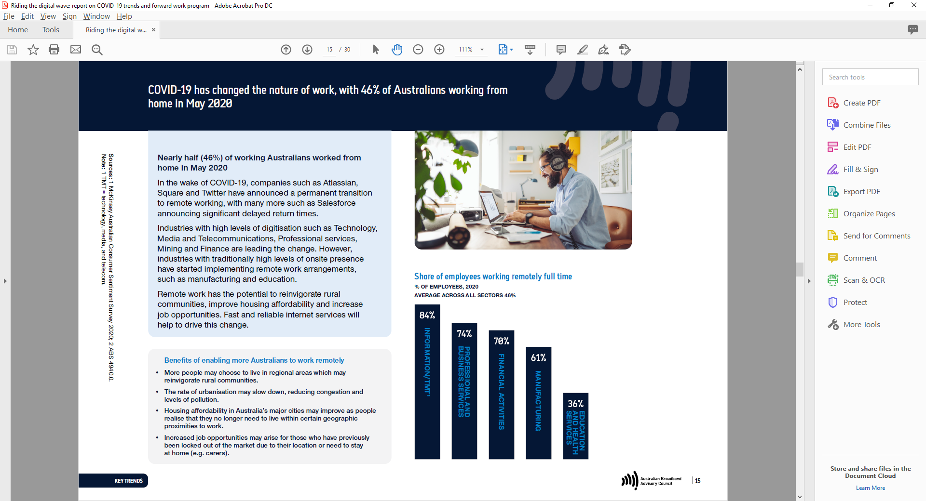

**Sources:** 1 McKinsey Australian Consumer Sentiment Survey 2020; 2 ABS 4940.0.

## Remote learning will be critical to COVID-19 recovery

**Remote learning will become increasingly important in the COVID-19 recovery as unemployed Australians seek to gain skills that are likely to be in high demand.**

COVID‑19 has provided a powerful test of the potential of online learning, with over 1 billion students worldwide shifting from the classroom. It has also revealed key limitations, such as the prerequisite of digital skills, computer equipment and internet connection to undertake training online, the difficulty of delivering traditional work‑based learning online, and the struggle of teachers used to classroom instruction.

Currently only about 40% of adults in OECD countries, participate in formal and non‑formal job‑related training annually. Lack of time, scheduling conflicts and distance constraints are among the key barriers reported by those who do not undertake any training.

Done well, expanding online adult training opportunities would help reach a greater number of learners, accelerating the post COVID‑19 recovery.

### Early evidence of increase in demand for adult remote learning

* In the Flemish Region of Belgium, the number of participants in online training provided by the Public Employment Service in the second half of March 2020 was four times as high as in the same period last year.
* In Canada, France, Italy, the United Kingdom and the United States, searches for terms such as online learning, e-learning and Massive Online Open Courses increased up to fourfold between end-March and early April 2020 as strict lockdown rules came into force in most OECD countries.

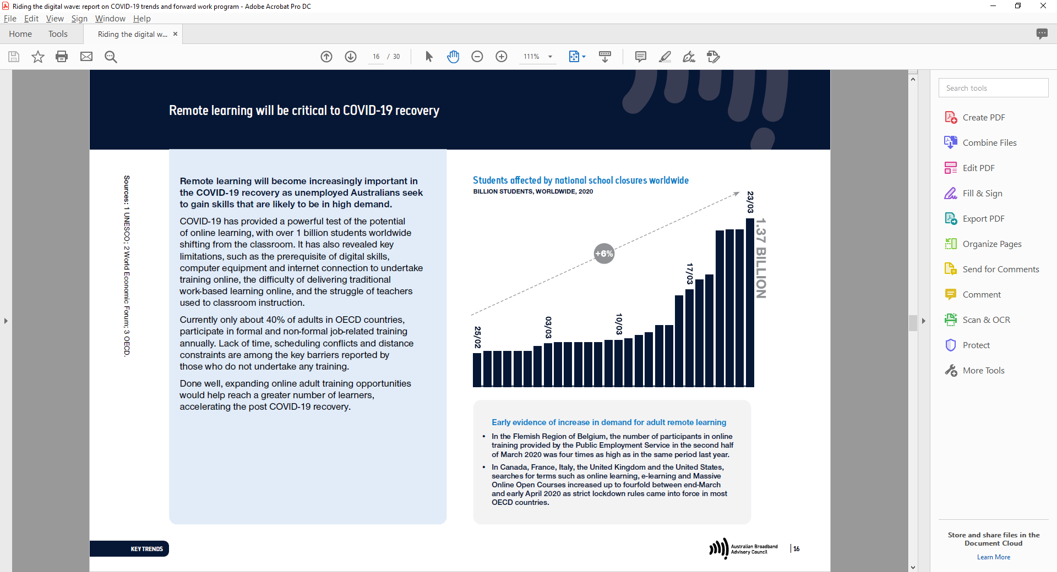

**Sources:** 1 UNESCO; 2 World Economic Forum; 3 OECD.

## Vulnerable groups

### Quality internet is critical in keeping vulnerable groups from falling behind

#### There are three main drivers to digital inclusion that have been highlighted during COVID-19

Access to the internet is defined by the availability, quality, capacity and flexibility of an internet connection. Vulnerable cohorts may find it difficult to access the internet due to a lack of access to connectivity or hardware. Access to public internet hubs has been impacted during COVID‑19 but equally has become even more important for those who have difficulty working or learning from home.

Affordability refers to the cost of internet connections relative to other living expenses. COVID‑19 has forced many Australians into unemployment, which could affect their internet access. This is particularly challenging for low‑income students who rely on the internet for continued learning.

Ability refers to the IT skills and attitudes needed to confidently use the internet. Historically, the elderly and migrants have found it difficult to navigate the internet due to language or other skill gaps. In‑person help and training is currently limited due to COVID‑19 health concerns.

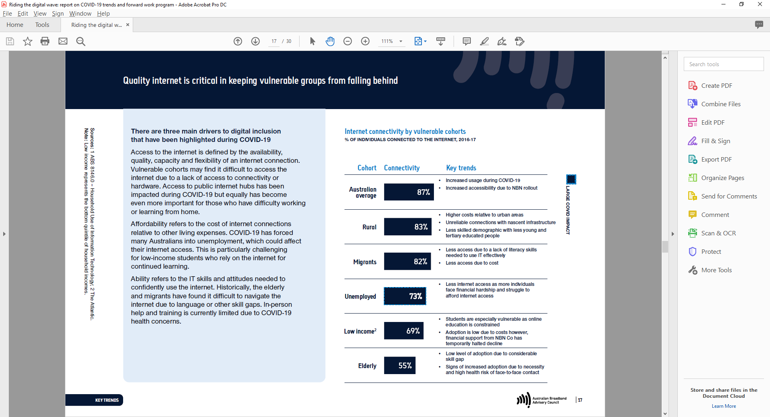

**Sources:** 1 ABS 8146.0 – Household Use of Information Technology; 2 The Atlantic.

## Leveraging Government Initiatives

Government measures to support connectivity and economic recovery.

Government initiatives include: Increased investment in public infrastructure; Connectivity measures, including co-investment; Supporting SMEs; and Acceleration of SME skill and innovation.

ABAC will explore: Opportunities to integrate digital infratsructure into new or upgraded assets; the impact of Business Fbre Zones in regional areas to enhance social and economic benefits; study where digital adoption is lagging and how it could be improved, including digital skills; and asset write-offs, digital apprenticeships, and uptake in target sectors.



## PLAN NOW: Applying a place-based lens to gaps in digital infrastructure

### Importance of state-based digital plans

* An evidence base is needed to map the fit between digital infrastructure and what States and territories have identified as their priorities for the economic and social development of their regions.
* Many states and territories have digital infrastructure plans but these plans could be used more effectively to assist the Commonwealth to target public investment in communications infrastructure to close gaps or to improve asset efficiency.

### Why is this evidence needed?

* A national lens is needed to make better use of existing broadband infrastructure; to identify service and performance issues; to ensure that regions make use of emerging technologies; and to track the effectiveness of existing programs.
* As more programs are rolled out to support digital skills and digital inclusion, regional planning would enable initiatives to be targeted and tracked over time.
* Increasing investment in public infrastructure in cities will create opportunities to integrate planning of next generation digital infrastructure.
* Planning and coordination could support the introduction of 5G or enable digital capabilities to be built into assets to introduce intelligence for maintenance and support or to secure end points for greater data security.

### ABAC will work with the Commonwealth to explore the best use of state-based digital plans, digital clusters in regional Australia, and City Deals

We will explore:

* how state-based digital plans that reflect the economic and social priorities and digital infrastructure needs of regional Australia can be consolidated and kept up to date.
* how digital clusters in regional Australia might be created from a range of existing programs to give critical mass to the local digital skills base.
* how the next City Deals might incorporate digital planning.
* how to amplify the impact of Commonwealth funding of regional infrastructure to bridge digital divides.

## ACT NOW: Digital Inclusion

### Common framework to identify gaps

The Australian Digital Inclusion Alliance recommended:1

* creating a Digital Capabilities Framework to provide a common understanding and goal for what it means to be a digitally capable individual.
* assessing which affordability measures taken in the immediate response to COVID-19 can be retained going forward, including a permanent low cost option for those on low income.
* moving towards all federal, state and local government websites being compliant with the latest accessibility standards (Web Content Accessibility Guidelines – WCAG 2.1).

ABAC notes and supports the proposals from the Australian Digital Inclusion Alliance and will draw on evidence provided by the 2020 Australian Digital Inclusion Index in our work on regional investment.

### Remote learning

* During COVID-19, heavier reliance on broadband clearly exposed vulnerable groups. State and territory governments, NBN Co and telcos subsidised data costs for fixed and mobile access, and provided laptops for students who had no home connection.
* This response helped redress the needs of vulnerable households with no fixed broadband or insufficient devices.
* The success of these support packages largely appeared to stem from a coordinated response between government departments, wholesale suppliers, such as NBN Co, retail
* service providers, education authorities and mobile operators.
* Some remote learners will continue to depend on public spaces or libraries.

ABAC will pursue a coordinated mechanism so economically vulnerable groups can access devices and bandwidth on affordable terms.

ABAC is continuing to consult on how public institutions, including public libraries, can support capacity building, and next generation Wi-Fi enabled working environments for those who cannot work or study at home.

**Notes:** 1 ADIA, A National Digital Inclusion Roadmap, October 2020; 2 Measuring Australia’s Digital Divide: Australian Digital Inclusion Index 2020.

## ACT NOW: Digital Skills

### Renewed focus on digital skills is urgently needed to realise the economic potential of the shift to online and the impact of digital transformation

#### Role of tertiary education

ABAC notes the reforms that are underway in the VET sector, including the rapid move by some universities to offer online micro-credentials and partner with industry. However, tertiary training systems must continue to adapt, including:

* developing a common understanding of the digital capabilities required by industry.
* simplifying pathways for foundation-level digital skills for employees.
* responding to demand for high end skills in emerging sectors such as fintech and agtech.
* assessing digital skills of students with reference to their ongoing employability within a standardised, industry-level framework.
* This work is now being led by the Digital Skills Organisation (DSO), including piloting industry-led digital training pathways. ABAC endorses the work of the DSO in leading progress on digital upskilling in Australia, the single most important lever in exploiting Australia’s growing broadband capacity.

ABAC will:

* Test whether existing public infrastructure in regional areas – such as TAFEs or universities – can be used to act as a local digital learning hub which offers blended online learning to build capacity in the regions.
* Encourage an industry-led approach, including by larger employers of tech workers to help standardise understanding of digital proficiencies and support digital traineeships.

#### SMEs

* Existing SMEs need to access appropriate training both remotely and “at the elbow” to participate effectively in the digital economy and to continue to upskill and stay current.
* Incentivising SMEs to invest in digital training for their staff, and to engage with local VET providers on their specific needs, are both important elements in supporting digital adoption.
* Leading edge companies in high tech industries are a key source of digital innovation across the economy more broadly.

ABAC will:

* Identify if the Government’s budget commitment to offer wage subsidies for apprentices and trainees can be used to take on staff with broader digital skills than IT support roles, and if not, to investigate what can be done to improve the targeting of this measure.
* Consider the best mechanism to ensure alignment of effort across the Commonwealth, as well as engaging with states and territories, and industry.

## Greatest productivity potential

### Sectors with greatest productivity potential if barriers to digitisation are removed

#### ABAC has considered three key factors in determining high opportunity areas

1. Size of the sector

The size of the sector and its relative contribution to the economy is important as it provides an important indication of the benefits to be gained by productivity increases.

1. Size of the digital opportunity

The size of the digital opportunity is measured by the global level of digitisation of the sector (with a low level of digitisation indicating a high level of opportunity), and how far Australia is from the global frontier (the further from the frontier, the higher the opportunity).

1. Impact of COVID-19

There are four key trends that have arisen from COVID‑19; the acceleration of offline to online, remote working, remote learning and the widening of the digital divide. The acceleration of offline to online particularly, and to some extent remote working, have had significant impacts on many sectors, providing opportunities which ABAC should harness.

Opportunities for ABAC will be determined by: size of sector; size of digital opportunity; and the impact of COVID-19. BAC should focus on sectors that contriburte significantly to Australia's economic output, considering Gross Value Add of the sector. ABAC should focus on sectors where there are the biggest digital opportunities to maximise productivity, considering pre-COVID-19 digitisation opportunities and Australia's performance relative to international peers. ABAC should take advantage of the accelerated digitisation trends due to COVID-19, consuidering the magnitude of the impacts, acceleration of offline to online, widening of the digital divide, and remote working.


In prioritising interventions, ABAC will consider:

* Variations in digital maturity between firms
* The potential for ABAC to add value by leveraging recent government announcements

**Note:** The scope of the analysis is limited to sectors identified in ABAC’s Terms of Reference, plus additional sectors of construction and utilities; and transversal issues.

## Assessment of sectors

### These criteria were then assessed using a range of public, propriety data and expert information

The relative size of the digital opportunity in sectors is not simple to identify

* For agriculture, some sectors were impacted by the acceleration of offline to online, such as livestock sales and restaurant suppliers who used digital platforms to access new markets. Supply chains were heavily impacted and access to itinerant workforce was restricted.
* There are also areas in which Australia has world‑leading capabilities where there is potential to further capitalise, including mining, agriculture, content development, higher education, medical sciences and biotech.
* To assess where the strongest opportunities lie, consideration must be given to the specific opportunities and barriers to digitisation.

The relative size of the digital opportunity in sectors is not simple to identify

* Agriculture – not directly impacted by the acceleration of offline to online, however supply chains were heavily impacted and access to itinerant workforce was restricted.
* Construction and utilities – stimulus packages announced by the Government, such as the HomeBuilder scheme and the acceleration of major infrastructure projects, will have a significant impact on the sector and provide opportunities to leverage.

Construction, health and education sectors show a higher proportion of Gross Value Add (GVA), compared to other sectors.

The graph shows GVA in millions and GVA percentages as follows: agriculture ($38.3, 3.1%); education ($93.7, 5.1%); tourism/arts ($54.2, 3.0%); media and digital ($21.3, 1.2%); health ($144.0, 7.9%); construction ($137.7, 7.5%); utilities ($47.2, 2.6%); and manufacturing ($108.4, 5.9%) sectors.

**Source:** 1. ABS; 2. OECD; 3 World Input‑Output database (2014); 4 AlphaBeta analysis (unpublished).

## Size of opportunity

ABAC will focus on sectors that have a large digital and export opportunity that have been affected by COVID-19

### Digitisation and export opportunities by sector presented by COVID-19

**By size of opportunity and covid-19 impact**

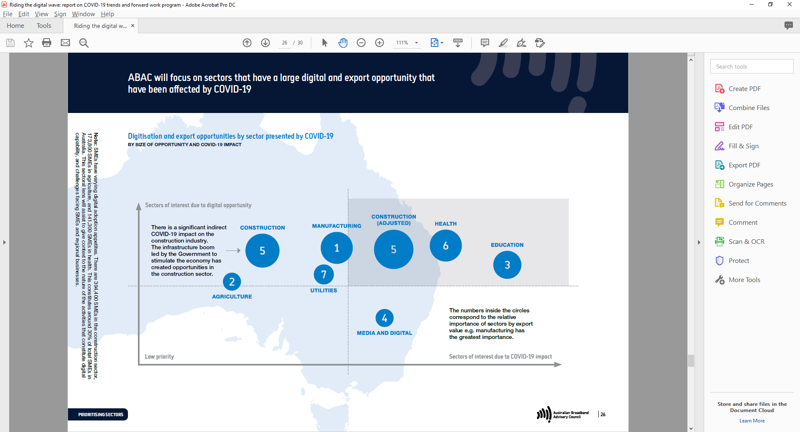

**Note:** SMEs have varying digital adoption appetites. There are 394,400 SMEs in the construction sector, 173,800 SMEs in agriculture, and 141,300 SMEs in health. This constitutes around 30% of total SMEs in Australia. This sectoral lens will assist to give context to the nature of the activities that constitute digital capability, and challenges facing SMEs and regional businesses.

## STUDY NOW: ABAC’s work program gives early attention to sectors with high economic potential and significant barriers to digitisation

### Agriculture

* Deriving information from sensors over Internet of Things (IoT) networks, or from aerial images, coupled with the power of data analysis offers exciting opportunities to improve agricultural productivity while at the same time contributing to sustainable farming practices.
* Software applications and blockchain can also assist in tracking and tracing agricultural products to open up new markets, including markets for locally sourced produce.
* Australia has a history of innovative farming practices and world leading agricultural research and indeed many research translation projects and pilots are underway to bed down new technologies.[1]
* Of interest to ABAC is how to accelerate Australian agtech innovation and adoption. We will be investigating whether and in what circumstances digital infrastructure, including the connectivity layer; data collection, management, storage and transfer capability;
* through to the perceived value proposition of the applications on offer, constitute a barrier to adoption.
* We have set up an Expert Working Group and will make recommendations after we receive its report.

## STUDY NOW: ABAC’s work program gives early attention to sectors with high economic potential and significant barriers to digitisation

### Health

Health counter measures during COVID‑19 have provided an opportunity to progress and test remote service delivery using broadband infrastructure.

* Telehealth consultations although largely by phone were widely used[2] and generated significant learnings on future directions for appropriate and quality care by means of telehealth.[3]
* Work is underway in determining the best care models using telehealth, including for the e‑mental health ecosystem.
* Clear benefits to patient care and to the health system have been extracted in replacing hospital visits with home‑based services where appropriate.
* Further advances were made and are planned in providing health care remotely for geographically isolated communities including Indigenous Communities.4
* ABAC will review the means by which better use can be made of digital infrastructure in the service of new modes of health care.
* ABAC has set up an Expert Working Group convened by industry specialists.
* The first stage of the Group’s work will be looking at the digital ecosystem for using telehealth (devices, skills, connectivity, data management) to support new models of care.

**Source:** https://digitalhealthcrc.com/telehealth

## STUDY NOW: ABAC’s work program gives early attention to sectors with high economic potential and significant barriers to digitisation

### Construction

* Construction has been identified as a high opportunity sector for digital transformation. It accounts for more SMEs than any other sector and
* a significant proportion of these businesses are in regional Australia.
* SMEs work as subcontractors within civil construction and major public works programs as well as operating independently within the residential building sector.
* Although this sector has been described as having low levels of digitisation,1[4] transformative change is now possible:
* The Tier 1 and 2 firms that secure most of the civil and public
* works and subcontract to SMEs are starting to adopt next generation technology to manage programs of work, including BIM2[5] and Industry 4.0 techniques to fabricate buildings and to operate them.
* These firms are at the tipping point in their ability to use on site applications for better decision making and to organise their supply chains.
* Construction SMEs enjoy high penetration of fixed and mobile broadband. SMEs are clearly moving up the digital maturity curve, with email,
* mobile payments and, increasingly, cloud‑based software to streamline back office operations and to improve collaboration.3[6]
* Australia has a flourishing tech sector working on the business productivity needs of this sector. These applications can be deepened with the rollout of 5G.

Our next steps will be to establish an Expert Working Group to focus on these opportunities and seek to resolve barriers to next stage of adoption for this sector.

## Where to from here?

### Quarter 4 2020

Coordinate opportunities to improve uptake of digital skills pathways with Digital Skills Organisation.

Expert working group – health

Expert working group – agriculture

### Quarter 1 2021

Workshop on regional digital planning

Expert working group – construction

Consider options for affordability and public Wi-Fi upgrades.

### Post-Q1 2021

Deep dive – education

Deep dive – tourism/arts

1. For example, the Victorian Government has set up an number of Smart Farm pilots and invested in Wide Area Narrow Band coverage to support IoT deployments working with ag tech developers, the CSIRO, universities and the Food Agility CRC (https://www.foodagility.com); NSW Farms of the Future (<https://www.nsw.gov.au/futurefarms>) WA Digital Farm Grants Program (<https://www.agric.wa.gov.au/r4r/digital-farm-grants-program>).
2. Anthony Smith , University of Queensland
3. CRC Digital Health has launched a Telehealth Hub where clinicians and telehealth experts can share experiences; 4 QLD Digital Health Plan.
4. Digital Foundations: How technology is transforming Australia’s construction sector, EY, Lend lease and Aconex and Start Up Australia, 2017.
5. Building Information Modelling
6. Note digital maturity chart, page 8, Small Business Digital Taskforce Report to Government, March 2018.