

# Review of the Viewer Access Satellite Television (VAST) service—final report

December 2018

Disclaimer

The material in this report is of a general nature and should not be regarded as legal advice or relied on for assistance in any particular circumstance or emergency situation. In any important matter, you should seek appropriate independent professional advice in relation to your own circumstances. The Commonwealth accepts no responsibility or liability for any damage, loss or expense incurred as a result of the reliance on information contained in this report.

This report has been prepared for consultation purposes only and does not indicate the Commonwealth’s commitment to a particular course of action. Additionally, any third party views or recommendations included in this report do not reflect the views of the Commonwealth, or indicate its commitment to a particular course of action.

Copyright

© Commonwealth of Australia 2018

Logo:  Creative Commons.  The material in this report is licensed under a Creative Commons Attribution—4.0 International licence, with the exception of:

* the Commonwealth Coat of Arms
* this Department’s logo
* any third party material
* any material protected by a trademark, and
* any images and/or photographs.

More information on this CC BY licence is set out as follows:

* Creative Commons website—[www.creativecommons.org](http://www.creativecommons.org)
* Attribution 4.0 international (CC by 4.0)—[www.creativecommons.org/licenses/by/4.0](http://www.creativecommons.org/licenses/by/4.0).

Enquiries about this licence and any use of this discussion paper can be sent to: [copyright@communications.gov.au](mailto:copyright@communications.gov.au).

Third party copyright

The Department has made all reasonable efforts to clearly identify material where the copyright is owned by a third party. Permission may need to be obtained from third parties to re-use their material.

Attribution

The CC BY licence is a standard form licence agreement that allows you to copy and redistribute the material in any medium or format, as well as remix, transform, and build upon the material, on the condition that you provide a link to the licence, you indicate if changes were made, and you attribute the material as follows:

Licensed from the Commonwealth of Australia under a Creative Commons Attribution 4.0 International licence.

Enquiries about the use of any material in this publication can be sent to: [copyright@communications.gov.au](mailto:copyright@communications.gov.au).

Using the Commonwealth Coat of Arms

Guidelines for using the Commonwealth Coat of Arms are available from the Department of Prime Minister and Cabinet website at [www.pmc.gov.au/government/its-honour](https://www.pmc.gov.au/government/its-honour).

Contents

Executive summary 5

1. Introduction 7

1.1 Background to the Review 7

1.1.1 Terms of reference 7

1.2 Approach to the Review 7

2. Background and context 8

2.1 What is VAST? 8

2.2 History of VAST 8

2.2.1 Satellite broadcaster obligations 8

2.2.2 Number and location of VAST households 9

2.2.3 Travellers 10

2.2.4 Broadcaster and community retransmission sites 10

2.3 Service delivery 11

2.3.1 VAST access and costs 11

2.3.2 Satellite delivery and lifecycle 12

2.3.3 Contractual arrangements with joint venture broadcasters 13

2.3.4 VAST channels 14

2.3.5 Conditional access 15

2.4 Changes in viewer trends 16

2.4.1 Emergence of video-on-demand 16

2.4.2 Difference of Australian market to other broadcasting markets 17

2.4.3 Content availability 17

2.4.4 Advertising revenue in the Australian broadcasting market 18

2.5 Changes in technology and distribution networks 19

2.5.1 National Broadband Network (NBN) 19

2.5.2 Technical standards 20

2.5.3 Mobile/wireless 20

3. Findings and recommendations 22

3.1 Effectiveness and efficiency of the current FTA TV services via VAST 23

3.1.1 The extent to which VAST meets Government policy objectives 23

3.1.2 Conditional access 26

3.1.3 Affordability and performance of end user equipment 30

3.1.4 Indigenous VAST access issues 31

3.2 Options relating to the delivery of FTA TV services in areas that do not receive a reliable local terrestrial transmission 31

3.2.1 The NBN 32

3.2.2 Other delivery platforms 34

3.2.3 Implications of changes to transmission type 38

3.3 Implementation 39

3.3.1 Contracts 39

3.3.2 Funding envelope 40

3.4 Recommendations 41

Appendix 1: List of submissions 42

Appendix 2: Channels available on VAST and in metropolitan and regional areas 43

Appendix 3: A comparison of various set-top box models 44

Tables / images

Table 1: Growth of VAST users by remoteness class, 2011–18 9

Figure 1: Location of viewers of the VAST service across Australia 10

Figure 2: Examples of VAST equipment 11

Figure 3: VAST delivery process 12

Figure 4: Optus’ Aurora Digital Platform 13

Figure 5: Providers of VAST commercial TV services in the three satellite licence areas 14

Table 2: Current VAST TV channels 15

Table 3: Categories of conditional access 16

Figure 7: Hours spent watching FTA TV daily in regional markets, 2013–17 18

Figure 8: Sources of advertising revenue for Australian television, 2016 18

Figure 9: Regional yearly gross advertising revenues ($000) 2010–15 19

Figure 10: Comparison of FTA services available to metro, regional and VAST viewers 24

Figure 11: Spencer Gulf area classified ads on VAST 25

Table 4: Strengths and limitations of conditional access 27

Figure 12: NBN fixed line, fixed wireless and satellite coverage and VAST user locations 32

Figure 13: Data streaming requirements for regional viewers 34

Figure 14: Indicative terrestrial TV coverage with the change in population density (2006–16) 35

Figure 15: VAST Contractual obligations 39

## Executive summary

Viewer Access Satellite Television (VAST) provides free-to-air television (FTA TV) to Australians unable to receive a reliable terrestrial transmission. The service provides television access to channels, which are broadly comparable to metropolitan services, and to a range of radio channels. Approximately 200,000 households and an additional 30,000 travellers rely on VAST for access to FTA television.

Government funding for the VAST commercial channels is due to end by 30 June 2020. The Department of Communications and the Arts was asked to evaluate the performance of VAST and consider options for future delivery. The Department’s Terms of Reference considered:

* the effectiveness and efficiency of the current FTA TV services via VAST, and
* options relating to the delivery of FTA TV services in areas that do not receive a reliable local terrestrial FTA transmission.

The Review’s assessment was informed by stakeholder feedback, including submissions from VAST users, government stakeholders and industry. The report builds on evidence provided through submissions and broader Department analysis to make key findings about the VAST service and consider alternative delivery mechanisms.

The Review concluded satellite remains the most effective option to deliver FTA TV to viewers unable to receive a terrestrial transmission. Satellite broadcasting provides clear advantages that other delivery technologies cannot, including Australia-wide coverage, reliable and uncongested reception, and access to a broadly metropolitan-comparable FTA TV service. There is overwhelming stakeholder support for continuing satellite delivery of FTA TV. Individual viewers were especially keen on this outcome, as most have no access to an alternative reliable terrestrial FTA TV service.

The Review finds other technologies would not provide the same level of service as delivered by satellite. Other delivery options considered included the National Broadband Network, alternative satellite technologies, mobile networks, and an expansion of the terrestrial transmission network, and other internet protocol-based (IP-based) delivery models.[1] Alternative delivery options would need to improve the service, reduce ongoing costs, and avoid imposing unnecessary additional costs given the equipment investment by households and by the Government in establishing the current model. A strong business case for delivery options other than satellite was not able to be demonstrated.

The Review developed findings and recommendations to make improvements to the existing satellite delivery service. While VAST is generally efficient, there are opportunities to optimise end user experience and administrative aspects of the next program. These include conditional access, the relevance of local content, a lack of complete equivalency to terrestrial services, and VAST set top box costs and functionality.

Data on consumer media consumption indicate FTA TV is still a major source of information and entertainment in regional communities. There is, however, a decline in advertising revenue for broadcasters, with limited opportunities for commercial returns from VAST services given the relatively small number of viewers and their wide geographic distribution. This supports claims from commercial broadcasters that they would not be able to provide a satellite-delivered FTA TV service in the absence of Government support.

Ahead of the expiry of VAST funding by 30 June 2020, the Review also considered high level funding estimates for a future satellite FTA TV delivery program. Consultation will be required with the broadcasters to inform Government on a more detailed costing model.Key findings and recommendations

Key Findings

**Key finding 1:** The VAST service is effective and fit for purpose in providing a FTA metropolitan television service equivalent. While efficient there are opportunities to optimise end user experience and administrative aspects of the program.

**Key finding 2:** Following an examination of all available options, compared to current satellite delivery arrangements, no viable alternative is available now or in the near future that offers equivalent or improved service delivery.

Recommendations

**Recommendation 1:**

* To promote consumer and industry certainty, the current satellite delivery model should be continued, for the next 5 years, as it currently provides the only available cost effective and fit- for- purpose service delivery model for free-to-air television in areas not served by a terrestrial transmission service.

**Recommendation 2:**

* In negotiating the next phase of the program, the Government should explore what scope there is to adjust the satellite delivery model to include:
* expanded channel selection, including high definition channels
* enhanced news and radio services
* improved local content and advertising, and
* access to a broader and more competitive set-top box market.

**Recommendation 3:**

* The satellite-delivered television application and appeals process should be simplified and streamlined so that consumers, including travellers, can have faster access to the service, and to remove unnecessary administrative burden, by:
* establishing a single website to find information about and apply for the service, and
* improving the administrative overhead and the appeals process.

**Recommendation 4:**

* The Government should explore opportunities to support users in remote communities by leveraging existing Indigenous employment programmes to train local job seekers to undertake repair and maintenance of user equipment and develop job opportunities in these areas.

**Recommendation 5:**

* The satellite delivery model should be reviewed before the next funding service period ends to determine whether other options have become viable, prior to extending the service for an additional five years.

## Introduction

### Background to the Review

The Minister for Regional Services, Senator the Hon Bridget McKenzie, announced on 29 May 2018 that the Department of Communications and the Arts (the Department) would undertake a Review (the Review) of the Viewer Access Satellite Television (VAST) service. The VAST service provides satellite delivery of free-to-air television (FTA TV) to approximately 30,000 travellers and 200,000 households that are unable to receive reliable local terrestrial transmissions. Users are largely located in regional and remote areas.[2]

The Australian Government previously committed $127.5 million (GST inclusive) in funding to the commercial broadcasters to deliver FTA TV services on VAST over 10 years. The Government has also provided annual appropriation funding to the ABC and SBS, some of which is spent on TV and radio services on VAST. The VAST service needs to be reviewed in advance of the contracts with commercial broadcasters ending by 30 June 2020.

There have been considerable changes to the media landscape since VAST was first introduced in 2010. This Review provides advice to Government on whether the current VAST arrangements represent the most efficient and effective way to provide FTA TV to viewers who do not receive a reliable terrestrial television signal.

#### Terms of reference

The Department will review the VAST program to advise the Minister for Regional Services on:

* the effectiveness and efficiency of the current FTA TV services via VAST; and
* options relating to the delivery of FTA TV services in areas that do not receive a reliable local terrestrial FTA transmission.

The terms of reference can also be found at: [www.communications.gov.au/vastreview](http://www.communications.gov.au/vastreview).

### Approach to the Review

In addressing the terms of reference, the Review has conducted research relevant to the delivery of television services. On 29 May 2018, the Department released an issues paper seeking views from interested stakeholders; 33 submissions were received (see Appendix 1) from representatives of the following groups:

* broadcasters (national and regional)
* industry groups, broadcasting associations, technical experts and non-government organisations
* government stakeholders, and
* VAST users.

The issues paper and public submissions are available at [www.communications.gov.au/vastreview](http://www.communications.gov.au/vastreview).

The Department has conducted follow-up interviews where necessary to ensure a complete understanding of the issues.

Research and stakeholder consultation has informed the development of an evidence base from which findings and recommendations have been presented for the Government’s consideration.

## Background and context

### What is VAST?

VAST provides a direct-to-home satellite television service to people in remote licence areas and a safety net to in-fill gaps in terrestrial FTA TV coverage wherever they occur throughout Australia and its island territories. It gives approved users a range of television channels that are broadly comparable to those available via FTA TV in metropolitan and regional licence areas. The service started in 2010.

### History of VAST

Prior to 2010, the most common way of addressing television signal deficiencies was to encourage broadcasters or community ‘self-help’ groups to establish new terrestrial transmission facilities in affected areas. This included the provision of Government-subsidised reception equipment, and a limited non-localised satellite service (Aurora) for remote households.

As part of the switch to digital television transmission, concerns were raised that digital coverage would not exactly match analogue coverage. The Government concluded that satellite delivery was the most practical means to ensure that all Australians could receive access to FTA TV.[3]

The Government funded an expanded satellite service comprising the full range of ABC, SBS and commercial FTA TV channels available at the time. VAST commenced on 15 December 2010, becoming progressively available across the country in line with the switchover to digital-only broadcasting.

#### Satellite broadcaster obligations

Commercial VAST services are provided through satellite transmission licences issued under Section 38C (s38C) of the *Broadcasting Services Act 1992* (BSA). There are several specific conditions which licence holders must adhere to:

* Licensees must provide at least three primary commercial television broadcasting services and provide high definition (HD) and standard definition (SD) multi-channelled commercial television broadcasting services. The channels available on VAST are discussed in section 2.3.4 and Appendix 2.
* Comply with conditional access schemes which control viewer access to commercial VAST services. These schemes are discussed in sections 2.3.5 and 3.1.2.
* Broadcast local news programming provided by regional commercial television that falls within the VAST satellite licence areas. Section 3.1.1 has further discussion of the local news services provided via VAST.
* Provide a captioning service for all non-exempt programming on the primary channels. Broadcasters are also required to provide a captioning service for programs transmitted on their secondary channels if the program has previously been broadcast with captions on their primary channel or another secondary channel in the licence area.

When VAST was established, the licensees were not obligated to comply with any local content quotas. The recent media reform changes to the BSA has the effect that some, but not all, of the related remote licence areas will face local content requirements if there is a change in control of a regional commercial television licence.[4]

#### Number and location of VAST households

The Department estimates that VAST serves approximately 200,000 households in areas which are unable to access reliable terrestrial FTA TV transmissions. At least another 30,000 mobile VAST receivers provide access to travellers (e.g. occupants of caravans and motorhomes).

In its submission to the Review, Optus states that there have been over 330,000 VAST set-top boxes (STBs) registered; however, figures from the system administrator RBA Holdings (RBAH) and VAST providers indicate a lower figure of 203,445. The Review has assumed, given each STB has a separate activation via its smartcard, that some STBs are no longer in use or there is more than one activated box in some households or businesses. Active services of around 200,000 is considered a reasonable estimation.

VAST is used by a wide range of households across all states and territories. As of 30 June 2018, RBAH data shows that approximately 51 per cent of VAST users are in either remote or very remote Australia; 40 per cent are in inner regional Australia or outer regional Australia; and 9 per cent are found in major cities, generally in locations without a reliable terrestrial television signal. There has been an increase in the uptake of the VAST service over time, with the total user base increasing every year since it commenced.[5] Table 1 indicates the growth of VAST users by remoteness class over time.[6]

Table 1: Growth of VAST users by remoteness class, 2011–18

|  | Metro | Regional | Remote | Travellers |
| --- | --- | --- | --- | --- |
| 2011 | 754 | 7,457 | 12,391 |  |
| 2012 | 2,045 | 33,272 | 31,879 | 12,956 |
| 2013 | 6,883 | 62,822 | 47,186 | 23,097 |
| 2014 | 13,238 | 77,951 | 64,262 | 23,412 |
| 2015 | 14,984 | 84,483 | 67,669 | 33,117 |
| 2016 | 16,161 | 87,815 | 69,496 | 29,426 |
| 2017 | 17,365 | 92,407 | 70,969 | 29,132 |
| 2018 | 18,364 | 103,544 | 81,537 | 31,788 |

Source: figures provided by RBAH to the Department, 25 July 2018.

Figure 1 indicates the location of VAST viewers across Australia.

Figure 1: Location of viewers of the VAST service across Australia

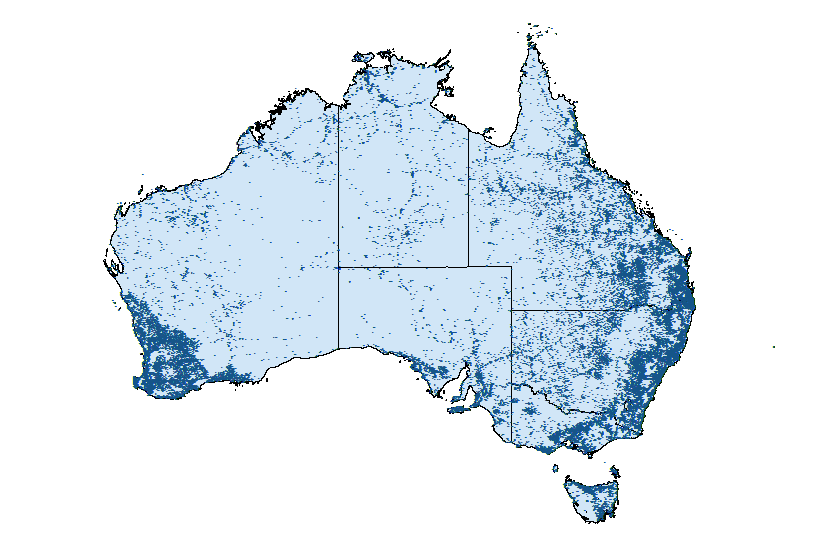

Source: Departmental analysis of 2016 broadcaster data

#### Travellers

Approximately 30,000 travellers rely on VAST to access FTA TV when they travel through areas without reliable terrestrial television signals. Several submissions, including the Isolated Children’s Parents’ Association of Australia (ICPA) and the Northern Territory Government, noted that the service was of particular importance for these travellers to receive emergency warnings and weather updates via satellite where internet access is limited. Travellers need to reapply every six months for access to VAST. (see also sections 2.3.5 and 3.1.2, conditional access)

#### Broadcaster and community retransmission sites

VAST serves more than just individual users; it has a role in distributing radio and television signals to terrestrial transmission facilities. The Australian Communications and Media Authority (ACMA) notes in its submission, remote commercial television broadcasters and the joint ventures use VAST to feed terrestrial broadcast sites in some areas. According to the ACMA, there are 49 sites in the Western Australian and 28 sites in the central and eastern remote broadcasting licence areas, and 48 community-licensed sites that use VAST to retransmit to their areas.[7] The ACMA advises that these community-licensed sites are generally in very small towns unlikely to be covered by commercial broadcasters and serve a total of around 22,000 people. Without VAST, other more costly input signal sources would have to be found, potentially making them unviable for these communities.

In addition to carrying television services, the VAST platform carries an extensive range of radio services. The ACMA advises ‘… many FM radio retransmission sites utilise VAST as the source of their national content.’ The ACMA roughly estimates there are 300 sites with national retransmissions and 500 sites sourcing community content.[8] This highlights the extent to which VAST has been integrated into the communications media landscape throughout regional Australia.

### Service delivery

#### VAST access and costs

In order to access VAST, users require a satellite dish of at least 65 cm in diameter and a VAST-certified STB. Users need to apply for and be granted access via the myVAST website. Although there are no costs to view VAST, viewers are responsible for their equipment costs and installation. There are self-help installation kits available but in general, installation is carried out by a professional satellite dish installer.

Figure 2: Examples of VAST equipment

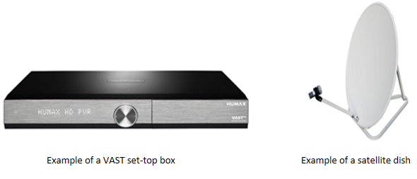

Source: <https://www.myvast.com.au/equipment>.

Depending on the type of STB purchased (see section 3.1.3, affordability and performance of end user equipment), a kit that includes the STB, satellite dish, and accessories, could cost around $400 or more. Installation, if hiring a licensed satellite dish installer, would be a separate payment. Users also need to consider their location when hiring a licensed installer, noting that many VAST users are in remote or very remote Australia, which is likely to increase the cost dependent on how far the installer has to travel.

#### Satellite delivery and lifecycle

In its submission to the Review, Optus described the role of broadcasters and Optus in the process by which content is loaded onto the satellite and received into VAST user homes. Figure 3 describes this process.

Figure 3: VAST delivery process

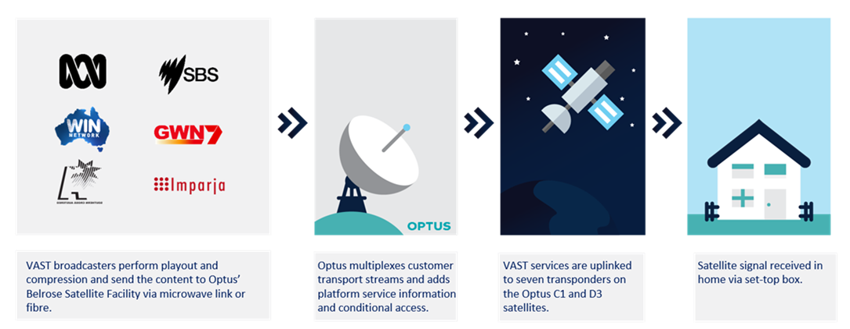

Source: Departmental infographic, representing a similar graphic provided by Optus in their submission, p. 7.

In a country the size of Australia, with a geographically dispersed population, satellite technology has been the only economical option for the delivery of communication services in some areas. VAST is delivered by Optus on two satellites—Optus C1 and D3. Optus notes in its submission that these satellites were specifically designed to cover the entirety of Australia’s landmass in terms of their orbital location, transponder configuration, beam shapes, and in terms of the receiving satellite dish.[9]

As the submission from the Australian Digital and Telecommunication Industry Association notes, these satellites are ageing but both are currently still suitable for delivering the VAST service.[10] Optus’ satellites, which host VAST, also carry a number of other services, including the Department of Defence (on the C1 satellite),[11] Foxtel and national Indigenous radio services. Optus has a separate product base for each service. Figure 4 describes the Aurora Digital platform from the Optus submission, indicates the types of service and customers, the product and technologies behind them on the Aurora Digital Platform. The term ‘bouquet’ refers to a collection of services marketed as a single entity, such as the group of VAST channels that a VAST user in a remote licence area is able to access.

Figure 4: Optus’ Aurora Digital Platform

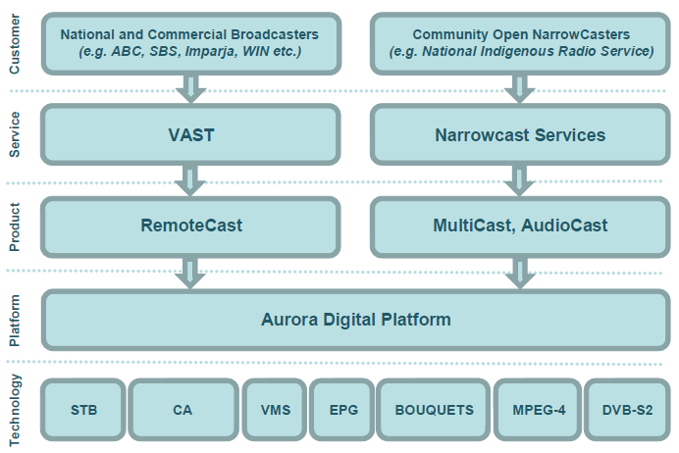

Source: Optus submission to the VAST Review Issues Paper, p.6.

#### Contractual arrangements with joint venture broadcasters

Viewers of VAST have access to both commercial (subject to access conditions) and national broadcaster (ABC and SBS) FTA TV services via Optus’s Aurora Digital satellite platform. Commercial FTA TV services on VAST are provided by joint venture companies formed from the broadcasters licensed to provide commercial FTA TV services in remote TV licence areas. Licences allocated by the ACMA to these joint venture companies authorise them to provide commercial FTA TV services via satellite into one of three satellite TV licence areas. The joint ventures are:

* **Eastern Australia Satellite Broadcasters Pty Ltd** (EASB—Imparja and Southern Cross Austereo): South Eastern Australia, Northern Australia, Norfolk Island
* **WA Satco Pty Ltd** (WA Satco—WIN and GWN7 (Prime)): Western Australia, Christmas Island and Cocos (Keeling) Islands Territories).

The satellite licence areas and joint ventures are illustrated in Figure 5.

Figure 5: Providers of VAST commercial TV services in the three satellite licence areas

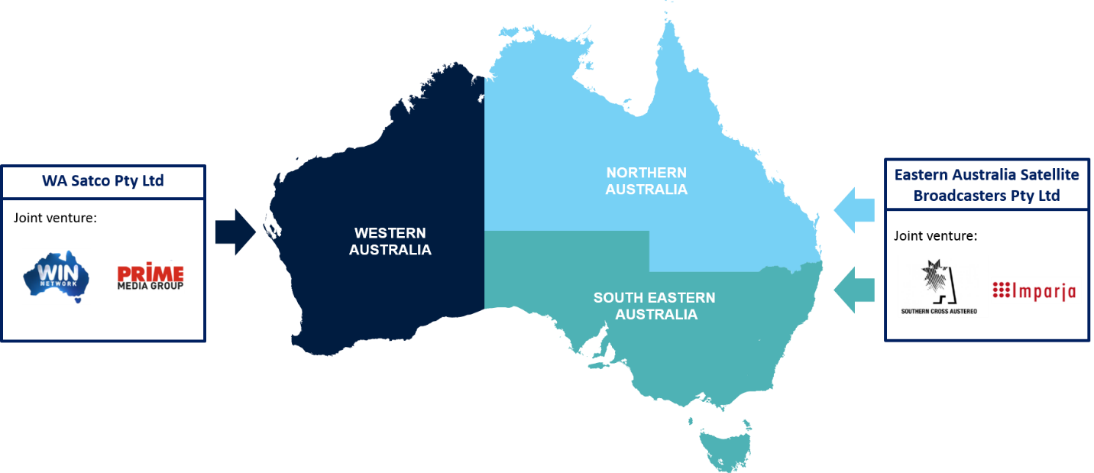

Source: Departmental analysis

The Department of Communications and the Arts manages two funding agreements with EASB and WA Satco. Additionally, RBAH represents the commercial television broadcasters who hold regional and remote area television licences.[12] RBAH was formed to take on the role of the VAST conditional access scheme administrator. On behalf of RBAH, Southern Cross Austereo (SCA) manages the day-to-day operations of the conditional access schemes. Optus applies conditional access when uplinking content to the satellite. Indigenous radio and TV services and the national broadcasters (ABC and SBS) are not subject to conditional access rules.

There are legislative requirements (see section 2.2.1, satellite broadcaster obligations) and conditional access arrangements (see sections 2.3.5 and 3.1.2, conditional access). EASB and WA Satco have met these requirements.

Both joint ventures are required in their contracts to provide FTA TV services that are as equivalent as possible to terrestrial services in metropolitan and regional licence areas. The total value of the contracts over 10 years by 30 June 2020 when the contracts end is $127.5 million (GST inclusive) broken down as follows:

* EASB—$82.8 million (GST inclusive)
* WA Satco—$44.7 million (GST inclusive).[13]

#### VAST channels

Viewers of VAST have access to both commercial and national broadcaster FTA TV services. The channels available on VAST vary in each region slightly, which is explained in more detail at Appendix 2. The satellite broadcasters provide a minimum of nine commercial channels, mainly drawing on content from the Seven, Nine and Ten networks. VAST also carries the full suite of the ABC and SBS TV services. Available channels are at Table 2.

VAST ensures that 100 per cent of Australian homes are able to receive ABC and SBS digital television transmissions. ABC and SBS also provide separate services for their primary and secondary channels in different states. In addition to TV channels, VAST carries a range of ABC and SBS radio services, along with a number of additional video and audio services, including Indigenous services supported by the Department of Prime Minister and Cabinet under its Cultural and Capability Program.[14]

In the Northern and South-Eastern satellite areas, the VAST service includes a dedicated regional news carousel, containing nightly bulletins from regional commercial FTA TV broadcasters. In Western Australia, regional commercial news bulletins are included in the main broadcast channels and so there is no need for additional dedicated news channels. Sky News was also added to the WIN bouquet in Western Australia on 2 September 2018.

Table 2: Current VAST TV channels

|  |  |  |  |  |
| --- | --- | --- | --- | --- |
| **Satellite TV  licence area** | **Broadcaster** | **Commercial channels** | **National broadcasters** | **Other services** |
| Northern  Australia | EASB | **Southern Cross 7**; 7mate; 7TWO  **Imparja Nine**; NineGem; NineGo!  **Ten;** One; 11 | **ABC;** ABC HD; ABC Comedy and ABC KIDS; ABC ME; ABC NEWS  **SBS;** SBS HD; VICELAND; Food Network; NITV | ICTV; 3ABN: regional commercial news channels |
| South Eastern Australia | EASB | *As above* | *As above* | *As above* |
| Western  Australia | WA Satco | **GWN7**; 7Two; 7Mate; Racing.com; ishopTV;  **Nine**; NineGo; NineGem;  **WIN**; 11; WinHD; One; Gold; TVSN, Sky News | *As above* | ICTV; 3ABN |

Source: Departmental Analysis.

#### Conditional access

Not all Australians are able to access commercial broadcasting via the VAST service. Aside from travellers, who need to apply every six months, the conditions of access to VAST depend on where households or businesses are located and whether they can access reliable terrestrial television coverage. The rules vary between geographic areas as follows.

Table 3: Categories of conditional access

| Category | Description |
| --- | --- |
| **Category A and B** | Areas that are included within the related remote television licence areas are Category A. Areas elsewhere in Australia, where industry-accepted coverage modelling suggests terrestrial reception is not available are Category B areas. People in these categories receive automatic access to VAST but must still apply for access. |
| **Category C and D** | Category C and Category D (applies to Western Australia only) applicants are expected to receive adequate reception. Both category applicants must apply to the scheme administrator for a reception certificate to demonstrate their lack of adequate reception. |
| **Service deficient areas** | Additionally, areas where the ACMA is satisfied that the number of terrestrial commercial services is less than the number of services required to be provided under a s38C licence are considered to be declared service-deficient areas. Persons in these areas have automatic access to VAST. |
| **Travellers** | Additionally, to the four categories above, people who register with the intent of travelling in areas without reliable transmission are treated in the same manner as those within Category C, in that they must apply and be approved. Travellers receive a temporary reception certificate and must reapply every six months.[15] |

Source: ACMA, 2017, Viewer Access Satellite Television, accessed 27 July 2018 at [www.acma.gov.au/theACMA/conditional-access-schemes-digital-switchover-i-acma](http://www.acma.gov.au/theACMA/conditional-access-schemes-digital-switchover-i-acma).

Conditional access to VAST provides protection to commercial broadcasters of their licence areas. Conditional access operates as a ‘walled garden’ with a gatekeeper, in VAST’s case, Optus as the satellite operator, which controls access to VAST via certified STBs.

In general, under the BSA, broadcasters are not allowed to transmit into another licence area. Prior to VAST’s implementation broadcasters argued controlling who had access to VAST would minimise audience loss, particularly from regional TV licence areas given VAST is a satellite service and transmits Australia wide.

### Changes in viewer trends

#### Emergence of video-on-demand

Video-on-demand is a system that allows users to select and watch video content of their choice on their TVs, computers or other connected devices. Video-on-demand includes ‘catch-up’ services such as iView and subscription services such as Netflix and Stan.

In Australia, the emergence of subscriber video-on-demand (SVOD) service providers has changed the media landscape. The ACMA reports that around 62 per cent of all Australians have a TV/video paid subscription.[16] On average Australians watch 4.7 hours of online television (catch-up TV, subscription services and free content) each week, although this varies significantly depending on age. Australians in the 18–34 demographic watch 9.2 hours a week of online television, while Australians in the 65+ age bracket only watch 0.9 hours a week.[17]

Online TV viewing figures suggest the internet has become another platform for content distribution in addition to FTA TV and satellite-based subscription television.

#### Difference of Australian market to other broadcasting markets

The main factor setting Australia apart from other comparable markets is that FTA terrestrial services remain dominant in Australia, due primarily to historically low take-up rates of subscription services. In contrast, the United States, Canada and Europe have a much higher rate of subscription television penetration across all platforms. Australian satellite subscription television operator Foxtel has just over 2.8 million subscribers (around 30 per cent of households) which is still relatively low in comparison to other countries.[18] The situation is very different in the US, where, for instance, approximately 73 per cent of all households subscribe to a type of subscription television service.[19] FTA broadcasters have maintained a central place in our media landscape as a result.

The launch of SVOD providers in recent years is changing the way television is consumed; in June 2017 there was an estimated 3.7 million subscriptions compared to 2.7 million in June 2016.[20] The biggest SVOD player in Australia is Netflix, which in 2018 according to Roy Morgan has around 3.9 million subscribers.[21] However, SVOD is still largely used to complement FTA.

While FTA TV broadcasting is the dominant viewing platform in Australia, there are challenges to the efficient operation of the FTA market. Sparse population density in some parts of Australia has resulted in a lack of economic return for broadcasters, which provides a disincentive to invest in these areas. Governments have subsidised satellite delivery to ensure that all Australians are able to have access to FTA television where the market would not otherwise deliver it.

#### Content availability

While the volume of content available to Australian households unable to access terrestrial television has increased significantly, FTA TV continues to be the national platform through which Australians watch television. In June 2016, FTA TV accounted for 50 per cent of Australians’ viewing of video content while video content delivered by an online subscription-based service accounts for 15 per cent of the time spent watching TV.[22]

The Review has used regional viewing patterns to indicate trends which are likely to be replicated by VAST users (given 91 per cent of VAST users are in regional or remote Australia). In regional markets there has been a decline in the hours of television watched since 2014. The average daily amount of time spent watching television has decreased from a high of 3 hours and 24 minutes in 2014 to 2 hours and 53 minutes in 2017. The 2016–17 period saw the average daily viewing drop by 15 minutes.

Older demographics in regional areas watch more television per day than younger cohorts. Individuals over 40 years watch 4 hours and 11 minutes compared to the average of 2 hours and 53 minutes.[23] The 65+ cohort makes up 34 per cent of the total regional population.[24]

Figure 7: Hours spent watching FTA TV daily in regional markets, 2013–17

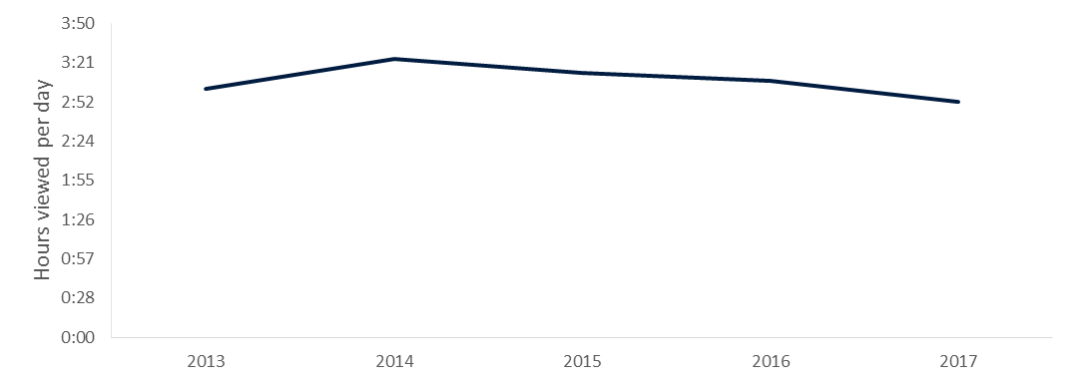

Source: Departmental analysis of Regional TAM year in Review 2013–2017.

Overall, while there has been a decline in the number of hours in recent years, audience trends indicate that now and into the foreseeable future FTA television remains important to regional households and that internet-based platforms are not being used as a substitute for traditional television.

#### Advertising revenue in the Australian broadcasting market

While relatively stable nationally, broadcaster advertising revenues are not keeping up with inflation. Overall, Australians are watching less FTA television. As a consequence, advertising demand is also falling. While revenue from online television advertising is increasing (e.g. from catch-up services) it is still only a minor source of income.

Figure 8: Sources of advertising revenue for Australian television, 2016

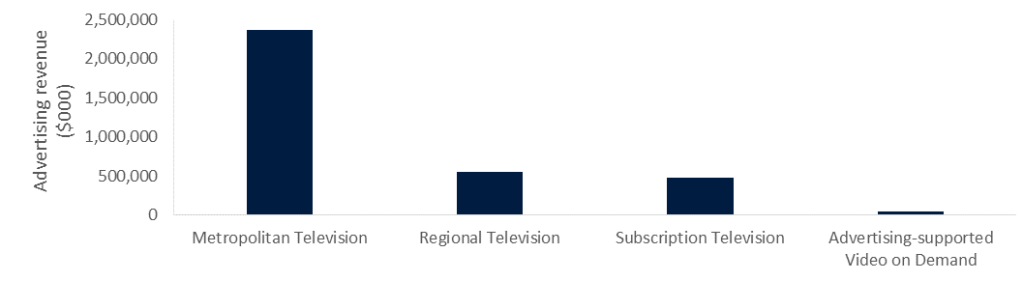

Source: Departmental analysis of 2016 Commercial Economic Advisory Service of Australia figures.

Regional FTA broadcasters are also facing the challenge of declining advertising revenues. Research suggests many large businesses do not consider regional markets as essential for their campaigns due to the smaller population base. Television advertising in these regions is often used to promote small businesses and as a result, the broadcasters have correspondingly lower revenues.[25]

Figure 9: Regional yearly gross advertising revenues ($000) 2010–15

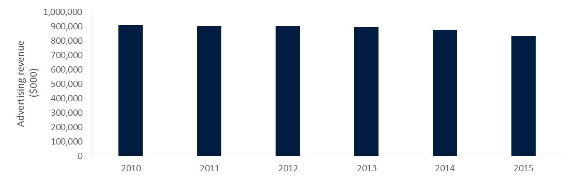

Source: Free TV media releases 2010–15.

In their submission, Imparja noted that in 2009, the remote Central and Eastern Zones had a total revenue of $19 million shared between two channels. In 2017, this market had shrunk to $17.5 million shared between nine commercial channels.[26] In addition, Imparja noted that many of the services they carry on the VAST platform are debt laden and carry severe financial impairment. These commercial pressures indicate that there is limited capacity for broadcasters to expand financial contributions towards VAST service delivery.

### Changes in technology and distribution networks

Developments in technology have driven changes in people’s viewing habits, particularly increases in the capacity and efficiency of digital distribution networks. Greater access to broadband, for example, has already significantly altered Australia’s communications landscape. This and other technologies will have an impact on regional areas over the coming years.

#### National Broadband Network (NBN)

The NBN is being progressively rolled-out to all households across Australia, and is expected to be completed in 2020. It utilises a mix of delivery technologies to provide fast broadband, including fixed line, fixed wireless and satellite, with a minimum target of 25 megabits per second. The NBN is already providing access to millions of households for on-demand video streaming and other services.

Video delivered over broadband usually operates on the principle of ‘best efforts delivery’. This means that most packets of data will be routed across all available network pathways in the most efficient way possible, but they will not have guaranteed priority. This can result in delays for users such as the intermittent buffering of video streaming services.

Importantly, video traffic carried over broadband networks drives data usage. While some NBN plans offer unlimited data, most Australian retail broadband plans are subject to data caps. As a general rule, the greater the data allowance the greater the cost of the plan. As discussed later in the report, delivering FTA TV over broadband networks has implications for data usage, meaning TV would no longer be free unless the data was zero rated.

#### Technical standards

VAST is broadcast via two Optus satellites using DVB-S2 modulation carrying MPEG-4 encoded programs. This is a very reliable service model and almost no complaints were raised in submissions about the technical foundations of VAST. However, technology has moved on since VAST commenced, and newer standards are available for consideration. For instance:

* The DVB-S2X standard developed in 2014 is an extension of DVB-S2, and offers a number of improvements. It has better back-end functionality, and more options for delivering ultra-high definition (UHD) channels.
* The High Efficiency Video Codec (HEVC) compression standard is a successor to MPEG-4, and roughly twice as efficient as its predecessor. It has been used extensively overseas in trials of UHD television, and some advanced STBs already support it.
* MPEG-4 itself has developed over time, and one broadcaster (Imparja) stated in its submission that tests with the latest encoding equipment showed that throughput could be improved by a significant margin, without requiring upgraded STBs.[27]

These advances, if implemented, could enable a greater number of services, or services with higher resolution, within a given amount of bandwidth. But implementation will, in most cases, require an upgrade to user equipment due to a lack of backwards compatibility between new standards and the current suite of STBs. An immediate update of standards would require all STBs to be replaced. Under current program settings, end users would be responsible for any equipment upgrade costs. However, as with all consumer electronics, the VAST STBs will eventually reach end of life and require replacement. The replacement of STBs over time, however, may present an opportunity to incrementally transition to new technology standards, as long as there is also backwards compatibility for users who have not yet upgraded.

#### Mobile/wireless

Mobile network operators have invested billions of dollars into extending 3G and 4G mobile coverage across Australia in recent years. These networks have become increasingly capable of delivering mass media video services; in some instances, network operators offer promotional deals which bundle video-on-demand services, such as Netflix, with mobile plans, often with generous data allowances. Network extensions have also been funded by the Government through its Mobile Blackspots Program.

In reality, there is unlikely to ever be 100 per cent coverage of the population achieved via terrestrial mobile towers. This is due to factors such as cost, the availability of backhaul suitable sites with access to mains power, as well as difficult terrain and vegetation, and the increasingly small size of the markets being served.

In Australia, the mobile market is preparing for the introduction of 5G technology promising improved connectivity, greater network speeds and bandwidth, and very low latency. 5G will enable a range of use cases, including more and higher quality video services to multiple users with full mobility.[28] However, this will take some time to be realised, as 5G standards and equipment are still being designed and at this early stage, it is unknown if 5G could be an IP-based alternative to satellite-delivered television or what the coverage may be in regional and remote Australia.

A significant factor for consumers is that, as with the NBN, delivering FTA television over mobile networks has implications for data usage. At the time this report was written, data allowances on mobile plans were typically less than plans offered through alternative broadband networks, such as the NBN fixed line or fixed wireless networks.

## Findings and recommendations

Findings and recommendations have been developed having regard to the:

* effectiveness and efficiency of the current FTA TV services via VAST; and
* options relating to the delivery of FTA TV services in areas that do not receive a reliable local terrestrial FTA transmission.

The Review’s assessment has been informed by stakeholder feedback. In considering the 33 submissions provided through the public consultation phase (see Appendix 1), a number of general themes emerged:

* **The current VAST service is fit for purpose**: The clear and unanimous message from all stakeholders was that VAST has performed very well since its inception and it has successfully delivered its program objectives. All stakeholders strongly supported VAST continuing, either in its current form or with minor changes. Individual viewers were especially keen on this outcome, as most do not have access to a reliable alternative service.
* **Satellite is the preferred platform for service delivery**: Stakeholders agreed that satellite delivery will remain the best option for the foreseeable future. RBAH believes that ‘… satellite delivery remains the best and most reliable option. As a one-to-many service, it is technically provisioned for delivery of free-to-air television services.’ The ACMA noted that ‘… providing universal terrestrial TV coverage to all Australians is not possible. Some kind of satellite service is also unavoidable for input feeds to the many terrestrial transmitters that it is not cost-effective to supply with programming in any other way’. Further, the Community Broadcasting Association of Australia (CBAA) expressed support for VAST as a ‘… valuable, cost effective, highly reliable and fit-for-purpose platform for distribution of community broadcasting related radio content’.
* **The NBN is not considered viable for FTA TV service delivery in the foreseeable future**: Many stakeholders were concerned about the ability of the NBN to provide an acceptable substitute (e.g. via catch-up streaming services) to VAST, at least in the short term. Variable speed, data charges and monthly caps on satellite broadband are currently limiting factors. RBAH noted that ‘… it is unreasonable to expect viewers located in regional and remote areas to risk breaching their data caps to watch content that viewers located in metropolitan areas can receive terrestrially and free of charge.’

While there was overwhelming support for the continuation of VAST, there is room for improvement. Stakeholders raised concerns regarding:

* conditional access as it imposes extra complexity, costs and delays in obtaining a service (section 3.1.2)
* a lack of relevant local content (section 3.1.1)
* the VAST service not continuing to be equivalent to terrestrial services. Not all metropolitan HD channels and other newer channels (such as 7flix, 9Life) are available on VAST (section 3.1.1), and
* the higher cost and limited range and functionality of the VAST STBs (section 3.1.3).

### Effectiveness and efficiency of the current FTA TV services via VAST

**Key Finding 1:** The VAST service is effective and fit for purpose in providing a FTA metropolitan television service equivalent. While efficient, there are opportunities to optimise end user experience and administrative aspects of the program.

In considering the effectiveness and efficiency of the current VAST service, the Review has assessed:

* the extent to which VAST achieves Government policy objectives
* service performance
* conditional access.

#### The extent to which VAST meets Government policy objectives

The VAST program was established to help drive the transition to digital-only television broadcasting. The primary policy objective of VAST was to ensure all Australians could access FTA TV, regardless of where they lived. VAST was designed to provide FTA TV services to people residing in digital terrestrial signal deficient areas. The intent was for people in these areas to receive the same television services that were available in metropolitan areas. VAST has played an important role in the digital switchover, and it continues to provide a free, accessible digital TV service to over 200,000 Australian households, with increasing levels of uptake since it was first introduced in 2010.

In this context, a key consideration is the extent to which VAST provides a metropolitan comparable service. The Review notes that FTA television services in Australia vary based on the location of the viewer and the services provided by broadcasters in those areas. When VAST was established, it provided the full range of channels, equivalent to those received in metropolitan and regional licence terrestrial service areas. However, as Free TV noted in its submission, additional channels have been introduced on terrestrial services since VAST launched (such as 7flix and 9Life), yet the new channels have not been introduced onto VAST because there is not a strong case for commercial returns. This means VAST does not currently provide a fully comparable service to metropolitan and regional licence areas.

Several submissions from VAST users noted that they would prefer to receive the full suite of television stations available in metropolitan areas. Some stakeholders were concerned by the lack of HD channels available on VAST and in addition, VAST viewers in the EASB service area receive different services to viewers in the WA SatCo service area. A comparison of channels available in metropolitan, regional and VAST areas is listed at Appendix 2, and explained at Figure 10.

Figure 10: Comparison of FTA services available to metro, regional and VAST viewers

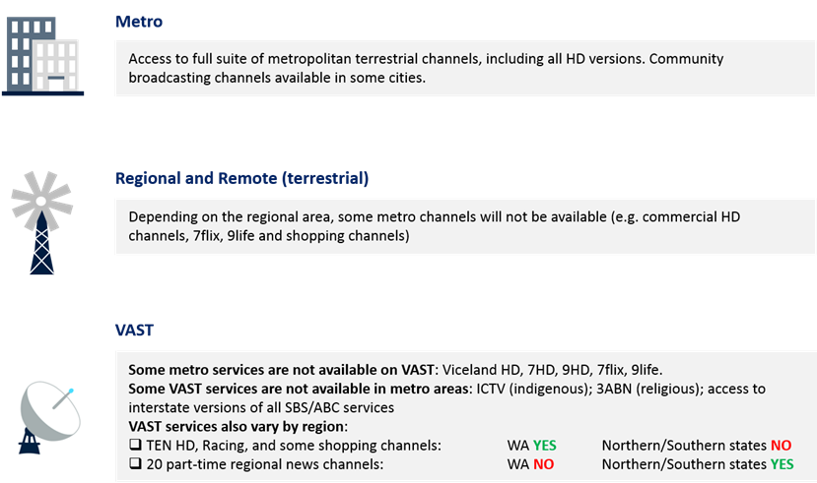

Source: Departmental analysis of channels available on http://www.freeview.com.au/tv-guide/ and <http://sattvguide.com.au/>.

Imparja stated that the business case for any additional services would need to be, at worst, revenue neutral. Additionally, EASB in its submission noted ‘… without additional funding, it remains uneconomic for Imparja, RTV and CDT to make these additional channels available in the RCE licence area’.[29] Free TV similarly expressed a desire for additional funding to improve the variety of services available on VAST.

The Review recognises that regional commercial broadcasters operate in a ‘thin market’. As described in section 2.4.4, regional advertising revenues have decreased in recent years, with regional broadcasters facing increased competition from online sources as well as increased content costs. Such commercial factors have negatively influenced the ability of broadcasters to increase VAST services in line with additional metropolitan services that have been introduced since digital switchover.

A key characteristic of the VAST program is how it delivers local news. VAST broadcasters are obliged to provide all first-run local news bulletins that are provided by regional broadcasters in the regional licence areas covered by the VAST footprint, as part of their funding and licence arrangements, as a supplement to programming sourced from the larger population centres. The ABC also provides versions of its primary television channel tailored to each state and territory (except the ACT), which the commercial broadcasters do not.

Most VAST users who provided submissions stated they were satisfied with the local news content. These comments reinforced the view that news was a critical part of the VAST service, without any obvious substitute. The 2018 *Digital News Report* survey indicated that Australians in regional and remote areas are more reliant on offline platforms to access news than those in major cities. Australians in outer regional locations (45 per cent) and Australians in remote or very remote locations (48 per cent) identified television as the most relied upon medium for receiving news.[30]

The Review is aware that over the life of the program, complaints have been made by viewers that some advertising and sporting material on VAST is unsuited to their location. This is due to the large size of the broadcast licence areas that VAST serves. Particular attention in individual submissions was drawn to Northern Territory advertisements being broadcast in NSW and Queensland. VAST users also raised concerns about a lack of relevant local emergency warnings and local election advertisements. The District Council of Kimba (South Australia), in its submission to the Review, noted the lack of relevant local advertising on VAST limited the information available to its residents, such as local and state government election material.[31]

The Review notes that the availability of regional news bulletins targeting particular areas may provide opportunities for broadcasters to screen local advertising. The Review noted, for example, one of the Southern Cross Austereo news services in South Australia contains local banner classifieds for communities and businesses in the Spencer Gulf region (South Australia). The following screenshots are examples of local banner classifieds from the region.

Figure 11: Spencer Gulf area classified ads on VAST

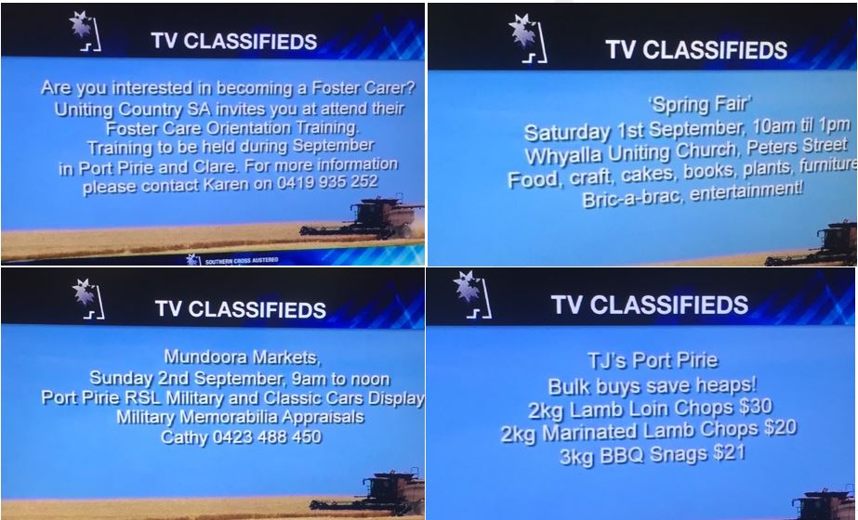

Source: Department research.

Additionally, the broadcast of radio over VAST may provide some local content to VAST users. The ABC, for example, provides a number of radio services over VAST. The ABC stated in its submission that its terrestrial analogue local radio covers 99.58 per cent of the population, although the Review notes ABC local radio stations are, in the main, not available on VAST. This may limit the availability of local emergency and other information where people in regional and remote areas are not able to access local AM and/or FM radio stations. [32] Several submissions indicated they receive no AM or FM radio in their local area. Mr Alan and Mrs Judith Smedley from Ravensdale in NSW, who referred to the VAST service as ‘substandard’, said in their submission to the Review, ‘Radio broadcast via the VAST system or from the Internet is our only way of receiving any form of reception in our valley so for us it is an invaluable service given our location.’[33] The Review considers that improving local radio content over VAST would be a better outcome for those unable to receive terrestrial radio transmissions over the AM and FM bands.

The Northern Territory Government, in its submission to the Review, suggested that following the cessation of the ABC’s shortwave radio service in January 2017, VAST is ‘… now the only remaining free means, and for almost half of the population in remote NT areas, the only means of receiving information from the outside world.’ The Review was further advised by the Northern Territory Government that of the 54,000 Territorians who live outside major population centres, there are approximately 28,000 residents who ‘… only have access to ABC services via a static service such as VAST.’ The Review considers that local content, particularly emergency information and community announcements, should be a consideration for future programs.

The Review considers that television content delivered on the VAST service generally aligns with the expectations of users. Further, in terms of metropolitan equivalence, the Review finds that the majority of channels available in metropolitan areas are available to VAST users and feedback received through submissions indicates an overall level of satisfaction with the program. Broadcast Australia summarised the views of almost all stakeholders when they stated that the VAST service has been effective over the last eight years in delivering FTA television to households in areas not able to receive reliable terrestrial FTA coverage.[34]

In addition to meeting the objective, the VAST service is not only popular, but is considered as an essential communication service for many viewers in regional and remote areas with little or no access to alternative services. For example, the Northern Territory Government described VAST as an indispensable service to some of the most remote areas of Australia,[35] which was echoed by Mr Ken Webb from NSW who wrote ‘… if we did not have a VAST, or equivalent scheme, we would not have any television coverage at all’.[36]

VAST is also a cost-effective alternative to a large number of licensed and unlicensed community ‘self-help’ transmitters which otherwise would become the responsibility of the Government. These self-help transmitters would all have required upgrades (at significant expense) to manage the transition to digital transmission, and ongoing maintenance. Self-help providers in small regional and remote towns included local councils, mining companies and local community organisations. The Review recognises the successful contribution of this measure in achieving broader Government objectives resulting from the VAST roll-out package.

The Review determines that the VAST service is fit for purpose, delivering metropolitan comparable FTA television to users located in areas without reliable terrestrial coverage. This is a view supported by all stakeholders. VAST remains the most cost-effective and reliable means of providing services to remote communities, which would otherwise miss out. The Review also recognises there are some areas of the service where there is room for improvement.

#### Conditional access

Conditional access largely drives how end users apply for and gain access to VAST services. Conditional access is therefore a key determinant of the overall efficiency of the program, in particular how it relates to end user experience and program administration.

In Table 4 the Review has considered the strengths and limitations associated with conditional access.

Table 4: Strengths and limitations of conditional access

| Strength | Limitations |
| --- | --- |
| * **Market share:** limits viewers to those who cannot receive terrestrial broadcasts and protects market share in a broadcasting environment where revenues are smaller. * **Secure and controlled STB environment:** provides a secure environment for programming delivery, which ensures no interruption of service. * **Content licensing:** ensures broadcaster content licensing arrangements are protected. | * **Costs to broadcasters:** administrative and time impost on commercial broadcasters who administer the conditional access schemes. * **Cost to the ACMA:** administrative cost and time burden on the ACMA who considers appeals against rejected applications, cost of mySwitch administration and maintenance. * **Impact on end users:** time and potential monetary cost on end users, particularly travellers, rejected applicants who appeal, and rejected applicants who do not appeal and have to find alternative TV arrangements. * **Set-top boxes:** high cost and limited functionality of VAST certified set-top boxes. |

Source: Department analysis.

Related to conditional access is how it is implemented by Optus, which controls the VAST environment via certified set-top boxes. It is important to note that a controlled set-top box environment is not required for conditional access; it is simply one way of implementing it. More commonly, conditional access implementation via a STB is used in subscription-based pay TV models. VAST is not a subscription service but conditional access implementation via the set-top box does operate in the same way. By controlling the set-top box environment, Optus provides access to authorised users only. This type of implementation also ensures control of content and a more secure environment.

Optus has noted that although conditional access was a result of commercial licence areas, its interest is in regard to implementation, i.e. controlling the VAST environment to ensure there is no interruption of service. Optus noted a controlled set-top box environment enabled the ability to comply with Australian broadcasting standards, deploy firmware updates to STBs, make headend changes, make the platform more efficient, recover more quickly from a transponder failure, and deploy anti-piracy measures.[37] The Review acknowledges that an uncontrolled STB environment does not allow for this.

A closed broadcast environment also protects the broadcasters’ content licence agreements. As noted in section 2.3.5, broadcasters are, in general, not allowed to broadcast into another broadcaster’s licence areas; programming rights are territory-specific, e.g. live sports rights, as noted by the ACMA in its submission.[38] EASB also noted in its submission conditional access ensures each broadcaster’s FTA TV service is restricted to its own licence area. Given satellite TV by its very nature is designed for the whole of Australia, the only way to ensure the VAST broadcasters keep viewers restricted to their own licence area is by using a controlled environment.

As discussed in section 2.3.5, the original decision to implement a conditional access scheme was to protect broadcasting licence areas. At the time, regional broadcasters did not want to lose audience share to VAST where advertising revenues are smaller. The Review notes that there are disincentives for those viewers who receive adequate terrestrial coverage to apply for VAST. The costs of equipment are greater and the STBs have less functionality than non-VAST STBs that are similarly priced (see section 3.1.3). Also, a viewer who has terrestrial access is unlikely to apply for a service that does not receive all the channels available in terrestrial metropolitan and regional licence areas.

The Review finds the argument of loss of audience share is not a reason for maintaining conditional access. However, ensuring VAST licensees met their obligations in terms of content agreements is a strong reason to keep a controlled environment. By default, the controlled environment provided by VAST-certified set-top boxes allows broadcasters to maintain these agreements.

##### Costs of administering conditional access

Several industry stakeholders noted the cost of administering conditional access. RBAH and WIN contended that all of the administrative overheads and costs were carried by the commercial broadcasters. The ABC and SBS do not provide costs or resourcing to administer conditional access.[39] The Review, however, notes that the ABC and SBS, as well as Indigenous radio and television services, are not subject to conditional access arrangements. There is also a time and cost impost on the ACMA to consider appeals, though the Review has been advised by the ACMA that this is fairly minimal.

RBAH also noted that travellers make up the bulk of contact with the administrator and suggested an administrative ‘one-off fee’ to contribute to costs. Currently, travellers need to reapply every six months to retain access to VAST. The justification for having travellers apply every six months, as advised by the ACMA, was to ensure only genuine travellers applied and to ensure access ceased when they return to their home base.

The Review notes that current legislation does not deal with travellers. The different conditional access schemes deem travellers to be in Category C and they are issued with a temporary reception certificate. The Review also notes that a conditional access scheme cannot be varied, only replaced and the ACMA must be satisfied the old scheme is not achieving one or more of its statutory objectives.

The ACMA and Imparja noted they were aware of instances of unauthorised use of VAST where persons were granted traveller licences but lived overseas. The Review understands this is a minor issue with mainly anecdotal evidence, which industry is best placed to address; Imparja, for instance, suggested geoblocking signals outside Australia could be a solution. The Review believes the administration costs of traveller reapplications needs to be balanced against the possibility of misuse but notes a fee for travellers would not prevent any misuse.

RBAH has provided details on contacts with travellers, estimating 50–65 per cent of call centre interactions were with travellers, including:

* new registrations followed by the six month renewal cycle
* being nomadic across states, including seasonal variations, and assistance with technical setup issues
* processing and verifying decoder registrations where these are and bought and sold
* replacement decoders activations and old decoder disablements
* removing expired traveller certificates.

The Review finds that many of the administrative issues and subsequently cost for RBAH could be removed with an automated application process (in the same way that access to ABC and SBS services are automated) and greater technical help information being available. The Review considers a fee for travellers is unnecessary and there would be less of an administrative burden if travellers were provided with permanent access to VAST.

##### Applying for VAST

The Review notes that conditional access also imposes a burden on VAST users. Even if automatically eligible, there is an extra time and cost impost on users to gain access to VAST that those who receive terrestrial transmissions do not incur. A number of submissions from individual VAST users noted issues with the application process. In particular, these submissions observed it was an outdated application form, which was cumbersome, difficult to navigate, and not mobile friendly. The Isolated Children’s Parents’ Association of Australia (ICPAA) welcomed having a phone number to ring but suggested the process of two websites (mySwitch to check address and mysatTV for the application) was confusing. The Review understands this is as a result of having two separate organisations involved (ACMA and RBAH) but agrees the process can be unclear to applicants and that a single multi-functional portal would provide greater clarity. The single portal could be managed by either the ACMA or RBAH.

The Review recognises the importance of mySwitch in relation to conditional access, and its role as the ‘front counter’ for VAST. The ACMA absorbed the management function of mySwitch and related costs following the digital switchover but has managed to reduce mySwitch maintenance costs to approximately $70,000 per annum. The ACMA recognise the website is now quite dated, and may not be sustainable as maintenance and support becomes increasingly problematic. Indicative costs for an upgraded or replacement website are likely to be in the range of $100,000 to $150,000.[40] The Review supports the need for a new or upgraded mySwitch tool, which can be part of a single portal.

##### Application rejections

Category C applicants for commercial TV services on VAST are not automatically eligible to receive access. RBAH (as the administrator) and the ACMA (for appeal processes) both discuss the application and appeals process in detail in their submissions. RBAH states they assess eligibility using ‘… computer generated coverage prediction maps [with] regard to visual data such as the presence of trees, terrain, topography, nearby premises with high antennas, and satellite dishes that may impact reception.’[41] RBAH also state their assessments are reviewed by commercial broadcaster engineers located in the licence areas who have extensive knowledge of local coverage conditions. Should an application be rejected, RBAH provides applicants with tuning options for nearby transmitters.

Rejected applicants may appeal to the ACMA. In its submission to the Review, the ACMA noted a relatively small discrepancy between the ACMA’s modelling maps, which predict coverage, and the broadcasters’ modelling maps, which test eligibility. The broadcasters’ modelling predicts larger Category C areas.[42] This has the subsequent issue of a person believing they are eligible for VAST based on the ACMA modelling but in terms of eligibility, the commercial broadcasters believe there should be coverage and that the person needs to apply for a VAST reception certificate.

The appeal process is time consuming (taking around 6–8 weeks as appeals are bundled into monthly lots). All appeals have been successful. The ACMA gives RBAH an opportunity to provide evidence the applicant has adequate commercial reception but notably, since the scheme commenced, the administrator has only provided evidence once.[43] Given this is the case, the Review finds there is considerable scope for updating how applicant locations are assessed to reduce the time, cost and regulatory burden on both RBAH and the ACMA.

Overall, the Review considers there is a solid basis for maintaining conditional access, particularly in how it supports a secure environment for content delivery and programming obligations. However, there are opportunities to improve efficiencies and administrative overhead, including the application and appeals process, and particularly the modelling used to assess VAST applicant locations.

#### Affordability and performance of end user equipment

While the Review finds that the VAST program is effective at providing a metropolitan comparable service, in assessing the effectiveness of the program, consideration is needed regarding the extent to which VAST end user equipment is affordable and performs adequately.

There are no subscription fees or ongoing costs to view FTA TV via VAST. Viewers are required to purchase and maintain their own satellite reception equipment to access the VAST service and a VAST-certified STB. Generally, feedback from individuals regarding VAST STBs was positive noting that the equipment was easy to purchase and reasonably durable.

While generally satisfied with the VAST equipment, several submissions noted that VAST-certified STBs have a higher cost and more limited functionality than non-VAST STBs. A comparative analysis of various STBs conducted by the Review confirms that VAST STBs are generally more expensive than comparable terrestrial, subscription (which often are part of a plan, similar to mobile phones) or non-VAST certified STBs. Appendix 3 shows an entry-level VAST STB retailing for $279, while the equivalent terrestrial STB can be found for $58 and an unlocked satellite STB retails for $160.[44] This aligns with the experience of viewers who raised the issue of STB prices through their submissions.

Notwithstanding the discrepancy in price between VAST STBs and other types of STBs, however, the Review considers that STB pricing has not been an impediment for eligible users to access the service.

Optus noted that a controlled STB environment has benefits that improve the reliability of the service. Since the launch of VAST, Optus has issued updates to correct software bugs and activate new features. Optus stated that if the STB environment was uncontrolled it would be more difficult to deploy firmware updates and ensure compliance with Australian broadcast standards. However, the ACMA has noted that conditional access can also be implemented with an uncontrolled environment, e.g. in any compatible STB that allows insertion of a smartcard.[45]

Aside from their cost, several stakeholders noted that VAST-certified STBs also have limited functionality when compared to modern terrestrial STBs. Modern terrestrial STBs are designed to serve a number of different functions and integrate a wide range of technologies, such as internet protocol (IP) based streaming, VAST STBs are, however, designed solely to decode the VAST signal. Fetch TV noted that it had developed a proprietary STB that was able to combine multiple tuners, personal video recorder (PVR) capabilities and access to IP over-the-top (OTT) services. The Review notes that this is a solely an IP-based solution which is not available for VAST at this time. Departmental analysis in Appendix 3 indicates VAST STBs do not have the same functionality as pay TV or terrestrial STBs that are similarly priced.

In addition to lacking modern functionality, there are concerns regarding how future proof the existing fleet of VAST STBs is. The ABC noted that since VAST was launched there have been advances in STB technology that have not been taken advantage of, including internet connectivity to access online services such as iView. Optus noted that they have been working with manufacturers to introduce new features to VAST STBs such as advanced PVR features and access to online video services.

In general, the VAST-certified STBs cost more than terrestrial equivalents and have less functionality. The controlled environment has technical benefits, but the Review found it has led to a lack of competition and has resulted in higher prices for end-users of VAST. Industry working to improve choice in the set-top box market would provide better outcomes for consumers.

#### Indigenous VAST access issues

The VAST equipment has been more of a concern in remote Indigenous communities. The Indigenous Remote Communication Association’s (IRCA) submission noted that when VAST was rolled out many STBs were not installed properly, leaving them exposed to damage.[46] The higher price of VAST STBs and the generally lower‑socio economic status of remote Indigenous communities makes the replacement of VAST equipment challenging. The easy removal of smartcards means they often go missing and there is also a lack of information regarding smartcards (particularly that they are locked to a single STB).[47] The 2016 Remote Indigenous Communications and Media Survey found that only 64 per cent of households in remote indigenous communities reported having working VAST equipment.[48]

Given the investment made by Government to provide VAST equipment in remote Indigenous communities the Review considers there should be consideration given to the ongoing care and maintenance of that equipment. The Community Development Programme provides opportunities to support job seekers in remote Australia to build skills, address barriers and contribute to their communities through a range of flexible activities. Recent reforms to the program introduced 6,000 subsidised jobs for remote Australia.[49] Local businesses in remote Indigenous communities may wish to make use of this program and train local VAST repair and maintenance staff.

### Options relating to the delivery of FTA TV services in areas that do not receive a reliable local terrestrial transmission

**Key finding 2:** Following an examination of all available options, compared to current satellite delivery arrangements, no viable alternative is available now or in the near future that offers equivalent or improved service delivery.

In considering options relating to the delivery of FTA TV services in areas that do not receive a reliable terrestrial FTA transmission, the Review has considered the extent to which alternative delivery platforms exist, including the NBN. Consideration is also given to whether new transmission technologies provide opportunities for future service delivery.

Adopting a new technology would likely result in significant transitional costs. A new technology, such as alternative satellite technology, non-satellite technology, or even using a different frequency band (e.g. the Ka broadband spectrum band) is unlikely be backwards compatible with existing VAST STBs and satellite dishes. Other frequency bands may also require different low-noise blocks on satellite dishes and dish size requirements may even be different. If any alternative option for delivering TV via satellite was technically feasible, consideration would need to be given to the costs associated with replacing the equipment and infrastructure needed for access.

#### The NBN

The NBN, as a nation-wide high-speed broadband network supports the delivery of video services. Given that an NBN connection will be made available to every eligible premise in Australia, the Review has considered the extent to which the NBN can or could support the delivery of FTA TV.

The NBN is delivered through a mix of technologies including fixed line, fixed wireless and satellite. The map in Figure 12 shows an overlay of the coverage of NBN technologies and VAST users. This map demonstrates that while some VAST recipients have access to NBN fixed line and fixed wireless technologies, the majority of VAST users would be reliant on Sky Muster for internet access. A key question, therefore, is whether the NBN satellite network could support FTA TV.

Figure 12: NBN fixed line, fixed wireless and satellite coverage and VAST user locations

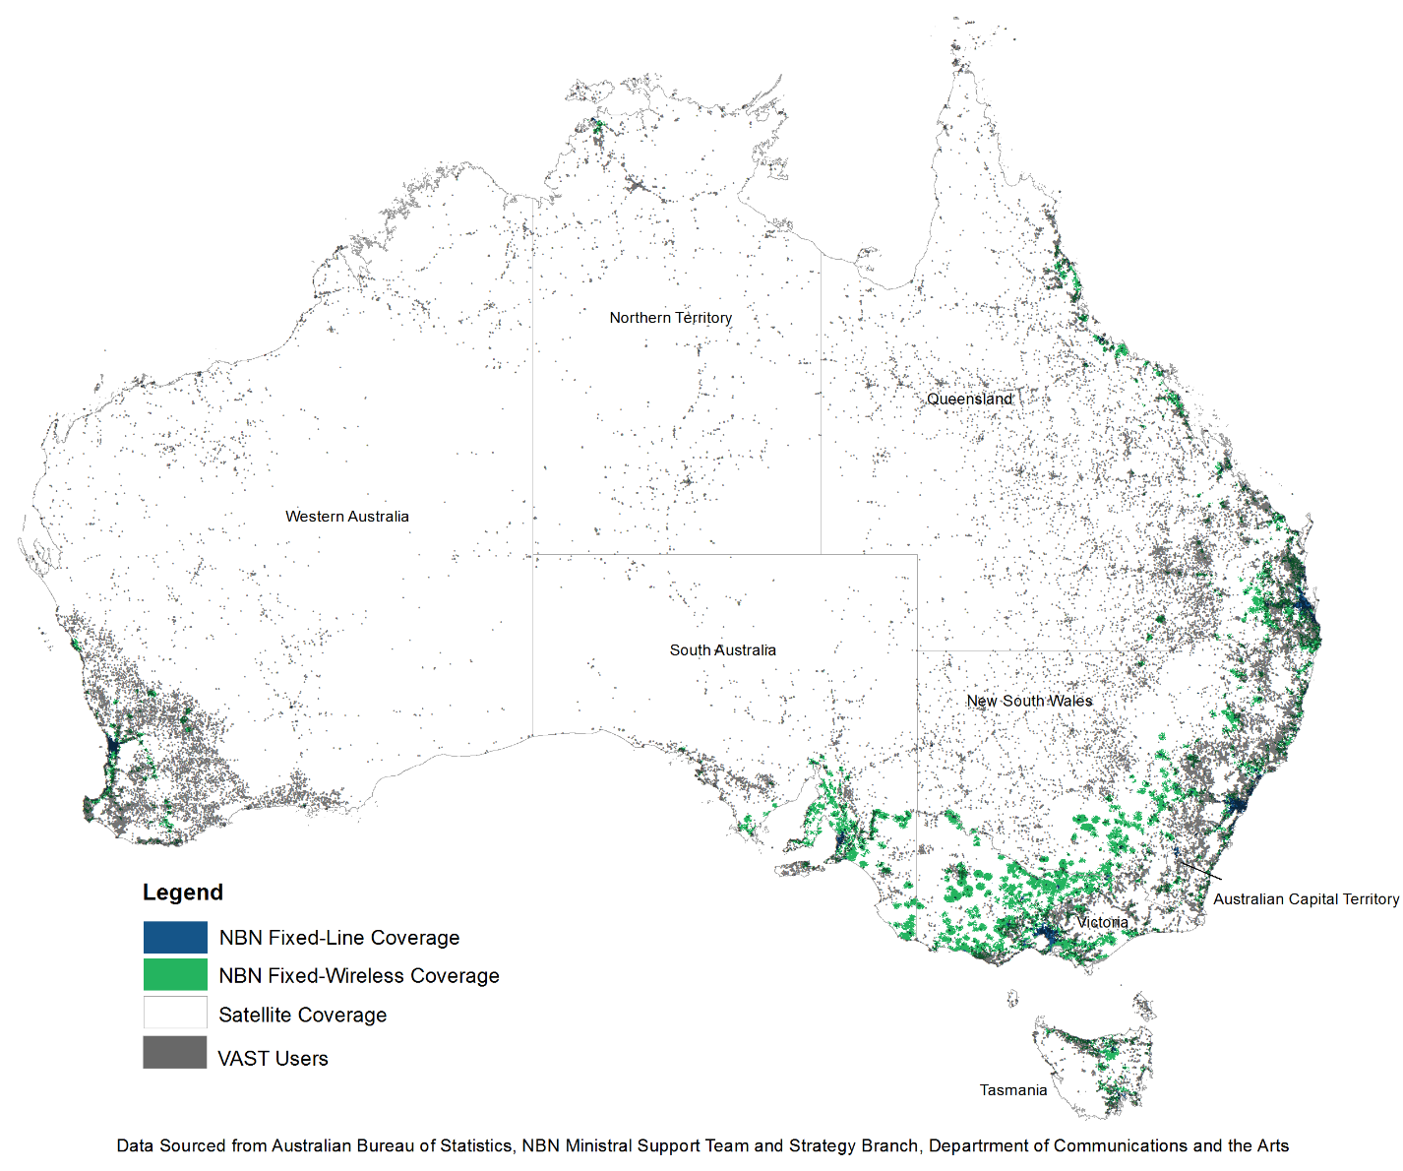

In terms of technical capability, the NBN satellite network is able to support standard and high definition video transmission. This is evidenced by the satellite network’s support of video-on-demand and catch up television services. Importantly, video transmission on the NBN satellites would be delivered using IP. When considering a VAST equivalent service over IP, this means that FTA TV would need be converted into an IP-based data stream. This would also require users to have equipment that could receive an IP-based video data stream.

The two NBN Sky Muster satellites are designed with a lifespan of around 16 years, which means they will require replacement around 2031 based on their 2015–16 launch dates.[50] Both Sky Muster satellites operate on the Ka band, which is generally used for national and regional broadband connections. The Optus satellites that currently deliver VAST operate on the Ku Band, which is used for broadcasting, including direct-to-home television services.[51]

Production cycles for commercial satellites vary, but often require at least two to three years, or longer for more complex productions. The Sky Muster satellites took about three years to build.[52] The long-lead times take account of defining user and system requirements, procurement activities, and arranging regulatory approvals. It should also be noted that broadcast and broadband satellites are fundamentally different:

* broadcast satellites have large diameter coverage beams designed to transmit the same information to geographically dispersed viewers
* broadband satellites have small diameter coverage beams to maximise frequency re-use, to transmit different information to individual users.

This means that using a broadband satellite to transmit content—such as FTA TV to every user—in every beam is inefficient. The lead times involved in satellite planning and production, that NBN satellites were not designed with broadcasting in mind and so have fundamental differences in their design from VAST, demonstrate some of the challenges that would need to be overcome for an NBN solution.

When considering implications for users’ data allowances, Free TV in its submission calculated that, to replicate the average amount of FTA viewing, a typical broadband user would consume approximately 143.3 GB per month on top of their existing internet usage.[53] Analysis conducted by the Review indicates in a 28-day period, streaming 80.73 hours of television would require between 68.5 GB (for SD) and up to 190.6 GB (for HD)[54] (see Figure 13). NBN satellite plans typically offer data allowances between 50 to 200 GB.[55] In November 2018 NBN announced that it would not meter essential data, such as email and internet banking; video streaming continues to count towards users download caps.[56] Consumption of programs in ultra-high definition (UHD) would require even higher rates of data usage. Further, as older Australians tend to watch more television, data requirements to replace their FTA television viewing would be higher in this demographic. This suggests that without subsidisation, satellite data plans are not adequate to support FTA TV delivery.

Figure 13: Data streaming requirements for regional viewers

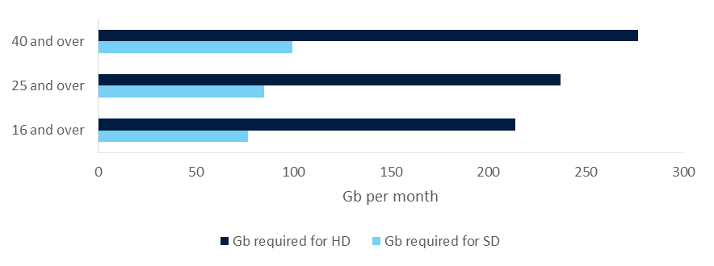

Source: Departmental analysis using NBN streaming estimates and Regional TAM Year in Review 2017

In considering submissions to the Review, most respondents were generally of the opinion that the NBN was not yet suitable as a replacement for VAST.

The ICPA noted that factors such as reliability, variable speeds, costly internet plans, and data restrictions are prohibitive factors in using the NBN for FTA TV online.[57] The CBAA also noted an IP based solution would have ongoing costs that terrestrial transmission and current satellite FTA TV do not.[58] Free TV, in its submission, pointed out technical issues: ‘… as a one-to-one transmission rather than a one-to-many transmission, IP-based delivery does not guarantee access to a suite of services comparable to the VAST channel offering (where IP access exists at all).’[59]

Regional stakeholders such as the NSW chapter of ICPA indicated that, while some regional and remote families have access to broadband, ‘… with limited slow data, online streaming is not a common option’. IRCA also noted, for remote Indigenous communities, affordability as well as availability meant streaming TV services online was not an option.[60]

The Review supports the view shared by all stakeholders that the NBN is not a viable delivery option at this time, primarily on the grounds of network capacity and potential costs to end users. However, the Government may wish to consider the NBN as an alternative option at future review points.

#### Other delivery platforms

**Extension of terrestrial coverage**

While terrestrial broadcasters are trialling new transmission technologies,[61] there is as yet no indication that signal coverage might be extended in remote areas. However, the Review notes Broadcast Australia’s comment ‘… there have been reductions in the cost of terrestrial transmission technology over recent years.’[62] The actual cost of a facility will depend on the size of the population to be served, the characteristics of the site and the type of infrastructure required. Ongoing operation, electricity and maintenance costs must also be taken into account. Costs vary with the location of the tower, the type of infrastructure, and other factors such as local weather conditions. These costs do not include any retransmission licence fees for national and commercial broadcasters.

With changes in demographics since 2010, particularly in inner regional areas, the Review has considered whether further analysis of prospects for terrestrial extensions might be warranted. In that context, Figure 14 shows indicative terrestrial television coverage areas as they relate to changes in population between 2006 and 2016.

Figure 14: Indicative terrestrial TV coverage with the change in population density (2006–16)[63]

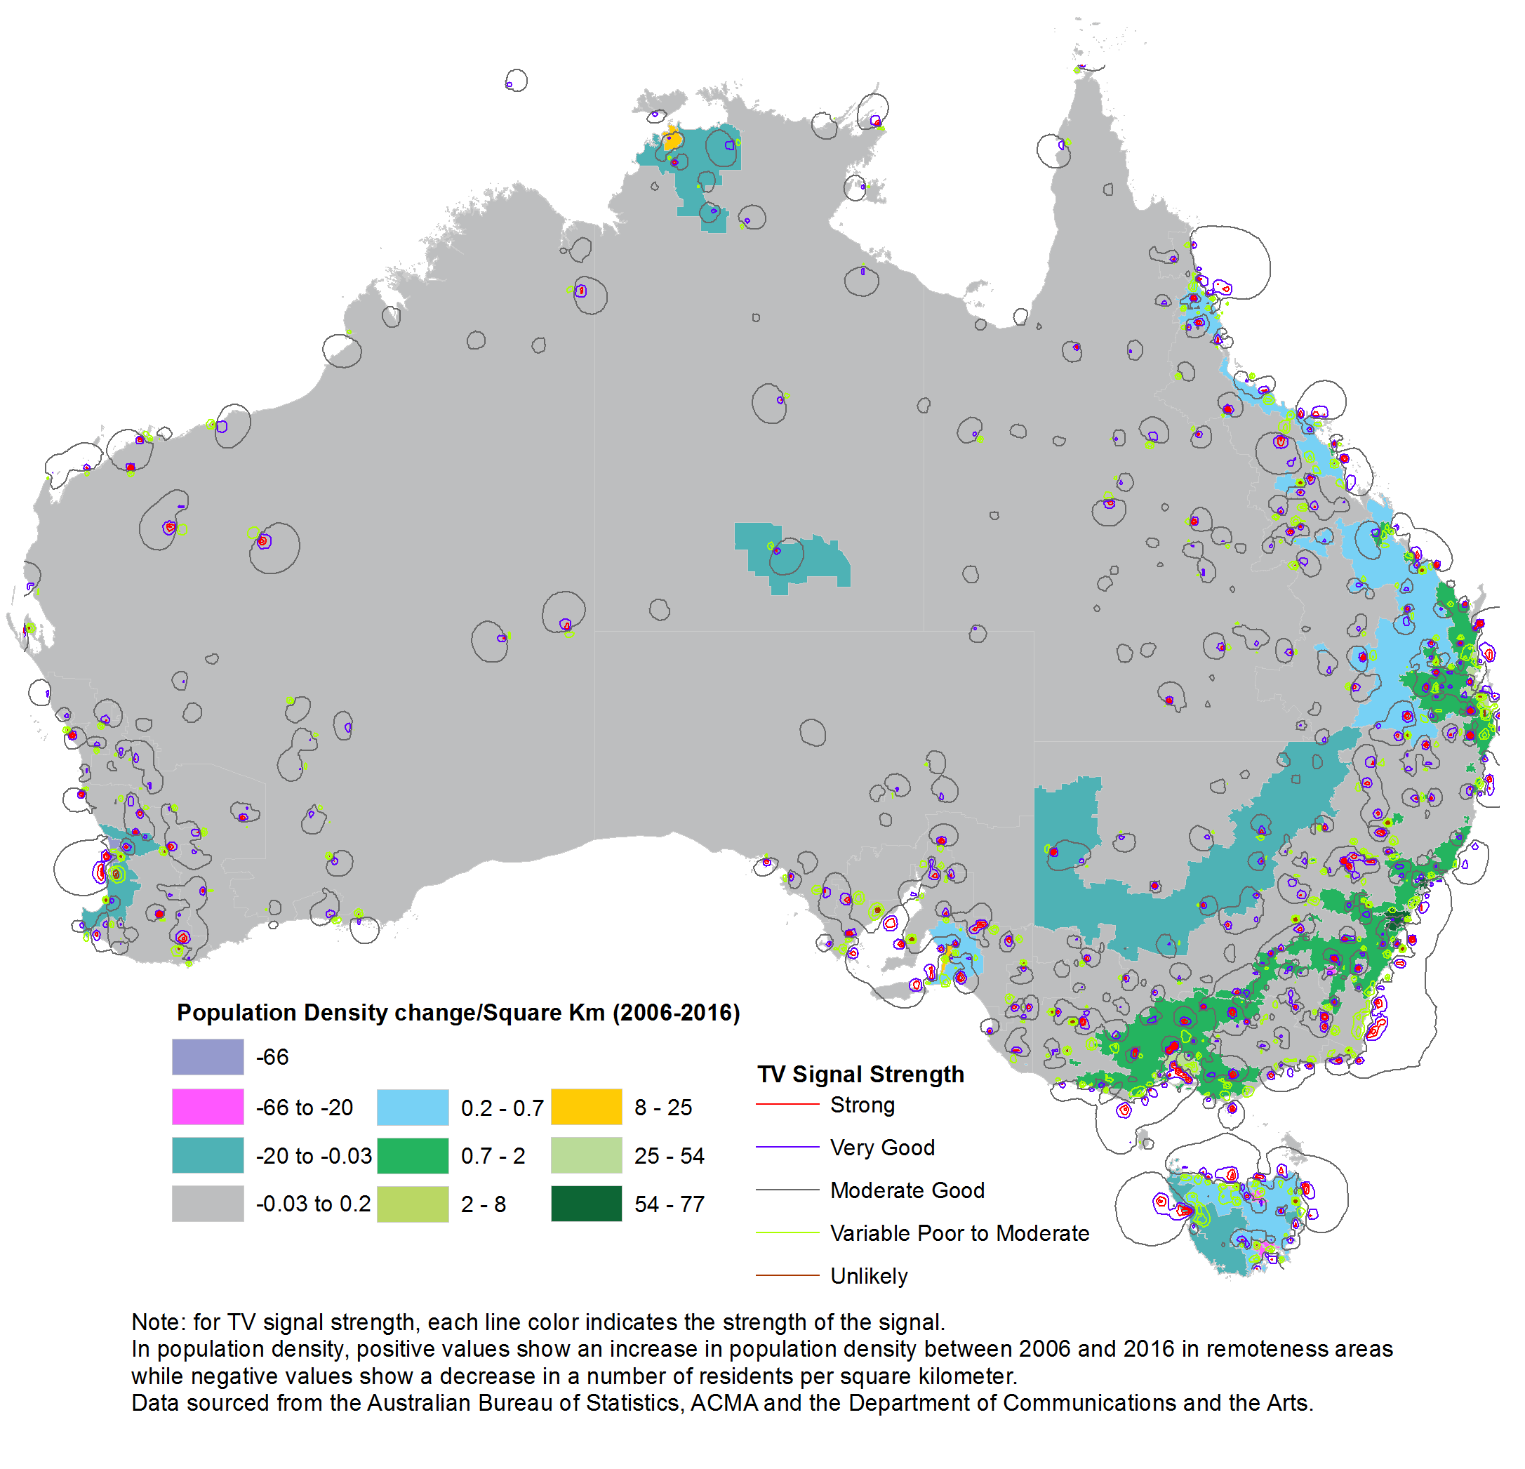

From Figure 14, it would appear that population growth has been modest in regional and remote areas. Most of the growth appears to be around areas such as Sydney which are, in the main, already served by terrestrial television. While individual areas may warrant more attention from broadcasters in the next few years, in terms of VAST, loss of population has mainly been around regional and remote areas, which would make terrestrial tower in-fill less warranted.

Population growth, however, is not the only consideration of whether the terrestrial network should be expanded. It should also be noted that new terrestrial facilities in regional and remote areas would still need to source their input feed via VAST, due to their remoteness, as many regional and remote areas do currently. Providing a terrestrial programming input feed is usually expensive and VAST already covers these areas. The Review finds that, overall, expansion of the current terrestrial coverage is not currently feasible in most signal-deficient locations.

**Mobile**

The Review has also considered mobile services connected to the internet as a potential alternative delivery platform for FTA TV services. Mobile devices such as smartphones or tablets can be used by themselves or connected to smart televisions to provide access to IP-based catch-up or streaming television services.

As with satellite broadband data, the cost of mobile data remains high, although costs have been trending down year-on-year (7.1 per cent average price fall over four years, with a 41 per cent average increase in data quotas).[64] The major carriers have introduced ‘unlimited data’ plans, although these can involve curtailing speeds after a certain data allowance is exceeded.[65]

As mentioned in section 2.5.3, the next generation of mobile technology, 5G, is expected to commence commercial rollout in the next few years. 5G will support improved connectivity, significantly faster data speeds, and very low latency. This is likely to underpin substantial economic and social benefits across the economy. 5G will undoubtedly increase consumers’ access to video-on-demand services.[66]

However, 5G is still very early in its development cycle, and there is uncertainty about how quickly 5G equipment will be rolled out, especially since mobile operators have yet to identify additional revenue streams to support it. Early deployments are likely to be concentrated around cities, and if the usual pattern of network building prevails, extension into remote areas will take some years to occur. Mobile data costs may continue to fall, but the historical trend is that this will be counterbalanced by increases in the amount of data consumed.

As was the case with regional broadband services, the Review finds that currently, variable mobile coverage, combined with high data costs and caps, make mobile services a supplement to VAST rather than an outright replacement.

**Subscription TV services**

Subscription TV services include established players such as Telstra TV, Foxtel and Fetch TV, and over-the-top streaming services such as Stan and Netflix. Most subscription services are pay-to-view, i.e. users must pay a fee to watch. Most services are also IP-based, that is they are delivered over the internet. The major commercial and national broadcasters also offer IP-based catch-up services.

The Review has considered subscription services as an alternative for VAST, including Fetch TV and Foxtel. Fetch TV, in its submission to the Review, noted that the amount of available on-demand content is significant. Fetch has around 650,000 subscribers on its IP-based service and provides a number of different STBs, including one with four HD terrestrial tuners and access to SVOD and catch-up IP-based services.[67] Given the current Fetch STB does not have a satellite tuner it cannot be used in terrestrial service deficient areas and as, Fetch TV notes in its submission, ‘… across the whole of the VAST user population, now and in the future, there will continue to be different levels of access to different delivery platforms (e.g. terrestrial, satellite, IP, etc).’ However, should the hybrid IP-enabled set-top box containing dual tuners (DVB-T and DVB-S) that Fetch TV discusses in its submission comes onto the market, it may be able to be used in satellite-enabled FTA TV locations and as part of, or as an alternative FTA TV provider to, the current VAST service.

Foxtel is currently available via cable[68] and satellite—in fact, on the same satellites as VAST. Some areas are able to access FTA TV via their Foxtel STB if in a terrestrial transmission area.[69] However, these channels typically originate on the East Coast, and Foxtel features very little in the way of regional content. The same is broadly true of the other subscription services.

Notably, these services are subscription only. VAST currently provides FTA TV and the only outlay for consumers is the equipment. By definition, subscription services are not free and being generally IP-based, cannot currently be used for FTA TV, unless there is a tuner which can then pick up terrestrial or satellite FTA reception.

The Review, however, has particularly considered Foxtel as a potential alternative FTA TV carrier to VAST, although it should be noted that Foxtel did not provide a submission to the Review. The Review considers there may be some advantages to carrying satellite FTA TV on a service such as Foxtel. The Optus satellites carrying VAST also carry Foxtel’s service. Foxtel also implements conditional access via a STB smartcard system and this could be done to limit FTA TV only to current VAST customers in the same way that current Foxtel subscribers are limited to the package they purchase. A FTA TV consumer could, for example, use a Foxtel STB and conditional access would confine their viewing to only the FTA TV channels.

However, there are also impediments to using Foxtel to carry FTA TV. Firstly, the FTA broadcasters do not currently have agreements with Foxtel to carry their channels on its satellite service. Foxtel’s policy is that broadcasters should pay to have FTA channels retransmitted on its service.[70] Foxtel have also said, in response to customer complaints about FTA channels not being transmitted on its service, that if it paid the FTA broadcasters the costs would be passed onto its customers.[71] Further, using Foxtel to carry FTA TV, instead of current arrangements, would require swapping out current VAST STBs with Foxtel boxes. The Review considers that VAST users, having already paid for their equipment, should not have to carry further equipment costs to transition to an equivalent service.

In terms of costs, if FTA TV services currently on VAST were switched to a subscription satellite service, such as Foxtel’s, the Government would, in all likelihood, need to subsidise either the satellite costs or the STB costs or potentially both. Taking the IQ3 cost of $125 per box as a guide, it would cost $23 million for 200,000 households to replace VAST STBs. While it is an alternative that could be explored the Review considers it is only viable if costs to the Government do not exceed the current costs for providing FTA TV services to those unable to receive terrestrial television.

#### Implications of changes to transmission type

As outlined in section 2.5.2, new transmission technology and standards have emerged which, if adopted, would increase the efficiency of a service such as VAST, allowing a greater number of channels (or higher resolution for existing channels) for a given allocation of satellite bandwidth (e.g. DVB-S2X, HEVC, or updated MPEG-4 encoding).

The pace of change in broadcasting and information technology means that many service models become outdated after 10–15 years in use. This is particularly evident in the mobile phone industry, with new generations (3G, 4G, 5G) being rolled out roughly each decade. The technical model adopted by VAST in 2010 remains solidly reliable in achieving the Government’s objectives, and is likely to continue to do so for many years but it will eventually become outdated with new technological satellite developments.

Upgrading the transmission technology of VAST would keep it relevant and flexible, allowing for more options in the future (e.g. the possible introduction of UHD television). However, the major drawback of such a change would be the necessity for consumers to upgrade their reception equipment or STBs. In this respect, the option of simply upgrading the existing MPEG-4 encoding to be more efficient would have the least impact on users, on the assumption that the majority of current STBs could cope with such a change. But the broadcasters would need to purchase new encoding equipment, and such   
‘fine-tuning’ would produce only minor benefits. The Review notes Imparja and SBS were the only broadcasters to raise this option in their submissions, though the ACMA and other organisations noted the possibility for improvements to transmission technology.[72]

A more wide-ranging change, such as shifting to HEVC encoding, while it would make VAST more future proof, would require users to buy new STBs, to meet the infrastructure standards. This would be a significant cost and disruption to users. Some submissions acknowledged this difficulty, and in consequence did not urge that this option be acted on, at least in the short term.

If this option were to be pursued, three mitigating strategies could be employed:

* **Subsidise** **new STBs.** When digital TV was rolled out, including VAST, the Government through the Householder Assistance Scheme and the Satellite Subsidy Scheme (SSS) the Government provided assistance to households.[73] A similar scheme could be introduced.
* **Simulcast existing and new transmissions** for a period (possibly several years) while users gradually update their STBs. This would entail much higher satellite costs for broadcasters. Again, there does not appear to be readily available funding or a rationale to cover such costs.
* **Require users to upgrade their STBs** by making only new models available to purchase, although the argument for a greater range of STB models would negate this as an option. It is more likely consumers will upgrade to newer models when they need to do so.

The Review acknowledges that there are good reasons to pursue upgraded transmission technology, but in the context of the current model working very well it is difficult to justify the cost and upheaval that would follow. If some minor technical improvements can be enacted then this should be explored as part of any decision to extend satellite TV delivery but currently, the case for a major upgrade is weak, particularly if it involves a cost to consumers.

##### Satellite developments

Optus satellites use 11.7 to 14.5 gigahertz of the radiofrequency spectrum (known as the Ku Band) to broadcast VAST services. The Ku band is customarily used to broadcast satellite services around the world in accordance with the International Telecommunication Union’s distribution of spectrum for satellite services.

The Review notes that the ACMA, in its draft five-year spectrum outlook for 2018–22, flags it will conduct several minor administrative and policy updates regarding satellite services, although none of these have any direct bearing on the operation of VAST.[74] The ACMA have advised the Ku band is the most suitable for VAST.

Alternative delivery models, such as utilising satellites in medium-to-low orbits, have not been mooted for television delivery. They instead focus on broadband delivery not direct-to-home broadcasting and are largely still in early planning or deployment stages. The Review finds that there are no current satellite developments that would have an immediate improvement on the delivery of FTA TV in areas currently served by VAST.

### Implementation

In considering the terms of reference, the Review finds that delivery of FTA TV via satellite is effective and efficient, though improvements could be considered. Additionally, in terms of future options for service delivery there is no viable alternative technology available now or in the near future that offers equivalent or improved service delivery.

In this context, the Review has considered what practical steps would need to be taken if the Government decided to continue funding the delivery of FTA TV via satellite following the expiration of the existing contracts by 30 June 2020. As part of this, the Review has provided a high-level funding estimate for future service delivery.

#### Contracts

Under current arrangements, the Government has entered into contracts with the regional broadcaster joint ventures. These contracts and the BSA specify the delivery of a set number of secondary channels. Funding deeds are in place to cover such costs as satellite carriage and satellite delivery-related wages.

Separately, the regional broadcasting joint ventures have contracts in place with Optus for the delivery of the satellite service. This contractual framework is described in Figure 15.

Figure 15: VAST Contractual obligations

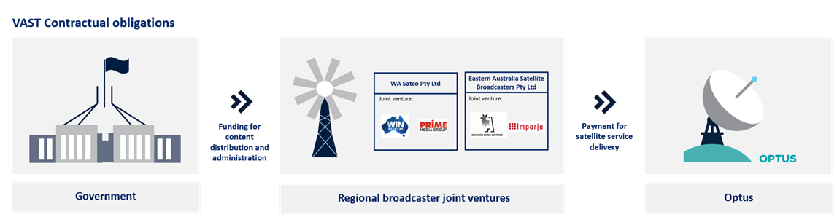

In terms of future negotiations, the Review considers it would be appropriate to approach the existing regional broadcasters to assess interest in a future satellite-delivered FTA TV program and to obtain detailed funding estimates both for the current or similar model and for potential service enhancements. These funding estimates would provide the basis for a new policy proposal to be considered by Government. The joint venture broadcasters would be asked to approach the market to determine delivery options and costs. Government parameters for the regional broadcasters to approach the market should include:

* **Contract period**: 5 years plus a further 5 years (i.e. a 5 + 5 approach). This will provide sufficient certainty to both users and industry. A review point could be considered ahead of the first 5-year mark to investigate if better service delivery options have become available. It should be noted that the Optus network has available satellite capacity for at least the next 5 years.
* **Delivery options and costs**: industry should test the market in order to evaluate different delivery options, including exploring options to reduce costs.
* **Channel selection**: the implications of adding further channels, and/or converting SD channels to HD.
* **Technology improvement**: regional broadcasters should evaluate the implications of introducing new technologies including the end user impacts. Broadcasters should identify how any future service delivery model would affect existing users of the service, particularly with regards to any equipment or technical standards upgrades, and how to minimise end user disruption.

Broadcasters would also be required to provide information on how a future program would comply with legislative, regulatory and other Commonwealth requirements.

In addition, the Review considers that in designing a future program, reporting should be improved, particularly in regards to monitoring take up of services, ongoing evaluation of the effectiveness of the program, and new technological developments.

While the national broadcasters are not funded to provide VAST in the same manner as commercial broadcasters, changes to the satellite FTA TV service may have flow-on effects. In their annual appropriations the ABC and SBS receive overall funding and from this determine where funds are allocated; this includes funding for VAST. Separately to the commercial broadcasters, the ABC and the SBS would need to negotiate for the ongoing satellite delivery of their content.

Regional joint venture broadcasters have indicated they may require up to six months to conduct negotiations.

If available funding is constrained, regional joint venture broadcasters could be approached by Government and asked to present a low-cost option. This would likely involve significant reduction in channels and service availability.

#### Funding envelope

The Review has conducted high level market soundings with both the regional joint venture broadcasters and Optus. Preliminary discussions suggest that a further satellite FTA TV delivery model could be delivered within current levels of program funding. Average annual program costs for the last five years (2013–14 to 2017–18) are around $10 million (GST exclusive). Funding satellite delivery of FTA TV for five years would equate to a funding envelope of around $50 million.

The Review also notes that the satellite costs for the northern and southern licence areas could potentially be reduced by providing one programming stream across both. There are currently six channels duplicated across the northern and southern satellite licence areas. Reducing the configuration to one stream across the northern and southern satellite licence areas would save approximately $1.3 million per annum, which could be put towards enhancing channel selection. If this were adopted, when daylight savings is in effect some viewers would receive television broadcasts that are not broadcast in local time.

### Recommendations

Following Departmental analysis of the VAST program’s effectiveness, its fitness for purpose, and options for the delivery of FTA TV services in areas that do not receive a reliable local terrestrial FTA transmission, the Review makes the following recommendations:

**Recommendation 1:**

* To promote consumer and industry certainty, the current satellite delivery model should be continued, for the next 5 years, as it currently provides the only available cost effective and fit-for-purpose service delivery model for free-to-air television in areas not served by a terrestrial transmission service.

**Recommendation 2:**

* In negotiating the next phase of the program, the Government should explore what scope there is to adjust the satellite delivery model to include:
* expanded channel selection, including high definition channels
* enhanced news and radio services
* improved local content and advertising, and
* access to a broader and more competitive set-top box market.

**Recommendation 3:**

* The satellite-delivered television application and appeals process should be simplified and streamlined so that consumers, including travellers, can have faster access to the service, and to remove unnecessary administrative burden, by:
* establishing a single website to find information about and apply for the service, and
* improving the administrative overhead and the appeals process.

**Recommendation 4:**

* The Government should explore opportunities to support users in remote communities by leveraging existing Indigenous employment programmes to train local job seekers to undertake repair and maintenance of user equipment and develop job opportunities in these areas.

**Recommendation 5:**

* The satellite delivery model should be reviewed before the next funding service period ends to determine whether other options have become viable, prior to extending the service for an additional five years.

## Appendix 1: List of submissions

| Submission | Organisation / name | Public / private |
| --- | --- | --- |
|  | John Murton | Public |
|  | Tim Murphy | Public |
|  | Sean McManus | Public |
|  | Private submission | Private |
|  | Private submission | Private |
|  | Private submission | Private |
|  | Private submission | Private |
|  | Private submission | Private |
|  | Ken Webb | Public |
|  | Indigenous Remote Communications Association (IRCA) | Public |
|  | Darryl Drake | Public |
|  | WIN Network | Public |
|  | Australian Digital Telecommunications Industry Association (ADTIA) | Public |
|  | FetchTV | Public |
|  | James Blomfield | Public |
|  | Alan Smedley | Public |
|  | Imparja Television | Public |
|  | Isolated Children’s Parents’ Association of Australia | Public |
|  | District Council of Kimba | Public |
|  | Optus | Public |
|  | RBA Holdings | Public |
|  | Isolated Children's Parents' Association NSW | Public |
|  | Community Broadcasting Association of Australia | Public |
|  | Broadcast Australia | Public |
|  | EASB (Eastern Australia Satellite Broadcasters) | Public |
|  | PRIME Media | Public |
|  | SBS | Public |
|  | Free TV | Public |
|  | Northern Territory Government | Public |
|  | Australian Communications and Media Authority (ACMA) | Public |
|  | National Farmers Federation (NFF) | Public |
|  | ABC | Public |
|  | James Muntz | Public |

## Appendix 2: Channels available on VAST and in metropolitan and regional areas

lTable listing 38 TV channels, cross referenced with Metro, Regional/remote terrestrial, WA Satco and EASB, indicating with coloured dots which category each channel is available in. 
The Metro category receives all channels except: SBN (religious), Aspire, iShopTV, Gold, ICTV, 3ABN (religious), interstate ABC/SBS services, Regional News carousel, Sky News.
Regional/remote terrestrial receives all channels except SpreeTV, Extra, ICTV, 3ABN, interstate ABC/SBS, Regional News carousel, Sky News. However, several channels are only available in some regional areas, such as TenHD, TVSN, 7HD, 7Flix, Racing.com. 9HD, 9Life, SBN, Aspire, iShopTV and Gold.
WA Satco carries all channels except: SpreeTV, Viceland HD, 7HD,7Flix, 9HD, 9Life, Extra, SBN, Aspire, Regional News carousel and Sky News.
EASB carries all channels except: TenHD, TVSN, SpreeTV, Viceland HD, 7HD, 7Flix, Racing.com, 9HD, 9Life, Extra, SBN, Aspire, iShopTV and Gold.
See section 2.3.4 and Table 2 for details.
 

Source: Departmental analysis of channels available on [www.freeview.com.au/tv-guide/](http://www.freeview.com.au/tv-guide/) and <http://sattvguide.com.au/>.

**Explanatory notes about this comparison table:**

* The metropolitan commercial FTA channels 7, 9, 10 and their respective HD channels are broadcast in regional areas by regional/remote affiliates (e.g., WIN, Prime7, GWN7, Imparja). Where this occurs in the regional/remote category, the services are marked as ‘green’.
* On VAST, all TV and radio channels from ABC and SBS are separated by state or time zone. They are unlocked to all VAST viewers regardless of their registered location. This means that SBS and ABC interstate versions are available on VAST.
* There are 20 part-time regional news channels available in the EASB service area (all states, except Western Australia).

## Appendix 3: A comparison of various set-top box models[75]

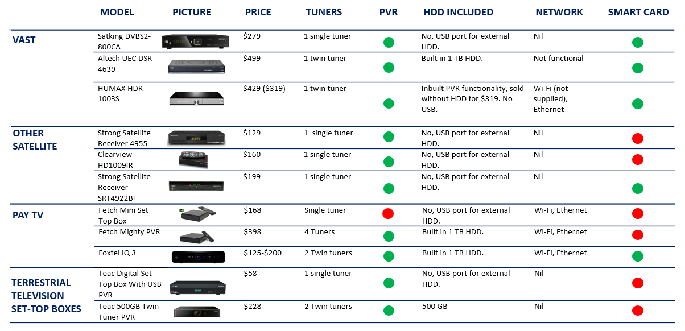

1. IP-based delivery: delivery of data, in this case media, over the internet.
2. Please refer to section 2.2.2 for discussion regarding the number and location of VAST households.
3. Report of the Senate Standing Committee on Environment, Communications and the Arts Legislation Committee Inquiry into the provisions of *the Broadcasting Legislation Amendment (Digital Television) Bill 2010*, <https://www.aph.gov.au/Parliamentary_Business/Committees/Senate/Environment_and_Communications/Completed_inquiries/2008-10/digitaltv2010/report/index>, accessed 24 April 2018.
4. Section 5D of the BSA outlines trigger events. A summary can be found at <https://www.communications.gov.au/what-we-do/television/media/updating-australias-media-laws>, accessed 21 August 2018.
5. VAST user data provided by RBAH to the Department, 25 July 2018.
6. Related to the growth of VAST users, section 3.2.2 examines population density in terms of terrestrial TV coverage.
7. ACMA, submission to VAST Review Issues Paper, p.6.
8. ACMA, submission to VAST Review Issues Paper, p.6.
9. Optus submission to the VAST Review Issues Paper, p.17.
10. ADTIA, submission to VAST Review Issues Paper, p. 3.
11. Department of Defence, Department of Defence extends Optus satellite contract, <https://www.minister.defence.gov.au/minister/marise-payne/media-releases/department-defence-extnds-optus-satellite-contract>, accessed 20 August 2018.
12. WIN Network, Southern Cross Austereo, Prime Media Group, Imparja, Nine Entertainment Co, and Seven West Media.
13. Referenced in grant reporting at: <https://www.communications.gov.au/documents/grant-reporting-department-broadband-communications-and-digital-economy-1january2009-30june2012>
14. Department of Prime Minister and Cabinet, Cultural and Capability Program—Indigenous Broadcasting, <https://www.pmc.gov.au/indigenous-affairs/culture-and-capability/indigenous-broadcasting>, accessed 12 April 2018.
15. ACMA Conditional access schemes, <https://www.acma.gov.au/theACMA/conditional-access-schemes-digital-switchover-i-acma>, accessed 20 August 2018.
16. ACMA, 2017, Communications Report 2016-17, <https://www.acma.gov.au/-/media/Research-and-Analysis/Report/pdf/Communications-report-2016-17-pdf.pdf?la=en> p. 72. Accessed 21 June 2018.
17. ACMA, 2017, Communications Report 2016-17, <https://www.acma.gov.au/-/media/Research-and-Analysis/Report/pdf/Communications-report-2016-17-pdf.pdf?la=en> p. 79. Accessed 21 June 2018.
18. Crikey, 17 August 2018, Telstra and News Corp profit reports don't paint a pretty picture for Foxtel.
19. PwC Global Entertainment & Media Outlook 2018–2022.
20. ACMA, 2017, Communications Report 2016-17, <https://www.acma.gov.au/-/media/Research-and-Analysis/Report/pdf/Communications-report-2016-17-pdf.pdf?la=en> p. 64. Accessed 21 June 2018.
21. Roy Morgan, Netflix set to surge beyond 10 million users, <https://www.roymorgan.com/findings/7681-netflix-stan-foxtel-fetch-youtube-amazon-pay-tv-june-2018-201808020452>, accessed 15 August 2018.
22. ACMA, 2017, *Communications Report 2016-17*, <https://www.acma.gov.au/-/media/Research-and-Analysis/Report/pdf/Communications-report-2016-17-pdf.pdf?la=en> p. 77. Accessed 21 June 2018.
23. Regional TAM, 2017: *Year in Review*, p. 14.
24. Regional TAM, 2017: Year in Review, p. 11.
25. Ibis World, *Free-to-Air Television Broadcasting in Australia*, November 2017, p. 15–16.
26. Imparja, submission to VAST Review Issues Paper, p. 5.
27. Imparja, submission to VAST Review Issues Paper, p. 2.
28. Australian Government, 5G—Enabling the future economy, October 2017
29. Remote Central and Eastern licence areas.
30. University of Canberra, *Digital News Report: Australian 2018*, p. 52.
31. District Council of Kimba, submission to the VAST Review Issues Paper, p. 1.
32. Australian Broadcasting Commission, submission to the VAST Review Issues Paper, p. 2.
33. Mr Alan and Mrs Judith Smedley, submission to the VAST Review Issues Paper, p. 1.
34. Broadcast Australia, submission to VAST Review Issues Paper, p.1
35. Northern Territory Government, submission to VAST Review Issues Paper, p. 2.
36. Mr Webb, submission to VAST Review Issues Paper, p. 1.
37. Optus submission to the VAST Review Issues Paper, p.9.
38. ACMA, submission to VAST Review Issues Paper, p.12.
39. RBAH, submission to VAST Review Issues Paper, p. 3.
40. ACMA, submission to VAST Review Issues Paper, p.15.
41. RBA Holdings, submission to the VAST Review Issues Paper, p.3.
42. ACMA, submission to VAST Review Issues Paper, p.9.
43. ACMA, submission to VAST Review Issues Paper, p.12.
44. Department research at September 2018.
45. ACMA, correspondence to the Department, 10 August 2018
46. IRCA, submission to VAST Review Issues Paper, p. 12.
47. IRCA, submission to the VAST Review Issues Paper, p. 12.
48. *Indigenous Communications and Media Survey 2016*, p. 16.
49. The Department of Prime Minister and Cabinet, the Community Development Programme, <https://www.pmc.gov.au/indigenous-affairs/employment/community-development-programme-cdp>, accessed 21 June 2017.
50. Sydney Morning Herald, 10 Cool Facts About the NBNs Forthcoming Sky Muster Satellite Service, <https://www.smh.com.au/technology/ten-cool-facts-about-nbns-forthcoming-sky-muster-satellite-service-20160202-gmjpow.html>, accessed 30 July 2018.
51. ACMA, Satellite Systems Future Needs, <https://www.acma.gov.au/theACMA/satellite-systems-future-needs-57-1>, accessed 30 July 2018.
52. NBN Co, Fun facts about nbn™ Sky Muster™ II Satellite, <https://www.nbnco.com.au/blog/the-nbn-project/facts-about-nbn-sky-muster-II.html>, accessed 30 July 2018.
53. Free TV, submission to the VAST Review Issues Paper, p.9.
54. This is the average monthly viewing of a regional television viewer in 2017 according to Regional TAM’s *2017 Year in Review*.
55. WhistleOut, <https://www.whistleout.com.au/Broadband/nbn-sky-muster-satellite-plans>, accessed 31 June 2018,
56. NBN Co, NBN Co boosts wholesale data allowances and bush connectivity with new Sky Muster™ Plus, <https://www.nbnco.com.au/corporate-information/media-centre/media-statements/nbn-co-boosts-wholesale-data-allowances-and-bush-connectivity-with-new-sky-muster-plus>, accessed 30 November 2018.
57. Isolated Children’s Parents’ Association of Australia (ICPA), submission to the VAST Review Issues Paper, p.6.
58. Community Broadcasting Association of Australia (CBAA), submission to the VAST Review Issues Paper, p. 2.
59. Free TV, submission to the VAST Review Issues Paper, p. 3.
60. IRCA, submission to the VAST Review Issues Paper, p. 14.
61. Free TV Australia and Broadcast Australia Media Release: *Free TV and Broadcast Australia partner on next generation TV trials*, <http://www.freetv.com.au/content_common/pg-free-tv-and-broadcast-australia-partner-on-next-generation-tv-trials.seo>, accessed 24 April 2018.
62. Broadcast Australia, submission to the VAST Review Issues Paper, p.2
63. Due to the difficulty in showing TV coverage contours alongside population density in the one map, Figure 14 shows an indicative contours and population density rather than actual coverage.
64. ACCC, *Competition and price changes in telecommunications services in Australia 2016-17*, p. 27.
65. Whistleout, <https://www.whistleout.com.au/MobilePhones/Guides/unlimited-data-mobile-plans-whats-the-catch>
66. Australian Government, 5G—Enabling the future economy, October 2017
67. JB HiFi, Fetch TV Mighty specifications, <https://www.jbhifi.com.au/tv-home-entertainment/players-recorders/fetch/fetch-mighty/974821/> accessed 16 August 2018.
68. Foxtel has stated it will be migrating cable customers to a satellite service. <https://community.foxtel.com.au/t5/Foxtel-TV/Foxtel-to-migrate-all-Cable-customers-to-Satellite/td-p/235618>,
69. For instance, the current Foxtel IQ3 box has multiple tuners to receive local terrestrial transmissions.
70. Foxtel, What FTA channels can I receive on Foxtel, <https://community.foxtel.com.au/t5/Programming-Technical-Support/What-Free-To-Air-FTA-channels-can-I-receive-on-Foxtel/td-p/523>, accessed 16 August 2018.
71. Foxtel, FTA channels for satellite, <https://community.foxtel.com.au/t5/Foxtel-TV/FTA-channels-for-satellite/td-p/242156>, accessed 16 August 2018.
72. ACMA, submission to VAST Review Issues Paper, p.6, and Community Broadcasting Association of Australia (CBAA), submission to the VAST Review Issues Paper, p. 3.
73. The Householder Assistance Scheme was aimed at recipients of government pensions, and provided practical end‐to‐end technical and installation services. The Satellite Subsidy Scheme provided a satellite conversion subsidy to eligible households located in areas served by ‘self‐help’ transmission sites which were not scheduled to be upgraded to digital.
74. ACMA, *Draft Five Year Spectrum Outlook 2018–2022*, pp. 40-43.
75. Departmental research as at September 2018.