Commonwealth Crest and National Relay Service logo with the words 'An Australian Government Initiative'.

communications.gov.au/accesshub

# Fact sheet 6—Voice Relay

In Voice Relay calls you speak directly with the other person. The relay officer is on the line to  
re-speak any of your words as required. This NRS call option is helpful for anyone who is hard to understand on the phone—you might have a speech impairment or use a voice output device.

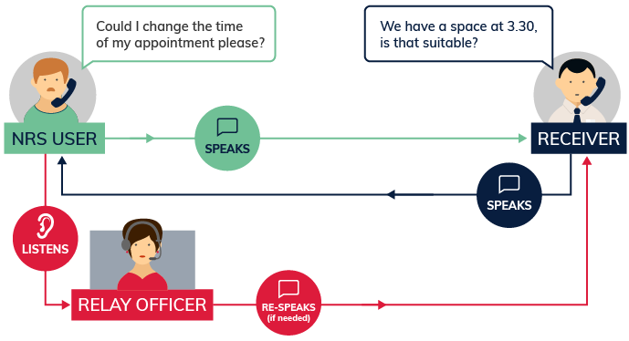

## What equipment is needed?

Any type of phone can be used to make standard Voice Relay calls. If using the NRS app, an Apple or Android smartphone or tablet and an internet connection is needed.

## How much will it cost?

A call from a landline phone will cost the same as any other call to a 13/1300 phone number depending on the phone plan you have. The cost of calls from a mobile phone will also depend on your phone plan. If you want to make Voice Relay calls through the NRS app, broadband data costs will apply to download the NRS app and make calls.

## Things to remember

* Voice Relay users can set up a specialised profile with a simple code. This lets the relay officers quickly connect you to commonly-used phone numbers you have saved in the profile. It also lets them know your preferred strategies to clarify words during the call. The profile form is available on the [Service Features page](https://www.communications.gov.au/what-we-do/phone/services-people-disability/accesshub/national-relay-service/service-features) of Accesshub.
* For a detailed step-by-step explanation about how to use this option, read the Voice Relay instruction sheets on the [Service Features page](https://www.communications.gov.au/what-we-do/phone/services-people-disability/accesshub/national-relay-service/service-features) of Accesshub.

The Helpdesk is open from 8am to 6pm, Monday to Friday (Eastern Standard Time). There are a number of ways to make contact with Helpdesk staff:

* email [helpdesk@relayservice.com.au](mailto:helpdesk@relayservice.com.au)
* phone 1800 555 660
* SMS 0416 001 350
* TTY 1800 555 630
* Fax 1800 555 690
* [Online contact form](https://www.communications.gov.au/node/19659).