

# An introduction to relay calls

If you have difficulty hearing or speaking to people who use a phone, the National Relay Service (NRS) can help.

## How a relay call works

* A relay call allows you to communicate with a hearing person who is using a phone even if you can’t hear or don’t use your voice.
* The NRS has specially trained staff called relay officers who are the central link in each relay call.
* The relay officer converts voice to text or text to voice. Sometimes they convert from sign language to English.
* Relay officers stay on the line throughout each call to help it go smoothly, but don’t change or interfere with what is being said.
* Depending on your hearing and speech, you can choose from one or more relay call channels.



## Which type of relay call is right for you?

|  | If you are deaf, can’t hear well or have difficulty using your voice.  NRS Chat | If you are deaf, can’t hear well or have difficulty using your voice.  SMS Relay | If you don’t hear well but can use your voice.  NRS Captions | If you don’t hear well but can use your voice.  TTY Speak and Read | If you have difficulty being understood on the phone.  Voice Relay | If you have difficulty being understood on the phone.  SMS Relay (Text and Listen) | If you want to use Auslan.  Video Relay | If you don’t want to use a computer or mobile phone.  TTY Type and Read | If you don’t want to use a computer or mobile phone.  TTY Type and Listen |
| --- | --- | --- | --- | --- | --- | --- | --- | --- | --- |
| **Prefer to type?** | ✔ | ✔ |  |  |  | ✔ |  | ✔ | ✔ |
| **Prefer to speak?** |  |  | ✔ | ✔ | ✔ |  |  |  |  |
| **Have some hearing and like to listen?** |  |  | ✔ | ✔ | ✔ | ✔ |  |  | ✔ |
| **Like to read captions or text?** | ✔ | ✔ | ✔ | ✔ |  |  |  | ✔ |  |
| **Use Auslan?** |  |  |  |  |  |  | ✔ |  |  |
| **Need bigger print?** | ✔ |  | ✔ |  |  |  |  |  |  |
| **Make a call on the move?** | ✔ | ✔ | ✔ |  | ✔ | ✔ | ✔ |  |  |
| **Equipment?** | Internet + computer, tablet or smartphone. | Any mobile phone | Internet + phone (e.g. phone + computer, or smartphone on speaker or using headphones.) | TTY | Any type of phone | Any mobile phone on speaker or using headphones | Internet + smartphone, computer or tablet | TTY | TTY |

You’ll find more details for each call option on the following pages.

## If you are deaf, can’t hear well or have difficulty using your voice—NRS Chat or SMS Relay

### NRS Chat

You type your side of the conversation through the NRS app or web call page and read the other person’s responses on your screen. NRS Chat calls can also be made using the app.

**You need:** a computer, tablet or smartphone and access to the Internet.

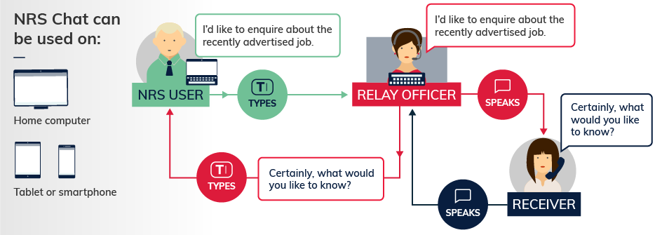

### SMS Relay

You text your side of the conversation and read the other person’s responses texted to you by the relay officer.

**You need:** any mobile phone. You don’t need an internet connection.

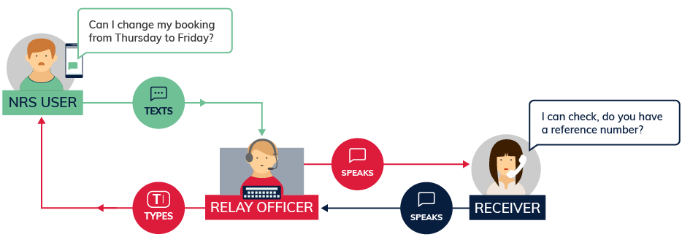

## If you don’t hear well but can use your voice—NRS Captions or TTY Speak and Read

### NRS Captions

You talk directly to the other person and read their words on your screen. You can also listen to the other person’s responses.

**You need:** a phone plus an internet connection—for example a phone plus a computer, or just a smartphone on speaker or using headphones. NRS Captions calls can also be made using the NRS app.

NRS Captions/Captioned relay call diagram.

The diagram shows how a call using NRS Captions/Captioned relay works, including the roles of the NRS user, the Receiver of the call and the Relay Officer. The NRS user speaks directly to the Receiver and asks ‘Could I change the time of my appointment please?’ The Receiver then speaks in response ‘We have a space at 3.30, is that suitable?’ The NRS user and the Relay Officer both receive the spoken audio from the Receiver. The Relay Officer then generates the caption ‘We have a space at 3.30, is that suitable?’ by re-speaking the words of the Receiver. Voice recognition software converts this to text which is transmitted to the NRS user’s device as captions. The NRS user receives the caption from the Relay Officer. 

Along the left hand side of the diagram there is a visual representation of three different combinations of devices that the NRS user can use in order to make a NRS Captions/Captioned relay call. These are: 1. Home computer plus a mobile or landline phone 2. Tablet plus a mobile or landline phone 3. Smartphone. 

### TTY Speak and Read

You speak your side of the conversation into the handset of the TTY and read the text of the other person’s words on the TTY which have been typed by the relay officer. The other person’s spoken words will also come through on the call. The volume can be turned up or down according to your preferences.

**You need:** A TTY which is a specialised fixed-line phone that has a screen and a keyboard that can be used to make relay calls. The TTY needs to be connected to power and plugged into the phone socket.

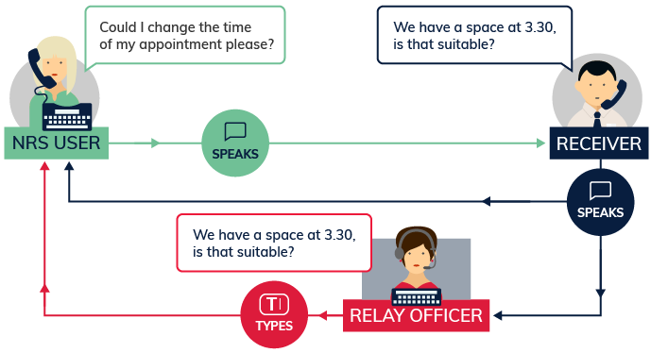

## If you have difficulty being understood on the phone—Voice Relay or SMS Relay (Text and Listen)

### Voice Relay

Speak directly to the other person and listen as well. The relay officer will re-speak any of your words not understood by the other person.

**You need:** Any type of phone can be used to make standard Voice Relay calls. If using the NRS app, an Apple or Android smartphone or tablet and an internet connection is needed.

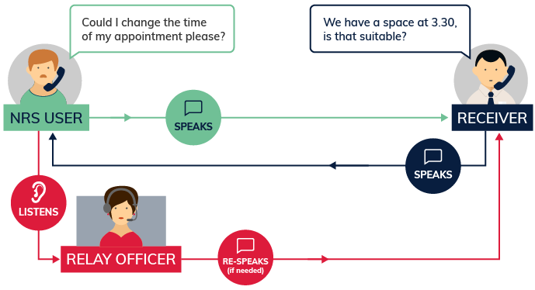

### SMS Relay (Text and Listen)

Type your side of the conversation on your mobile phone as an SMS and listen to the other person speaking.

**You need:** any mobile phone. You don’t need an internet connection. You can put your phone on speaker or you will need earphones to listen to the other person.

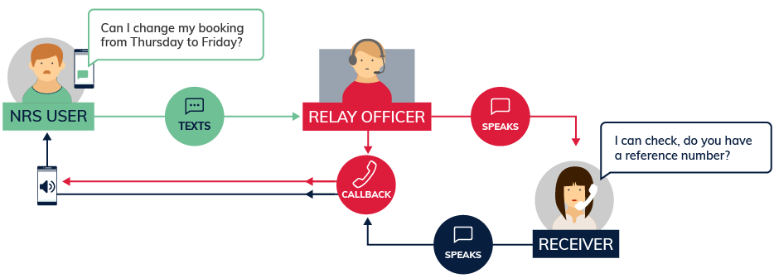

## If you want to use Auslan—Australian Sign Language—Video Relay

The relay officer communicates with you in Auslan and speaks with the other person in English. Available in limited hours.

**You need:** a good internet connection, and a tablet, a smartphone or a computer with a webcam. Video Relay calls can be made using Skype or through the NRS app.

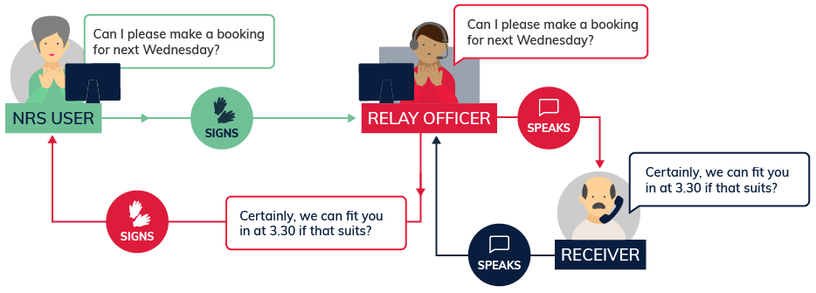

## Download the app

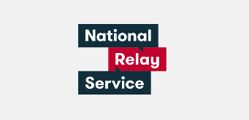

You can make relay calls through the NRS app. The call options currently available on the app are NRS Chat, Voice Relay, NRS Captions and Video Relay.

The app is available on Apple and Android smartphones and tablets—free from the [Apple](https://apps.apple.com/au/app/nrs/id1483420984) and [Google](https://play.google.com/store/apps/details?id=au.gov.doca.nrs) stores.

The app is a great option if you want to make relay calls on the move.

## If you don’t want to use a computer or mobile phone—teletypewriter (TTY)

**You need**: A TTY which is a specialised fixed-line phone that has a screen and a keyboard that can be used to make relay calls. The TTY needs to be connected to power and plugged into the phone socket.

With a TTY you read what is said to you if you can’t hear, and type what you want to say if you can’t speak. The handset of the TTY also gives you the option to speak and listen to the other person.

### TTY Type and Read

You type your side of the conversation on a TTY and read the responses from the other person on the TTY which have been typed by the relay officer.

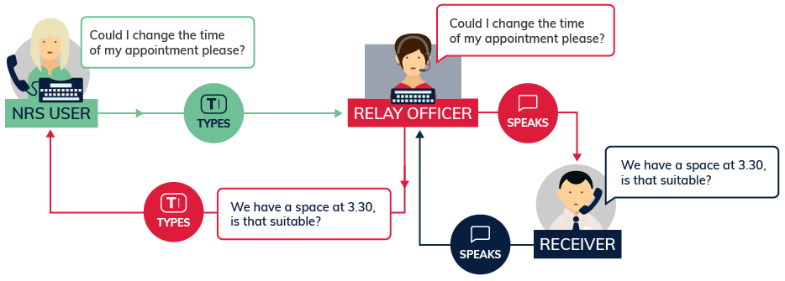

### TTY Type and Listen

You type your side of the conversation using a TTY and a relay officer will speak your typed words to the other party. You can listen to the other person’s reply using the handset of the TTY.

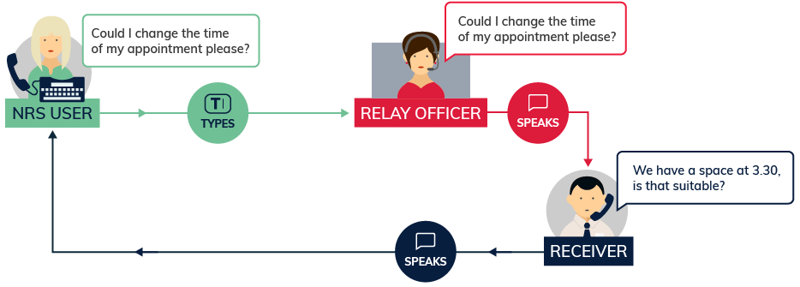

### TTY Speak and Read

Please refer to the section titled If you don’t hear well but can use your voice—NRS Captions or TTY Speak and Read.

## The NRS is free and confidential

* There is **no extra charge** for making a relay call. You just pay your regular data or phone costs to make your call through the NRS.
* All calls are **confidential**—your privacy is protected by law.
* The **NRS Helpdesk** can assist you to get started, give you tips on making the most of your call, and help you with any call problems.

## Making a call in an emergency

If you find yourself in an emergency which is either life threatening or where time is critical, you can make a relay call to fire, police and ambulance services.

You can connect to the NRS and ask for **Triple Zero (000)**. The relay officer will stay on the line to relay the conversation.

If you are a TTY user and need to contact **emergency services**, just ring **106 on your TTY**.

## More information

More information about the NRS is available at [www.communications.gov.au/accesshub](http://www.communications.gov.au/accesshub)/nrs.

There are also a number of convenient mainstream communications options for people who are deaf, hard of hearing and/or have a speech impairment. Find out more information about these options that don’t use the NRS on the [Mainstream communications options webpage](http://www.communications.gov.au/node/13316).

For help with making relay calls, contact the **NRS Helpdesk:**

* Phone: 1800 555 660
* Fax: 1800 555 690
* SMS 0416 001 350
* TTY 1800 555 630
* Email: [helpdesk@relayservice.com.au](mailto:helpdesk@relayservice.com.au)
* Online : [Online form](https://www.communications.gov.au/node/19659).

The NRS Helpdesk operates from 8 am to 6 pm, Eastern Standard Time.