

# A call through the National Relay Service

If you work in a contact centre or as a receptionist, you may occasionally receive calls from your customers through the National Relay Service (NRS).

The NRS is an Australian Government initiative that enables people who are deaf or have a hearing or speech impairment to make phone calls in the same way as anyone else.

People use the NRS when they need to talk to a hearing person who is using a phone. This includes contacting organisations like yours to do business over the phone. A call through the NRS is known as a relay call.

## How do relay calls work?

The NRS has specially trained staff called relay officers who act as a ‘relay’ or a bridge between people with hearing or speech impairments, and the person or organisation they are calling—in this case your organisation.

The relay officer is the central link in any relay call, relaying what is said by each party. The relay officer stays on the line throughout each call, but doesn’t interfere with what is being said.

The NRS is available 24 hours a day, every day. It relays more than a million calls each year throughout Australia.

### What a relay call looks like

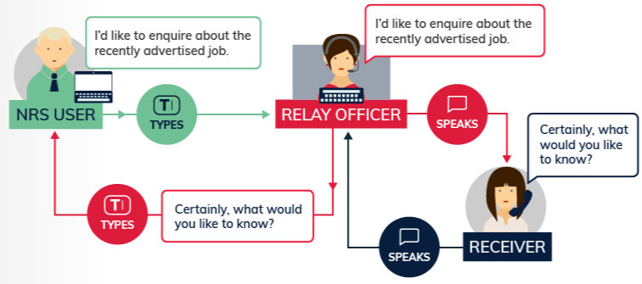

## Do relay calls breach privacy laws?

No, the Australian Privacy Commissioner recognises that the use of NRS relay officers in phone conversations complies with privacy legislation.

Relay officers receive extensive training about their role and their legal and ethical responsibilities. They sign a confidentiality agreement when they start work.

## Why do I need to know about the NRS and relay calls?

All your customers have equal rights of access to information and services. People with hearing or speech impairments have difficulty contacting you directly by phone but still need to do all the things that regular phone users do through your business.

These rights are specifically guaranteed in disability legislation around Australia. Taking calls through the NRS enables you to meet this obligation.

It is also good business for your organisation to provide access to as wide a group of people as possible.

## How do I authenticate the caller?

If you are required to authenticate each caller, the process for a relay call is straightforward—you simply ask the same questions that you would of any caller. The relay officer then relays your questions to the caller and relays the caller’s responses back to you.

If your organisation deals with private financial or personal information, you will have your own specific questions and procedures for authenticating callers. Again, you don’t need to change these procedures. In handling a relay call it is useful to think of the relay officer as not strictly a party to the call but more of an ‘invisible’ facilitator.

## What do I do when I receive a relay call?

When you get a call via the NRS, the relay officer will generally introduce him/herself and explain that it is a National Relay Service relay call. Relay officers identify themselves by a unique name, e.g. RO Kathy.

The first time you receive a relay call, it might appear a bit strange to have your conversation ‘relayed’. But as the call progresses you will quickly get used to it.

The call will usually take a little longer than a similar direct call. If you are concerned about this, just tell your supervisor that it was an NRS relay call. If your organisation has a special procedure for logging exception calls, you can use that.

## Ten tips for managing a relay call

1. Remember the National Relay Service is a phone service used by people with hearing or speech impairments.
2. There is a relay officer on the line—relaying the caller’s words to you, your words to the caller, or both.
3. Be patient—a relay call may take longer than a normal phone call.
4. It is a turn-taking conversation—it’s a good idea to say ‘go ahead’ each time you finish your turn.
5. Speak slowly and clearly.
6. Cover one topic at a time and wait for your caller to respond.
7. Speak directly to the NRS user—use ‘I‘ and ‘you’.
8. On some calls you can also speak to the relay officer—but only do so if you have a question or problem about the call process.
9. Handle the call as usual—all relay calls are strictly confidential.
10. End the call by saying ‘Goodbye, signing off’ or something similar.

## More information

For help with making or receiving relay calls, contact the **NRS Helpdesk:**

* Phone: 1800 555 660
* Fax: 1800 555 690
* SMS 0416 001 350
* Email: [helpdesk@relayservice.com.au](mailto:helpdesk@relayservice.com.au)
* Online: [Online form](https://www.communications.gov.au/node/19659).

The NRS Helpdesk operates from 8 am to 6 pm, Eastern Standard Time.

Find out more about relay calls and the other communication options for people who are deaf or have a hearing or speech impairment from Accesshub at [www.communications.gov.au/accesshub](http://www.communications.gov.au/accesshub).