# CIRCULAR 0 – 4 – 8

## REGISTRATION AND USE OF EVALUATION VEHICLES (Including their Importation)

### INTRODUCTION

* 1. This circular sets arrangements under which *manufacturers* and importers may register vehicle(s) for the purposes of evaluation. This circular applies to vehicle(s) that are to be used for evaluation purposes on public roads, including as applicable their importation.
  2. These arrangements apply only to ‘full volume’ original *manufacturers*. i.e. licensees holding an identification plate approval (IPA) under Section 10A (1) - ‘Approval for the Placement of Identification Plates’, of the *Motor Vehicle Standards Act 1989* (the Act) without restriction on the volume of vehicles that can be supplied. These arrangements do not apply to Low Volume *manufacturers* or to the Registered Automotive Workshop Scheme.
  3. The Applicant for *pre-release-evaluation* and/or *market evaluation* vehicles must be either the company that manufactured the vehicle in its original state, or related by ownership and under the control of the company that manufactured the vehicle’s original state, or the vehicle manufacturer’s nominated national representative in Australia.
  4. The State and Territory Registering Authorities (STRA) have agreed on the arrangements for the registration of evaluation vehicles outlined in this circular. The STRA where the evaluation vehicle is to be registered must be contacted to ascertain its particular registration requirements.
  5. Evaluation vehicles are categorised as *pre-release-evaluation*, *market-evaluation* or *engineering-evaluation* and separate conditions for registration for road use and disposal apply to each category. Only *pre-release-evaluation* vehicles may be supplied to the market in Australia and only if the Approval conditions have been met.
  6. Vehicles imported under the arrangements provided by the visitor convention for the temporary importation of private road vehicles (carnet) must not be used as evaluation vehicles.
  7. The number of vehicles registered of any make and model is to be restricted to a minimum number necessary for the evaluation program. In applying for registration, the *manufacturer* or importer will be required to declare the total number of vehicles proposed for registration in Australia for each evaluation programme and to specify the use to which each vehicle will be put within the programme.

### DEFINITIONS

* 1. Terms shown in italics are defined within the Motor Vehicle Standards Act 1989, the Australian Design Rules for Motor Vehicles and Trailers – Third Edition, or this Circular.

### 3. PRE-RELEASE-EVALUATION VEHICLES

3.1 Application

3.1.1 A *pre-release-evaluation* vehicle is a new vehicle of a design for which applications to the Administrator of Vehicle Standards (the *Administrator*) for:-

* Approval to Place an Identification Plate (referred to as a Compliance Plate Approval or CPA) has been made; or
* an amendment to an existing CPA due to a production change and the applicant specifically requests approval as a *pre-release-evaluation* vehicle has been made; and
* an Application for Pre-Release-Evaluation Vehicles under the provisions of Circular 0-4-8 as per Attachment 1 has been made to the *Administrator*.
  + 1. An application to place Identification plates on *pre-release-evaluation* vehicles may be made for vehicles which have not been used in transport. The application must identify the Vehicle Identification Numbers (VINs) of the *pre-release-evaluation* vehicles. These vehicles must not be development prototypes or early engineering development vehicles but may be vehicles made during proof runs of production processes/tooling or from a running production change that is sufficient to require amendment to the existing ‘full volume’ CPA.

3.2 Approval

* + 1. A *pre-release-evaluation* vehicle may be issued with a CPA under section 10A of the Act with additional *pre-release-evaluation* conditions where the *Administrator* is satisfied that a completed Road Vehicle Descriptor (RVD), summary of evidence (SE) and summary of fleet selection (SF) forms for all safety related Australian Design Rules(ADRs)(e.g. all except ADRs 79/…,80/…,81/...,82/... and 83/…) have been submitted via the Road Vehicle Certification System (RVCS) and the outstanding submissions are awaiting the completion of testing to confirm compliance with the relevant ADRs.
    2. *Pre-release-evaluation* vehicle CPA is only available to vehicles in categories MA, MB, MC, MD, NA, NB or NC.

3.3 Conditions of Approval

3.3.1 The *pre-release-evaluation* vehicle conditions will include:-

* that the vehicle(s) when driven on public roads may only be driven by persons in the employ of, or contracted to, the holder of the CPA, or other persons under the supervision of such a person, or by a member of the motoring press when associated with a structured release program for that particular vehicle model. Vehicle dealers or members of the general public must not drive the vehicle unsupervised on public roads;
* that the identification of the vehicles to be covered by the CPA will be by their VINs;
* prohibition on the transfer of registration and/or sale of the vehicle until the vehicle conforms to the design contained in the final form of an application for a CPA issued by the *Administrator*;
* expiry within six (6) months of the date of issue; and
* conditions of disposal or export, including a requirement to remove and destroy any identification plates affixed to the vehicles if the vehicles do not conform to the design contained in the final form of an application for a CPA issued by the *Administrator* before the expiry date.

3.3.2 The vehicle’s VIN will be flagged on the national VINs register so as to prevent transfer of ownership while the *pre-release-evaluation* conditions are in place. This flag will be removed on request when the *Administrator* is satisfied that the vehicle(s) conform to the design contained in the final form of a CPA issued by the *Administrator* before the expiry date.

### 4. MARKET-EVALUATION VEHICLES

4.1 Application

4.1.1 A *market-evaluation* vehicle is a vehicle(s) that is to be used on public roads under conditional registration to assess its viability in the Australian market. The vehicle(s) cannot be supplied to the market in Australia for use in transport and will not be eligible for CPA under section 10A (1) of the Act. *Market-evaluation* vehicles must not be left-hand-drive and must comply with the technical requirements of all applicable safety-related ADRs or with corresponding national or international standards, and meet all STRA registration requirements. For imported *market-evaluation* vehicles, it is a requirement that an Application for Vehicle Import Approval under the provisions of Circular 0-4-8 as per Attachment 2 has been made to the *Administrator*.

4.1.2 A *market-evaluation* vehicle is not required to have an Identification Plate placed on it as a condition of registration.

4.1.3 The application for registration must be in the name of the vehicle *manufacturer* or the vehicle *manufacturer’s* nominated national representative in Australia and must declare the expected period for completion of the evaluation.

4.1.4 The STRA’s will require:-

* a submission on the vehicle’s status of compliance with the ADRs and other requirements for registration and
* after assessment of this submission, an inspection of the vehicle to verify the submission.

4.2 Registration

4.2.1 If the vehicle is consistent with the submission and the vehicle(s) meets the STRA’s registration requirements, it will be registered for the period necessary for the completion of the evaluation programme.

4.3 Conditions of Registration

* + 1. The conditions of registration will include:-
* that the vehicle(s) when driven on public roads may only be driven by persons in the direct employ of, or contracted to, the applicant for the approval in the course of business, and that the vehicle(s) must not be driven on public roads by vehicle dealers, journalists, or members of the public;
* a prohibition on the transfer of registration or sale of the vehicle during the registration period; and
* that the vehicle is to be disposed of at the end of the period of registration either by export, destroying, or by means agreed to by the *Administrator* (eg. making the vehicle available to training providers) and that the vehicle must never be supplied to the market for use in transport in Australia.

### 5. ENGINEERING-EVALUATION VEHICLES

5.1 Application

* + 1. An *engineering-evaluation* vehicle is a vehicle that is to be used on public roads under conditional registration in the evaluation and development of vehicle components and systems (e.g. climate testing, dust ingress testing, rough road testing, benchmark testing and transmission calibration). The vehicle(s) cannot be supplied to the market in Australia for use in transport.

NOTE: Left-hand-drive and dual-control vehicles may only be registered as *engineering-evaluation* vehicles.

For imported *engineering-evaluation* vehicles, it is a requirement that an Application for Vehicle Import Approval under the provisions of Circular 0-4-8 as per Attachment 2 has been made to the *Administrator.*

* + 1. *Engineering-evaluation* vehicle(s) must comply with the objectives of all applicable safety related ADRs (excluding ADR 34/…, and excluding the steering control location requirements of ADR42/… in the case of left hand drive and dual control vehicles), and must meet all STRA registration requirements.
    2. The application process in clauses 4.1.2 to 4.1.4 for *market-evaluation* vehicles also applies to *engineering-evaluation* vehicles. However, where the vehicle is to be used for the evaluation and development of components, the application may request that the vehicle be registered in the name of the component manufacturer or the component manufacturer’s nominated national representative in Australia.

5.2 Registration

5.2.1 Registration will be in accordance with clause 4.2 for *market-evaluation* vehicles

5.3 Conditions of Registration

5.3.1 The conditions of registration, in addition to those applicable to *market-evaluation* vehicles in clause 4.3.1 (second and third dot-point only) above, include:-

* that the vehicle(s) when driven on public roads may only be driven by persons engaged directly or indirectly by the applicant to perform development work and who are in the direct employ of or contracted to, the *manufacturer* or the *manufacturer’s* nominated national representative in Australia or who are under the supervision of such a person (i.e. all personnel who drive the vehicle must be engaged in development work for the applicant); and
* the fixing of a durable warning label fixed in a position that is clearly visible to the driver and which contains the following warning:-

“WARNING**: This vehicle is registered for ‘Engineering Evaluation’ purposes only. Use of this vehicle on public roads is strictly limited to the evaluation and development of vehicle components and systems. When this vehicle is used on public roads it is to be driven only by personnel involved in those evaluations**.”

### ATTACHMENT 1

### Application to the Administrator for PRE – RELEASE – EVALUATION VEHICLES under the provisions of CIRCULAR 0 – 4 – 8

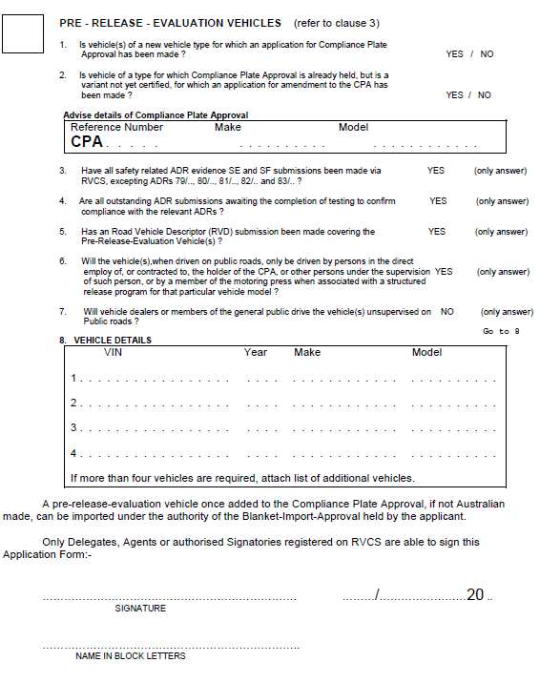

### ATTACHMENT 2

### Application to the Administrator for VEHICLE IMPORT APPROVAL under the provisions of CIRCULAR 0 – 4 – 8

