Logo: Australian Government, Department of Infrastructure, Transport, Regional Development and Communications.

www.infrastructure.gov.au


# National Freight Data Hub

# Options Discussion Paper

August 2020

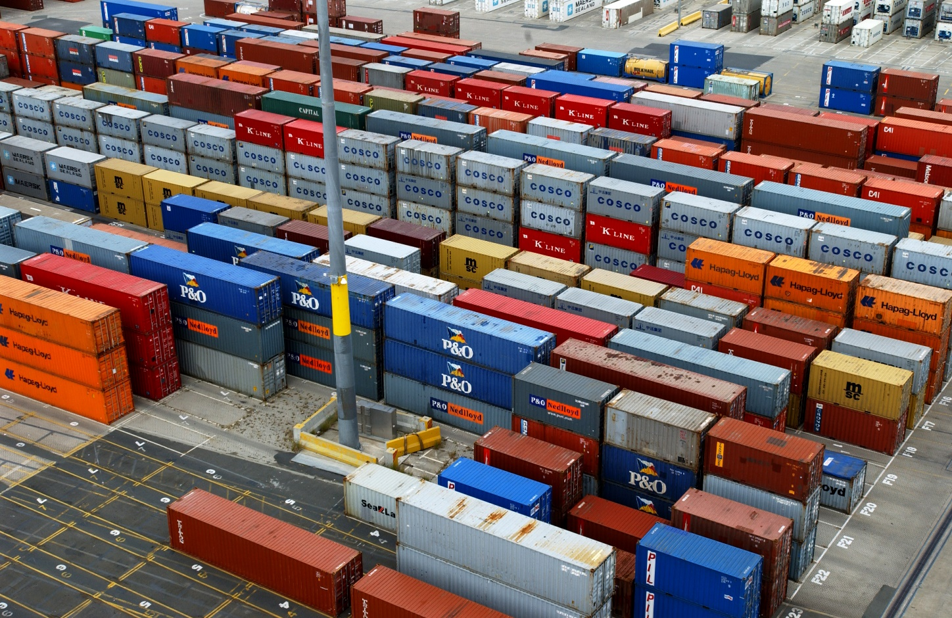  
Image of Brisbane Port

Ownership of intellectual property rights in this publication

Unless otherwise noted, copyright (and any other intellectual property rights, if any) in this publication is owned by the Commonwealth of Australia (referred to below as the Commonwealth)

Disclaimer

The material contained in this publication is made available on the understanding that the Commonwealth is not providing professional advice, and that users exercise their own skill and care with respect to its use, and seek independent advice if necessary.

The Commonwealth makes no representations or warranties as to the contents or accuracy of the information contained in this publication. To the extent permitted by law, the Commonwealth disclaims liability to any person or organisation in respect of anything done, or omitted to be done, in reliance upon information contained in this publication.

Creative Commons licence

With the exception of (a) the Coat of Arms; (b) the Department of Infrastructure, Transport, Regional Development and Communications photos and graphics copyright in this publication is licensed under a Creative Commons Attribution 4.0 Australia Licence.

Creative Commons Attribution 4.0 Australia Licence is a standard form licence agreement that allows you to copy, communicate and adapt this publication provided that you attribute the work to the Commonwealth and abide by the other licence terms.

Further information on the licence terms is available from <https://creativecommons.org/licenses/by/4.0/>.  
This publication should be attributed in the following way: © Commonwealth of Australia 2020.

Use of the Coat of Arms

The Department of the Prime Minister and Cabinet sets the terms under which the Coat of Arms is used. Please refer to the Commonwealth Coat of Arms — Information and Guidelines publication available at [www.pmc.gov.au](http://www.pmc.gov.au).

.

Contents

Introduction 4

Purpose of this paper 4

Designing a National Freight Data Hub 4

Option design framework 8

Element One: Data 10

Element Two: Technology 12

Element Three: Governance 15

Element Four: Funding 16

Element Five: Regulation 17

Next Steps 19

Tables and figures

Figure 1 Problem statement 4

Figure 2 Purposes and Functions 5

Figure 3 Foundation freight data enduring questions 6

Figure 4 Proposed design principles for the Hub 7

Figure 5 Options framework 8

Figure 6 Summary of range of options 9

Figure 7 Data Priorities 11

Figure 8 Architecture options 13

Figure 9 Governance options 15

Figure 10 Funding options 16

Figure 11 Regulatory options 18

Table 1 Technology architecture solutions 14

## Introduction

The Department of Infrastructure, Transport, Regional Development and Communications (DITRDC) is leading a process to settle the design of a National Freight Data Hub. The Hub will enable freight data creators, data owners and data users to more easily and securely access and share freight data. Better access to robust freight data will help businesses, governments and researchers make data-driven insights to solve business challenges.

### Purpose of this paper

This paper builds on the discussion paper released by DITRDC in December 2019 ([*National Freight Data Hub: Discussion Paper 1*](https://www.infrastructure.gov.au/transport/freight/national-freight-data-hub/index.aspx)) that sought feedback on the freight data that should be included in the Hub, together with considerations for sharing data and data products.[1]

The purpose of this Options Discussion Paper is to share progress on the design elements of the Hub and gather input on possible models and structures to inform the business case and roadmap for implementation.

PricewaterhouseCoopers Consulting (Australia) Pty Limited (PwC) is supporting DITRDC to settle the design of the National Freight Data Hub, and an implementation roadmap.

### Designing a National Freight Data Hub

Consultation with industry, governments and other stakeholders has defined a set of foundational ‘enduring questions’, and three high level functions for the Hub:

* Open data
* Data exchange
* Leadership and innovation

Stakeholders have also articulated three key problems to be solved by the Hub, outlined in Figure 1.

Figure 1 Problem statement

|  |  |
| --- | --- |
|  | * The data exists but we can't see it * The data exists but we can’t compare it * The data doesn’t exist |

The freight environment, along with the broader economy has been significantly impacted by COVID‑19. The future has become less predictable. All parties are looking for more up to date and higher quality data to manage risk, plan for different scenarios, and increase resilience. This is in addition to improving the efficiency, productivity and competitiveness of Australia's freight supply chains. These considerations will be incorporated into the design and business case for the Hub.

Figure 2 Purposes and Functions

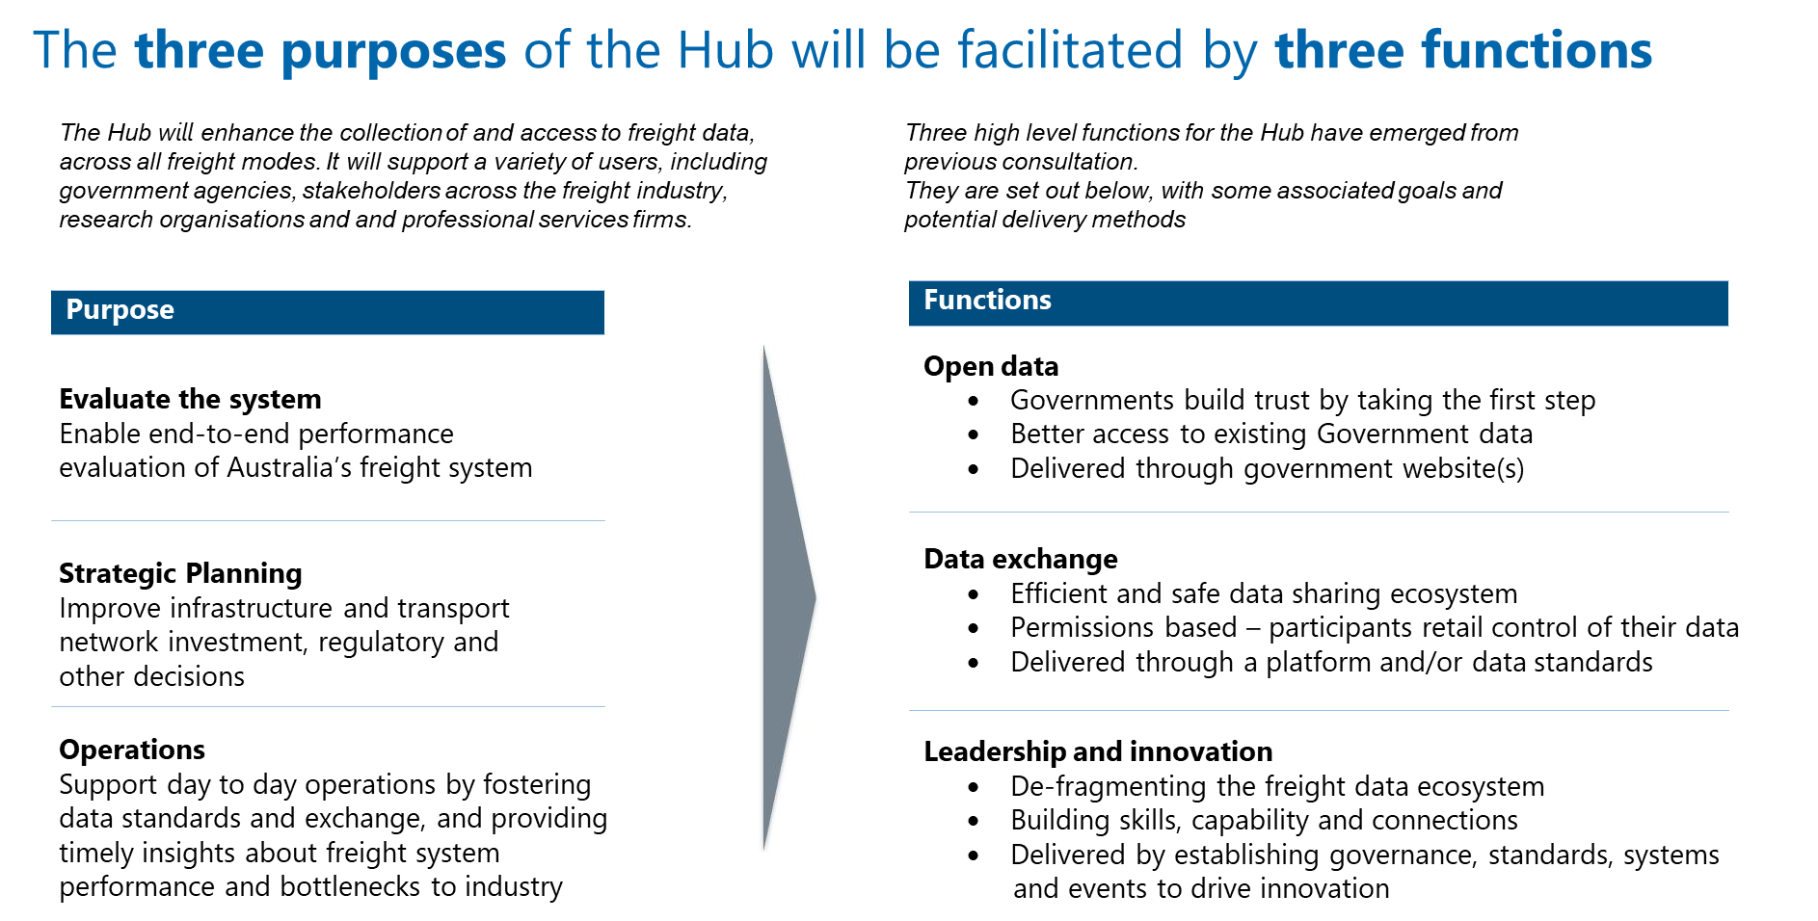

*The Hub is not intended to replace existing systems being used by businesses to support day to day freight operations, rather it will likely draw data from those systems and provide aggregated data back to improve efficiency.*

Figure 3 Foundation freight data enduring questions

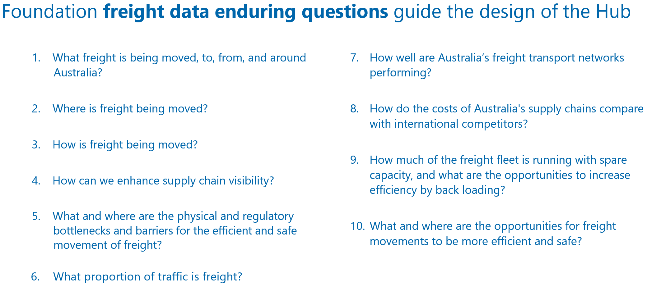

Source: DITRDC analysis of submissions to Discussion Paper #1

Design principles

Importantly, investment in the Hub and the activities it fosters must generate value to industry, government and other parties. To support the design of the Hub, proposed design principles have been developed based on previous stakeholder feedback.

Figure 4 Proposed design principles for the Hub

This figure lists five design principles: 
- Demonstrate value, early
- A trusted, independent facilitator
- Lead by example
- Data exchange is a collaboration
- High quality data and insights. 

Source: DITRDC / PwC based on discussion paper submissions

Questions for discussion – Design Principles

1. Please share your organisation’s perspectives on the proposed design principles, including any which are not represented here.

## Option design framework

Five key design elements are needed to deliver the functions:

* **Data**: Key data assets captured by the Hub to enable smart investment and operational decisions. The prioritisation of these data assets by stakeholders will inform the roadmap for potential phased implementation of the Hub.
* **Technology**: Technology approaches that progressively support the data requirements, additional functionality, use cases, and business requirements.
* **Governance**: Potential roles and responsibilities for the Hub and its users (e.g. industry, government, regulators, the research community, and the community more broadly).
* **Funding**: Varying options for funding and commercial pricing to promote the take-up of data standards and data sharing between participants, to support government and industry costs, and/or to enable purchase of existing data sets.
* **Regulation**: The potential extent of government regulatory responses such as changes to existing policy and/or regulation to support the Hub’s establishment and ongoing operation.

Together, the functions and design elements form the options framework shown in Figure 5.

Figure 5 Options framework

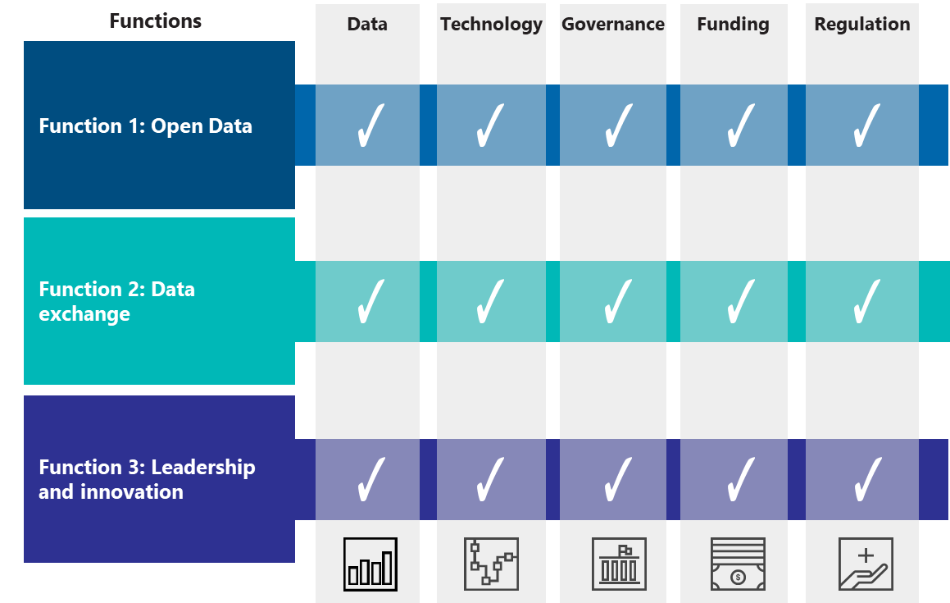

Source: PwC based on DITRDC analysis of submissions to Discussion Paper 1 (2020)

Each element has a range of options which can be combined in different ways to design the National Freight Data Hub.

Figure 6 Summary of range of options provides an overview, and the following sections of the paper set out more detail and discussion questions.

### This figure shows data, technology, governance, funding and regulation mapped against the different options for each. The following sections expand on this visual.

### Element One: Data

Drawing on findings from the iMOVE [*Freight Data Requirements Study*](https://imoveaustralia.com/project/freight-data-requirements-study/)*,* and submissions to the first Discussion Paper, a set of Enduring Questions and five high level data priorities have been identified for the Hub:

1. Consignment data
2. Container data
3. Vehicle data
4. Infrastructure data, and
5. Cost data.

The Hub will address deficiencies across these data priorities over time. It will focus on data that is needed for priority analysis and insights, and progressively build up data, standards and linkages from use cases and projects over time. It will generate significant efficiencies by enabling data collected and curated for one project to be easily found and re-used by other stakeholders.

Reponses to the first Discussion Paper identified a number of initial priorities for the Hub, including improved data on heavy vehicle and urban freight movements, improved data standards and protocols, and enhanced investment planning. These opportunities have been reflected in a set of ‘Enduring Questions’ that the Hub should address (see Appendix A). A number of these opportunities are currently under exploration through the delivery of pilot projects. The knowledge and data gained through the pilot projects will transition to the Hub.

The purpose (or use case) for the data will drive the level of fidelity (the granularity of the data) and frequency (time intervals of the data collected or reported) of data collection and aggregation.   
Figure 7 Data Priorities (overleaf) outlines options for capturing data to meet the Hub’s data priorities.

Questions for discussion – Data

1. What specific benefits would each data priority provide to your organisation?
2. What level of data fidelity (i.e. transaction level data or aggregated data) and frequency (i.e. near real-time, weekly, monthly, quarterly) would be required to make the data priorities you’ve identified be of value?

Figure 7 Data Priorities

This figure lists five data priorities: consignment, container, vehicle, infrastructure and cost. 
It then outlines what is existing, what would be small change, medium change or high change across the data priorities.   

Source: DITRDC, Foundation Enduring Questions and Freight Data Priorities, June 2020 (drawing on iMOVE study and stakeholder feedback on the December 2019 Discussion Paper) see Appendix A

### 

### Element Two: Technology

Technology has a key role to play in supporting the three key functions outlined above: leadership and innovation, open data and data exchange. The technology options for the Hub could change, and grow with the Hub over time.

There are four broad technology options:

* **No technology:** There is potential for the Hub to focus solely on leadership and innovation in respect of freight data exchange and open data.
* **Existing technology:** There is potential to continue to make use of, or adapt the existing technology systems used by governments, industry and other stakeholders to store and share data. In addition, the Hub would take a leadership role in developing technology and data standards to support improved integration and consistency.
* **Limited technology uplift:** Implementation of a modest platform suited to sharing and exchange freight industry data with a limited uplift in capability to support the Hub’s purpose.
* **Major technology uplift:** Implementation of a tailored solution to address the Hub’s purpose.

Based on the technology options, two potential technology architectures can be considered separately or also as a combination:

* **Centralised Architecture**: A single, centralised platform shared by users to exchange data (or publish open data sets) across the Australian freight system. This could consist of a limited web-based platform through to a more sophisticated and scalable solution. An example of a solution with a centralised architecture is the Australian Border Force’s Integrated Cargo System which receives data from importers, exporters and freight operators on cross border movement of goods to perform revenue collection and for community protection.
* **Federated Architecture**: Many distributed but interconnected platforms (which could be existing or new) working in unison with a common set of rules, to meet the unique data needs of users in the Australian freight system. An example is the design currently being investigated by the European Union (EU) through the European Federated Network of Information Exchange in Logistix (FENIX) for the purpose of near real-time freight data exchange.

Each potential architecture model has a logical flow-on effect on the delivery model and data related capabilities, which are illustrated by Figure 8 below.

Figure 8 Architecture options

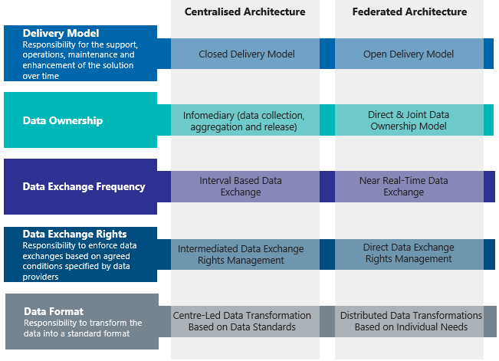

|  |
| --- |
|  |

Source: PwC Market Scan of Technology Providers and Peer Jurisdictions (2020)

Questions for discussion – Technology

1. If a centralised or federated architecture model were pursued, what would be the benefits and challenges to your organisation to participate in the Hub?
2. What are the preferred methods and technologies to integrate with the data exchange platform?

Table 1 below shows how the technology solutions vary for each of the architecture models.

Table 1 Technology architecture solutions

|  | Existing technology | Limited technology uplift | Major technology uplift |
| --- | --- | --- | --- |
| Centralised Architecture | **Leadership and Innovation**  The Hub publishes freight data sharing and integration recommendations. | **Leadership and Innovation**  The Hub invests in upgrading existing technology to facilitate data exchange and sharing. | **Leadership and Innovation**  The Hub takes the leadership role in investing in the development and deployment of a tailored, centralised data exchange and open platform. |
|  | **Data exchange**  Existing data platform is repurposed to facilitate data exchange. Participation is constrained by technology limitations. | **Data exchange**  Existing data platform to be uplifted to facilitate data exchange. Some constrains are alleviated through capability uplift. | **Data exchange**  A single, centralised, dedicated solution deployed by the Hub for gathering, processing, storing and distributing the freight data across all ecosystem players. |
|  | **Open Data**  Data published voluntarily by the data owners. | **Open Data**  Limited data sets published through a newly established bulletin board style web portal. | **Open Data**  The Hub provides a centralised open data platform where all users can search open data sets and download them. All users can upload their open data sets to this centralised portal. |
| Federated Architecture | **Leadership and Innovation**  The Hub publishes freight data sharing and integration recommendations. | **Leadership and Innovation**  The Hub develops technology and data standards to support improved integration and consistency. | **Leadership and Innovation**  The Hub assigns accountabilities and setting data agenda in collaboration with the industry. |
|  | **Data exchange**  Data integration and exchanges using existing technologies governed by direct agreements between organisations. | **Data exchange**  Key data integration and exchanges adhere to a common set of data standards and rules set by the Hub. | **Data exchange**  Data integration and exchanges fully systemised to meet the unique needs of all users across the industry. |
|  | **Open Data**  Data published voluntarily by the data owners at various locations. | **Open Data**  The Hub manages a catalogue of information published by the data owners, who are bound by a common set of data publishing schedules and standards. | **Open Data**  The Hub open data platform provides the capability to federate the search of open data sets across multiple open data platforms. |

Source: PwC Market Scan of Technology Providers and Peer Jurisdictions (2020)

### Element Three: Governance

The Hub governance model will play a key role supporting data collection, exchange and storage, managing interfaces and relationships across data users and suppliers, and providing leadership and innovation in the role of freight data in the sector.

Potential governance options are explained in Figure 9. These options draw on the Australian Government *Governance Structures Policy*, and incorporate an additional option relating to the potential for industry or an independent party to play a lead role governing the Hub.

The governance model could evolve over time from an initial arrangement, to one that offers increased longevity and commercial potential.

Figure 9 Governance options

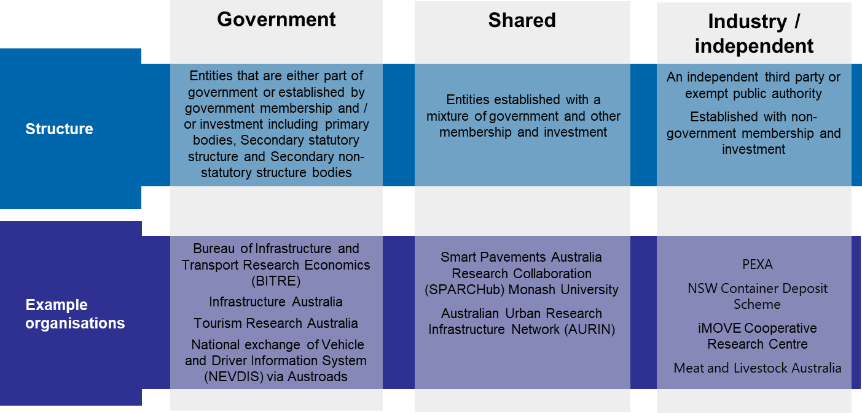

Source: DITRDC based on Commonwealth Government *Governance Structures Policy*

Questions for discussion – Governance

1. Which governance structure could enable the Hub to be established quickly and generate quick wins, and should it change over time?
2. Which governance structure is most likely to facilitate the greatest use and participation?

### Element Four: Funding

Funding options for the Hub will be closely linked to the governance, data and technology requirements. The potential to move to a more commercialised funding model is anticipated to be closely linked to the value generated for users through innovation and data-driven insights. Partial or full commercialisation either initially or over time, could provide higher certainty of the Hub’s ongoing operation.

Figure 10 outlines the three main potential funding options for the Hub.

Figure 10 Funding options

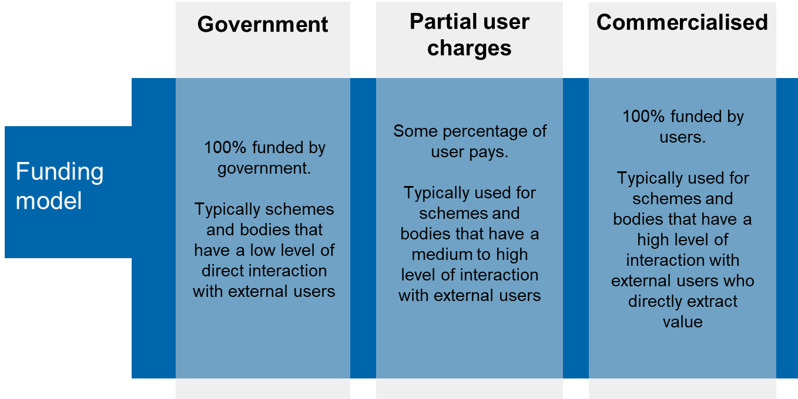

Source: PwC drawing on Department of Finance Australian Government Cost Recovery Guidelines (2014)

Questions for discussion – Funding

1. What funding arrangements could ensure users gain the value they are seeking from the Hub?
2. What services could the Hub provide that could be paid for by users?

### Element Five: Regulation

The Australian Government 2014 Guide to Regulation states that “regulation [should] never be adopted as the default solution, but rather introduced as a means of last resort. [This] requires that a range of feasible policy options must be considered”.[2] This guide sets out a spectrum of regulatory options for consideration when designing new policy, starting from no regulation to explicit government regulation.[3]

According to the Guide to Regulation, changes to regulation also need to consider several factors:

* Regulation should not be the default option for policy makers.
* Regulation should be imposed only when it can be shown to offer a net benefit.
* The cost burden of new regulation must be offset by reductions in existing burden.
* Consider impacts on affected businesses.
* Community organisations and individuals.
* Consider state and national options to avoid creating cumulative or overlapping regulatory burdens.

The requirements for regulatory change will depend on the other elements of the Hub design, the current regulatory framework, and whether changes are required to enable each use case and its requirements. The potential circumstances that may warrant a change, introduction or removal of a regulatory mechanism are:

* **To support the governance model**: The governance option may require regulatory change to implement, for example, new legislation to establish a new responsible entity.
* **To support data collection standards**: To define and implement a national framework of standards for freight data to facilitate aggregation and comparison across diverse data sources.
* **To support the ability to collect and share data**: To encourage data owners to share data and to protect data.
* **To support funding collection**: To enable collection of fees, cognisant of specifications that may consider a tax versus fee-for-service funding model.

Therefore, the changes required for the successful operation of the Hub may involve a range of regulatory responses, from light touch to more regulation. An overview of potential regulatory options is shown in Figure 11.

Figure 11 Regulatory options

This figure outlines no change, medium change and large change of the following: 
- Form
- Data collection
- Data security and privacy 

Source: Adapted from OBPR, PwC analysis (2020)

Questions for discussion – Regulatory

1. To support the Hub’s governance, ability to collect and share data, setting of standards and funding model, which regulatory option is best suited?
2. Would there be significant costs or benefits for your organisation associated with each of the regulatory options?
3. Are there additional circumstances to those outlined above, that may warrant a change, introduction or removal of a regulatory mechanism?

## Next Steps

**WEBINARS:**

There will be two webinars where stakeholders can participate in a briefing session on the Hub design elements. These webinars will be held:

* Monday 31 August, 14:00-15:30pm AEST
* Tuesday 1 September, 14:00-15:30pm AEST

Please email [freightdatahub@infrastructure.gov.au](mailto:freightdatahub@infrastructure.gov.au) to register and you will be provided with the details of the webinar.

**SUBMISSIONS:**

Please include in your submission:

* The name of your organisation.
* Contact details for a person within your organisation to whom any correspondence in relation to your submission can be addressed.
* A brief description of why your organisation is interested in the National Freight Data Hub.

Submissions close on 11 September 2020 at 17:00 AEST, and should be emailed to [freightdatahub@infrastructure.gov.au](mailto:freightdatahub@infrastructure.gov.au).

Your submission will be published on the website unless you request otherwise. Information collected during this consultation process may be provided to persons making an application under freedom of information laws. Personal details will not be published in any report.

1. That previous discussion paper built on preceding work through the *iMove Freight Data Requirement Study* and stakeholder consultation conducted through the *National Freight and Supply Chain Strategy*.
2. <https://www.pmc.gov.au/sites/default/files/publications/Australian_Government_Guide_to_Regulation.pdf>
3. There is a spectrum of regulatory responses: no regulation, better enforcement of existing regulation, light-touch regulation, self-regulation, quasi-regulation, co-regulation, explicit government regulation, as well as alternative policy instruments.