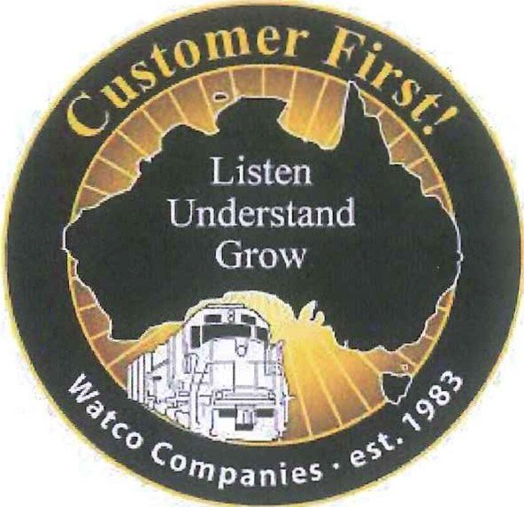

ENQ: Mr Grant Thompson

P: M: +61438 930 832

E: [gthompson@watcocompanies.com](mailto:gthompson@watcocompanies.com)

27 July 2017

Freight and Supply Chain Inquiry

Department of Infrastructure and Regional Development

GPO Box 594

CANBERRA CITY ACT 2601

Email- [freightstrategy@infrastructure.gov.au](mailto:freightstrategy@infrastructure.gov.au)

**Inquiry into National Freight and Supply Chain Priorities**

Watco Companies, LLC ("Watco") is a United States (Pittsburg, Kansas State) based company providing transportation, port and terminal, supply chain, and mechanical solutions for customers throughout North America and Australia.

Since 2012, Watco has undertaken the rail task on behalf of Co-operative Bulk Handling Limited

("CBH"), operating CBH's rail fleet for the dedicated service of grain haulage in Western Australia. 1

Watco notes the Federal Government's Inquiry into National Freight and Supply Chain Priorities and is naturally very supportive of efforts to develop a freight system that boosts the nation's prosperity and meets community expectations for safety, security and environmental amenity.

While Watco acknowledges the broad scope of the Inquiry, this submission focuses primarily on the need for Government strategy and planning around the development of intermodal facilities (as a means of better transitioning freight between modes) that will generate efficiencies in Australia's supply chains.

This sentiment is in line with Watco's ongoing support for Infrastructure Australia's National Freight Strategy and its call for"... greater intermodal terminal capacity in the capital cities ..." as a means of enhancing the efficiency and safety of Australia's landside logistics task;in particular for the transport of containers.2

1The CBH Group is a Western Australian farmer-owned cooperative that was established in 1933. It's controlled by more than 4,000 grower-shareholders who plant and harvest grain grown across the 320,000 square kilometres that comprise the Western Australian grain belt.

2 Quoted variously including Infrastructure Australia's National Land Freight Strategy Discussion Paper, February 2011.

1 Campbell Street • West Perth WA 6005 • Phone: +61 8 9416 6381 • Fax: +61 8 9226 0309

**Background**

***Watco Western Australia***

In December, 2010, CBH announced that Watco had been awarded its long-term grain rail contract. Concurrent with this announcement was CBH's statement they would be investing $175 million in rolling stock which Watco would operate and maintain, including 25 locomotives and more than 570 wagons (railcars).

The Western Australian grain network is similar in carload volume and track length to Watco's Central Region grain network consisting of the Kansas and Oklahoma Railroad, the South Kansas and Oklahoma Railroad and the Stillwater Central Railroad.

Watco began its Western Australian operations in March of 2012 and provides comprehensive rail logistics services including train planning and scheduling, tracing, maintenance and inventory control. The railroad transports an average of 10-12 million tonnes of grain annually from around

190 country receival sites to CBH's four export terminals.

In 2016 Watco Western Australia was awarded an infrastructure train contract by Arc Infrastructure (formally Brookfield Rail) to operate infrastructure trains. In December 2016, Watco acquired a majority shareholding in lntermodal Group, a Western Australian intermodal container transport group.

In July 2017, Watco took over the operation of the Forrestfield to Fremantle Harbour intermodal container service including management of the North Quay Rail Terminal.

***The Western Australian Rail Freight Network***

Watco undertakes rail freight operations on Western Australia's two major rail networks:

• The State-owned freight network is operated by Arc Infrastructure under lease until 2049.

Arc operates the network as an open-access, multiuser business incorporating track infrastructure and train control service. Arc is also responsible for negotiating commercial access with end users and above-rail service providers; and

• The interstate main line (together with the track east of Kalgoorlie, which is owned by the Australian Rail Track Corporation) and the south-west mainline are also recognised under the National Land Transport Network. 3

**Responding to the Discussion Paper**

***Planning for future growth* - *the need for the effective transition between modes of freight"***

While the Discussion Paper makes limited reference to the requirement for intermodal facilities, it is Watco's view that any strategy that seeks to improve freight and supply chain efficiency and capacity and to reduce the costs of transporting goods through Australia's major national container ports must feature planning around the requirement for (and expanding) intermodal terminals.5

This is an important point, one supported by the Western Australian Department of Transport's

(Transport WA) *Western Australian Regional Freight Transport Network Plan* that notes:

• Western Australia's regional road freight task is likely to increase substantially, from 20+ billion tonne kilometres per annum of freight in 2010 to 40 billion tonne kilometres per annum of freight moving into, within and out of the State's regions by 2030. This corresponds to a doubling of the road freight task in the next two decades; 6

• Priorities therefore to develop new and expanded outer-metropolitan corridors and intermodal facilities to improve freight distribution to Western Australia's regions and to reduce the impact of heavy freight movements on metropolitan communities has been stipulated as an important strategic planning consideration for Government;

3 Who Moves What Where- Freight and Passenger Transport in Australia- National Transport Commission, August 2016

4 An intermodal site in this instance being a facility used to transfer freight (containers as twenty-foot equivalent units (TEUs) or forty-foot equivalent units (FEUs)) from one mode of transport to another- road to rail (for export bound TEUs)/rail to road (for imported TEUs))

5 Although it is noted that in developing the review, mention is made that "Establishing the capacity of the key national ports, airports and

intermodal terminals in comparison to international markets with similar characteristics..."

6 The Western Australian Regional Freight Transport Network Plan (undated)- page 9

• This incorporates options for an expanded intermodal terminal network located in outer­ metropolitan Perth areas to ensure efficient freight distribution to the State's north-eastern and south-eastern regional areas. Initial investigations are to focus on assessing the suitability of intermodal freight terminals in the Bullsbrook/North Ellenbrook and Mundijong areas, including road and rail connections, site options and essential services requirements.7

***Enhanced container management***

Fremantle Port's ("FP") inner harbour is currently handling around 700,000 TEUs each year with rail's share of landside logistics approximately 14% (and steady). With a forecasted increase in TEU

growth of between 1.5 to 1.8 million by 2030, without significant intervention, most of this growth will be carried by road transport.

While Watco considers that road transport should always constitute an important component of Australia's logistics mix, such a considerable increase in TEU movements into and from Fremantle Port cannot be handled by road on the basis that:

• The management of this growth by way of heavy vehicles alone will bring inefficiencies and negative social impact including a lessening in road safety, increased traffic congestion and pollution (noise and air); and

• The current road freight dominated nature of container operations at the Fremantle Inner Harbour creates an operational ceiling on port capacity; that may force the State into a premature and significant investment into other areas such as the proposed Outer Harbour initiative.

***The need for increased intermodal capacity in Western Australia***

Western Australia, in the context of the global container market is a net receiver of freight with loaded import containers representing the largest proportion. FP data indicates that around 50% of the export containers are empty for return to origin markets meaning an important requirement for the port and associated intermodal terminals is providing sufficient capacity to handle empty containers (as overall demand grows). In this regard,it makes sense to store and handle empty containers away from valuable port land for subsequent delivery on a just in time basis.

It is considered that the Perth metropolitan area has insufficient intermodal terminal capacity for this forecasted increase in container numbers. As a case in point, Watco's current intermodal terminal at Forrestfield is at near capacity with limited options for increasing volume available for development. Additional capacity is therefore required to maintain momentum towards ensuring rail is able to handle the targeted share of port-related container traffic (often quoted at around

30%).

Into the future, further collaboration and integration across supply chains (such as Watco's intermodal chain) will be critical to ensure that road and rail modalities work together optimally. Indeed, this type of "hub and spoke" strategy allows State and Federal Governments to balance competing interests by easing road congestion into highly urbanised port precincts, identify priorities for capital investment in roads leading to rail hubs, support rail corridors into ports and

optimise the last mile distribution by road from intermodal and supply chain precincts for export and import freight.

***Supply chain priorities and corridor protection***

Urbanisation is placing pressure on the ability of supply chains to act optimally and to support economic growth. Corridor protection is crucial to the efficiency of any supply chain, creating a balance between the need for residential development and the effective operation of supply chain networks that ensure Australia is competitive in global markets.

Despite the obvious nature of this problem, urban encroachment on major supply chain corridors and industrial areas is occurring. Planning, transport and land agencies must ensure there is coordination and collaboration to protect freight corridors (including rail and road) into the future.

7 The Western Australian Regional Freight Transport Network Plan- Page 42

**To conclude**

Watco has already had encouraging consultations on these issues with a range of key stakeholders including representatives from Government. While we have plans over the coming months to present our more detailed views regarding the requirements for enhanced intermodal facilities in Western Australia, Government's Review into National Freight and Supply Chain Priorities is a timely opportunity to once again articulate the importance of planning for intermodal networks within Australia's broader landside logistics strategy.

We look forward to the opportunity of having further discussions on this matter. In the interim, please do not hesitate to contact me direct should there be anything further you wish to discuss.

Yours sincerely

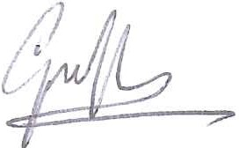

**Grant Thompson**

**Chief Operating Officer**