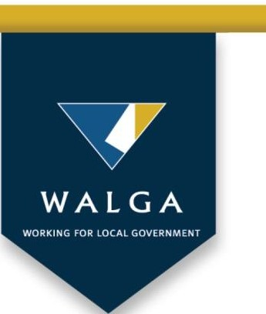

National Freight and

Supply Chain Priorities

Submission to the Department of

Infrastructure and Regional Development

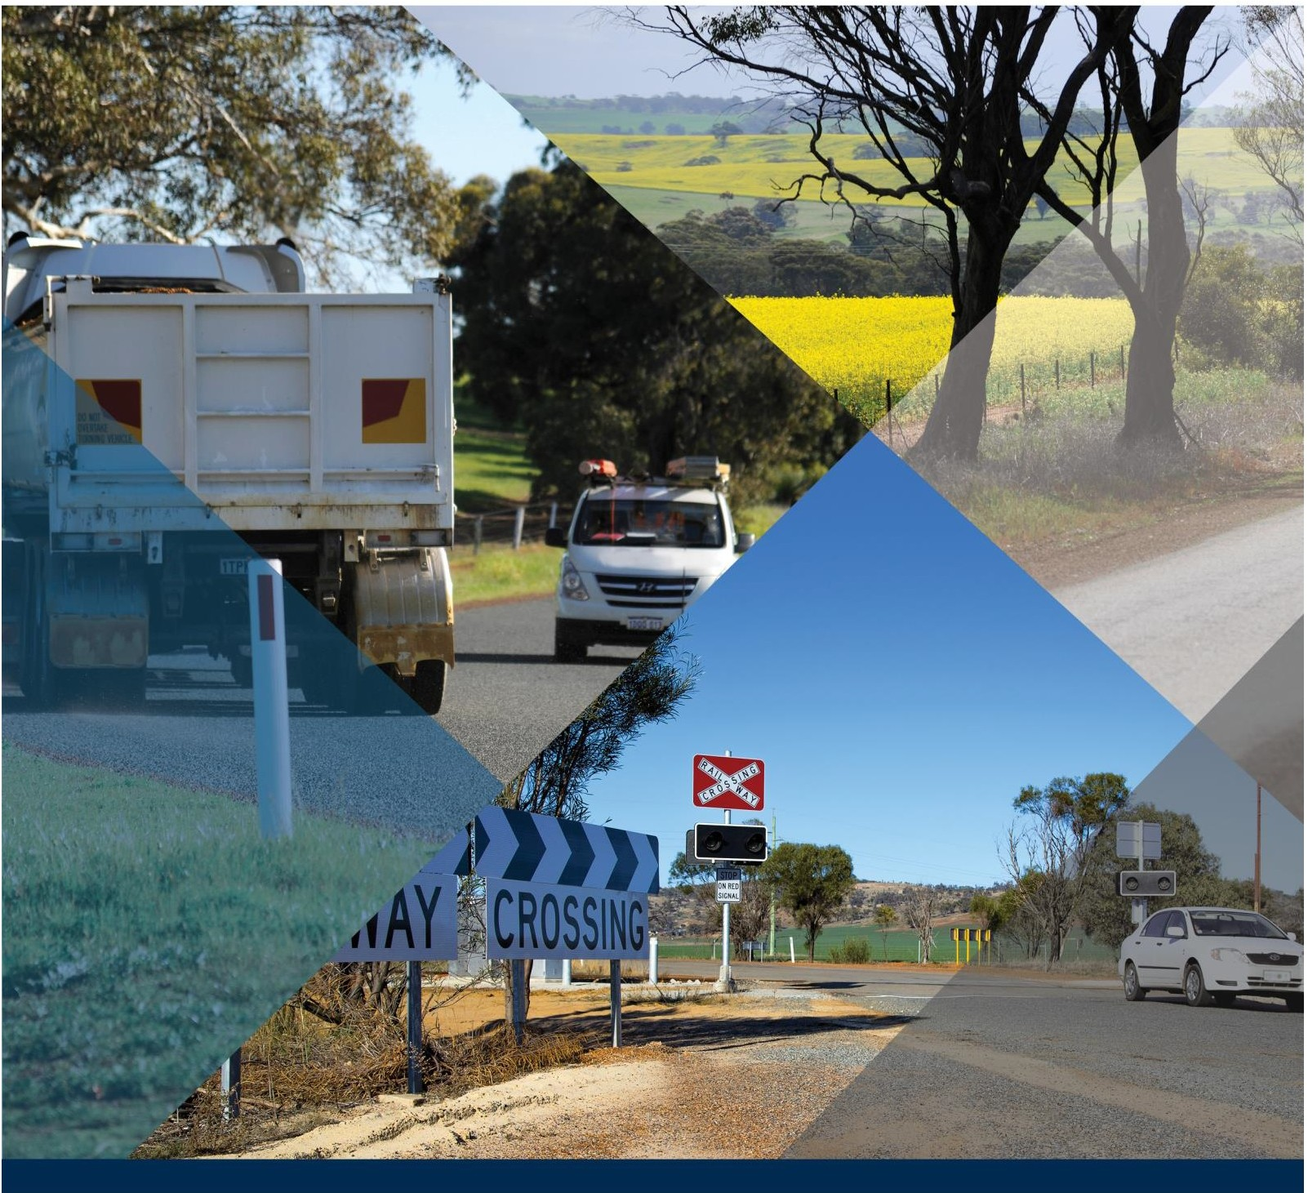

walga.asn.au

**Contact:**

|  |  |
| --- | --- |
| Ian Duncan | |
| Executive Manager Infrastructure | |
| WALGA | |
| ONE70, LV 1, 170 Railway Parade West Leederville | |
| Phone: | (08) 9213 2031 |
| Fax: | (08) 9213 2077 |
| Mobile: | 0439 947 716 |
| Email: | [iduncan@walga.asn.au](mailto:iduncan@walga.asn.au) |
| Website: | [www.walga.asn.au](http://www.walga.asn.au/) |

**Contents**

Executive Summary .............................................................................................................. 4

1.0 About WALGA ............................................................................................................ 6

2.0 Introduction ................................................................................................................ 6

3.0 Freight, Supply Chains and Local Government........................................................... 7

3.1 Road Manager Perspectives ................................................................................... 7

3.1.1 Access ............................................................................................................. 7

3.1.2 Knowledge of Freight Movements .................................................................... 8

3.1.3 Maintenance and Renewal............................................................................... 9

3.2 Sustainable Economic Development....................................................................... 9

3.3 Communities and Freight ...................................................................................... 10

4.0 Nationally Significant Supply Chains in Western Australia ........................................ 11

4.1 Cereal Grains........................................................................................................ 12

4.1.1 Traditional Supply Chain ................................................................................ 12

4.1.2 Contemporary Supply Chain and Trends ....................................................... 12

4.2 Metalliferous Ores................................................................................................. 12

4.3 Sand, Stone and Gravel........................................................................................ 13

5.0 Issues for Investment Focus ..................................................................................... 13

5.1 Information Capture .............................................................................................. 13

5.2 Encouraging More Efficient Use of Existing Infrastructure ..................................... 14

6.0 Infrastructure Investments ........................................................................................ 14

6.1 Wheatbelt Secondary Freight Routes.................................................................... 14

6.2 Indian Ocean Gateway ......................................................................................... 16

6.3 Bunbury Outer Ring Road ..................................................................................... 16

6.4 Albany Ring Road ................................................................................................. 16

6.5 North West Coastal Highway ................................................................................ 17

**Executive Summary**

Local Governments manage the majority of Australia’s road network and play an important role in economic development and in the creation of liveable communities. Freight intersects with these responsibilities and objectives in many ways.

Recognising that the freight task is growing and changing, many Western Australian Councils and Regional Organisations of Councils have invested in transport plans that identify key transport routes and linkages, and investment needs at the local and regional level. These plans address the requirement for efficient intraregional freight movements as well as the critical “last mile” access that if not resolved can seriously diminish the value of investments elsewhere in the supply chain.

Enhanced engagement between all spheres of government and industry is critical to improving the efficiency of supply chains in Australia.

In volume terms, movement of commodities including ores, grains and basic raw materials dominate the freight task in Western Australia. These industries are export focussed and so the efficiency of the supply chain underpins the global competitiveness of Australia in these markets.

In addition to identifying some priority infrastructure investments this submission identifies investments in data capture, information management and sustainable funding models that will establish a sound basis for continuing improvement in the efficiency of Australia’s supply chains and the investment in them.

The recommendations identified within this submission are:

**1. The Federal Government should support the development and acceptance of project evaluation methods that enable the effective consideration of investments in the first and last mile of distributed supply chains.**

**2. The Federal Government should work with State agencies and industry to require the provision of basic spatial information about the movement of all heavy vehicles on the road network and this information be available in aggregate to road managers to support effective investment and maintenance planning.**

**3. Funding provided to upgrade Local Government roads to accommodate freight tasks should include provision for funding maintenance and renewal of those assets.**

**4. The Federal Government work with State Governments and industry to develop funding models that better align the beneficiaries of investments in freight infrastructure with those bearing the capital and on-going costs.**

**5. That where new freight corridors are planned, reservations include sufficient buffers to manage anticipated noise, vibration and other impacts.**

**6. That Local Governments be supported in their efforts to address the existing issues arising from noise, vibration and other external impacts from freight operations.**

**7. That Federal and State regulations and policy encourage freight operators to invest in equipment that provides quieter and safer operations with less environmental impact.**

**8. That Federal and State regulations and policy encourage freight operations to occur in such a way as the external impacts are minimised to the extent that is reasonably practicable.**

**9. That the on-going evolution of road user charging arrangements associated with defined freight tasks be supported.**

**10. That Governments work with industry to better understand the impact of**

**movement of basic raw materials in urban and peri-urban environments and work to ensure that this supply chain operates efficiently including consideration of externalities such as noise, dust and safety of all road users.**

**11. That the Federal Government invest in national systems for the capture and depersonalised sharing of data on the movement of freight vehicles captured from in-cab geo-locating equipment.**

**12. That the Federal Government invest in planning and the development of a business case for the development of the secondary freight network in the southern half of Western Australia.**

**13. That the Federal Government engage and invest in planning for the development of the Outer Harbour and associated freight infrastructure as the long term freight hub for Western Australia.**

**1.0 About WALGA**

The Western Australian Local Government Association (WALGA) is the united voice of Local Government in Western Australia. The Association is an independent, membership-based organisation representing and supporting the work and interests of 138 mainland Local Governments in WA, plus the Indian Ocean territories of Christmas Island and Cocos (Keeling) Islands.

The Association provides an essential voice for over 1,200 elected members, some 14,500

Local Government employees, as well as over 2.6 million residents of Western Australia. WALGA also provides professional advice and services that provide benefits to Local Governments and the communities they serve.

Due to timing the comments and recommendations contained in this submission have not yet been considered or endorsed by WALGA’s State Council. This is an interim submission and as such the Association reserves the right to modify or withdraw any element of this submission as directed by State Council.

**2.0 Introduction**

Australia’s domestic freight task increased 50% in the decade to 2016, despite the Global Financial Crisis, and is forecast to increase a further 26% in the coming decade1. In Western Australia the total freight task increased much more quickly, growing by 10.5% per year in the ten years to 2014 to reach 294.5 billion tonne kilometres, with 85% of this carried by rail (primarily privately owned and operated iron ore movements)2. Although representing only

15% of the freight task (expressed in tonne-kilometres), road freight also more than doubled in the ten years to 2013/14 to over 44 billion tonne-kilometres3 and is expected to continue to increase, despite slowing economic and population growth.

Recognising these challenges at a regional and local level, many Western Australian Councils and Regional Organisations of Councils have invested in transport plans that identify key transport routes and linkages, and investment needs at the local and regional level4. These plans address the requirement for efficient intraregional freight movements as well as the critical “last mile” access that if not resolved can seriously diminish the value of investments

elsewhere in the supply chain.

1 National Transport Commission 2016, Who Moves What Where

[(https://www.ntc.gov.au/Media/Reports/(D62E6EFC-36C7-48B1-66A7-DDEF3B04CCAE).pdf)](https://www.ntc.gov.au/Media/Reports/(D62E6EFC-36C7-48B1-66A7-DDEF3B04CCAE).pdf))

2 ibid

3 ibid

4 Examples include South West Group (ROC) ([http://www.southwestgroup.com.au/regional- priorities/projects/page/2/](http://www.southwestgroup.com.au/regional-priorities/projects/page/2/)); Eastern Metropolitan Regional Council [(http://www.emrc.org.au/Documents/8020/download/38815/Regional-Integrated-Transport-Strategy-2017-](http://www.emrc.org.au/Documents/8020/download/38815/Regional-Integrated-Transport-Strategy-2017-2021.pdf)

[2021.pdf](http://www.emrc.org.au/Documents/8020/download/38815/Regional-Integrated-Transport-Strategy-2017-2021.pdf)); City of Cockburn [(https://www.cockburn.wa.gov.au/getattachment/36bc6b4e-422a-4af4-87a3-](https://www.cockburn.wa.gov.au/getattachment/36bc6b4e-422a-4af4-87a3-71ca655f0af1/ECM_5543738_v1_Cockburn-Coast-DSP-Part-2-(2012)-Integrated-Transp-pdf.aspx))

[71ca655f0af1/ECM_5543738_v1_Cockburn-Coast-DSP-Part-2-(2012)-Integrated-Transp-pdf.aspx)](https://www.cockburn.wa.gov.au/getattachment/36bc6b4e-422a-4af4-87a3-71ca655f0af1/ECM_5543738_v1_Cockburn-Coast-DSP-Part-2-(2012)-Integrated-Transp-pdf.aspx))

**3.0 Freight, Supply Chains and Local**

**Government**

Local Governments have a keen interest in the design and implementation of efficient freight movement from three key perspectives:

a) as the responsible manager of the vast majority of the State’s road network. A significant proportion of goods moved do so for at least part of that journey on road, and most freight movements at least start or end on a road under the control of a Local Government;

b) as a facilitator and promoter of sustainable economic development; and c) as a planner of liveable communities.

**3.1 Road Manager Perspectives**

Almost every road freight task includes at least some use of the road network that is under the care and control of Local Governments. In Western Australia, Local Governments are responsible for the management of 127,500 kilometres of road, 88% of the public network. Most supply chains include at least some road segments, typically the first and last links. Just as a chain is only as strong as its weakest link, so supply chain efficiency is determined by the least efficient sector. There are three important priority investments that are most acutely recognised by Local Governments.

**3.1.1 Access**

The focus on constraints faced by road transport operators in accessing the so called “first and last mile” of a freight journey has and will continue to increase as a result of more widespread utilisation of high productivity or restricted access vehicles, consolidation in the transport industry enabling loads to be allocated to the most efficient vehicles and increasing end to end transport, by-passing the traditional use of depots and warehouses that previously enabled goods to be staged, at least at one end of the supply chain. This trend is particularly obvious in the fertiliser and grain supply chains, where the once dominant role of up-country depots and grain bins is much diminished. Inputs are now primarily moved directly on to farms, and outputs moved directly to customers, ports or major regional facilities. Where up-country depots and grain receival facilities continue to be used, the number of these is diminishing and their size increasing meaning the length of the “last mile” is increasing.

Highly limited road funding is generally allocated between competing uses on the basis of benefit cost ratios or multi-criteria analyses. With often limited volumes of freight carried on the “first / last mile” the economic benefit from significant or costly improvements to the road network to allow safe access for large (restricted access) vehicles is too often not achievable. The alternatives, double handling through depots with connections to strategic freight routes, breaking down multi-combination vehicles or using smaller general access vehicles are not commercially attractive.

In response, Local Governments in Western Australia have widely supported conditional access for multi-combination vehicles to 27.5m length and 87.5 tonnes gross combination mass on roads with pavement widths as little as 3.5m and unsealed roads. Conditions under which access is provided include speed restrictions, communications protocols (with school buses and other heavy vehicles), use of warning lights etc. These measures are intended to mitigate the risks to other road users given the inadequate road width and geometry. These measures are, however, only effective while the volumes of freight vehicles and other traffic remain low. When the traffic volumes grow, improvements to road width, geometry, intersections and strength are required. These road improvements can be difficult to economically justify once access for PBS or RAV vehicles has been provided unless there are a sequence of serious crashes.

In order to be able to maintain access for increasing volumes of larger and heavier trucks, some infrastructure improvements will be required. Traditional benefit – cost analyses will not support this investment in many cases. Alternative approaches to assessing the relative merits of investments need to be developed and accepted within the context of the whole supply chain.

**Recommendation**

**The Federal Government should support the development and acceptance of project evaluation methods that enable the effective consideration of investments in the first and last mile of distributed supply chains.**

**3.1.2 Knowledge of Freight Movements**

Traffic counters are typically installed by road managers for a few weeks in order to quantify the traffic on each road segment. However, in rural and remote areas it is not unusual to observe 80% of the annual heavy vehicle load on low volume roads occurs in just a few weeks (harvest and pre-seeding, other seasonal operations) each year. Furthermore, construction activities, changes in grain marketing strategies and seasonal conditions can significantly alter the flows of freight at the local level from year to year. These factors, coupled with the extensive nature of the road network, makes it difficult for road managers to fully understand the freight flows and demands on the road network.

GPS based technologies offer the opportunity to replace occasional sampling of traffic volumes with continuous data of all heavy vehicle movements. The value of this in better understanding existing freight flows on the low volume road network is significant. Cooperation between industry and government in achieving this is paramount.

**Recommendation**

**The Federal Government should work with State agencies and industry to require the provision of basic spatial information about the movement of all heavy vehicles on the road network and this information be available in aggregate to road managers to support effective investment and maintenance planning.**

**3.1.3 Maintenance and Renewal**

Nearly 73% of expenditure on Local Government roads in Western Australia is applied to the maintenance and renewal of existing assets. This contrasts with the State road agency (Main Roads WA) which directs about a quarter of expenditure to asset maintenance. For many Local Governments expenditure on maintenance and renewal of roads and associated assets accounts for half (or more) of total expenditure. This leaves little room for improvements and makes Local Governments highly focussed on the life-cycle cost of any new assets, including upgraded roads.

It has been demonstrated that the impact of heavy vehicles on road infrastructure is greater in those situations where the road has not been designed and constructed for the task. This applies to both pavement strength and road width, as multi-combination vehicles result in excessive damage to road edges and shoulders where inadequate pavement width is provided.

Proposed investments in secondary freight routes and last mile access must consider and fund the life-cycle costs on the asset.

**Recommendation**

**Funding provided to upgrade Local Government roads to accommodate freight tasks should include provision for funding maintenance and renewal of those assets.**

**3.2 Sustainable Economic Development**

Local Governments across Australia take a strong role in economic (and social) development of their regions. These roles can include; facilitator, co-ordinator, promotor and developer in different circumstances. The movement of goods and people is central to the sustainable growth of local economies. Consequently Local Government will work hard with local industries, identifying constraints to growth and employment and seeking to overcome these. Access to efficient movement of freight is central to this.

It is more challenging when economic development in one Local Government requires investment in transport infrastructure in another Local Government area. Conceptually this issue is resolved by the State and national road network. However, in Western Australia there are some Local Government areas that are not served by any State or National roads. Furthermore, the cost of “last mile” access to facilities serving large areas are typically borne by the ratepayers of one area. The employment and other benefits arising from the location of the facilities may be marginal. Mechanisms to fund freight infrastructure improvements and maintenance that better link the user to the provider are required.

**Recommendation**

**The Federal Government work with State Governments and industry to develop funding models that better align the beneficiaries of investments in freight infrastructure with those bearing the capital and on-going costs.**

**3.3 Communities and Freight**

The development of policies to manage conflicts between freight operations and incompatible land-use developments adjacent to freight corridors is a long standing challenge that Local Governments seek to address with the support of State Governments.

The key principles are to protect strategic freight infrastructure from encroachment of incompatible development and to minimise the impact of freight movements on existing and future communities. While noise, and to a lesser extent vibration, from freight movements are the most strongly focussed on, a range of other issues including odours, diesel particulates, nitrous oxides, dust and safety are raised by the community with their Local Governments.

Land-use planning in Western Australia is centralised when compared to other Australian jurisdictions. The Western Australian Planning Commission is a statutory authority with vested powers under the Town Planning and Development Act 1928 and is responsible for assessing all subdivision and some development applications. Nevertheless Local Governments continue to come under pressure from developers to support development of land in proximity to freight corridors and from residents adversely affected by freight noise and vibration.

There are some recent examples of innovative approaches to managing the urban – freight corridor interface such as the City of Cockburn Local Planning Scheme No 3 Amendment No

118 and Draft Local Planning Policy 1.17. This seeks to define a special control area and utilise the built form to manage the impact of rail freight noise into urban areas.

It is acknowledged that noise and vibration are inherent to some degree in freight operations. However, there are also opportunities to manage the externalities associated with freight movements. Improvements in truck and train technology has resulted in quieter, safer, and more efficient trucks and rail operations. These not only have a lower environmental impact but offer cost savings over the longer term. Across Australia 46% of articulated trucks and

59% of heavy rigid trucks registered are more than 10 years old5, meaning that these new

technologies take a very long time to positively impact on the community. State and Federal Governments need to ensure that the regulatory and policy environment encourages operators to invest in equipment and processes that deliver these benefits.

**Recommendations**

**That where new freight corridors are planned, reservations include sufficient buffers to manage anticipated noise, vibration and other impacts.**

**That Local Governments be supported in their efforts to address the existing issues arising from noise, vibration and other external impacts from freight operations.**

**That Federal and State regulations and policy encourage freight operators to invest in equipment that provides quieter and safer operations with less environmental impact.**

5 Australian Bureau of Statistics 2016, Census of Motor Vehicles, Australia (Cat No 9309.0)

**That Federal and State regulations and policy encourage freight operations to occur in such a way as the external impacts are minimised to the extent that is reasonably practicable.**

**4.0 Nationally Significant Supply Chains in**

**Western Australia**

The freight task in Western Australia is different from the national picture in several important ways as illustrated in Figure 1.

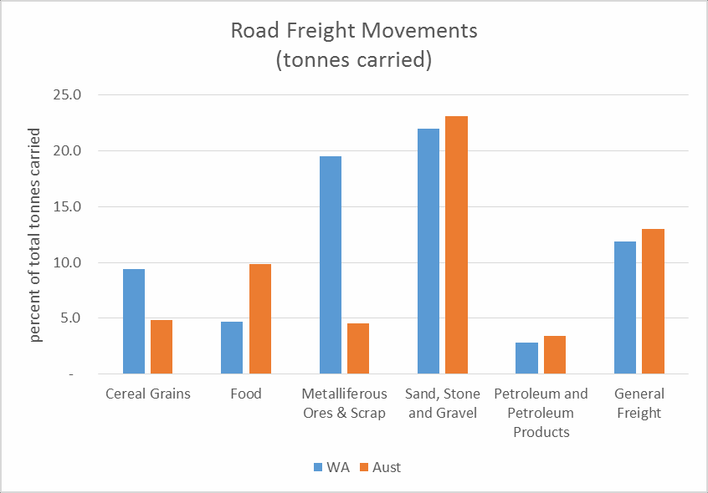

**Figure 1**

*Figure 1: Selected road freight movements, tonnes carried in Western Australia and Australia*

Most noticeably metalliferous ores and cereal grains represent a much greater proportion of total tonnes carried by road in Western Australia, relative to the national average. Food represents a significantly lower proportion of total tonnes carried in Western Australia compared to Australia as a whole.

The cereal grains and metalliferous ores supply chains in Western Australia are highly export oriented. As Australia is largely a price taker in these commodity markets, an efficient supply chain is a critical element in achieving and maintaining international competitiveness. In some cases these supply chains receive less public focus as they are strongly managed by the private sector and are typically remote from major urban centres. These supply chains are explored in more detail below.

**4.1 Cereal Grains**

In Western Australia, cereal grains comprise nearly 10% of the total tonnes carried, compared with under 5% of the national freight task. This task is predominantly to service the export grains industry. The majority is delivered to port by rail, highlighting that the export grain supply chain is a multimodal arrangement. The supply chain has changed, and is expected to continue to change into the future.

**4.1.1 Traditional Supply Chain**

Historically grain producers delivered to grain handling facilities in their local area, using farmer or contractor owned vehicles with a typical payload of 10 – 25 tonnes. The distance to the grain bin was typically 20 kilometres, meaning that turnaround time at delivery was critically important to the grower. When first constructed, most grain receival bins were adjacent to rail lines.

**4.1.2 Contemporary Supply Chain and Trends**

Over many decades the size of individual grain producing businesses has grown. The level of mechanisation has increased, leading to very rapid harvest operations. In 2016 the average size of a load delivered by truck to Cooperative Bulk Handling (CBH) was 45.5 tonnes, a 23% increase compared with the average load size four years earlier6. Seeking greater operational efficiency, grain handling organisations have reduced the number of receival facilities, focussing capital and operational resources on a smaller number of large, high throughput facilities. Over the coming harvests this rationalisation will increase the average farm to receival bin distance by 18.9 kilometres according to modelling completed by CBH. Furthermore, closure of bins currently emptied by rail will result in an additional 400,000 tonnes of grain in an average year being transported an average of 15 kilometres by road. Provided that the combined capacity of on-farm storage and farm to bin transport increases, the grain industry believes that this will result in a more efficient supply chain.

While the data shows that a high proportion of grain arrives at the export terminal by rail, these changes in the grain receival facilities mean that produce is travelling further by road from farm to receival bin and bin to port transfers by road continue to be important, particularly during periods of peak demand.

**4.2 Metalliferous Ores**

Metalliferous ores represent nearly 20% of the West Australian road freight task in terms of tonnes carried. While there are very large tonnages carried in the Pilbara, primarily on the State and National road network, there are also significant tonnages carried on roads throughout the Mid-West and Goldfields regions.

The establishment of mining operations in remote locations, only accessible by low standard roads initially developed by the pastoral industry, has necessitated the development of

6 Co-operative Bulk Handling, personal communication

innovative approaches to upgrading and maintaining access roads. Relatively simple agreements between mining operators and Local Government authorities have underpinned the ability to capture huge freight productivity gains including in some cases enabling access to quad road trains with high axle weights. These road user agreements may include funding initial investment in upgrading and strengthening sections of road, funding contributions to maintenance of the road to agreed standards (managed either by the Local Government or the mining operator) and provisions regarding the condition of the road at the conclusion of the operation.

There is the potential to apply such agreements to significant freight tasks in other sectors and to consider how this approach may assist in progressing broad road pricing objectives that are a long elusive area of micro-economic reform.

**Recommendation**

**That the on-going evolution of road user charging arrangements associated with defined freight tasks be supported.**

**4.3 Sand, Stone and Gravel**

The movement of raw materials for the construction of civil infrastructure and buildings is a very important supply chain, representing 22% of tonnes carried and nearly 10% of tonne- kilometres in Western Australia; but often receives less focus than other supply chains. Like mining operations, quarry materials are typically sourced in areas with limited connectivity to major freight routes. When heavily trafficked by trucks, these access roads may consume a disproportionate share of road maintenance resources within a Local Government. These materials are also widely dispersed throughout urban and industrial areas before or after processing (into bricks, concrete etc). These operations can have significant impact on urban amenity and road safety. Given these external impacts from industry operations, there is an important role for Government to ensure that these supply chains operate in a way as to maximise the benefits for the community, including consideration of factors that are external to industry participants.

**Recommendation**

**That Governments work with industry to better understand the impact of movement of basic raw materials in urban and peri-urban environments and work to ensure that this supply chain operates efficiently including consideration of externalities such as noise, dust and safety of all road users.**

**5.0 Issues for Investment Focus**

**5.1 Information Capture**

The value of information on the actual movement of freight is detailed in Section 3.1.2 above. In addition to the regulatory and policy changes proposed, there will also be a requirement for significant investment in systems and processes to capture and manage data. If GPS based

movement data was required only from articulated and heavy rigid trucks, there would still be more than 430,000 vehicles impacted across Australia7 and an enormous amount of information gathered on a daily basis. Secure, commercially confidential systems will be needed so industry is confident that sensitive data is appropriately guarded.

**Recommendation**

**That the Federal Government invest in national systems for the capture and depersonalised sharing of data on the movement of freight vehicles captured from in- cab geo-locating equipment.**

**5.2 Encouraging More Efficient Use of Existing Infrastructure**

Opportunities to efficiently move more freight using existing infrastructure, without adverse impact on the community should be supported. Major public infrastructure including ports, key urban freight routes etc are not fully utilised on a 24/7 basis for a range of reasons. Some are associated with community concerns regarding noise and other impacts. These externalities should be addressed as set out in Section 3.3. For other economic and operational reasons intense freight movements often coincide with peak demand on road and rail infrastructure.

**6.0 Infrastructure Investments**

**6.1 Wheatbelt Secondary Freight Routes**

The gross value of broadacre crops, livestock and hay production in Western Australia was

$6.3 billion in 2015/16, which represented 78% of the total value of agricultural production in that year. The majority of this production occurs in the southern half of the State. Although there is some domestic consumption, the majority of this production is exported through Geraldton, Fremantle, Bunbury, Albany or Esperance Ports.

In the critically important grains industry, supply chain costs contribute, on average, 30% of the cost of production8. Driving supply chain costs down is important to the survival and prosperity of this industry on which many Western Australian local communities rely. As referenced in Section 4.1, the grains supply chain has and continues to evolve in efforts to drive greater efficiency and reduce costs in order to maintain or increase international competitiveness. Much of this investment is private, such as that made by Bunge Corporation, or industry lead such as the investments in rail rolling stock and receival facilities made by Cooperative Bulk Handling in recent years. However, to make the supply chain from production to export work, relies on around 60,000 kilometres of Local Government roads connecting farms to State roads, rail terminals and ports.

A desktop study conducted by Parsons Brinkerhoff estimated that the cost to upgrade Local

Government roads in the grain production areas that were used by 27.5m road trains to the

7 Australian Bureau of Statistics 2016, Motor Vehicle Census, Australia (Cat No 9309.0)

8 Australian Export Grains Innovation Centre, 2014 The cost of Australia's bulk grain export supply chains - An information paper

minimum width set out in the relevant Main Roads WA Guide9 was of the order of $355 million in 2008 dollars10. This equates to approximately $412 million in 2015 dollars11. While dependent on traffic volumes, this guide provides for a 6m seal and an 8m wide carriageway. Since this time there has been a considerable expansion of the network legally accessible by RAV 3 and RAV 4 vehicles, closure of Tier 3 rail lines in the central Wheatbelt, a significant increase in grain production and an increase in the volumes of grain delivered in larger vehicles.

The efforts of Local Governments in these regions, strongly supported by Main Roads, is to provide as much access as safely achievable on extremely low traffic volume roads by applying a range of operating conditions and focus investment on those roads where the volume of heavy vehicles is greater. This approach has led to the cooperative development of a draft secondary freight network for the Wheatbelt Region. These are the routes that connect to the State road network (referred to as the Primary Freight Network).

One of many challenges is that these secondary freight routes typically extend across the boundaries of more than one Local Government authority which means that to be fully effective, planning and investment in the route must be done cooperatively. Differing priorities in each community make this difficult, but not impossible if appropriately supported by State and Federal Governments that can legitimately take a broader perspective and are much better resourced.

As a pilot project, 42 Wheatbelt Local Governments have engaged with industry and their community to identify and agree with their neighbouring local authorities an integrated secondary freight network. The outcome is the identification of 80 routes, with a total length of 4,675 kilometres. This is equivalent to around 10% of the length of the heavy vehicle road network in the region which starts to focus planning and resources.

The next stage is to assess these routes against the service level requirements and safety standards for the anticipated volume of heavy and light traffic in order to establish the costs and benefits of a proposed program of improvement works. Preliminary estimates suggest that this assessment and design work will cost of the order of $2 million. For the reasons outlined above the capacity of Local Governments to fund this work is extremely limited and unlikely to progress unless strongly supported by State and Federal Governments who can adopt a wider road network and industry perspective.

**Recommendation**

**That the Federal Government invest in planning and the development of a business case for the development of the secondary freight network in the southern half of**

**Western Australia.**

9 Main Roads WA 2002, Guidelines for Assessing the Suitability of Routes for Multi-combination Vehicles

10 Parsons Brinkerhoff 2009, Grain Freight Local Government Road Evaluation Study

11 Bureau of Infrastructure, Transport and Regional Economics 2016, Road Construction and Maintenance Price

Index – 2015 Update

**6.2 Indian Ocean Gateway**

The Indian Ocean Gateway consultation draft proposal has been developed by the City of Kwinana in consultation with a range of key stakeholders12. This sets out a vision and investment plan for a fully integrated harbour for bulk goods and container freight linked to the industrial area, intermodal facilities, rail and road freight connections to Perth and the State. As this area has existing rail freight lines and freight roads constructed or reserved, it addresses many of the conflicts between sensitive land uses and freight that currently exist.

**Recommendation**

**That the Federal Government engage and invest in planning for the development of the Outer Harbour and associated freight infrastructure as the long term freight hub for Western Australia.**

**6.3 Bunbury Outer Ring Road**

The Bunbury Outer Ring Road (BORR) is a planned Controlled Access Highway linking the four major highways radiating from Bunbury on the outer edge of the City (namely the Perth Bunbury Highway, South Western Highway, Boyanup Picton Road and Bussell Highway) to the planned Bunbury Port Access Road. The concept for the road was originally developed in the early 1970s and in consultation with other State Government departments and Local Authorities included in the Bunbury Region Plan13.

When completed the Bunbury Outer Ring Road will:

• Facilitate the development of the Bunbury Port and South West industry;

• Reduce congestion on the existing network;

• Improve travel times and freight efficiency;

• Reduced air and noise pollution in the developed urban areas along the existing route;

• Improve road safety; and

• Improve access to the existing and developing industrial areas south east of Bunbury from the four major inter-regional routes.

If constructed, it is forecast that 10,000 to 15,000 vehicles per day will use various sections of the new road by 2021, which would otherwise use the already congested existing road network.

**Recommendation**

**That the Federal Government continue to support the planning and development of the**

**Bunbury Outer Ring road as a priority freight network investment.**

**6.4 Albany Ring Road**

The Albany Ring Road is a proposed heavy haulage route for the transport of products including grain, fertiliser and woodchips to and from the Albany Port. The Albany Ring Road

12 City of Kwinana 2016 Indian Ocean Gateway <http://indianoceangateway.com.au/files/iog_proposal_new.pdf>

13 State Planning Commission 1987 Bunbury Regional Plan

will link the existing major arterial main roads and highways radiating from Albany, and also provides improved access to the Mirambeena Industrial Estate. The proposed route will provide:

• Much improved levels of service for the freight industry;

• Improved road safety outcomes;

• Reduced travel times.

**Recommendation**

**That the Federal Government continue to support the planning and development of the**

**Albany Ring Road as a priority freight network investment.**

**6.5 North West Coastal Highway**

There is strong industry demand to improve access for multi-combination vehicles between Muchea on the outskirts of Perth and Carnarvon. The development of appropriate solutions to manage heavy vehicle movements through the City of Geraldton is a key planning issue to be resolved in order to progress this project. This will require strong engagement between all three tiers of Government and industry to ensure that the most appropriate proposals are taken forward.

The North West Coastal Highway services the oil and gas industry and some mining operations in the Pilbara as well as pastoral industries in the Mid West and Gascoyne regions.

**Recommendation**

**That the Federal Government continue to support the planning and development of the North West Coastal Highway between Northampton and Dongara as a priority freight network investment.**