**Inquiry into National Freight and Supply Chain Priorities – Transport for NSW**

**Introduction**

Transport for NSW (TfNSW) welcomes the opportunity to contribute to the Inquiry into National Freight and Supply Chain Priorities (the Inquiry). Freight is an essential but often unrecognised part of NSW’s economic success. Acknowledging the national and international importance of freight, and finding ways to collaborate will enhance our productivity and competitiveness.

A draft Freight and Ports Plan is being developed and relates to NSW Government’s Future Transport Strategy which will be released later this year for consultation and finalised early in 2018. The Freight and Ports Plan enables industry to contribute to strategic transport planning for the next 40 years.

The NSW Government’s program integrates transport, infrastructure, and land use planning across NSW, with TfNSW working in partnership with key agencies including Infrastructure NSW, the NSW Department of Planning and Environment and the Greater Sydney Commission. The program provides a vehicle for rapidly advancing technology to be assessed and shared with business and the community.

The NSW freight task is complex and multi modal. TfNSW is working closely with stakeholders to ensure that the collaborative work of NSW Government agencies sets clear directions for policy and investment in the freight industry, and the businesses that depend upon it.

**Improving Australia’s freight system efficiency and productivity - Priority Issues**

TfNSW believes that the following priority issues should be addressed to improve Australia’s freight system efficiency and productivity:

**Infrastructure**

* Ensure that the inland rail project optimises the logistics network in NSW by having linkages to the NSW ports and the development of intermodal freight hubs by the private sector at appropriate intervals along the route.
* Provide road infrastructure funding to support access of High Productivity Vehicles and CBD Freight, including investment to address last mile issues.
* Fund improvements to the urban and regional rail network, which may include technology improvements, given the capacity of transport infrastructure to contribute to national productivity.
* Support corridor preservation which is critical to delivering new freight rail and road infrastructure.
* Support the development of sustainable intermodal facilities in regional and metropolitan areas by protecting land and freight corridors and identifying supporting road and rail infrastructure for planned projects.
* Work with private port operators and other parties in the supply chain to maximise the efficiency of landside transport networks which support imports and exports, including ensuring the effective commencement of operations at Moorebank Intermodal Freight Terminal.

**Technology and Data**

* Technology projects are important to drive additional efficiency, safety and productivity out of our networks. The benefits of technology should be considered in both dense urban areas where land is not readily available for new infrastructure and regional areas where lower density of development challenges the economic efficiency of new infrastructure provision.
* Encourage improved availability and management of freight and supply chain data to better understand system performance over time and areas where efficiencies may be achieved.

**Improved Regulation**

* Transport regulation should be sufficiently flexible to accommodate new technology, consistent with the National Transport Commission Report entitled Land Transport Regulation 2040. The NTC identified the following key technology trends and factors of change that could have an impact on land transport in the future: automation, shared mobility, data availability and sharing, and consumer demand for convenience and new services.
* Appreciate the benefits of performance-based regulatory frameworks, and harmonised approaches to regulation for industry. NSW strongly supports the general duties approach for heavy vehicle regulation, which is an outcomes-based approach that is designed to encourage a general culture of safe and efficient operation.
* Opportunities for improving planning for urban freight including:
  + Preservation of land – “space for freight” – close to key urban centres to support the last mile task and major freight generators, such as ports and airports.
  + Opportunities to support innovative and sustainable last mile logistics solution from these freight facilities to the final consumer
  + Opportunities to incorporate sustainable logistics practices in building design and operation.

**National Rail Vision**

* That all jurisdictions, including the Commonwealth, and the rail industry support as a matter of priority the development of the National Rail Vision which aims to ensure that the rail network across Australia is as productive as possible and issues of harmonisation and interoperability continue to be improved. The National Rail Vision includes reforms relating to:
  + Access, pricing and interoperability
  + Safety and incident regulation
  + Coordinated approaches to environmental regulation and corridor protection
  + Funding and investment
  + Establishment of national rail performance measurement and management processes to allow a greater understanding of freight and dynamic system planning.

**Background: Freight in NSW in key challenges**

**NSW freight task**

An estimation of freight movements by commodity, mode, origin and destination can be found in the NSW Freight and Ports Strategy 2013. Updated freight volumes are currently being finalised and will be released via the updated NSW Freight and Ports Strategy. The NSW strategy and Freight Report Card for July 2017 is available at:

<https://www.transport.nsw.gov.au/sites/default/files/media/documents/2017/NSW_Freight_and_Ports_Strategy-Full_Strategy-High_Resolution_0.pdf> (pages 165 - 207)

<https://www.transport.nsw.gov.au/sites/default/files/media/documents/2017/TfNSW%20Freight%20Report%20Card.pdf>

**Current projects and programs**

**Freight network improvements**

The NSW government understands the importance of having an effective and connected regional freight network to support key supply chains. Various major local government grant programs have been implemented by NSW to deal with freight access constraints and last mile issues. The Fixing Country Roads, Fixing Country Rail and Fixing Country Truck Washes were developed to improve the freight transport network to move goods in an efficient, safe, and environmentally sustainable manner. As part of Restart NSW, nearly $1 Billion has been allocated to delivering these programs.

**Inland Rail**

The Inland Rail project has the potential to significantly influence the movement of freight flows across NSW, and the broader east coast corridor from Victoria to Queensland. Its construction will change freight flows both along and across its corridor. NSW wants to ensure this project is effectively integrated with current transport networks.

Terminals should be located so as to facilitate improved access for agricultural and mining exports, and to expedite interstate freight flows traversing NSW. This should include good connectivity for higher productivity trains and trucks to terminals on its route.

As a ten year project spanning over a thousand kilometres, the staging of the Inland Rail construction and the location of intermodal terminals that serve it are critical to its success. The map below highlights the major transport arteries intersecting the Inland Rail route and the connectivity constraints imposed by low train axle loads on branch lines.

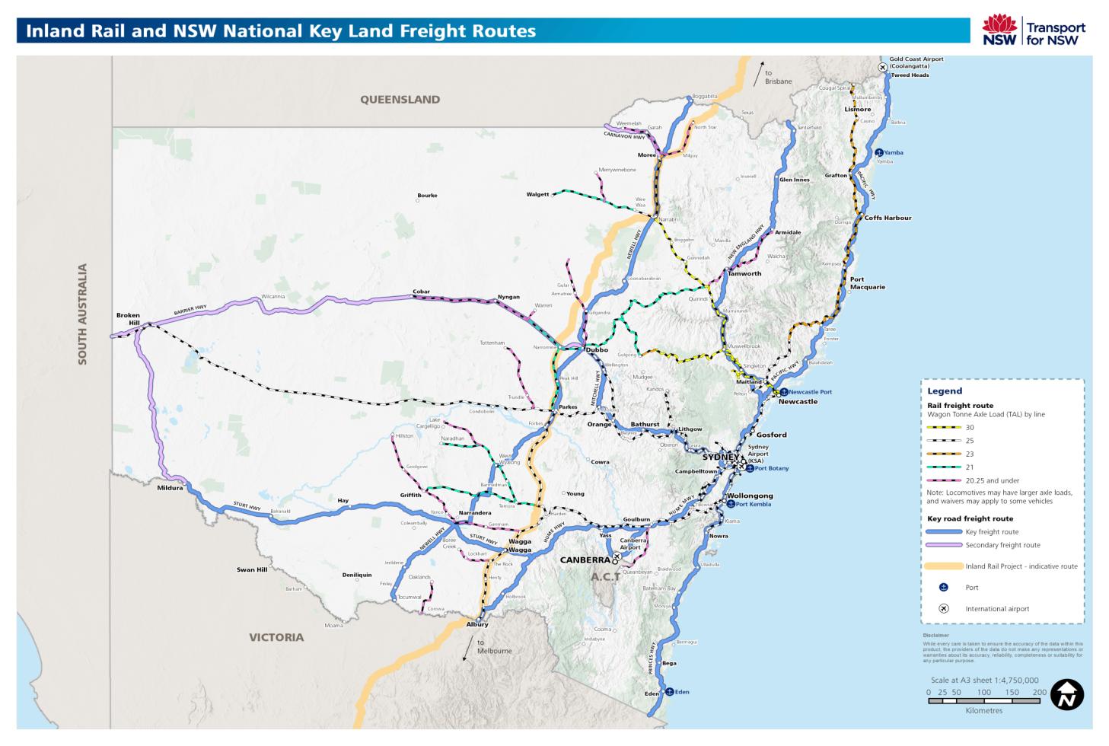

The NSW Freight and Ports Plan will provide more detail on the investment and upgrade program for NSW, including works required for the successful integration of new freight corridors.

**Technology and Data**

New technology provides major opportunities to improve the way we measure, analyse and optimise the NSW freight network. TfNSW recently released its Future Transport Technology Road Map which sets out key strategies and initiatives to maximise the opportunities presented by new technology and data, including for freight:

<https://future.transport.nsw.gov.au/wp-content/uploads/2016/11/Future-Transport-Technology-Roadmap_2016__.pdf>

In 2016, TfNSW established a new data and analytics group, integrating the former Bureau of Transport Statistics and Bureau of Freight Statistics. The new team, Transport Performance and Analytics (TPA), is responsible for developing and maintaining the evidence base and models which support freight planning.

In line with the Future Transport Technology Road Map, the Transport Open Data Hub will continue to be used to make freight data and forecasts more accessible to the community and industry and to support innovation. TfNSW will actively participate in discussions on the national freight performance framework. The framework will need to be devised with industry so that baselines are meaningful, and measurement requirements are not a burden for the freight industry.

**Productivity and regulatory factors**

The NSW Cargo Movement Coordination Centre (CMCC) works with road carriers, rail operators, stevedores and other supply chain stakeholders to optimise the use of existing network capacity and continuously improve the efficiency of cargo movement through Port Botany, Port Kembla and regional NSW.

The CMCC focuses on key supply chain interfaces – ports, roads, rail and intermodal terminals – for bulk commodities (such as grain and coal) and container freight. It is working to reduce cargo movement costs and increase productivity at key supply chain interfaces, including via the Port Botany Landside Improvement Strategy, and the Port Botany Rail Optimisation Group.

<https://www.transport.nsw.gov.au/newsroom-and-events/media-releases/new-app-to-improve-efficiency-port-botany>

**Road freight productivity schemes**

A number of targeted vehicle productivity schemes have been implemented in NSW to support key supply chains and improve the efficiency of freight transport for primary producers and regional transport operators. These include the Grain Harvest Management Scheme, Livestock Loading Scheme, Sugar Cane Harvest Management Scheme and Safety, Productivity & Environment Construction Transport Scheme (SPECTS). The programs are implemented where both management systems and infrastructure support increased movements and safe operation.

**Key challenges**

**Key issues for freight in major NSW cities**

The challenges for freight productivity in Sydney and the Greater Metropolitan Area are significant. These include:

* Congestion and the impacts of growth in population and urban development on the freight task
* Competition for scarce network capacity between passenger and freight transport
* The high cost of preserving corridors and providing new freight network capacity in established urban areas
* Changes in the economy and employment resulting in goods travelling longer distances
* Increased travel distances for specific supply chains such as construction materials waste/recycling
* Community resistance to freight activity and freight facilities

In Sydney, freight precincts include industrial land, commercial land and distribution centres. Ports and their access corridors are under threat from urban encroachment. This applies to Port Jackson, Port Botany with the Ports of Newcastle and Port Kembla.

Freight solutions for cities include:

* Facilitating 24 hour operations
* Separating freight from passenger tasks during peak times/directions
* Designing places for freight in cities; precincts, streets and major buildings
* Enabling the use of higher productivity vehicles where they are required.

TfNSW is developing the Freight and Ports Plan which will address these issues in greater depth.

**Congestion**

The avoidable cost of congestion for Australian capital cities was estimated at $16.5 billion for the 2015 financial year, up from $12.8 billion in 2010 (BITRE, 2015). The last mile freight task, which comprises the journey to every door of every business and home in the country, has a significant influence on the overall contribution of freight and servicing activity to total cost of congestion.

With the last mile already making up between 25 and 50 per cent of total supply chain costs[1] (including direct congestion costs), this creates the risk of exacerbating last mile inefficiencies.

**Coordinating CBD freight and servicing**

Last mile deliveries in urban environments are generally completed using smaller vehicles such as vans and light trucks. The prevalence of this type of vehicle reflects key characteristics of the urban last mile task, including small average consignment size, multiple drop locations, access constraints and customer driven delivery times. Over the last six years, there has been significant growth in the number of small vehicles registered in urban areas reflecting the growth in the size and complexity of the last mile task. Between 2012 and 2017, NSW experienced a 21 per cent growth in Light Commercial Vehicle[2] (LCV) registrations and 24 per cent growth in light rigid truck registrations[3] (ABS, 2017). By comparison, registrations for articulated vehicles only grew by 18 per cent over the same period (ABS, 2017).

A key driver of the overall growth in the last mile task is the growth in Business-to-Consumer (B2C) market. Enabled by the evolution of e-commerce, the B2C market links the consumer directly with the supplier rather than through traditional retailers. By providing consumers access to a greater number of suppliers both nationally and internationally and offering high levels of customer service, B2C significantly increases the complexity of the logistics task. In summary, there are a greater number of smaller items moving from suppliers directly to the consumer. An indication of the strength of the B2C market is the recent growth in airfreight volumes, with international airfreight increasing at an average of 5.2 per cent each year since 2010 (BITRE, 2016). This is supported by observations from major logistics companies operating in the B2C market that up to two thirds of their volumes are now B2C freight. A further indication of the growth in the B2C market is the level of investment in major new facilities at the urban fringe and infrastructure by major distribution companies that are involved in the B2C task including TNT’s 78,000m2 facility at Erskine Park, opened in 2015 and DHL’s 90,000m2 “Campus” at Horsley Park developed since 2009, with the most recent 32,000m2 facility on this site opened in 2014.

Driving and delivering in the CBD is becoming more challenging, particularly during the morning and afternoon peak periods and while major works are underway. TfNSW is trialling the retiming of some deliveries to outside peak periods with CBD businesses and their delivery companies. The aim of the trials is to measure the effectiveness of retiming, identify and resolve issues and demonstrate how challenges can be overcome. Growth in CBD residents potentially constrains late night deliveries.

For more information several CBD Case Studies are available at [*http://mysydneycbd.nsw.gov.au/supportingbusiness/freight-and-servicing*](http://mysydneycbd.nsw.gov.au/supportingbusiness/freight-and-servicing)

**Competition for network capacity**

Accommodating growth in passenger and freight transport on existing networks is a significant challenge in Metropolitan Areas. This is a particular issue on the rail network. NSW and the Australian Government have a number of priority projects for separating passengers and freight. The success of these projects will depend on effective corridor protection and community acceptance in the short term and continued funding and investment in the longer term. The Western Sydney Freight Line and new intermodal terminals in Western Sydney will be critical. The effective commencement of Moorebank intermodal freight terminal will also be vital for increasing the share of rail freight transported in the metropolitan area.

NSW has excellent Port facilities but the landside response to larger ships will require a continuous investment in road and rail corridors. It will be critical for the NSW to work closely with NSW Ports to maximise the efficiency of landslide transport networks which support the movement of import and export freight which plays a vital role in the NSW and national economy.

Maintaining existing land-use for deep water berths such as at Glebe Island will also be important for supporting the continued operation of sea freight as a lower cost and more sustainable alternative to road transport.

**Urban encroachment**

Reserving land for light industrial use (specifically for warehouse and distribution centres) has generally not been a key consideration in the traditional approach to urban planning. In part, this has been due the fact that while significant portions of light industrial land have been rezoned for residential use and industrial activities relocated, the impacts of these changes on the logistics task have been offset by other factors (such as improvements in road infrastructure, the development of more efficient freight vehicles and overall expansion of the urban area). It has also been due to a legitimate objective of separating industrial and residential land uses.

The encroachment of residential land around major freight generators such as ports and airports, which are not readily relocatable, has created a far more complex planning challenge. This is particularly evident in Sydney, where the port and airport are co-located in an area which is experiencing rapid residential growth. The potential impacts of not reserving sufficient light industrial land to support the secondary logistics activities generated by the port and airport include increasing the freight tonne kilometres generated by these logistics tasks and disproportionately increasing the congestion impact of freight vehicles on the transport network as a whole.

The effect of residential land use encroachment is particularly pronounced for air freight and international port movements. Although the gross volume of air freight is relatively modest, its growth forecast is as substantial as port freight. Furthermore, while a significant portion of port freight is traditional business to business (B2B) freight destined for intermediate deconsolidation facilities for sale and distribution to the end consumer, air freight is increasingly B2C. As B2C demand is typically highest in dense residential and commercial areas close to the CBD, the impact of the encroachment of residential land on efficiency of the last mile for air freight is more pronounced. Over two-thirds of international freight being landed in Sydney by international airfreight logistics companies is B2C consignments. This is additional volume without any decline in base B2B activity.

Freight planning also needs to ensure community expectations on transport noise and emissions are addressed, with mitigation requiring both policy measures and infrastructure responses, for example the [Freight Noise Attenuation Program](https://www.transport.nsw.gov.au/projects/programs/freight-noise-attenuation-program).

**Planning for Freight**

Incorporating spaces for freight in urban planning is a key priority to drive more efficient last mile outcomes. Increases in population density, especially around key urban centres in major cities, drive corresponding increases in freight and servicing demand. Without suitable light industrial land to support this demand, however, the distance of the last mile is stretched from available land on the outskirts of cities to the end-consumer in the urban centre. In a city such as Sydney, this can easily be a distance of 50 kilometres or more. The result is to increase the number of smaller last mile delivery vehicles, increase the freight kilometres travelled and increase the social and economic costs associated with this task.

As well providing space for freight, consideration needs to be given to how this space should be used. The greatest economic benefits are likely to be secured from freight facilities that are intensive, multi-tenant and potentially multi-level developments, with the possibility of competing logistics operators being located in the same facility[4].

Locating freight facilities close to the final point of demand generate also opportunities to explore the use of alternative last mile solutions, in particular more sustainable modes of transport. An example is the UPS depot at Tuffnell Park in North London, which is seven kilometres north of Trafalgar Square. Semi-trailers are used to move goods efficiently to the facility, and a fleet of zero‑emission electric vehicles is then used to deliver throughout central London.

Recent trials conducted by TfNSW have demonstrated the challenges of generating outcomes from commercial property businesses to be involved in freight distribution within the CBD. It is not viewed as a business priority.

Opportunities exist to improve the outcomes from major developments in urban centres through innovative approaches to planning and approvals. Schemes such as those administered by the Green Building Council and the National Australian Built Environment Rating Scheme (NABERS) offer incentives for developers to adopt best-practice in sustainable building design and operation to secure broader economic outcomes. While these schemes do not currently encompass sustainable logistics practices, international examples such as the Delivery and Servicing Plans used in London and other cities in the European Union provide an indication how this might be achieved.

**Airport integration**

Air freight is growing very rapidly, but the location and regulation of Kingsford Smith Airport imposes limitations on using modern specialised aircraft for freight movements, especially overnight. Effective planning for Western Sydney Airport (WSA) is vital, encompassing road and pipeline infrastructure to support the construction of the airport and surrounding development. WSA presents an opportunity to introduce modern, quiet air freighters that can operate over 24 hours.

**Safety**

Safety is the primary consideration for the trialling and introduction of new transport technologies. National standards and Intelligent Transport Systems infrastructure will continue to offer safety and efficiency benefits for all transport operators and customers. Road focussed Intelligent Transport Systems (ITS) can improve safety by:

* Connecting to infrastructure (V2I) and other vehicles (V2V)
* Improving vehicle compliance
* Fatigue management compliance
* Lane departure and Collision avoidance
* Freight Automatic Traffic Information Services
* Automatic Weather Systems
* Improving access to data and information about demand and network performance.

TfNSW is planning the introduction of more ITS technologies, including participating in national initiatives to trial connected and autonomous vehicles. Interoperability between infrastructure, vehicles and transport systems is essential and will required dedicated radio spectrum. Interoperable systems across Australia are needed to realise the potential of applications such as ‘truck platooning’ and adaptive cruise control.

TfNSW independently reviewed a wide range of crash avoidance and harm minimising technologies currently available on the market. These Crash Avoidance, Protective and General Safety Technologies will become more prevalent as the vehicle fleet is updated. The Review findings publication is *Safety Technologies for Heavy Vehicles and Combinations, The NSW Centre for Road Safety, 2017*. For statistics and more information please refer to the NSW Centre for Road Safety’s [webpage](http://roadsafety.transport.nsw.gov.au/).

**Conclusion**

TfNSW’s time frames and goals for the NSW freight and supply task are aligned with the issues and aims of the Inquiry. TfNSW welcomes the opportunity to contribute to the Inquiry and Strategy as our program progresses over the next eight months.

1. McKinsey, 2016; Parcel delivery: The future of last mile. Additional work completed by Holguin Veras and Tanaguchi flag the same conclusions.
2. Vehicles primarily constructed for the carriage of goods, and which are less than or equal to 3.5 tonnes GVM.
3. Rigid trucks of GVM greater than 3.5 tonnes and less than or equal to 4.5 tonnes.
4. This already happens to freight forwarding operations in proximity to airports in particular both in Australian and internationally.