**fJ TOOWOOMBA**

.... **RE.::II111-.6111'11111 Rich raditions. Bold ambition** .

Your reference: DM7594640

Contact Officer: Mike Brady

Telephone: 07 4688 6616

28 July 2017

Freight and Supply Chain Inquiry

Department of Infrastructure and Regional Development

GPO Box 594

CANBERRA CITY ACT 2601

Via email: [freightstrategy@infrastructure.gov.au](mailto:freightstrategy@infrastructure.gov.au)

Dear Sir/Madam

**Submission to the Inquiry into National Freight and Supply Chain Priorities**

Thank you for the opportunity to make a submission to the above Inquiry. Our region covers nearly

13,000 km2 and Toowoomba Regional Council (Council) maintains a large growing road network of over 6535km. The Darling Downs is arguably the largest agricultural producing region in Australia and hence the movement of freight within our region is one of the key elements considered in our

2014 Toowoomba Region Sustainable Transport Strategy (copy attached).

With over 50% of the freight that moves through the Port of Brisbane coming through Toowoomba, we are fast becoming the transport logistics hub (inland port) of South East Queensland. This includes:

• the development of the Toowoomba Enterprise Hub, 1800 hectares of industrial and commercial development that will make Toowoomba one of the largest transport logistic centres in Australia;

• the recent development of the new Brisbane West Wellcamp (BWW) Airport, focusing on flying freight into Asia;

• the Australian Government's significant investment in the Toowoomba Second Range Crossing (TSRC) project and Warrego Highway upgrades to improve national road freight outcomes;

• the Melbourne to Brisbane Inland Rail (MBIR) project will create major opportunities in national freight movement, particularly within the Toowoomba region where Council is very keen to leverage and support local opportunities and development, for example the lnterlinkSQ intermodal hub project at Charlton.

With all the above currently happening within our region, it places tremendous pressure on Council to plan and where possible fund the upgrade of local transport links to ensure optimal freight movement around our city and region. Council has invested over $1OOM in recent years in our local road network to support the unprecedented changing transport dynamics in our region.

P 131 872 I F 1800 448 882 I info(gitr.qld.gov.m• I l'c'''IWc r.qldcgovcaU PO Oox 3021 Toowoomba OLD 4350

Toov oc cnba R [,:analCc ncil ABN 99 788 305 ?50

\ -.-

; \ .' \ *1* \ \

_/ ......

Council also proactively engages with transport industry and with the support of Western Downs Regional Council (WDRC), the Department of Transport and Main Roads (DTMR), the National Heavy Vehicle Register (NHVR) and the Local Government Association of Queensland (LGAQ), Council chairs a regional Agricultural Transport and Logistics Working Group with the aim of streamlining access permits, supporting improvements and harmonisation of regulatory and legislation requirements and through our First and Last Mile project (with WDRC and LGAQ), examining and prioritising opportunities to take to State and Federal Government for funding assistance to improve

the economic productivity of our whole region.

With the above in mind, Council strongly supports the recommendations as noted in the LGAQ

submission to this Inquiry, namely:

• *recognises the challenges faced by local government in addressing first and last mile access issues and provides financial support to regional groupings of councils (RRTGs in Queensland) to complete first and last mile identification and analyses projects, similar to that completed on the Darling Downs, within* a *1-2 year period of the Strategy's commencement. Initial estimate of*

*funding required: $5 million over two years, nationally;*

• *recognises the ongoing capability development task at the local government level and provides financial support to State/Territory local government association's to assist council capability development for four years from the commencement of the strategy. Initial estimate of funding required: $3 million over four years, nationally;*

• *establishes* a *federally funded program dedicated to addressing first and last mile access issues on the local government road network, with preference given to projects that have been identified through regional analyses (refer to first recommendation above). In line with 2016 Election Plans (refer to Appendix 1), funding requested: $200 million per annum nationally for five years.*

Council understands the need for integration across the three levels of government to support ongoing improvements to the national freight movement task, in particular Council requests the direct funding support of the Australian Government to assist with the challenges of the 'First and Last Mile' as noted within the LGAQ submission.

Thank you again for the opportunity to make a submission to the National Freight and Supply Chain Priorities Inquiry and should the opportunity arise, Council believes that a case study of our region would be beneficial. Should you have any queries in relation to Council's submission, please contact myself directly either via email [mike.brady@tr.qld.gov.au](mailto:mike.brady@tr.qld.gov.au) or via phone- 07 4688 6616.

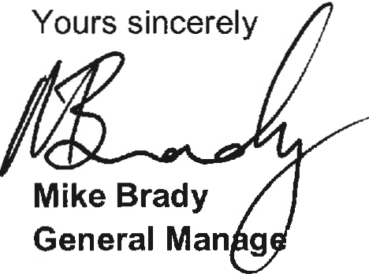

**r Infrastructure Services Group**