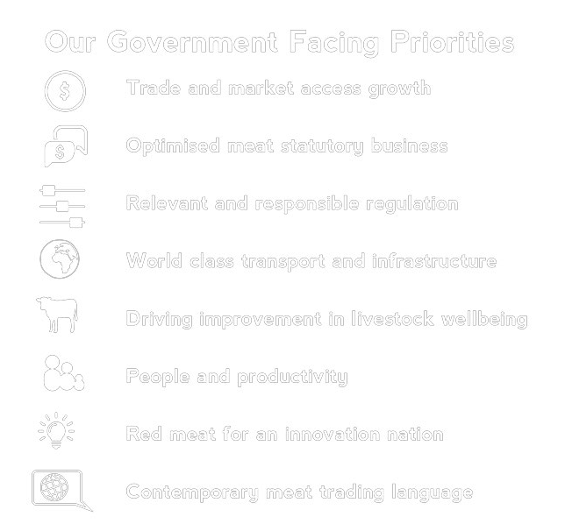

**Red Meat Advisory Council**

**Submission to the National Freight and Supply Chain Strategy**

**2017**

**In proud partnership with our red meat members:**

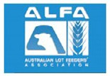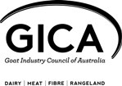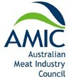

Executive

Summary

The red meat and livestock transport task supports an Australian industry worth approximately $AUD18 billion in gross domestic product and employing some

200,000 people directly and many more indirectly, mostly in remote, rural and re- gional Australia. Australia is the world’s leading live exporter and the largest ex- porter of beef, sheepmeat and goatmeat by value.

The sector is transport-intensive. Supply chain efficiency is a source of major price advantage if planning, infrastructure investment and regulations are optimally aligned, but overall sector competitiveness suffers greatly from poor transport out- comes.

ROAD

Road freight is the dominant land transport mode for livestock and meat products.

In many places road freight inefficiencies can be overcome by innovative new ve- hicles such as the A-Double truck trailer combination. Case studies in this submis- sion reveal major productivity gains to the supply chain where such vehicles are operating.

Research suggests that Performance-Based Standards-accredited vehicles such as the A-Double also offer safety levels that are between 60 and 70 per cent higher than the existing general fleet.

Insufficient matching of the latest high-productivity vehicles is a significant drain on productivity. In many instances, State and local governments continue to oversee safety and productivity-sapping breaks in network interoperability via inconsistent vehicle access regulations.

PORT

Seaports and the shipping interface are critical infrastructure and at risk of monop- oly pricing abuse, in line with recent ACCC comments.

Road and rail approaches to seaports constitute the largest single cost to moving a container through the port. Where road freight deliveries to ships do not ar- rive at optimal weights, significant productivity is lost. This places obligations on government to retrofit key supply chains to accommodate the highest productivity vehicles. Some of these projects are likely to be worthy of consideration as national priority projects.

RAIL

Rail remains an important freight mode especially in Queensland and to major seaports. The viability of Inland Rail for the industry will rest on matching this rail with highest productivity road freight connections, as well as resolving the direct full cost recovery pricing of interstate road freight operating on highways in direct competition with Inland Rail.

AIR

Airfreight is a growing part of the export value chain but experiences less physical

supply chain pressures but relies heavily on efficient customs and related processes.

Supply chain efficiency and integrity – worth up to 3.45 billion to the industry out to 2030

RMAC economic modelling and

benefits analysis

Professional dynamic economic modelling (Centre for Poli- cy Studies for RMAC) has established that the industry sup- ports use of resources equivalent to $11.424 billion in GDP:

Note: Livestock and processing figures do not sum due to

non-linear effects

Further dynamic modelling and simulations of road trans- port productivity gains in the Australian red meat supply chain suggests that annual gains of around $AUD 740 mil- lion and increased sector employment of c. 4,000 people are plausible across the coming decade, given due attention to

supply chain improvements.

$12,000

$10,000

$8,000

$6,000

$4,000

$2,000

0

9,315

$ m. 2015-16 prices

8,333

11,424

**Direct and indirect use of resources supported by Australia’s red meat industries ($ m. GDP)**

Sheep and Ca ttle

Mea t pr ocessing

R ed mea t industry

**Impact on GDP of productivity improvements in road transport used by Australia’s red meat industry**

1,000.0

800.0

$m.2015-16 prices

600.0

400.0

200.0

767.1 751.4 741.0 732.4

726.1 724.2 725.5 730.3 742.7 759.4

0.0

2016-17 2017-18 2018-19 2019-20 2020-21 2021-22 2022-23 2023-24 2024-25 2025-26

Sheep & beef cattle Meat products Red meat Industry

**Impact on employment of productivity improvements in road transport used by Australia’s red meat industry**

1,000.0

8.00

6.00

000 persons

4.00

2.00

6.12 5.36

4.83 4.45 4.19 4.02

3.91 3.86 3.84 3.86

0.0

2016-17 2017-18 2018-19 2019-20 2020-21 2021-22 2022-23 2023-24 2024-25 2025-26

Sheep & beef cattle Meat products Red meat Industry

RMAC considers these modelling outcomes conservative, and if key recommendations (below) are implemented, major high-value infrastructure projects could deliver a much more productive and globally-competitive sector for the future.



Recommendations

In the short term, RMAC recommends that resolution of many smaller scale supply chain problems in

regional areas can be achieved through reinstatement of programs which fund transport improvements with strong

economic credentials across local government boundaries.

1. The former Auslink Strategic Regional Program was a successful and worthwhile template in this respect and

should be reinstated.

In the longer term, RMAC suggests a three-step process for the Commonwealth in relation to the livestock and red meat supply chain that should be enshrined in the National Freight and Supply

Chain Strategy with respect to agrifood growth:

1. First, identify and publish the key networks, efficient network breakages that exist in them and examine better solutions for these tasks at an infrastructure and regulatory level;

2. CSIRO’s Transit model can and should play a larger role in developing better infrastructure solutions in the sup- ply chain in support of this objective; and

Match highest-productivity and safety freight vehicles to upgraded key networks without network breakages wherever possible - in road freight, such breakages should be viewed

in the same way as damaging ‘break of gauge’ rail inefficien- cies and resolved accordingly wherever possible. Infrastruc- ture investment packages backed by facilitating regulatory arrangements should be developed to encourage action on these upgrades: without complementary deal structures for investment,

Supply chain efficiency and integrity – worth up to 3.45 billion to the industry out to 2030

Supply chain efficiency and integrity – worth up to 3.45 billion to the industry out to 2030



**CONT ENTS**

**1 About RMAC and this submission**

**3 Importance of supply chain to the sector**

**4 Opportunities are large; so is the cost of inaction**

**5 An exacting, time-sensitive task**

**6 Red meat supply chain pressure by mode**

**Road pressures Port presures Rail pressures**

**Airfreight pressures**

**28 Modelling: practical gains, economic benefit**

**31 Recommendations: achieving ‘quick wins’**

**32 Recommendations: more strategic actions**

**33 Endnotes**

About RMAC

and this submission

The Red Meat Advisory Council (RMAC) is an inclusive industry organisation that represents the beef, sheepmeat and goat- meat supply chain from ‘paddock to plate.’ We aim to create whole-of- industry value for our industry through:

Industry leadership

Ministerial Advisory Council to the Federal Minister for Agriculture

Advocate key solutions to improve Australian red meat and livestock businesses to the community,

industry and government

Coordinate the Meat Industry Strategic Plan

Manage the Red Meat Industry Fund.

The Australian red meat and livestock industry creates approxi- mately $AUD 18 billion in gross domestic product and employs around 200,000 Australians directly and many more indirectly, mostly in rural and regional Australia. The meat processing sec- tor alone turns over $AUD 20 billion annually and is Australia’s largest rural and regional-based manufacturing sector. RMAC represents the world’s largest livestock export community and the world’s largest exporter of beef, sheepmeat and goatmeat by value.

RMAC brings together representation on strategic matters for the Australian Live Exporters Council, the Cattle Council of Aus- tralia, Sheepmeat Council of Australia, Goat Industry Council of Australia, Australian Meat Industry Council and Australian Lot- feeders Association. RMAC has as its ‘stakeholders’ the Federal Minister for Agriculture and Water Resources and this depart- ment, the Australian Meat Processors Corporation, Livecorp and Meat and Livestock Australia. RMAC is proud to work in partnership, through the Red Meat Memorandum of Under- standing, to advance the interests of Australian red meat and livestock businesses across the value chain.

As part of this, RMAC coordinates across 10 partners industry investment and advocacy priorities through the Meat Indus- try Strategic Plan (MISP) 2020 identifies a growth opportunity worth up to 7 billion dollars’ worth of value to be returned the Australian industry and economy by 2020.

Of relevance to National Freight and Supply Chain Strategy, a central pillar of the MISP2020 is supply chain efficiency and integrity across the industry which has an ambitious target of

up to $3.45 billion to the industry out to 2030. A key imperative of this is improving efficiencies in regulation, infrastructure and logistics (MISP 2020, Page 23).

In addition to the MISP2020, RMAC has released Feeding Our People 2017; which outlines the whole-of-supply chain prior- ities to achieve ‘World Class Transport & Infrastructure.’ The Australian red meat industry supports a modern transport and infrastructure network that improves human safety, animal wel- fare, eating quality and productivity outcomes. In turn, we seek governments to recognise the economic and non-economic dividends of a reform agenda that delivers a world class freight network for the Australian red meat industry. The reality is that freight remains the largest absorber of profit for our industry – up to 30 per cent – and is a key area government can influence in a strategic and coordinated manner in line with existing government funding (Source: Australian Farm Institute). Freight challenges and opportunities to move our products more safe- ly and efficiently are therefore a first order concern for RMAC and our membership. We welcome an opportunity to provide a submission to this much-needed inquiry; and thank the Minis- ter Chester for this initiative.

Our submission attempts to provide the inquiry with a sense of this supply chain’s pressures by mode, as well as a sense of pri- ority challenges and some solutions. Wherever possible, actual case studies have been presented to demonstrate how these pressures and potential solutions impact on the daily freight task. Most of these case studies reveal that productivity gains and transport safety gains can coexist.

The submission also offers dynamic economic analysis to re- veal the likely scale of plausible road freight productivity gains on offer to the sector. This is done to reinforce that improved research plans, regulation, planning and importantly infrastruc- ture investment will have significant economic impacts for the sector and for the wider Australian community.

Finally, the submission offers recommendations on how matters could be improved - both in terms of more modest but import- ant ‘quick wins’ for the industry as well as the more strategic regulatory, planning and investment reform paths for success.

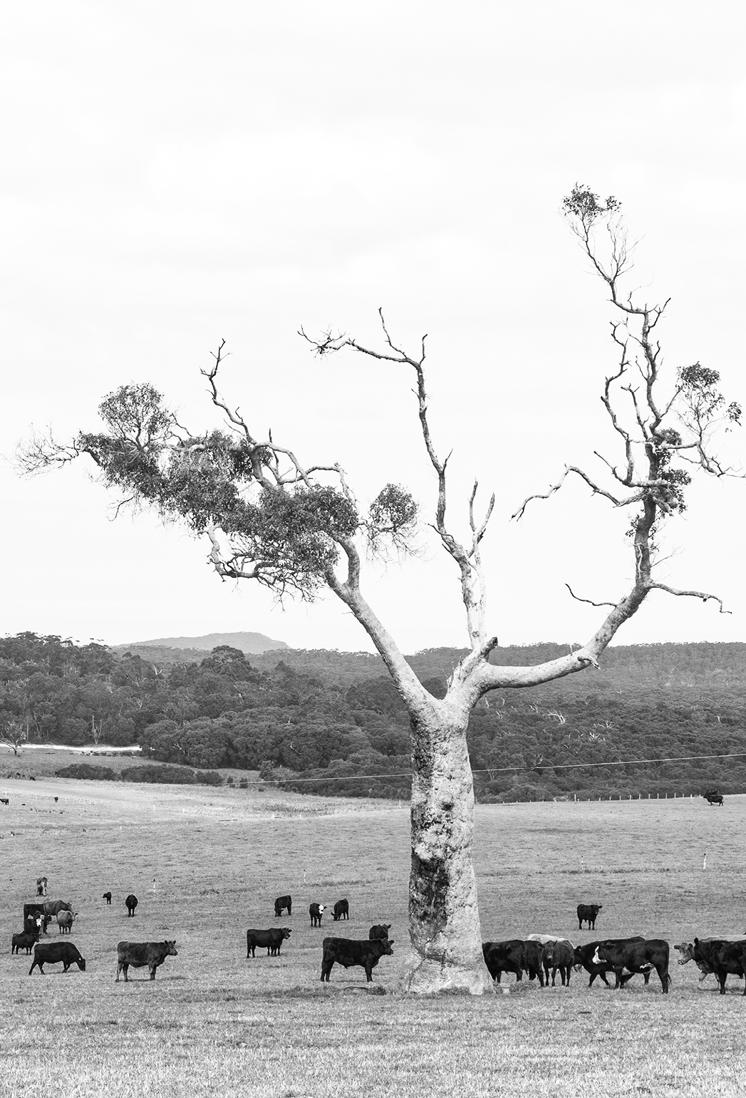

This submission’s key recommendations may not entirely align with the Inquiry discussion paper’s notion of a ‘National Freight Performance Network’. RMAC is conscious that the red meat sector is only one of many ‘supply chains’, but hopes that its views on how to unlock more productivity and safety from the supply chain will help guide more effective Commonwealth planning, investment and regulatory reform effort.

***Anna Campbell***

***CEO***

***Red Meat Advisory Council***

***August 2017***

Importance of supply

chain to the sector

RMAC considers the transport supply chain to be one of the most significant cost pressures facing the sector - given the scale of such costs, transport can rightly be considered in and of itself a ‘maker or breaker’ of sector profitability overall and for individual actors within the sector.

Australia’s red meat sector is a world leader in export: in 2015, approximately 70pc of Australian beef production, 53pc of lamb and

98pc of mutton production were exported worldwide, as well as 1.9 million live sheep and 1.1 million live cattle exported.

Unlike some export competitor nations which might be able to draw on other comparative advantages such as much larger herd and flock sizes, proximity to markets and far lower- cost labour, Australia must instead rely - in addition to attributes such as world-leading quality, food safety and traceability - on efficient transport to ensure continuing success in an increasingly competitive world market for meat products.

THE FREIGHT TASK

Being innately heavy and transported on multiple discrete journeys across the supply chain of both live animal and meat or hide/ render offal product, Australia’s red meat sector is exposed to very considerable transport costs. It is therefore impacted heavily by the quality of government policy, investment and regulatory choices around transport.

In many instance the red meat sector shares key roads, railways, port and airports with other Australian agricultural and regional- ly-based sectors. Common use of key arteries by these sectors follows well understood least-cost pathways to domestic consumption and export.

Grain movement in particular is of interest to the red meat feedlot sector, which relies on efficient grain freight input supplies to its

operations. More generally, wider rural freight inputs to farms contribute to bottom line red meat productivity.

It is important to appreciate that in benefit-cost terms, resolving red meat sector’s transport problems in turn greatly improves the cost-effective productivity of many other trade-exposed agricultural sectors. The following table shows how exposed the meat sector is to transport input efficiency, but it also reveals the wider scale of the challenge and gestures to the wider dividends from doing things smarter and better in these supply chains

**Table 1: Total requirements of road transport for selected industries (%/$ of gross output FY14/15**

**16**

**14.9%**

**14**

**12**

**10**

**8.62%**

**8**

**6**

**7.72% 7.63%**

**6.8%**

**6.12%**

**6.07%**

**5.98%**

**5.54% 5.44%**

**4**

**2**

**0**

|  |  |  |  |  |  |  |  |  |
| --- | --- | --- | --- | --- | --- | --- | --- | --- |
| Sawmill Product Other Wood | | Grain Mill | Cement, Lime | Pulp, Paper | Meat & Meat | Dairy Product | Oils & Fats | Other Non Other Food |
| Manufacturing | Product | & Cereal | & Ready Mixed | & Paperboard | product | Manufacturing | Manufacturing | Metallic Mineral Product Manufacturing |
|  |  |  |  |  |  |  |  |  |
|  |  |  |  |  |  |  |  |  |
| Source ABS |  |  |  |  |  |  |  |  |

Manufacturing

product

Manufacturing

Concrete

Manufacturing

Manufacturing

Manufacturing

Product Manufacturing

Supply chain efficiency and integrity – worth up to 3.45 billion to the industry out to 2030



Opportunities are

large; so is the cost of inaction

Most of the planning, investment and regulation of the supply chain cross all transport modes remains in government hands. It is therefore essential that governments appreciate transport challenges and opportunities as they relate to the red meat sec- tor. This submission intends to shed light on such matters.

RMAC is of the view that meat transport inefficiencies through the supply chain represent a latent source of further competitive advantage to Australia. RMAC is convinced that fresh approach- es to planning, investment and regulations in the transport sec- tor can deliver major efficiencies in the supply chain to underpin ongoing success for all involved in the sector and for the nation- al economy generally. Suggestions in this respect are included in this submission.

Conversely, RMAC is also anxious for governments to appreci- ate that transport and supply chain efficiency is not a zero-sum game: transport remains the major absorber of profit across the red meat supply chain. Inadequate approaches to planning, investment and regulation do not occur in isolation: other ex- port competitors are making efficiency gains in their red meat exports and other products will compete with domestic red meat consumption in part on price, which can be very adversely affected by poor government policy impacts to the red meat supply chain.

In short, it is not only a matter of taking advantage of good pol- icy choices to move the sector forward: the sector can regress in real terms depending on the transport policy, investment choic- es made today.

4

An exacting,

time-sensitive task

The red meat supply chain employs the full spectrum of road, rail, air and sea freight to deliver its value proposition. Being either a live export or perishable meat product, the industry works largely on a just-in-time logistics model, rather than a commodity stockpiling model such as iron ore. Food safety, eating quality and phytosanitary concerns govern time- critical and fully-traceable transport episodes.

Live export and domestic livestock transport add further com- plexities:

Livestock wellbeing remains the single largest consumer concern for our industry (Source: Pollinate). RMAC and our member strive for a zero harm culture for in the treat-

ment of livestock in our care (Source: Feeding Our People

2017.) Good outcomes in this space correlate positively to good food safety and food quality practice, such as more tender meat and less animal bruising, which can negative- ly affect eating quality.

Livestock transport inherently involves managing effluent spill which can present safety hazards. The professional livestock transport industry spends considerable sums managing this unique challenge with on board effluent tanks and stock crate washes at saleyards and other facilities.

Parts of the livestock transport task and some meat trans- port tasks involve very long distance driving. This is gov- erned by heavy vehicle driver fatigue laws which require specialised programs for the longer-haul tasks. The ability to drive long distances in large specialised livestock transport vehicles sets Australia apart from many other countries. It is the ability to move stock great distances in response to climatic conditions that underpins the scale and viability of much of the supply chain, particularly in vast northern Australia. Such tasks must be carried out while remaining within healthy and safe limits of driving and work hours.

All of these areas are regular sources of challenges at the mar- gins for the sector, as regulations and laws are adapted to the sector freight task. These matters are specialised and exacting tasks which deserve to be better recognised by governments for the role they play in making Australia’s red meat sector successful.

A freight and supply chain strategy that takes into account these key considerations could enhance this potential consider- ably.

RMAC notes the excellent work of the Australian Livestock and Rural Transporters Association (ALRTA), which provide training, quality assurance, awareness and advocacy across all aspects of the Australian livestock transport task [(www.alrta.org.au)](http://www.alrta.org.au/); and for the role played in developing the Land Transport Standards for Livestock.

Red meat supply chain pressures by mode

In encompassing all modes of transport, the red meat sector

is in turned shaped by the inefficiencies of each mode. RMAC considers road and port transport pressures to be the most significant followed by rail. Air freight is a growing part of the high- quality red meat export sector but is not judged to be facing major physical supply chain pressures.

For each mode, a summary box provides RMAC’s view of the key implications of these pressures for the National Freight Supply Chain Strategy.

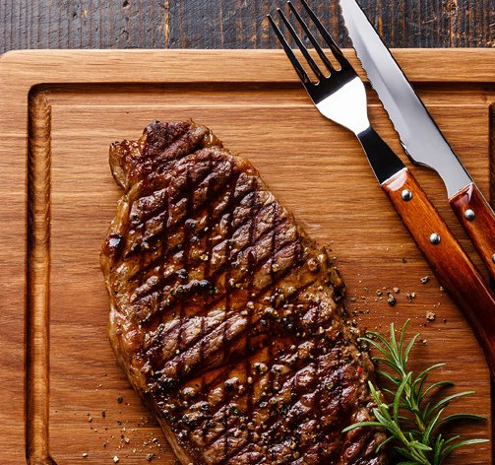

Road Pressures

The time-sensitive nature of perishable meat movements and the food safety and animal welfare obligations on livestock transportation ensure that road freight has become the domi- nant land transport mode for livestock and meat products - they can deliver generally faster and more flexible end-to-end solu- tions for the sector. This is not exclusively so, however - see also the rail freight discussion below. The sector’s road transport task can be thought of as occurring in two phases, mostly on distinct parts of the Australian road network:

**Preliminary road movements**

Live cattle, sheep and goats can be moved multiple times across stations, farms, feedlots and saleyards prior to final assembly live export or domestic slaughter.

This allows the livestock to be sold, breed, put on the appropri- ate weight and condition and react to times of the year when sufficient feed is not present in a given location. The majority of this task occurs outside far from major urban road networks, on remote, rural and regional roads.

**Final road movements**

The final land transport journeys for live export and meat prod- ucts are either to:

live export ports for shipping to live markets

container ports for export as chilled or frozen product

to processing plants and post-slaughter to major domestic food distribution warehouses, mostly as chilled or frozen product for wholesale retail purchase.

These final aspects of the journey often see the red meat sup- ply chain interacting with the very large urban and periurban seaport and processing and distribution centres and to a less- er extent, to major airports. This phase of the journey sees the products more likely to be using major capital city or regional centre roads, where most of the key export seaports, airports and distribution/retail food centres are located. The inquiry and expert panel might benefit from considering road freight chal- lenges in the following categories:

Productivity and safety nexus: larger, safer more productive vehicles

Next major opportunity: the A-Double

Case study - EC Throsby and the A-Double

The vehicle access and infrastructure investment ‘discon- nect’

Productivity ‘breakages’ in transport networks

Case study: TFI Murray Bridge: major freight task on a

‘broken’ network

Road pricing reform

Case study - Rural roads paying for themselves at cur- rent charging level

In addition to NFSCS mapping and analysing freight flows, em- phasis should be placed on analysing the availability or other- wise of highest-productivity, highest-safety vehicles on these networks - where freight is being carried by less-than-optimal- ly-efficient and safe vehicles, this should be identified. Break- ages in seamless network access for such vehicles on these key networks should be a priority for infrastructure investment strat- egies, with supporting heavy vehicle regulatory arrangements.

**Implica tions for NFSCS:**

With the productivity of the red meat freight task in mind, care should be taken when approaching road pricing reform strat- egies - especially strategies which do not align with Australian competition reform principles.

Productivity and safety nexus: larger, safer, more productive vehicles

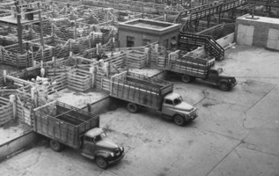

The history of Australian road freight is one of high competition, creativity and adaption. The development of larger and more productive, safer road freight is a field in which Australia leads the world. Historically, the development of double and triple road train combinations was a major productivity enhancer for Australian livestock and meat transport. In the late 1980s, Aus- tralia adopted the B-double - a vehicle which offered superior braking and tracking capability to the semi-trailer, but which also offered towards a 50 per cent freight volume gain to users.

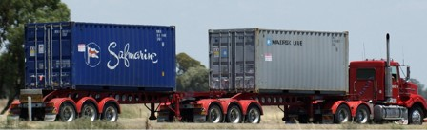

A standard B-double carrying two 20-foot shipping containers

Next major opportunity: the A-Double

As a Performance Based Standards vehicle with higher operator training, route limitations and compliance requirements, Aus- troads research judges this vehicle and others like it represent perhaps a 60-70 per cent improvement on road safety from the current broad fleet safety profile.

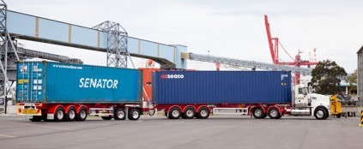

Australia has a pedigree of road freight innovation and high-productivity In simple terms, the A-Double is two articulat- ed trailer units with a very innovative steerable converter dolly arrangement which allows much more payload to be carried, without creating adverse road wear (equivalent standard axle) outcomes, or performing in a more unstable way than an articu- lated truck or B-double on the road.

The tracking fidelity of the A double and turning circle make it a superior vehicle to the B-double (ie PBS Class 1), yet under the PBS system the A-double can operate largely within B-double and even semi-trailer operational envelopes in many aspects.

Industry design leaders have noted that compared to even an extreme version of the B-double using quad axles (77 tonne GCM), the A-double with tri axles carries 85 tonne GCM. Of cru- cial interest to RMAC is this vehicles extra tonnage capacity and what it means for aligning the road freight task with, in particu- lar, the full export weight shipping container task.

RMAC understands that the A-Double at its best can carry two

8

1111

40-foot shipping containers at or near sailing weight.

This is of significance to the sector, with many processing plants being restricted at present to using the 20-foot ship- ping container at a time when In short, the ability to carry two

40-foot shipping containers, or the equivalent of livestock or domestic product, in a dynamic operational envelope that ap- proaches a B-double, appears a realistic and vital supply chain productivity gain for the sector.

In cases where exporters are limited to moving 2 x20-foot shipping containers to export on a B -Double unit, A-double network access will present nominal freight volume gains of

100 per cent - noting that the larger vehicle will necessitate

a different capital purchase and depreciation arrangements, higher training and compliance and slightly less fuel efficien- cy. Nevertheless, for set-route freight such as the predictable,

high-tonnage livestock and meat road freight tasks, the A-Dou-

ble offers a significant opportunity.

**Safety and productivity benefits co-exist**

At present the A-double vehicle is classed as a Performance Based Standards vehicle. This assumes a level of safety compli- ance, accreditation and route operating restrictions which are more stringent than the wider trucking industry faces. Accord- ingly, Austroads research advises that PBS truck trailer combi- nations are between 60 and 70 per cent safer than convention- al combinations .

In advancing the A-Double opportunity, RMAC notes not all parties in the supply chain would necessarily take up this ve- hicle, given their particular freight requirements. It also notes the very considerable safety improvements and lowered truck numbers created by vehicles like the B-Double and would not wish to underplay the continued importance of such vehicles.

Supply chain efficiency and integrity – worth up to 3.45 billion to the industry out to 2030 8

Case study

EC Throsby and the A-Double $1.5 million in cost saving, 550 fewer trucks on road, superior shipping solution

THE SUBJECT

EC Throsby is an export accredited beef processing plant located on a major highway intersection near Singleton in the Hunter Valley, 2 hours north of Sydney. EC Throsby employs

c. 250 people and has an annual turnover of c. $250 million per annum - as such, it is a major wealth and job creator for the Hunter Valley and its red meat industry.

PRESENT: B-DOUBLE NOT A-DOUBLE

At present, rather than perform this road to rail haul task

with an A-Double, EC Throsby’s is restricted to thirty year-old B-Double technology. This means that 7 x 40-foot export refrigerated meat containers per week are each loaded around 5.5 tonnes lighter than ideal shipping and buyer sail- ing weights. On an annualised basis this represents a loss of

1,771 tonnes of shipping space wasted, compared to the like- ly weights that a superior A-Double would allow. This is not the only productivity loss incurred through lack of A-Double access from plant to railhead: use of 20-foot containers incurs an additional cost of $450 per B-Double load for 2 x 20-foot containers compared to a single 40-foot unit. Each B-Double journey costs $1,800.

At present, the requirement to use the B-Double forces EC Throsby into an unwanted bias to use of the 20-foot contain- ers, as these can be loaded closer to full sailing weight on the B-double combination. The shippers and agents for buyers would prefer the 40-foot unit to be employed.

THE FREIGHT TASK

EC Throsby makes 35 B-double transports per week of con- tainers of beef for export through Port Botany in Sydney, 46 weeks per year. The freight task involves first road freighting the refrigerated shipping containers on B-doubles c. 41 kms to a railhead at Newcastle NSW - the containers are then railed to Port Botany for export. The alternative would be

to send 1,610 more B-doubles on a 400km round trip into an already congested Port Botany. Presently the 35 trips are an average mix of 28 x 2 x 20-foot containers and 7 x 1 x 40-foot units, all on B-double.

The road route between EC Throsby’s processing plant and the Newcastle railhead involves the New England Highway and the Hunter Expressway - both major highway and motor- way infrastructure assets designed to induce and transit heavy freight combinations away from secondary roads.

NET GAINS FROM EMPLOYING THE A-DOUBLE ON THE FREIGHT TASK

EC Throsby indicated for this case study that, were A-Double access available at an assumed sailing weight loading of 29 tonnes per 40-foot unit - a figure which appears a manage- able goal with an A-Double under PBS accreditation - the mix of weekly containers would shift to 19 x 2 x 40-foot A-Double units and just 4 x 2 x 20-foot B-Double units per week. This would secure the following benefits:

552 fewer truck movements annually to move an almost identical amount of nearly 60,000 tonnes of meat exports - over 45,000kms of truck travel avoided for New England roads and other commuters.

An annual truck operating cost saving of $994,000 (noting a marginally higher unit operating cost for the A-Double over the B-Double) plus a further saving of $497,000 in annual container rental cost for a total indicative saving of almost

$1.5 million annually.

Lower handling cost/faster load/unload for the rail journey (not calculated).

**The vehicle access and infrastructure**

**investment ‘disconnect’**

**Better vehicles not being matched strategically to future networks backed with infrastructure plans**

**and investments**

While the gains of wider adoption of the A-Double and similar higher productivity vehicles are very considerable for the sector, RMAC also considers that lessons can be learned from the way in which governments in the past have failed to match more productive road freight vehicles with upgraded key freight cor- ridors. The B-double combination was first introduced in the

1990s. Yet even in 2017, the National Heavy Vehicle Regulator is still having to work hard to gain agreement from State road agencies and local governments on an agreed national B-dou- ble notice system for truck operators.

Ideally, RMAC members would wish to see the most heavi- ly-used livestock and meat road freight networks - from key feedlots and saleyards to live export, or from processing plants to seaports, for example - treated as major infrastructure up- grades which present very high benefit-cost ratios given the major freight productivity and safety gains on offer. Yet at pres- ent, to RMAC’s knowledge there is no plan to identify a national A-double port access network at full shipping weights, for ex- ample - even though, as case studies in this submission sug- gest, this is the one of the major freight gains in prospect for the sector.

Instead, as also indicated in the case studies, individual trucking operators or their freight customers, such as feedlots, live ex- porters or processors, must themselves lodge individual high- er productivity vehicle access applications and in many cases are asked to pay for their own engineering route assessments to be conducted. Feedback from industry is that many such access requests are virtually open-ended, with long delays, multiple uncertain processes and few if any customer service guarantees. This would appear to underline a deep disconnect between vehicle innovation, priority full network identification and approval and, where necessary, major infrastructure project investment to unlock the economic gains.

The opportunity to connect the latest safety and productivity enhancing freight vehicles to key networks at the proper scale of productivity a consideration of investment - on large net- works, multiple bridges, intersections and pavement depths and alignments may need to examined and possibly upgraded.

RMAC considers that in cases where the gains from higher pro- ductivity vehicles are high, there is a proper role for government to establish the necessary upgrades to road assets through dedicated planning and major infrastructure investment pro- grams. This task should not be left to individual actors within the supply chain to resolve through access requests. Given the very significant potential benefits on offer, it would make sense for governments to be planning such infrastructure ahead of time, to be fitted to emerging high-productivity vehicles. Only in this way will the full economic benefits of such vehicles be secured, noting that the gains for the A-Double on the right networks go far beyond the red meat and livestock sector.

The two prime objectives - productive, safer freight and better investment structures and pipelines for large scale productive freight infrastructure projects - are interconnected and cannot occur without development of better integrated and timed in- vestment deal structures for the freight task.

**Productivity-sapping ‘breakages’ in transport networks**

RMAC understands that the term ‘network’ implies full interop- erability. If a network is not interoperable, it cannot truly be considered a very productive network.

In the absence of optimised interoperability across an entire red meat network, efficiency runs to the lowest common denomi- nator on that network. In road freight’s case, this means using the least-productive truck and possibly less-safe truck and trail- er combination on the wider delivery or pickup network. This is because in many cases it is not cost-effective to ‘cross load’ and

‘double handle’ freight mid-network.

Unfortunately, cases of one section of a network not affording the highest productivity vehicle access are very common in the livestock and red meat freight task.

RMAC believes this ‘network breakage’ should be viewed by governments in the same way that governments recognised rail

‘break of gauge’ at State borders as both a barrier to free and

more efficient trade.

In rail, interstate gauge breakage has largely been eradicated. For roads, the problem is still very common and debilitating to the freight task.

1111

In many cases, different political, bureaucratic and perhaps community attitudes to road freight will condition vehicle ac- cess arrangements and freight weights allowable. While RMAC appreciates the rights of State and local governments to have their preferences reflected, the wider economic and safety im- plications of such arrangements are rarely considered and in- deed, remain hidden.

The following case study of a major Australian processing plant (see overleaf) reveals significant barriers to high-productivity road freight networks. This impacts on the price and viability of the entire production chain, right back to the farmer. The case study also shows the value of visual appreciation of the network breakages and the opportunities on offer from fixing them. Once rendered visible, the strategic solutions become easier to establish.

Supply chain efficiency and integrity – worth up to 3.45 billion to the industry out to 2030 11

Case study

TFI Murray Bridge - major freight task on a broken ‘network’

PROFILE

Thomas Foods International is one of Australia’s largest meat processors with annual revenue in excess of $AUD1 billion. It employs over 2,000 employees. It operates four export accred- ited processing plants nationwide and is based in South Aus- tralia where its largest plant is located, at Murray Bridge. The Murray Bridge plant and Thomas Food International’s nearby Lobethal plant are together a very significant regional employ- er.

Given the volumes of product coming in and out of the plant weekly, transport costs are very high and in this context, any transport productivity gains deliver important cost-effective productivity gains. The nature of Murray Bridge’s business sees livestock drawn from across South Australia, south-west Victo- ria and sometimes further afield; meat product is exported to world markets from Adelaide and Melbourne and domestic de- liveries which extend to other State capitals, as well as a consid- erable local freight task servicing Greater Adelaide.

This freight task is represented on the diagram on the next- page.

DISTINCT FREIGHT GAINS ON OFFER, DISTINCT REGULATORY INCONSISTENCIES IN EVIDENCE

Each of the three core freight task - livestock, domestic and export meat - were examined in interviews and via site visits and freight task analysis for the potential for freight productivity gains to be secured with minimum infrastructure upgrade.

Of the three tasks, livestock transport is at this stage consid- ered best served for realistic productive access, with wide- spread B-Double access and larger double road train access to at least the Dublin saleyards which are an important sourcing point, especially for western freight. There does appear to be some prospect for A-Double access given targeted road and intersection upgrades (see also the A-Double discussion earlier in this submission). However in general, recent upgrades and access improvements by the State government have provided routes which the livestock transporters for TFI Murray Bridge consider a mostly efficient end-to-end network.

There are larger gains in prospect for both export and domestic meat products, especially for the longer-haul deliveries inter- state. It is when crossing State borders that the broken nature of the network becomes clearer:

At present, the annual Murray Bridge export task is sent by the carrier (Qube) on 7,000 B-Double movements. 85 per cent of these flow to the local Port of Adelaide, but due to a rel- atively steep descent from the Adelaide Hills en route (up to

8% gradient), the South Australian road agency rates the route for B-Double only. This forces the Murray Bridge export carrier (Qube) to only carry 2 x 20 foot containers down the Adelaide Hills.

INCONSISTENT TREATMENT OF ACCESS COMPARED TO BEST PRACTICE QUEENSLAND SOLUTIONS?

By comparison, an almost identical range descent to a major port occurs in Toowoomba, as vehicles travel down the range to the Port of Brisbane (gradient up to 10%). This freight task was the site of the first A-Double trials and A-Doubles now run

2 x 40-foot shipping containers down the Toowoomba range at levels approaching full sailing weight. A-Double operation brings all of the additional safety compliance of the Perfor- mance Based Standards. The most modern trucks and trailers, equipped with large engine retarders, can be brought down in the left lane at very low speeds in conditions of greater safety than the wider B-double and articulated and rigid truck fleet.

POTENTIAL FOR A C. 80% FREIGHT PRODUCTIVITY GAIN BY FOLLOWING SAFE, INNOVATIVE BEST PRACTICE

Adopting the A-Double Toowoomba range descent access standard in Adelaide would create a productivity gain for Mur- ray Bridge in the order of over 80 per cent, taking into account gear upgrade, reduced fuel efficiency and additional compli- ance costs - it would also remove 3,000 truck movements a year from the Adelaide road network. Qube at present have com- mitted considerable effort to establishing a compromise solu- tion of a 20-foot + 40-foot trailer combination, operating under evening curfew with due compliance, which would at least give

Murray Bridge a c.35 per cent productivity gain on status quo.

Supply chain efficiency and integrity – worth up to 3.45 billion to the industry out to 2030 12

Thomas Foods International Murray Bridge Plant, South Australia

TFI Murray Bridge

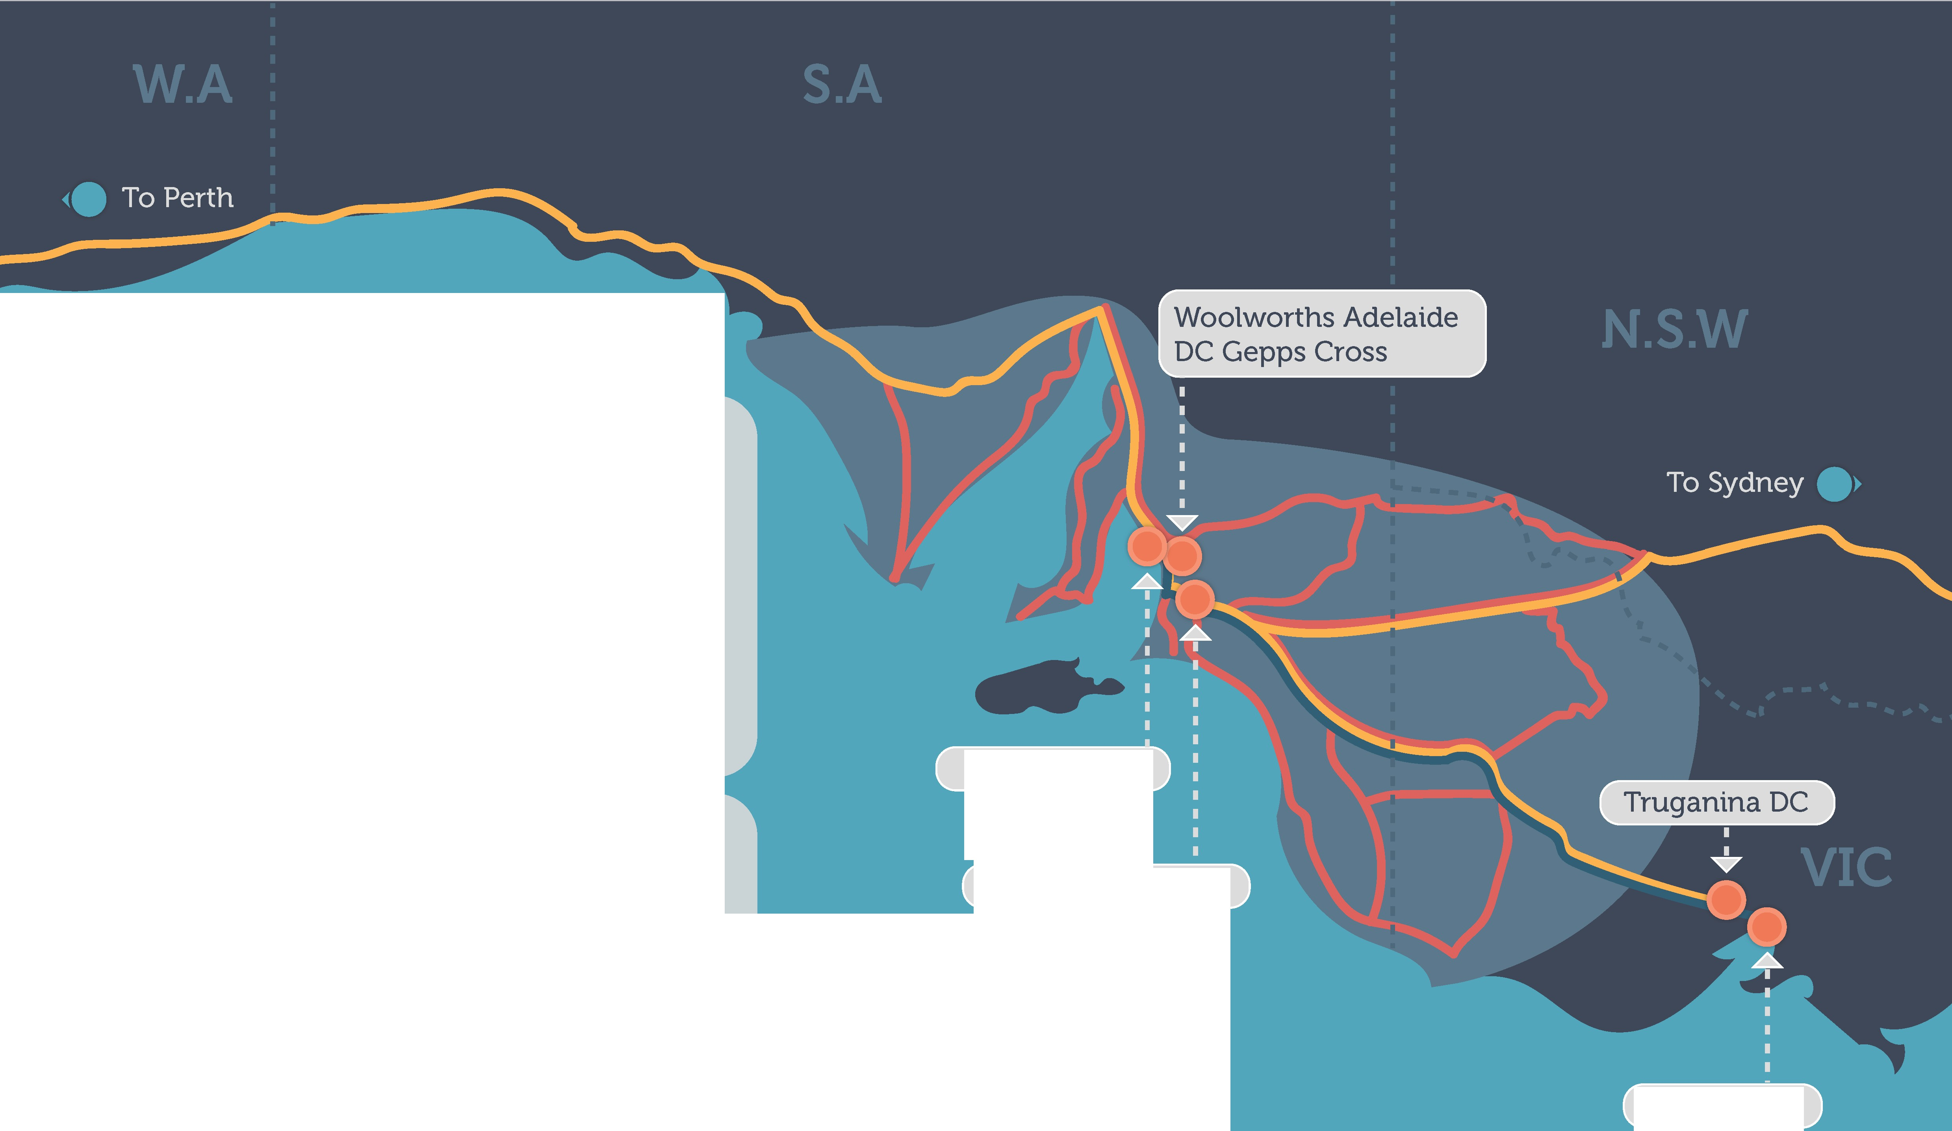

• Direct employees: 1,600.

• Weekly livestock processed: 5,000 cattle,

50,000 small stock.

• Weekly meat production: 1.3 million tonnes beef; 1.35 million tonnes other livestock.

• Total livestock and meat transport costs c. SAUD 8 million dollars per annum.

MAP KEY

Q Domestic meat transport Export meat transport Livestock transport

Livestock source area

Port Adelaide

TFI Murray Bridge

Melbourne

Case study

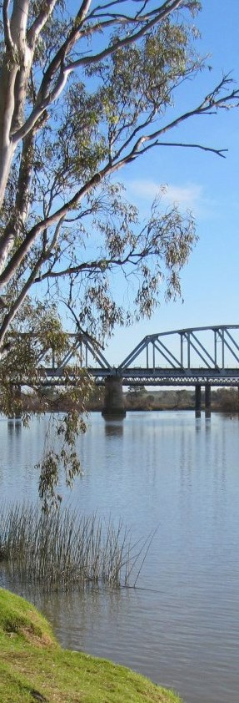

TFI Murray Bridge - major freight task on a broken ‘network’

The remaining 15 per cent of the Murray Bridge export task goes to the Port of Melbourne. While 2 x 40-foot containers per vehicle are acceptable at Port of Melbourne itself, access is still restricted on the highway between Adelaide and Mel- bourne. South Australia’s road agency will give higher access to the border, but the vehicle is then illegal if it crosses into Victoria. Again, the scale of gains, reduced truck movement percentages and improved safety outcomes on offer apply as for the Adelaide export task.

Much of Murray Bridge’s domestic production goes via B-dou- ble in pallets to a major distribution centre in Truganina, off the Western Highway in western Melbourne; the remainder goes to Sydney, Perth and Adelaide (often on smaller pantechs). The carrier for Murray Bridge would like to move to a B-triple com- bination for the interstate task, which would provide Murray Bridge with a net 25 per cent freight saving. B-triples are ap- proved for part of the highway journey on the Victorian side of the border. B-triples are not yet available from Murray Bridge to the Victorian border.

Time limitations on this case study have prevented a detailed weighted average productivity gain analysis, but it can be es- timated that reasonable road freight productivity savings of at least 20 per cent overall could be achieved for Murray Bridge’s freight task. If this were linked to a parallel major infrastructure retrofit of the corridor to ensure sailing weight A-Double access, the gains are more likely to approach 40 per cent. On current figures this would represent in the order of a $AUD1.6 to $3.6 million dollar annual freight saving to Thomas Foods Interna- tional at this plant.

Supply chain efficiency and integrity – worth up to 3.45 billion to the industry out to 2030 14

**Road pricing reform**

Just as there are significant achievable gains for the sector in transport productivity, RMAC remains concerned that ill-con- ceived road reform proposals would serve to erode the gains and in some cases threaten the viability of parts of the industry.

Road reform has been a policy objective of governments for at least a decade since the Productivity Commission Inquiry into the matter in 2007 .

RMAC considers it essential that any examination of freight sup- ply chains and productivity matters also examine the potential for adverse impact that poorly-credentialed heavy vehicle pric- ing reforms might have on the supply chain freight task.

For over a decade, road agencies have advocated a form of di- rect heavy vehicle pricing of all trucks on all roads to better cov-

RMAC remains extremely concerned for both the cost in- creases entailed in such arrangements, and on the policy va- lidity of such outcomes for the bulk of the livestock and red meat freight task.

**Scale of proposed increases**

In 2012 Meat and Livestock Australia published a collection of six detailed economic case studies and analysis detailing the likely effect of alternative heavy vehicle charging regimes on Australia’s red meat industry transport prices. This report showed that some of the options for pricing reforms being proposed by road agencies would result in cost increases for certain parts of the livestock and red meat sector:

**Table 2: Increase relative to PAYGO charges of road transport costs per steer equivalent associated with alternative heavy vehicle charges (cents/steer eqv. 2010-11 charges)**

er Australia’s future road capital and operating expense. This would replace the PAYGO or pay-as-you-go system - a form of direct charging of the sector via fuel taxes and truck and trailer registration charges, which is recalibrated every few years by the National Transport Commission and approved via parliamentary tabling and ministerial vote. In 2006 the Productivity Commis-

Mass Distance

Location

Distance mass

34.4

86.6

90.3

67.2

76.4

189.4

474.5

sion found after extensive inquiry that the PAYGO system, while being somewhat rough and ready, broadly covered the cost on and of capital in terms of the heavy vehicle sector contribution to total road costs.

**Road spending in Australia: increasing at over 12**

Distance Location

22.3

13.8

8.6

4.6

47.6

52.4

111.1

85.5

112.0

344.9

**per cent per annum**

87.6

Since that time, road spending in Australia has increased at over

12 per cent per annum in real terms, from $9 billion in 2004 to

$24 billion in 2016 (BITRE yearbook statistics).

Distance (axle group)

12.0

10.7

19.4

24.4

57.6

136.3

This has driven a push from governments to find ways to in- crease revenue collection from the road user, beginning with heavy vehicles. The current favoured process is, as indicated,

to charge all heavy vehicles directly for their road use in most

Flat fuel charge

17.0

29.5

33.6

11.0

9.0

69.5

likely a form of mass, distance and or locational charging re- gime.

The two most recent policy documents seeking reform of this system are the Transport and Infrastructure (Ministerial) Com- mittee’s Heavy Vehicle Reforms (2016) and the Department of

PAYGO 00

00

00

00

00

00

0.0 100.0 200.0 300.0 400.0 500.0

Cents / Steer equivalent compared to PAYGO (2010 - 11 charges)

Infrastructure and Regional Development’s Land Transport Mar- ket Reform Discussion Paper (2017).

6. Export 10 live goats from Adelaide

4. Live export steers Western Australia

2. NSW Feedlot

5. Production and slaughter steers Queensland

3. Export 10 chilled sheep carcasses from Victoria

1. NSW Abattoir

**Inequitable outcomes**

RMAC’s principal policy concern in relation to these charging approaches relates to equity.

A key feature of the proposed charging reform is that it affects all roads. This is a problem for the red meat sector, which tends to use remote, rural and regional networks which have not seen significant benefits akin to the 12% real annual growth in total road funding over the past decade and which are for the most part unlikely to see such gains in future.

A further RMAC concern relates to the inadequacy of the pro- posed pricing reform direction, in that it is not consistent with Australian competition reform principles, which bestow choice, transparency and legal recourse for lack of access and agreed

service levels to customers.

Instead, the preferred road agency charging reform appears to put in place direct charging measures that collect more revenue from trucking and its users, but allow the truck operators and customers no role in establishing how and where funds should be spent in the future - such as identifying key freight upgrade and new vehicle matching opportunities, for example.

The road agency proposed model would retain the deep cross subsidy of the current system, where one truck’s fuel tax and registration charges could be subsidising somebody else’s use of a far more expensive road somewhere else.

To date, government has made no effort to establish whether the roads used predominantly by RMAC’s members warrant such major price increases. What can be observed is that even on current heavy vehicle tax and registration charges, some of these rural roads probably already more than pay for them-

selves:

**Table 3: Partial equilibrium model estimates of the impact of road transport price changes on the beef and veal industry (% change).**

0.10

0.05

0.05%

0.054%

Supply

0

Domestic

Demand Eport

Total

Demand

-0.05

-0.10

-0.20

-0.25

-0.30

-0.35

-0.06%

-0.06%

-0.07%

-0.08%

-0.05%

-0.32%

-0.06%

-0.24%

At port price

Model 1

Model 2

Case study -

Do some rural roads already pay for themselves from their users’ current heavy vehicle user taxes and charges?

In 2011 the Australian Rural Roads Group produced an import- ant report which for the first time examined direct rural local road charging, revenue and maintenance and renewal costs . Rural local roads used by heavy vehicles had traditionally been assumed to be highly maintenance-intensive and worthy of higher charges in order to better reflect the cost of provision.

|  |  |  |
| --- | --- | --- |
| Road (length in kms) | Annual taxes and charges incurred on road by local HV traffic volumes ($) | Long-run annual mainte- nance and renewal cost estimate of road ($) |
| Elcome Road  (49.92) | 96,076 | 75,890 |
| Barooma Downs Road (20.56) | 18,366 | 32,865 |
| Croppa Creek  Road (23.6) | 39,979 | 39,855 |
| Horton Road  (22.07) | 19,298 | 57,029 |
|  | | |

The ARRG report examined four representative shire roads used as livestock and grain haul roads in the north western New South Wales shire of Gwydir. Working with the shire engineers, accu- rate annualised traffic count analysis and representative long term maintenance and renewal assumptions for these roads as well as accurate assessments of the revenue that current road freight levels ‘paid in’ to these roads, the study found that two of the four roads already paid for themselves with standard cur- rent direct fuel tax and registration fee levels and overall, local HV traffic was already paying for 84 per cent of these assets (see Table 4 below)

TOTAL 173,689 205,669

The lesson from this study is that it is a false assumption to sug- gest that all rural roads are highly maintenance-intensive, tax- payer subsidised and in need of significant heavy vehicle charge increases to their users in order to continue to provide them in future. The study also suggests that perhaps many rural net- works are in effect being ‘asset stripped’ to pay for increasingly expensive urban road ‘mega projects’.

RMAC is concerned that a move to increased pricing along the lines conceived by agencies could simply generate more reve- nue for future governments to commit along current spending patterns, which is heavily weighted to major urban motorway programs, some of which (such as Clem7 and Lane Cove Tunnel) have proven to be of questionable value in recent years. Prop- er road reforms should instead start from the premise of find- ing ways to reduce spending pressure on the areas which are self-evidently soaking up most funds: major highways, motor- ways, urban networks. Doing this, along with establishing better mechanisms for government and market investment in target- ed infrastructure projects that can benefit key livestock and red meat supply chains - such as major retrofits of key processing plant to port operations to maximise high productivity freight corridors - would be a more practical and positive outcome for the red meat sector and for productive road reform generally.

**Table 4: Australian Rural Roads Group findings of direct rural road cost versus heavy vehicle road reve- nues - Gwydir NSW 2011**

An efficient port sector is vital for an export-led Australian industry such as ivestock and ed meat. RMAC considers he inquiry might benefit from considering he following categories of pressures elating to ports:

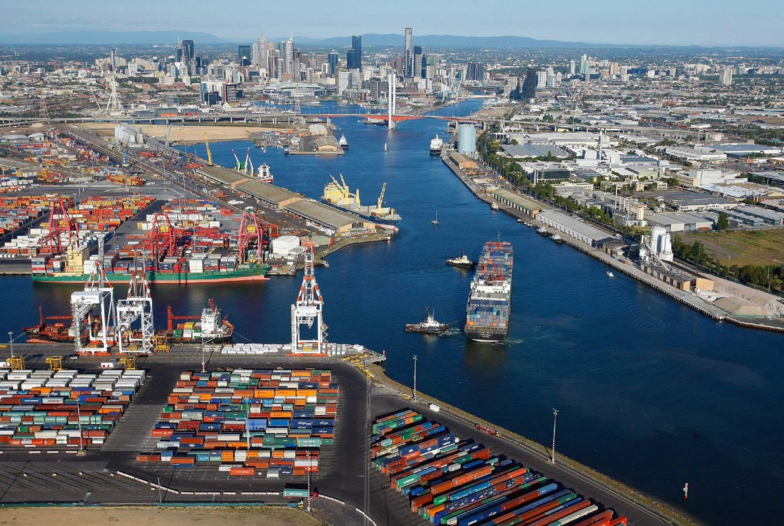

Port Pressures

l r t t r

Monopoly port pricing power challenges

Port road and rail freight interfaces: larger pressures than port itself

Case study: road freight costs continue to build

Governments provide insufficient strategic planning and investment certainty to relieve supply chain pressure at ports

Case studies of a port interface planning/investment vacuum:

Tasmania

Port Botany

Port of Fremantle

Supply chain efficiency at port and therefore the export price-competitiveness of the Australian red meat sector rests heavily on addressing the efficiency of road freight interfaces at the port for container movements. The cost per container of this interface is generally greater than the balance of all freight relat- ed port interfaces for containers. Again, efficiency in this sense means highest-productivity and safety vehicles are in operation.

**Implica tions for NFSCS:**

With this in mind, major red meat supply chains to seaports from processing plants, should be mapped and as already dis- cussed in this submission, examined for infrastructure upgrade/ regulatory packages that will allow the highest productivity ve- hicles to access these ports.

NFSCS information developed in this manner should be used to inform longer-range port planning and corridor protection strategies which would facilitate such infrastructure invest- ments. Where appropriate this should include relocation plans for some ports nearing site obsolescence.

These plans should be published nationally by Infrastructure Australia, which should also consider the related major infra- structure/high-productivity/high-safety vehicle upgrades as pri- ority projects.

**Monopoly pricing power challenges at port**

Australian ports have been subject to competition reform since the 1990s and today, almost all major export seaports of sig- nificance for both live export and red meat products (except Townsville, Tasmania’s northern ports and Fremantle) are in pri- vate hands.

It is a matter of record that the leadership of Australia’s peak regulator, the Australian Competition and Consumer Commis- sion, has expressed concern at the excessive monopoly pricing power of divested public infrastructure assets, including ports .

One of the cost pressures on ports is stevedoring. The pric- ing power of monopoly port owners can manifest itself in much higher rental charges to stevedores - prices which are passed on to port users including red meat and live exporters. In recent times, the Port of Melbourne, in preparing itself for sale to the market, sought to levy a 750% rental increase on one of its ste- vedores. While this attempt failed (as did an earlier similar at- tempt by Port Botany some years before), the major stevedore DP World still faces a rental increase of 60 per cent on 1 January

2018. Such cost increases cannot help but refract to port users, including red meat and live exporters.

RMAC notes the ACCC Chairman’s concerns in this respect.

**Port road and rail freight interfaces are larger pressures than port itself**

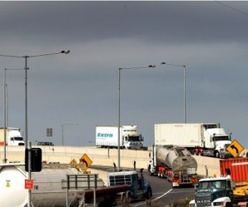

The dominant port interface cost remains road transport

While port monopoly powers are concerning, RMAC recognises that the major port cost - one which generally represents around half the total cost of moving a shipping container through the Australian port system - is not even under the control of the private port owners, or of government port authorities. Yet this cost continues to grow and to place more and more pressure on the export task.

This cost is road freight. The solutions lie with government in the first instance, especially with the Commonwealth govern- ment, which has the opportunity to show leadership in devel- oping practical high-productivity freight planning and invest- ment programs for major ports. In its National Ports Strategy discussion paper of 2010 (NB: no link provided as the document appears to have been removed from the internet), Infrastruc- ture Australia pointed to vital analysis which showed that at Australia’s major container ports over the preceding 15 years, port-specific costs such as stevedoring, wharfage fees, customs clearance and pilotage etc had reduced, but road freight costs to port had increased markedly, with no sign of slowing:

**Table 5: Port interface cost % changes in road-related and total port charges per TEU - 1996-2009 (incl. manufacturing cost index for comparison).**

-40% -20% 0% 20% 40% 60% 80% 100% 120%

Brisbane Sydney Melbourne Adelaide Fremantle

Manufacturing cost index

Road transport charges All other charges Manufacturing cost index

*Source: Infrastructure Australia analysis of BITRE Waterline statistics 1996-2009*

**Case study: Port of Melbourne - road freight pressures continue to build**

A contemporary examination of this situation confirms that the trend is continuing. Taking Melbourne as an example, road freight

remains over half the cost of moving a shipping container through the port:

**Table 6: Disaggregated transactional costs ($) per container – Port of Melbourne 2015**

Source: BITRE Waterline Port Data report 2015

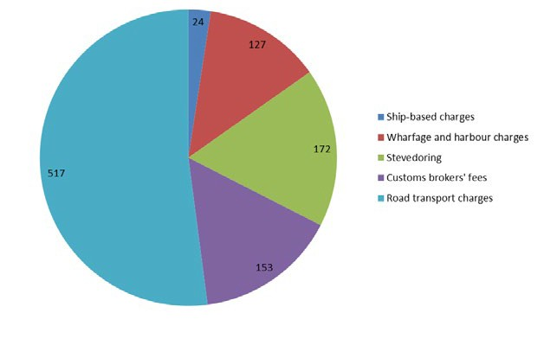

As this analysis shows, while much is made of stevedoring and other port challenges, the greatest port interface cost pressure on red meat exports are road transport charges. This situa- tion is common to all container ports. Of the major Australian container ports, Waterline data suggests Melbourne is already the most expensive port through which to move a container at well over $1,000 per container. This situation is being further exacerbated at Melbourne in recent times due to wider road fee increases agreed between the Victorian government and the Transurban motorway operator. The fees amounted in

some instances to a 125 per cent increase on current tolls and greatly increase port cost exposure.

**Grain trips to port, like meat, become signifi- cantly more expensive**

While not a red meat transporter, prominent grain carrier Rior- dan Grains of Lara near Geelong illustrates the challenge well

- advising at interview that from 17 April 2017, new user levies of

$38 per container were placed on trucking operators at Port of Melbourne, in addition to new Citylink (Transurban) toll increas- es. This equates to an additional $100 freight cost per trip for

2 grain export containers, or an additional $2 per tonne on all grain sold via Melbourne. Similar cost increases face red meat exports from Melbourne.

On the basis of this analysis, RMAC is not inclined to agree with the inference in the departmental discussion paper (p. 10) that

‘there are indications that poor or decreasing productivity and high costs are not across the board in the freight sector’. In justifying this statement, the department advanced Shipping Australia analysis showing Australian ports in the mid-range for global port prices:

**Table 7. Shipping Australia Global Port Price Index**

Hong Kong

Busan

China Ports

Singapore Fremantle Los Angelas Brisbane Wellington Melbourne Adelaide

Sydney

New York Auckland Rotterdam Japan Ports

Hamburg

23.21%

36.05%

38.31%

44.72%

66.13%

66.53%

71.51%

82.41%

100.00%

103.81%

118.47%

121.99%

135.00%

164.67%

165.19%

183.71%

Crucially, this analysis does not indicate road freight costs as an input. This is an important omission. In the Australian economic framework, transport can and should be a source of relative advantage, in a way that Australian port labour, for example, can never be in a strict relative sense compared to port economies such as Hong Kong, China, Busan and Singa- pore.

0% 20% 40% 60% 80% 100% 120% 140% 160% 180% 200%

Once land freight costs are included in an efficiency analysis, the picture for Australian port productivity is not as positive as the department suggests. This may help to explain why Infrastructure Australia’s comparison of Australian and international ports in

2012 found Australian ports were not competitive with global benchmarks:

**Table 8: Australian seaport* return on equity (%) relative to global comparators (2012)**

9.2

9

8

7

6

5

Supply chain efficiency and integrity – worth up to 3.45 billion to the industry out to 2030

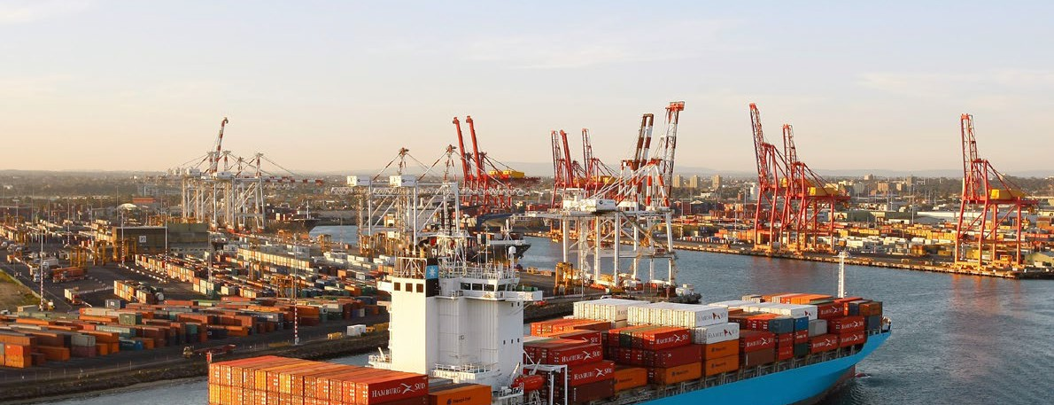

3.6

3

2

1

Australian reference ports Global reference ports

Source Deloitte Infrastructure Australia Review of Port Balance Sheet Capacity Draft Report 2012

* These numbers are averages across several reference ports in Austra- lia and globally. Australian reference ports were Melbourne; Newcastle; Kembla; Townsville; Fremantle; Bunbury; Hedland; Tasports. International reference ports were DP World Ports; Lyttleton; Auckland; Sydney; Singa-

pore; Toronto; Vancouver.

21

Governments provide insufficient strategic planning and investment certainty to relieve supply chain pressure at ports.

Supply chain efficiency and integrity – worth up to 3.45 billion to the industry out to 2030

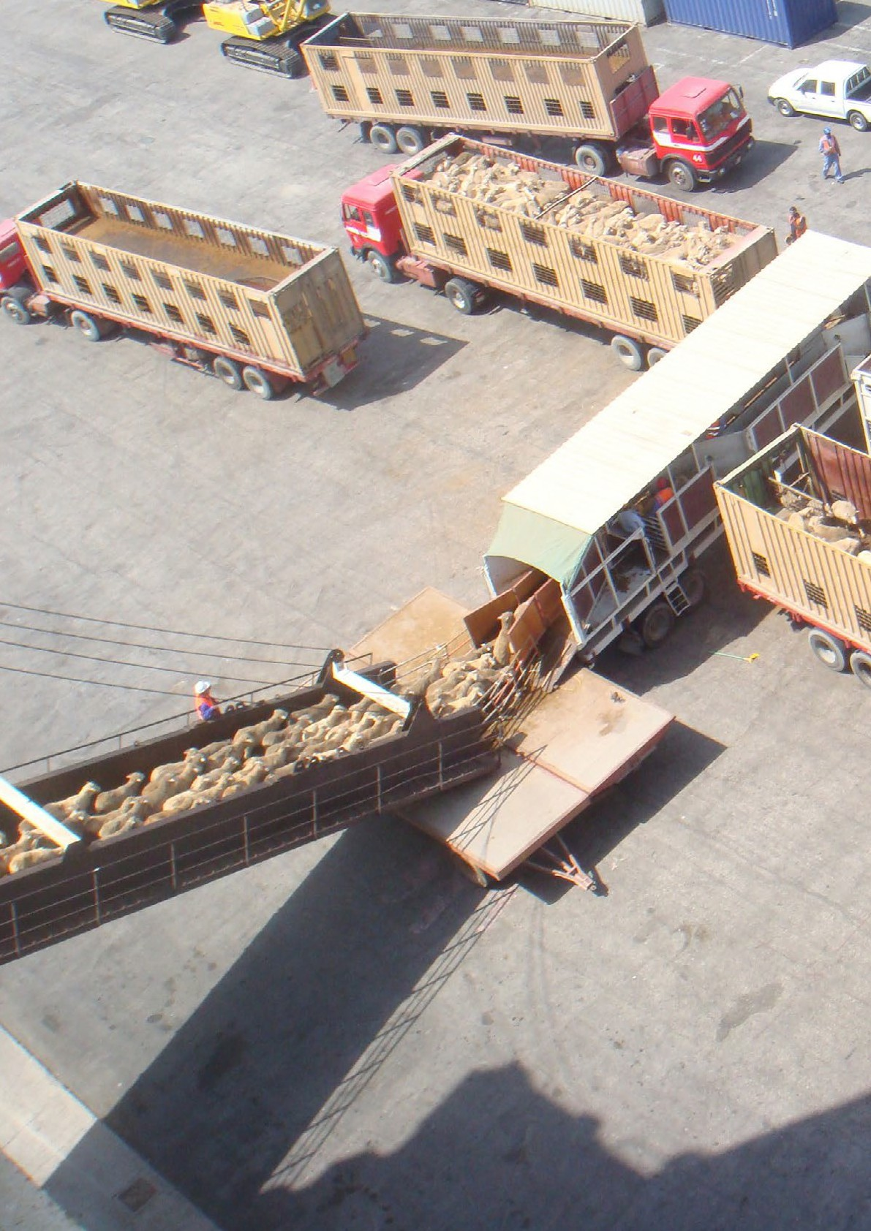

In order to make strategic progress on port land transport interface costs, RMAC believes the Commonwealth gov- ernment can show national leadership by examining large scale, high benefit-cost-positive infrastructure refits to im- prove road and rail freight access. In some cases where amenity is challenged, this might involve new strategic freight only access corridors, such as the Alameda sunken rail freight corridor between the Ports of Long Beach and Los Angeles in California, USA .

As discussed in the road pressures section of this submis- sion, it is imperative that the solutions match the highest productivity port vehicles with effective new road and rail infrastructure. In some cases this could mean providing certainty to markets about port relocation rather than com- mitting to further investment in a congested urban environ- ment. Both Fremantle and Melbourne appear candidates for such strategic planning and targeted, large-scale infra- structure investment pipelines.

RMAC is concerned particularly at the role of Infrastructure Australia in this field. It does not appear to be offering planning leadership on specific port interface infrastructure and a glance at Infrastructure Australia’s latest Priority List shows no dedicated landside freight interface projects of the kind discussed in this submission.

22

Case study

A port interface planning vacuum?

A lack of strategic planning and infrastructure invest-

ment certainty which in the end leads to higher export prices for the red meat and livestock sector:

TASMANIA

Tasmania’s sea freight and port interface task is made addition- ally complex by the subsidised nature of Bass Strait services, as well as by the historical coastal shipping legislative arrange- ments impeding more commercial shipping visits. In addition northern Tasmanian ports have been run by a port authority which for a long time adopted a policy of providing equal infra- structure (incl.equally-inadequate channel depths for modern international vessels) to three separate and in effect compet- ing ports at Burnie, Devonport and Bell Bay (Launceston). This is despite the fact that as both a 2013 independent Tasmanian Infrastructure Systems Review[i] and a subsequent Productivi- ty Commission Inquiry[ii] acknowledged, Port of Burnie was an obvious superior candidate for strategic dredging to open the prospect of direct international exports including meat. Mem- ber feedback suggests this could reduce meat export costs by c. $1,000 per TEU.

There needs to be strategic clarity around long-term infrastruc- ture and operational structure for livestock and red meat farm- ers, feedlots, processing plants and live exporters to the main- land. This is especially required for King Island producers, who are suffering from extremely high-cost and inadequate supply chains at present. RMAC recognises that these matters are very complex, but they would benefit from direct and strategic Com- monwealth involvement to provide a long-range infrastructure plan and preferably an infrastructure investment pipeline to fu- tureproof these industries and their communities.

PORT BOTANY

While RMAC acknowledges excellent efforts made to improve truck and train access and vehicle queuing at Port Botany under the auspices of new port management, at a strategic level - re- lated more to the freight planning role of government - Sydney’s land freight interface with Port Botany remains com- promised and the source of very high costs. It is not clear to RMAC why the c. $20 billion Westconnex motorway project does not provide a dedicated road freight linkage to relieve much of the road freight queueing and curfew pressure at Port Botany and offer better linkages for freights like red meat approaching from major rail and road distribution centres further west, such as Chullora and Moorebank. There appears to be no dedicated major freight infrastructure investment project to match Botany with higher productivity vehicles, connect to Sydney’s west and lower congestion.

FREMANTLE

The Port of Fremantle‘s land freight interface costs were meant to be improved with the advent of the Perth Freight Link, but this project, which remains on Infrastructure Australia’s priority list, seems at odds with the current state government’s stated interest in a longer term relocation of the Port of Fremantle to a superior new offshore container port at Kwinana, closer to Perth. This appears evidence of a disconnect in planning which risks not sequencing high-productivity road and rail freight ac- cess to a future port as well as making potentially redundant industry and taxpayer investments in a potentially obsolete ex- isting port, noting that Fremantle Port Authority advised in its

2014 Annual Report that the current port could exceed its useful life within a decade .

Rail pressures

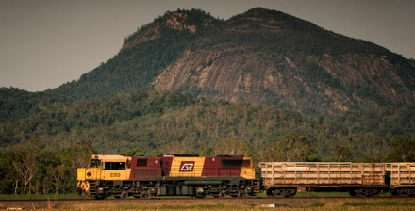

A number of processing plants retain rail sidings or truck to rail sidings where rail can be an efficient option for large density movements to seaport in particular. If managed properly, with proper access, scheduling, train sizes and logistics arrange- ments at both ends and assuming all important high densities and regular schedules, rail can be a very cost effective alterna- tive to road freight for both livestock and red meat freight.

RMAC is particularly appreciative of Federal government commitments to drive innovation into railed livestock ser- vices, through its support for the new Morven rail hub land in Queensland. This sort of infrastructure expands potential for livestock on rail, by introducing services to offer store cattle owners new more efficient transport opportunities as well as serving traditional slaughter cattle rail customers .

**Queensland’s rail task**

The cattle herd in Queensland is more than twice the size of any other Australian State (11.3 million ABS final estimates 2015). The right market conditions can create a need for uplifts of very large volumes of cattle; here rail can act in concert with high-productivity trucks and improved road networks to deliver an efficient freight task for Queensland’s cattle sector.

There are also challenges to railing of livestock related to animal welfare in particular. Member feedback suggests Queensland above-rail providers such as Aurizon are continuing to improve this aspect of livestock services, with new cattle trucks being introduced and penning densities and livestock handling and monitoring working to comply with ever-increasing expecta- tions of animal welfare in the community.

**Queensland government preservation of livestock rail paths remains essential**

Under the 2010 sale terms of the former State-owned Queensland Rail, the government mandated that the new owner would commit to guaranteeing a pre-agreed number of available rail ‘paths’ for the industry. This arrangement origi- nally had a sunset clause attached which was renegotiated. In- dustry experience is that the efficiency of this service continues to evolve and remains important to the sector. As such, RMAC considers it a priority that guaranteed livestock rail paths be retained into the future.

Particularly in red meat, some larger processing plants are tak- ing steps to improve their rail access logistics with upgraded rail spurs, so as to send product by rail.

The most common complaint of the sector in this regard is the high transactional cost of negotiating access and scheduling and the difficulty of affecting continuous improvement. Com- monly, processors will work with willing above rail providers, but will find it very hard to coordinate changes to rail paths, sched- ules or other innovation with the below rail track owner.

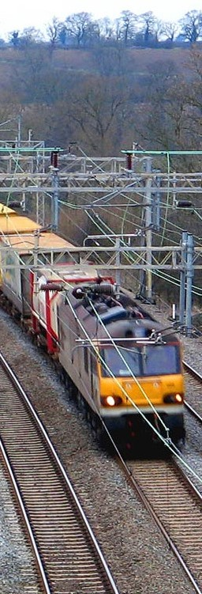

Improving the market responsiveness of the below-rail provider to be more in line with the objectives of efficient market access to rail assets appears a major opportunity to drive more produc- tivity into rail in the red meat and cattle sector alike.

INLAND RAIL

RMAC welcomes the vision shown by the Commonwealth in

funding the Inland Rail project.

Inland rail is of direct interest to the red meat sector, as meat processing is a largely regionally-based task which is the larg- est manufacturing sector outside the capital cities.

RMAC is interested in the commerciality of this railway for its membership and communities. In this respect it notes three matters which deserve Commonwealth attention if the Inland Rail is indeed to prove successful:

Inland Rail must have high-productivity intermodal con- nections. Inland Rail must be met at key railheads by highest productivity trucking and seaport interfaces. Lack of efficient linkages will threaten the overall com- merciality of the Inland Rail offering to red meat and oth- er industries.

Inland Rail must have access to sufficient freight densities to be commercially viable. In time it should be afforded the ability to extend its network further, possibly further north to major mineral ports like Gladstone, to secure superior and diversified densities on the line.

The Commonwealth must work to analyse direct pricing outcomes for interstate road freight competing directly with Inland Rail on interstate highways, or Inland Rail risks being non-competitive with trucking due to subsidised

Supply chain efficiency and integrity – worth up to 3.45 billion to the industry out to 2030 25

Case study

Borthwicks Mackay - rail efficiency obtainable, but not realised

Thomas Borthwick and Sons Mackay is a major North Queensland export processor employing over 250 people. Recently it has recommitted effort to develop an efficient rail service from western Queensland. Borthwick’s above rail trans- port provider, Aurizon, has also committed considerable effort to this end, including the purchase of new cattle wagons which transport the cattle in better conditions.

At present, Borthwicks receive a 40-wagon Aurizon cattle train to their siding. While the service is good, the siding length is limited, so that the full 40-wagon train will occupy the mainline while unloading.

The default solution has been to break the Borthwicks cattle train into four separate loads of ten wagons which do not in- terfere with the mainline. The remainder of the cattle stand in wagons at Mackay and transported sequentially from Mackay as each 10 wagon section is unloaded. These sections have been timed by Borthwicks and Aurizon to take almost an hour to complete. This outcome is not desirable from productivi- ty, animal welfare and food safety perspectives. Accordingly, Borthwicks sought permission from the Queensland below rail track owner, QR, via Aurizon. Borthwicks were informed that the request would not be granted because a single unloading episode, although far quicker, would see the train occupy the mainline.

Borthwicks worked with Aurizon to establish that there would be hours of time to spare between a full continuous unload- ing and the next mainline train, if effort was made by QR to make the matter work. Yet the matter remains unresolved. This episode should be viewed in the context of wider below-rail access service in similar situations, including those with much busier operating environments:

**Best practice: Cooks River Intermodal Terminal**

**Sydney - same freight problem, superior outcome**

The Cooks River Intermodal Terminal, ten kilometres from Port Botany, is directly connected to the Port by the Port Botany Freight Rail Line . The Terminal is an inland extension to the Port. Approximately ten years ago, long container trains work- ing into this intermodal

were faced with the same challenge as at the Borthwicks plant siding - full train single unloading/loading would occupy the mainline. Given the cost penalties associated with breaking down these trains for this task, the NSW below-rail operator worked diligently to manage the busy mainline path so that the Cooks River intermodal train could complete a single-pass de- livery safely, without impeding other Sydney rail freight.

RMAC is convinced that if this can happen in Sydney, it should certainly happen in North Queensland given the right manage- ment commitment to customer service.

**Implica tions for NFSCS:**

In mapping supply chain strategies and inefficiencies within the rail sector, priority attention should be given to the interface between the red meat sector and the be- low-rail provider, which can be a source of major ineffi- ciency and lost opportunity.

National, strategic rail projects such as Inland Rail should be examined for their compliance with well-understood economic efficiency principles for commercial railways, including seamless intermodal connections to high pro- ductivity road and portside solutions, ability to maximise density of freight traffic on the line and resolution of po- tential subsidised road freight running in direct opposi- tion to the rail task on competing interstate highways.

Airfreight pressures

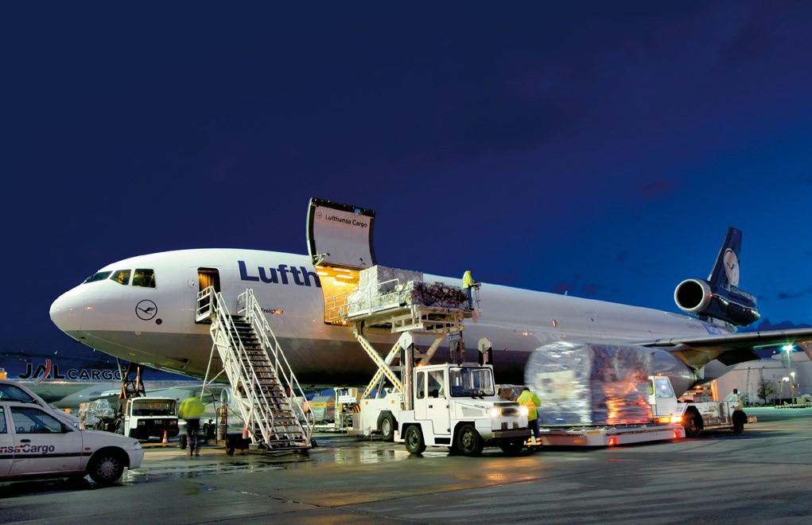

Airfreight is an increasingly important element of the red meat supply chain, as Australian meat and live animal producers continue to open new markets and establish reliable delivery supply chains for premium products, particularly in the Middle East where some products can take advantage of fast freight to access local requirements for carcass freshness. In 2016, Aus- tralia’s red meat and pork sector combined shipped a total 1.6 million tonnes of product worldwide with airfreight just under

96,000 tonnes (DAFF statistics).

New airport infrastructure has been provided at places like Wagners Toowoomba, which increases the ability to grow the airfreight trade to China as customs and supply chains process- es become reliable and trusted.

In physical infrastructure terms, RMAC sees less significant pressures on the airfreight supply chain - consignments are usu- ally transported by road on smaller vehicles at lower

weights; in many cases airfreight is occurring at capital city air- ports where airfreight will contend with wider congestion, but many airports themselves such as Melbourne Tullamarine have invested considerably in air freight infrastructure.

Of perhaps greater concern to RMAC is the need to ensure that where new air export services are developed, processes for DAWR and customs accreditation is as seamless and delay-free as possible. At existing red meat air freight centres such as Perth and Melbourne, these services need to be sufficiently resourced to keep up with the demand for fast turnaround logistics.

**Implica tions for NFCS**

Monitoring of airfreight supply chains should include metrics to capture the efficiency of customs clearance and related com- pliance activities in airside operations. Streamlining processes and ensuring effective resourcing of such matters can improve the turnaround and reliability of this emerging high-value as- pect of the red meat sector.

Modelling: practical

gains, economic benefit

**The sector-wide and national economic implications of doing better**

In order to provide the inquiry with the value on offer to both red meat sector and national economy from attending to the supply chain pressures identified in this submission, RMAC commissioned professional computable general equilibrium dynamic modelling of the likely impact of conservative levels of productivity gains in road transport associated with the red meat processing supply chain.

This modelling subject was chosen due to the prime importance of road freight to land transport of red meat, but also due to the importance of road freight in port container interface costs (see Port pressures above).

**Modelling methodology applied**

The Centre of Policy Studies (CoPS) was tasked to provide model-based analysis of the economic contributions of the livestock and meat industries, and of the effects of improved transport productivity in those sectors. The analysis relies on an application of the Victoria University Regional Model (VURM), which is the rebranded version of the Monash Multi-Regional Forecasting model (MMRF). The change of name reflects CoPS’ move from Monash University to Victoria University in early

2014. VURM is a dynamic model of Australia’s six states and two territories. It models each region as an economy in its own right, with region-specific prices, region-specific consumers, re- gion-specific industries, and so on. Full documentation of the model’s equations can be downloaded from http://www.cops- models.com/elecpapr/g-254.htm.

Two sets of simulations were undertaken with the model. In both sets of simulations results were compared to the models reference case.

The Reference case incorporates a large amount of information from specialist forecasting agencies. VURM traces out the im- plications of the specialists’ forecasts at a fine level of industrial and regional detail.

The first set of simulations examined the year-to-year effects of improvements in road transport productivity on site and in the carriage of products to customers by the livestock and meat in- dustries. The second examined the economic contribution of the livestock and meat industries in a single year. The second set of simulations employed a version of the model which was

configured to produce outcomes similar to an input/output

framework.

The road transport productivity scenarios deviate from the Ref- erence case on the assumption that in 2016-17 there is a once- off improvement in road transport productivity in the livestock and meat industries alone. This improvement occurs across all regions and affects own use of road transport, and road trans- port used to take production to customers.

The second set of simulations was designed to explore the eco- nomic contribution made by Australia’s red meat industry. For these simulations, VURM was configured as a comparative static input/output model via changes to model closure. All dynamic mechanisms were turned off and changes were implemented such that:

1. All final demand (domestic and international) was exoge- nous by commodity;

2. There were no supply constraints on the availability of la- bour, capital and land by industry;

3. Export demand schedules were flat (export demand elas-

ticities were infinitely large); and

4. Prices (still present in the model) were largely passive and played no role in determining real behavior.

The model set up in this way was run off the 2015-16 database with shocks that eliminated all demand for the livestock and meat industries. The subsequent changes in real GDP, employ- ment, etc., are reported as industry contributions (after and ap- propriate change in sign).

**Indicative productivity gains - assumptions employed**

Indicative productivity gains of 10 per cent for livestock and 20 per cent for meat products were chosen for dynamic modelling as being representative of practical sector wide gains on offer to red meat transport in the processing supply chain.

RMAC considers these gains to lean to the conservative end of the spectrum; they reflect the fact that volumetric loading weights are now generally available to livestock transporters na- tionwide, but they also take into account the major safety and productivity opportunities offered by resolving broken network access and moving to higher productivity combinations such as

the A-Double across many of Australia’s major highways and key

feedlot, saleyards, plant and port networks.

Due to time and resource constraints, this modelling was also unable to incorporate all of the productivity information con- tained in CSIRO’s Transport Network Strategic Investment Tool (TRANSIT). For now, TRANSIT expresses gains in terms of dol- lar per head savings. As CSIRO resources permit, this material would benefit from being expressed as net percentage road

**Economic modelling and benefits analysis:**

Professional dynamic economic modelling (Centre for Policy Studies for RMAC) has established that the industry supports use of resources equivalent to $11.424 billion in GDP:

freight gains.

$12,000

11,424

For these reasons, the productivity input assumptions employed for these simulations rely on case studies conducted for this submission, observations, previous case studies and the consid- erable red meat logistics industry experience of the modelling team. Noting some data limitations, these modelling assump- tions are offered to provide the inquiry with a starting point for further and better analysis of the upside on offer to the sector given a commitment to improvement from governments.

$ m. 2015-16 prices

$10,000

$8,000

$6,000

$4,000

$2,000

9,315

8,333

0

Sheep and Ca ttle

Mea t pr ocessing

R ed mea t industry

**Direct and indirect use of resources supported by Australia’s red meat industries ($ m. GDP)**

Note: Livestock and processing figures do not sum due to non-linear effect

Further dynamic modelling and simulations of road transport productivity gains in the Australian red meat processing supply chain alone (ie net of live export) suggests that annual gains of around $AUD 740 million and increased sector employment of

around 4,000 people are plausible across the coming decade, given due attention to supply chain improvements:

**Impact on GDP of productivity improvements in road transport used by Australia’s red meat industry**

1,000.0

800.0

$m.2015-16 prices

600.0

400.0

200.0

767.1 751.4 741.0 732.4

726.1 724.2 725.5 730.3 742.7 759.4

0.0

2016-17 2017-18 2018-19 2019-20 2020-21 2021-22 2022-23 2023-24 2024-25 2025-26

Sheep & beef cattle Meat products Red meat Industry

**Impact on GDP of productivity improvements in road transport used by Australia’s red meat industry**

1,000.0

800.0

$m.2015-16 prices

600.0

400.0

200.0

767.1 751.4 741.0 732.4

726.1 724.2 725.5 730.3 742.7 759.4

0.0

2016-17 2017-18 2018-19 2019-20 2020-21 2021-22 2022-23 2023-24 2024-25 2025-26

Sheep & beef cattle Meat products Red meat Industry

RMAC considers this modelling outcome conservative, and if key recommendations (below) are implemented, major high-val-

ue infrastructure projects could deliver a much more productive and globally-competitive sector for the future.

Further detail of this dynamic model, its data sets, simulations and input assumptions can be made available by RMAC upon request.

Recommendations:

achieving ‘quick wins’

RMAC is more than willing to contribute to a detailed policy debate, but it is also conscious of the need to deliver practical quick wins to its members and it hopes this inquiry will take the same view.

The great majority of the terms of reference concern themselves with how the department itself can better understand supply chain problems. This is sensible for larger matters where gov- ernment leadership of planning is essential.

**The TRANSIT model and the Beef Roads Program**

In recent times RMAC has worked alongside with Meat and Livestock Australia to partner with CSIRO’s Transport Network Strategic Investment Tool (TRANSIT) which draws on a very comprehensive livestock and red meat transport database to analyse potential efficiency savings for the sector. This model in turn helped establish the Commonwealth Government’s Beef Roads Program, which has been an excellent development in improving the supply chain at critical productivity-sapping road points in the network, especially in northern Australia.

Nevertheless, central agency planning has its limitations. RMAC believes that the red meat industry is the party best-positioned to identify more localised problems as they occur, or anticipate transport productivity opportunities as they emerge.

For now, such parties already can and do raise road, rail, port and air freight challenges with their local governments and relevant transport agencies - or with bodies like the National Heavy Vehicle Regulator, which sees this as core business. But the common denominator of these interactions between gov- ernment and industry is that the government bodies being con- sulted rarely have ready access to discretionary funds which, as- suming safety amenity and economic benefits are established, can be made available to resolve the matter quickly - this might take the form of an intersection upgrade, or a longer slipway to connect a highway to saleyards, or establish better rest areas for drivers to manage their fatigue obligations (which extend via chain of responsibility laws to the wider sector) or various similar first and last mile access challenges. Without such discretionary protected funds, RMAC members and the wider supply chain are wrapped in lengthy application and consideration process- es which too often are costly, lengthy and open-ended.

**Reinstate the Commonwealth Strategic Regional**

**Programme**

One former federal government grant program -the Strate- gic Regional Program - greatly empowered rural and regional freight businesses to resolve their own problems where good arguments existed to do so. At the same time, the economic benefit tests applied to these applications ensured that these funds were not absorbed into wider rural and regional pro- grams, such as Roads to Recovery, which is provided directly to local governments through an agreed formula. The meat and livestock industry benefited from targeted, productivity and safety-enhancing projects as a result. Importantly, Strategic Re- gional Programme could address supply chain challenges which cut across more than one local government area - a traditional fragmentation risk for the network.

The Strategic Regional Programme program ran in the last years of the Howard Government. In 2004 $120 million was made available for ‘local road projects of strategic regional impor- tance’. The project ran successfully for several more years but was then cancelled in the early years of the Rudd government. A comprehensive ANAO review of the program exists.

RMAC commends the program to this inquiry as a good mech- anism for market rather than government-led improvements to the red meat supply chain . Such a program can act as cir- cuit-breaker to resolve lengthy local government and State road agency standoffs over funding.

In short, reinstating such a program would be an excellent means of gaining ‘quick wins’ for the red meat supply chain.

Recommendations:

more strategic actions

In consideration of the different supply chain pressures, inad- equacies and opportunities outlined in this submission, RMAC considers there are three key steps that the Commonwealth government should consider in order to deliver optimal pro- ductivity gains to the supply chain that should be enshrined in the National Freight and Supply Chain Strategy with respect to agrifood growth:

1. First, identify the key networks, the breakages that exist in them and examine better solutions for these tasks at an infrastructure and regulatory level

The major supply chains in the red meat and livestock sector are well appreciated by industry itself, but not by government agencies. This lack of transparency is creating conditions where productivity-sapping network breakages can occur. The depart- ment should commit major feedlot, saleyards, meat processing and live export supply chains to visual representations: network productivity breakages across jurisdictions should be made transparent and their costs quantified to drive subsequent high-value planning and investment actions.

With key supply networks understood, effort should turn to eliminating network breakage and placing highest productivity vehicles on these retrofitted networks. This work should in- clude structuring major road and rail investments in these plac- es and/or planning and corridor protection of new sites, where existing sites and networks are deemed to be obsolete for fur- ther investment. Such projects could be expected to be major projects, above $100 million in value, which should command priority project status with Infrastructure Australia.

In proposing these outcomes, RMAC would note that this may not entirely align with the Inquiry discussion paper’s notion of a ‘National Freight Performance Network’. RMAC is conscious that the red meat sector is only one of many ‘supply chains’, but hopes that its contribution will help guide more effective Com- monwealth planning, investment and regulatory reform effort.

2. CSIRO’s Transit model can and should play a larger role in developing better infrastructure solutions in the supply

chain in support of these objectives

The CSIRO Transit model was built with the assistance of the Red Meat Industry. lt is an excellent tool for mapping freight flows and building critical data to drive both small scale ‘quick wins’ and more strategic projects to match highest safety and productivity vehicles with upgraded freight routes. TRANSIT should be expanded and become an integral part of depart- mental assessment for supply chain investment planning and

business case assessments.

3. Match highest productivity and safety freight vehicles to upgraded key networks without network breakages: in road freight, such breakages should be viewed in the same way as damaging ‘break of gauge’ rail inefficiencies and resolved accordingly wherever possible. Infrastructure investment packages backed by facilitating regulatory ar- rangements should be developed to encourage action on these upgrades: without complementary deal structures for investment, identifying the problems remains an aca- demic exercise which does not drive economic growth in the red meat sector

Endnotes

1.

2.

3.

4.

5.

6.

7.

8.

9.

10.

11.

12.

13.

14.

<http://www.primemovermag.com.au/featured/article/can-the-a-double-change-the-trucking-industry>ht[tps://www](http://www.onlinepublications.austroads.com.au/items/AP-R465-14).onl[inepublications.austroads.com.au/items/AP-R465-14](http://www.onlinepublications.austroads.com.au/items/AP-R465-14) <http://www.pc.gov.au/inquiries/completed/freight>

ht[tps://www.mla.com.au/globalassets/mla-corporate/r](http://www.mla.com.au/globalassets/mla-corporate/research-and-development/documents/industry-issues/effect_of_)esear[ch-and-development/documents/industry-issues/effect_of_](http://www.mla.com.au/globalassets/mla-corporate/research-and-development/documents/industry-issues/effect_of_)

alternate_ heavy_vehicle_charges_on_australias_red-meat_industries.pdf

<http://austwideruralroadsgroup.com/wordpress_2_9_2/_key_not_found_/wordpress_2_9_2wordpress/wp-content/up>loads/2011/12/ Reduced-Size_AARG-Paper_Worth-Feeding.pdf

ht[tps://www.accc.gov.au/speech/ports-what-measur](http://www.accc.gov.au/speech/ports-what-measure-of-regulation)e-of-r[egulation](http://www.accc.gov.au/speech/ports-what-measure-of-regulation) ht[tps://www.cbfca.com.au/documents/CT](http://www.cbfca.com.au/documents/CTAA_Notice_to_Alliance.pdf)AA_Not[ice_to_Alliance.pdf](http://www.cbfca.com.au/documents/CTAA_Notice_to_Alliance.pdf) <http://www.acta.org/><http://infrastructureaustralia.gov.au/projects/infrastructure-priority-list.aspx>

<http://www.stategrowth.tas.gov.au/> data/assets/pdf_file/0006/88557/Tasmanian_Freight_Infrastructure_Systems.pdf <http://www.pc.gov.au/inquiries/completed/tasmanian-shipping/report/tasmanian-shipping.pdf><http://www.fremantleports.com.au/Planning/Pages/Kwinana-Quay.aspx>

<http://www.fremantleports.com.au/News/Publications/AnnualReport/Reports2014/2014%20Annual%20Report>

%20-%20Full%20Report.pdf

ht[tps://www.nswports.com.au/ports-and-facil](http://www.nswports.com.au/ports-and-facilities/cooks-river-intermodal-terminal/)it[ies/cooks-river-intermodal-terminal/](http://www.nswports.com.au/ports-and-facilities/cooks-river-intermodal-terminal/)

Acknowledgements

**This Submission is provided by RMAC with the support of our red meat members and their member networks:**

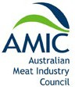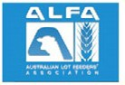

**This Submission was developed with policy research assistance from:**

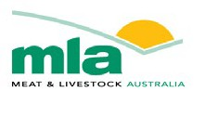

**And technical advice from:**

Juturna Infrastructure P/L



Centre for Policy Studies, Victoria University

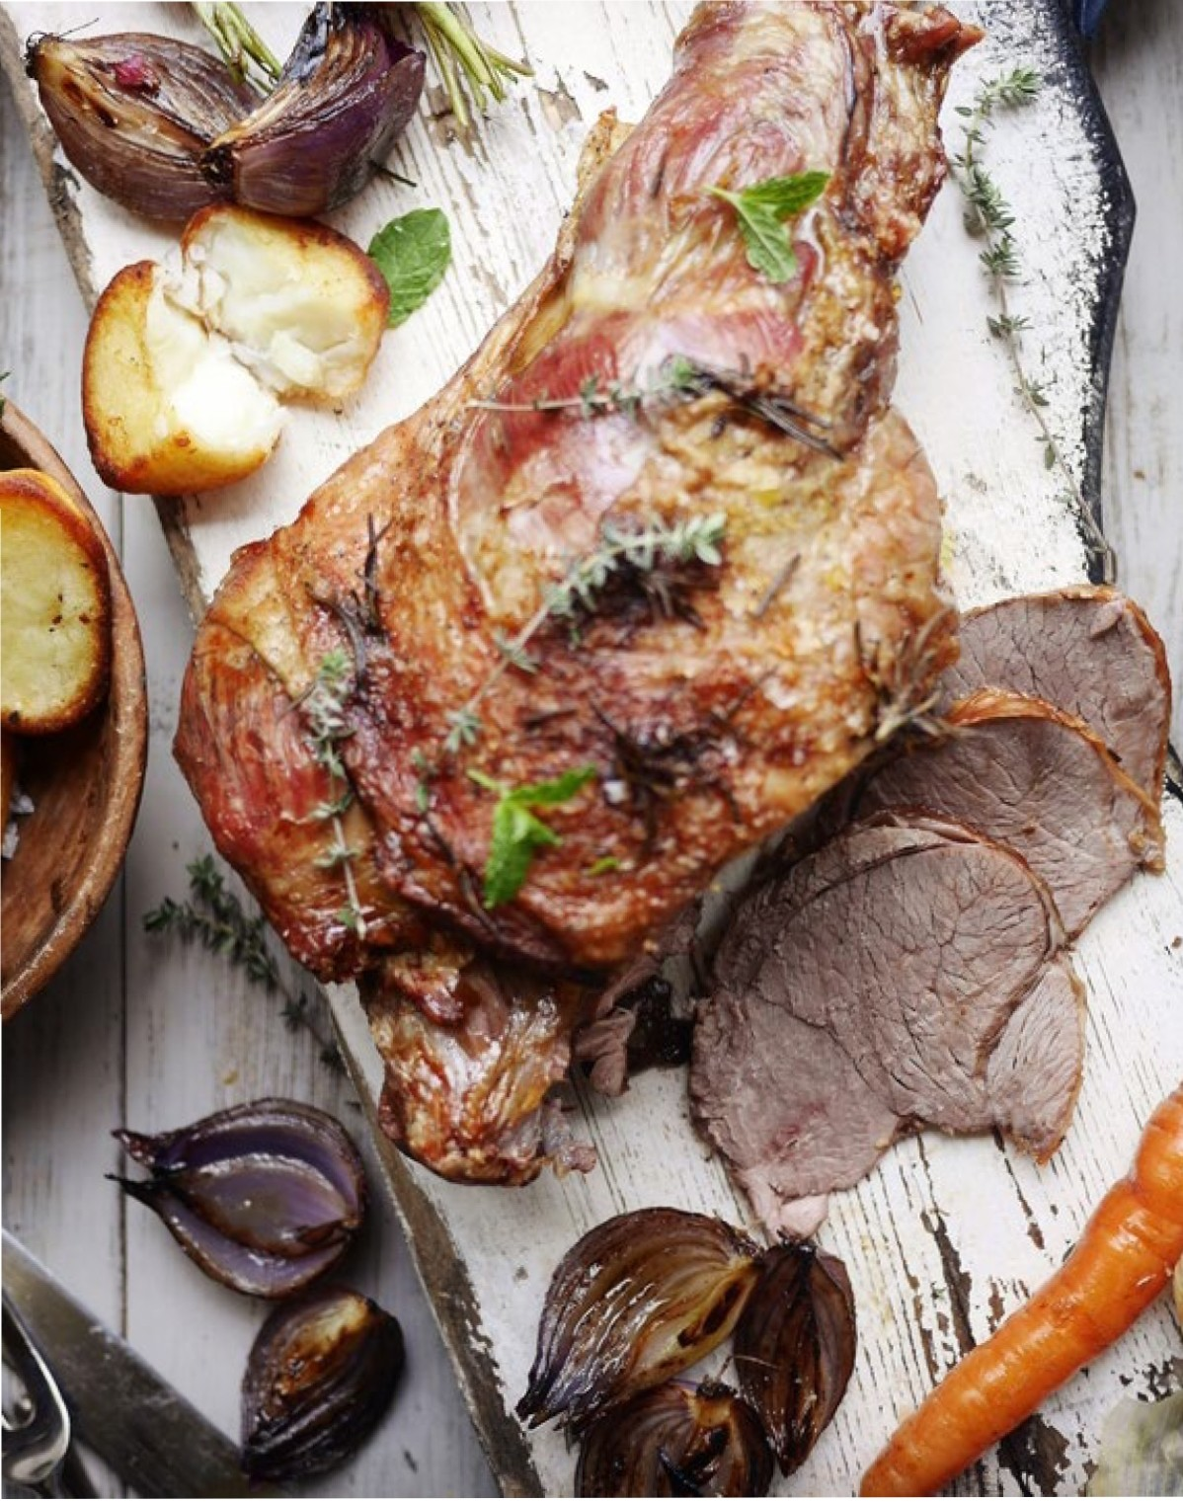

Red Meat Advisory Council Level 3, 14 Brisbane Avenue Barton *Aa* 2600

***'JI*** @redmeatcouncil

0 [www.rmac.com.au](http://www.rmac.com.au/)

'- (02) 6269 5606

.:,·:..,..**R**.**MAC**

**··'t**\**::-:·**

.

**REO MEAT** ADVISORY COUNCILLTO