

**NATIONAL FREIGHT SUPPLY CHAIN**

**PRIORITIES INQUIRY**

**Submission to Department of**

**Infrastructure & Regional Development**

**Southern Melbourne RDA Committee**

**July 2017**

***Background***

***The Southern Melbourne RDA Committee***

As one of 55 Regional Development Australia (RDA) Committees across Australia, the Southern Melbourne RDA provides responses to economic, infrastructure and social issues affecting Melbourne's south by building partnerships across the three levels of government, local industry, community and other stakeholders.

The Committee is an important link between the Commonwealth and Victorian Governments, the 10 local government authorities (LGAs) of Bayside, Casey, Cardinia, Frankston, Glen Eira, Greater Dandenong, Kingston, Mornington Peninsula, Port Phillip and Stonnington and the many regional stakeholders.

The RDA’s core business is to develop a regional framework to support a growth economy and a regional plan is prepared on a tri annual basis to identify strategies for this growth. The 2016 – 2019 Regional Plan is supported by data from the ABS and National Economics, by state and local strategies and by RDA evidence based research, consultation and reports. The current Plan proposes five priorities for the southern Melbourne RDA region and provides strategies to address them. Transport and freight are identified as a key priority given their role in supporting business and industry in an economic environment.

Although this submission focusses on the southern metropolitan region of Melbourne, the Southern Melbourne RDA recognises that transport and freight supply chains are an ecosystem which goes beyond state, local or regional borders. Accordingly, much of what is being discussed will apply across the Melbourne south east region and include the municipalities of Monash, Knox, Maroondah and the Gippsland region.

***The Southern Melbourne Region***

Southern Melbourne is Melbourne’s key economic region. It accounts for one third of the employed in metropolitan Melbourne and a quarter of its GDP. It is only eclipsed by the high value added from the City of Melbourne LGA which contains the CBD.

With a population of 1.4 million people, and municipalities which are urban, peri urban and rural, the region has a wide variety of attributes:

▪ Established, densely populated inner urban areas in the south west of the region;

▪ A highly industrialised manufacturing ‘belt’ across the Melbourne south east municipalities of Kingston, Greater Dandenong, Casey, Monash, Maroondah and Knox;

▪ Rapidly expanding population growth in the south east of the region;

▪ Agricultural and rural areas in the outer south east of the region;

▪ A working port at Hastings;

▪ An intermodal port in development at Dandenong South.

The region's relationship with central Melbourne and other parts of the larger metropolis is multi-faceted, reflecting its breadth and diversity. Whilst the inner municipalities have strong links to the CBD, the south east of the region has an increasingly self-contained

industry base, several university and further education campuses and two significant Activity

Centres, at Monash and Greater Dandenong.

***RDA Regional Priority – Transport and Freight Infrastructure***

The southern Melbourne region has many transport infrastructure strengths. In terms of connectivity, it is generally well connected to the CBD and ports by road and rail. It has seven major lines as part of its rail network and key road arterials in the form of the M1

Monash Freeway, EastLink and PeninsulaLink.

Nevertheless, the RDA’s Regional Plan notes that the region faces substantial connectivity challenges due to population and industry growth. The existing transport infrastructure has been designed for a monocentric city (with predominantly radial movements) rather than a polycentric city (with both radial and cross-town movements). Current freight movements and increased congestion, particularly on the M1, present significant inhibitors to investment, and could prove detrimental to the region’s future productivity and growth if not addressed.

The Plan identifies the Dandenong South Intermodal Port (DSIP) as a priority piece of freight infrastructure for Melbourne’s south east region. This is of particular importance now that the Port of Melbourne lease has been extended and Webb Dock’s container capacity is being increased. The RDA recently commissioned a study to define and ‘map’ the supply-chain and commercial benefits to businesses based in Melbourne’s south east and Gippsland (importers/exporters) of the proposed Dandenong South Intermodal Port (DSIP) development. This will be discussed later in the submission and a full copy of the study will

be attached to the submission.

***Road Freight Connectivity***

As previously noted, efficient and effective freight transport infrastructure is essential for the economic health of the Melbourne south east region. The freight task created by the region's large manufacturing and wholesale trade sectors is massive, with these industries predominantly based in the municipalities of Monash, Knox, Kingston, and Greater Dandenong.

Greater Dandenong currently has the highest internal freight movement activity of any metropolitan LGA. It is the largest generator of freight movement overall, with over 1,800 individual truck trips in the morning peak alone. The Victorian Freight and Logistics Council estimated in 2010 that freight volume, across all modes, will double by 2031. The volume of freight in the south east region is predicted to further increase as more industrial land is opened up in Greater Dandenong, Frankston and Cardinia, more activity is centred around logistics and warehousing, and more investment is attracted to the region.

The integrated economic triangle proposed by Plan Melbourne is part of a long held road infrastructure vision for Melbourne. It will connect the Hastings–Dandenong corridor with the Hume corridor to the north and the Wyndham–Geelong corridor to the south west. The RDA believes it is essential that the following road infrastructure optimisation be undertaken to support the freight task growth and the Port of Melbourne expansion. It includes:

***1. Upgrading Freeway Connections from the North to the South East***

These connections need to be upgraded as the movement of freight across Melbourne is affected by the lack of direct access to the national road network. Freight traffic wishing

to access the southern Melbourne RDA region from the northern suburbs is forced to use the heavily congested M1/ Tullamarine Freeway/ M80 routes.

***2. Dingley Bypass***

The first section of the Dingley Bypass was completed in 2016. It is a fully divided road of

19 km that is expected to carry approximately 45,000 vehicles per day. It connects Warrigal Road to Westall Road and Dingley Village and completes the route between South Road, Moorabbin, Westall Road and Dandenong South.

*Benefit to Southern Melbourne RDA region:*

▪ The route provides a direct road freight route linking South Road Moorabbin to the Dandenong hub and EastLink. The connection to Westall Road is an important link within the south eastern suburbs.

▪ The remaining sections of the Dingley Bypass need to be completed, as the route will provide important alternative access to the M1 and the Princes Highway (from Warrigal Road), and Nepean Highway from South Road to Dandenong and EastLink.

***3. North East (Ring Road) Link***

The North East Link is a priority project identified in [Infrastructure Victoria’s](http://www.infrastructurevictoria.com.au/) 30 year plan and in the Regional Plans of the Southern, Eastern and Northern Melbourne RDAs. The link is intended to link Greensborough to the Eastern Freeway at Bulleen with a six lane freeway standard road, which would provide existing freeway standard connections to EastLink and Peninsula Link.

*Benefit to Southern Melbourne RDA region:*

▪ The link is estimated to carry around 100,000 vehicles per day, and will provide quicker and easier access for freight operators particularly between Monash, Knox, Dandenong, Campbellfield and Donnybrook. It is expected that this interconnectivity between freight and the Monash and Dandenong industrial hubs will optimise

freight movements and increase productivity.

▪ The link is expected to enhance Australia’s freight productivity by reducing congestion times and improving travel times and their reliability.

▪ The link will reduce the reliance on the ‘missing link’ roads in the local road network.

Since the opening of EastLink, freight traffic has increased and will continue to do so, placing further pressure on the arterial network currently performing the ‘missing link’ function: these roads being on Fitzsimons Lane, Heidelberg Road and Rosanna Road.

▪ The link will enhance access to the Dandenong South Intermodal Port and

Melbourne airport.

***Container Supply Chains to Southern Melbourne RDA region***

***Insufficiency of Container and Freight Movement Data***

Containerised supply chains served by the Port of Melbourne have either an inland origin where the product is packed into a container for export, or an inland destination where the product is unpacked for further distribution to wholesale/retail markets or use in manufacturing. However, the data on the location of these inland container origins, their destinations and where particular activities occur is incomplete.

The most comprehensive data available is a survey of inland container movements conducted by the Port of Melbourne in 2009 which extrapolated on a base sample of container movements. The available data however, only indicates where containers are packed or unpacked and does not capture:

▪ Products moved from a manufacturing site to a different location for packing into containers for export, or;

▪ Products moved from an unpacking location (warehouse/distribution centre) for example in the west, to secondary locations such as the south east for use in manufacturing or wholesale/retail markets.

The lack of complete and accurate data means that the current picture of where and how export and import products are actually moving around metropolitan Melbourne and into regions, such as the south east, is distorted. Consequently the data is unreliable and potentially incorrect.

For example, Dandenong is ranked as the number one Port of Melbourne destination for full import containers amounting to around 132,000 TEU; the number two full import container destination was Altona/Laverton in western Melbourne with around 109,000 TEU. If imported products destined for Melbourne South East but unpacked in the west of Melbourne, are taken into account, then the Dandenong area assumes even greater significance as the principal point for container origin and destination when compared with the rest of metropolitan Melbourne.

***Melbourne South East has the Highest Container Destination***

The Institute of Supply Chain and Logistics conducted a study for Infrastructure Victoria in

2017, as part of the work undertaken for the State Government regarding the timing and location of a second container port in Melbourne. They reviewed the destinations of container trucks and found that southern Melbourne receives the second highest number of import containers (29% compared to the west’s 30 %). When eastern Melbourne is included,

39% cent of containers come to Melbourne’s east and south east; well over a third of

Melbourne’s freight task.

A study undertaken by GHD for the RDA estimated that Melbourne south east generates a significant portion of the Port of Melbourne’s container throughput. The larger population base alone means more freight movements into the region. The region accounts for:

▪ 24% (rising to 33% for Metropolitan Melbourne) of all full containers amounting to around 376,000 TEU. This compares with 24% for western Melbourne

▪ 33% of full import containers amounting to around 298,000 TEU. This compares with

26% for the western Melbourne region. However, Melbourne south east is the single most important region in Melbourne for imported products, particularly when products unpacked in the west of Melbourne and moved across to the south east

are also considered.

▪ 12% of full export containers amounting to around 78,000 TEU. This compares with

22% for the western Melbourne region. However, this misrepresents the Melbourne south east share as it excludes a proportion of export products manufactured in Melbourne’s south east but packed for export in the west of Melbourne.

▪ 40% of all Tasmanian full import containers amounting to around 33,000 TEU.

Melbourne south east is the single most important area in Melbourne for sourcing

Tasmanian products.

▪ 31% of all Tasmanian full export containers amounting to around 35,000 TEU.

Melbourne south east is the single most important area in Melbourne for supplying products to Tasmania.

***This lack of up to data, comprehensive data means that the current picture of where and how export and import products are moving around metropolitan Melbourne is very misleading. It does not provide an accurate picture. Indeed, the locational drivers of any future container movements cannot be determined by interpreting the 2009 published survey data on containers.***

***Dandenong South Intermodal Port***

A number of reports over the past decade have recommended the construction of an intermodal port in the south east of the southern region to complement the metropolitan freight terminal network. In 2010, the Department of Transport’s intermodal system discussion paper noted that it was possible to re-route freight operations to an intermodal terminal in the south east using high productivity freight vehicles. The paper also identified the need to move away from Melbourne’s existing traditional radial pattern of transport connections to effectively service freight into the future. The Metropolitan Intermodal System (MIS) is envisioned as a state of-the-art rail-based container logistics and inland port network. As part of the MIS, the Port Rail Shuttle will directly connect the Port of Melbourne by rail to three suburban inland ports located at Dandenong South, Altona and Somerton.

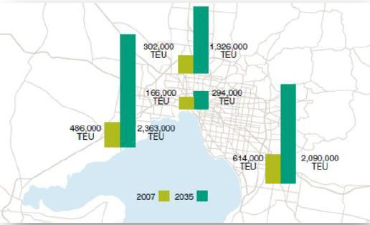

The RDA and many regional stakeholders believe that an intermodal port at Dandenong South is a critical piece of infrastructure, now that the Port of Melbourne is to be leased for another 50 years. A longer lease at the Port of Melbourne will inevitably create more pressure on the freight network around the Port itself and in the western suburbs.

Re-routing freight operations to an intermodal terminal in Dandenong South will mean that containers can be freighted direct, rather than being unpacked in the west and then transported to the south and east in multiple vehicles, adding further congestion to the M1. Land has been reserved at Lyndhurst by SALTA to develop the site and a considerable amount of funds and resources have been invested to influence the government in terms of its necessity.

***Dandenong South Intermodal Port Business Benefit Analysis***

As previously mentioned, the RDA commissioned Jacobs to examine the supply-chain and commercial benefits of the proposed Dandenong South Intermodal Port (DSIP) development. The purpose of the study was to provide an evidence based analysis of the costs and benefits associated with the DSIP. The study mapped and quantified the supply

chain and commercial benefits to Melbourne south east and Gippsland based importers and exporters who could use the DSIP.

The approach adopted by Jacobs included the following steps:

Review - desktop review of relevant studies and policies completed to date. Overview - DSIP development and operational plan.

Description - current south east import/export supply chain and port connectivity.

Consultation - key stakeholders, including import/export business operators and groups such as Melbourne South East Manufacturers’ Alliance, South East Business Networks and the Committee for Dandenong.

Analysis - a qualitative analysis of the benefits of supply chain and commercial benefits of the DSIP to local business operators including importers and exporters.

- a quantitative analysis that estimates the dollar difference (benefit)

between the DSIP proposition and the status quo.

***Quantitative Assessment Outcome***

The study’s assessments of comparative costs to importers/exporters from use of container movement involving the DSIP versus status quo were assessed separately for import/export packages of services. Costs and savings accruing to users operating via the DSIP are summarised below:

▪ The DSIP PRS would reduce importers costs per container by approximately 37% per

20’ container and 16% per 40’ container (see chart below)

▪ Exporters will be able to accrue larger savings than importers. The DSIP will deliver a

36% reduction in costs per 20’ container and 21% per 40’ container (see chart

below).

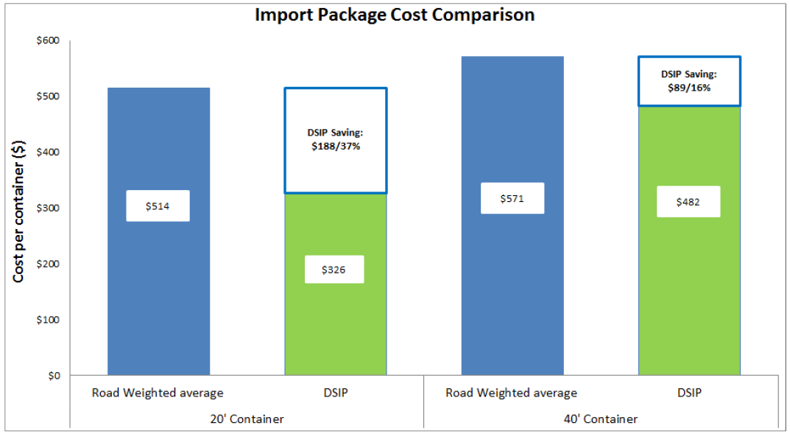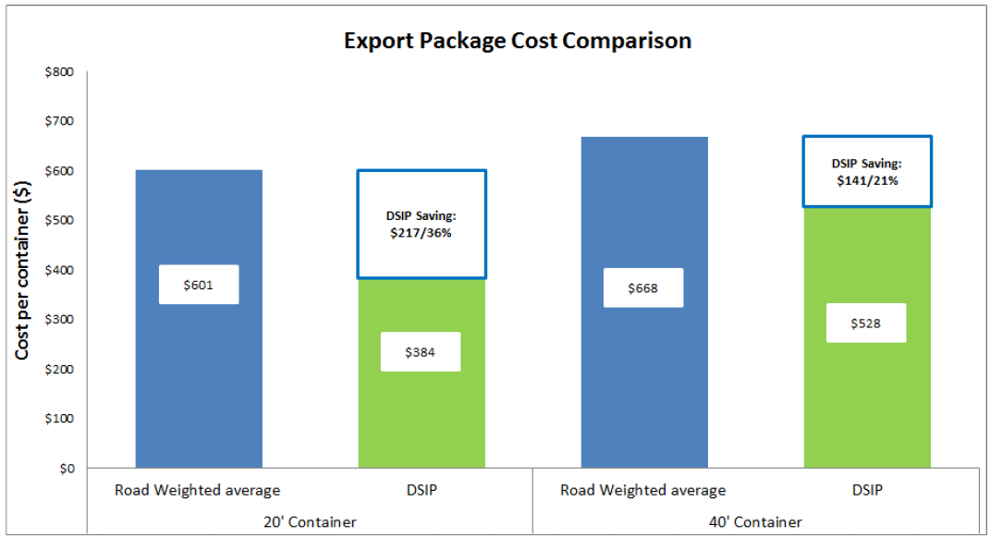

These analyses included a stevedore rail handling charge of $35.00 per container for PRS

options, based on estimates provided by DPW (Dubai Ports World) and modelling

undertaken for this study and reported in Jacobs (2015). This demonstrated that the viability of PRS services is sensitive to the scale of these charges. If a mandated maximum price similar to the $15.00 per container imposed at Port Botany (NSW) was imposed, the PRS savings increase by 3% over those shown above.

If costs similar to the current disadvantage that railed containers suffer remained (around

$120 per container from the short road journey between rail and stevedore terminals), the savings of PRS over road is reduced by around 15%, and for 40’ export containers, virtually disappears. If enhanced transfer arrangements between stevedore port terminals can be established and resultant savings passed on to importers and exporters using the DSIP via rail, savings increase by a further 3% over savings for all packages shown above.

In effect, savings totalling around $13.5M pa would accrue to exporters through use of the DSIP. Exporter users would incur costs of approximately $23.8M, compared with current arrangements of $37.3M. This indicates that the DSIP could deliver an annual cost saving of

$14 M to exporters. This suggests that exporters will benefit slightly more from the DSIP than importers, mainly due to the greater proportion of exports in 20’ containers and greater savings achievable for 20’ containers.

The DSIP is expected to have an annual throughput count total of 124,000 TEUs, half of which are expected to be import containers. Using the costs shown below, usage of the DSIP would incur total costs of $20.2M, compared to a current arrangement (road transport) cost estimate of $31.9M. This indicates that the DSIP could deliver an annual cost saving $11.7M to importers.

***Qualitative Assessment Outcome***

The study concluded that the establishment of the DSIP will provide substantial benefits to importers and exporters in the container supply chain. Broader community benefits will also be realised in the form of job creation and environmental benefits.

The major supply chain benefit is that businesses will have much earlier access to import containers, which will:

▪ Improve customer service and ability to meet customer needs.

▪ Reduce costs to importers by greatly reducing the incidence of demurrage charges for containers (where they are held for periods exceeding the allowed number of

‘free’ days).

▪ Improve importers’ inventory management performance, increasing goods

availability to meet customer orders in a timely matter.

The variability of time taken to move containers between Dandenong South and Swanson

Dock will also be reduced, which will:

▪ Reduce transport costs to and from the port.

▪ Reduce the incidence of export containers missing the cut off time for vessel sailings.

▪ Reduce costs for unloading and loading containers, by providing greater certainty regarding when containers will be available.

▪ Reducing labour costs when containers are not available for hired casual labour.

▪ Improve efficiency of warehousing operations for import containers, by improving the accuracy of meeting arrival schedules.

▪ Reduce dependence on the Monash M1 freeway corridor, which is at capacity most days and is very vulnerable to extended periods of very slow traffic speeds when collisions, breakdowns or other disruptions occur.

***Findings and Conclusions***

The study concluded that the DSIP could deliver cost savings averaging 23% per import container and 25% per export container. It will generate savings to facility users of $25.1M per annum at the initial throughput target of 124,000 TEU per annum. It was also estimated that the establishment and operation of the DSIP will generate an estimated 2,800 FTE jobs during the construction phase and 6,100 when fully operational.

In percentage terms, average savings to importers and exporters using import/export supply chain via the DSIP over existing arrangements will be:

|  |  |  |
| --- | --- | --- |
|  | ***20’ containers*** | ***40’ containers*** |
| *Importers* | *37%* | *16%* |
| *Exporters* | *36%* | *21%* |

Use of the DSIP in combination with Port Rail Shuttle (PRS) container train movements to and from the Port of Melbourne will provide users with operational supply chain benefits including:

▪ Providing much earlier access to import containers

▪ Reducing the variability of time taken to move containers between Dandenong south and Swanson Dock

▪ Establishing empty container depot services at Dandenong south

▪ Establishing quarantine and customs related services and facilities at Dandenong south.

Additionally, the total PRS system, including DSIP, will increase the container throughput capacity of the Port of Melbourne by around 36%.