

28 July 2017

Inquiry into National Freight and Supply Chain Priorities Department of Infrastructure and Regional Development GPO Box 594

CANBERRA CITY ACT 2601

By email: [freightstrategy@infrastructure.gov.au](mailto:freightstrategy@infrastructure.gov.au)

**INQUIRY INTO NATIONAL FREIGHT AND SUPPLY CHAIN PRIORITIES**

Regional Development Australia Illawarra is pleased to provide this submission, which responds to questions identified in the *Inquiry into National Freight and Supply Chain Priorities Discussion Paper, May 2017,* in relation to Urban Growth Pressures and Port Corridor Pressures.

The Illawarra region is contiguous with Sydney’s south and south-west, see attached Appendix 1 – map of Greater Sydney and Illawarra Strategic Opportunities. Its regional capital Wollongong is NSW’s third largest city. The Illawarra region includes the Local Government Areas (LGAs) of Wollongong, Shellharbour and Kiama.

As the third largest economy in NSW, the Illawarra contributes significantly to the State’s production output ($16.5 billion in 2012-2013) and is experiencing its own residential growth across the West Dapto Urban Release Area. Once complete, the release area will house around 50,000 residents over the next 30-40years.

**The Illawarra region is becoming increasingly integrated with Sydney**, including:

• Freight distribution to and from Sydney, especially the dense urban and industrial areas of Western and South Western Sydney

• An average of 42,300 passenger and freight vehicles per day travel between the

Illawarra and the Sydney on the M1 Princes Motorway. This corridor is one of

Australia’s busiest inter-city roads. In addition, another 3,000 people per day travel between the Illawarra and Sydney by rail

• Housing markets are becoming increasingly linked, with Sydneysiders sea-changing

and moving to the northern suburbs of the Illawarra for more affordable housing

• Around 20,850, or 15% of our workforce commute to Sydney for work, and 10,000 people living in Sydney make the reverse trip to work in the Illawarra

• Sydney airports are critical gateways enabling us to connect, with the new

Badgerys airport set to amplify the Illawarra’s interaction with Western Sydney.

**Ground Floor, 87–89 Market Street, Wollongong I PO Box 1152, Wollongong NSW 2500**

**T: 02 4227 4500 I F: 02 4227 4700 I E:** [**enquiries@rdaillawarra.com.au**](mailto:enquiries@rdaillawarra.com.au) [**www.rdaillawarra.com.au**](http://www.rdaillawarra.com.au/) **I ABN: 46 389 260 571**

A similar theme reverberates through [the NSW State Infrastructure Strategy, 2012, p](http://www.infrastructure.nsw.gov.au/pdfs/SIS_Report_Complete_Print.pdf)

[69 (Infrastructure NSW. First Things First 2012-2032):](http://www.infrastructure.nsw.gov.au/pdfs/SIS_Report_Complete_Print.pdf)

*‘The Illawarra and the Hunter Regions are increasingly becoming integrated with the economy of the Greater Sydney Region. Many residents commute by rail and many more make the journey by road to work in Sydney every day. As Newcastle and Wollongong grow in size and importance to the NSW economy, they need faster and more efficient links to Sydney’*

Transport infrastructure cannot be considered in isolation. There are clearly inter- dependencies between modes of transport, which have a ripple effect. In the Illawarra, freight paths are primarily utilised outside of peak passenger commuting periods. However, this causes delays to freight movements, which equates to additional freight costs. Conversely, if rail freight is uneconomical, this could be moved off rail and onto road, causing additional pressure on both Sydney and the Illawarra’s road networks.

The NSW Government plan for the Illawarra [(NSW Planning & Environment: Illawarra Shoalhaven Regional Plan, November 2015, p16)](http://www.planning.nsw.gov.au/Plans-for-your-area/Regional-Plans/%7E/media/3316E0D25C04474AB7E4D3D6648C6B97.ashx) notes that Illawarra’s proximity to Sydney provides good opportunities for infrastructure-led growth. In addition to benefits of growth and employment in the region, ‘these investments would also deliver significant economic and employment benefits to Sydney’. The Regional Plan identifies inter-regional transport infrastructure that supports growth as:

• Improvements to rail travel times between Sydney and Wollongong

• Extension of the M1 Princes Motorway from Waterfall to Alexandria

• Completion of the Maldon to Dombarton freight line; and

• Duplication of Picton Road in the long term.

A regional consortium endorsed the top three of these infrastructure priorities at the end of 2014  [(‘ Advanc ing Infrastructure in t he Illawarra’](http://www.rdaillawarra.com.au/assets/Australian-Infrastructure-Audit-Illawarra-Submission/IBC-and-RDA-Illawarra-Submission-to-the-Infrastructure-Audit-Appendix-2-Advancing-Infrastructure-in-the-Illawarra.pdf) ) in its response to the NSW Government’s Rebuilding NSW Discussion Paper.

*Advancing Infrastructure in the Illawarra* provides a detailed analysis of a dedicated freight rail project through the construction of the Maldon to Dombarton Railway line, see pages 37 – 43. It contends that the Maldon to Dombarton Railway line should be constructed as a dedicated freight rail corridor by 2020, further that government commits $200 million towards the construction, to be matched by at least $500 million in private sector funding.

**Maldon to Dombarton Freight Rail Line**

Ports and related rail and road infrastructure are fundamentally important facilitators of economic activity and growth. As well as contributing to the Illawarra regional economy, all the bulk trades will add valuable export revenue to the NSW economy.

A missing piece in the freight network jigsaw that is needed to support the efficient movement of bulk commodities from mines to farms located in Western NSW to Port Kembla, as well as to and from Greater Western Sydney is an efficient rail linkage. The Maldon-Dombarton railway would provide this critical linkage, but in its absence the new trades will need to be transported on the highly congested south coast rail line, or on the key road freight corridors of the Illawarra and the Sydney metropolitan area, and to Western and South Western Sydney which are struggling.

The proposed Maldon-Dombarton rail project description is as follows:

• Construction of a single track 35 kilometre dedicated freight line

• Connects the Main South line at Maldon with the Moss Vale to Unanderra line at

Dombarton

• Consists of three rail brodges over the Cordeaux and Nepean Rivers and three over road bridges; a rail crossing under the Hume Highway, a 4 kilometre

tunnel; reinstallation of 10 kilometres of bottom ballast; signalling, drainage and power systems; 35 kilometres of new sleepers and rail; new passing loops

and the upgrade to the rail line between Coniston and Unanderra.

The objectives of the Maldon-Dombarton project are to:

• Meet the capacity for rail freight to and from Port Kembla from Western

Sydney, South Western Sydney and NSW regional areas

• Improve efficiency of the rail freight supply chain by providing greater flexibility in train arrival and departure times, improved reliability, shorter cycle times, separation of freight and passenger services

• Maintain or improve the level of safety risks to the rail networks, and

• Optimise overall rail network investment for the NSW freight task.

A diagram of the Maldon-Dombarton rail line and broader rail linkages is provided in the Appendix 2 attached.

We contend that the Port of Botany and Port Kembla and their port related road and rail networks should be strategically considered as part of a single integrated freight transport system. This will optimise the use of the whole network, support the expected growth in freight volumes and ensure the networks are most efficiently utilised.

The Port Kembla Outer Harbour development has approval for 1.2m TEU per year of containers, however the March 2011 Concept Approval for this growth in Port Kembla’s containerised trade limits the volume that is moved by road to 10% or

120,000 TEU’s per year. The remainder of containerised trade, or 90%, must be transported by rail.

Port Kembla is well located to support the State’s growing container imports and exports, 50% of which are expected to concentrate in Sydney’s south western areas. However, the completion of the Maldon-Dombarton railway is essential if the Port is to fulfil this role.

RDA Illawarra has been a long term advocate for the development of the Maldon- Dombarton freight line, and continue to support its construction.

***Port Kembla*** → ***NSW Port of Growth***

Port Kembla is Australia’s largest vehicle import facility, has the largest grain handling

terminal on the East Coast and is the second largest coal export facility in NSW. It is a key driver of economic growth in the Illawarra region, with capacity to expand following further Outer Harbour infrastructure development, and therefore has the capability to benefit from an expansion of international trade.

NSW Ports in their  [‘N avigat ing the Future, NSW Ports’ 30 year Master Plan’, October](http://www.nswports.com.au/assets/Publications/NSW-Ports-Master-Plan-2015.pdf)

[2015,](http://www.nswports.com.au/assets/Publications/NSW-Ports-Master-Plan-2015.pdf) state that Port Botany and Port Kembla are economic assets of national significance, critical to the future economic growth and development of NSW.

*“Port Kembla, as the NSW port of growth, will continue to be NSW’s largest motor vehicle import hub and bulk grain export port while catering for a growing range of dry bulk, bulk liquid and general cargo. Port Kembla will also be home to NSW’s second container port.”*

The port of Port Kembla is a key economic asset which is under-utilised and could be further leveraged by a global Sydney, particularly in the face of growing population and transport pressures. To enable this economic asset to be effectively utilised, road and rail connectivity and an efficient supply chain will also be required, as mentioned above in transport connectivity.

As identified in the ‘[February Infrastructure Australia Priority Lis t’,](http://infrastructureaustralia.gov.au/projects/files/IPL_170225.pdf) Port Kembla’s Outer Harbour development is expected to attract overflow containers from Port Botany (p83). ‘[NSW Ports Five Year Port Development Plan’ (M arch 201 4](http://www.nswports.com.au/assets/Publications/NSW-Ports-Five-Year-Port-Development-Plan-March-2014-Final.pdf) ) notes, however:

*“The greatest challenge facing the Port-related transport-logistics chain is the provision of efficient road and rail connections to and from the Ports. As Port-related throughput increases over the next five years and beyond, landside transport volumes will increase. Improvements in the efficiency and productivity of landside transport operations, optimising the use of existing infrastructure and building new infrastructure to provide additional capacity.”*

The [‘ NSW Government’s Freight and Port Strategy’, 201 3,](https://www.freight.transport.nsw.gov.au/sites/default/files/uploads/NSW_Freight_and_Ports_Strategy-Full_Strategy-High_Resolution.pdf)

aims to deliver a freight

network that efficiently supports the projected growth of the NSW economy. It states that ‘Network capacity and performance must develop ahead of demand’. Further, it is predicted that the freight task will double in the next 20 years.

It is our understanding that Illawarra First has commissioned the University of Wollongong’s SMART Infrastructure Facility to examine the potential value and benefits of the construction of the Maldon-Dombarton rail line, which they have

referred to as the South West Illawarra Rail Line (SWIRL). The release of this study is imminent.

In **summary**, the Illawarra’s economy is increasingly linked with Sydney’s. The Illawarra can support the freight challenge of NSW, if it is considered as a key part of an integrated freight transport system. The construction of the Maldon-Dombarton rail line is required to optimise the port of Port Kembla’s growth.

The Maldon-Dombarton rail line construction would also reduce pressure on Sydney’s road and rail networks, as well as the Illawarra’s passenger rail line and road networks. If freight could be removed from the South Coast rail line, this line could benefit from a more reliable and faster passenger service.

Yours sincerely



**Debra Murphy**

Chief Executive Officer

Affordable Housing

Rapid Growth

Beaches and Other

Natural Attractions

L11911nd

-- El!ollrg "'*' lb>d

=

Ell:litO -LPil

- EmiliO *'f* ILP!J

Flbw..:

" J Cftxer&:;x:arlhur

"""-1\tNo

Future Infrastructure

-Ra.xl

IIIII"" oay FYo,et!.

High« Order

Health & Education

SefVices

High Capacity Port

South Coast Regional Attractions

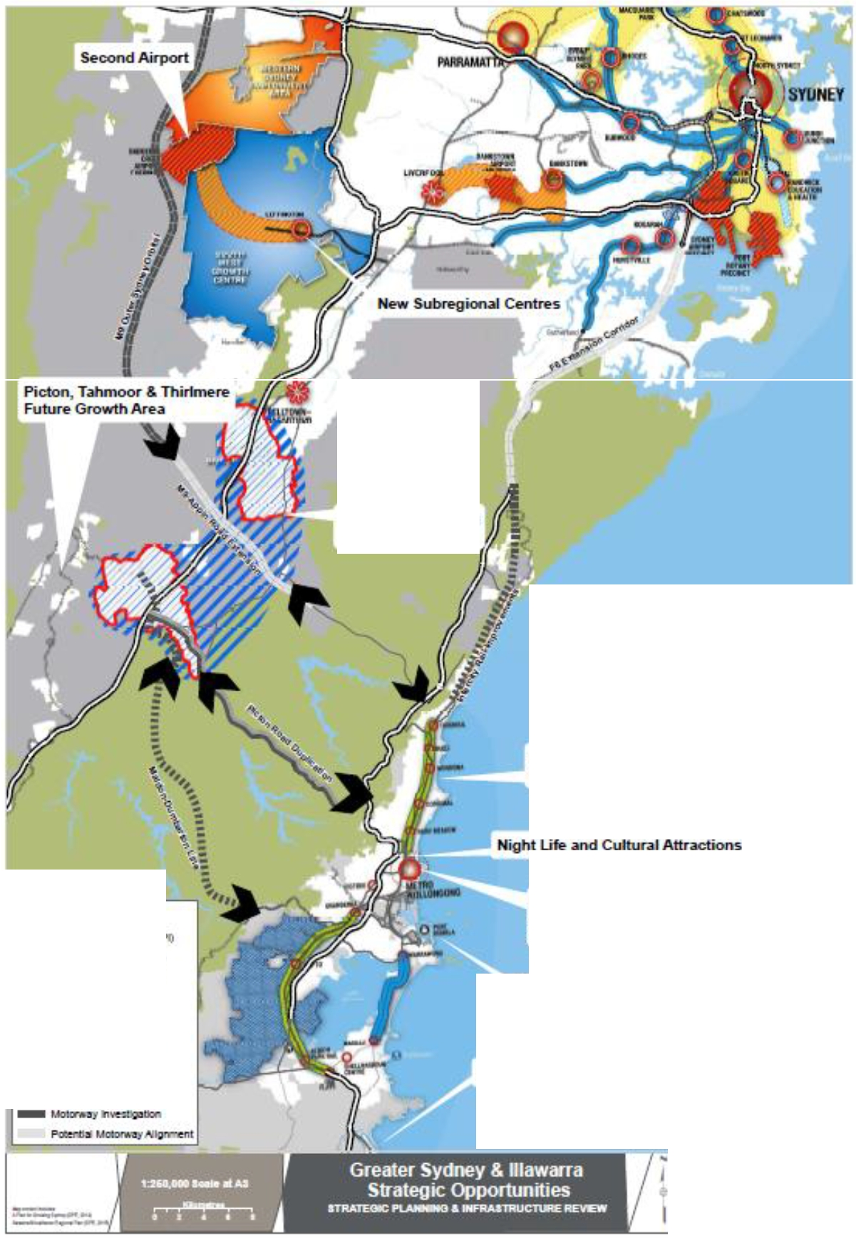

**_.......,c.a.-=:""...oJI**

<.JCtwdno

.....-....-.....-. .

**s-•• •**

**-**

**- .---&l**

Figu re 9 M aldon Dombarton and Related Raih,ays

0

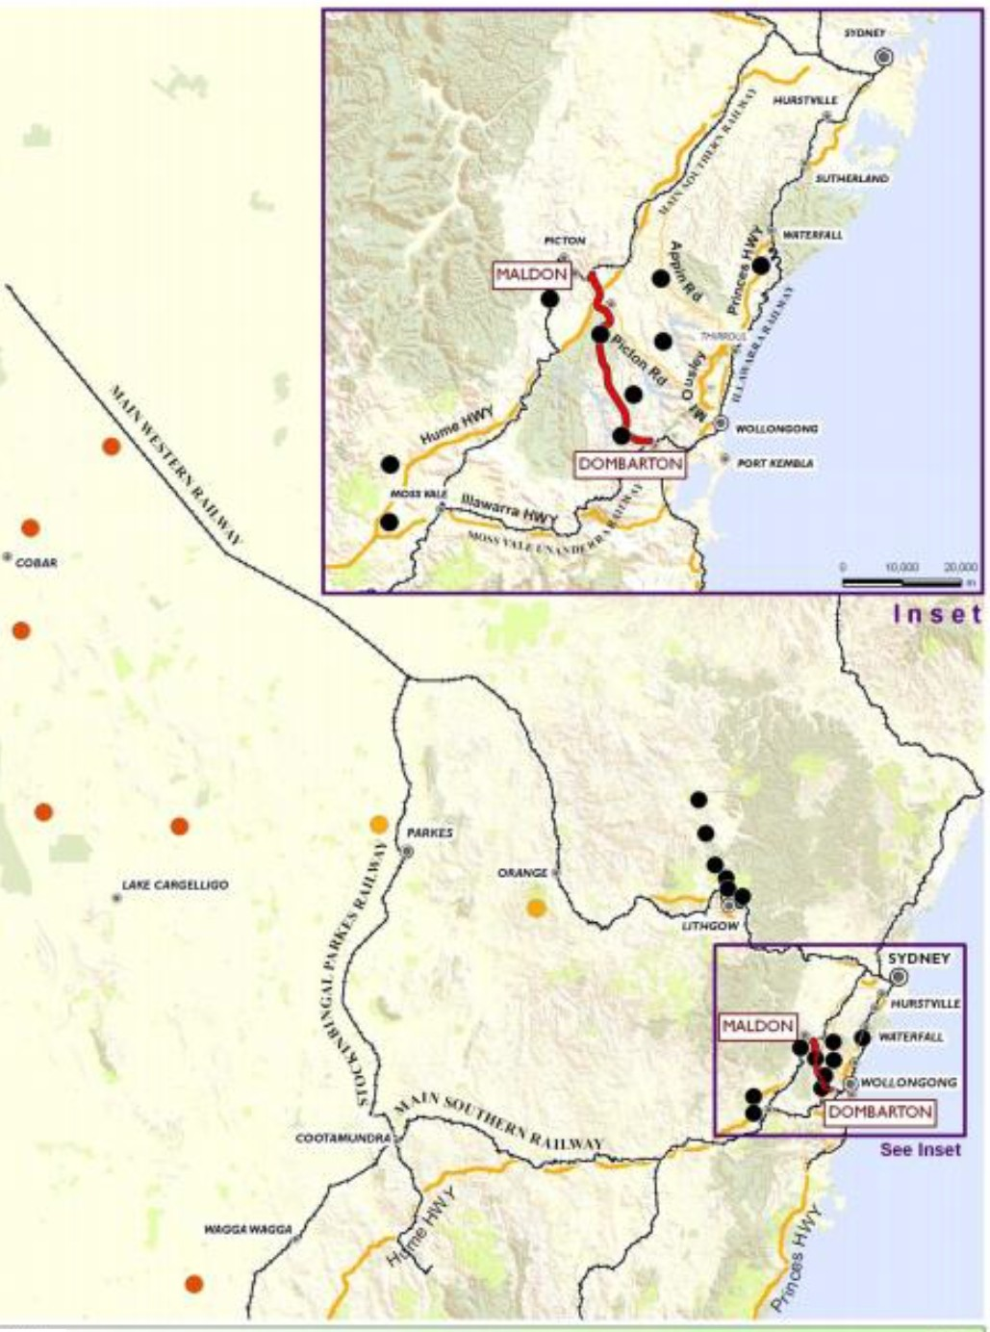

LEGEND

Mam Roads Mlne SIIes

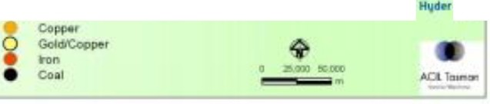

MniiO,...•t



-- Pn""'ry road

An <road

*Source: Hyder,Ad/ Tasman,Malden Dambarton Rail Link Feasibility Study, Final Report, prepared for Department of Infrastructure and Transport,September, 2011*