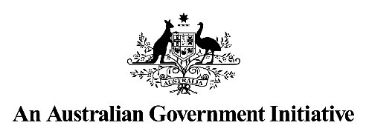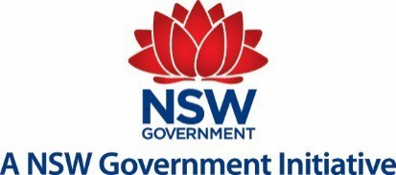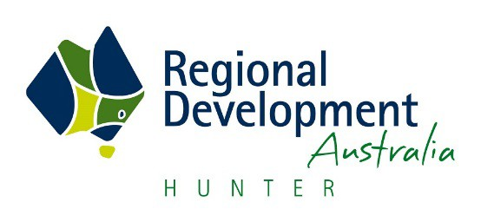

Submission to

Australian Government

**Inquiry into National Freight and**

**Supply Chain Priorities**

by

RDA Hunter

**RDA Hunter Suite 3, 24 Beaumont Street Hamilton NSW 2303**

Ph: 02 4940 8355

Web: [www.rdahunter.org.au](http://www.rdahunter.org.au/)

Email: [admin@rdahunter.org.au](mailto:admin@rdahunter.org.au)

Thursday 27 July 2017

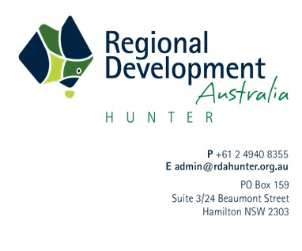

The Hon Darren Chester MP

Minister for Infrastructure and Transport

Members of the Expert Panel

National Freight and Supply Chain Inquiry

Department of Infrastructure and Regional Development

Email: [freightstrategy@infrastructure.gov.au](mailto:freightstrategy@infrastructure.gov.au)

***Inquiry into National Freight and Supply Chain Priorities***

**Submission by Regional Development Australia Hunter**

Dear Minister and Expert Panel Members,

Regional Development Australia (RDA) Hunter welcomes the opportunity to make a submission to the inquiry into the *National Freight and Supply Chain Priorities*.

RDA Hunter fosters economic development, identifies priorities, advances prospects and meets challenges. In conjunction with Infrastructure NSW and local stakeholders, RDA Hunter developed an integrated program of road network upgrades, beyond the boundaries of the Hunter region, to address pinch points along the input chain for the mining sector. The Hunter Economic Infrastructure Plan (HEIP) also identified solutions which deliver improved amenity for mining impacted communities.

The Hunter is a pivotal location for road, rail and sea freight, with opportunities to develop high-value air freight capabilities. It’s also home to the exemplar for management of a collaborative supply chain within an economically competitive environment: Hunter Valley Coal Chain Coordinator (HVCCC).

In response to the request for case studies, the HVCCC and HEIP, would make excellent candidates. Our submission presents opportunities for the future development of freight and supply chain capability.

RDA Hunter looks forward to the development of a National Strategy to progress freight and supply chain priorities. Please call me on 0417660629 or send an email if you have any questions or would like further information about regionally significant priorities for the Hunter region, NSW.

On behalf of RDA Hunter, thank you again for the opportunity to contribute to the inquiry.

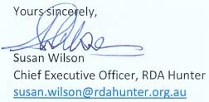

**TABLE OF CONTENTS**

**Cover letter from Susan Wilson, CEO: RDA Hunter 1**

**Terms of Reference 4**

**RDA Hunter’s Submission 5**

*Introduction 5*

**1. Hunter Freight Network Priorities 6**

*Road Freight Network 6*

*Rail Freight Corridor 7*

*Port of Newcastle 7*

*Coal Supply Chain 8*

**2. Hunter Industry Development 8**

**3. Last word 9**

**Appendix A: RDA and the Hunter region 11**

*RDA Hunter 11*

*Strategic planning by RDA Hunter 12*

*The Hunter – A Region of Economic Strength 12*

Figure 2 Hunter Region, NSW Planning & Environment 12

*Hunter’s Population 13*

*Hunter Comparative Advantages and Economic Highlights 13*

**TERMS OF REFERENCE**

**Scope of the inquiry for a national freight and supply chain strategy**

Without limiting related matters, the inquiry and development of a national freight and supply chain strategy through consultation with industry will inform Transport and Infrastructure Council members, by:

1. Establishing the capacity of the key national ports, airports and intermodal terminals in comparison to international markets with similar characteristics, identifying trends occurring in the global supply chain and reviewing the adequacy of investment planning to efficiently meet forecast growth to keep Australia’s position with its trading partners;

2. Determining the regulatory and investment barriers to improved efficiency and access to key national terminals, including road and rail corridors;

3. Establishing the opportunities for regulatory changes and targeted investment to lift the capacity of key supply chain nodes and improve efficiency of operations, including an analysis of the implications of the changing profile of ownership in large scale supply chain infrastructure such as ports and rail;

4. Identifying the costs and benefits of options at a national level to improve:

a. The efficient operation of our national supply chain system, including effective and transparent public performance measures for key national terminals; and

b. Broad first and last mile issues.

5. Providing options for scenario planning and predictions, where possible, related to the following areas:

a. Future developments across the supply chain e.g. distributed production and changes in technology;

b. Urban distribution and impacts of the movement of freight in urban areas due to population growth and changing consumer activities such as online shopping;

c. Decentralisation and redistribution of the population into regional centres;

d. Trade arrangements and the development of distribution systems in agriculture;

and

e. Impacts on the supply chain following major climatic events.

6. Exploring opportunities to use big and open data and new digital technologies to improve the performance of our freight infrastructure; and

7. Identifying options and recommending regulatory changes and investment actions (public or private) that will benefit the economy over the next 20 years. Specifically through improved performance, productivity and efficiency of the freight and supply chain network and infrastructure.

**Submission contact:**

Susan Wilson

Chief Executive Officer, RDA Hunter

Office (02) 49408355

Email: [admin@rdahunter.org.au](mailto:admin@rdahunter.org.au)

4

**RDA HUNTER’S SUBMISSION Introduction**

RDA Hunter welcomes the Australian Government’s commitment to develop a National Freight and Supply Chain Strategy.

The inquiry’s Discussion Paper opens with an observation on the overall growth of the freight task due to population growth. Over the 20-year timeframe for the Strategy, the Hunter’s resident population is estimated by NSW Planning and Environment1 to grow from 732,400 to

862,250 in 2036. Most of the population of the region living within 25 km of the coast, 25% aged over 65 years and at least 55% of the Hunter’s population living in the Newcastle and Lake Macquarie Local Government Areas (LGAs).

RDA Hunter recommends long-term, integrated infrastructure planning for 1 million residents in the region. There will be a population of this size in the Hunter; it is only a question of “when?”. Preparing plans now for corridor protection and construction of connecting infrastructure will reduce future costs, deliver the environment for productivity growth and avoid the stifling congestion and housing unaffordability that is experienced by businesses and communities in Sydney and Melbourne.

It is well known locally, but sometimes comes as a surprise to visitors, that during the past 20 years, the Hunter has transformed from its dependency on heavy industry to a diversified resource, services and business growth centre.

RDA Hunter’s Chief Executive Officer, Susan Wilson, brings a wealth of national and international business and management experience to the table. Susan’s leadership in business, government and public/private sector R&D, together with a practical focus on strategy, public affairs and innovation is a valuable source of expertise in the region. (See Appendix A for further information about RDA Hunter and the region.)

Beyond offering constructive thoughts and responses to the inquiry’s terms of reference, we want the Expert Panel to appreciate RDA Hunter’s readiness and capacity to work with the department, and all stakeholders, to increase the economic development impact of efficient freight and supply chain networks in the Hunter.

1 <http://www.planning.nsw.gov.au/Plans-for-your-area/Regional-Plans/Hunter>

**1. HUNTER FREIGHT NETWORK PRIORITIES**

The Hunter’s proximity to Sydney and existing key infrastructure makes the area a prime location as a major regional freight hub. The region has a comparative edge in accessing Australian and International markets due to its location on Australia’s east coast, between Melbourne and Brisbane, together with a deep-sea port and an airport with potential for growth.

An extensive amount of under-developed land is adjacent to both the airport at Williamtown and the Port at the mouth of the Hunter River. This land can be activated as freight, supply chain and employment hubs to deliver economic development.

**Road Freight Network**

The Infrastructure Priority List (Infrastructure Australia, July 2017)2 includes the **Pacific Highway (M1) extension to Raymond Terrace** as a proposed initiative for the near term. This missing link between the M1 (John Renshaw Drive intersection) and the A1 across the Hunter River is a vital piece of the national road freight network. RDA Hunter understands the local regional office of Transport for NSW, Roads and Maritime Services, is working on a business case to progress his project. Over $5m has been allocated to planning for this major project in the 2017 NSW Budget.

Supported by a grant from the Australian Government’s Regional Infrastructure Fund, RDA Hunter partnered Infrastructure NSW to develop the **Hunter Economic Infrastructure Plan (HEIP)**. This Plan takes a whole of supply chain view of mining inputs related activities in the Hunter to identify: capacity constraints; impacts on communities; and the economic infrastructure required to deliver improvements in productivity and community development.

As the Hunter’s future growth of inbound freight logistics to the mining sector is expected to double over the next two decades, the HEIP identified and produced the business case for priority economic infrastructure projects including:

• Connectivity: Port of Newcastle, Kooragang Island, Newcastle Airport

• Scone – bypass and rail level crossing

• Singleton – Gowrie Gates underpass;

• Bypasses of Muswellbrook and Singleton; and,

• New England Highway Belford to Golden Highway interchange.

All Hunter-based priority projects in this Plan have attracted Federal and State funding. In addition, the HEIP prioritised a road bridge over the northern rail line at Gunnedah, in the Liverpool Plains; which has also been funded.

The HEIP extends beyond the boundaries of the Hunter to support consistent capacity for B- doubles along the entire supply chain to export ports. Ideally, the National Freight Strategy will bring uniformity across regional and other jurisdiction boundaries.

**Rail Freight Corridor**

**Freight rail bypass of Newcastle between Fassifern and Hexham**

Infrastructure Australia (July 2017) has included the preservation of the corridor and construction of Lower Hunter freight rail bypass in its 15-year pipeline of priority infrastructure projects. Pending development and acceptance of a business case, RDA Hunter anticipates this initiative will move to priority project status in the IA Plan.

The 2017 NSW Budget allocates $11.8m planning and pre-construction to 2018 on this initiative. This bypass supports the Northern Sydney Freight Corridor Program and will improve productivity of freight transport; support future growth plans and separate passenger trains from freight trains, with commuter experience improvements at Newcastle suburban level crossing gates.

**Port of Newcastle**

The NSW ports strategy (2013) places Port Botany as the state’s container terminal. Costs and logistic difficulties result from this arrangement. Containers are transported from Botany to Western Sydney, where they are unpacked and the contents then loaded onto trucks to be taken to northern NSW via Newcastle. Of course, there are return trips of empty trucks

between northern NSW and Western Sydney and between Western Sydney and Port of

Botany.

There is an opportunity for the former BHP site at Mayfield to be used as a **container terminal**; capacity 3 million containers a year. However, the government has added a fee of $100 per container, after container movements through Newcastle exceed 30,000 per year, increasing at a rate of 6 per cent per annum. Currently Newcastle’s container throughput is carried by general cargo ships, not container ships. The current ports strategy in NSW has introduced a monopoly and inefficiencies to the container market and associated freight and supply chain networks.

In 2016, 2,258 ships visited the Port of Newcastle. Management at the Port have calculated capacity to double the current operations at Newcastle’s working harbour. There is also an appetite to diversify cargoes, which supports RDA Hunter’s industry development plans (see section 2.).

Newcastle has a long heritage as a shipbuilding centre; over 300 vessels built, specialist module constructions and hundreds more ships repaired and maintained in the region. There is significant infrastructure around the working harbour to support the re-establishment of this industry and land available for further development. With businesses, such as Thales and Civmec’s riverfront heavy engineering and shipbuilding facility, Forgacs Marine and Defence, the region has a demonstrated partnership approach to shipbuilding and repair contracts. As such, the Port of Newcastle is well-placed to expand its role in maritime freight task and merchant fleet maintenance.

**Coal Supply Chain**

The Hunter Valley Coal Chain Coordinator3 is a world class logistics supply chain that coordinates the cooperative operation of the largest coal operation in the world. It consists of:

• 35 coal mines owned by 11 coal producers;

• Haulage distances up to 380km;

• Over 31 points for coal loading onto trains;

• 4 rail haulage providers;

• 3 port-side coal; terminals; and

• Over 1,500 coal vessels per year through the Port of Newcastle.

“The HVCCC’s mission is to plan and co-ordinate the co-operative daily operation and long term capacity alignment of the Hunter Valley Coal Chain. Its strategic objectives include;

• To plan and schedule the movement of coal through the Hunter Valley Coal Chain in accordance with the agreed collective needs and contractual obligations of Producers and Service Providers;

• To ensure minimum total logistics cost and maximised volumes through the provision of appropriate analysis and advice on capacity constraints (whether physical, operational or commercial) affecting the efficient operation of the Hunter Valley Coal Chain; and

• To advocate positions, on behalf of Producers and Service Providers, to other stakeholders and governments on issues relevant to the efficient operation of the Coal Chain in order to maximise opportunities for improved co-ordination and/or further expansion of the Coal Chain.”

The CEO of the HVCCC, Dr Kirsten Molloy, is also a Member of the Board of RDA Hunter.

**2. HUNTER INDUSTRY DEVELOPMENT**

Shipping Hunter coal to China, India, Japan, South Korea and other countries is a well-known story with a long history. The regional economy is intertwined with these foreign economies and susceptible to any reduction in demand and/or commodity prices.

RDA Hunter is taking a long-term view of industry development across the full range of economic sectors. Agriculture and value-added Agrifood in the Hunter will increasingly be a significant contributor to industry development, research collaboration, innovation and employment.

While recognising the current and long-term contributions made to the region by coal mining, coal fired energy production and coal exports, there are opportunities for other areas of comparative advantage in the Hunter. The Hunter Valley is a strong brand in wine products that also integrates well with regional tourism.

3 <https://www.hvccc.com.au/Pages/welcome.aspx>

As the Asia region’s economies expand to be as large as Europe and the USA combined, with a middle class of around three billion people by 2020, the Hunter’s agriculture producers, and tourism and education providers will have an increasing market that demands higher value products and services. Increasing demand for high value added and high protein agricultural products points to prospects for economic growth if adjustments can be made locally to meet new market demands in taste and product preference.

Conflicting land use options is a major issue in the resources and agriculture rich Hunter. Development opportunities are emerging for new businesses within the Agrifood sector; especially with processing and packaging value-add potential. Areas within and beyond the resource mining lands are likely sources of raw product. As with coal, efficient movement by rail of bulk quantities of food products will be vital to these new ventures. New infrastructure to handle and store food products will be required along the supply chain and at points of distribution. After reading the example of a new mine being able to apply for access to existing transport infrastructure under the National Access Regime (*Recent policy reviews of relevance paper*), RDA Hunter is interested to explore how the application of the Regime may apply across industry sectors.

**3. LAST WORD**

Community education programs should be delivered to elevate awareness of the practical issues faced by infrastructure planners and construction managers, with topics covering:

a. Timeframes for planning and building economic infrastructure;

b. Costs associated with transport infrastructure;

c. Funding models and alternatives to pay for infrastructure; and

d. Jobs – what are the skills needed to deliver Australia’s transport infrastructure?

A major concern is that long term transport planning frameworks, freight, commuter and public, do not fully reflect future population growth in the Hunter. There is a need to prioritise a more integrated strategy to meet longer term capacity requirements.

Current operational issues associated with the use of shared rail infrastructure for both freight and passenger services impact passenger and freight services. To improve productivity, the key transport infrastructure issues and priorities for the Hunter centre on:

• freeing up road network bottlenecks;

• protecting road and rail transport corridors around (and to/from) the port and airport;

• constructing the Lower Hunter freight rail bypass;

• continuing the M1 beyond John Renshaw Drive to connect with the A1 north of the Hunter

River;

• connecting urban areas with transport choices, including increased public transport use;

• additional rail services to the Upper Hunter; and,

• extending the northern rail corridor improvements between Sydney and Newcastle.

There have been repeated calls, particularly on the basis of road safety and traffic management, for greater levels of freight to be carried by rail to take more trucks off the highway network.

Improving connectivity, investing in road and rail corridors, reducing congestion and completing priority infrastructure projects will support:

1. Growth in productivity through improved mobility of freight and workers;

2. Plans to expand industries and increase employment levels;

3. Increases in Port of Newcastle export volumes and cargo diversification;

4. Improvements in commuter experience; and

5. Better liveability across the region.

**APPENDIX A: RDA AND THE HUNTER REGION**

**RDA Hunter**

Regional Development Australia in New South Wales is a partnership between the Australian and State Governments created to strengthen regional communities. RDA Hunter is part of a national network of 55 RDA committees. These committees are made up of local leaders who volunteer their time to work with government, business and community groups to grow and strengthen their communities.

RDA Hunter is an autonomous organisation that fosters economic development for the Hunter region of NSW by building partnerships between governments, regional organisations, local businesses, community groups and regional stakeholders.

Susan Wilson is RDA Hunter’s Chief Executive Officer. Susan is an executive and non-executive leader with an international career across business, government and public/private sector R&D, who delivers economic impact through innovation, investment, industry and regional development. Her career highlights include the establishment and expanded role of Innovation

& Science Australia; advisory and governance of the National Innovation & Science Agenda; leading NZ's $10B Bioeconomy economic development portfolio; and mentoring start-up to scale- up entrepreneurs through DIIS, CSIRO, Austrade & Slingshot programs/accelerators.

RDA Hunter has a mandate to provide independent and impartial advice directly to governments on priorities and to provide strategic and targeted responses to issues affecting the Hunter. By taking the lead role on initiatives and collaborating with local stakeholders, RDA Hunter supports:

• Economic growth and Productivity gains;

• Jobs and a Skilled Workforce for the future;

• Federal and State programs at a regional level;

• Integrated long-term regional planning; and

• Local businesses and industries developing globally competitive advantages.

Our activities and initiatives support three strategic areas: **investment**; **infrastructure**; and **innovation**. Actions by RDA Hunter that cultivate inter-connections between these three strategic themes help to meet the regional development goals of Commonwealth, State and Local governments.

The Hunter is widely known as a major centre for mining and resources with a history of large- scale heavy industry, coal exports and shipbuilding. However, it is the small and medium enterprises (SMEs) sector which constitutes the majority of businesses in the region.

RDA Hunter commissioned Deloitte Access Economics to analyse economic data and report on possible impacts of various trends and scenarios on the Hunter’s future. In *Prospects and Challenges for the Hunter Region – a strategic economic study4* it is forecast that by 2036, the Hunter’s economy will have grown by about 75 per cent, to be delivering a Gross Regional Product of $64.8 billion.

4 The Deloitte Access Economics report is available at: <http://www.rdahunter.org.au/>under ‘Initiatives’.

**Strategic planning by RDA Hunter**

RDA Hunter collaborates with Hunter stakeholders to:

• Identify funding opportunities. From January 2010, funding commitments totalling over

$850million for the Hunter directly secured by RDA Hunter advocacy and projects.

• Lead regionally significant projects and partner on planning and service delivery programs.

• Produce the *Hunter Plan for Regional Growth 2016 – 2019: Economic Development Strategy for the Hunter.* The Plan describes the Hunter’s attributes, industries, employment base, areas of economic strength, drivers of change and priority actions.5

• Promote the region’s comparative and competitive advantages and attract investment via the Hunter Investment Prospectus***.***

• Identify infrastructure priorities and facilitate delivery of business cases for projects that will deliver efficiencies and support productivity improvements.

• Partner industry development activities.

**The Hunter – A Region of Economic Strength**

The Hunter is located north, north-west of Sydney. For statistical purposes, the Hunter is often represented as two regions: *Newcastle and Lake Macquarie* and *Hunter Valley exc. Newcastle*.

At a government level, the Hunter currently contains 6 Federal electorates, 10 State electorates and 10 local government areas.

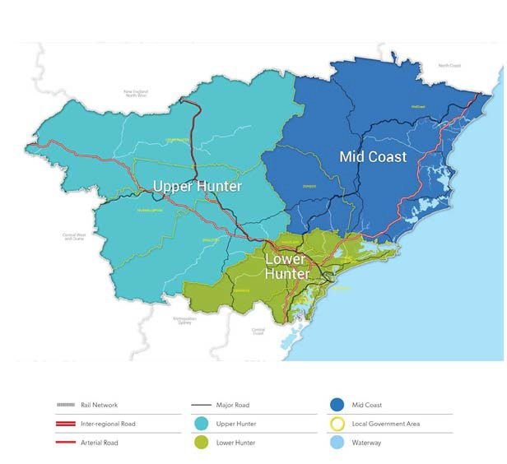

***Figure 2 Hunter Region, NSW Planning & Environment***

*Hunter Regional Plan 2036, page 62*

5 <http://rdahunter.org.au/hunter-region/hunter-region-plan-2012-2022>

**Hunter’s Population**

The Hunter is home to over 860,000 people; around 9% of NSW population. Most of the population of the region lives within 25 km of the coast, with 54.4% of the Hunter’s population living in the Newcastle and Lake Macquarie Local Government Areas (LGAs).

In the year to 30 June 2016, the significant urban areas of the Hunter generally experienced population growth slightly below the 1.4% state average. Highest growth was in the southern parts of the region; Morisset – Cooranbong, up 1.7% on 2015 numbers. This was followed by Muswellbrook, up1.5%, three areas with an increase of 1.3% for the year (Cessnock, Forster - Tuncurry and Nelson Bay – Corlette), hen Newcastle – Maitland, up 0.9%. Almost zero growth around Kurri Kurri – Weston (0.3%) and negative growth in Singleton, -0.2%.6 This follows the national pattern of population losses in mining areas and mining service centres. Fourth largest growth for a NSW SA2 area outside of Sydney was Maitland – West, with 550 new residents.

**Hunter Comparative Advantages and Economic Highlights**

The region’s natural comparative advantages, include proximity to Sydney, deep water sea port, fresh water rivers, productive lands and a diverse supply of resources.

The Hunter is the major region for economic activity in New South Wales:

• At least 130,000 additional people are expected to be living in the region by 2036;

• Gross Regional Product for 2016 of $41.3 billion, ranking above Tasmania, NT and ACT;

• Contributing more than 8 per cent of Gross State Product and 2.6 per cent of GDP;

• In 2016, the Port of Newcastle’s total trade value was $18.69 billion from 167.7 million tonnes in throughput, for 25 cargoes; third largest total volume port in Australia;

• Producing upwards of 60 per cent of the electricity for the State of NSW.

• Significant investment in Defence facilities particularly at RAAF Base Williamtown and

Infantry Army Barracks and Special Forces Training Centre at Singleton; and,

• Re-emerging shipbuilding capabilities, including Navy sustainment programs.

The Hunter’s positive economic development will be built on the region’s capacity to:

• Grow through the attraction of investment and talent;

• Construct the economic infrastructure required to maximise its comparative advantages;

• Secure smart partnerships to overcome challenges and commercialise opportunities; and,

• Energise its innovation system to support internationally competitive businesses.

– End –