***A ""s-fv(;lt{i(;lt***

MIDWEST GASCOYNE

Freight and Supply Chain Inquiry

Dept Infrastructure & Regional Development

GPO Box 594

CANBERRA CITY ACT 2601

**INQUIRY INTO NATIONAL FREIGHT AND SUPPLY CHAIN PRIORITIES**

To whom it may concern,

Thank you for the opportunity to provide a submission to the Department of Infrastructure and Regional Development's inquiry into national freight and supply chain priorities. Regional Development Australia Mid West Gascoyne is part of the Regional Development Australia (RDA) network; a nationwide initiative ofthe Commonwealth Government. RDA aims to work with State and local government for the betterment of regional Australia and to provide a framework for reporting to Canberra the issues facing the regions. This submission reflects the experiences of Mid West supply chain participants.

*Supply chain system and specific commodities being transported*

With the region's prime exporting facility (the port) located in Geraldton, this major regional centre acts as a hub for the Mid *West's* freight network. By road, Geraldton is connected to the rest of the state by the Brand and North West Coastal Highways that run parallel to the coast.

From Geraldton,industry is connected to the Murchison sub-region by the east-west oriented Geraldton-Mount Magnet Road. Murchison centres are also serviced by the north-south running Great Northern Highway. North-Midlands communities are joined by Morawa­ Perenjori Road (intersecting the Geraldton-Mount Magnet Road at Mullewa) and the North Midlands Road that loops back into the coast at Dongara. Both of these North Midlands arteries lay parallel to the Brand Highway.

By rail, the Midlands and Morawa-Perenjori lines connect the North-Midlands to the port. There have been discussions about resurrecting the historic rail line running east-west, thereby providing a more cost effective transport solution for the magnetite sector, but a viable business case is yet to be developed.

Also requiring a convincing business case, the proposed deep water port at Oakajee is dependent on sufficient bulk freight tonnages. The region's existing sea port is ideally located

***A "'s-fvG-t{iG-t***

MIDWEST GASCOYNE

in close proximity to its major Asian markets and does not experience the congestion pressures of Pilbara and metropolitan ports. Similarly,the Geraldton regional airport is well situated with low traffic volumes.

The Mid West region is an export based economy with the mainstay industry's being grain, minerals,lobster, fertiliser and fuel distribution,live cattle and public transport.

**What is moving where, why and how?**

GRAIN NETWORK

The grain network uses both rail and road modes. The rail paths (see Figure 1) branch out from Geraldton with the northern path (Morawa-Perenjori line) heading south east from Mullewa and terminating at Perenjori. The southern path (Midlands line) runs south east from Mingenew, ending at Marchagee.

Figure 1. The Mid West strategic grain rail network paths

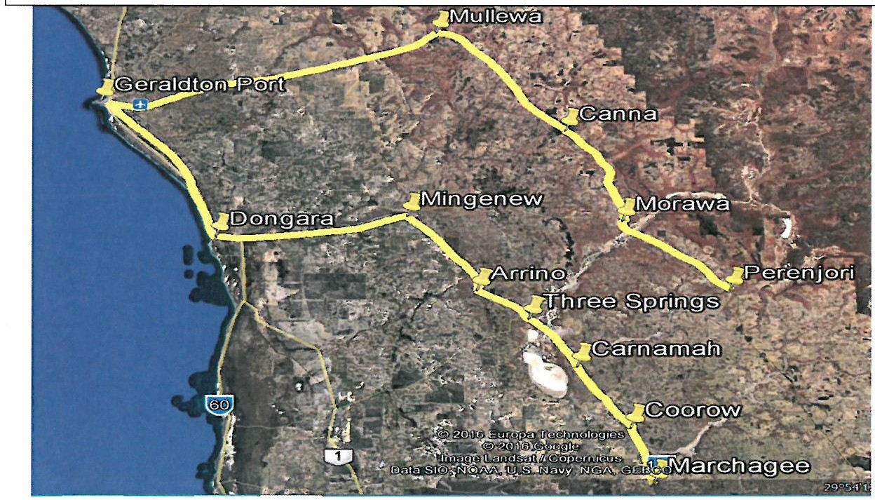

***Marchagee* -7 *Coorow* -7 *Carnamah* -7 *Three Springs* -7 *Arrino* -7 *Mingenew* -7 *Dongara* -7**

***Geraldton Port***

***Perenjori* -7 *Morawa* -7 *Canna* -7 *Mullewa* -7 *Geraldton Port***

MIDW ES T GAS COYNE

The road network (see Figure 2) also branches out from Geraldton with the northern path travelling through Northampton and ending at Binnu. The north eastern paths finish at Yuna and enter Geraldton by either the Geraldton-Mount Magnet Road or the North West Coastal Highway. The south eastern routes terminate at either Moora or Wubin. The Wubin path follows the Wubin-Mullewa Road and enters the port via the Geraldton-Mount Magnet Road. The Moora route uses the Midlands Road that joins the Brand Highway into Geraldton at Dongara. The eastern path out to Eradu follows Peter Rd on to the Geraldton-Mount Magnet Road and into the Geraldton port.

Figure 2. The Mid West strategic grain road network paths

*Binnu* 7 *(NW Coastal Hwy)* 7 *Northampton* 7 *(NW Coastal Hwy, John Willcock Link, Port*

*Way)* 7 *Geraldton Port*

Yuna {Chapman Valley Rd,Morrell Rd, Narra Tarra-Moonyoonooka Rd,Geraldton-Mount

Magnet Rd,STC,John Willcock Link,Port Way) 7 Geraldton Port

*Yuna* 7 *(Chapman Valley Rd/NW Coastal Hwy,John Willcock Link, Port Way)* 7 *Geraldton*

*Port*

*Morawa* 7 *(Mingenew-Morawa Rd)* 7 *Mingenew* 7 *(Midlands Rd)* 7 *Dongara* 7 *(Brand*

*Hwy, John Willcock Link, Port Way)* 7 *Geraldton Port*

*Moora* 7 *(Midland Rd)* 7 *Mingenew* 7 *(Midlands Road, Brand Hwy)* 7 *Dongara* 7 *(Brand*

*Hwy,John Willcock Link, Port Way)* 7 *Geraldton Port*

*Wubin* 7 *(Wubin-Mullewa Rd)* 7 *Morawa* 7 *(Wubin-Mullewa Rd)* 7 *Mullewa* 7 *(Geraldton-Mount Magnet Hwy,* STC,John Willcock Link,Port Way) 7 *Geraldton Port Dongara* 7 *(Brand Hwy, Rudds Gully Rd, Edward Rd, Deepdale Rd,* STC,John Willcock Link, Port Way) 7 *Geraldton Port*

*Eradu* 7 *(Peter Rd, Geraldton-Mount Magnet Rd, STC, John Willcock Link, Port Way)* 7

*Geraldton Port*

MINERALS NETWORK

***&AS-{-Vt;;tfi* (;I(**

MIDWEST GASCOYNE

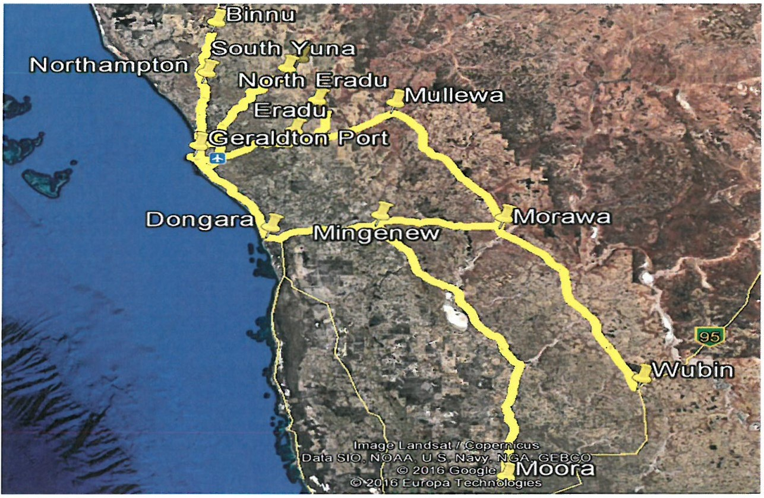

The minerals network uses both rail and road modes. The single strategic rail path (see Figure

3) runs ea st from Geraldton, turning south to Perenjori at Mullewa. There is a privately owned rail spur from Morawa east to Karara that is not available to other users.

*A.,..s-fv r;*

MIDWEST GAS C OYNE

Figure 3. The Mid West strategic minerals rail network path

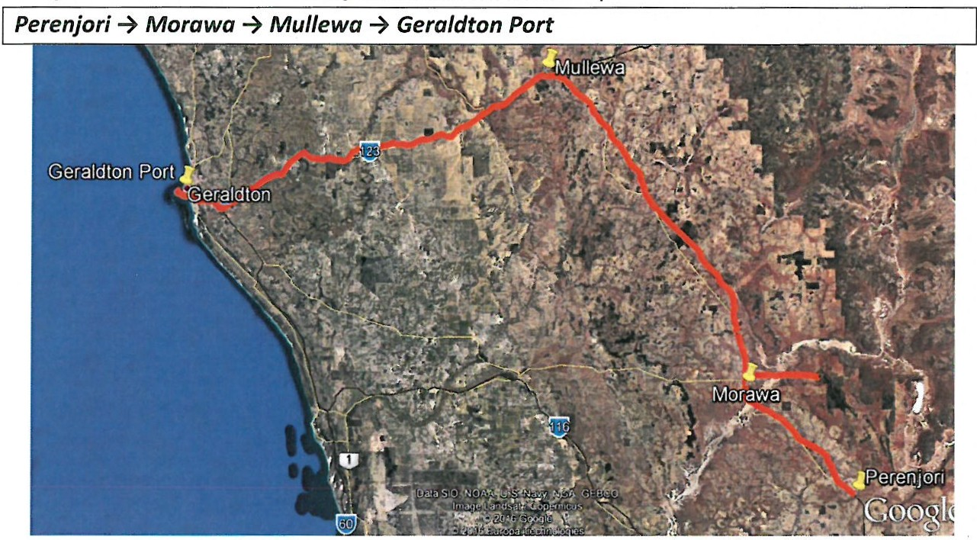

The primary road network (see Figure 4) used by the minerals sector travels east from Geraldton and then runs either north to Meekatharra from Mount Magnet,or east to Leinster along the Mount Magnet-Sandstone/Agnew-Sandstone Roads. Southern mining projects are serviced by the Brand Highway or the Midlands Road. The route from the Geraldton port to Narngulu via Port Way,John Willcock Link,the Southern Transport Corridor and Goulds Roa d, is also an integral part of the minerals road network.

Figure 4. The Mid West strategic minerals road network paths

*Geraldton Port(Port Way, John Willcock Link,STC, Goulds Rd) Narngulu Meekatharra (Gt Northern Hwy) Mount Magnet {Geraldton-Mount Magnet Rd STC John Willcock Link Port Way) Geraldton Port*

*Geraldton (Port Way, John Willcock Link, STC, Geraldton-Mount Magnet Rd)* -7 *Mount*

*Magnet (Mount Magnet-Sandstone Rd) Sandstone (Agnew-Sandstone Rd) Leinster*

*From the South (Midlands Rd/Brand Hwy) Dongara* -7 *(Brand Hwy, John Willcock*

*Link,Port Way) Geraldton port*

*A ""'s-fv fi*

*1*

LOBSTER NETWORK

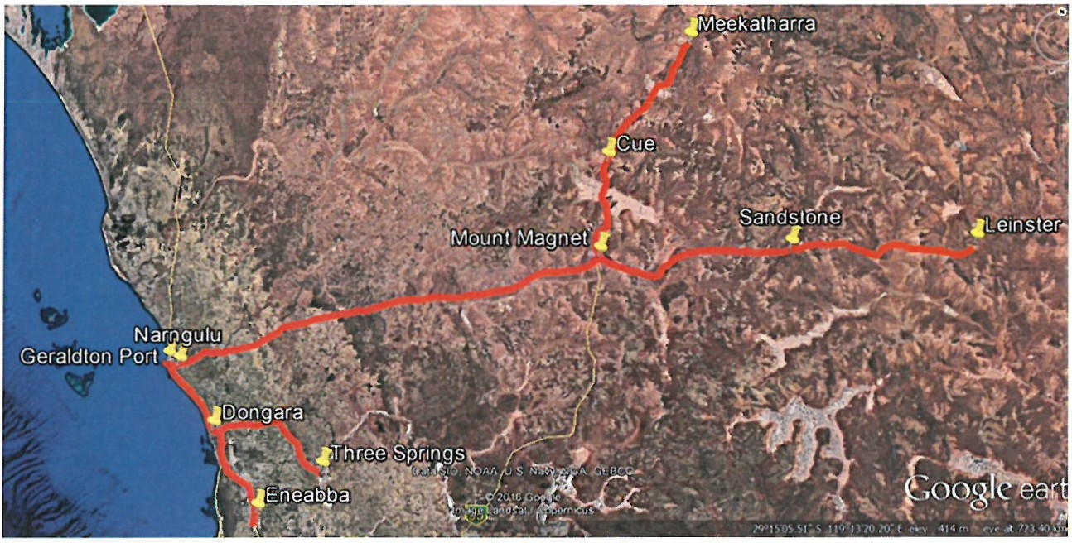

MIDWES T GASCOYNE

Live lobsters are transported only by road (see Figure 5) and come from Kalbarri in the north, via Horrocks and Northampton,to processing facilities at the Geraldton port. From the south the lobster trucks travelfrom Greenhead using the Indian Ocean Drive and the Brand Highway back to the Geraldton port. Once processed,the lobster are then trucked to the Perth airport following the Brand Highway.

Figure 5. The Mid West strategic lobster road network paths

*Kalbarri* 7 *{George Gray Rd, Port Gregory Rd)* 7 *Port Gregory (Port Gregory Rd, Horrocks Rd)* 7 *Horrocks* 7 *(Horrocks Rd, Port Gregory Rd)* 7 *Northampton* 7 *(NW Coastal Hwy, John Willcock Link, Port Way)* 7 *Geraldton Port*

*Greenhead* 7 *{Indian Ocean Dve)* 7 *Leeman* 7 *{Indian Ocean Dve)* 7 *Cliff Head* 7 *{Indian*

*Ocean Dve)* 7 *Desperate* -7 *{Indian Ocean Dve, Brand Hwy)* -7 *Dongara* 7 *(Brand Hwy, Seven Mile Rd)* 7 *Seven Mile Beach* 7 *(Seven Mile Rd, Brand Hwy,John Willcock Link, Port Way)* 7 *Geraldton Port*

FERTILISER NETWORK

**Development *t.***

***AIAs-fv t;***

MIDWEST GA S COYN E

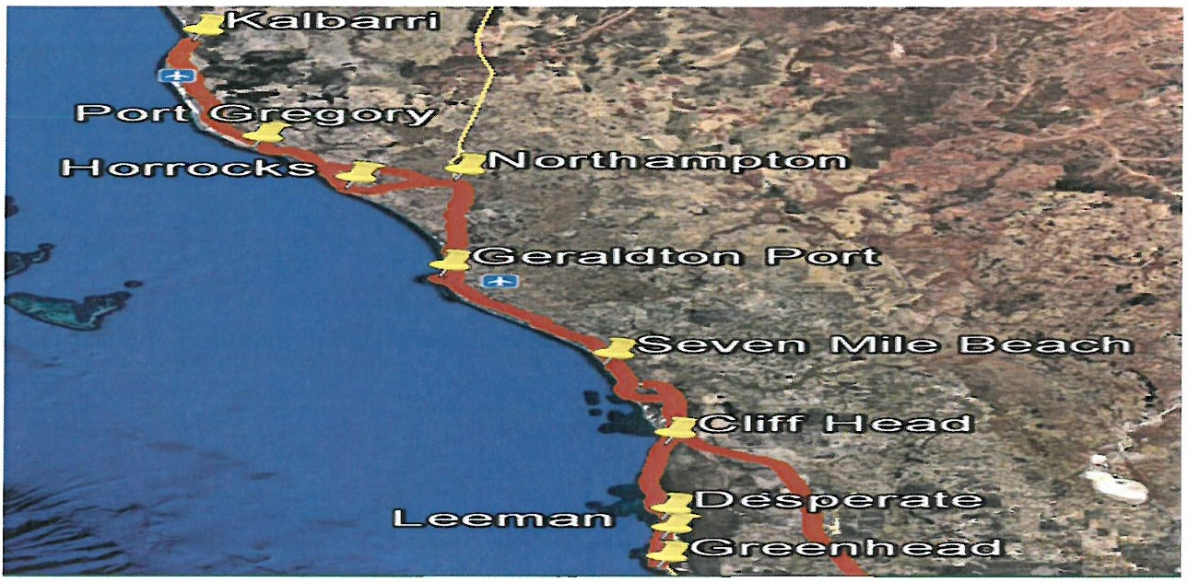

Fertiliser is transported into the Mid West via the Geraldton port or by road from Kwinana. From the port, the products are shifted north using the North West Coastal Highway or east following the North West Coastal Highway and the Southern Transport Corridor. Products from the south come in through the Brand Highway and continue north on the North West Coastal Highway or north east using the Rudds Gully Road to the Narngulu industrial area (see Figure 6).

**Development** *I.*

*A V\.s-f-v&-t{i&-t*

MIDWEST GASCOYNE

Figure 6. The Mid West strategic fertiliser road network paths

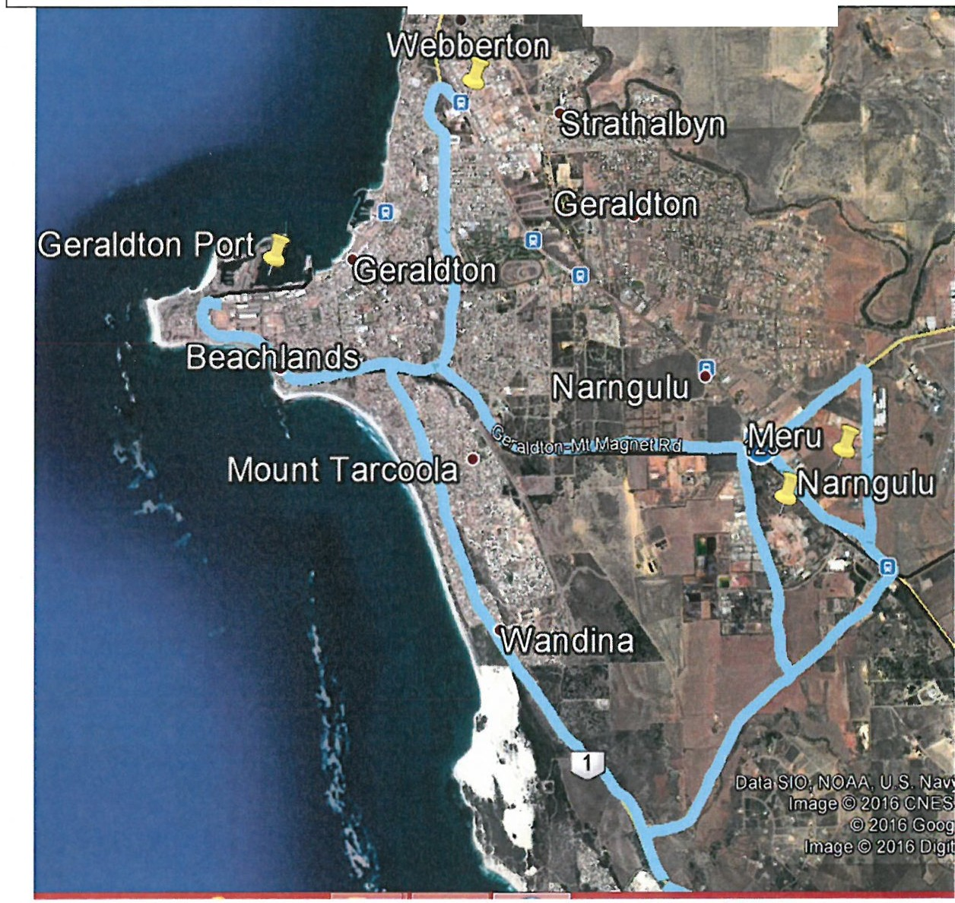

*Geraldton Port* 7 *(Port Way, John Willcock Link, STC, Edward Rd, Deepdale Rd)* 7 *Meru*

*Geraldton Port* 7 *(Port Way,John Willcock Link,STC,Goulds Rd)* 7 *Narngulu Geraldton Port* 7 *(Port Way,John Willcock Link, NW Coastal Hwy)* 7 *Webberton Perth* 7 *(Brand Hwy, Rudds Gully Rd, Edward Rd, Deepdale Rd)* 7 *Meru*

*Kwinana* 7 *(Brand Hwy, NW Coastal Hwy)* 7 *Webberton*

**r:-::--:--Dl!P.!'!f.i!I!IQ**

*A s-f-ve;..fie;..*

*1*

M I DW E ST GASCOYNE

PETROLEUM NETWORK

Like fertiliser, petroleum is also supplied to the region by the port or by the Brand Highway from Kwinana. From the port, the products are shifted north using the North West Coastal Highway or east following the Geraldton-Mt Magnet Road and the Great Northern Highway. The petroleum sector also uses the Mount Magnet-Sandstone/Agnew-Sandstone Roads to supply leinster (see Figure 7).

Figure 7. The Mid West strategic petroleum road network paths

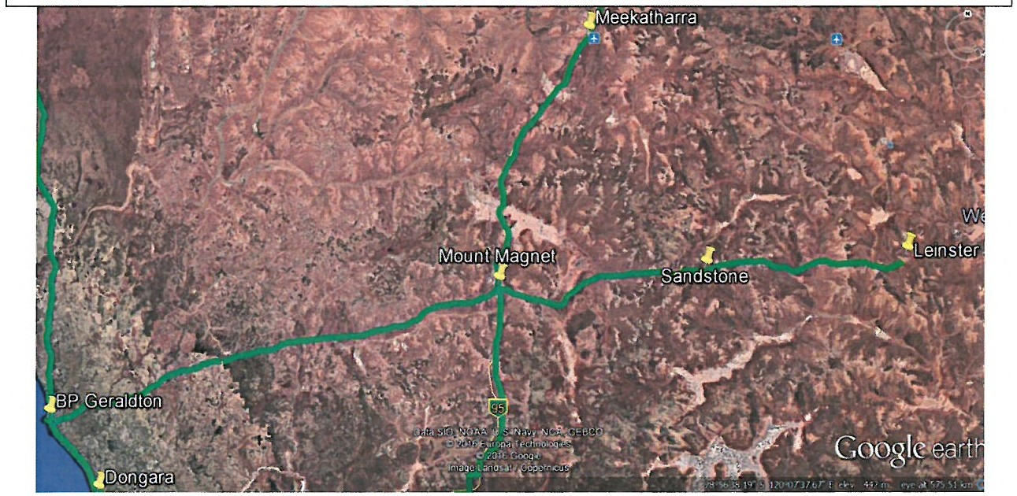

*BP Geraldton* 7 *(Port Way,John Willcock Link,NW Coastal Hwy,STC,Geraldton-Mt Magnet*

*Rd}* 7 *Mt Magnet* 7 *(Mt Magnet-Sandstone Rd)* 7*Sandstone* 7 *(Agnew-Sandstone Rd}* 7

*Leinster*

*BP Geraldton* 7 *{Port Way,John Willcock Link, Brand Hwy)* 7 *Dongara*

*BP Geraldton* 7 *(Port Way,John Willcock Link,NW Coastal Hwy)* 7 *Carnarvon/Exmouth BP Geraldton* 7 *(Port Way,John Willcock Link,STC,Geraldton-Mt Magnet Rd, Gt Northern Hwy)* 7 *Meekatharra and North*

*BP Kwinana* 7 *(Thomas Rd, Freeway North, Roe Hwy,Brand Hwy)* 7 *Geraldton*

*BP Kwinana* 7 *(Thomas Rd, Freeway North, Roe Hwy,Gt Northern Hwy)* 7 *Meekatharra*

*AIAs-fv1ti*

MIDWEST GASCOYNE

LIVE CATILE NETWORK

Road paths used by live cattle logistics providers originate from as far north a s Fitzroy Crossing and from Wiluna in the north east (see Figure 8). From the northern parts of the State, the trucks use either the North West Coa stal or the Great Northern Highway to connect to grow­ out facilities in the Shire of Irwin. The Meekatharra-Wiluna section of the Goldfields Highway is an integral piece of cattle transport infrastructure connecting to the Great Northern Highway. From the Great Northern,logistics operators use the Geraldton-Mt Magnet Road to Geraldton or the Wubin-Mullewa Road to Irwin. The Brand Highway completes the loop from Irwin back to the Geraldton port.

Figure 8. The Mid West strategic live cattle road network paths

*Fitzroy Crossing* -7 *{Gt Northern Hwy, Geraldton-Mt Magnet Rd, Edward Rd/Deepdale Rd)*

-7 *Narngulu*

*East of Nanutarra* -7 *{NW Coastal Hwy,STC, Edward Rd/Deepdale Rd)* -7 *Narngulu*

*Lindon Station, East of Mini/yo* -7 *{NW Coastal Hwy, Brand Hwy, Midlands Rd, Milo Rd)* -7

*Dongara*

*Mulga Downs, North of Wittenoom* -7 *{Nanutarra-Wittenoom Rd, Gt Northern Hwy, Geraldton-Mt Magnet Rd,Edward Rd/Deepdale Rd)* -7 *Narngulu*

*Wiluna* -7 *(Granite Peak-Lake Violet Rd, Goldfields Hwy, Gt Northern Hwy, Geraldton-Mt Magnet Rd)* -7 *Mullewa* -7 *{Mullewa-Mingenew Rd}* -7 *Mingenew* -7 *{Midlands Rd, Milo Rd)* -7 *Dongara*

*Wiluna* -7 *{Granite Peak-Lake Violet Rd, Goldfields Hwy, Gt Northern Hwy, Geraldton-Mt*

*Magnet Rd, Edward Rd/Deepdale Rd)* -7 *Narngulu*

*From the North/East* -7 *{Gt Northern Hwy, Geraldton-Mt Magnet Rd, NW Coastal Hwy, Brand Hwy)* -7 *To the South*

***A "'s-f-v****1****t;***

MIDWEST GASCOY N E

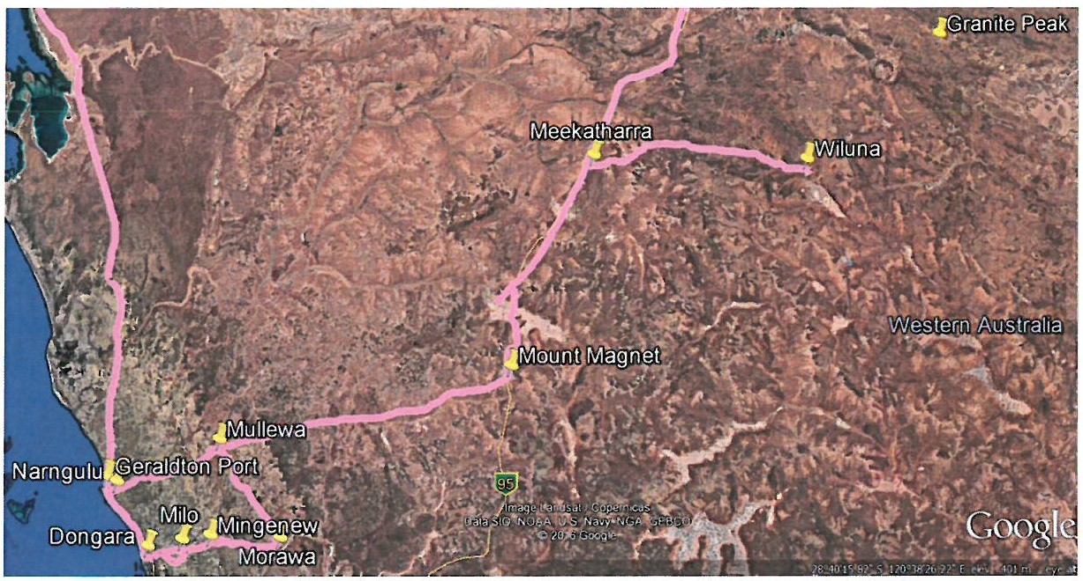

PUBLIC TRANSPORT NETWORK

The public transport network comprises both air and road infrastructure. Perth is the hub for all flights in, out and through the region. The Geraldton Regional Airport is used by aircraft that service the Pilbara region. Regular Passenger Transport Routes (RPT) utilise the region's Geraldton, Mount Magnet, Meekatharra and Wiluna airports (see Figure 9). Charter services also use the aviation infrastructure at Kalbarri,Dongara, Morawa and Perenjori.

*A* "'s-fv&-t*1;*&-t

M I DWES T GASCOYNE

Figure 9. The Mid West strategic public transport air network paths

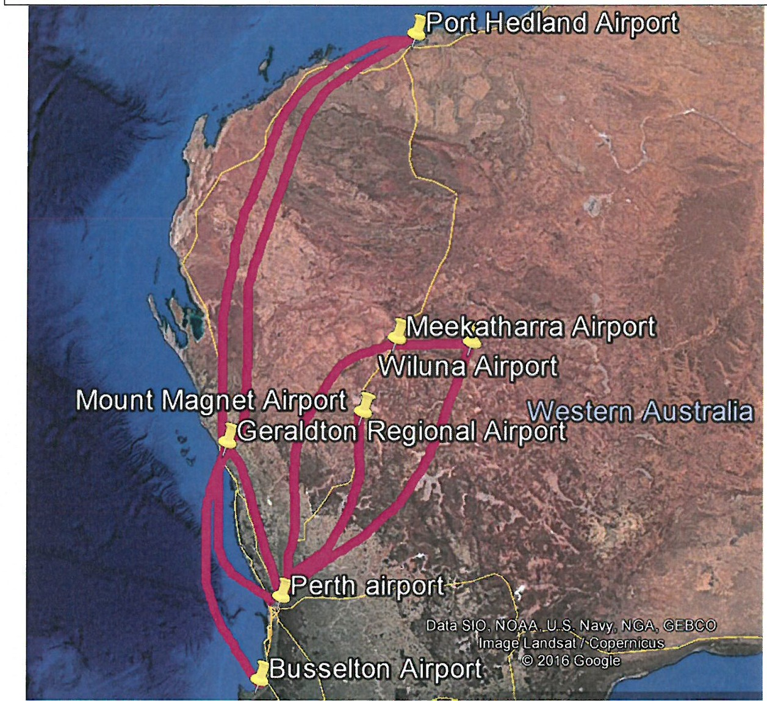

*Perth* -7 *Geraldton* -7 *Perth*

*Perth* -7 *Mt Magnet* -7 *Perth*

*Perth* -7 *Meekatharra* -7 *Wiluna* -7 *Perth*

*Perth* -7 *Mt Magnet* -7 *Meekatharra* -7 *Wiluna* -7 *Perth*

*Perth* -7 *Geraldton* -7 *Pilbara*

*Pilbara* -7 *Geraldton* -7 *Busselton*

**Development** *1*



*A"""s-fv t;*

MIDWEST GASCOYNE

Mid West communities are fortunate to be well serviced by an extensive network of road coach routes (see Figure 10). The more densely populated towns in the Murchison, North Midlands and Batavia sub regions are included in the network. From as far north as Meekatharra, the buses travel the Great Northern Highway and use either the Geraldton­ Mount Magnet Road to Geraldton, or the Wubin-Mullewa Road (turning south at Mullewa) to Perth.

Both the Brand Highway and the Indian Ocean drive form part of the network connecting

communities between Perth and Geraldton. Residents of the North Midlands rely on the service that runs via Dongara to Geraldton using the Midlands Road and the Brand Highway. Kalbarri residents are also catered for with a bus that uses the George Gray and Port Gregory Roads before entering the North West Coastal Highway south from Northampton.

Figure 10. The Mid West strategic public transport road network paths

*East Perth* -7 *Joondalup* -7 *Lance/in* -7 *{Indian Ocean Drive)* -7 *Jurien Bay* -7 *{Indian Ocean Drive)* -7 *Leeman* -7 *{Indian Ocean DriveBrand Hwy)* -7 *Dongara* -7 *(Brand Hwy Cathedral AveChapman Rd)* -7 *Geraldton*

*East Perth* -7 *Bul/sbrook* -7 *Gingin* -7 *Badgingarra* -7 *Warradarge* -7 *(Brand Hwy)* -7

*Eneabba* -7 *(Brand Hwy)* -7 *Dongara* 7 *(Brand Hwy, Cathedral Ave, Chapman Rd)* 7

*Geraldton*

*East Perth* 7 *Northam* -7 *Goomalling* 7 *Wongan Hills* -7 *Wubin* -7 *(Wubin-Mullewa Rd)*

-7 *Perenjori* -7 *(Wubin-Mullewa Rd)* -7 *Morawa* 7 *(Wubin-Mullewa Rd)* -7 *Mullewa* 7

*(Geraldton-Mt Magnet Hwy,STC, NW Coastal Hwy)* -7 *Geraldton*

*East Perth* 7 *Bindoon* -7 *New Norcia* -7 *Moora* 7 *(Midlands Rd)* -7 *Coorow* -7 *(Midlands Rd)* 7 *Carnamah* -7 *(Midlands Rd)* -7 *Three Springs* -7 *(Midlands Rd)* 7 *Mingenew* 7 *(Midlands Rd, Brand Hwy)* 7 *Dongara* -7 *(Brand Hwy, Cathedral AveChapman Rd)* -7

*Geraldton*

*Geraldton (Geraldton-Mt Magnet Rd)* 7 *Mullewa* -7 *(Geraldton-Mt Magnet Rd)* -7

*Yalgoo* -7 *(Geraldton-Mt Magnet Rd)* -7 *Mt Magnet* 7 *(Gt Northern Hwy)* -7 *Cue* -7 *(Gt*

*Northern Hwy)* -7 *Meekatharra*

*Geraldton* -7 *(NW Coastal Hwy)* -7 *Northampton* 7 *(Port Gregory Rd,George Gray Rd)* 7

*Kalbarri*

**Development**



***AIAs-fv****1****ti***

MIDWEST GASCOYNE

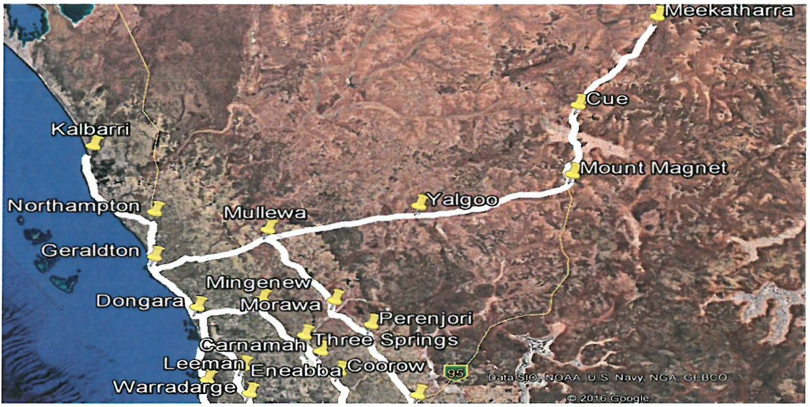

*What infrastructure is used in your supply chain and how well does it perform?*

The following sections describe each mode of infrastructure in the Mid West region in detail with Appendix 1providing a useful visual overview.

ROAD

The Mid West is well serviced by a 20 427km network of sealed roads that provide critical linkages within and beyond the region. Major arterial roads include the Brand Highway (from Perth to Geraldton); Indian Ocean Drive (connects Lancelin to just south of Dongara); the North West Coastal Highway (northwards from Geraldton); the Midlands Road (from Moora to Dongara); the Mullewa-Wubin Road (connects Perenjori to Mullewa); the Geraldton­ Mount Ma gnet Road (extends to Leinster); the Great Northern Highway (from Perth to Port Hedland);and the Goldfields Highway (from Meekatharra to Kalgoorlie).

The Brand and North West Coastal Highway form the major freight route connecting Perth to major regional centres north of the city with the latter providing principal access to coastal destinations north of Geraldton. Both of these are critical paths for all of the Mid *West's* mainstay industries. Heavy freight was successfully separated from light traffic flows through the sealing of the Indian Ocean Drive that branches off the Brand Hwy thirty kilometres south of Dongara and provides a slightly shorter route to Perth. Lobster exporters and road based public transport depend on the Indian Ocean Drive to move their cargo throughout the region.

**Development** *1*

***AIA.s-fv r;***

MIDWE S T GA S COYNE

To the east,the Midlands and Mullewa-Wubin Roads form part of the preferred pathways for the grain, minerals, live cattle and human movement sectors. These industries and the petroleum distributors also rely heavily on the Geraldton-Mt Magnet Road. Further east, the Great Northern is used by miners,petroleum distributors,live cattle and public road coaches. Branching off the Great Northern, the Meekatharra-Wiluna section of the Goldfields Highway (when it is finally sealed) is expected to accommodate even more live cattle trucks.

As the State's most central region, it is inevitable that land-based bulk freight being transported from the north to the south, or the south to the north, will travel through the region. In other words, other regions and rest of the State rely on Mid West transport infrastructure. At present, high wide load and restricted access vehicles (53 metres and longer) cannot travel the North West Coastal Highway through Northampton,Geraldton and Dongara. Adding time and kilometres to many road transport tasks, logistics operators have no option other than to use less economic smaller combinations or the Great Northern Highway.

Furthermore, industrial activity within the region combined with increasing heavy freight haulage to and from the Pilbara is compromising road standards, and the safety and amenity of several Mid West communities. As its administrative centre, Geraldton is experiencing significant traffic pressures that are stymying industry and placing residents at risk. A number of bypass projects have been touted as potential solutions to traffic pressure issues, in particular a new dedicated heavy freight corridor located between Dongara and Northampton (bypassing Geraldton). Regardless of the solution, continued investment is necessary to maintain existing road infrastructure to a reasonable standard as well as satisfying future traffic demands.

RAIL

Passengers were once able to travel by rail between Perth and Geraldton until the 1970's, at which time these services were no longer considered viable. A high speed rail service between the two population centres would improve accessibility to the region but would require a significant upturn in population and/or tourism for the benefits to outweigh the costs.

Another innovative option being explored internationally (i.e. currently being researched and trialled in the USA) is the proposed 'Hyperloop' concept. The Perth to Geraldton route could possibly provide for an ideal location to trial such an innovative and potentially cost effective, alternative solution.

**Development/**

***A ""s-f-v***;

MIDWEST GASCOYNE

Today's infrastructure, owned by the State and leased by Brookfield Rail, is characterised by two lines running through the North Midlands sub-region to the Geraldton port. One line, known locally as the Karara line, tracks from Mayo to Geraldton via Morawa and Mullewa. This line includes a closed section between Buntine and McLevie that could potentially connect the Mid West to the southern parts of the state via Avon.

The Midlands line runs from Perth to Geraldton via Moora and Mingenew, including a spur from Eneabba to Dongara. This spur was built to service the now idle mineral sands mine at Eneabba. The main railway depot at Narngulu sits at the junction of the two lines, thirteen kilometres east of the Geraldton port.

Grain and iron ore mineral producers compete for rail paths on the Karara line but the Midlands line is used only by grain producers. The Midlands line operates safely and efficiently, however with its limited axle load and track speed, significant investment would be required to use the track for other commodities.

The Mid West's network comprises a mix of standard and narrow gauge rail with varying tonne axle loads (TAL). This infrastructure has the capacity to transport 25mtpa and expand beyond 75mtpa. Some sections ofthe network were built to take 16TAL and others can carry

21TAL. In other parts of the global market, standard gauge rail normally accommodates

around 32 tonne axle loads and narrow gauge takes thirty. Therefore, not only are the axle load ratings below that of competitors, but the inconsistencies also prevents the economies of scale that could be achieved if the rail network was one integrated system. These metrics are important because transporting bulk commodities in excess of one million tonnes per year by road negatively impacts public infrastructure,and is not cost effective.

Access to a cost effective transport solution would improve the viability of the region's mainstay industries and make it more globally competitive. Indeed, investment in expanding and integrating the region's rail infrastructure could act as a catalyst for further activation of the mining sector. Any upgrades should serve current and predicted opportunities and enable connectivity with existing rail infrastructure in other parts of the State including the standard gauge lines of the Goldfields and potentially the Pilbara.

PORTS

Located 424km north of Perth, the Geraldton port is the keystone piece of infrastructure in the Mid West's export based economy. Geraldton port is administered by Mid West Ports Authority, a Government Trading Entity responsible to the Minister for Transport. In 2016,

**Development**



***A*** *1*

***IAs-f-vt?t{it?t***

MIDWEST GASCOYNE

the Mid West had visits from 425 vessels including 409 cargo ships, two rig tenders and fourteen cruise vessels *(DoT,* 2016). The cargo ships originated from or were destined for 23 different countries.

Mid West Ports provide berthing facilities and lease land to exporters for cargo consolidation close to the wharf face. The port has seven berths including berth three dedicated to grain, four to minerals, five to iron *ore,* and seven to a privately owned magnetite operation. The port's capacity comprises a vessel length overall of 50-250m,a beam of 32.5m, a draft of 8.5-

13.3 metres at zero tide, and the maximum draft of vessel is 8.5-13.1m. Testing the limits of the port's capacity, a record single consignment of 75 349 tonnes of iron ore wa s shipped from berth seven in June 2015.

Ship loaders on berths four and five are owned by Mid West Ports and their operations contracted out. The berth four ship loader has a design capacity of approximately 1 800 tonnes per hour (tph),and the berth five ship loader has a loading capacity of 5 OOOtph of iron ore. The bottom dump iron ore train unloader, also owned by Mid West Ports, has a design capacity of 3 OOOtph at berth five but only discharges at 1800tph at berth four. In addition to these, there is a privately owned dual wagon rotary iron ore unloader and ship loader on berth seven. A major capital upgrade of berth four commenced in 2016 to replace the CV03 and 04 galleries, the ship-loader's electrical control system and the concrete structures.

Located south of the commercial shipping harbour, the Fishing Boat Harbour houses local fishing, fish processing, marine servicing, and boat building industries. These industries are supported with berthing and land facilities, maintenance, waste disposal and security services. A significant refurbishment and expansion ofthese facilities is envisaged through the potential growth of an emerging Aquaculture sector.

The Geraldton port is the most diverse regional port in WA, and the second largest grain export terminal closest general cargo and agriculture port to South East Asia in Australia. This close proximity offers significant economic freight rate benefits with a ship able to sail to Asia in four to thirteen days, and to the Middle East in fifteen days. In 2015-16, 76% of trade originated from or was exported to China (DoT,2016).

It is the diversity of the Geraldton port that affords it the flexibility and capability to handle growth in a broad range of exports (grain,minerals and livestock) and imports (fertilizer and petroleum products). In 2015/16, 15.4M tonnes were exported and 758K tonnes were imported *(DoT ,* 2016). The record was 18.4MT in 2013/14 however these numbers have since

**Development**

*1*

***A V\sfvt;;tfit;;t***

MIDWEST GASCOYNE

declined due to a reduction in minerals trade. Despite the downturn,iron ore still represents

75% of the port's total trade. Other commodities comprising total trade include grain at twelve per cent, and mineral sands and concentrates at four per cent each. Imports account for two per cent.

Lower trade performance has resulted in some latent berth capacity, however new business opportunities are constrained by access to storage areas. New opportunities are also limited by the lack of container facilities and scale in the containerisation trade which results in additional transportation costs for Mid West businesses having to import and export containerised goods through Fremantle.

The current throughput capacity of the Geraldton port is around 20mtpa. To achieve the port's practical capacity of around 30mtpa, upgrades to power, road and rail infrastructure would be required. Beyond this capacity, the State has invested considerable resources in planning for a deep water port at Oakajee. Being a greenfields project, there would be no constraints from residential encroachment, the depth of the turning basin or the number of berths.

AIRPORTS

The Mid West has a network of airports located in Geraldton, Meekatharra, Mount Magnet, Wiluna, Kalbarri, Morawa, Cue, Dongara, Murchison, Perenjori, Sandstone and Yalgoo. Geraldton has the region's main Civil Aviation Safety Authority (CASA) certified aerodrome located twelve kilometres inland of the city.

Qantas and Virgin Airlines provide multiple daily RPT services between Perth and Geraldton. Qantas uses B77 or Network Aviation FlOO jet aircraft. Fokker FSO turboprop and FlOO jet aircraft are operated by Virgin. In addition to RPT, there are a number of private charter operators based in the Mid West that service the mining, fishing and tourism sectors.

Meekatharra, Mount Magnet and Wiluna also have CASA certified aerodromes that accommodate regulated RPT, charter and RFDS flights to and from Perth. Registered aerodromes are located in Kalbarri and Morawa. Although not used for RPT or as a freight hub, the airport at Morawa has been identified as an important step in realising the redistribution ofthe State's population to regional areas. Other localgovernment aerodromes served by charter and RFDS operations exist in Cue, Dongara, Murchison, Perenjori, Sandstone and Yalgoo.

***A"'s-f-v****1****ti***

MIDWEST GASCOYNE

The Geraldton Regional Airport has three operating runways, taxiways, and general aviation (GA) and regular public transport (RPT) aprons. The RPT runway is 1981m long and 45m wide, with the pavement developed to unrestricted Code 3C standard. Of the five taxiways,the 22m wide RPT Taxiway Alpha connects the main runway to the RPT apron. This apron has room for four RPT aircraft up to the B737-800 size. Apron Charlie with its 22 tonne pavement capacity is used by non-RPT aircraft. Further parking can be found near the existing hangars and the main general aviation terminal.

The Regional Airport's navigation equipment includes the Doppler Very High Frequency Omni Range,Distance Measuring Equipment,Non Directional Beacon,Satellite Ground Station and Global Positioning System aids. Airservices Australia owns all the radio navigation aids. Lighting of the airfield is achieved through pilot activated Runway Edge Lighting and Precision Approach Path Indicators, seven apron floodlight towers, emergency standby power, and Illuminated Wind Indicators.

Four airport-owned and two private terminals operate at the Geraldton Regional Airport. The main Greenough RP Passenger Terminal is equipped with full security screening operations including sterile departure lounges and gates to the RPT apron. Airfreight contractors use the Brearley Terminal while the GA Terminal is leased to a single fixed base charter operator. Refuelling of all aircraft is carried out by a fuel tanker that transports JetA1and Avgas from two 110 000 litre above ground storage facilities.

Along with the fuel storage, the Geraldton Regional Airport is located on 532 hectares of freehold land. Making the most of unconstrained land ownership, the City of Greater Geraldton has developed a broad band connected technology and business precinct to accommodate aviation support services, warehousing and transport logistics operations. Other potential industries could include telecommunications, flying training, trades training, offices,technology businesses,alternative energy generation,data centres and light industry.

*What changes would you like to see to make your supply chain work better?*

Industry operators and infrastructure managers were consulted to determine the bottlenecks in the region's transport network. During the analysis of these consultations, a number of themes emerged. These themes related to constraints in storage, rail, road, port,airport and government policy. For storage, some grain receival points are too small and the load out speeds of grain infrastructure are variable; there is only one fuel terminal in the region; and there is a fertiliser distribution centre located in a Geraldton residential area.

***A lAs-f-vi/(***

*1*

***t;*** (

/(

MIDWEST GASCOYNE

Limitations in rail infrastructure include inconsistent and inadequate rail axle load ratings, congestion on the Karara line, a single line into the port, manual set points at the port, and inadequate safety devices at some level crossings. Issues with road can be summarised as a legacy network infrastructure incapable of accommodating current traffic and climatic conditions; inconsistent and inadequate RAV ratings; and unsuitable feeder road intersections with major regional arteries.

In regards to the port, there are the physical constraints of infrastructure, high costs of demurrage,half loaded ships taking up operational time,and insufficient and inadequate use of common user port-owned land and privately-owned equipment used at the port. At the Geraldton Regional Airport the pavement is eighteen years old and becoming unsuitable for its current uses. Furthermore, the runway is too narrow and short to accommodate larger aircraft which limits carriers from operating other aircraft to meet the needs of special events, and transporting freight.

Finally, regulation of infrastructure was cited as being a major impediment to industry. This is evidenced with industry unable to acquire permits to run more cost effective longer loads; feeder roads for grain storage infrastructure not being included in the RAV network;curfews implemented on some sections of the road network; overly burdensome compliance requirements; inefficient road infrastructure permitting; and inefficient port policies and procedures.

The following projects are required in the short,medium and long term to address the priority issues:

SHORT TERM

Renew the Geraldton Regional Airport runway Increase resources allocated to MRWA permitting Construct/provide a public weighbridge in Geraldton

Upgrade the Hosken St/NW Coastal Highway intersection in Geraldton

Include grain storage feeder roads in the RAV network Heavy freight bypass of Geraldton & Northampton Review the Mid West RAV network

Further analysis ofthe use/demand for RAV9/10 access to the coastal route

Seal the Meekatharra-Wiluna (Goldfield's) Highway

***A s-fv fi***

MIDWEST GASCOYNE

MEDIUM TERM

Upgrade the capacity of grain receival points

Cattle holding yards

Construct dedicated cruise ship facilities at the Geraldton port

Re-establish and secure the historic rail corridor from Mullewa to Wiluna (via Mt Magnet and

Meekatharra) and from Mt Magnet to Leinster Upgrade the Wubin-Mullewa Rd north of Morawa Construct passing lanes on the Indian Ocean Drive

Lengthen and widen the Geraldton runway to accommodate larger aircraft

LONG TERM

Assess the viability of a rail corridor from Wubin to Mt Magnet to Newman

Seal the road connecting Meekatharra to Carnarvon

Seal the road from Mullewa to Gascoyne Junction via the Murchison Settlement

*What data gaps are you aware of in relation to Australia's freight and supply chains?*

The number of logistics operators that would prefer to use the coastal route between Muchea and Carnarvon (Brand Highway and North West Coastal Highway) but are not able to due to the restrictions against 53.5m road trains using the route due to conflicts with commuter traffic. Anecdotal evidence indicates that this is the preferred route for the live cattle and mining sectors travelling south from Karratha.

**Competitiveness in the Australian freight sector**

*In your view, is Australia's freight system internationally competitive?*

At present, the Mid West part of Australia's freight system remains less competitive than optimal due to the number of bottlenecks stymying its efficiency.

*What are the key indicators which tell us this?*

Operators in the grain and minerals sector use a range of indicators and benchmarks to gauge the performance of their logistics including cycle times,daily tonnages, cost of running sites, return on investment, payload capacity, fuel use, dashboards,scorecards and crew hours. It

is the feedback received from these indicators that lets industry know where the bottlenecks in the supply chain network occur.

***A""s-fv****1****t;***

MIDWEST GASCOYNE

Fishing industry participants have limited operational reporting requirements but what there is relates to quality, safety and efficiencies. Indicators like price per kilogram to run trucks and loading/unloading time were cited. Live cattle producers and transporters use the time taken to travel from the point of origin to the finishing pastures,speed and distance to measure the efficiency of logistics.

Fertiliser distributors have benchmarks relating to quality and contaminants as opposed to time or network performance but they do take note of the length of the boat's stay in the port. Based on the cost in cents per litre of fuel to deliver, how long a job takes to *do,* the paths taken and the speed, petroleum distributors are well aware of what factors impede their business.

Airlines gauge their operational efficiencies using on time performance. This data is collected on a daily basis including departure and arrival times, and turn time (how long the plane is on the ground). The standard turnaround time is thirty minutes and according to industry, Geraldton turnaround times are above average. Similar to the airlines, the public road coaches use on time running key performance indicators.

*How important is freight movement to your business competitiveness?*

The operational benchmarks (cited in the previous section) used by the Mid West region's mainstay industries highlight that efficient movement of freight is critical to the competitiveness, and hence success of businesses.

*Are regulatory factors affecting productivity for your business? How could this be improved?*

Regulation of infrastructure was cited as being a major impediment to industry. This is evidenced with industry unable to acquire permits to run more cost effective longer loads; feeder roads for grain storage infrastructure not being included in the RAV network;curfews implemented on some sections of the road network; overly burdensome compliance requirements; inefficient road infrastructure permitting; and inefficient port policies and procedures.

***A &A.S-{-V&tt{i&tt***

*1*

MIDW E ST GASCOYNE

**Port Corridor Pressures- Protecting Land, Sea and Air Connections**

*Do you face, or expect to face, problems moving your freight through Australian air, land or sea ports?*

In regards *to* the port, there are the physical constraints of infrastructure, high costs of demurrage,half loaded ships taking up operational time,and insufficient and inadequate use *of* common user port-owned land and privately-owned equipment used at the port. At the Geraldton Regional Airport the pavement is eighteen years old and becoming unsuitable for its current uses. Furthermore, the runway is *too* narrow and short *to* accommodate larger aircraft which limits carriers from operating other aircraft *to* meet the needs *of* special events, and transporting freight.

**End-to-end supply chain integration and regulation**

*What regulations do you have to deal with in your supply chains?*

Road infrastructure manager's reluctance to permit industry *to* run more cost effective longer loads;feeder roads for grain storage infrastructure not being included in the RAV network; curfews implemented on some sections ofthe road network;overly burdensome compliance requirements; inefficient MRWA permitting; and inefficient policies and procedures at the port.

Airport and airline regulation is predominantly governed by the Federal government, requiring considerable local government resources to remain compliant. Some believe that engineers are now needed to manage airports. State government powers are relatively limited, however the policy and strategy position of State government influences administration and decision making. For example, restricted approvals are issued for some regional airports for operating purposes and only extends them for twelve months at a time. These short term approvals create uncertainty for both airlines and airport managers.

*Could any of these be simplified?*

It is suggested that the current State strategies be reviewed to ensure that policy and strategy positions are not constraining the efficiency of air transport. Consideration should also be given to the deregulation of intrastate air service routes,allowing market forces to determine

***A£;'1..>-fv***;

MIDWEST GASCOYNE

provision of RPT. State interference/intervention in aviation commerce should be minimised with regulation of RPT routes only in response to demonstrated market failure.

Non-profitable routes are currently regulated to ensure the provision of RPT aviation services where traffic is considered too light to sustain open competition. Certainty needs to be created around airline access to regional airports through longer term approvals.

Conversely, deregulation can stimulate competition, increase choice,introduce more flights, and lowers airfares. Many believe the State should deregulate routes wherever fea sible and encourage low-cost carriers to operate on intrastate routes. When current licences for exclusive services expire, wider opportunities for network development and multi-leg intraregional services should be explored,inviting bids from regional carriers.

Geraldton would make an excellent case study to evaluate the impact of going from being a regulated to a deregulated route. Analysing Geraldton's situation may reveal if competition does indeed result in the anticipated benefits, or would providing better economies of scale to a single operator (enabling lower airfares and a better spread of services throughout the day,locked in through the tender process) have greater advantages?

Allowing RPT pa ssengers on flights chartered by mining companies was proposed at one stage but will require a change in legislation. It is understood that there are difficulties with insurance and liability that have to be resolved to allow this to happen.

Some believe the State should continue to subsidise non-profitable routes, prioritising social ahead of economic objectives. There are social benefits in retaining ownership/operation of regional airports in local government hands (keeping costs down) so a statutory mechanism is needed to enable private sector participation (other than sale, lease or debt capital) in regional airports in instances where private sector investment will result in improved outcomes.

**The Air Freight Market**

*Can Australia be making greater use of air freight?*

In 2015/16, 115 299 RPT passengers were transported to, from and through Geraldton by Virgin,Qantaslink and Skippers (pers comm. CGG 2017). Charter passengers in the same time frame amounted to 11 405, making the total passenger numbers 126 704. Based on current

***ACAs-fv****1****ti***

MIDWEST GASCOYNE

growth rates, RPT out of Geraldton is expected to increase to 150 000-200 000 per year in the medium term.

From the City of Greater Geraldton's perspective, the Free Trade and Free Skies Agreements with China represent significant opportunities for air freight transport out of the Mid West. Out of this, the Chinese city of Lin Fen has expressed a strong desire to commence two way trade between Lin Fen and the Mid West via Shanghai.

Regardless of the market, both industry and the infrastructure provider expect to see an increase in freight. Both of the major RPT carriers stated a definite interest in air freight but the existing capacity at the Geraldton regional airport is insufficient for the types of aircraft that would be used for this purpose.

Although the demand for dedicated air freighters is expected, it is unlikely that the Mid West will accommodate belly freight. Instead,dedicated freighters may transport graphite, around

23 400 live cattle, and 1 000 tonnes of fresh produce annually. There is a possibility of investment in increasing the capacity of the Geraldton airport by an agricultural company exploring direct freight out of Geraldton.

**Changing Technology**

*What emerging technological trends do you think will impact on your supply chain?*

Economically dependent on China and other countries in the Asia-Pacific region, Australia's real economic growth rate is projected to slow to 2.7% over the next forty years (Department of Infrastructure and Regional Development 2014). To counter this decline, Australian transport network planners will need to consider and respond to global transport network trends like the re-regionalisation of production back from Asia, the need for transport individualisation and flexibility,heightened security requirements,and networks that operate

24/7 with maximum visibility (Department of Infrastructure and Regional Development 2014; Jeschke 2011;Stank et al. 2007).

Integral to global transport, international loading units are becoming more intermoda,l catering to rail, road, sea and air transport (Jeschke 2011). Optimal efficiency in the global transport network could be achieved through consensus on loading unit dimensions and government policy ensuring future transport flow (Jeschke 2011; Stank et al. 2007). The transport and logistics sector currently favours containers due to their functionality in

***A "'s-fv&-t{i&-t***

MIDWEST GASCOYNE

intermodal supply chains. Micro-containers hold potential in that they can be adapted to the internal dimensions of international loading units (Jeschke 2011).

Containers of the future will continue to be filled with commodities and food with the trend towards more locally manufactured goods, thereby wresting production back from Asia. Additionally, increases in market awareness and expectations are expected to drive the demand for these goods to be of higher quality and ethically produced (Jeschke 2011).

Improvements in the efficient transportation of these goods from origin to market will be achieved through internet-based technologies that increase supply chain visibility (Department of Infrastructure and Regional Development 2014; International Association of Public Transport 2015;Jeschke 2011;Williams & Hammond 2015;Stank et al. 2007). Advances in road transport technology will be needed to combat the predicted trebling in the numbers of vehicles on roads worldwide. Similar increases are anticipated in the rail, aviation and maritime transport sectors with ocean going bulk freight carriers are also predicted to keep getting bigger (Caplan 2006; Department of Infrastructure and Regional Development 2014; Dulac 2012; International Association of Public Transport 2015; Jeschke 2011; Williams & Hammond 2015).

While transportation modes are becoming more sophisticated, the global population is likely to continue to increase with seventy per cent residing in cities in the next forty years. This in turn will place increased pressure on mass transit modes and infrastructure (Department of Infrastructure and Regional Development 2014;International Association of Public Transport

2015; Williams & Hammond 2015). Concurrently, Australia's ageing population profile will

soak up significant resources for health and pensions, and the transport industry will experience skills shortages that will impact on the productivity of this sector (Department of Infrastructure and Regional Development 2014).

Despite the global population rapidly depleting fossil fuels,it is anticipated that conventional fuels will continue to be used and the demand for fuels will continue to increase. Carbon emissions may be offset by the market's demand for cleaner transport fuels and cars with more efficient engines using less fuel. Australia will become increasingly dependent on imported fuels unless the oil price reaches four digits. If this occurs, there may be regionalisation of supply chains and relocation of production sites (Caplan 2006;Department of Infrastructure and Regional Development 2014; Dulac 2012; Jeschke 2011). The volatility of oil prices in Australia and elsewhere will continue to impact the competitive strength of supply chains.

**Development**



***ACAs-fv r****1****;***

MIDW ES T GASC OYNE

Market demand for transport solutions emitting less carbon is a result of society's increased awareness of their impact on the environment. Awareness and associated changes in consumer behaviour have been heightened by noticeable changes in the climate and increased incidences of extreme weather events. These events can damage transport infrastructure, negatively impacting supply chains and transport sector profitability (Bray

2014; Department of Infrastructure and Regional Development 2014;Jeschke 2011).

One change in consumer behaviour has been the uptake of smart grids plus smart transport resulting in smart cities ie greater internet connectivity enabling new mobility services. Efficient public transport systems facilitate economic growth and employment, and help to manage congestion issues in built up areas. The debate over the most efficient form of rail continues but there is also a growing interest in unconventional public transport modes like cable cars, trams and monorails (Bray 2014; Department of Infrastructure and Regional Development 2014;International Association of Public Transport 2015;Williams & Hammond

2015).

REFERENCES

Bray,J 2014,*Three Global Transport Trends: Reshaping Urban Policy,* Meeting of the Minds, viewed 29 July 2016, http://cityminded.org/three-global-transport-trends-reshaping-urban­ urban-policy-11459.

Caplan, R 2006, *Global Trends in Transport Fuels and the Implications for Australian Policy,*

Shell Companies in Australia.

Department of Infrastructure and Regional Development 2014, *Trends: Infrastructure and*

*Transport to 2030,* Australian Government.

Dulac, J 2012, *Global transport outlook to 2050: Targets and scenarios for a low-carbon transport sector,* International Energy Agency.

International Association of Public Transport 2015, *Public Transport Trends.*

Jeschke,S 2011, 'Global Trends in Transport Routes and Goods Transport: Influence on Future

International Loading Units', *European Automobile Manufacturer's Association.*

Stank, T, Goldsby, T & *Crum,* M 2007, *Transportation Management Trends,* Industry Week, viewed 29 July 2016, [http://www.industryweek.com/regulations/global-transportation­](http://www.industryweek.com/regulations/global-transportation) management-trends.

Williams, R & Hammond, P 2015, *2015 Passenger Transportation Trends,* Price Waterhouse *Cooper,* viewed 29 July 2016, <http://www.strategyand.pwc.com/perspectives/2015->transportation-trends.

**Development** *I.*



***A &As-fvc-tfic-t***

MIDWEST GASCOYNE

**Capacity Forecasting**

Please see Appendices 2 and 3.

**Key Drivers of Change for Use in Scenario Planning**

*Factors and key drivers of change that should be considered in the scenario planning analysis;*

and *Potential future trends in supply chains.*

The most significant global trends likely to have an effect on the Mid West's transport sector comprise:

• increased pressure on all transport infrastructure;

• the uptake of internet-based technology to integrate and increa se the visibility and efficiency of supply chains;

• containerised transport of freight;

• the continued expansion of *food* and commodities export to China;

• increased consumer demand for individual, flexible, sustainable, secure and visible transport of products and people;

• continuing and increased demand for conventional, imported fuels;

• the continued shift of population from regional areas to the city;

• skill shortages in the transport sector;

• use of alternative funding models to facilitate efficient transport networks; and an

• increased likelihood of extreme weather events impacting on transport infrastructure, resulting in productivity losses.

*Key functional elements of supply chains through case studies demonstrating how Australia's freight system is working on the ground, including case studies about thing working well, as well as examples of the problems and where improvements can be made.*

The Mid West Development Commission is in the process of developing the *Mid West Transport Strategy* which is expected at the end of the year. This work captures how the Mid West transport network is working on the ground, highlighting elements that work well, the bottlenecks and potential solutions, and forms the basis of this submission.

The Mid West region presents a unique opportunity for Federal and State governments to investigate an entire supply chain network. This is because this geographically islanded area is the most economically diverse area in Western Australia, covering 478,000km2 or almost one fifth ofthe WA landmass.

***AIAs{--v r****1****;***

MIDWEST GASCOYNE

This isolated land mass hosts one of Australia's most diverse mining provinces, it has the largest fishing industry in the State, and the CBH grain receival point in Mingenew is the largest inland facility in the southern hemisphere. Geraldton is the second largest grain export terminal in Australia and the port is the most diverse regional port in WA.

Geraldton was also the first regional area in the State to be connected with the National Broadband Network's (NBN) 'fibre to the premises' platform and will become the Point of Interconnect for all telecommunications activity in WA (north of Geraldton).

**National Freight Performance Network**

*Potential need for a national freight performance framework and the likely key indicators*

Operators in the grain and minerals sector use a range of indicators and benchmarks to gauge the performance of their logistics including cycle times, daily tonnages, cost of running sites, return on investment, payload capacity, fuel use, dashboards, scorecards and crew hours. It

is the feedback received from these indicators that lets industry know where the bottlenecks in the supply chain network occur.

Fishing industry participants have limited operational reporting requirements but what there is relates to quality, safety and efficiencies. Indicators like price per kilogram to run trucks and loading/unloading time were cited. Live cattle producers and transporters use the time taken to travel from the point of origin to the finishing pastures, speed and distance to measure the efficiency of logistics.

Fertiliser distributors have benchmarks relating to quality and contaminants as opposed to time or network performance but they do take note of the length of the boat's stay in the port.

Based on the cost in cents per litre of fuel to deliver, how long a job takes to do, the paths taken and the speed, petroleum distributors are well aware of what factors impede their business.

Airlines gauge their operational efficiencies using on time performance. This data is collected on a daily basis including departure and arrival times,and turn time (how long the plane is on the ground), with standard turnaround time being thirty minutes. Similar to the airlines, the public road coaches use on time running key performance indicators.

***A &A$-{-VI/t{il/t***

MIDWE S T GA S COYNE

The Mid West Gascoyne branch of Regional Development Australia anticipates that this submission will be useful in your deliberations into National Freight and Supply Chain Priorities and welcomes further engagement with the Department of Infrastructure and

Regional Development.

Alan Bradley

*I*

*MAS2:? ,*



n trett-aIf-o-fF----'---_-*--=="=--- -===-*

**EXECUTIVE OFF CER**

**RDA MID WEST GASCOYNE**

28 July 2017

***A&As-fv r;***

MIDWEST GASCOYNE

Appendix 1. Mid West region: key features (DoW for MWDC-2009)

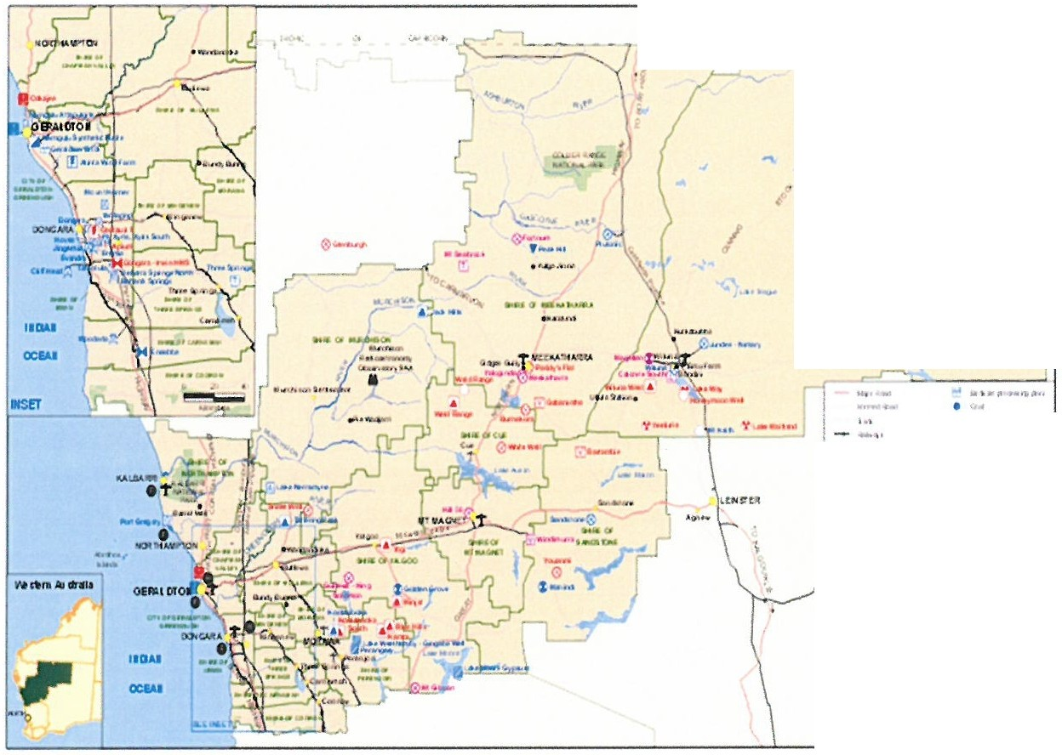

: ...,_,........

--- '":"L:-'

**...... 01 ........**

"

.......

***s*** ""· · ···j

I = -;::-·*3*

I • ....,.. **H**.•.•, .,...t_

..

"' - ,,,

.

I • "''"""..' •• • .._" ...,

I 't .. ··......

t **1"** ,_, • ...,., **.....h.,**

**'**.**-**.**i**.**.• • ,. ,..... ., T** ..11,• • , ..

. .

l :.·:-·

t .

-..,..,.

.....,,,

....... ..........

**e N-.14 H f**

l •**.,:;::.:.tiA.,uJ** I

l "·' -·-,...,..,

.-,. ........

1 ·......,..,...

.., ***'t*** , ,

***A""'s-fv t****1****;***

MIDWEST GASCOYNE

Appendix 2. Mid West road freight by segment to 2050 (MWDC 2017)



i

i -

I

,,,

. - . L

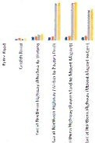

' l ·,

lI

d

; :

l l

!' l !i l I I

I ' . I l j *i*

I I

i

1 ! l! o l l I

I ; l ' J l l I

l J *I*

• !

1

l *t*

1 I \I . j

i i

i ) l l

j

I l •

l !

Appendix 3. Mid West rail freight by segment to 2050 (MWDC 2017)

Rail freight by segment

12,000

- 10,000

QJ

'iii

0; 8,000

"'

"' 6,000

"*<=*'

-"" 4,000

0

0

*?*

2,000 ...

0

••• ••• **Il l Il l**

.£,

e ·§ ., 0

" c: 3 "" - 0 " "l;';



6 0 ,g

c: "'

0 0 *:.*

c..: 0c0:

.,

0 *<5* v ., B .£ "

>c:

£ v ., :::; B £

8 B .,

£ *{;.*

" B ;.:. £

:::; .fi :b' ;: ;, 0 "

.8 0 0 .£

0 e £

":s' ""'

0c:

0

0 "" ::: 00

*{;.* 0

..,

0 v :::;

*.!!!* >

c:

0

0 v

:::;

•2018 • 2025 •2035 2045