

**Inquiry into Freight and Supply Chain**

**Productivity**

Department of Infrastructure and Regional Development

**Feedback from Regional Development Australia – South West**



**Provided by: Charles Jenkinson**

**Executive Officer, RDA-South West** [**eo@rdasouthwest.com.au**](mailto:eo@rdasouthwest.com.au)

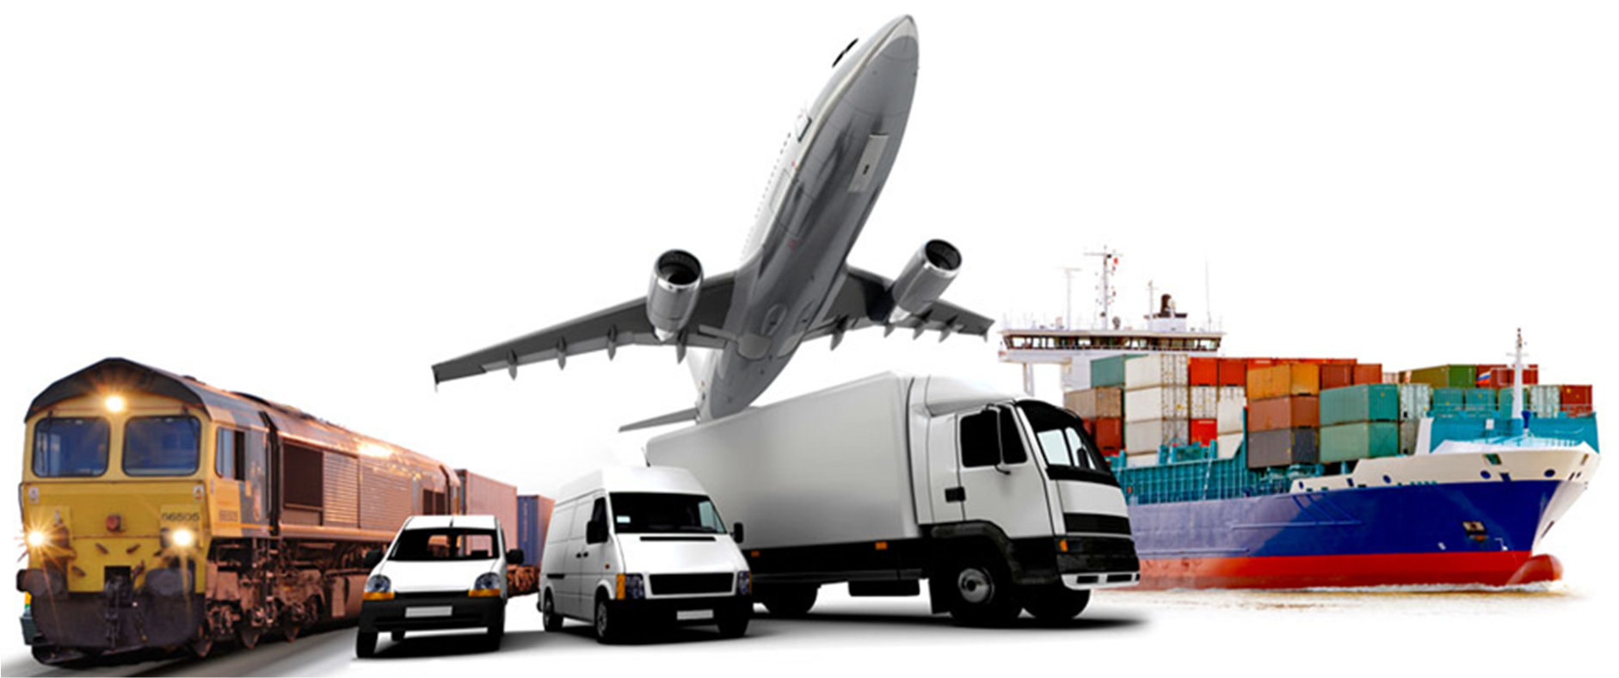

**Summary points**

• Engage with logistics/supply chain sector when planning infrastructure, particularly working with businesses that keep the nation moving.

• There needs to be a process that is fully inclusive of regional Australia and its freight needs.

• Concentrating hubs in capital cities is fuelling a constraints time bomb. Alleviate pressure by investing appropriately in nearby regions.

• Create fit-for-purpose, basic infrastructure.

• Target roads to provide free-flowing freight capacity with minimal intersections, fewer speed restrictions and separation from local traffic where possible.

• Look to separate rail from road to improve efficiencies.

• Adopt a shift in thinking from a traditional approach of responding to sweated assets, to instead acknowledge that infrastructure generates demand and attracts business investment ie. recognise potential and what might be, looking beyond what is.

• Investigate ‘trucks on trains’ options, allowing a smoother and efficient transition to more cost-effective transport.

• Efficient transport infrastructure is a business attractor.

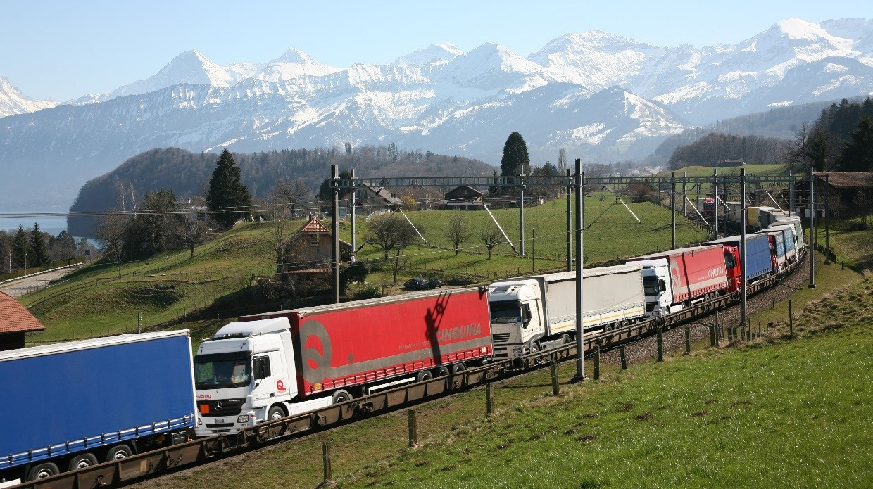

**Background**

This submission is made in response to the Australian Government’s investigation of freight and supply chain efficiencies in respect to transporting goods and enabling competitive advantage. The question has been reframed but echoes the 2013 State of Play1 paper which aimed for context around an overall rationale for an assessment framework around infrastructure sectors.

It is understood that there has been a long-held belief among those working at the leading edge of infrastructure investment that there should be a nationally agreed approach to infrastructure provision that is based on reason and sequential logic.

As might be expected, this RDA-South West feedback will be examining the issues from a regional perspective. It is also worth mentioning that the South West’s regional capital, Bunbury, is 185km south of Perth and features a diverse geographical product.

The 175,000 people that make up the South West have a GRP of more than $15bn, 2 exporting more than a fifth the total global supply of alumina, the majority of lithium, almost all tantalum and significant volumes of mineral sands.

The Port of Bunbury exports to 31 countries and imports from nine.3 It has broken growth records every year of its history except the year following the GFC.

A freight strategy discussion is particularly welcomed in the South West where it is felt that investment is desperately needed to provide a freight corridor links to two highways and the port, as well as providing core infrastructure to support the development of a master-planned

new town.

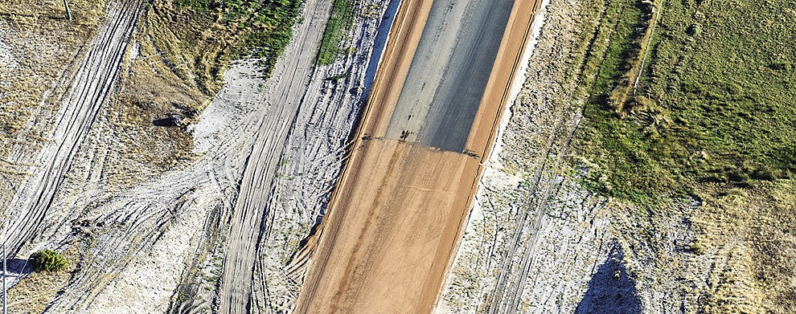

1 <http://infrastructureaustralia.gov.au/policy->publications/publications/files/2013_State_of_Play_Report_on_Australias_Key_Economic_Infrastruct ure_Sectors_FINAL.pdf

2 <http://www.rdasouthwest.com.au/uploads/3/8/0/4/38040777/sw_blueprint_final_2015.pdf>

3 <http://www.byport.com.au/stats/ctry_fm.htm>

**Introductory comments: Strategic timeframes and political reality**

It is noted that the inquiry is looking at 20-year timeframes and while a vision for the future is useful, that level of forward thinking in a rapidly changing world may be stretching the limits of what can reasonably be predicted. However, setting aside reservations for the future is to be commended and enables an adaptive capacity.

In terms of actual construction plans, looking at short and medium-term activities may be more functional, particularly where the politics can be taken out of five-year national plans and successive governments (of any persuasion) will honour agreements and plans put in place by predecessors.

Reviewing strategies in rolling five-year blocks would also be effective and echoes the ongoing review work done by Infrastructure Australia. Indeed, the concept of five-year planning blocks reaches back to the former Department of Transport and Regional Services, AusLink and its reincarnation as ‘Nation Building’.

The various concepts are not new but each iteration of the basic idea has suffered from accusations of political interference with the hope that Infrastructure Australia would lay to rest any future issues. That has clearly not been in the experience in Western Australia and given that a newly-elected government went so far as to break contracts and begin undoing work that had been already done4, the question is where that leaves us?

What timeframes will represent functional planning given that freight supply chains are subject not simply to increasing efficiencies, but also subject to political positioning?

Perhaps an approach through COAG will lead to more bi-partisan arrangements, but that may still leave regions out in the cold. The Australian Government infrastructure package for WA sees $1.6bn contributed to roads programs – just $10m of that is to be spent on major transport projects outside metropolitan Perth5.

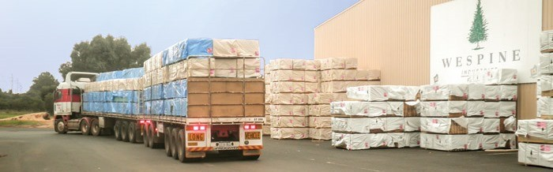

**Freight corridors**

While it is not suggested that infrastructure should be of a poor standard, it is strongly advised that corridors do not need to be over-designed but simply fit-for-purpose, free-

flowing freight routes that should skirt around residential areas as much as possible.

4 https://[www.mainroads.wa.gov.au/BuildingRoads/Projects/UrbanProjects/Pages/roe8.aspx](http://www.mainroads.wa.gov.au/BuildingRoads/Projects/UrbanProjects/Pages/roe8.aspx)

5 <http://investment.infrastructure.gov.au/funding/projects/waip.aspx>

Western Australia recently experienced a community backlash to the Roe 8 development due to its impact on homes and the environment. Future projects must be mindful of both in the context of community support to avoid wasting money.

Setting aside corridors should also be integrated into population growth planning. The issue works both ways. Firstly, avoid residential areas when planning corridors; and secondly, when corridors are planned then avoid allowing residential expansion close to them. Failing to do this raises health, safety and liveability concerns.

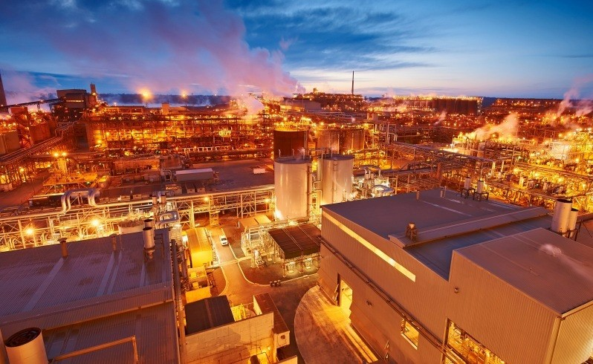

**What is moving where, why and how?**

**Infrastructure and information**

The South West is a net exporter of goods and services. Last year’s export trade (through Bunbury Port) was 16.25mt while imports were 1.84mt.6 Some regional product, particularly lithium and silicon, is exported through Kwinana.

The mining resources sector value adds bauxite, to export alumina. This is brought by rail to the Port of Bunbury and shipped overseas. Alumina manufacturing also attracts imports – caustic soda is brought in for use in the production process. From later this calendar year, an alumina manufacturer will also export bauxite directly. It is expected that will be by road freight.

Cristal Global and Iluka Resources both export ilmenite/synthetic rutile (titanium dioxide for use in paints and ceramics). It is trucked and exported through Bunbury Port.

The Greenbushes lithium mine is one of the largest in the world. It is currently undergoing a

$320m upgrade to double output7. This is transported by road to be either further processed at a $400m plant being developed in Kwinana, or exported through Kwinana.

6 <http://www.byport.com.au/stats/stats_fm.htm>

7 <http://www.talisonlithium.com/projects>

Other export resources include spodumene, copper concentrates, iron concentrates, silica sand and mineral sands, timber and oil. Grains exports are expected to quadruple in

2017-18 as port facilities are expanded.

Woodchips are a key export commodity to Korea and Japan. Last year $1.6mt were exported.

The timber sector is closely aligned in the South West. Wespine manufactures more than

80% of WA structural timbers for construction and Laminex is the largest particle board manufacturer in Australia. Hexion makes glues for the timber industry and accounts for about 10,000 tonnes of imported methanol annually. These products are moved by road.

The key movements are focused on the port ie. supplies coming from the south and product moving north.

Much of the road traffic from the south comprises logging trucks, but there is a significant amount of lithium and agricultural product also on the road. The South West agricultural sector is worth $630mpa.8

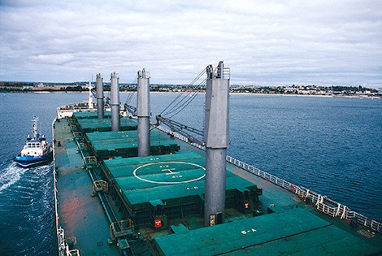

**Performance**

Freight traffic around Bunbury is challenged by the lack of grade separation at rail crossings which feature on major highways.

The system was largely planned as a whole inter-modal transport solution, but the plan has been only partially delivered. The intent was to connect the South Western Highway to the

Bussell Highway and also link to the port in a project named Bunbury Outer Ring Road.

8 ABARES: Agriculture, Fisheries and Forestry in the Bunbury region of Western Australia, 2013

Elements that have been delivered include a port road connected directly to an industrial area and early stage of the highways connector which today remains a stranded asset which fails to link the highways as intended.

The current situation sees heavy vehicles seeking passage through residential suburbs at worst and, at best, taking a cost and time wasteful option to travel “the long way round” past an education and hospitals health hub.

The significance of ports to Western Australia cannot be over-stated. A case can be made which demonstrates impacts in Bunbury have strategic implications for Fremantle and Kwinana which suffer land constraints. For example, efficiencies at Bunbury could see state car imports come through Bunbury Port. Vehicles cannot be stacked and take up a huge amount of valuable port space. Bunbury has the space while Perth ports do not. Efficiencies at Bunbury would pave the way to address such problems.

It is important to note that the Busselton-Margaret River region of Western Australia is the most visited region in WA and is the seventh most tourism-dependent region in the whole of Australia.9 It receives 1.8m visitors each year with 87% of them travelling from Perth. Holiday weekend traffic can double travel times. The current system which directs traffic through Bunbury simply cannot cope. This is the same route shared with log trucks and resources traffic.

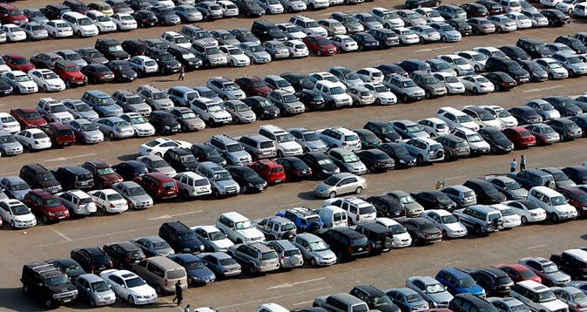

Greater Bunbury issues can be summarised as:

• Inefficiencies in the system (longer routes to port combining freight with local traffic).

• Lack of grade separation.

• Freight mixing with local traffic.

• An historic road system and subsequent ‘patch’ (Robertson Drive) forming a bottleneck which is exacerbated by a rail intersection.

• Growing population.

9 https://industry.gov.au/Office-of-the-Chief- Economist/SkilledOccupationList/Documents/2015Submissions/Australian-Hotels-Association- Attachment-3.pdf

• Growth of the port and tipping point for expansion (plus constraints at Kwinana and

Fremantle).

• Investment in lithium mining, bauxite and wheat exports that will intensify issues.

• Tourism traffic in the holiday season.

• Road dangers.

• Linkages for a newly planned township.

• Importance of the port connectivity for the regional economy and strategic importance to significant national exports (alumina particularly).

**Data gaps**

There is less an issue with data gaps than with the task of keeping updated in a commercially dynamic environment.

In the case of the Bunbury Outer Ring Road, initial project discussions were predicting coal and urea exports which failed to eventuate. However, new (and continued) investment in grains export capability, huge investment in lithium and current plans to export bauxite have superseded those losses.

Had the road been built at the time then there is every chance that lithium manufacturing opportunities, now being developed at Kwinana, would have been developed in the Bunbury area. Knowing the full consequences of inaction will never be known but it remains clear that efficient transport infrastructure is a business attractor.

The South West region is currently seeing the development of Busselton-Margaret River Airport which will have international freight capacity. Supply chain professionals have a particular way of analysing opportunities and in the case of the South West, look at the region as an extension of Perth ie. freight movements, back-loading, airport links and sea ports are all a part of a single commercial equation. This level of analysis is uncommon outside of the speciality and much of that information is intellectual property held by those businesses looking for an edge over their competitors.

An issue for government is that it can only work with what it knows, but that is because it largely fails to engage with those people who work with available infrastructure but who might have suggestions for improving networks. This is a data gap that should be addressed.

**Competitiveness**

Australia is placed in a global region of competitive economies where labour costs are lower and low levels of regulation have little impost on overall costs. Given that other countries are raising their standards, Australia cannot rely on a ‘quality’ branding nut will need to do everything it can to boost business competitiveness.

Most analyses of competitiveness indices unsurprisingly point to Australian wages as a key cost component problem. What was a surprise was that the World Economic Forum listed

‘inefficient government bureaucracy’ as second on the list of five factors which saw Australian global competitiveness slip to a ranking of 22nd for 2016-17.10 Supply chains did not make the top five list. This suggests supply chains are less of an impact factor to date, although Australia does sit behind other OECD nations.

It can also be noted that Australia is not responding to advances in such transport opportunities including the “rolling motorway” which places trucks on trains, removing the need for the multiple handling of containers and intermodal transfer costs/delays.

The ‘trucks on trains’ transport mode features highly among the most competitive countries and it would appear there would be robust opportunities for Australia’s metropolitan port constraints and inner regional support capability.

**Last word**

It is often cited that the bulk of the nation’s wealth is focused on its capital cities, but rarely acknowledged that the regions fight well above their weight on a per capita basis.

Regional Australia feeds the cities and export capacity. Any review of freight supply chain priorities must bear that in mind and investment should be made accordingly.

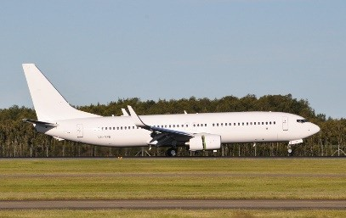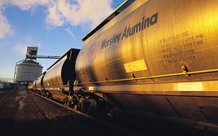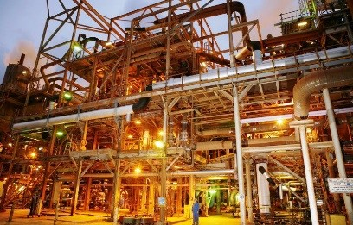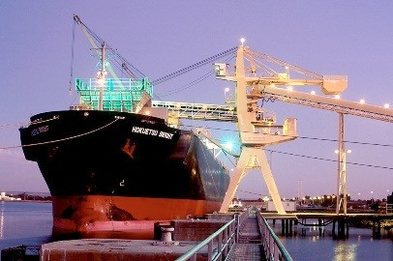

10 https://[www.weforum.org/reports/the-global-competitiveness-report-2016-2017-](http://www.weforum.org/reports/the-global-competitiveness-report-2016-2017-)

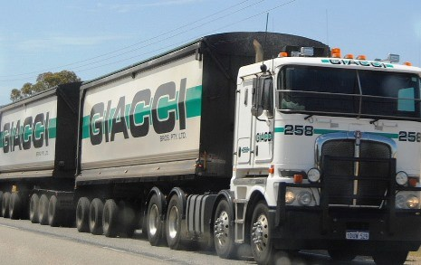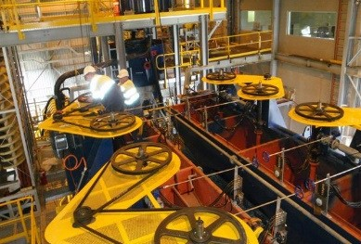

1?_cldee=YnJlbnQuYmFsaW5za2lAY2lycnVzbWVkaWEuY29tLmF1&recipientid=lead- a2e1861b155ee61180cd0050568067c2-7cbfd27d341949bb907da06bbef45a40

**Snapshot study**

**The case for the Bunbury Outer Ring Road**

**Introduction**

The original intent of a proposal put forward in 2010 was to adopt an inter-modal approach to freight efficiencies around Bunbury to support trade and encourage investment.

Transport links included ties to the Kemerton Industrial Estate, Collie Shotts Industrial Estate via the Coalfields Highway (and rail), duplicated rail from Brunswick ,and the Bunbury Outer Ring Road (BORR) linking the South Western Highway to the Bussell Highway.

The Coalfields Highway component of the plan is now complete and the Port Access Road (Willinge Drive) has been constructed with a heavy goods truck park created. The first stage of the Bunbury Outer Ring Road has also been constructed but remains a stranded asset.

At the same time, Brookfield Rail has found ways to better utilize its existing infrastructure and any thoughts of rail links to the south of the region have been abandoned. This means all freight from the south must go by road.

**Present situation**

The Commonwealth has made $10m available to advance the planning of the Outer Ring

Road.

Planning to the south is advanced while planning of the northern section is not.

An emerging opportunity in WA Main Roads has seen a different approach with a greater focus on creating a freight corridor that is stripped down to the essentials and removes multiple intersections saving costs and allowing a free-flowing freight corridor.

There have also been changes to the commercial environment with:

• a drive to further develop the timber precinct;

• more tree planting to support woodchips exports;

• $320m investment to double the lithium mine at Greenbushes;

• direct bauxite shipping from South32; and

• Bunge’s push to expand on grain exports.

On the social front, there is a need to settle on the BORR to advance planning for the new residential suburb, Wanju, and improve road safety by creating a corridor that takes heavy vehicles away from residential areas and education and health campus.

**Problem definition**

IA wants to know the problems and the following solution that is offered. Frame the strategic issues around the project goal/aim and the problem/s that identify as a blockage.

The problem is generally multi-faceted and can involve some conjecture on population growth, business growth, trends in the regional economy etc. Try to talk in terms of national significance when discussing the port. Sell the corridor as a no-frills freight solution to a freight problem that currently has social externalities as well degrading opportunities.

Our problems:

• Inefficiencies in the system (longer routes to port combining freight with local traffic).

• Lack of grade separation.

• Freight mixing with local traffic.

• An historic road system and subsequent ‘patch’ (Robertson Drive) forming a bottleneck which is exacerbated by a rail intersection.

• Growing population.

• Growth of Bunbury Port and tipping point for expansion (plus constraints at Kwinana and

Fremantle).

• Investment in lithium mining, bauxite and wheat exports that will intensify issues.

• Tourism traffic in the holiday season.

• Public safety.

• Linkages for the newly planned township (Wanju).

• Importance of the port connectivity for the regional economy and strategic importance to significant national exports (alumina particularly).

**Opportunities**

This section deals with not just the problem fix but other opportunities that will develop such as port expansion at Bunbury will ease pressure on Fremantle and Kwinana Ports.

This creates an environment in which could be developed further points on tourism possibilities created by bringing activities at the old Bunbury Outer Harbour site within the area bounded by the Inner Harbour. This move would be facilitated by supply chain infrastructure and would free up a prime site for other economic development.

**A few salient points …**

• Consider the whole and what broader connectivity will deliver both directly and indirectly.

• A road is just a road, but what does it deliver in addressing identified issues:

• Economically

o Truck movement efficiencies

  Woodchip exports (plus expansion in Collie catchment)

  Ilmenite/mineral sands

  Lithium

o Providing rail via grade separation efficiencies which supports alumina exports.

o A no-frills freight corridor with only key intersection points will maximize benefits while minimizing costs.

o Minimum intersections aids freight flows and efficiencies.

o Supporting Bunbury Port

  Links to Willinge Drive.

  Links into Waterloo and Picton industrial areas.

  Alignment benefits to Dardanup timber precinct and methanol truck movements to Hexion.

  Bunbury Port is at capacity so growth prompts expansion which also triggers Outer Harbour move and central operations to one site.

  Bunbury Port growth eases pressure on Kwinana and Fremantle.

  Growth and links to industrial areas opens door to vehicle imports which generates local jobs and frees up land at Fremantle.

o Supporting tourism

  Outer Harbour potential as a link with the Bunbury Waterfront

Development and return of Outer Harbour site to public ownership.

  Road efficiencies for Capes traffic. (Note that Busselton/Margaret River is the sixth most tourism-dependent region in Australia.)

o Stimulus for housing and population sustainability (Wanju ie this is the place to expand when Dalyellup, Treendale, Kingston and Millbridge are done)

• Socially

o Heavy goods vehicles away from Robertson Drive

o Trucks removed from roads including a high school, TAFE and regional university.

o Complete removal of freight traffic from the point where a major residential suburb joins the existing commuter route into town. (Dalyellup)

• Environmentally

o The project should be delivered with the lightest footprint possible.

o Not only will residential areas not be impacted by the proposal, there will be improvements as freight and any other traffic would move to the new road corridor.

o More efficient travel times will mean less energy consumption.

Map showing key connections

