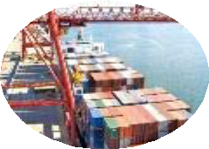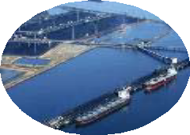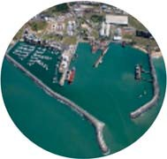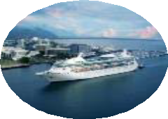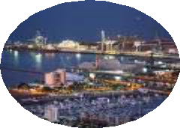

INQUIRY INTO NATIONAL FREIGHT

AND SUPPLY CHAIN PRIORITIES SUBMISSION BY QUEENSLAND PORTS ASSOCIATION July 2017

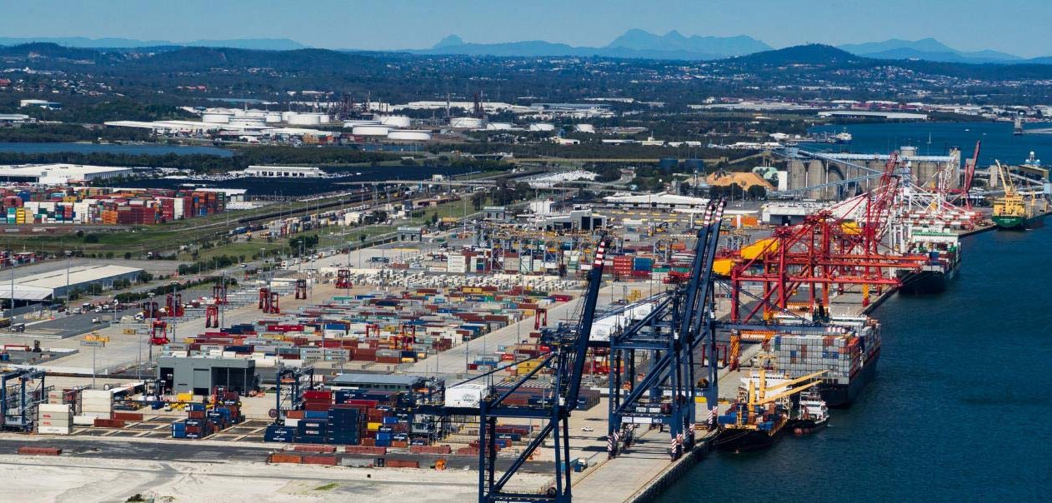

Introduction

We thank you for the opportunity to comment on the *National Freight and Supply Chain Priorities Discussion Paper*, and strongly support the Inquiry to investigate ways to lift productivity and improve efficiency of Australia’s freight and supply chain infrastructure.

As the gateways for international and domestic trade, seaports are critical to Australia’s freight network, with over 90%

of freight to and from Australia by tonnage going through ports.

Queensland Ports Association (QPA) represents the five (5) port corporations (1 private, 4 State Government Owned Corporations) which own and manage Queensland’s 15 trading ports. Covering almost 7,000 kilometres of coast line and 22% of Australia’s land mass, Queensland’s ports play a vital role in servicing 4.7 million people living in major urban centres and remote and regional centres, as well as major mining provinces and rich agricultural precincts. Queensland’s ports also support significant cruise tourism operations and provide strategic naval capabilities.

QPA is pleased to provide this submission in response to the Discussion Paper. The matters of key priority for

Queensland’s Ports include:

• Protecting ports and end-to-end supply chain corridors as nationally significant infrastructure;

• Ensuring sea channels are able to maintained and expanded to cater for bigger ships;

• The need for a targeted review of freight policy to support coastal shipping;

• Recognition that regional ports play a significant role in the national economy and social structures.

QPA would welcome the opportunity to meet with members involved in the Inquiry and the expert panel to discuss this submission and the challenges and opportunities for improving freight efficiency and competitiveness further. Enquiries can be directed to Ranee Crosby, [rcrosby@townsvilleport.com.au](mailto:rcrosby@townsvilleport.com.au) and Phone: 07 4781 1521.

Chris Boland

Chair, Queensland Ports Association

What is Moving Where, Why and How

Queensland’s Ports combined handle around 330 million tonnes of freight worth more than $100 billion each year.

Queensland Ports Key Commodities (By Tonnage) 2015-2016

• 221 million tonnes of coal;

• 51 million tonnes of bauxite;

• 12.5 million tonnes of petroleum products

• 12.2 million tonnes of gas;

• 6.7 million tonnes of minerals;

• 5.5 million tonnes of alumina;

• 3.8 million tonnes of sugar;

• 2.2 million tonnes of silica sand; and

• 2 million tonnes of grains.

Natural Gas

4% Bauxite 16%

Metals & Minerals 2%

Alumina 2%

General & Other 2%

Petroleum

Products 4%

Coal 70%

;

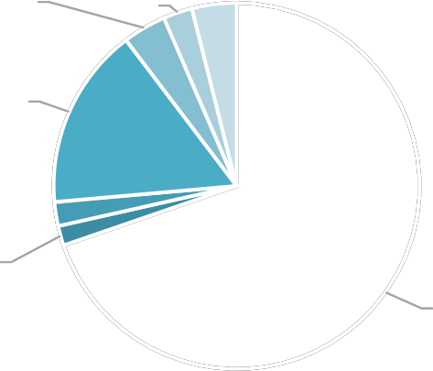

Queensland’s ports also handle around 1.2 million TEU’s and 250,000 motor vehicles, predominantly through the Port of Brisbane, and around 260,000 head of live cattle through the Port of Townsville. Queensland’s ports also support significant tourism operations with 326 cruise ship visits in 2015-2016, and provide strategic naval capabilities.

Queensland’s 15 trading ports cover almost 7,000 kilometres of coast line and service 4.7 million people living in major urban centres and remote and regional centres spanning 22% of Australia’s land mass. These ports also service major mining provinces and rich agricultural precincts which are often located extensive distances from the location of sea ports.

The movement of freight within Queensland is dominated by road (69%) and rail (29%), with sea freight only moving

2% of cargo. The vast majority of coastal shipping within in Queensland is in dry and liquid bulk occurring within closed supply chains, where low value, high tonnage, long distances and handling requirements for bulk commodities combine to make this sector suited to coastal shipping. This includes for example bauxite between Weipa and Gladstone and cement between Gladstone and Townsville.

In terms of movement of freight from source locations to port, bulk commodities are typically railed from mines and mills to ports as large volumes and long distances make this economically feasible. Smaller volume operations in mining and agriculture generally are trucked. The majority of container freight, motor vehicles, live cattle etc is trucked.

Competitiveness in Australian Freight Sector

Coastal Shipping

While coastal shipping is the safest, most environmentally sustainable and economic mode of transport across longer distances, coastal shipping has had limited success in being competitive against other modes in Queensland and Australia. Coastal shipping would enable overall efficiency gains in the movement of freight, maximising the efficient use of existing assets. Increasing freight load on coastal shipping would contribute to significantly reduced congestion on roads and allow for future freight growth. Coastal shipping also enables the movement of cargo in bulk, and cargo that is too large to be carried by other modes of transport, reducing safety risks on roads that are utilised by the public.

Containerised and break bulk transport in particular is dominated by road and rail modes due to a lack of competitive neutrality, and the current low efficiency of coastal shipping services. There is currently not a level playing field amongst the various transport modes due to the different ownership models and various government policies and subsidy arrangements that have been in place over long periods of time.

Coastal shipping must be a viable freight alternative and reforms must be implemented to achieve this. The infrastructure already exists in Queensland Ports and with the broader maritime sector to significantly ease the burden on existing freight and supply chain networks. Coastal shipping reforms can be undertaken at negligible cost and deliver reduced end costs to consumers. Utilisation of coastal shipping would enable the ‘latent capacity’ of international container ships on voyages between Australian ports and integration of domestic and international supply chains.

Coastal shipping needs to investigated and evaluated as part of an integrated freight transport model, “right mode for the right load”

Rail Transport

Ports are the international gateways for freight, with around 90% of Australia’s trade going through ports. However getting products to port for export or getting goods to consumers from ports is not always well planned or efficient. First and last mile issues are a significant challenge to many Queensland Ports, particularly in relation to efficient use of rail networks in a State as vast as Queensland.

At Queensland container ports, off dock intermodal facilities (the interface between rail/road and container terminals) are critical for the efficient movements of containers. Investment into intermodal infrastructure is required to manage ever growing container imports and to service the growth potential of key agricultural and resource exports throughout regional Qld.

The development of dedicated/segregated rail freight corridors to ports is also vital. Current freight services often share the same corridor as passenger rail services. The potential to maintain or grow rail freight using these lines is constrained as a result of the increasing frequency of, or priority given to, passenger rail services. Without significant improvements and/or development of new dedicated freight rail corridors, productivity will decline and trade will be constrained.

Port of Brisbane’s Port Rail Connection (PRC) and Port of Townsville’s Eastern Access Rail Corridor (TEARC) are examples of dedicated rail freight corridors.

In Brisbane’s case, the PRC will:

• Reduce growing congestion,

• Improve road safety;

• reduce road capital and maintenance costs;

• reduce greenhouse emissions;

• improve residential amenity;

• create a viable, efficient, long term route to market for agricultural products and coal exports;

• enable the development of the Melbourne to Brisbane Inland Rail.

In Townsville’s case, TEARC’s facilitation of longer freight trains directly into the Port will:

• provide additional network capacity to cater for trade growth;

• eliminate supply chain constraints and bottlenecks and improve productive capacity of the network;

• improve community amenity, safety, sustainability and eliminate congestion-related conflicts and impacts associated with future increases in rail freight by removing trains from the Townsville urban centre.

As more cargo is handled on rail due to increased road congestion and expanding hinterlands, additional rail paths will become necessary. With coal exports also forecast to increase substantially, additional rail infrastructure including new or upgraded main lines, rail marshalling sidings and unloading facilities will also be required.

Investment in rail into the hinterland needs to be advanced to enable the growth of commodities to market at a lower cost.

Road Transport

Road transport, for many Queensland ports, remains the most effective and cost efficient mode of transporting containers to and from port. Many freight proponents consider road to be more responsive, reliable and timely than alternative modes. This is in many ways due to the significant level of investment by State and Federal governments into road infrastructure relative to other transport modes.

With road congestion predicted to increase considerably, other mode shares must increase (particularly where improved rail freight infrastructure and services are provided) to accommodate longer term demand.

The configuration of the roads around many Queensland ports do not support the use of high productivity vehicles. This results in a greater number of smaller trucks on the road meaning higher costs to the consumer, further congestion and poor environmental outcomes. Roads connecting to the ports need to enable higher productivity vehicles to access the roads. Ports should be linked into the NHVR permitting system so it can streamlined.

Notwithstanding improvements in road networks and mode shifts to rail and sea, projected growth will still result in heavy road traffic thus road capacity will need to be monitored, maintained and planned for. There is a need to ensure “whole of corridor” planning for infrastructure investment for the roads, rather than fixing one part of the freight corridor which simply moves the constraint further along the route. Support to enhance the connection between local, state and national road networks will be critical to delivering a more seamless national approach to freight. This includes supporting local network assessments, communicating access issues and sharing assessment information.

General Comments

• Transport logistics costs are too high and make low margin industry sectors unviable.

• Currently there is no or limited visibility of costs across the different modes of transport, and no significant mapping of start and end points for freight, or at least not shared.

• Coastal shipping would alleviate pressures of transporting freight through large urban centres.

• The Discussion Paper focusses on capital city ports – QPA submits that a broader view of strategic ports needs to be undertaken, particularly given Northern Australia challenges of remoteness and regional centres.

• Transparency of freight costs and mode is critical to improve efficiencies.

Recommendations:

1. A targeted assessment of methods to increase the use of coastal shipping and the development of Australia’s maritime fleet and workforce capability is required, including a comprehensive and holistic productivity assessment of shipping compared with other transport modes. This should include detailed assessments of the whole-of-life economic, social and environmental costs to Australia across all transport modes.

2. Improve transparency of data on freight movements across all modes in a manner that protects confidentiality, for example through the establishment of an independent body to receive, de-identify and distribute private sector freight data to government agencies that need it.

3. Public sector investment in transport infrastructure should take a longer-term perspective, and should be

prioritised in a manner that encourages investment into more productive and efficient freight capacity creation.

Urban Growth Pressures

Urban growth and the pattern of increased urbanisation around waterfronts places significant pressures on port operations and future expansions necessary to cater for freight growth. The nationally significant nature of ports makes it essential that ports and supply chain corridors are protected so they can service communities and facilitate economic growth.

A port’s footprint must be strategically accommodated in local, regional and state planning to avoid the consequences of unfettered urban growth.

In Queensland, Port Master Plans are required for the Port of Brisbane, and for Great Barrier Reef Priority Ports to protect ports from urban encroachment and to support expansion of freight pathways.

Northern Queensland is also home to more than 70% of the population of Northern Australia, with extensive distances between regional centres in Northern Australia and capital cities. It is important that freight planning consider the most efficient ways to service and support regional centres, particularly in Northern Australia. Distribution hubs, shared by major retailers, could be suited to regional locations through a hub and spoke model, which would also assist in reducing congestion challenges in capital centres.

Recommendations:

1. Ensure protection of ports, channels and supply chain corridors to enable future growth.

2. Priority transport corridors and precincts preserved across all jurisdictions.

3. Coastal shipping should be utilised to avoid heavily congested road routes through capital cities.

4. The benefits of regional locations for distribution centres through a hub and spoke model should be considered.

Port Corridor Pressures

It is essential that strategic freight corridors (sea, rail and road) to ports are identified and protected for future growth. Sea channels must be protected to ensure that freight is able to be imported and exported. The critical nature of these

assets in strategic ports, and the need to assure future dredging to maintain access and expand access as vessel

sizes increase, needs to be reflected as a national priority. Increasing trade is driving increased shipping efficiencies through use of longer, wider and deeper vessels.

The need to accommodate bigger ships is not confined to Queensland Ports. Specific challenges do, however, existing in Queensland Great Barrier Ports due to State and Federal government imposed bans on sea placement of capital dredge material. This is of particular relevance to planned shipping channel works in Cairns, Gladstone and Townsville Ports. If inaction results in vessel restrictions, the economic impact and flow-on effects to freight networks will be significant.

Current freight rail access is constrained by low infrastructure standards (axle loads, train length and structure clearances) and availability of train paths, a combination of needing to share sections with passenger trains and severe capacity constraints. Rail has struggled to provide effective service with road significantly increasing its market share. Major investments into the road network and the upgrading of major links to accommodate high productivity vehicles has significantly contributed to this loss of rail mode share. In Brisbane Port, for example, less than 3% of containers are transported on rail.

While some modal shift of freight is required to alleviate congestion, trucking will always remain a vital mode for freight movement to and from ports. Higher Productivity Vehicles (HPVs) provide significant efficiencies for transport of freight to and from ports, however the benefits of using these vehicles is often constrained due to differing jurisdictions of road connections, resulting in permitting inefficiencies and a disconnect in infrastructure investments to facilitate their movement.

Recommendations:

1. Ensure that sea channels are able to be effectively maintained into the future to ensure safe and reliable access for shipping, and that channel expansions to cater for bigger ships are recognised as a national priority.

2. A national framework of freight corridor protection to and from ports is required to guide coordinated and meaningful planning, permitting and investment across these corridors by ports and all levels of government. This framework should thoroughly assess the benefits of different modes, and encourage the most productive and efficient mode of transport for freight movement.

End to End Supply Chain Integration and Regulation

Lack of supply chain visibility across transport modes generates inefficiencies and costs to freight owners and end users. This is due to poor, inefficient or incompatible interfaces between systems and organisations within supply chains, over-reliance on manual transactions and lack of data standards and inter-operability between systems as most supply chains comprise a number of independent entities which are required to interface with each other. The inefficiencies of IMEX container supply chains are a good example because of the number of organisations involved

– importers, exporters, forwarders, customs brokers, stevedores, shipping lines, road and rail transporters, container parks, regulators such as ABF and quarantine.

The adoption of Heavy Vehicle National Law (HVNL) and the creation of the NHVR was a good initiative to provide a national approach to the regulation of heavy vehicles and reduce the impact of jurisdictional differences in relation to regulation and access. However there are a number of inefficiencies in the system and still some off getting meaningful benefits

It is essential that end-to-end supply chains are identified, planned and protected.

A key case in point is the Inland Rail proposal for railing freight between Brisbane and Melbourne. This $10 billion project – the Federal Government’s largest rail infrastructure project in a century – fails to include a connection directly to the Port of Brisbane (the current proposals stops at Acacia Ridge, 38 kilometre away from the port). It is essential that this missing link is addressed as a priority, in particular ensuring that the land corridor is preserved in order to realise the benefits of the Inland Rail project.

The Mount Isa to Townsville rail line has provided a connection for one of the world’s largest base minerals provinces to export through Townsville Port. An 8 kilometre Townsville Eastern Access Rail Corridor is proposed to connect this line and the North Coast Line directly to the port, avoiding the urban centre of Townsville. A Business Case is currently being developed for this rail link.

Recommendations:

1. Develop a Port Community System/Port Information System, a key port IT infrastructure system to assist stakeholders reduce supply chain costs.

2. Ensure that corridor preservation, acquisition and investments for freight infrastructure extend the full extent of

supply chains to so that the full benefits of investment are realised.

3. Strengthen relationships between all levels of governments and states for delivery of efficient, cost effective supply chains and avoidance of duplication.

4. Streamline and simplify access and permit requirements under the NHVR by reducing the number and class of vehicles which require permits and reduce the time allowed for road managers to consent to access requests.

Air Freight Market

Approximately 500,000 tonnes of freight in Queensland is moved by air each year. While the volume of freight moved by air is small (less than 1% of freight by mode), air freight is critical for time sensitive cargo and high value items to reach markets.

Often initial exports of perishable and high value goods by air freight leads to establishment of new markets that will support increased volumes of product via sea transport. Carrying freight by air also helps make air routes viable that would otherwise not be on passenger numbers alone. This is particularly important in regional centres, such as in Northern Australia, where population presents challenges in achieving volumes. With both modes available for freight, exporters can spread the risk between both modes for some commodities.

Recommendations:

1. With the synergies that exist between air ports and sea ports, shared resources such as customs, quarantine, border security, cold storage facilities, treatments (e.g. irradiation) and freight handling facilities should be investigated. These synergies extend across freight as well as other industries such as cruise shipping.

Changing Technology

Automation of container terminals is essential to achieve productivity through operating efficiencies and for improving safety performance. Automation has been a feature at Port of Brisbane since 2005 when automated straddle carrier technology was introduced, yielding up to a 90% reduction in safety incidents and improved operational efficiencies. Subsequent container terminal developments have utilised systems to track and manage the movement of containers through terminals and operate automated stacking cranes. Stevedore automation significantly improves operating efficiencies and safety performance and will become increasingly important to the productivity of container ports.

There is an opportunity to extend automation beyond terminals. Advances of electrified, fully automated road vehicles resulting from technological advances when applied to freight will help ameliorate the two largest social costs associated with road transport – accidents and congestion. Most medium to long term transport planning does not include planning for automated vehicles.

With significant advances in technology, data collection on freight movements (across all modes) should be improved and integrated to better inform transport planning, permit systems and investments.

Recommendations:

1. Future business cases for both infrastructure upgrades and new infrastructure should include the impact of autonomous stevedoring and other transport operations such as vehicles.

2. With significant advances in technology, data collection on freight movements (across all modes) should be improved and integrated to better inform transport planning, permit systems and investments.

Capacity Forecasting

Queensland’s Ports combined handle around 330 million tonnes of freight, which is forecast to grow to more than 500 million tonnes by 2036. Queensland’s Ports produce Port Master Plans which typically have 30-year infrastructure planning horizons. Queensland’s Ports are generally well positioned to facilitate future trade growth because of these long-term master plans.

In some cases these master plans identify supply chain requirements, however there is often a disconnect between port freight and infrastructure planning and that undertaken, where it is undertaken, for road and rail corridors. This disconnect can relate to the timeframe of freight and infrastructure forecasting, forecasting methodology, catchment area definition, investment planning approach, jurisdictional scope etc.

Recommendations:

1. Freight forecasting should be more integrated across supply chains to ensure that infrastructure planning and investments can be more appropriately prioritised.

Key Drivers of Change for Use in Scenario Planning

Key drivers of change affecting ports in Queensland include global and domestic economic conditions, global and domestic production and consumption patterns, global shipping trends, political factors, social factors, technology and natural resources.

A National Freight Performance Network

QPA supports the development of a National Freight Performance Network which has the potential to provide useful information and indicators of capacity, productivity and efficiency across modes.