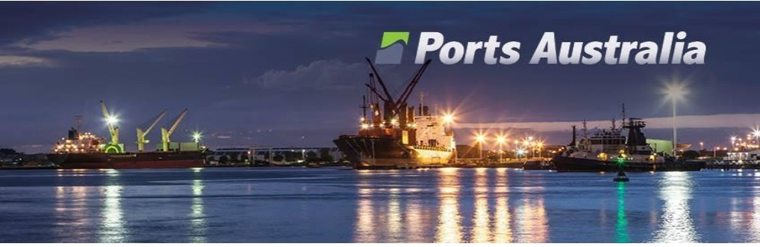

Submission:

Inquiry into National Freight

and Supply Chain Properties

**28 July 2017**

Position

Ports Australia is pleased to provide comments to the Inquiry that we consider are key to shaping the future of freight and supply chains in this country. Ports Australia utilises this opportunity to focus the debate on what we consider are key priorities on this issue and the pragmatic role the Commonwealth can play in delivering on the priorities. Ports Australia would also like to take this opportunity to highlight the efficiencies being gained by the country’s ports and note that this is limited by the inefficiencies caused by other transport infrastructure. As outlined in this submission, Ports Australia is advocating a multi-modal solution for challenges facing freight transportation in Australia, with a primary focus on increasing coastal shipping.

Ports Australia is happy to engage with the Inquiry Panel and/or the Government in helping to further discuss this submission with the view to resolving the current problems faced in the freight and supply chain networks.

**Ports Australia**

Ports Australia is the peak industry body representing port authorities and corporations, both publicly and privately owned, at the national level. Ports Australia is governed by a Board of Directors comprising the CEOs of eleven Member port corporations.

Ports Australia works closely with the Government and its agencies on the development and implementation of policies and regulatory settings that will facilitate the efficient operation of our ports and provide the ability to develop capacity to meet Australia’s freight task.

**Contents**

Contents ...................................................................... 2

Summary Position ........................................................ 3

Coastal Shipping ........................................................... 7

Rail and Road Connectivity ......................................... 10

Corridor Protection .................................................... 13

**Summary Position**

Critical freight and supply chain infrastructure has not been a tier one priority for a number of decades and as a result Australia’s network needs innovative and immediate attention. Social infrastructure such as welfare spending and the national disability insurance scheme, together with traditional policy priorities in areas such as health, national security and defence have become the significant focus of successive Governments looking towards the current and future needs of our population.

The limited policy initiatives and related spending on freight and supply chain networks are aimed at alleviating some of the existing failures in the transport network.

Australia’s ports are the gateway to the national economy, 90 per cent of the nation’s trade goes through our

ports.

Due to the scale of trade moving through the ports any increase in efficiencies surrounding them no matter how small provide massive economic benefits. Similarly any inefficiencies impact negatively. The NSW Government estimates that a one percent increase in freight efficiency could save the national economy

$1.5 billion1.

Australians are indirectly paying a premium for the inefficiencies in our freight transport network.

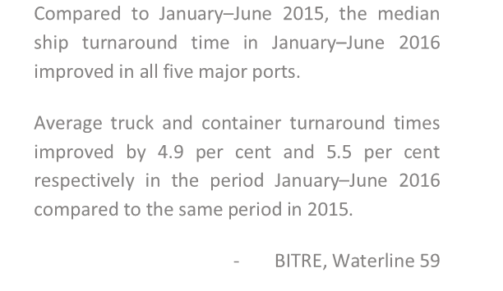

Australia’s ports have actively pursued measures to improve logistical efficiency and port throughput through investment in capital infrastructure and technology such as robotics and truck queuing systems. The lack of certainty and future planning by all level of Government ‘outside the port gate’ has serious detrimental impacts on any efficiencies achieved dockside.

Road congestion in our capital cities continues to grow and is a

challenge for Government. Australia’s population is growing and so

Compared to January–June 2015, the median ship turnaround time in January–June 2016 improved in all five major ports.

Average truck and container turnaround times improved by 4.9 per cent and 5.5 per cent respectively in the period January–June 2016 compared to the same period in 2015.

- BITRE, Waterline 59

is the domestic freight task. The National Transport Commission notes the domestic freight task increased by

50 per cent in the 10 years to 2016 and is forecast to grow another 26 per cent by 20262. Australia simply does not have an adequate plan to deal with this growth.

The current ‘political’ response to this transport infrastructure problem is short sighted expenditure solutions that are increasingly focused on growing road user/commuter capacity. Case in point is recent investments in Westconnex and the widening sections of the M4 motorway. These infrastructure investments are well

overdue for a burgeoning Sydney population and industry. However, they are reactive spending by

1 NSW Ports and Freight Strategy 2013

2

National Transport Commission (2017), *Who moves what where: Better informing transport planning for Australians*, discussion paper

Government to tackle a problem that many in Sydney have faced for several years. These two examples are mirrored across the country.

It appears little is being done to find alternative solutions to the pressures arising out of the nation’s steadily increasing freight task and the diminishing benefits that will come from short sighted investment in existing infrastructure.

The Office of the Infrastructure Coordinator Commission’s paper on the Development of a National Corridor Protection Strategy highlights that significant focus on freight and supply chains was previously given by the Governments of the 1950s, 1960s and 1970s. For example the corridors for Sydney’s M7 was quarantined 40 years ago and land for the North East Link extension in Melbourne was set aside 50 years ago. The decisions of past governments have enabled recent Governments to easily build infrastructure such as the M1, M2, M4,

M5 and M7 motorways, and to accommodate the development of the Western Sydney airport.

However, there has been some sporadic and noteworthy investment in freight and supply chain infrastructure. The Commonwealth Government’s planning and investment in the Moorebank Intermodal freight terminal will assist manage the future container capacity of Port Botany and reduce the number of trucks on Sydney roads by freighting containers by rail from the port to the terminal. Similarly planning and investment in the Inland Rail is projected to cater for the increased freight task between Melbourne and Brisbane (4.9 million tonnes in

2016 to around 13 million tonnes by 2050). More of this vision, planning and investment is necessary to better manage our freight and supply chains, and for broader city planning.

Ports Australia seeks leadership from the Commonwealth Government in prioritising infrastructure that better supports our freight and supply chains. We note the limitations in our system of federalism and the agreements necessary with the states and territories to implement new initiatives. We suggest the Government look past heavy-handed measures such as tied/conditional funding given the poor track record this arrangement has and work towards a genuine partnership with other levels of government on this issue. The Commonwealth Government can show leadership by:

• **Being active in engagements** with states, territories and local governments to seek agreement on the policy priorities and achievable targets prior to developing national strategies and plans. The business community will gain greater confidence to operate and invest knowing that all levels of government are in agreement on the direction being set for the freight and supply chain networks.

• **Integrating its workforce** with the relevant areas of state and territory governments that are focused on planning and implementation. This will give the issue prominence and ensure that discussions at the bureaucratic level mirror those at the political level, strategies are negotiated prior to Ministerial considerations, and there is alignment in implementation approaches.

• **Educating and promoting supply chain requirements** and benefits to the broader community through everyday examples that are relatable. We need our Governments to show leadership and outlined the vision on what is required for nation building, which is rarely at the forefront of the average person’s mind, mainly because s/he is busy managing their jobs, families, health, etc.

**Priority Areas**

Ports Australia considers that there are **three priority areas** that the Commonwealth should look to improve transport infrastructure. **Freight corridor protection** is one, and encompasses planning and management of our road and rail networks:

• Better management of urban encroachment so that businesses such as ports can plan, operate and invest with confidence;

• Coordinated planning with local and state governments for the efficient and continuous movement of freight through our cities without travel restrictions on freight business; and

• Planning our freight and supply chain networks for the future requirements of our communities.

Focus on freight corridor protection is required to build business confidence and security which will result in investment to grow our economies and improve the prosperity of the country. Efficient movement of freight will also result in better environmental outcomes, reduced congestion and lower end costs for the consumer.

Ports Australia considers that the second priority that the Government should focus on is **road and rail connectivity**. Ports are the trade gateway of this country given that around 90% of Australia’s trade goes through our ports. However, getting goods to Australian consumers from the port and from businesses to the port is not efficient. Concerns entail first/last mile issues, consideration of segregated sections of rail lines for freight, and increased and reliable use of the rail network.

• The configuration of the roads around many of our major ports and intermodal terminals do not support the use of high productivity vehicles. This leads to smaller and numerous trucks on the road leaving the port/terminal which eventually results in higher end costs to the consumer than required, greater congestion on our roads and poor environmental outcomes.

• The use of rail to and from our ports is underutilised and leads to freight being moved primarily by trucks. Rail facilitates the most efficient movement of freight on land but rail lines are shared between passengers and freight, and the former is prioritised. Accordingly, businesses choose to move their freight along transport modes that are less restrictive and comparatively more efficient.

The Commonwealth Government has invested in **Inland Rail**, a dedicated rail freight line. However, **the line does not connect to Melbourne or Brisbane**. Freight has to be moved inefficiently by shared rail lines or onto trucks to various other destinations including the port. The lack of efficient connectivity to the port will increase travel times for the movement of freight, lead to road congestion due to increased truck movements, and result in higher end costs.

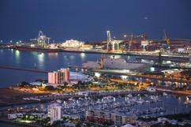

Ports Australia considers that the third priority that the Government should focus on is reforms to **coastal shipping policy** including abolishing the current cabotage regime. Unlike the other two priority areas which necessitate partnership across all levels of government, coastal shipping can be unilaterally implemented by the Commonwealth Government and will result in significant benefits for the consumers, the economy and the environment. Additionally, Inland Rail requires billions to build to cater for the increased freight task between Melbourne and Brisbane. However,

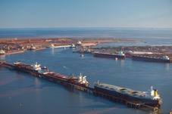

the infrastructure already exists at our ports and with the broader maritime sector to significantly ease the

burden on our existing freight and supply chain networks.

**Coastal shipping reforms can be undertaken at negligible cost and deliver reduced end costs to consumers**. It will reduce the inefficiencies of the current transport network by reducing the number of trucks on roads in our major cities, thereby reducing congestion and saving $1.5 billion. Improved coastal shipping policies will also:

• lead to less Government spending on road infrastructure;

• result in improved environmental outcomes due to less CO2 and noise emissions; and

• result in cheaper products due to the economies of scale gained through mass volume shipping.

Reforms in this space could also lead to **jobs growth** outside many of our major cities. Increased coastal shipping will lead to fewer trucks carrying freight long distances, but more short haul journeys in regional areas to/from the local port. As a result, regional jobs in the trucking and complementary sectors should receive a boost as will regional economies.

Ports Australia is not suggesting that significant reforms to coastal shipping policies will be the panacea to resolving the current issues facing the freight and supply chain network. We are merely suggesting that this is a key option in a suite of measures that the Government should consider in helping solve the issues facing the network, and one that will deliver significant benefits for little cost.

Ports Australia has outlined three priority areas that we consider will improve our freight and supply networks. Ports Australia is advocating a multi-modal solution to the challenges facing freight transportation, with a primary focus on increasing coastal shipping. Ports Australia has outlined below in further detail our focus on the three national freight and supply chain priorities.

**Coastal Shipping**

The coastal shipping sector has been characterised by a dual policy failure that has seen firstly the stagnation of the coastal shipping task and secondly the decrease of Australian licensed ships in our coastal trades. Current policy has not “revitalised” Australian flagged shipping as

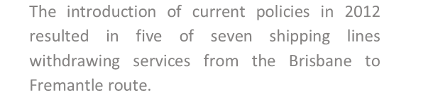

was the objective. Since the introduction of the current policy

shipping lines have withdrawn from the movement of domestic freight with only two operators dominating the coastal trade

market.

The introduction of current policies in 2012

resulted in five of seven shipping lines withdrawing services from the Brisbane to Fremantle route.

Data provided by the Bureau of Infrastructure, Transport and

Regional Economics (BITRE) shows that between 2004/05 and 2013/14 both the weight of coastal cargo and the coastal freight task in tonne/kilometre terms remained static3. The task has been essentially pared back to freights where there is no viable alternative namely iron ore out of the Pilbara, Bauxite out of Weipa, NW Shelf oil and Bass Strait freight. The most recent BITRE data shows that Australian ports handled 101.3 million tonnes of coastal freight during 2014–15, a 2.9 per cent decrease on 2013–14 and an average annual trend decline of 0.4 per cent over the five years to 2014-154. Furthermore despite dramatic growth in total Australia freight over a decade, coastal shipping freight has decreased since 2006-075.

The Coastal Trading Act has also failed to deliver some of its key goals including to “contribute to the broader Australian economy” and to “promote competition in coastal trading”. The effect of current legislation is that the movement of coastal freight is uncompetitive with that of

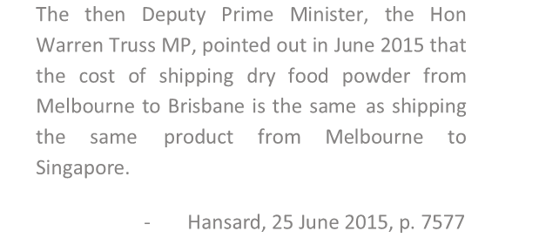

international freight. The high cost of coastal shipping has resulted

in disadvantaging Australian producers and manufacturers attempting to sell domestically because many imports are cheaper than moving freight between domestic ports.

Where the alternative is that moving freight between domestic ports is cheaper than international freight movement, high shipping costs resulting from current policy settings has led to consumers and business paying significantly higher prices due to

poor Government policy.

The then Deputy Prime Minister, the Hon Warren Truss MP, pointed out in June 2015 that the cost of shipping dry food powder from Melbourne to Brisbane is the same as shipping the same product from Melbourne to Singapore.

- Hansard, 25 June 2015, p. 7577

According to a Western Australia’s Department of Planning, rail freight services deliver 80% of groceries by rail from the east coast. Rail is the primary mode of transporting these goods given that it is more cost effective than road. Coastal shipping would be significantly more viable, but the limited services stemming from the

current regulatory regime does not allow for consideration of this option. Accordingly, the prices paid in

3

Australian Sea Freight 2013-14

4 Australian Sea Freight 2014-15

5

BITRE 2016, Australian Infrastructure Statistics Yearbook 2016

Western Australian supermarkets for groceries and other products are infrequently higher than they otherwise should be because the inefficient movement of road freight is incorporated in the cost of these products.

While there are a few options to transport freight in and out of Western Australia, there are even less in Tasmania. According to the Productivity Commission, coastal shipping accounts for 99% of freight moved in and out of the state, which is serviced by high cost containerised

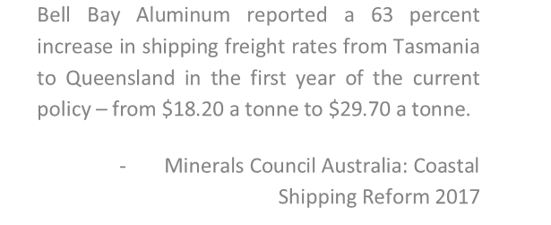

domestic shipping services. Given its reliance on sea transport,

Tasmania is particularly affected by inefficiencies embedded in coastal shipping regulation. The Productivity Commission notes that Government policies put in place to limit the effect of the current coastal shipping regime, i.e. the Tasmanian Freight Equalisation Scheme, have “no coherent economic rationale” as it

falls well short of its intended outcomes6.

Bell Bay Aluminum reported a 63 percent increase in shipping freight rates from Tasmania to Queensland in the first year of the current policy – from $18.20 a tonne to $29.70 a tonne.

- Minerals Council Australia: Coastal

Shipping Reform 2017

Furthermore, the Productivity Commission has also observed that

cabotage restrictions are a significant impost for Australian businesses that rely on coastal shipping, and they deter businesses from using coastal shipping. The Productivity Commission also indicated that cabotage restrictions protect some jobs at the expense of growth in other industries.7

Other benefits of reformed coastal shipping policies are that it facilitates the repositioning of containers from a surplus port to a deficit port by some shipping lines, as was done prior to 2012. According to NSW Ports, as an example, some shipping lines in the past had excess containers in Sydney as an import dominant port, but limited supply in Western Australia that needed containers for overseas export. Coastal shipping policies prior to 2012 would enable some shipping lines to earn revenue on the coastal leg and then re-use the container for an export movement.

A previous Bill to reform coastal shipping, rejected by the Senate in 2015, estimated net economic benefits of close to $700 million and an annual reduction in regulatory burden of $21.4 million.

Given the various issues highlighted above, the Government should in the near future look at meaningful reforms to coastal shipping as it will ease the future pressures on existing freight and supply networks, results in various economic benefits as outlined previously (e.g. lower end costs, jobs growth, etc), and lead to improved environmental outcomes.

*Management of Sea Channels*

Like roads, our shipping channels are a key component of our supply chains enabling the safe and efficient movement of ships transporting goods and passengers. As the shipping industry is moving to bigger and more economical ships, our shipping channels will need to accommodate their movement if Australia is to continue

relying on its over 90% of trade via shipping. The ports at Melbourne and Townsville are already undertaking

6 Productivity Commission Inquiry Report on Tasmanian Shipping and Freight, June 2014

7

Productivity Commission, Regulation of Australian Agriculture: Final Report

operations to ensure that are shipping channels can accommodate bigger ships. It is imperative that governments look to protect the ability of ports to develop and maintain our shipping lanes, instead of creating ‘road blocks’ that will ultimately have significant consequences on the state and national economy.

Sound and scientifically based government approval processes are necessary for ongoing management of our sea channels. Current approaches to dredging in Queensland are not based on scientific rigor and are potentially harming the land. Ports are part of the community and wish to work for a long time to come in their surrounding environment. Accordingly, ports work to develop leading scientific practices in the environmental management of their operations. We seek governments’ cooperation in working together to find optimal solution to managing our sea channels.

**Rail and Road Connectivity**

*Roads for High Productivity Vehicles*

Shipping is the most environmentally friendly and economically viable solution for the mass movement of freight. Likewise High Productivity Vehicles (HPV) are key to the transportation of freight to/from the port and intermodal terminals. However the roads surrounding these precincts and/or along the journey through local council land do not necessarily accommodate the movement of HPVs. This can be due to:

• Turning performance

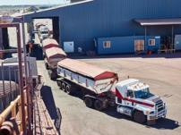

• Road space requirements

• Entry length onto main roads and highways

• Approach visibility

• Vertical (overhead) Clearance

Some local government roads provide a critical link between places for freight such as commercial and industrial sites, and strategic freight networks. However, access to these roads for HPVs is often resisted by local government due to concerns such as:

• lower levels of road network structure capabilities

• limited communication and awareness of the performance benefits offered by these types of vehicles

• concerns about higher risk exposure to the local network without the ability to recover maintenance costs.

As a result, productivity issues arise due to the mismatch between freight vehicles allowed on the freight corridor and the short section connecting an origin/destination point into that corridor. This mismatch often means that businesses will often use a smaller vehicle instead of a HPV to complete the entire journey due to cost and logistic benefits. Accordingly, we see an increase in the number of trucks on our roads. The end result is productivity being reduced along the full corridor and the full logistics task, increases in overall transport costs, poor environmental outcomes and our goods being less competitive in the global market.

Industry estimates indicate that an exporter using a semi-trailer instead of a B-Double due to first/last mile issues could gain up to 50% in freight productivity if able to use B-

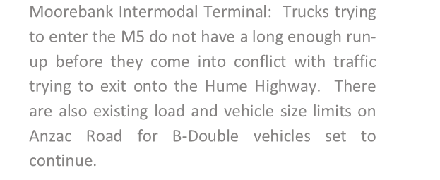

Doubles for the entire journey. Or a facility with B-Double access

and an adjacent Double Road Train or B-Triple corridor could gain up to 25% in freight productivity.

While there has been some focus on this issue over the last few years, not enough consideration is being given if governments are to meet the future freight task. Better ways to working with local government to support and enhance the connection between

Moorebank Intermodal Terminal: Trucks trying to enter the M5 do not have a long enough run- up before they come into conflict with traffic trying to exit onto the Hume Highway. There are also existing load and vehicle size limits on Anzac Road for B-Double vehicles set to continue.

local, state and national road networks will be critical to delivering a more seamless national approach to freight. This includes supporting local network assessments, communicating emerging access issues and sharing assessment knowledge and information.

*Rail Connectivity*

Australia’s rail networks are underutilised for freight movement. This has occurred for various reasons including, port-rail interface issues (e.g. a lack of adequate below-rail infrastructure, lack of flexibility in train windows and unreliable train departure and arrival times), conflicts with passenger movements on the same lines, inconsistent state and territory network regulations and operating conditions, and maintenance and investment costs that are not supported by required utilisation rates.

Maximisation of network capacity by reforming railway access is critical. Current access requirements add significant costs and impediments to railway operations. These impediments include high administrative and compliance costs, constraints on the infrastructure providers’ ability to deliver and price service efficiently, reduced incentives to invest in infrastructure facilities and inefficient investment in related markets

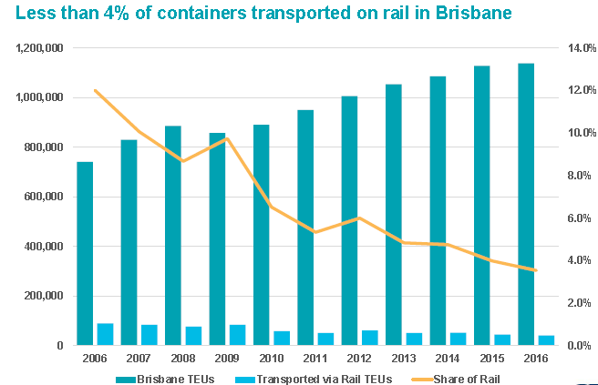

Due to these problems plaguing freight rail, many freight forwarders believe road to be more responsive, reliable and timely. As a result trucks carry over 80 percent of freight to/from ports which cause congestion on our roads, lead to poor environmental outcomes, etc.

Solutions utilised in some parts of the country are to shift more freight movement to off-peak period to level out network demand, decrease congestion on the freight and passenger networks, and improve freight access and reliability. This requires rail network managers to give greater priority to freight rail during off-peak periods, develop timetables that manage the expectations of the population, and undertake other operations and services that are not in conflict with the scheduled movement of freight rail. At present, most road freight movement takes place during the daylight on weekdays so assurances by state governments to more

effectively utilise rail during these windows will create direct competition and build confidence in businesses wanting to utilise rail.

The shared rail network will not always be able to handle the exponential growth forecast for Australia. This is especially the case for Brisbane with the new Cross River Rail that will come online in less than two years and add more pressure on the shared network. In these cases Governments need to consider segregating passenger and freight rail networks, or creating sufficient passing loops to mitigate service conflicts.

If nothing is done to address this issue the network capacity will be reduced, freight costs will increase and rail will become even more uncompetitive. Road freight movements will also rise and create further congestion on the network along with other disadvantages previously mentioned.

*Inland Rail*

The Commonwealth Government $10 billion Inland Rail will be a vital part of the freight and supply network for decades to come. However, the current planning of this infrastructure captures some of the issues highlighted previously in regards to HPVs and the current shared rail network.

Inland Rail does not connect Brisbane and Melbourne, but stops approximately 20-30 kilometers short of both locations, at Acacia Ridge and Tottenham, respectively. Freight will be moved on to:

• trucks that will travel on poorly protected corridors, limiting the efficiency of their movement, creating congestion on metropolitan roads, increasing noise and CO2 emissions, etc; or

• the shared rail network exacerbating the problems with regard to limited windows that freight rail is currently utilising and the unreliability of the network.

While funding may be the likely issue as to why Inland Rail is not being developed to the port, there is still an opportunity to preserve corridors for future investment.

**Corridor Protection**

During the mid-twentieth century jurisdictions had the vision and courage to secure future transport corridors which we now view as essential to the effective functioning of cities. As a result city planning and development was cost effective compared to many current strategies, e.g. digging tunnels to create transport corridors.

The benefits of focusing on corridor protecting are quite clear:

• It enables the development of future infrastructure networks;

• It ensures advanced integration with competing urban planning requirements and land management strategies; and

• It results in lower upfront cost to develop, protect and manage corridors.

The demand for residential land has grown exponentially in some of our major cities resulting in conflicts with the ability to expand transport infrastructure.

What the community is faced with today is failings by Governments in undertaking planning for corridor protection. Infrastructure Australia estimates that the cost of existing urban transport congestion in Australia’s capital cities is forecast to increase from approximately



$14 billion to $53 billion a year by 2031 unless significant

infrastructure investment and planning is undertaken8.

Existing planning and policy illustrate poor outcomes for business, e.g. restricted timings for undertaking commercial activities, sensitively managing urban encroachment, and limited and inefficient transport routes. As a result businesses do not generate profits they plan for or expect, which results in less investment back into the economy and lack of job creation. Businesses are also not investing because they lack the confidence in Governments to prioritise transport infrastructure spending for the future of the country.

The results of a lack of focus on corridor protection also affects our communities, e.g. significant transport and operational noise emissions near or through residential areas, fumes from large traffic volumes, congestion or industrial exhausts affecting residents living

near business precincts or transport corridors, and higher taxes to



Prohibit the rezoning of industrial land to

residential land near precinct such as ports



Prohibit incompatible development along key access roads



Establish buffer zones around business precincts

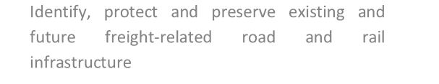

Identify, protect and preserve existing and future freight-related road and rail infrastructure

8 Australian Infrastructure Audit, 2015

Identify future zoning and requirements for business precincts, such as expansion of ports

maintain road and rail because of inefficient operations. These issues not only impact the livability of cities but

affect the health and wellbeing of its citizens.

There is recognition that some state governments are finally investing in infrastructure and transport corridors, but most of it is to alleviate problems facing businesses and communities. The investments are rarely visionary to protect/meet the future requirements of Australia’s population. Without transport

infrastructure the growing communities of our cities will not be able to be serviced. Accordingly, it is essential that greater priority is given to transport corridor protection.

Governments need to go past the rhetoric of 24/7 operational environments, but work together at all levels to implement this

Map environmental planning instruments with consideration of the affected areas around precincts such as ports, thereby not limiting commercial operations

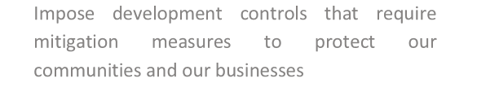

Impose development controls that require mitigation measures to protect our communities and our businesses

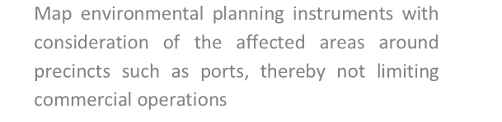

approach. State Government planning needs to be better integrated with local government planning and implementation. The development of regional freight plans need to align with state networks. Commonwealth Government taskforces and agencies should be better integrated with other levels of government in developing their strategies/frameworks/plans. There is no point in placing the cart before the horse and hoping the goods will reach their destination.

This is especially true for the proposal by Infrastructure Australia to develop a National Corridor Protection Strategy. While we fully support the merits of such a proposal, the Commonwealth needs to first initiate engagement with other levels of government to integrate their planning priorities and reach a landing on what is achievable and pragmatic in the short, medium and long term. Only then can a strategy that is supported by all levels of Government carry weight with the community and business.