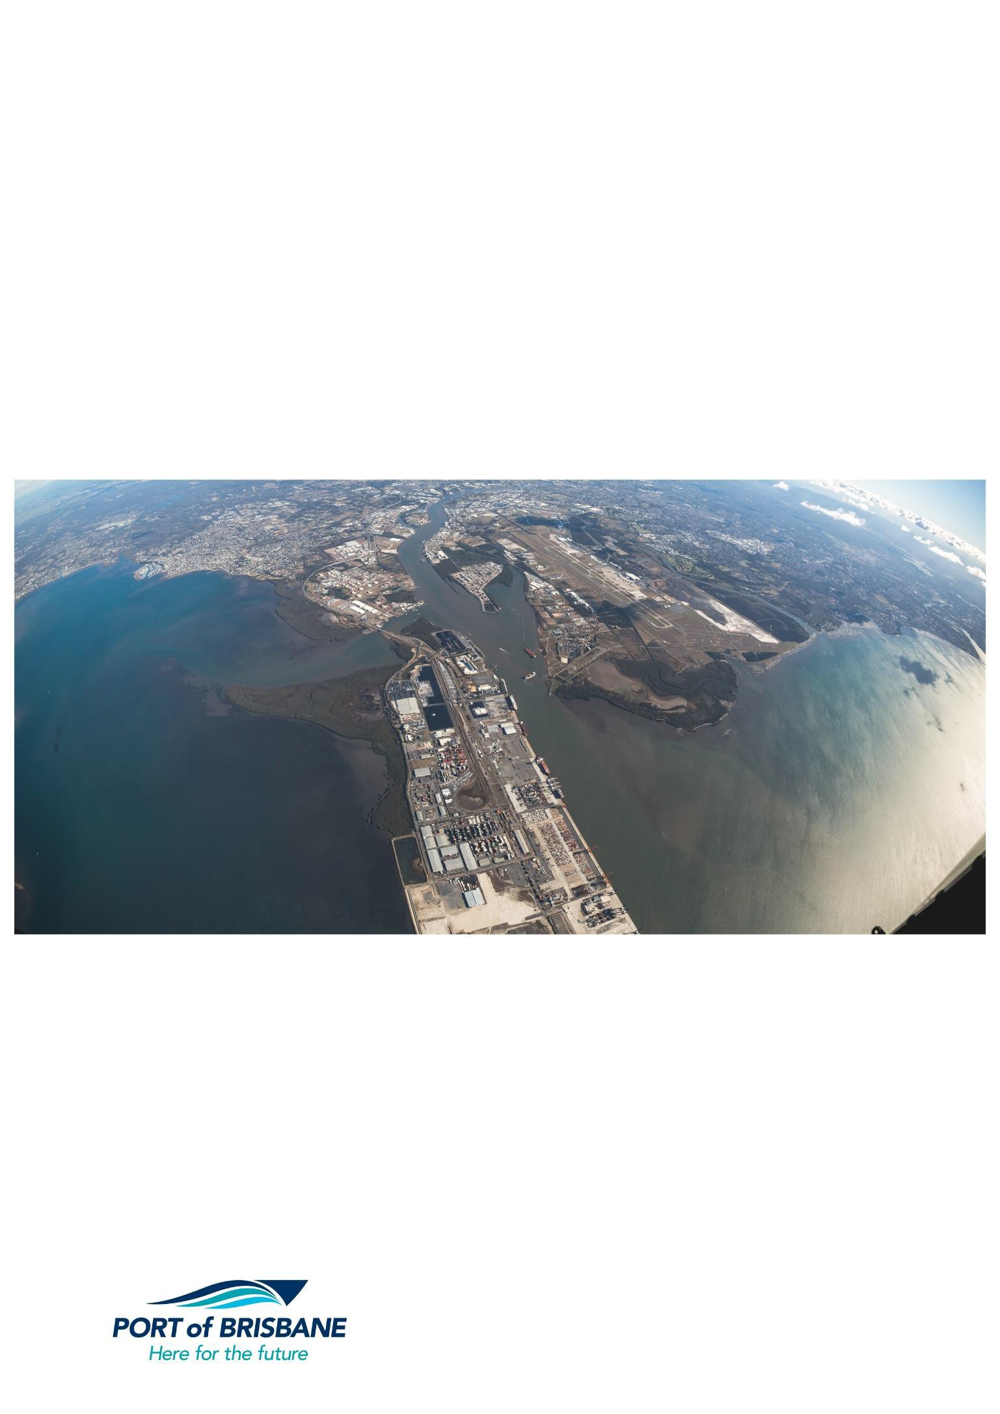

PORT OF BRISBANE RESPONSE TO THE INQUIRY INTO NATIONAL FREIGHT SUPPLY

CHAIN PRIORITIES

JULY 2017

1.0 Approach.................................................................................................................................................... 3

2.0 Priority Issues ............................................................................................................................................ 3

2.1 What constitutes the Port of Brisbane? ........................................................................................................ 3

3.0 What is moving where, why and how? ...................................................................................................... 5

3.1 Key Port Infrastructure.................................................................................................................................. 5

3.2 Quay Line - containers ................................................................................................................................. 5

3.3 Brisbane Multi-modal Terminal (BMT) Intermodal Terminal) ....................................................................... 6

3.4 Road Infrastructure and Access ................................................................................................................... 7

3.5 Rail Access and Capacity........................................................................................................................... 10

4.0 Freight Data Gaps.................................................................................................................................... 13

4.1 Collection of Data ....................................................................................................................................... 13

5.0 Urban Growth Pressures ......................................................................................................................... 14

6.0 Port Corridor Pressures ........................................................................................................................... 14

6.1 Port Rail Connection (PRC) ....................................................................................................................... 14

6.2 Cross River Rail (CRR) .............................................................................................................................. 15

6.3 Bigger Ships/Channel Deepening .............................................................................................................. 15

6.4 Dredging and Land Reclamation ................................................................................................................ 17

6.5 The Future Port Expansion (FPE) Area ..................................................................................................... 19

6.6 Post Completion of the FPE ....................................................................................................................... 20

7.0 Supply Chain Integration and Regulation ................................................................................................ 20

7.1 Supply Chain Integration ............................................................................................................................ 20

7.2 Regulation .................................................................................................................................................. 20

7.2.1 Coastal Shipping ..................................................................................................................................... 21

7.2.2 Regulation of Heavy Vehicles ................................................................................................................. 21

7.3 Empty Container Management................................................................................................................... 22

8.0 Changing Technology .............................................................................................................................. 22

9.0 Capacity Forecasting ............................................................................................................................... 23

9.1 Ability to meet forecast demand ................................................................................................................. 24

10.0 Key drivers of Change for Use in Scenario Planning .............................................................................. 24

11.0 A national freight performance network ................................................................................................... 27

12.0 Summary.................................................................................................................................................. 28

Freight and Supply Chain Inquiry

Department of Infrastructure and Regional Development

GPO Box 594

CANBERRA CITY ACT 2601

Email: [freightstrategy@infrastructure.gov.au](mailto:freightstrategy@infrastructure.gov.au)

28 July 2017

Dear Minister

**Port of Brisbane Response to the Inquiry into National Freight Supply Chain Priorities**

The Port of Brisbane Pty Ltd (PBPL) welcomes the opportunity to comment on, and contribute to, the May 2017 Discussion Paper on the Inquiry into National Freight Supply Chain Priorities. The Government’s decision to develop a National Freight and Supply Chain Strategy provides an unparalleled opportunity to articulate the challenges confronting the nations’ supply chains and set out practical steps to deal with them.

PBPL comments on the Discussion Paper are set out below.

1.0 Approach

PBPL’s approach is not to replicate previous submissions and to only highlight issues from these submissions relevant to this Inquiry. This applies particularly to Coastal Shipping and Inland Rail.

2.0 Priority Issues

The issues which are the greatest priority for the Port of Brisbane and are relevant to the national Freight and Supply

Chain Strategy (the ‘Strategy’) are the Port Rail Connection from Acacia Ridge to the Port (an extension of Inland Rail) and

the need to accommodate bigger ships.

**2.1 What constitutes the Port of Brisbane?**

As a confluence point for land and sea freight transport, the Port handles approximately $50 billion of trade per year including

> 1.2 million containers, >240,000 motor vehicles and large volumes of wet and dry bulk and general cargo.

The Port of Brisbane incorporates a total of ~1,860.5ha of wet and dry land, designated for industrial, commercial and environmental / buffering purposes. These lands include estates in the suburbs of Port of Brisbane (Port Bris, Port Central a nd Port Gate), Lytton (Port West), Pinkenba and Bulwer Island (Port North) and Colmslie (see Figure 1). Collectively, these estates host 30 operating berths over more than 8.2km of quay line.

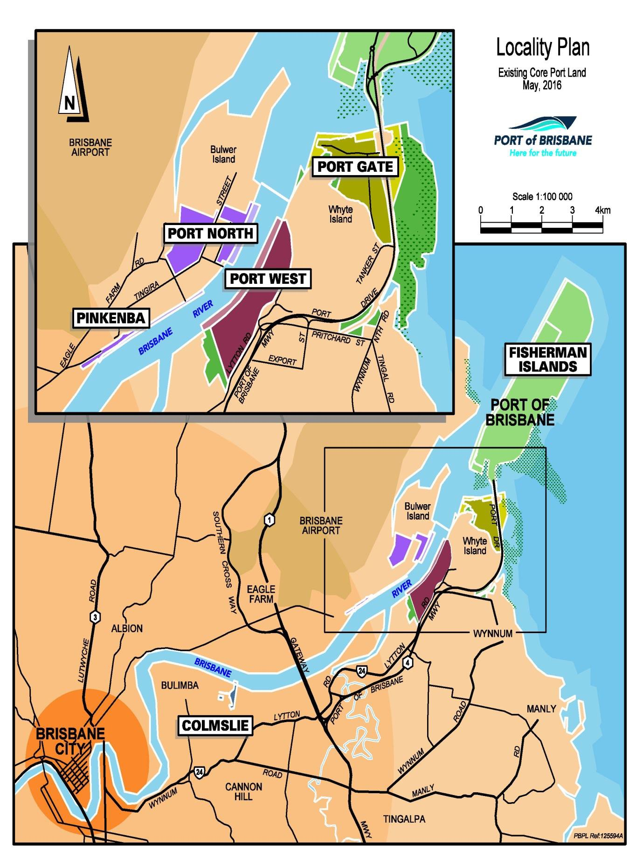

*Figure 1. Port of Brisbane Locality Plan*

The Port is approximately 24km from the city’s Central Business District and features world-class cargo handling capabilities and warehousing facilities. The port provides an interface between rail, road and sea transport (including the Brisbane Multimodal Terminal (BMT)) and over the past 40 years has benefited from infrastructure investment exceeding $2 billion.

Operationally, ‘Port Limits’ (see Figure 1.2) extend geographically beyond PBPL’s ‘core port lands’ from Caloundra to the

southern tip of Moreton Island and some 16km up the Brisbane River to Breakfast Creek. They include the:

• Shipping channels in Moreton Bay, which are dredged where necessary to ensure a minimum depth of 15m below LAT (Lowest Astronomical Tide)

• Channels, swing basins and berth pockets at Fisherman Islands and Luggage Point (channel, swing basin and most berths dredged to a minimum depth of 14m below LAT)

• Channels upriver of Fisherman Islands, which are dredged to a minimum depth of 9.1m

The Port of Brisbane is one of Australia’s fastest growing and most diverse ports. The port primarily serves the communities of Queensland and northern New South Wales and is recognised as a strategic asset of national importance that provides critical links to world markets.

The port is centred within one of Australia’s fastest growing urban areas, South East Queensland (SEQ). This region comprises 11 local government authorities and is the focus of the Queensland Government’s SEQ Regional Plan (SEQRP) which sets out a broad framework for managing growth, change, land use and development to 2031. SEQ is expected to experience continued strong population growth during this period and beyond. This underlying population growth supports the port’s strong trade forecasts and the need for continued infrastructure investment and development at the Port of Brisbane.

The port is located at the entrance to the Brisbane River, on the edge of the Moreton Bay Marine Park. Being a ‘river-mouth

port’ provides the strategic advantage of separating Brisbane Core Port Land from residential and other sensitive land uses.

The closest residential properties to port activities on the south-side of the river are a kilometre away in Wynnum North while on the north-side of the river, the Pinkenba community is approximately 500m from the nearest port lands. Such separation is further supported by substantial buffer areas. PBPL seeks to preserve these strategic advantages and reinforce the precinct- based approach to land use planning captured in the LUP.

One of the key planning advantages of the Port of Brisbane is that nearly all core port infrastructure areas within the Port of Brisbane, particularly at Fisherman Islands, are almost entirely surrounded by water or buffered by other parcels of Brisbane Core Port Land.

A key feature of PBPL’s strategic planning is the minimisation of amenity concerns between core port infrastructure and residential or other sensitive uses, primarily through maintaining adequate buffering between these land uses (including

~635ha of Brisbane Core Port Land zoned as ‘Open Space’, ‘Conservation/Buffer’ or ‘Buffer/Investigation’). It is anticipated that Brisbane City Council’s planning will continue to support this key strategic planning element, while also reinforcing the

importance of the port in terms of the local, regional and state economy.

3.0 What Is Moving Where, Why And How?

**3.1 Key Port Infrastructure**

The Port of Brisbane provides a range of infrastructure and facilities which are an essential component of all import/export (IMEX) supply chains. They key components are: a shipping channel, quay line for ships to be loaded and unloaded, terminals for handling IMEX cargo, road and rail infrastructure, an intermodal terminal (Brisbane Multi-modal terminal (BMT). These are explained below.

**3.2 Quay Line - Containers**

The Port of Brisbane currently has quay line capacity of 8 x 300m dedicated container berths, comprising approximately 2,460 metres of quay line. These are allocated to DP World (wharves 4 to 7), Patrick Stevedores (wharves 8 to 10) and Brisbane Container Terminals, operated by Hutchinson Port Holdings (wharves 11 & 12). The level of utilisation of each of these wharves is currently well below capacity, meaning that substantial growth can be accommodated before additional infrastructure is required.

A number of productivity factors are used to determine the container capacity of the port i.e, quay line, terminal, and landside productivity factors.

Combining trade and productivity targets, the capacity of the current and planned infrastructure of Berths 4-12 (comprising

2,460m of quay line) is considerable. With expected growth and high productivity (2,000 TEUs per quay line metre), existing capacity would not be reached until beyond 2040, which would then require a further berth from that date.

The capacity of the port, based on the remaining available quay line and likely productivity levels (utilising current technology), shows capacity running out in approximately 2040. It should be noted that increasing productivity from 1,600 TEUs per quay line metre to 2,000 TEUs per quay line metre extends the sufficiency of already-committed quay line an extra 14 years (based on long-term trade growth assumptions).

The wharves are necessarily integrated with the terminal operations immediately adjacent to the wharves. As additional berth and terminals are required, the land immediately behind the wharves will be preserved to ensure that this integration can occur.

The current container wharves at the Port of Brisbane have significant inbuilt capacity, meaning PBPL does not need to invest in new infrastructure to achieve greater TEU numbers for a considerable period. Rather, stevedores will need to invest in infrastructure to enable greater TEUs per quay line metre. PBPL has clauses in its lease agreements with stevedores to ensure that this happens.

The staging of developments is such that the next wharf and terminal development, in line with the expectations above, will be required beyond 2040, necessitating the preservation of future wharf and terminal space.

**3.3 Brisbane Multi-modal Terminal (BMT) Intermodal Terminal)**

The Brisbane Multi-modal Terminal (BMT) is an open access intermodal terminal providing an interface between rail/road and the container terminal operations at the Port of Brisbane. The BMT has two side-by-side 900m rail sidings and a dual gauge through-line which are linked with the Queensland rail network. The BMT is an ‘off dock’ facility, in that there is a short road leg between the BMT and the stevedores. Trucks transport full containers to the stevedores and empty containers from the container parks to the BMT.

Containerised trade through the BMT comes solely from north and far north Queensland. In 2016/17, 85% of containers moved on rail were export-related (empty containers for packing and full containers for export).

Cargos generated from SEQ are generally not transported by rail due to higher costs and lower efficiencies. In the longer

term, towards the end of this plan timeframe, the lack of land for additional intermodal activities, combined with increased road congestion may drive the movement of additional containers onto rail, which may warrant the need for intermodal hubs (e.g. at

locations that could include Bromelton, Ebenezer, Charlton Wellcamp etc.). This may also result in logistical solutions to

attract additional cargos from SEQ to use rail instead of road. This would require further investigation in conjunction with the relevant government agencies. There is also a possibility that new container trains may commence services from SW Qld (Goondiwindi/Oakey/Wellcamp) in the near term.

As more cargo is handled on rail, due to road congestion and an expanding hinterland, additional rail paths will become necessary. The economies of transporting cargoes by rail improve with increased competition and rail paths, leading to increased utilisation and lower costs. The development of a dedicated/segregated rail freight corridor to the port will be vital in this regard.

Based on current conditions at the BMT, there is sufficient capacity in the current facility to meet the needs of the port until there is significantly increased rail capacity on the rail network and therefore increased services (the BMT’s capacity is

>250,000 TEU per annum). There is 4ha of land located adjacent to the BMT which could be developed to cater for additional

demand if required. The facility has the ability to accommodate 900m trains without breaking up and up to 1,800m trains by breaking and shunting or 1200m trains with infrastructure changes.

The existing Fisherman Islands rail loop is the smallest gauge rail loop in Queensland and requires a higher level of maintenance because of its size. A maximum rail loop of 180m radius is achievable when required. Presently there is land reserved for an expanded rail loop, with tenure arrangement in place with Queensland Rail Ltd to allow a transition to the new loop. The land is temporarily being used for container and cargo storage and handling.

In the future should coal exports increase substantially, additional rail infrastructure such as rail marshalling sidings and an additional unloading facility may be required. The marshalling provision cannot be accommodated on Fisherman Islands due to existing land uses and leases, however it is possible that a single additional rail line could be accommodated on the bay side of the existing rail corridor (from the Boat Passage through to Pritchard Street).

**3.4 Road Infrastructure and Access**

Approximately 97% of the port’s container trade is presently handled by road, making this form of transport a key consideration in the development of current and future land use. Road transport within SEQ presently remains the most effective and cost efficient mode of transporting export and import containers to and from the port, That said, given that road congestion in SEQ is predicted to increase in the short to medium term, rail’s mode share must increase (particularly where improved rail freight infrastructure and services are provided).

The Port of Brisbane Motorway (PoBM) is the key road corridor connecting the port to the National Highway system (see Figure 2). This recently completed road is motorway standard with two lanes in each direction, posted at 90km/hr. and is managed by DTMR using sophisticated computer systems to monitor traffic. It connects the Gateway Motorway to Port Drive and also services a number of other adjacent industrial areas.

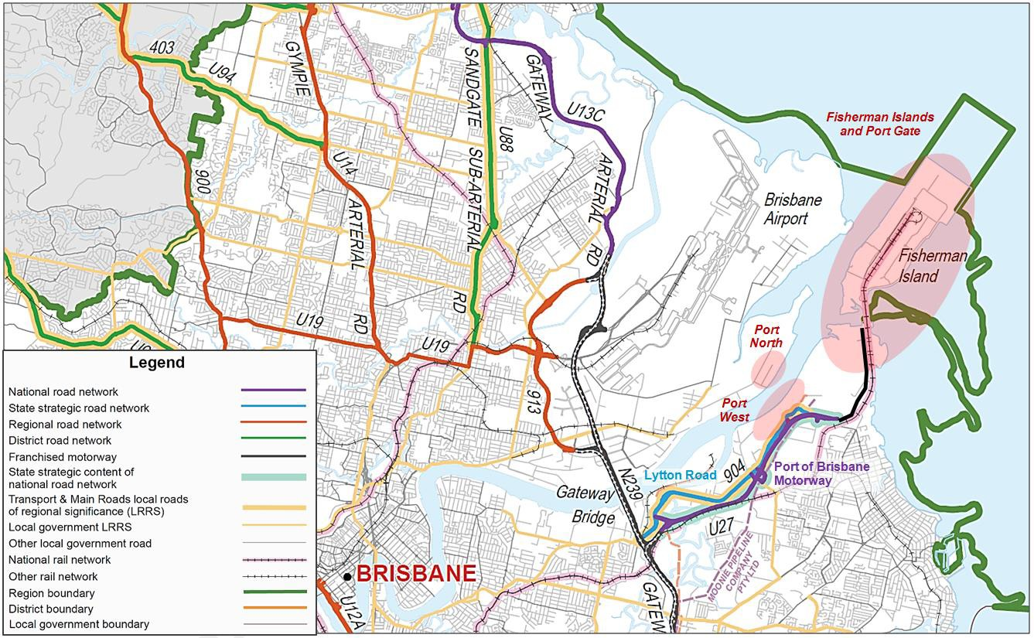

*Figure 2 Local Transport System Interface*

The Department of Transport and Main Roads (DTMR)-managed PoBM is the key road transport linkage for the port and is vital for trade. With its connection to the recently upgraded Gateway Motorway and the motorway network beyond, improved road transport linkages are available to most of the major industrial areas in Brisbane and to the port’s hinterland.

In accordance with its lease requirements (yet several years ahead of demand), PBPL is presently linking the second stage of the PoBM to Fisherman Islands via the funding and management of a $110M upgrade to Port Drive (see figure 3 below). This will provide a four lane motorway-standard connection, an overpass over a major roundabout, and a new bridge with capacity to accommodate the heaviest vehicles. It is expected to be completed in mid-2018.

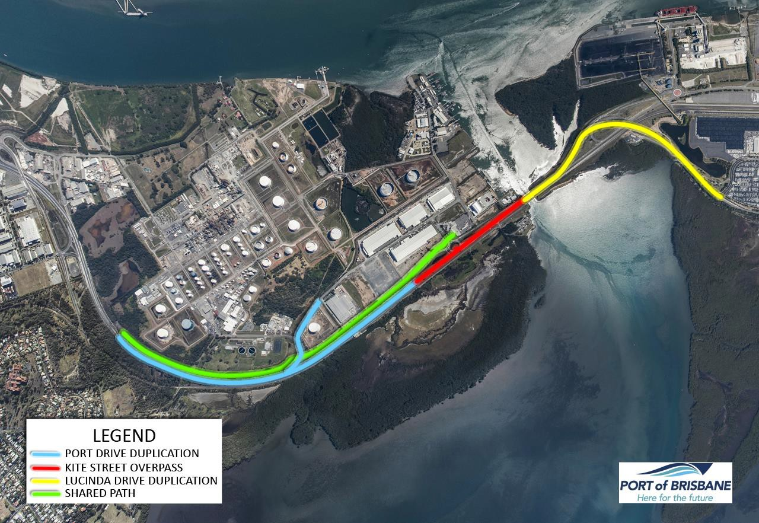

*Figure 3: Port of Brisbane Pty Ltd’s $110 million Port Drive Upgrade.*

While the PoBM is a vast improvement on the previous access to the Port (i.e. along Lytton Road), traffic congestion is already being seen at the south-bound confluence with the Gateway Motorway.

Based on projections for container trade alone (see figure 13) considerable growth in truck movements to and from the port is expected over the next 20 – 25 years

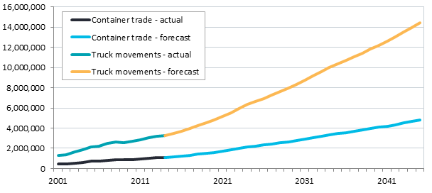

*Figure 4: Projected Container Trade and Truck Movements at the Port of Brisbane*

Notwithstanding improvements to regional road networks, changes in trucking technology and/or mode shifts to rail and coastal shipping, such growth is likely to result in very heavy road traffic congestion (see figures below where the Level o f Service is described on a range from A - being ‘free flow’ conditions to F - being very heavy congestion (Austroads 2009)).

The 2013 PBPL/Queensland Transport and Logistics Council (QTLC) Import/Export Logistics Chain Study identified the following:

• The existing road transport network currently experiences significant congestion at various times of the day

(particularly the morning peak period).

• Commuter periods impact on major road performance, principally to/ from the CBD.

• Industrial areas, including the Port can have longer periods of higher activity during the day.

• Key routes likely to experience periods of congestion in the short-term include:

- Toowoomba Range crossing

- Ipswich Motorway

- Gateway Motorway

- Port Drive

• Key routes used by Port traffic which may be impacted by congestion by 2040 include the:

- Pacific Motorway

- Ipswich Motorway

- Warrego Highway

- Gateway Motorway (existing two-lane carriageway sections)

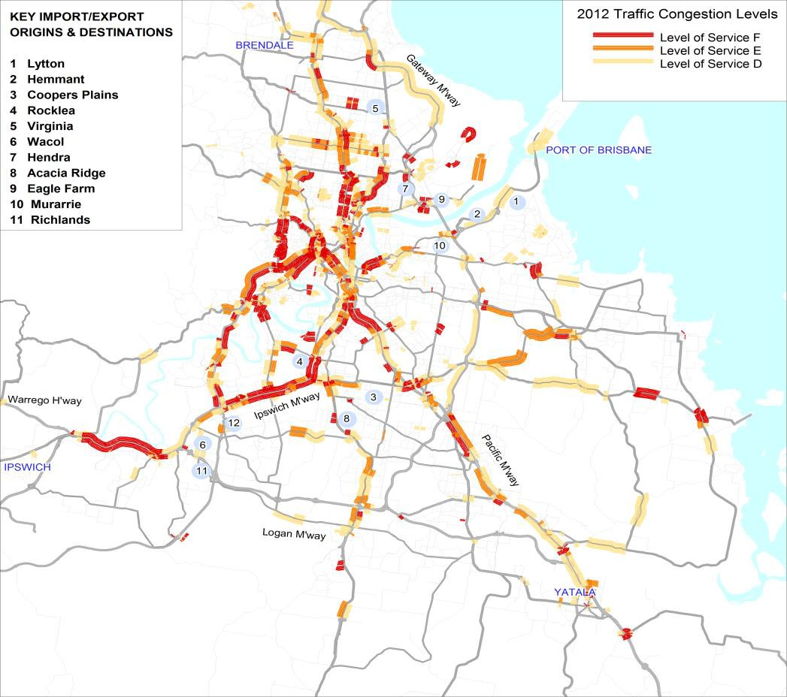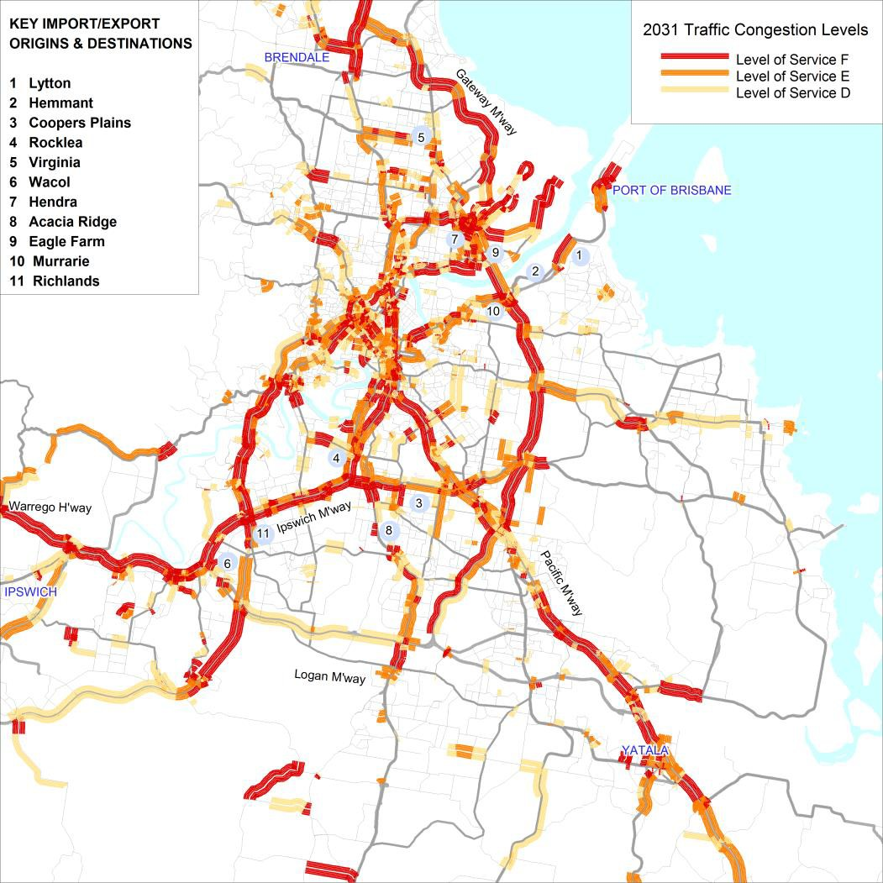

*Figures 5 and 6: Estimated Level of Service for Brisbane and Adjacent Regions 2012 and 2031*

While the recently completed PoBM, and soon to be delivered Port Drive upgrade, will provide significant benefits to the port and its supply chain, road capacity will need to be monitored and maintained to accommodate longer-term demand (see further discussion about this in relation to the national freight performance network).

**3.5 Rail Access and Capacity**

Freight throughput at the Port of Brisbane is growing. By 2040, the port is expected to be handling up to 4 million TEU. However, without dedicated freight rail access to the Port, pressure will increase on existing landside infrastructure, including the broader road and rail network.

The current freight line to the port shares the same corridor as a number of Brisbane’s metropolitan passenger rail services (the Metro). The potential to maintain and/or grow rail freight using this line is constrained as a result of the increasing frequency of passenger rail services. The result is Australia’s poorest performing freight rail share at less than 3% of intermodal freight (see figure 7). Without significant improvements to the existing line and/or the development of a new dedicated freight rail corridor, productivity will decline due to increased road congestion, transport costs will increase and these factors could potentially constrain trade growth through the Port of Brisbane.

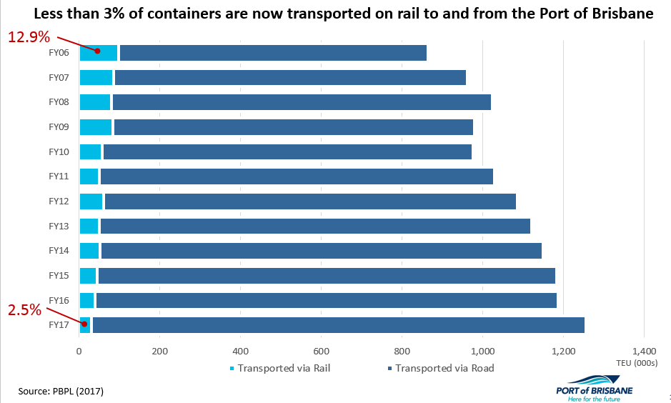

*Figure 7: Continuing Low Rail Mode Share*

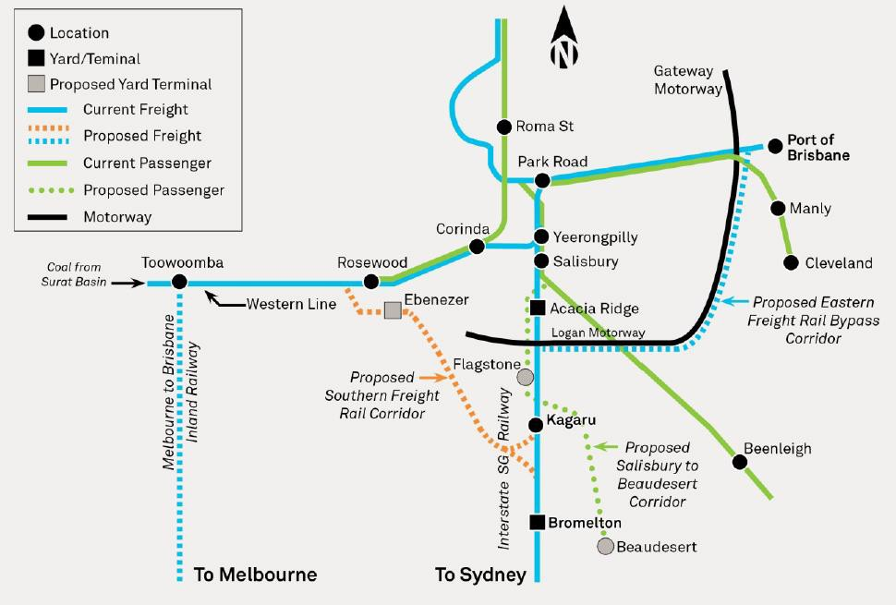

*Figure 8: Port Rail Network (Existing and Indicative Proposed*

PBPL strongly supports the preservation of a dedicated/segregated freight rail corridor to the port which may link with the Federal Government’s Inland Rail project; a 1700km dedicated freight network linking Melbourne to Brisbane that is presently being planned for development over the next decade by the Australian Rail Track Corporation (ARTC).

The Port of Brisbane requires dedicated freight rail infrastructure to handle increasing numbers of containers but also to service the growth potential of the key agriculture and resource sectors throughout regional Queensland and New South

Wales. Once complete, a dedicated freight rail connection to the Port of Brisbane can link to a national freight rail network , providing greater access and modal choice between Australia’s ports. Ultimately, these projects will transform freight transport on Australia’s east coast. Containerised rail export potential through the Port of Brisbane is predominantly primary products (e.g. meat, grain and cotton) but, due to rail capacity / infrastructure constraints, the volume of such trade is presently restricted as is the potential to carry imported products by rail.

The key rail constraints are:

• Passenger volume growth in, and conflicts with, the Brisbane metropolitan network especially the impact of passenger timetables moving to 15 minute intervals (passenger trains are given priority over freight under State government Legislation)

• Restrictive axle-loading limits that reduce freight train load capacity / payload

• Existing restrictions on freight train lengths

• Seasonal fluctuations in demand for agricultural bulk rail services (e.g. Reductions in grain train sets)

• Restrictions on larger locomotives and the inability to carry 9’6” ‘high cube’ containers on the western line due to restrictive tunnel clearances

• Restrictions on bulk coal movements resulting from the limitation of range crossing infrastructure / path slots (that would open up exports through Brisbane from the Surat Basin), and conflict with non-coal traffic

• The competitive prices and flexibility to move cargo via road as opposed to rail potentially stifles modal shift

Rolling upgrades of road infrastructure alone are not seen as providing a long-term solution for the region’s freight transport

challenges due to:

• The capital and higher maintenance cost of road infrastructure

• The negative environmental impacts of road transport

• Increased overall logistics costs associated with road usage (particularly when the true costs of road usage are factored in)

• Safety issues of increasing freight on road

• (Ultimately) increasing congestion at pinch-points even with continual expansion

In line with global transport trends, South East Queensland must plan for a more balanced appropriate modal share for its landside logistics function. The existing transport network does not have the capacity to meet the future freight task in the long-term due to the expected strong, long-term growth in trade.

As a consequence, PBPL initiated a detailed pre-feasibility study in 2013 to investigate the need and priority for a dedicated freight rail corridor connecting the Port of Brisbane, South East Queensland and the regions to ensure Brisbane and Queensland continue to grow and remain domestically and internationally competitive. There are four strong rationales for the Port Rail Connection (PRC):

• Reduces growing congestion problems in South East Queensland by dealing with the growing freight task which ultimately enables better long-term planning in Brisbane that will also deliver:

- improved road safety

- reduced road capital and maintenance costs

- reduced greenhouse emissions

- the potential to provide better inner-city residential amenity and passenger train services by removing freight rail traffic from inner-city areas

• Creates the viable, efficient, long-term route to market that the region’s agricultural industry needs to compete successfully in the future global marketplace as demand for Australia’s food exports increases.

• Unlocks the significant potential for thermal coal exports in the southern Surat, Ipswich and Clarence-Moreton Basins as well as providing a significant funding source for the development of the (PRC).

• Enables the development of the Melbourne to Brisbane Inland Rail to create a truly national rail freight network with the ability to improve the efficiency of container movements on the Eastern Seaboard by solving a key freight bottleneck for containers travelling to or through Brisbane. It also has the potential to increase competition between ports.

**Case Study – The Impact of the Imbalance between spending on roads and rail.**

There appears to be significant imbalance between expenditure on road and rail infrastructure, with roads the winner. This has contributed to the gradual decline in the number of containers transported to the Port from the west on the western and south western lines, to the extent that it is now zero. At the same time improvements on roads has allowed high productivity vehicles (HPVs) with bigger payloads to access the network and get access to the Port.

For example, the ability of the 30m 4TEU A double HPV to access the Port of Brisbane from as far away as Goondiwindi and Moree in Northern NSW has proved a major productivity gain for the transport of containerised grain and cotton to the Port of Brisbane for export, because an A double can transport two heavy 20 ft grain containers and two 40 ft heavy cotton containers, compared with previous vehicles (B doubles and semi-trailers), which are only able to carry one 20 ft grain container or one 40 ft cotton container.

These vehicles have been approved access to the Gore Highway, the Cunningham Highway, the Warrego Highway, as well as the Ipswich, Logan, Gateway, and Port Motorways in order to get to the Port. Although the performance of these vehicles has been comprehensively assessed, they have been granted access to the above roads and motorways because these roads have been upgraded to 4 lanes (two in each direction – except for the Cunningham Highway) and can safely accommodate a longer vehicle. This is the result of significant expenditure of funds on road infrastructure in SEQ over the last few years. It is therefore no surprise that rail is no longer used for the transport of these commodities from the west and south west.

Evidence for this imbalance is provided in the April 2016 Grattan Institute Report “Roads to Riches – Better Transport Investment”. For the period 2005-6 to 2014-15, “Road investment has been notably high in Queensland, both in freight and passenger terms, and not simply because Queensland has a larger road network”. (P27). In addition the DTMR QTRIP investment breakdown of 2 August 2016 indicates that the four year (2016/17 to 2019/20) total of road and rail expenditure is

$17.526m on roads and $2.476m on the QR network. Rail gets 12%.

4.0 Freight Data Gaps

The 2016 NTC Report “Who moves what where” identified a gap in rail data caused by rail operators being reluctant to provide data on a commodity specific level, likely because of concerns about confidentiality. This problem extends to track owners (at least in Qld). They also get limited information from their above rail customers (at least in Qld) beyond tonne/kilometre figures. If they are unable to access more detailed freight data from their customers, it is not surprising governments can’t.

However this issue extends well beyond rail data. The Container Logistics study carried out by PBPL in 2013 required access to container origin and destination data, which was provided by the stevedores and transport operators, and to a l esser extent shipping lines and container parks. The study was carried out by an independent consultancy and required both the privacy and confidentiality of data to be preserved. Had an independent firm not been used, it is highly unlikely industry would have been prepared to provide the data, even though individual businesses would not be identified. The same situation would apply to other major ports which have carried out similar container logistics origin/destination studies.

For this study, PBPL was provided with access to ABF data (with some difficulty). ABF data was vital because it enabled container origin/destination data, especially for imports, obtained from other sources (mainly transport operators) to be validated.

The NTC has only recently announced that the ABS and the NTC have negotiated access to ABF IMEX data on a more regular basis. It is not clear how this data will be able to be accessed, especially by Ports. Nevertheless it is a positive development.

A Grattan Institute Report (mentioned earlier) stated that 20% of road freight (measured in tonne kilometres) occurs within the four cities with major container ports, however it also stated that it could not be valued because the data is not available. A sizeable proportion of this will be IMEX freight.

The ABF data would enable at least the IMEX portion of it to be valued.

**4.1 Collection of Data**

Much of the freight data which is so essential for transport planning is held by the private sector and it is often reluctant to provide it to governments because of concerns about commercial confidentiality. Aside from legislation, one way to solve this would be to establish an independent body (or utilise an existing one) to receive, de-identify and distribute private sector data to government agencies who need it. It could be set up to handle freight data for both the Commonwealth and the States, or each state could set up its own body (or use an existing one) and link it o the Commonwealth.

It is understood that this model applies in other countries, and could be applied here as well.

5.0 Urban Growth Pressures

Urban growth, such as the sun-belt migration experienced in SEQ over recent decades, is simultaneously a key driver of economic growth and (where poorly managed) a potential constraint on port capacity.

Where a port’s footprint (including shipping channels, wharves, berth pockets and swing basins, port land, surrounding buffers and landside freight transport linkages) is not strategically accommodated in local and regional planning, unfettered urban growth can:

• constrain existing freight corridors thus leading to congestion, compromised road safety, increased road maintenance costs, increased greenhouse emissions and reduced economic efficiency. While such impacts are of notable concern to ports and port related industries they also have the potential to collectively reduce a region’s liveability.

• restrict the ability to physically and politically accommodate new transport infrastructure (e.g. new rail infrastructure)

through the burgeoning fabric of a cityscape.

• simultaneously reduce the amenity of higher-order land uses (e.g. residential areas and public realm) and industrial areas where incompatible activities are not appropriately or effectively segregated and/or buffered.

In order to address these challenges, PBPL has:

• developed close working relationships with Brisbane City Council (BCC) and a variety of State regulatory agencies in jointly delivering local and regional land use planning strategies aimed at recognising the port’s primacy as a regional industrial and freight hub;

• sought recognition of the ports existing and future transport infrastructure corridor requirements in BCC’s City Plan

and the SEQ Regional Plan 2009-2031;

• through, its own Land Use and Master Plans sought to accommodate growth while preserve industrial amenity via integrated port buffering strategies;

• sought to achieve the broader planning principles outlined in such government initiatives as the National Ports

Strategy (2010), the Australian Infrastructure Plan (2015), Moving Freight (2013), the Coastal Management Plan

(2014), the Queensland Ports Strategy 2014 and the State Infrastructure Plan 2016.

The pressures of urban growth have a significant impact on the Port of Brisbane. This was clearly demonstrated in the 2013 supply chain investigation by PBPL/(QTLC). Of the full and empty containers (975,000 TEUs in 2012 – now >1.2M TEU) tracked along the Port’s logistics chains, 95% (97% in 2016/17) of all import/export containers were transported on road (with the balance transported by rail to and from the BMT – primarily from the Darling Downs (this service has since ceased), central Queensland and Townsville). Of the containers transported by road:

Import Containers

• About 25% are unpacked in or near the Port

• Over 60% unpacked in Brisbane, the majority being within 40km of the Port,

• Over 90% are unpacked in Brisbane or adjacent regions, the majority being within 100km of the Port

Export Containers

• About 30% are packed in or near the Port

• Over 40% are packed in Brisbane, most being within 40km of the Port

• About 75% are packed in Brisbane or adjacent regions, the majority being within 100km of the Port

• About 25% are packed in other Queensland regions (e.g. Darling Downs, and a small percentage are packed in

Northern NSW)

The container movements by road to importers and from exporters used most sections of the major road network in and beyond Brisbane. Significant congestion occurred on a number of road sections in 2012. The quality of the road network and the capacity of rail to meet the growing freight task (where rail can be utilised in metropolitan and regional areas) are critical to the Port’s ability to optimise freight efficiency by road.

As indicated earlier in the Grattan Institute report (page 29), the importance of urban freight is evidenced by the fact that 20% of Australia’s road freight (measured in tonne kilometres) occurs within the four cities with major container ports: Sydney, Melbourne, Brisbane, and Fremantle (this is further discussed below).

6.0 Port Corridor Pressures

**6.1 Port Rail Connection (PRC)**

As noted above, the current freight rail access to Port of Brisbane is constrained by a range of factors including low

infrastructure standards (axle loads, train length and structure clearances), and availability of train paths. Train path constraints are a combination of needing to share trackage on sections of the freight routes through the Brisbane metro system, and the severe capacity constraints on the main freight link across the Toowoomba Range.

Rail has struggled to provide an effective service for agricultural products from the Darling Downs region, exported through Brisbane, with road significantly increasing its share of this market. Major investments in the road network, and the upgrading of the major road links to the Port for A-Double high productivity vehicles, has significantly contributed to this loss of rail mode share for these contestable freights.

The Melbourne – Brisbane Inland Rail project offers a game changer in respect of the major rail infrastructure limitations on the existing narrow gauge network from the south west to Brisbane (Acacia Ridge). This provides for a significant increase in axle load and maximum train length, and elimination of the vertical clearance constraints to permit high -cube containers and double stacking. The Inland Rail Business Case relies on a significant uplift in railed freight volumes for export through the Port of Brisbane. This includes coal, bulk grain, and containerised grain, meat and cotton exports. There is also an expectation that new, more remote intermodal terminals in South East Queensland (e.g. at Bromelton, Ebenezer and Toowoomba) will result in viable rail port shuttles.

The current Inland Rail project planning stops at the southern entry to Acacia Ridge. Planning for the rail link from Acacia

Ridge to the port has yet to arrive at a definitive future-proofing to meet the future rail freight traffic demand.

The existing route provides for dual gauge, but shares track sections with the Brisbane Citytrain passenger services, has infrastructure limitations (train length and height clearances), and is capacity constrained. It is subject to the priorities of the passenger network operation, with freight curfews during the weekday AM and PM passenger peaks, and a track maintenance and asset renewals closure regime optimised to suit passenger operations. This includes night time closures and extended week-end shutdowns to undergo programmed maintenance and asset renewal activities. It also includes a number of level crossings, including the high volume crossings at Cavendish Road and Kianawah Road.

On 9 May 2017, the Federal Government included $8.4 billion in its 2017/18 budget to deliver the Melbourne to Brisbane Inland rail project. While PBPL supports the project, we also support the development of a dedicated freight rail connection from the Inland Rail project to the Port. In our view, it is necessary to ensure long-term future trade growth does not negatively impact Brisbane’s liveability – if the containers don’t come by rail, they will ultimately come by road

The Minister for Transport, Darren Chester has recently said that the Commonwealth is keen to work with the Queensland Government on how best to move freight from Acacia Ridge to the Port of Brisbane, which involves initial planning on the most efficient way to get to the Port. That work is likely to involve a corridor assessment, and we hope both levels of government can work together to make that happen as soon as possible. There is still no timeframe for when this assessment will be undertaken.

If the Port is not be constrained by reduced rail and road capacity in the future, the Port Connection needs to be constructed in conjunction with Inland Rail.

Measures to preserve the corridor should be initiated now, as the PRC will likely be required within 10 or 15 years, depending on the impact of Cross River Rail (CRR) and the level of congestion on the urban road network.

The impetus for preservation of this corridor now has been highlighted by a July 2017 Infrastructure Australia Report “Corridor Protection – Planning and Investing for the Long Term” which estimated savings of about $66 m in projects costs from protection and early acquisition.

PBPL supports the finding of the Report that a national framework of corridor protection is required to guide coordinated and meaningful action by all levels of government.

**6.2 Cross River Rail (CRR)**

There is an additional rationale for the Port Connection – Cross River Rail (CRR). CRR is a major rail project which is designed to provide a significant increase in passenger rail capacity in SEQ. It comprises the proposed construction of new tunnels under the Brisbane River, a number of new stations, and rail upgrades in the Brisbane metropolitan area. The recent Queensland State budget allocated $2bn towards the project.

CRR will have a negative impact on freight rail capacity, especially for trains from the west and south west, which are required to use the urban network to get to and from the Port. CRR proposes no increase in capacity for freight trains from the west

and south west, which, given mooted increases in the number of passenger trains (the rationale for CRR), will effectively reduce capacity for both narrow gauge and standard gauge freight trains. The Port Connection solves this problem, as it will

allow freight trains travelling to the Port from the west and south to avoid the urban network completely.

**6.3 Bigger Ships/Channel Deepening**

Increasing trade is driving increased shipping efficiencies, with longer, wider and deeper vessels being built to service this demand. PBPL is currently experiencing demand from shipping lines to accommodate up to 8,500 TEU vessels ( a 8,500

TEU vessel recently successfully docked at the Port). Over the next 30 years the maximum size of vessels will increase further: potentially up to 13,500 TEU, neo-panamax vessels. This will drive required improvements to the shipping channel and swing basin(s).

The need to accommodate bigger ships is not confined to the Port of Brisbane given that most container ships call at all the major Australian Ports (Sydney, Melbourne, Fremantle). Therefore this is an important consideration for the Strategy, because if inaction results in vessel restrictions, especially on the eastern seaboard, the economic impact is likely to be significant.

These changes have implications for dredging (and the disposal of dredge spoil) and the need to optimise future channel, berth and swing-basins.

Access to the Port of Brisbane is via Moreton Bay, where deep-water channels are a minimum 280m wide from Fairway Beacons to Entrance Beacons, and the minimum depth is 15m LAT. Pilotage is compulsory for ships over 50m length overall.

Maintaining deep-water access to the port via the channels in Moreton Bay is required to safely accommodate future trade with larger vessels. It is essential that PBPL provides appropriate channel width and depth, berth and swing-basin arrangements as part of its Port Access Strategy.

Port access channel initiatives include the widening, deepening and realignment of the shipping channel.

It is proposed to widen and realign the Spitfire Channel, which will shorten the overall length of the channel and remove two sharp turns. The Spitfire Channel forms part of the 90km navigational shipping channel, which stretches from the northern ti p of Bribie Island to the mouth of the Brisbane River. PBPL has secured approvals to remove a total of 15 million m3 of sand

from the Spitfire Channel over a 15 year period (approval issued in 2006 and amended and renewed in 2012). Presently there is approximately 7.8 million m3 of this approval remaining. Based on current assumptions, the existing development approvals require review in around 11 years. Sand removed will be subsequently used in the reclamation of the FPE and land improvements at Port North.

The Harbour Master and Brisbane Marine Pilots have indicated that current pilot practices can require ships to navigate outside the bounds of the declared shipping channel in parts of the North West Channel in certain circumstances. It is proposed as part of the channel optimisation work (discussed below) to modify/realign the shipping channel to better accommodate vessel manoeuvring and to both optimise natural depth and dredging requirements.

As mentioned, the aim for optimisation of the main shipping channel to Fisherman Islands is to progressively accommodate larger vessels (initially up to 8,500TEU) entering and exiting the Port on commercially viable tidal windows. This may require some truncation of the corners and relatively minor adjustments in the North West Channel. Beyond these initial requirements, the deepening of the Bar Cutting and Fisherman Islands’ existing Swing Basin (currently declared at 14m) and some selective channel deepening (beyond existing 15m declared depths) will be required. Allowing for larger cruise vessels at a new, adjacent deep-water berth and terminal is also viewed as a high priority in this regard.

A new Swing Basin is also likely to be required as part of this channel deepening project due to the length of the larger container vessels, which will not be able to swing in the current Swing Basin if vessels are at the Port North Common User Berth and Caltex berths. A second swing basin is being advocated by MSQ for this purpose and the area opposite berth 10 has been identified should this be required. Further study of these requirements may be required in the medium term to determine future needs for a second swing basin in the Fisherman Islands precinct.

Once modelling results have been verified, to optimal access for 8,500 TEU ships, new operational rules and dynamic systems will need to be implemented by the Harbour Master.

Initial investigations have confirmed that subject to minor dredging and modifications in the North West channel, it will be possible that the larger 8,500TEU container vessels may be able to utilise the existing channel (subject to some realignment) on limited tidal windows. PBPL is therefore finalising additional studies with the Harbour Master and pilots to assess this possibility and/or to identify the extent of any deepening required.

When deepening is required, one of the risks this project presents is the dredgeability of the indurated sand located in the North West Channel. A dredging trial has recently been conducted (December 2014) to determine with more certainty the ability to dredge this material and its engineering properties. Understanding these will inform future dredging costs, the optimal amount of deepening and the disposal strategy for the material.

The Bar Cutting/Swing Basin deepening work could potentially be undertaken by the company’s own dredger (TSHD *Brisbane* or a replacement), but the North West Channel would be required to be undertaken by a contract dredger because of the potential volume to be removed and the hardness of the indurated sand. The deepening work in the Bar Cutting and Swing Basin would be timed to suit the program of the company’s dredger and the phasing of reclamation paddocks’ availability. The material from the Bar Cutting dredging is suitable for bund strengthening works and is critical in terms of the timing and availability of relevant parts of the FPE land for development.

Monitoring and investigation of future channel depth is an ongoing safety and environmental requirement and involves:

• More detailed dredging investigations

• Developing a greater appreciation of industry demand and the progressive trend toward the use of larger cargo ships

• The ongoing reviews of how changes in channel depth will impact upon the FPE reclamation program

• Ensuring the minimisation of any adverse environmental impacts associated with additional dredging activity. In the event that additional channel deepening may be pursued, the relevant state and federal approvals would be sought in accordance with all relevant legislation (including requirements to engage / consult with the community).

The timing of any deepening work will in part be dependent on the demand for larger vessels servicing Australia. This

demand is expected to come primarily from larger container vessels but may also result from coal and wet bulk. The impact of any change on the FPE Reclamation Program will need to be assessed because most of the material from the deepening project is placed ashore into the FPE.

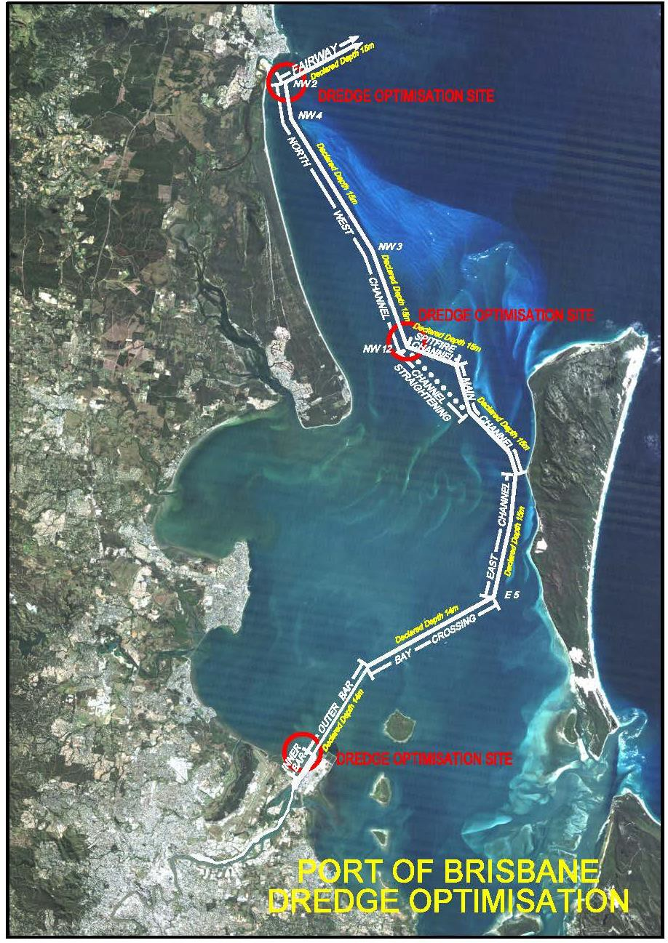

*Figure 9 Channel Optimisation Dredged Investigation Sites*

In a MSQ Report (2008), utilisation of the existing channel was estimated to be at between 20-30%, with 2,500 movements

per annum. Currently the port still has around 2,500 port calls per annum. As container ships generally get larger, this level of shipping movements is not expected to grow significantly, which means that there is more than adequate capacity for at least the next 30 years before we could anticipate any channel congestion impeding efficient port access.

Other initiatives include investigations to incrementally deepen river channels by targeting high points at the Lytton Rocks precinct using PBPL’s Ken Harvey grab dredger. The objective of these investigations is to obtain greater under keel clearance in the river channels if possible.

A critical aspect of maintaining Port access is maintaining a dredge material disposal area for material dredged from channel maintenance, channel deepening and development of new berths.

PBPL is currently working with Maritime Safety Queensland and industry experts to finalise the deployment of an under- keel management system that will significantly improve the navigability of the Port of Brisbane shipping channel. It is intended to introduce this system in 2017/18. It is expected to allow greater channel access for bigger ships and negate/delay the need for the channel to be deepened.

**6.4 Dredging and Land Reclamation**

Currently, material dredged during maintenance of the port’s channels in the Brisbane River (including the Bar Cutting) is us ed as the initial filling layers in the FPE to create new land which will be used in the future for port related development. The river frontage of the FPE will ultimately be developed as shipping terminals and new berths will be dredged along this frontage.

The exact timing for such uses will depend on demand as trade growth continues.

In addition, PBPL currently possesses conditional approvals to place up to 5 million m3 of suitable dredge material at the Mud Island disposal site until 2023 (see diagram below).. Under these approvals all dredged material must be sampled and tested in accordance with the 2009 National Assessment Guidelines for Dredging (NAGD) and only material determined to be suitable for ocean disposal is placed at Mud Island in accordance with the conditions of.

The purpose of these approvals is to accommodate for the Mud Island placement of low risk material thereby maintaining the FPE for material unsuitable for ocean disposal in accordance with the NAGD (either contaminated or not yet tested – i.e. flood material). This arrangement:

• provides PBPL with sufficient State-sanctioned capacity/flexibility to deal with seasonal variations in sediment loads

(up to and including major flood event sediment deposition)

• extends the ‘working life’ of the FPE as a dedicated site for dredged material placement (including material unsuitable for ocean placement)

• avoids the alternative scenario where PBPL and the State would need to seek and sanction time and resource consuming Temporary Emissions Licenses

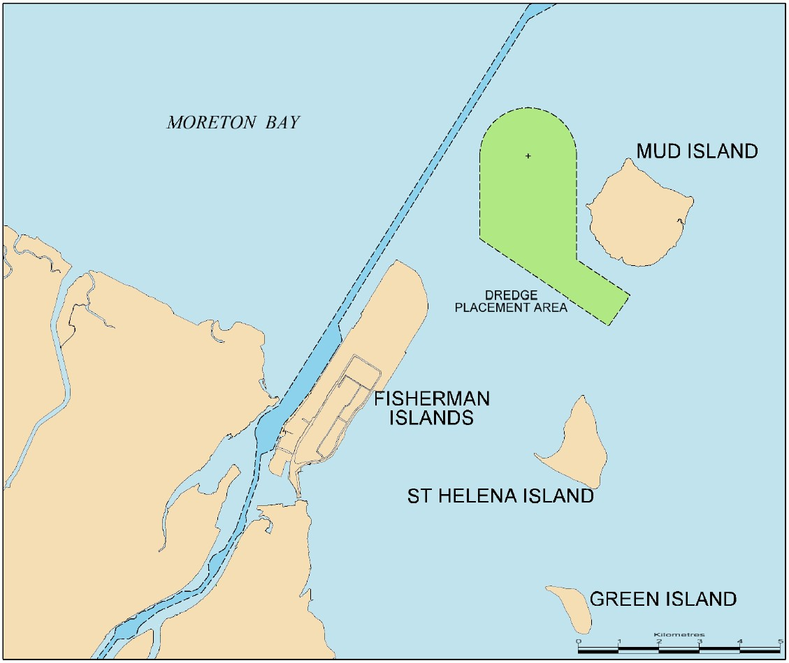

*Figure 10: Mud Island Dredged Material Placement Area*

These factors highlight the importance of the Mud Island disposal arrangements in PBPL’s longer-term planning for sustainable dredged material placement and emergency response to flood events and as such highlights the importance of this arrangement being secured permanently (i.e. beyond 2023).

**6.5 The Future Port Expansion (FPE) Area**

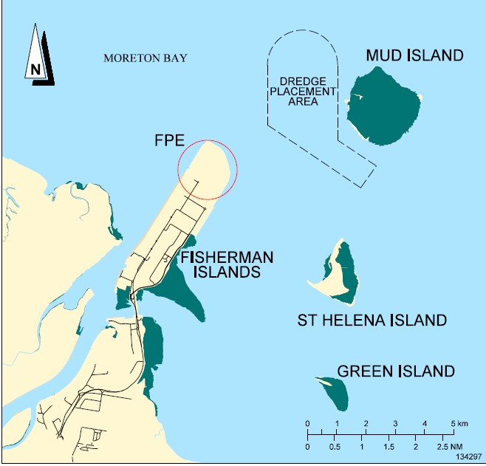

*Figure 11: Future Port Expansion (FPE)*

The FPE (see diagram above) is divided into a series of paddocks that:

• Require the construction of internal walls within the outer rock wall formations

• Are progressively filled and surcharged to create areas that will eventually be used for port-related development

• Primarily use material sourced from capital and maintenance dredging in the Brisbane River and Moreton Bay

It takes approximately 10 years from the commencement of dredged material placement in a paddock, to have land in a geotechnical state capable of supporting port-related industrial development.

PBPL has developed a reclamation model in-house to take into account various drivers and provide an estimate of the life of the FPE based on the numerous factors discussed. Its primary function is to guide the shorter term reclamation and ground improvement activities and inform longer term planning. It is reviewed annually and updated taking into account actual reclamation and ground improvement activities completed during the year.

PBPL’s port reclamation modelling takes into account factors including:

• The anticipated volumes of river material to be dredged (i.e. ~450,000m3 per annum (accounting for flooding events)

until 2026 then reducing notably due to fulfilment of dredging obligations upstream of Pinkenba)

• The anticipated volume of material to be dredged by deepening the main shipping channel. High estimate of volume to be accommodated with the FPE are more than 4M cubic metres

• The receiving capacity of each FPE paddock (including surcharge requirements, ground improvement timings and the requirements for channel deepening)

• Obtaining relevant approvals to place suitable material (i.e. select maintenance material, capital material from the bar cutting and future berth pockets), at the Mud Island Placement Area.

• The requirements for future channel deepening and berth development (e.g. Berths 13-16 at Fisherman Islands)

Based on the factors above, it is anticipated that the FPE could be managed to enable it to receive dredged material from port operations until at least ~2045. This date is subject to change, as land reclamation rates may need to be increased to cater for additional land demand for port industry.

Despite this capacity, a critical issue for the port remains the ongoing need to have a site for disposing / handling of the maintenance dredge material from the river. In this regard, strategies are currently being investigated to prolong the life of the FPE as a dredged material placement site, while accommodating envisaged demand for additional port land. These

strategies include raising the level of the land as much as possible and maximising the capacity of approved offshore disposal locations (e.g. the site at Mud Island).

Another factor is the timing of demand for port land to service the anticipated growth in trade volumes. Although accelerated demand needs to be considered relative to the competing need to preserve/optimise dredged material disposal capacity, if land demand slows there are potential benefits in delaying reclamation activities with regard to delaying cargo, preserving disposal capacity and not hindering land take up. Therefore, land demand needs to be carefully modelled so as to optimise land reclamation to meet demand on a ‘just in time’ basis.

Should the timing for development of additional infrastructure, such as berths 13-16 and channel deepening change, and/or approvals for placing dredged berth material at Mud Island not be renewed beyond 2023, then the capacity of the FPE could be consumed at a much faster rate.

**6.6 Post Completion of the FPE**

To mitigate a key strategic risk, various strategies have been identified for the disposal / handling of material once the FPE can no longer be used for this purpose. Final conclusions on this issue will not be determined for some time, as implementation of a deliberate strategy is some years away and future environmental management requirements are presently unknown.

As the current placement strategies are expected to meet the needs of the port for the medium term, PBPL in consultation with government will continue to develop and refine strategies for material placement beyond this time in accordance with our general obligations under the lease from the State of Queensland. Such investigations will consider the options outlined above in addition to monitoring the emergence of new technologies and commercial opportunities associated with the use of dredged materials.

7.0 Supply Chain Integration and Regulation

**7.1 Supply Chain Integration**

Whilst the physical movement of freight along both domestic and international supply chains in Australia is probably efficient, the lack of supply chain visibility across transport modes generates inefficiencies and costs to freight owners and end users /customers alike. This is largely because of poor, inefficient or incompatible interfaces between systems and organisations within supply chains, over-reliance on manual transactions, and lack of data standards and interoperability between systems, which results in loss of visibility and increased costs. This has been demonstrated in a recent project undertaken by Austroads “Investigating the potential benefits of enhanced end to end supply chain visibility”

This not a major problem for integrated supply chains which have effectively removed the interfaces by internalising them eg, international freight forwarders which control the movement of import cargo from overseas origin through to destination DCs in Australia. However most supply chains comprise a number of independent entities which are required to interface with each other to meet freight owners’ requirements.

The inefficiencies of import/export (IMEX) container supply chains are a particular manifestation of this issue, because of the number of organisations involved (eg, importers, exporters, forwarders, customs brokers, stevedores, shipping lines, road and rail transporters, container parks), and the involvement of regulators such as ABF and Quarantine. These inefficiencies can be overcome by a Port Community System (PCS) or Port Information System, which when developed, becomes a key piece of port infrastructure, albeit IT infrastructure.

The technology to develop a PCS exists now.

The Port of Brisbane is investigating the development of a PCS to assist its stakeholders to reduce supply chain costs, especially for exporters.

**7.2 Regulation**

There are two areas of regulation which are adversely affecting the Port and its supply chains: coastal shipping and the regulation of heavy vehicles.

**7.2.1 Coastal Shipping**

The current regulatory regime has effectively resulted in uncompetitive coastal shipping services to the detriment of farmers, manufacturers, and the economy. Details of the impact of current regulations were outlined in 2015 in PBPL’s submission to the Australian Government’s Options Paper on “Approaches to regulating Coastal Shipping in Australia”.

One example from the PBPL submission is illustrative. In 2010 there were seven shipping lines providing regular efficient and competitive services from Brisbane to Fremantle. Immediately prior to the introduction of the revised coastal shipping regulations in 2012, five of the seven lines withdrew their services from this route. This situation remains with only one line offering a service to Fremantle.

A recent March 2017 Discussion Paper “Coastal Shipping Reforms” proposed limited changes to existing regulations to make

them more workable and flexible. Our submission (PBPL ref A1463616 dated 11 May 2017), strongly supported the proposal.

PBPL believes these reforms will open further opportunities for coastal shipping.

PBPL maintains that current regulatory arrangements have resulted in reduced coastal shipping services and an uncompetitive Australian shipping industry. PBPL believes the proposed reforms and amendments will allow the shipping industry improved opportunities to respond more readily to commercial opportunities to carry domestic cargo.

**7.2.2 Regulation of Heavy Vehicles**

The adoption of Heavy Vehicle National Law (HVNL) and the creation of the National Heavy Vehicle Regulator (NHVR) in

2014 was a step in the right direction to provide a national approach to the regulation of heavy vehicles and reduce the impact of jurisdictional differences in relation to regulation and access.

Nevertheless it is taking a long time to get any meaningful benefits from these changes and in some cases the reverse has occurred. One reason for this is that there are now three agencies involved in regulating heavy vehicles: the NHVR, state jurisdictions (road managers for state-controlled roads and state policies), local councils (road managers for council roads), and non-council road owners eg, Ports.

The major issue is access and the major part now played by road managers especially for vehicles which require perm its to access the network. One effect of the new legislation is that road managers have 28 days to consent to requests for access. This is too long and is contributing to delays. It should be acknowledged however that Councils were unprepared for the introduction of HVNL and many do not have the resources to provide a quick turnaround of access requests. Delays inevitably result.

This issue has been exacerbated by the increasing preponderance of high productivity vehicles (HPVs) operating under Performance Based Standards (PBS) Scheme. These vehicles provide safety and productivity benefits but they also require permits to access the road network, which means operators have to apply and pay for permits, often for individual vehicles, and road managers have to consent to access to their roads. Delays in getting permits are common. In addition the visibility of road access decisions is often obtuse. Similar issues exist with over size, over mass (OSOM) vehicles, because many loads moved on these vehicles require a permit and often a police escort as well.

PBS vehicles are also required to participate in the Intelligent Access Program (to confirm route compliance) and in Qld, must be equipped with an On Board Mass (OBM) system to confirm mass compliance, both of which are costly.

These inefficiencies are of direct concern to the Port of Brisbane, because as indicated previously, it is a ‘truck’ port: it relies on trucks for the transport of 97% of its IMEX cargo. It is now heavily reliant on the 30m long 4 TEU A double, a permitted HPV, to transport containerised grain and cotton to the Port from Northern NSW and southern Qld. In 2017, the A double represents 10.2% of container trucks at the Port, compared with 10% for the ubiquitous B double. The utility and importance of this vehicle has grown quickly in a short period: in 2014 it represented only 4.8% of container trucks.

There are a number of ways of streamlining and simplifying access and permit requirements, for example, pre-approving access for a class(es) of vehicle to the relevant road network, or using a Notice (which negates the need for a permit), or

‘gazetting a road for access to a class(es) of vehicles. In Queensland, up until two months ago, no Council road or State- controlled road had been pre-approved for any class of vehicle (PBPL pre-approved access for A doubles to Port roads

three years ago, the only road manager in Qld so far to have done so).

The simplest way of streamlining and simplifying heavy vehicle access is to get of, or reduce, the number and class of vehicles which require permits.

Two examples highlight the issue:

• About 12 months ago, the Port of Brisbane missed an opportunity to import blades and turbines for a wind farm project in Northern NSW. The length of the blades required them to be transported on extendable trailers, and required a police escorts. The difficulty and costs of co-ordinating police escorts in two states with different police forces and requirements – NSW and Qld – was factor in the cargo being imported through Newcastle.

• 30m A doubles are classified as road trains in NSW and are required to have a “ROAD TRAIN” sign affixed. In

Qld a “LONG VEHICLE” sign is mandated, which means the signs have to be changed at the NSW/Qld border, in

Goondiwindi, every time an A double crosses the border.

The real issue here is the economic and cost impact of existing heavy vehicle regulations and processes. Anecdotally it is significant, but it has not been measured or quantified.

One of the key actions of the National Land Freight Strategy 2013 was ‘to review the economic impact of the national transport regulation reforms”. This has yet to occur.

At the very least the issue of permits and access needs to be measured as part of the National Freight Performance

Network (further discussed below).

HVNL should be amended to reduce the time allowed for road managers to consent to access requests. 7 days seems reasonable.

**7.3 Empty Container Management**

Empty container management, and especially transport, is a major task for the container logistics chain. In 2016/17,

312,149 full TEUs were exported, as against 249,897 empty TEUs. In the same year 505,342 full TEUs, and 70,669 empty TEUs were imported. The on-hire of empties for export, and the de-hire of empties post unpack of imports consumes an equivalent amount of transport resources as the movement of full containers. Most of these movements occur on SEQ roads, because this where container origins and destinations are located.

The major issue is the imbalance between imports and exports, including a mismatch between the containers used for most imports (40 foot) and a higher proportion of 20 foot containers required for exports, especially agricultural products eg, grain and meat. Also the propensity of shipping lines to reposition empties back to load ports, mostly in Asia, occasionally reduces the supply of available containers for certain exports. This has been evidenced recently with some shortages of 40’ containers for cotton and other cargoes being experienced during peak demand periods.

The Port of Brisbane is fortunate to have its three largest empty container parks (ECPs) (about 80% of ECP capacity) located close to the wharves, which reduces the cost of transport of empty containers to/from the wharves. However it does require empty containers to be transported to exporters’ premises within SEQ and adjacent regional areas, and from importers (most within SEQ) to ECPs for de-hire.

8.0 Changing Technology

The most important technological trends from PBPL’s perspective are the rapid advance of electrified, fully automated road

vehicles resulting from advances in:

• Intelligent transport systems (ITS) – systems in which information and communication technologies are applied in the field of road transport, including road-side infrastructure, vehicles and users. (ITS) technologies have a broad scope and comprises many component technologies, some physical, some software or computational.

• Cooperative-ITS (C-ITS) – technology that enables vehicles to wirelessly communicate with other vehicles (V2V), infrastructure (V2I), or other parts of the road network

• Automated Vehicles – vehicles capable of sensing their environment and navigating without human input.

These technologies may help ameliorate the two largest social costs associated with road transport – accidents and congestion. Applied to freight vehicles, they have the potential to significantly reduce freight transport costs. A recent International Transport Forum (ITF) report “Managing the Transition to Driverless Road Freight Transport” estimated a reduction in operating cost from adopting driverless trucks is in the order of 30% compared with today’s costs. US studies suggest similar cost reductions.

The Port of Brisbane is already experiencing the impacts and benefits of these technologies. With all three stevedore terminals being semi-automated, it is the most automated port in Australia and probably the world. Driverless vehicles are already being used at the Patrick terminal to transport containers within the terminal and to load and unload trucks. In addition the receival and delivery process for trucks of all three stevedores is now largely paperless, which has almost eliminated truck queues and reduced truck turn times (TTTs).

There is an opportunity to extend automation beyond the stevedore terminals. This is being investigated, including the use of public access roads.

The inexorable trend towards autonomous vehicles, coupled with complementary concepts such as Mobility as a Service (MaaS), are already having a significant impact on freight transport, and this will only accelerate as these technologies mature.

It will also have significant impacts on infrastructure and transport planning. Potential impacts are:

• Automated vehicles will require high quality line markings, traffic signals and other road infrastructure.

• ITS could optimise the capacity of new and existing infrastructure and substitute for new infrastructure.

• The combined effects of increasing road capacity and changes in vehicle kilometres travelled may change the need for road infrastructure. It is not clear whether that change will be an increase or decrease.

• Autonomous vehicles are likely to add pressure to maintenance processes due to their reliance on accurate road markings and signage.

• In the future road ‘upgrades’ might not mean increasing the physical space for vehicles but instead focus on

improving the interface between vehicles and infrastructure.

• Because this is new technology there is little real-world data that can be used, so quantitative processes involved in transport planning eg, transport modelling, will need to initially rely on assumptions.

• Road pricing. Improving levels of automation will be accompanied by significantly more data, which will likely provide the basis for a more appropriate and accurate road pricing model. In fact there is an argument that the

development of road user charging models should be accelerated to accommodate – and anticipate - the march

towards autonomous vehicles.

Most medium to long term transport planning does not include planning for automated vehicles. Future business cases for both infrastructure upgrades and new infrastructure should include the impact of autonomous vehicles.

9.0 Capacity Forecasting

Container trade revenue makes up just over half of the Port of Brisbane’s overall trade revenue and has been the fastest

growing commodity stream over the past 10 years.

The composition of full imported containers is made up of consumer goods (grocery items, clothing, electronics etc.), durable goods (such as whitegoods and furniture), building products and equipment and materials to service infrastructure projects. Import trade figures are closely aligned with the QLD and Northern NSW economic, population and GSP growth results. By contrast, the export container trade through Brisbane has a high seasonal and weather dependency in regards to export of agricultural products.

The cargoes that make up full export containers are primarily agricultural products such as wheat, chickpeas, sorghum, cotton lint, cotton seed and refrigerated beef. These products are sourced primarily from Queensland regional areas and some from northern New South Wales.

Over the last 5 years average container growth at the port of Brisbane has been ~3.9% per annum. Container growth has a very high correlation (>90%) to gross state product (GSP for both full imports and full exports). In the long run, the correlation of full import and full exports growing at 1.1 times nominal and real GSP is expected to continue.

Trade forecasts are considered by commodity including containers (and certain cargoes within containers), general cargo, motor vehicles, dry bulk (including coal), wet bulk and others. Container trade figures are depicted in the two charts below (over the page).

5,000,000

4,500,000

4,000,000

3,500,000

3,000,000

**TEUs**

2,500,000

2,000,000

1,500,000

1,000,000

500,000

-

7%

**Container Trade**

6%

5%

4%

3%

2%

1%

0%

Container Volumes Growth rate (rhs)

*Figure 12: 30 year Container Growth Targets*

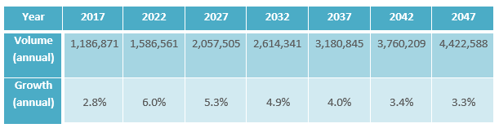

*Figure 13: Container Trade Growth to 2047*

**9.1 Ability to meet forecast demand**

Previous discussion about the Port of Brisbane’s capacity indicates that we have plenty of infrastructure capacity in terms of land, road, rail, berths, shipping channels, wharf terminals, and the BMT to meet trade demands in both the near and medium term. Beyond that the major issue for the Port will be truck access, not at the Port, but on the urban road network, because of its reduced capacity and increased congestion. This is why it is so important to increase rail’s share of the IMEX freight task from 3% now and build the Port Rail Connection to facilitate this.

Also in the near and term our shipping channels can also accommodate bigger ships, especially with the deployment of a new under-keel mismanagement systems (discussed previously). Longer term, the channels will likely be required to be deepened, the issues about which were also discussed previously.

10.0 Key drivers of Change for Use in Scenario Planning

PBPL has undertaken a rigorous analysis of longer term economic growth scenarios and the impacts on global trade and the Port of Brisbane. This was achieved by undertaking a series of interviews with senior executives and business leaders, allowing them to articulate their long term perspectives and put forward future scenarios. The result is a collection of high- level observations linked together by a consensus view of those interviewed.

Two broad scenarios were considered: positive growth and less positive growth. In both scenarios four broad therres were considered: growth and the macroeconomic and political environment to support it (or not), social environment, technological environment and natural resources.

Page 251 24 July 20171 Response to the Inquiry into National Freight Supply Chain Priorities

***PORT* of *BRISBANE***

*Here for the future*

The key drivers of change identified in this analysis are as follows:



|  |  |  |
| --- | --- | --- |
| **Themes** | **Positive Growth** | **Less Positive Growth** |
| **Macroeconomic and Political Environment** | • Australian GDP growth resumes at higher rates.  • Consumer confidence returns  • Australian agriculture becomes the ‘deli of  Asia’.  • Technology advancements emerge at an increasing pace  • Boom-bust economic cycles return with greater volatility and ferocity.  • Corporations shift to energy self-reliance | • Global growth slows.  • Consumption remains subdued.  • Technological disruptions continue, reduces the flow of bulky goods.  • Australian resources continue to lose competitiveness.  • Slow decline in oil demand continues.  • Political decisions increasingly focus on the short term.  • Nationalism and parochialism put pressure on free trade. FTAs break down.  • Governments become handicapped by slow decisions.  • Deficits have developed.  • Governments become more interventionist. |
| **Social environment** | • Immigration is increased to leverage growth  • Population continues to move towards urbanisation  • Lower cost of living  • Car ownership decreases in the city, but not the country.  • Discretionary spend is focused on services and experiences  • Social expectations and awareness of environmental impacts and emissions continues to increase. | • Lower growth expectations lead to subdued consumer sentiment.  • Sharing economy develops significantly.  • People live longer, increased proportion of older people.  • Social cohesion drops. Social tensions increase.  • Population growth slows  • People work to their 70s as retirement costs escalate. |
| **Technological**  **Environment** | • Coal energy has become more viable due to Clean Coal.  • Solar technology has become economically viable.  • Commerce has methods of leveraging big data.  • The new data-sharing environment is creating high productivity and enabling  bigger and faster DCs.  • ‘big data’ has become a commodity, but the analysis of it is creating real value. With size and capacity increasing at  pace.  • Drone technology being used in freight industry | • Continued evolution of IT disrupts industries and reduces appetite for traditional investment models and assets.  • Moves to driverless freight vehicles limited by relative economics and slow pace of legislative change. Also limited take-up of driverless cars.  • Automation in most sectors slows.  • Sharing of data between businesses is less advanced than consumer data analytics.  • Global trend towards larger ships remains and supply chain benefits are demanded by customers.  • Ports start to see excess capacity in terminal operations from more efficient  handling driven by data mining.  • Increased pressure for technological changes in dredging operations driven  by environmental concerns.  • Ports are faced with higher cost infrastructure demands such as deeper channels to handle ever larger ship  sizes.  • Drones available but impact on supply chains limited. |

**Natural**

**Resources**

• Demand from Asia for food has increased.

• Australian exporters have responded by increasing exports of fresh and

packaged goods to the region.

• Demand for coal and oil remains strong

• Move toward renewable technologies not significant in 20 year time frame.

• Globally coal remains most efficient source of energy, but Australian mines

further up the cost curve.

• Seaborne coal traffic displays anaemic growth.

• Oil prices drop < $50 per barrel.

• Demand for unleaded petrol slows.

• Limited action or uncoordinated action by world governments on climate change.

• Solar has not achieved sufficient critical mass to replace coal.

• Food and fresh water experience periodic shortages resulting in more

price volatility.



Following this exercise in planning for the future, PBPL has incorporated the insights into its own planning frameworks, including the Port of Brisbane Master Plan 2016 – 2046.

11.0 A National Freight Performance Network

PBPL supports the development of a National Freight Performance Network. It is a welcome initiative which has the potential to provide useful productivity and efficiency data, provided the right things are measured and it is clear how they will be used to improve productivity or efficiency.

The ‘Waterline” publication produced by BITRE which provides data on wharf-side and land-side container movements for the five major port terminals is perhaps a model. It provides valuable productivity data, even though there is a six month to eight month lag between the period being reported on and the date of publication, which reduces its utility somewhat.

The DIRD Working Paper “National Freight Performance Framework” indicates that a number of new indicators are proposed (tables 1.2, 1.3 and 1.4). Indicators regarding access and land use/encroachment are supported, however more thought is required as to what needs to be measured and how the measure is to be used to report on and improve productivity or efficiency.

• Access The need for additional measurement to provide better visibility, especially related to productivity, was outlined previously. The most important issues to be measured are: the number of permits being issued for each class of vehicle, the length of permits, the time taken to issue them, the number of applications being refused (and why), the percentage of the network (including council roads) accessed by each class of vehicle, the incidence of pre-approved or gazetted routes, and routes subject to a Notice. Access/regulation indicators need to focus on the impact on productivity. We would be very happy to assist in developing detailed measurements.

• Measurement of congestion. This is an excellent idea, especially for the major roads which carriers use to get to the Port. We would be happy to assist to determine detailed measurements and locations. To demonstrate its intent, we intend to determine a number of pre and post construction measurements for the PDU in order to demonstrate its benefits to the Port’s stakeholders. They will mainly focus on average speeds, level of service (LOS) measurements, and trip times from various origins and destinations and at various times of the day and the weekend. A measurement in relation to access will also be developed. Similar measurements could be replicated for other infrastructure projects.

Table 1.3. The information in this table is too general to assess the utility of the ‘potential supply chain indicators’, however containerised and non-containerised transport should be differentiated if possible, particularly for export commodities.

There seems to be a limited nexus between the DIRD Working Paper and the Transport and Infrastructure Council (TIC) “National Rail Vision and Work Program” for example, none of the Proposed Rail Activities in the TIC document refer to the need for, or development of, rail productivity or efficiency measurements.

One productivity measure which has not been suggested is a comparative measurement of the funds being invested in rail infrastructure compared with road infrastructure. The utility of such a measure was discussed earlier in the Case Study.

12.0 Summary

The following is a summary of the key points/issues PBPL believes should be reflected in the Strategy:

• The critical importance of the preservation of the Port Rail Connection as part of a wider requirement to have priority transport corridors and precincts preserved across all jurisdictions.

• The importance of ports being able to handle bigger ships in the near term and the impact it will have on the country if measures required to accommodate bigger ships are thwarted.

• The importance and impact of urban growth pressures on freight and the need to measure and monitor the impact of increasing congestion on freight movement.

• The potential for lower costs and greater efficiency offered by coastal shipping and the adverse impact of current regulatory arrangements on farmers, manufacturers, and the economy more generally.

• The need to incentivise the sharing of supply chain data amongst supply chain participants to facilitate greater efficiencies and lower costs.

• Consideration of arrangements to facilitate the provision of freight data to governments for transport and infrastructure planning purposes which protects commerciality and confidentiality.

• Ensuring that advances in technology and automation are reflected in future transport and infrastructure planning.

• A review of the economic and productivity impact of the current regulation of heavy vehicles, including the development of measurements which provide better visibility and allow productivity to be measured.

• The development of a National Freight Performance Network.

Yours sincerely



Andrew Rankine

**Logistics Manager**