Submission to the

**DEPARTMENT OF INFRASTRUCTURE AND REGIONAL DEVELOPMENT Inquiry into National Freight and Supply Chain Priorities**

**INTRODUCTION**

This submission to the Inquiry is made by Orange City Council. The City of Orange is located in Central NSW in the Central Tablelands and:

• is 257km (3 hours 38 minutes) from Sydney CBD and 280km (3 hours 23 minutes)

from Civic (ACT)

• has a Local Government Area (LGA) population of 42,356

• has a regional (SA3) population of 60,105

• is the fourth largest inland city in NSW and the 36th largest city in Australia1

The Council is the key body for attracting industry, business development and relocation to the city and the region, and it actively seeks diversification of the local economy. The diversity of the economy, amenity and quality services have contributed to attracting people to relocate to Orange.

The Orange economy was traditionally built on agriculture and mining. Newcrest Limited continues the tradition of mining with its Cadia Valley Operations and is a major economic contributor. The Orange region continues to expand its range of agricultural produce. From fat lambs and wool to dairy and beef cattle, from intensive horticulture to cropping. Orange is a diversified agricultural region and is becoming well known for high altitude wine and niche agricultural product.

The region has not relied solely upon its agricultural and mining activities, and has been proactive in encouraging diversification of other industry sectors as well as encouraging innovation and entrepreneurship. This approach, together with its location, has seen Orange grow to be the largest city in the Central NSW Region and a major regional service centre.

**SUMMARY OF PRIORITY ISSUES:**

***Infrastructure:***

• Road projects including the Bells Line of Road expressway, planned upgrades to the Great Western Highway, and a number of town bypasses where road access conflicts between freight and passenger transport are expected to grow.

• The Inland Rail will unlock significant value in the supply chain, open up new markets to freight users across the region and has the potential to provide significant benefits to the Central West and the broader.

• Development of land around the Orange Airport creates the opportunity for a three- way intermodal business park as the airport is located adjacent to a national rail route and in close proximity to a major regional highway.

• Development of the South Orange Economic Development Corridor Project that will create an orbital road network around the city of Orange. From 2014 data collected by Orange City Council, approximately 34,303 tonnes of freight (vehicle weight included) comes in and out of Orange through the township of Lucknow.

***Regulation:*** NA ***Technology:***

Major technological advancements, including GPS tracking of produce from paddock to plate, automation of heavy vehicle driver log books via mobile devices, driverless vehicles and drones are just a few innovations that may impact our regional supply chain in the foreseeable future.

Orange City Council recently held a Supply Directory workshop which included presenters from Channel 40. This is a new business in Dubbo that uses an app to assist with freight movement. Using alerts that are sent to freight providers within a specified GPS range likely to significantly improve road freight efficiencies and affordability. Further information at [www.channel40.com.au](http://www.channel40.com.au/)

***Productivity:***

Orange City Council has recently undergone a project specifically on supply chains and the development of a Supply Directory for the Orange region. A key find of the 150 businesses that completed a participation survey found that freight was a key issue for businesses. A copy of the report is included as Appendix A.

**SUBMISSION**

The submission is outlined below in accordance with the terms of reference structure:

***1. Establishing the capacity of the key national ports, airports and intermodal terminals in comparison to international markets with similar characteristics, identifying trends occurring in the global supply chain and reviewing the adequacy of investment planning to efficiently meet forecast growth to keep Australia’s position with its trading partners;***

Orange City Council will not be commenting on this point.

***2. Determining the regulatory and investment barriers to improved efficiency and access to key national terminals, including road and rail corridors;***

Key national terminals for the Orange region are located in Sydney and more recently Canberra airports. Access to both of these regions are critical to ensure an efficient supply chain.

To improve efficiency and accessibility, the following point are raised: Road corridors:

• High priority needs to be assigned to the Bells Line of Road expressway to ensure the following freight / supply chain efficiencies are realisable:

➢ Reduced travel distance to Sydney

➢ Shorter travel times

➢ Likely reduction in accidents

➢ Less incidences of driver fatigue

• Significant congestion on the M7 and M5 motorways acts as a bottleneck and continues to hamper access through Sydney en route to Port Botany

Rail corridors:

• The rail corridor from Penrith to Lithgow is an impediment to rail freight as it is operating at, or close to, capacity. Logistical issues with this congested rail corridor lead stem from the competing priorities between freight trains and passenger trains.

• Investment in a road-rail interchange near Liverpool (Sydney) would reduce the need for trucks travelling to Port Botany, Port Kembla and the Newcastle region.

Freight movements across the Central West region alone are projected to increase by 80% by

2034, to 45 million tonnes per year, which will put significant pressure on local and rural roads. A shared vision from all levels of government is needed to cope with this predicted increase in freight volumes. [RDA Media Release – Freight Study]

***3. Establishing the opportunities for regulatory changes and targeted investment to lift the capacity of key supply chain nodes and improve efficiency of operations, including an analysis of the implications of the changing profile of ownership in large scale supply chain infrastructure such as ports and rail;***

The most significant investment required to improve road transport is the Bells Line of

Road expressway.

The most significant investment required to improve rail transport in the central west is the Inland Rail from Brisbane and Melbourne and the Blayney to Demondrille Line.

***4. Identifying the costs and benefits of options at a national level to improve:***

***a. The efficient operation of our national supply chain system, including effective and transparent public performance measures for key national terminals; and***

Poor infrastructure on the Bells Line of Road significantly reduces efficiency of road freight from the Orange region to the Sydney basin and beyond. It is generally not an option to transport products with a limited shelf life by rail, which is problematic for a region reliant on agriculture and fresh produce sales. The use of air freight for fresh produce out of Orange / Dubbo / Parkes is generally not an option due to size constraints and lack of affordability.

With the opening of the Canberra Airport to freight, this increases option for businesses in the central west of New South Wales to export products.

***b. Broad first and last mile issues.***

First mile: infrastructure in place to better co-ordinate the beginning of the supply chain.

Last mile: congestion on routes to ports (Sydney area), driver fatigue issues, timeframes/ logistics.

***5. Providing options for scenario planning and predictions, where possible, related to the following areas:***

***a. Future developments across the supply chain e.g. distributed production and changes in technology;***

Consideration is needed for the future provision of Amazon establishing in Australia. This will see significant impact on freight in coming years. Just-in-time delivery more prevalent, so consistency and predictability in respect of travel times is essential.

Innovation around securing the safe and timely delivery of freight and parcels will increase as more demand occurs in the future.

***b. Urban distribution and impacts of the movement of freight in urban areas due to population growth and changing consumer activities such as online shopping;***

Australia Post transitioning from a letter carrier to a parcel delivery service due to a significant increase in online shopping, resulting in more small delivery vehicles on the roads. Need to consider new models such as centralised 24 hour self-service parcel pick up centres.

***c. Decentralisation and redistribution of the population into regional centres;***

Orange City Council supports the decentralisation of the nation’s population into regional centres. To date, Orange has accommodated the government office of DPI. Further decentralisation of government agencies and larger businesses would ensure population growth in regional centres and improve transportation movements in and around the large cities motorways.

***d. Trade arrangements and the development of distribution systems in agriculture; and***

The Orange region has clean and healthy soil, water and air. With good rainfall annually, the agriculture land in the region is of high value. The region grows a variety of crops, livestock, horticulture and viniculture.

Agriculture makes up 7.3% of the central west NSW GRP, making it the regions third section of importance after mining and manufacturing. Historically the backbone of the regional economy, agriculture in central western NSW experienced a growth of 5% in GRP between 2006 and 2013.

Development of distribution systems in the agriculture industry would ensure product to market and income stability for the local agricultural industry.

***e. Impacts on the supply chain following major climatic events.***

Snow: forces road closures on both routes over the Blue Mountains providing no access from Orange region to Sydney, unless diverting through Cowra, Boorowa, Yass and the Hume Highway.

Flooding: Newell Highway was closed between Forbes and Marsden for six weeks due to flooding in the area. Flooding also occurs at Bathurst on the Mitchell Highway – Macquarie River crossing going through the main access road to Sydney.

Coastal Weather: when seas are too rough, ships coming into dock are significantly hampered.

***6. Exploring opportunities to use big and open data and new digital technologies to improve the performance of our freight infrastructure; and***

Major technological advancements, including GPS tracking of produce from paddock to plate, automation of heavy vehicle driver log books via mobile devices, driverless vehicles and drones are just a few innovations that may impact our regional supply chain in the foreseeable future.

***7. Identifying options and recommending regulatory changes and investment actions (public or private) that will benefit the economy over the next 20 years. Specifically through improved performance, productivity and efficiency of the freight and supply chain network and infrastructure.***

**Road – regional:**

Significant investment is required in the Bells Line of Road expressway to facilitate reduced travel times, reduce accidents, improve consistency of travel times, and reduce the incidence of driver fatigue.

Investment is also needed to resolve the issue of ongoing congestion on the M5 and M7 motorways.

Rail corridor on the Bells Line to reduce the passenger / freight conflict that impedes the Penrith to Lithgow rail freight option.

**Road – local:**

Orange City Council is keen to construct the South Orange Economic Development Corridor. This is part of Councils strategy to create an orbital road network around the city linking the Northern Distributor Road to the new Southern Distributor Road. Total project cost to develop the southern section of the orbital is $32 million. The project is a

4 stage process, with stage 1 now completed and stage 2 commencing (bridge works over the railway line at Orange East Fork). Stage 3 will see the road link to the Mitchell Highway that will enable employment centres in Orange’s growing health precinct, Orange Health Service, Cadia mine and the Leewood industrial estate. Stage 4 from Anson Street to Pinnacle Road will link Orange city’s newest 1600 lot residential suburb with the rest of the Project route. The completion of the South Orange Economic Development Corridor will allow timely passage west of the city including the Regional Transport Hub in Parkes on the Newell Highway and the agricultural industry centres of Canowindra and Manildra.

**Air:**

Orange City Council is in the process of developing a greenfield business park around the existing Orange Regional Airport to allow for establishment of businesses requiring ease of access to the airport. The business park is a pre-emptive buffer to allow the airport to further develop and grow for decades while the location of the airport adjacent to a national rail route, a high pressure gas main and a close proximity to a highway creates the unique opportunity of a three way intermodal business park.

Air freight is reliable, time sensitive and often can be a valuable option for high value freight, especially for products with a limited shelf life. This could be particularly useful for the fresh food produced in the Central West and any industry growth around agribusiness [RDA – Freight Study]

Appendix B refers to the proposed Orange Airport Business Park. Please review for further detail.

**Rail:**

Inland Rail will unlock significant value in the supply chain, open up new markets to freight users across the region and potentially provide significant economic benefits to the Central West and to the broader NSW economy [RDA Inland Rail media release]

1 [http://blog.id.eom.au/2016/population/australian-population/latest-population-figures- top-SO-largest-cities-and-towns-in-australia/](http://blog.id.com.au/2016/population/australian-population/latest-population-figures-top-50-largest-cities-and-towns-in-australia/)

AND SUMMARY REPORT

**INTRODUCTION**

Orange City Council (“OCC”) launched the Orange Region Supply Directory Project in April 2017, aimed at matching business-to- business opportunities that will encourage purchasing from regional suppliers and drive growth in local jobs. This project is being jointly funded by Orange City Council and the NSW Department of Industry under the Murray Darling Basin Regional Economic Diversification Program (Energise Enterprise Fund). The project was supported by Blayney Council, Cabonne Council, Central NSW Business HQ, Orange Business Chamber, and the Department of Industry.

The key milestones of the project are outlined below:

1.  **Survey design and distribution** – the online questionnaire was designed to collect the required data whilst minimising time constraints on the respondents. The survey was hosted on the “Your Say” engagement platform within the Orange City Council website, and was widely distributed via email, as well as being publicised on various social media platforms and in traditional media such as television and newspapers.

2.  **Analysis of Survey Results** – refer detailed discussion in next section on ‘Key Survey Results’.

3.  **Workshop Event** – refer section on ‘Workshop Feedback’ in this report.

**KEY SURVEY RESULTS**

As at Friday 4th August 2017, there were 151 responses to the questionnaire from a diverse range of businesses throughout the Orange region, including Orange, Cabonne and Blayney Local Government Areas (LGA’s). This report summarises the key results from the survey based on the responses to that date.

**Location of Respondents**

Of the 151 respondents, 79% were from Orange, 15% were from

Cabonne and 6% were from Blayney.

**Chart 1: Location of Respondents**

**Cabonne**

**Blayney**

**Orange**

**Industry Representation**

The businesses responding to the questionnaire represented a diverse range of industries, as shown in the table below:

Table 1: ANZSIC 2006 coding – Level 1 (Division)

**Sales**

Businesses were asked about their main products and/or services sold and the location of each of the top 5 sales.

Almost 40% of all products and services are sold within the Orange Region. A further 27% were sold in the Central West Region of NSW and 20% were sold to another part of NSW. Only

8% of businesses sold a product or service in another state and

4% exported their goods overseas.

**Chart 2: Location of Sales**

40%

|  |
| --- |
| **Industry Responses Percentage** |
| Professional, Scientific and Technical Services 34 22% |
| Manufacturing 31 20% |
| Retail Trade 23 15% |
| Construction 9 6% |
| Rental, Hiring and Real Estate Services 7 5% |
| Education and Training 7 5% |
| Administrative and Support Services 6 4% |
| Wholesale Trade 5 3% |
| Transport, Postal and Warehousing 5 3% |
| Health Care and Social Assistance 5 3% |
| Agriculture, Forestry and Fishing 5 3% |
| Other Services 4 3% |
| Financial and Insurance Services 4 3% |
| Mining 2 1% |
| Information Media and Telecommunications 1 1% |
| Electricity, Gas, Water and Waste Services 1 1% |
| Arts and Recreation Services 1 1% |
| Accommodation and Food Services 1 1% |
| Public Administration and Safety 0 0% |

27%

20%

8% 4%

Orange

Region

CW Region NSW Other

State

Overseas

**Purchases**

Businesses were asked to specify the main products and services that they purchased to run their business and where they purchased them from.

**Location of Purchases**

More than 60% of purchases are from outside the Orange

Region. However, almost half of goods and services were

Chart 4: Main Reason for Purchase Outside of the Region

purchased within the broader Central West region (including the Orange Region), which is encouraging. Almost 6% of all purchases come from overseas.

Chart 3: Location of Purchases

Not known to be available

Price is more competitive

More readily available

18%

15%

51%

38%

11%

30%

15%

6%

**Freight**

Quality is not appropriate

Other

6%

10%

Orange

Region

CW Region NSW Other

State

Overseas

Businesses were asked about their freight requirements for sales and purchases. Almost 60% of businesses use freight for their purchases and 43% used freight for their sales.

**Reason for purchase outside of the region**

If a product or service was purchased outside of the region, the business was asked for the main reason.

Just over half of all products and services that were sourced outside of the Orange Region, were purchased because the product or service was not known to be available in the region. A further 18% indicated that the price was more competitive outside the region, 15% indicated that it was more readily available and 6% commented on the quality.

Chart 5: Percentage of Business using freight

59%

|  |  |  |  |  |
| --- | --- | --- | --- | --- |
|  |  | 43% | | |
|  |  |  |

Purchases Sales

Road is the most commonly used freight for both sales (29%)

and purchases (35%).

40%

30%

20%

10%

0%

Chart 6: Types of Freight used by Businesses

Businesses were asked if anything would influence their decision to change the type of transportation they used. Almost one-third (30%) of businesses would change their freight decision based on cost whilst 28% indicated that availability and convenience would influence their decision.

Rail Road Air Australia

Post

Sales Purchases

Private

Courier

Chart 8: Factors Influencing Choice of Freight

30%

28%

25%

The largest proportion of business use freight daily for their sales (37%) and purchases (39%).

Chart 7: Frequency of use of Freight

50%

Cost of transport

Availability / convenience of transport type

Urgency of need for transport

11%

Size of the product

40%

30%

20%

10%

0%

Daily Weekly Monthly Occasionally Never

**Size of Business**

Businesses were asked if they could provide the number of employees at their business. The largest proportion of business were small businesses.

Sales Purchases

Table 2: Number of Businesses by Size of Business

|  |
| --- |
| **Permanen Permanen Contractor t FT t PT Casual FT Casual PT s** |
| 1-4  Employees 70 46 13 34 27 |
| 5-19  Employees 36 10 1 12 7 |
| 20-199  Employees 20 5 3 5 |
| 200+  Employees 1 2 |

Contractors Casual PT Casual FT Permanent PT

Permanent FT

Chart 9: Size of workforce

Businesses were also asked if they were intending to change the size of their workforce in the next 12 months.

On average, businesses are expecting to increase their number of contractors and casual full time workers over the next 12 months. However, businesses are decreasing the number of permanent part time staff. Two-thirds of businesses indicated that their permanent full time workforce will remain about the same over the next 12 months.

0% 20% 40% 60% 80% 100% Increasing About the same Decreasing

**WORKSHOP FEEDBACK**

Orange City Council hosted a free breakfast workshop on Thursday 27th July 2017, with over 80 business representatives in attendance.

The workshop agenda included feedback on the survey process from Kathy Sloan, as well as some inspirational guest presenters, and an opportunity for the attendees to provide feedback on how they would like the project to progress into the next stage.

The guest speakers represented three different methodologies of how we as a region can approach the next phase of the Supply Directory Project, and included:

**Wayne Diemar – Project Director, HunterNet** – HunterNet is widely recognised within Australian manufacturing and academia as the most successful industry ‘cluster’ of its type nationally. Wayne spoke of the need for regions to take ownership of their networking model, to develop trust of their perceived competitors, and work collaboratively to identify synergies with other businesses in the region.

**Ian Hudson – Regional Manager, Industry Capability Network (ICN)** – ICN operates as a business network, offering a sophisticated search service that introduces companies to projects of all types and scale. Ian discussed how ICN works, and presented a demonstration of their online platform and search

Capabilities. The ICN platform also represents a possible option for hosting the Orange Region Supply Directory.

**Tom Cavanagh and Drew Davis – Channel 40** – Channel 40 is Australia’s fastest and most advanced freight management platform, changing the way freight moves across the country and connecting freight owners to truck drivers like never before. Tom, the founder and owner of Channel 40, discussed his view of industry issues with freight, and how the idea for this concept arose. Drew then presented how the online platform and mobile device application has created the opportunity for businesses to increase efficiencies and improve profitability for both freight owners and truck drivers alike.

Kathy Woolley, Director Corporate and Commercial Services at OCC, then facilitated a feedback session to understand audience views on how we can capitalise on the momentum gained to date on the Supply Directory Project. There was significant audience engagement, with many great ideas proffered, including:

➢ Establishment of a regional business supply directory that provides detailed information on the products and services available from regional businesses, ensuring that the information is current, accurate and has an interesting user interface;

**WORKSHOP FEEDBACK (continued)**

➢ The supply directory be hosted via an online platform with capacity to use on mobile devices, with positive feedback on the ICN platform as one option for presentation;

➢ Improvement in collaboration between businesses in

the region in respect of projects and other opportunities

(in line with the HunterNet networking model);

➢ Council (or other organisation) to host networking forums (similar to the workshop) to provide more opportunity for businesses to ‘meet and greet’, and increase local awareness of their products and services;

➢ Reigniting the ‘buy local/regional’ campaign to

encourage people to keep the business-to-business dollar local, with the suggested slogan of ‘100-mile Buy- It’;

➢ Identifying solutions to the downturn in retail trade;

➢ Capitalising on existing business networks (e.g. Orange

Business Chamber, Orange Young Professionals);

➢ Improvements in the appearance and functionality of the OCC website, with advertising opportunities for local businesses.

**NEXT STEPS**

The Supply Directory Project team from OCC were very impressed with the quantity and quality of feedback, and are committed to working towards providing responses and solutions to issues identified during the workshop, in consultation with the regional business community.

The next phase of the project will cover:

➢ Involvement of Central NSW Business HQ (previously the Central West Business Enterprise Centre) to assist with establishing a regional business supply directory and to coordinate ongoing networking opportunities that cross industry groups and incorporate all business sizes and types;

➢ Sending individual consent emails to all businesses

involved in the survey process and/or the workshop to seek permission to disclose business information in a static supply directory list on Orange City Council’s website;

➢ Ongoing consultation with the business community to understand their preferences on the presentation and content of the regional business supply directory;

➢ Consideration of all comments raised in in the workshop

feedback session (as noted on pages 6 and 7 of this report).

**NOTE OF THANKS**

Orange City Council would like to take this opportunity to extend a big thank you to all involved in the Supply Directory Project to date, including (but not limited to):

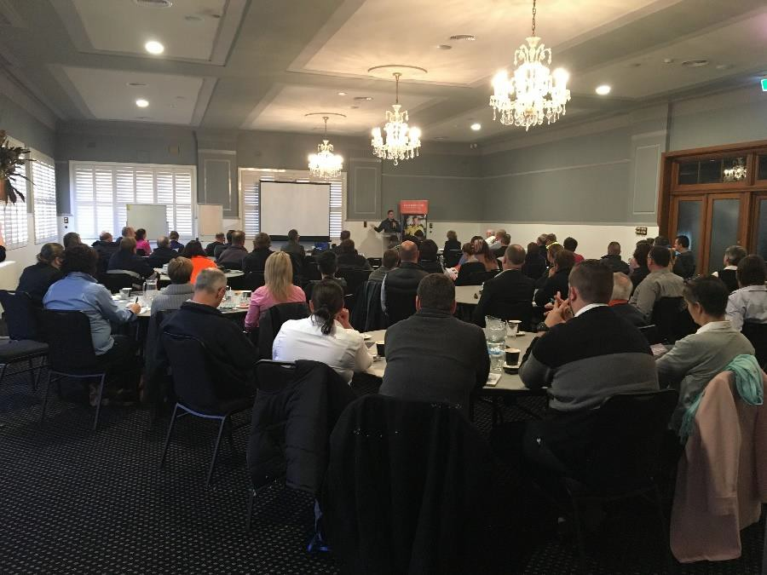

• Bruce Buchannan – Central NSW Business HQ

• Kathy Sloan – Kathy Sloan Consulting

• Wayne Diemar – HunterNet

• Ian Hudson – ICN

• Tom Cavanagh and Drew Davis – Channel 40

• Cabonne Council

• Blayney Council

• Orange Business Chamber

• All regional businesses participating in the survey process and/or the workshop

We look forward to working with you on an ongoing basis as we move towards a stronger, better-connected business community for the Orange region.

ORANGE SUPPLY CHAIN PROJECT 4% EXPORT OVERSEAS

HALF

PURCHASE OUTSIDE REGION

HALF

PRODUCT NOT AVAILABLE

148

Respondents

Orange 74%

40%

27%

20%

Orange business sells to

8%

4%

38%

11%

30%

Orange business buys from

15%

6%

Because…

51% not available

18% price

15% timeliness

Cabonne 16%

Blayney 6%

Orange

Region

CW

Region

NSW Other

State

Overseas

Orange

Region

CW

Region

NSW Other

State

Overseas

6% quality

Sales

Purchases

F R E I G H T

43%

59%

More than

30%

use freight DAILY

ROAD TRANSPORT

29% sales

30%

FACTORS THAT IMPACT FREIGHT CHOICE

28% 25%

11%

35% purchases

Cost Convenience Urgency Product Size

PURCHASES



-

•

I"·i n.Qp



hi

I:::] ture _ ...

Phot;oJgt/)ecbManagement rn

Educat;ion,cr·; -

-4·I _



-·_

, •I

Ii_0 liCADIC:·:J

c...,. 0 a .

i

Hlnstalla.

b"IOn

*::r r-·*C Ill . . I!JmanResoorccs

'·i.w3, J::J .,

__,. _

..,.

Fencing

51 _

. . iJ,p

I ;: ._I E!PSafety

»!o'i=ie

ComDIIanc- e TaggT-nSguperannualiion



.......·1ronm- ·



-..-.1-. ll'lrt.-

,...,

- C D . -.:v-F ;·t J

g

f.;- i

'"-.e.t



r:.a

1sl

s·a- j-J'!1!! iiniccil t

l

1D llil• (D 4/

ca H11e FirsbAid

OilS•'•lh•nn:::- :T:::s

-

1\'DHilad

--· - -

Jm- •.,

!i-

Engineer.!!!J-nm! CD

[J

·n e r,.,.&Dwo\r. 0f tr....:1f t:r ,., *I*ft 8

Ma. l

u Q!Oc-eo ::::!. v, X'

Toys :I:,...<5 • () 0

"'::l

JJ(TJ ....., Q) CD

tfcc- Jfi-

0



n:T

m...

(D

*i* 9" Comrm. icabi0f16

I(Q MenboMng

**APPENDIX B - ORANGE AIRPORT BUSINESS PARK**

Orange City Council has developed a concept plan for the development of an industrial and business park around the Orange Airport. This proposal represents a significant and long term opportunity for the development of a new style of industrial and business precinct around the Orange airport.

One of the strengths of the proposal is the convergence of several key drivers for

development. These include the area’s natural and man-made attributes, particularly:

• extensive areas of flat land

• key infrastructure such as gas and a future water pipeline

• regional road connections and rail and air links.

This proposal aligns with Orange City Council’s strategy to create more jobs in the region following the closure of Electrolux. The plan also acknowledges the limitations surrounding the availability of industrial land in the city.

Following on from the $19 million upgrade of the airport, the precinct will become a major economic driver for the region. It can address the need for employment well into the future as a logical extension of the increased level of potential economic activity associated with the airport expansion.

The purpose of building a business park around an airport was twofold. The business park acts as a buffer around the airport and allows the airport operations to expand in the future. The second reason is a unique opportunity for a business park to have access to three modes of transport (road, rail and air) for inputs and product. It is in effect a three way intermodal business hub.

As a green field development a company can negotiate alternative land and building envelopes to take advantage of any combination of access to the airside facilities, the proposed rail siding or the yet to be identified B-Double route to the highway. The final B- Double route to the Mitchell Highway is yet to be approved.

The runway at the airport is rated to take cargo transport aircraft. This will allow a company to fly in raw materials and fly out the finished product if they desire. They can have direct airside access in accordance with CASA regulations if required.

The Mitchell Highway is a National Highway and is a B-Double approved route. The highway is 3.8 km from the Airport Business Park. Council is currently considering a range of options to enable B-Double access.

The business park will be serviced with water and sewer from Orange and will have internet capacity through fixed wireless technology (100/40 mbps in 2018) or 4G mobile.

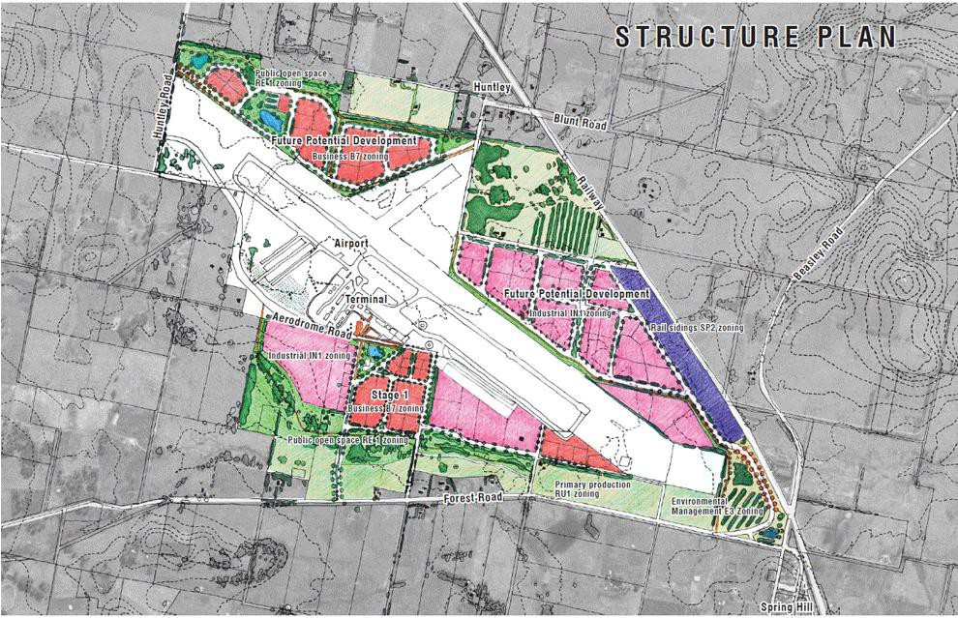

**ORANGE AIRPORT STATISTICS**

RUNWAY

|  |  |
| --- | --- |
| Runway length | 2,213 metres |
| Runway width | 30 metres |
| Height above mean sea level | 948.5 metres |
| Main runway identification | 11/29 |
| Pavement Strength | PCN 39/F/C/1500 (218PSI)/T WID30 RWS150 |

LIGHTING

|  |  |
| --- | --- |
| Low Intensity Runway Lights (LIRL) |  |
| Precision Approach Path Indicator (PAPI) | 3.0 DEG48.5FT |
| Runway Threshold Identification Lights (RTIL) |  |
| Secondary Power Available | 15 second switchover |
| Taxiway Lighting | Blue Edge |
| Illuminated Wind Direction Indicator (IWI) |  |
| Apron Lighting |  |
| Terminal Lighting |  |

FACILITIES

|  |  |
| --- | --- |
| Passenger terminal | New |
| Aviation Security | Category 6 |
| Passenger Screening | Not currently (incorporated into planning) |
| Baggage Screening | Not currently (incorporated into planning) |
| Baggage carousel | Newly installed |
| Airside access | ASIC clearance required |
| RPT Services (REX & Air Corporate) | SAAB 340 turbo prop |
| Regular charter aircraft | Boeing 717, Fokker F70 and Fokker F100 |
| Military aircraft | Lockheed C-130 ‘Hercules’, DHC-4 ‘Caribou’ |

GENERAL INFORMATION

|  |  |
| --- | --- |
| Internet connection | NBN Fixed Wireless 25/5 (100/40 in 2018) |
| Mobile phone coverage | Yes |
| Refuelling options | Avgas and Avtur |
| IATA airport code | OAG |
| ICAO airport code | YORG |
| Automatic Weather Station | ID 063303 Lat -33.38 Long 149.13 |