11August 2017

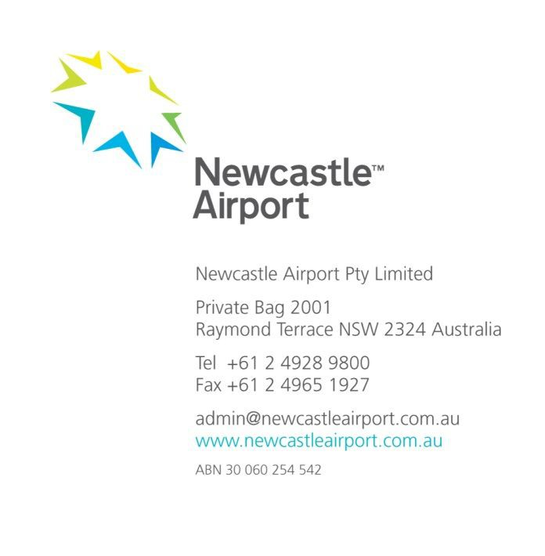

Freight and Supply Chain Inquiry

Department of Infrastructure and Regional Development

GPO Box 594

CANBERRA CITY ACT 2601

By Email: [freightstrategy@infrastructure.gov.au](mailto:freightstrategy@infrastructure.gov.au)

Dear Sir/Madam,

**RE: Inquiry into National Freight and Supply**

**Chain Priorities**

**Submission by Newcastle Airport**

**Introduction**

Newcastle Airport Pty Limited (NAPL) welcomes the opportunity to provide feedback on the Inquiry into National

Freight and Supply Chain Priorities discussion paper.

Newcastle Airport is a significant economic enabler for the Hunter region, stimulating economic growth and generating job opportunities. Our vision for the future is to be *‘the airport the region deserves’* – we believe that with the Hunter Region being the nation’s largest regional economy and containing the nation’s 7th largest city,

deserves an airport that can provide the domestic and international passenger and freight linkages and services that support and can further enhance its economic prosperity.

The focus of NAPL is not only to operate an efficient and effective airport terminal business for itself but to contribute to the development of the future of the region, by ensuring that NAPL provides the air transport infrastructure to enable Hunter Region and Newcastle businesses to grow and realise their potential.

In the present circumstances, there are both opportunities for and barriers to this being effectively achieved.

**The Hunter Region Economy**

The Hunter Region relates to a geographical area comprising the following eleven local government areas, Cessnock, Dungog, Gloucester, Great Lakes, Lake Macquarie, Maitland, Muswellbrook, Newcastle, Port Stephens Singleton and Upper Hunter1 as is shown in Annexure 1.

It is the largest growth centre in NSW outside the Sydney basin and is forecast to have a population greater than 1 million within around 30 years.2

The Hunter Region 2036 Plan, developed by the NSW State Government, identified four key pillars to ensure the Hunter region optimises the opportunities available for the region. The Plan identified both of the Hunter’s *’global gateways’* – that is, the Port of Newcastle and Newcastle Airport – as being key pillars to enable success. This was based on these Ports being able to deliver increased connectivity and import/export opportunities for the region.

**Newcastle Airport – Key Attributes**

Newcastle Airport is located on land owned by the Department of Defence at RAAF Base Williamtown, 17 kms north east of the City of Newcastle.

Newcastle Airport facilitates passenger and freight civil aviation for the Hunter Region, the City of Newcastle and surrounding LGAs3 through:

*1* [*http://rdahunter.org.au/hunter-region/hunter-region-plan-2012-2022*](http://rdahunter.org.au/hunter-region/hunter-region-plan-2012-2022)

*2 ibid*

3 *Joint Study on Sydney Region Aviation Capacity*

1

Inquiry into National Freight and Supply Chain Priorities

A civil lease area of 28 ha;

Shared use of a 2778m by 45 m runway with the Department of Defence;

Aircraft parking positions comprising 2 x Code B; 5 x Code C (2 pushback);and 1 x Code E; A 5000 sq. m. terminal with 17 check-in desks and two baggage reclaim units; Approximately 2000 car parking spaces;

A small air freight building and facility.

Civil operations are currently limited to 6 per hour. Under the current arrivals cap Newcastle Airport has substantial capacity to increase operations providing opportunities to increase passenger numbers and greater *“belly freight”4* capacity on routes that have suitable aircraft.

Domestic RPT5 operations at Newcastle airport are predominantly as listed in the table in Annexure 2 and the main aircraft types are Code C such those operated by Virgin (B737-800) and Jetstar (A320- 100/200).

From this table, it can been seen that domestic airfreight opportunities to Sydney, Canberra, Taree, Ballina and Dubbo are extremely limited and probably would not be more than small package freight. Gold Coast is served only by Jetstar which does not carry air freight although the aircraft is capable of doing so.

Accordingly, the current major sources and destinations for Newcastle air freight are Melbourne and Brisbane.

**Air freight capacity at Newcastle Airport**

Newcastle Airport currently handles approximately 100 tonnes of air freight per annum – all of which is transported via RPT operations as belly freight.

The current total passengers travelling on all RPT services to and from Newcastle Airport was 1.18M in 2015/16 and1.257 million in 2016/17. Accordingly, air freight per total passengers through Newcastle averaged about 0.08 kgs. However, given that the bulk of freight is likely to have been either Brisbane or Melbourne, then air freight per passenger carried on those services was probably more of the order of 0.24 kgs per passenger.

Nationally, actual domestic belly freight is about 3 kgs per passenger carried while through Sydney Airport it is higher at about 4 kg per passenger carried.6 By contrast, belly capacity on aircraft, which have freight capability on the Melbourne and Brisbane routes to/from Newcastle, is of the maximum order of 15,000 tonnes per annum or about 20 – 30 kg per passenger – seat operated.

Accordingly, based on 2015/16 traffic on aircraft with freight capacity operating to/from Newcastle to Melbourne and Brisbane and adopting the national average per passenger carried, a more realistic annual target is about 1200 tonnes.

Clearly, even though such a realistic target is far below the maximum capacity, it is obvious that there is still greater potential for domestic belly freight to be carried into and out of Newcastle than has been the case.

There are currently no dedicated freighter services, domestic or international, operating at Newcastle Airport. However, international air freight has continued to grow at Sydney Airport, both in terms of dedicated freighter tonnages and as international belly freight. In respect of the latter, loads per international passenger are much higher than domestic freight at about 30 - 35 kgs per passenger.7

4 *Belly freight is freight carried in the cargo compartments of passenger aircraft*

5 *Regular Public Transport*

*6 Transportation Associates Pty Ltd research 2014*

7 *Ibid*

**Air Freight Issues and Opportunities**

Currently, Newcastle Airport and surrounding lands support the Defence and aerospace industries.

In an 8 November 2016 press release8 Minister for Defence Industry, the Hon. Christopher Pyne said:

*“In a major win for the nation’s defence industry, Australia has been chosen to provide Maintenance, Repair, Overhaul and Upgrade for the componentry of the Joint Strike Fighter in the Asia Pacific Region worth approximately*

*$100 million to our economy, creating and sustaining hundreds if not thousands of jobs.”*

Many of the Defence prime contractors who have already been successful in winning $800 million in contracts from F-35 design and production work, are based at Williamtown, including BAE Systems, Lockheed Martin, and Boeing. In 2018, RAAF Base Williamtown will receive the first two Joint Strike Fighter – F35A aircraft, with a further 70

aircraft to be deployed between 2019 and 2022. Defence prime contractors are currently vying for F35A contracts in the Asia Pacific region, including logistical chain and warehousing opportunities.

These opportunities will require parts distribution, both nationally and globally. To ensure opportunities associated with the JSF are optimised, the logistical freight chain at Williamtown will need to be ready to meet the needs of industry. This may lead to specialised civil and military freight services needing to operate to and from Newcastle Airport.

Additionally, the Hunter Region generates a diverse range of freight across a multitude of industrial sectors including mining, manufacturing, and agriculture.

Through being the world’s biggest coal port, Newcastle has already established linkages with Asia at a business level and those international linkages could be enhanced through air services and trade via Newcastle Airport for , inter alia,

Agricultural producers of wine, meat and dairy products; Thoroughbred horses and other valuable livestock;

Those seeking Australian educational facilities such University of Newcastle;

Inbound tourism based on the Hunter’s existing strengths in beaches and the coast, golf resorts, eco- tourism and wineries;

Airfreight is typically low weight and high value in nature, and also time sensitive, so many of the products from the

Hunter Region are potentially suitable. For example ABARE9 reports that:

*“Major ports for commercial fishing in the Newcastle and Lake Macquarie region include Newcastle and Swansea. Species caught by commercial fishers in the area include prawns, eastern rocklobster, bugs, a range of finfish, and blue swimmer crabs”*

*and noted that*

*“In 2014–15, New South Wales fisheries product exports were valued at $18.6 million. The main export products include live and fresh, chilled or frozen fish, rock lobster, and abalone. Japan and New Zealand, are the major destinations for New South Wales fisheries exports, accounting for 33 per cent and 15 per cent of the total value of exports in 2014–15, respectively. Other major export destinations include Taiwan (14 per cent), Vietnam (12 per cent), and Italy (5 per cent)”*

Such seafood products are most suitable for airfreight and a reasonable proportion of these NSW exports could be expected to be generated by the fishing industry of the Hunter Region.

Another commodity which is suitable for air freight export is wine of which the Hunter Region is a significant producer of quality, if not vast quantities of, product.

Wine Australia10 reports that, for example:

*8 https://*[*www.minister.defence.gov.au/minister/christopher-pyne/media-releases/minister-defence-industry-jsf-announcement-create-defence*](http://www.minister.defence.gov.au/minister/christopher-pyne/media-releases/minister-defence-industry-jsf-announcement-create-defence)

*9* [*http://www.agriculture.gov.au/abares/research-topics/aboutmyregion/nsw-newcastle#references*](http://www.agriculture.gov.au/abares/research-topics/aboutmyregion/nsw-newcastle#references)

*10 https://*[*www.wineaustralia.com/selling/by-market/export-market-guide-china*](http://www.wineaustralia.com/selling/by-market/export-market-guide-china)

*“China has signed Free Trade Agreements (FTA) with Chile and New Zealand which has resulted in the significant reduction of import duties for products originating in these countries. In April 2005, Australia and China agreed to commence negotiations on a FTA. The China-Australia Free Trade Agreement (ChAFTA) was signed on 17 June 2015 and came into effect December 20, 2015. Upon entry into force, ChAFTA will deliver substantial benefits for the Australian economy, building on this highly complementary relationship.”*

and that:

*“Local awareness of Australian premium wine has improved due to increasing bilateral business between China and Australia. Promotion and education of Australian wine products from the Australian wine industry will certainly help expand the market and increase market share. The Chinese demand for premium wine is evident with strong growth in the higher price segments. There is a move towards Westernisation and a strong appeal towards foreign products which, in conjunction with wine education, should result in the development of a wine appreciation culture in China. This transition is likely to take some time however.”*

Hunter Valley wine producers should be well placed, given their quality products, to export into this market. Newcastle Airport has recently engaged with several local providers of produce in the region.

These providers believe the current airfreight logistics chain is not optimal for producers in the Hunter region. This dissatisfaction was based on:

The time taken for produce to be hauled via road to Sydney or Brisbane airport for airfreight dispatch;

An inability to use Newcastle Airport, given it has the potential to provide a significant advantage to these providers to mitigate the timeframe for delivery, reduce haulage costs, and deliver a fresher product to the boom markets within Asia;

Newcastle Airport lacking appropriate infrastructure.

Accordingly, achieving resolution of these infrastructural and operational shortcomings is likely to have a beneficial impact on the businesses of the primary producers of the Region, with consequent wider economic benefits flowing to the Region.

**Airport Master Plan and Airport limitations**

Newcastle Airport is finalising a 20 year Master Plan for the Airport. This Plan considers increases to passenger traffic and aircraft movements. The Master Plan has identified a target increase in freight demand from the current

100 tonnes to at least 250 and up to 500 tonnes per annum in 2036, which is still modest by what is possible. The differential in demand is based on the provision of long-haul international flights to destinations in Asia – which are expected to significantly increase the opportunities for just-in-time freight from the region. The projected demand outlined in the draft Newcastle Airport Master Plan is based on unstimulated passenger airliner growth and does not consider specific targeted opportunities for freight growth from the Hunter Region.

Notwithstanding that Newcastle is designated as a restricted use international airport, the predominant issue at present is that, whilst there is adequate runway length, there are limitations associated with pavement strength at RAAF Williamtown, which prevent Code E aircraft to operate into and out of the airport. Code E aircraft are those typically used for long haul passenger and freighter routes such to Southeast Asia and longer and include B747, A330, B777 and B787 aircraft types.

Newcastle Airport is currently engaged with the Department of Defence to develop an appropriate infrastructure plan to upgrade the airfield infrastructure to be capable of handling Code E aircraft. It is likely that the airfield will require significant upgrades to allow regular Code E aircraft operations to operate from Williamtown. This will require Federal Government support to develop and fund the appropriate airfield upgrades.

**Competitor Airports**

As shown in Annexure 3, Queensland has the most international capable airports throughout Australia with two major fully operational airports - Brisbane and Cairns, two restricted international – Townsville and Gold Coast and one alternate international capable at Rockhampton as well as a new international capability in Sunshine Coast Airport and an international dedicated freight service operating to and from Brisbane West (Wellcamp) Airport11,

130 kms directly west of Brisbane Airport in Toowoomba. By comparison, Newcastle Airport is 140 north east of

Sydney Airport and, therefore, has the same distance relationship to a major international airport.

By contrast, NSW has only one major international – Sydney and three restricted use international airports – Canberra (which serves a large region of NSW), Newcastle and Coffs Harbour. Of these, only Canberra now has an international passenger service, with attendant belly freight opportunities and none have dedicated freighter services.

Within NSW, there are several regional airports with ambitions to being an international airport, as is indicated below.

|  |  |  |  |  |  |
| --- | --- | --- | --- | --- | --- |
| **Airport** | **Main**  **Runway** | **Aircraft Code**  **Capable** | **International**  **Designation** | **Principal International air market potential** | **Current International**  **Freight Operation** |
| Coffs  Harbour | 2,080 m x 45 m. | Code D  e.g. B767 | Restricted | Passenger | None significant – more limited suitable industrial and agricultural air freight base |
| Parkes | 1,684 m. x 45 m. | N/A | None | Freight | None operational but has ambitions to develop. |
| Tamworth | 2,200 m. x 45 m. | Code C e.g. Boeing B737 -  800 | None | Freight | None operational but has ambitions to develop. |
| Canberra | 3,223 m. x 45 m. | Code E  e.g. B787 | Restricted | Passenger (but with domestic, Singapore and NZ freight linkages) | None significant as yet; but now has direct Singapore and Wellington links. |
| Newcastle | 2,778 m. x 45 m | Code C  e.g. B737 - 800 | Restricted | Passenger and Freight – International and domestic | None operational but has suitable industrial, aquaculture and agricultural air freight base |

Based on this assessment, it is clear that Newcastle Airport has the best overall capacity and opportunity to develop a sustainable air freight operation, whether as international belly freight or on dedicated freighter aircraft, of all other NSW locations by virtue of its strong industrial, aquaculture and agricultural base as well as its tourism potential. It would appear entirely possible to generate similar payloads to Wellcamp Airport and to attract a similar

1 stop service from another airport in the region, such as Melbourne, for services to Asia.

11 *See Annexure 4*

It is further relevant to note that, whilst the new Western Sydney Airport is expected to absorb both some of the existing and future air freight traffic through Sydney Airport as well as generating its own market, this airport is not scheduled to open until 2026.

This is more than sufficient time to enable Newcastle Airport, if appropriately supported, to develop its own position in the air freight market.

**Connecting and Supporting Infrastructure**

It is well established that land transport access to airports is critical to their ability to operate at maximum efficiency. This is recognised in the NSW Freight and Ports Strategy of 2013 (the Strategy)12. The Strategy recognizes that, inter alia:

The freight logistics task is generally undertaken on shared transport systems and infrastructure; The efficiency of the freight logistics system is crucial to the NSW economy;

Inefficiencies, *“friction – in the sense of those aspects of the logistics chain that cause delays or disincentives”*, and lack of adequate capacity add costs for users of the system;

Government has a role to deliver network capacity to ensure supply chain efficiency. It further recognises that, in respect of air freight13:

Air cargo is time sensitive, relatively low mass and volume but high value;

As such, it requires efficient and reliable airside and landside infrastructure;

Most freight international or domestic is “belly freight” carried by passenger airlines, with freight carried by dedicated freighter aircraft being much lesser;

Imports are much greater than exports;

Currently, 50% of all Australia’s air cargo moves to and from Sydney Airport by the road network and must compete therefore with both airport and non-airport related traffic on the road network, including that which is related to Port Botany;

Government has a role to ensure air cargo is included the land transport systems planning for the Sydney

Airport and Port Botany precincts.

It is to be expected that as the second most important economic region in NSW, the same principles would apply in respect of Newcastle and the Hunter Region and Newcastle’s Airport.

The Hunter Region is served by a number of major arterial roads which, under normal conditions, provide free flowing high capacity road transport:

The MI southwards to Sydney from John Renshaw Drive (A1) at Beresford;

The A1 northwards from John Renshaw Drive (A1) at Beresford across the Hunter River and thence via the coast to the Queensland border;

The M15 and A43 westward up the Hunter River Valley and thence the A15 to the Upper Hunter rand beyond;

A43 eastwards into the industrial and civic heart of Newcastle.

This major network provides comparative travel times as indicated in the following table:

|  |  |  |  |  |
| --- | --- | --- | --- | --- |
| **Possible Air Freight**  **Commodity** | **Source** | **Newcastle Airport** | **Sydney Airport** | **Newcastle Airport**  **Time Advantage** |
| Wine | Pokolbin | 52 minutes | 138 minutes | 86 minutes |
| Seafood | Port Stephens | 30 minutes | 166 minutes | 136 minutes |
| Beef Meat Products | Whittingham | 55 minutes | 143 minutes | 88 minutes |

12 *NSW Freight and Ports Strategy November 2013 pp5*

*13 ibid*

|  |  |  |  |  |
| --- | --- | --- | --- | --- |
| **Possible Air Freight**  **Commodity** | **Source** | **Newcastle Airport** | **Sydney Airport** | **Newcastle Airport**  **Time Advantage** |
| Seafood | Lake Macquarie | 48 minutes | 116 minutes | 68 minutes |
| Livestock | Scone | 118 minutes | 209 minutes | 91 minutes |

Clearly, for time sensitive, high value freight export, an ability via Newcastle Airport, coupled with slightly shorter air travel times to destinations in Asia and greater flexibility to arrive and depart the Airport due to much lesser road and runway congestion than exists at Sydney Airport could help reduce transport costs and improve returns to producers in the region.

Newcastle Airport is served by two specific local road corridors which link to this major road network: Cormorant Rd and Nelson Bay Road from Newcastle (including the Port of Newcastle)

Cabbage Tree Rd – the road link between the A1 Pacific Highway and Newcastle Airport.

NSW RMS is completing upgrades to Cormorant Road and Nelson Bay Road providing dual carriageway between Newcastle, the Port of Newcastle, and Newcastle Airport. These upgrades are well supported by both the Port and Airport, and are future-proofing for the significant benefit of freight transport into the future between the key global gateways and the metropolitan city of Newcastle.

NSW RMS is also reviewing a project to complete a bypass link from the M1 Motorway to the Pacific Highway from Beresfield to Heatherbrae. Newcastle Airport strongly supports the development and delivery of this project. However, the vital connecting road link between this project and the Airport (Cabbage Tree Road) has not been identified for upgrade as part of this project. This road links the Airport to the main arterial roadway of the Pacific Highway and M1 Motorway.

Whilst the airport is already moderately well linked, an upgrade to Cabbage Tree Road is vital to provide an optimised, integrated, free flowing, land transport logistics chain to encourage and support further growth of air freight through Newcastle Airport.

This will be instrumental in helping Newcastle Airport realise its opportunity for airfreight and to be a more effective part of the overall freight logistics network.

**Questions posed by the Inquiry**

The Inquiry has posed questions in relation to the role of airports in air freight which are addressed, relative to the position and views of Newcastle Airport, as follows:

***Are our airports appropriately integrated into surrounding freight networks?***

Historically, Australia has concentrated both international passenger and freight air services through state capital

city airports and, 50 years ago, most international services were concentrated just through Sydney. This is due to the fact that, unlike the USA, even accounting for population differences, Australia has not developed many strong and economically independent regional cities with integrated supporting air and land transport infrastructure.

The impact of this is that surface transport for freight – predominantly road as rail is not used for the high value, low weight freight that is best suited to air transport – needs to navigate the more congested road systems that give access to capital city airports. As very few airports in Australia have ever been planned and purpose built in conjunction with their road access, such links are not generally optimal.

Nevertheless, over the passage of time, the air freight industry develops networks and linkages which are shaped to circumstances of each airport, such as they are. For example, 60% of registered air cargo agents serving Sydney Airport are located within 15 minutes’ drive of the airport and are within 10km; Furthermore, they are located so as to make best use of the major road network that gives access to Sydney Airport.

The key point here is that Newcastle and the Hunter Region is one location that is economically strong, independent and growing but whose airport infrastructure and road access needs to be upgraded to realize full potential and this

should be done ahead of demand exceeding capacity. It has the developable land, within 10 kms and which is linkable to its major road network, to permit establishment of an air cargo industry.

***Are there any international examples of where airports are used more effectively in freight networks?***

San Diego International Airport is located 202 kms from Los Angeles International Airport and fully connected by the

I-5 N and I-405 N Freeway system. Travel time between the two airports is about 130 minutes.

Newcastle Airport is located 189 kms from Sydney International airport and is mostly connected by the M1 Freeway. Travel time between the two airports is about 140 minutes

Los Angeles International Airport (LAX) 14 is the second busiest airport in North America in terms of passenger traffic, reaching 70.7 million in 2014. The number of operations reached 708,674 in 2014. In 2014, LAX was the fifth busiest airport in terms of cargo volume —15th in the world — with 1,816,269 metric tons of freight and mail moving through its facilities i.e. 26 kgs per passenger.15

San Diego International Airport (SAN) 16 is the 30th busiest airport in North America in terms of passenger traffic, which grew in 2014 to reach 18.8 million. The number of operations grew in 2013 to 191,761. In 2014, SAN was the

31st busiest airport in terms of cargo volume with 156,149 metric tons of freight and mail passing through its facilities i.e. 8.3 kgs per passenger17. Its single main runway is 2865m in length and 60m in width. Available runway length is reduced by displaced thresholds at each end. It is also relevant to note that along the I-5 N and I-405 N Freeway system between LAX and SAN, there are three other civil airports and that it operates within military airspace and 30 kms of 4 airports heavily used by the US Navy.

The key point here is that, despite San Diego having only about one sixth of the population of Los Angeles1819and despite the relative proximity of San Diego International Airport to one of the world’s busiest airports, it is able to generate and transact a significant amount of air freight in its own right. By inference, given the right support, investment, removal of barriers and encouragement by Government, the Hunter Region, Newcastle and Newcastle Airport should be able to do similarly.

***Can Australia be making greater use of air freight?***

Domestic air freight declined nationally from around 250,000 tonnes in 2010 to 180,000 tonnes in 2014.20As has already been discussed, nationally *“belly freight”* is significantly less on a domestic per passenger basis than it is on an international per passenger basis. This suggests that significant belly space is available on most domestic routes. The issue appears to be making use of it. This may be because of increased difficulties in accessing airports and processing freight through them in comparison to door to door road transport services.

Certainly what is currently carried on domestic routes to and from Newcastle Airport is well below both the national average on a per passenger basis and far below that which aircraft operating on the two major routes could uplift.

In terms of international freight21:

Australia’s total airfreight in 2014 including mail was ~897,000 tonnes of which ~516,000 tonnes (58%) was inbound and 381,000 (42%) was outbound;

Of this total, freight carried by dedicated freighter aircraft was ~65,000 tonnes, with 68% inbound and 32%

outbound;

Clearly, there exists significant ability for Australia to make use of both spare belly and dedicated freighter capacity for international exports.

*14 https://*[*www.faa.gov/nextgen/snapshots/airport/?locationId=36*](http://www.faa.gov/nextgen/snapshots/airport/?locationId=36)

*15 Noting that this freight tonneages probably includes both belly and dedicated air freighter cargo.*

*16 https://*[*www.faa.gov/nextgen/snapshots/airport/?locationId=44*](http://www.faa.gov/nextgen/snapshots/airport/?locationId=44)

*17 Ibid*

*18 Los A ngeles/Long Beach statistical area population of 18.55 million; San Diego/Carlsbad statistical area population of 3.26 million;*

*19 And therefore similar to the Sydney/Hunter Region population ratio*

*20 Source BITRE stats and Transportation Associates research;*

*21 ibid*

In the case of the dedicated air freighter traffic, the question is whether the airport slots exist at Sydney Airport to permit expansion of inbound traffic.

The key point here then is that Newcastle Airport has that capacity and, with some road upgrading, the land transport linkages to the northern part of the Sydney region and via the M1, North Connex, M2 and M7 to the freight distribution centres in western Sydney , the Hunter Region generally, Western and North-western NSW and the North Coast of NSW

**Summary and Key Points**

Newcastle Airport is currently developing a freight strategy for the Airport in conjunction with local providers and industry.

Significant latent capacity exists at Newcastle Airport for:

Expanded domestic air freight especially for time sensitive goods destined for the two principal linkages to Melbourne and Brisbane using the existing “belly freight” capacities of current aircraft operating these routes;

Introduction of direct passengers services to/from ports in South East Asia - (using Code C aircraft) and with an upgrade to the runway facilities to Code E capabilities to North Asia to expand inbound tourism and to yield belly freight capability for exports from the Hunter region as demand for high quality foodstuffs continues to expand;

Dedicated freighter aircraft to serve specialised high volume, high value agriproduct exports as well as inbound high value technology componentry for local industries and Defence;

In general, adding overall air freight capacity for the NSW and more broadly Australia economy to supplement that which is and will possible through Sydney Airport and until Western Sydney Airport is operational in ten years’ time.

Augmenting the capacity of Sydney Airport and in the longer term Western Sydney Airport.

To fulfil its potential as a major airport not just in NSW but in Australia and in order to truly to be *‘The airport the*

*Hunter Region deserves’* Newcastle Airport needs:

Upgraded runway pavement strength to enable operation by Code E aircraft as are used by airlines operating to/from North Asia and as used by operators of dedicated freight aircraft on international routes; Upgraded local roads to provide free flowing capacity suitable to permit ease of road transport access to and from the airport to link with the major highway network.

With the right infrastructure development, Newcastle Airport believes that both passenger aircraft with attendant belly freight capacity and dedicated freight aircraft from Asia to Newcastle Airport can be attracted to Newcastle Airport in the near future. This would have significant sustainable economic benefits for the region and is a core action under Newcastle Airport’s strategic plan.

Newcastle Airport would welcome the opportunity to discuss the outcomes of this freight strategy with the Department and appropriate stakeholders, with a view to establishing a clear pathway by which Newcastle Airport can develop to its full potential.

Should you have any questions relating to Newcastle Airport’s submission, please contact Marcus Lancaster, Executive Manager Operational Delivery on (02) 4928 9815, or via email at [mlancaster@newcastleairport.com.au](mailto:mlancaster@newcastleairport.com.au)

Should the committee wish to visit Newcastle Airport, I and my team would be pleased to welcome and meet with you.

Yours sincerely,

**Peter Cock**

CEO

**Annexure 1 – The Hunter Region**

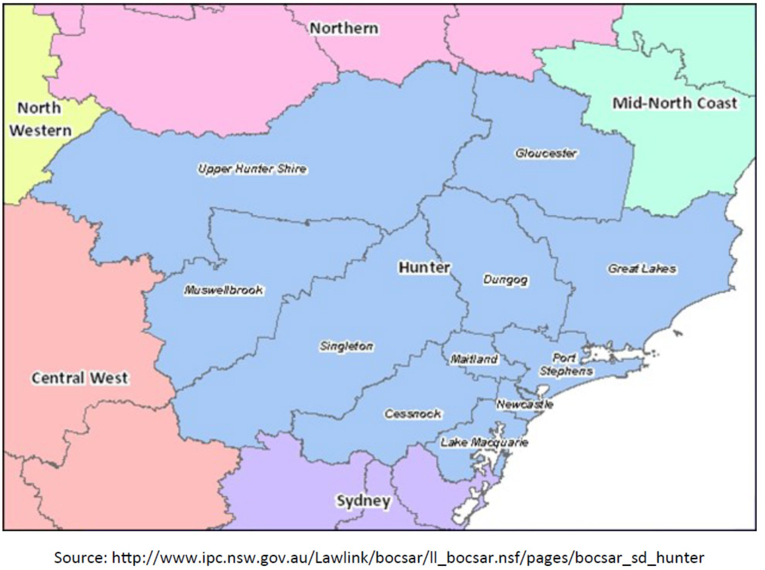

**Newcastle Airport**

**Return**

**Seats per**

**Belly Freight**

**Return**

**Yearly**

**Annual One Annual Two**

**Annual Two way Freight**

**Linked City Airline Aircraft Type**

**Services**

**per day**

**Aircraft**

**Capability**

**(tonnes)**

**Yearly**

**Services**

**One way**

**seats**

**way**

**tonneages**

**way**

**tonneages**

**Capability**

**(Kilograms per seat)**

Sydney Rex Saab SF340 ~2-3 34 Very limited Sydney FlyPelican BAe Jetstream 32 ~1-2 19 Very limited Canberra FlyPelican BAe Jetstream 32 ~2-3 19 Very limited

**Annexure 2 – Passenger Aircraft Traffic at Newcastle Airport**

11

Inquiry into National Freight and Supply Chain Priorities

Submission by Newcastle Airport

Melbourne Virgin Australia Boeing 737-800 ~1 176 3.6 365 64240 1314 2628 20

Melbourne Jetstar Airbus A320-100/200 ~3-4 180 None (s ee note 1)

Brisbane Virgin Australia Boeing 737-800 ~2-3 176 3.6 1095 192720 3942 7884 20

Brisbane QantasLink Bombardier Q400 ~2-3 74 2.14 1095 81030 2343 4687 29

Brisbane Jetstar Airbus A320-100/200 ~2-3 180 None (s ee note 1) Gold Coast Jetstar Airbus A320-100/200 ~1-2 180 None (s ee note 1) Taree Rex Saab SF340 ~3 34 Very limited

Ballina / Byron Bay FlyPelican BAe Jetstream 32 ~2 19 Very limited

Dubbo FlyPelican BAe Jetstream 32 ~1-2 19 Very limited

**Note 1:** Jetstar does not carry freight although aircraft has capacity of 3.6 cu m. or 1 tonne

**Annexure 3 – International Designated Airports in Australia**

|  |  |  |  |
| --- | --- | --- | --- |
| **Airport** | **Major** | **Restricted use** | **Alternate** |
| Adelaide | **X** |  |  |
| Brisbane | **X** |  |  |
| Cairns | **X** |  |  |
| Darwin | **X** |  |  |
| Melbourne | **X** |  |  |
| Perth | **X** |  |  |
| Sydney | **X** |  |  |
| Avalon |  | **X** | **X** |
| Broome |  | **X** |  |
| Canberra |  | **X** | **X** |
| Coffs Harbour |  | **X** | **X** |
| Gold Coast |  | **X** | **X** |
| Hobart |  | **X** |  |
| Learmonth |  | **X** | **X** |
| Lord Howe Island |  | **X** |  |
| Newcastle |  | **X** |  |
| Port Hedland |  | **X** | **X** |
| Townsville |  | **X** | **X** |
| Alice Springs |  |  | **X** |
| Kalgoorlie |  |  | **X** |
| Launceston |  |  | **X** |
| Rockhampton |  |  | **X** |
| Tindal |  |  | **X** |

Source: https://infrastructure.gov.au/aviation/international/icao/desig_airports.aspx

In addition, Sunshine Coast in Queensland is developing 2450m runway capability for handing Code E aircraft and accordingly be able to handle international traffic.

**Annexure 4 – Brisbane West (Wellcamp) Airport**

Brisbane West (Wellcamp) Airport has recently been established near Toowoomba 130 km west of Brisbane Airport

The following extracts provide information on Wellcamp Airport’s air freight handling details

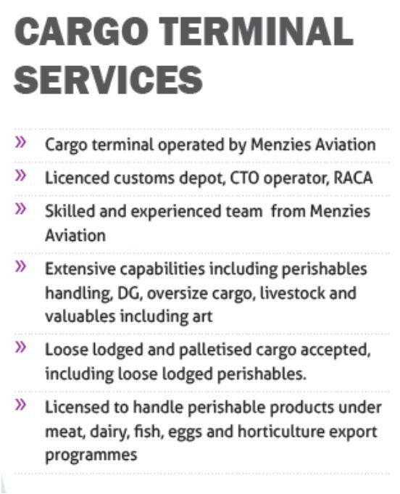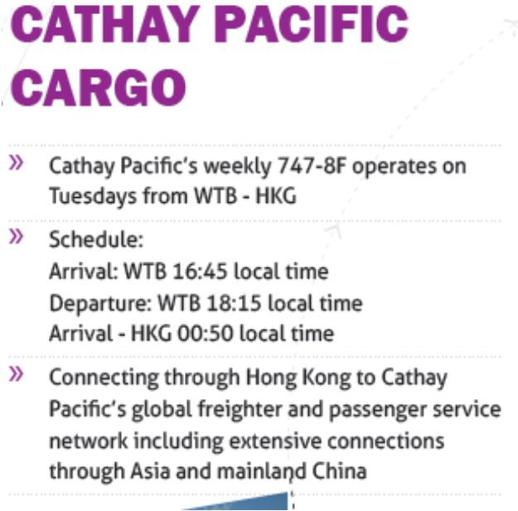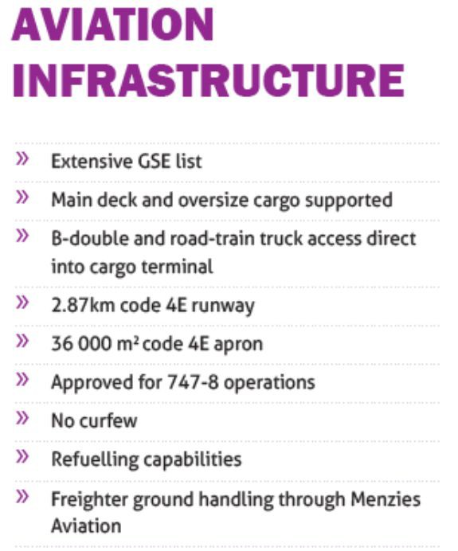

Source: [www.wellcamp.com.au](http://www.wellcamp.com.au/) *“Australia’s New Air Cargo Hub”*

It is notable that since opening the freight tonneages moved are reported as being in the table below.

|  |  |  |  |  |  |
| --- | --- | --- | --- | --- | --- |
| **Month** | **Australian Port** | **Foreign Port** | **Freight In**  **Tonnes** | **Freight Out tonnes** | **Total Freight tonnes** |
| Nov-16 | Wellcamp | Hong Kong | 0.0 | 39.2 | 39.2 |
| Dec-16 | Wellcamp | Hong Kong | 0.0 | 47.9 | 47.9 |
| Jan-17 | Wellcamp | Hong Kong | 1.3 | 93.8 | 95.1 |
| Feb-17 | Wellcamp | Hong Kong | 4.0 | 15.5 | 19.5 |
| Mar-17 | Wellcamp | Hong Kong | 8.5 | 69.5 | 78.0 |
| Apr-17 | Wellcamp | Hong Kong | 0.0 | 28.8 | 28.8 |
| May-17 | Wellcamp | Hong Kong | 0.3 | 18.4 | 18.7 |
| Total to date | Wellcamp | Hong Kong | 14.1 | 313.1 | 327.2 |

Source: BITRE analysis and data.

On this performance to date, average inbound tonneages per month are about 2 tonnes while outbound tonneages are about 45 tonnes per month. If this is sustained, then annual tonneages of 24.2 inbound and 536.7 outbound would result, with an annual total of about 560 tonnes.

This service is operated by Cathay Pacific as a part of a once per week Hong Kong -Melbourne - Hong Kong B747 -8F freighter aircraft only service. This aircraft has a 135 tonne maximum payload of which Wellcamp Airport is contributing on average 0.47 tonnes inbound and 10.3 tonnes outbound or about 8% of maximum capacity. However, actual payload may be constrained by Wellcamp’s runway length.