

***Inter-Port Global***

**ACN 614 434 865**

**MAY 2017**

Multi-Billion Dollar Integrated SDA

and Eastern Australian Rail Freight Proposal

Positions Gladstone as the Premier Hub for

Global Trade Exchange and Economic Integration

*‘A Place for Freight’*

**Table of Contents**

Strategic Imperative 2

The importance of freight logistics infrastructure cannot be underestimated 2

Infrastructure Reports Reinforce Concerns 2

BITRE Forecasts: Containerised Trade Growth 3

Sydney: Logistics challenge 3

Independent Traffic Modelling Report 3

Forecast Capital City Congestion Costs 3

Submission on Draft National Ports Strategy 3

I-PG MULTI-BILLION DOLLAR SDA PROJECT AND 4

Gladstone -Toowoomba Railway Project Development 5

Global Benefits for Australian Import/Export Organizations 6

Realistic economic strengths and enduring benefits 6

In summary: 7

Salient features 7

The I-PG strategy is structured to address the following operational objectives 7

The economic significance of the I-PG project can be summarised as follows 7

The economic significance of the I-PG project can be summarised as follows 7

**Strategic Imperative**

With Australia’s freight task projected to double by 2030 and triple by 2050, there is a clear impetus to lift the level of efficiency and coordination between the port gate and end users.

For land-side freight operations to keep pace with forecast trade growth, it is essential that port-hinterland connectivity becomes a fundamental part of the ports overall strategy and management process. In this context, the port is part of the overall logistics operation where logistics and multimodal transport corridor issues are considered in parallel.

With Australia’s population growth now forecast to reach 30 million by 2031, in conjunction with the forecast doubling of the national freight task by 2025, pressure is on all Australian Governments to deliver large and complex infrastructure projects in an environment of fiscal constraint, where spending of public money faces intense scrutiny from a value-for-money perspective.

Population growth, traffic congestion in conjunction with the magnitude of the freight task overlapping with inter-competing land-uses have collectively conspired to reduce the operational capacity and efficiency of eastern Australia’s major seaports. Additionally, at a national level, the lack of standardization in national rail gauges have resulted in fragmented operations due to the inability to rapidly and efficiently move rolling stock between networks, resulting in higher operating costs due to suboptimal utilisation and minimal investment in other interrelated infrastructure.

**The importance of freight logistics infrastructure cannot be underestimated**

With some ninety percent of the world’s merchandise and commodity trade transported by ships, ports are vital to the health and wellbeing of the global economy. While this percentage has remained relatively constant throughout the 20th century, the past two decades have seen volumes increase rapidly with all forecasts pointing towards continuing growth.

One of the most pressing issues facing Australia is how to deal with a substantial increase in port trade activities, not just today but well into the future. This brings to the forefront - how do we successfully handle trade growth whilst at the same time retain a competitive edge in light of high terms of trade and tightness in labour markets as well as infrastructure and regulatory constraints.

With seven to nine percent growth in container volumes and similar numbers for commodities exports over the next decade, this level of growth is challenging, particularly in terms of increased pressure on our current ports and inadequate supply chain infrastructure.

**Infrastructure reports reinforce concerns.**

Reports issued from the Bureau of Infrastructure, Transport and Regional Economics (BITRE), Infrastructure Australia (IA) and Engineers Australia reveal an infrastructure deficit of more than AUD$470 billion. (2015) Left unchecked, transport and freight logistics infrastructure will continue to constrain economic growth.

The major reported issues were:

* Inadequate land-side efficiency at Port Botany and Port of Melbourne;
* Population growth and land-use competition restricting land-side expansion in Melbourne and Sydney;
* Absence of dedicated land-side freight corridors (Melbourne, Sydney and Brisbane)
* Mounting traffic congestion;
* Land resumption costs;
* Infrastructure impacts – (social fabric and vice-versa);
* Container trade growth increasing by 200% by 2050.

**BITRE Forecasts: Containerised trade growth**

**Projected average annual growth rate: 5.8%**

|  |  |  |
| --- | --- | --- |
| Location | 2030-33 TEU’s | Percentage Increase |
| Brisbane | 3.6m | 6.2% |
| Melbourne | 6.4m | 4.8% |
| Sydney | 5.2m | 4.5% |
| Adelaide | 1.0m | 5.4% |
| Fremantle | 2.1m | 5.8% |
| Other ports | 1.2m | 5.0% |
| All Ports | 19.4m | 5.1% |

**Sydney: Logistics challenge**

Approximately 85 per cent of Port Botany’s container freight is packed or unpacked within 40kms of the port and transported via some of Sydney’s key arterial road networks, the shared rail network and the metropolitan freight network. With Sydney’s population forecast to grow from 4.1 million to 5.3 million by 2031, future freight demands on the shared passenger transport network add to an already significant logistics challenge.

**Independent traffic modelling report**

**Moorebank Intermodals – ‘Key assumptions require greater scrutiny’**

<http://www.lcit.com.au/wp-content/uploads/2013/06/Intermodals_Book_Web_V19.pdf>

**Bureau of Infrastructure Transport and Regional Economics (‘BITRE’) 2015-2030**

**Forecast capital city congestion costs**

|  |  |  |
| --- | --- | --- |
| Location | 2015 | 2030 |
| Sydney | $6.1b | $12.6b |
| Brisbane | $2.3b | $5.9b |
| Melbourne | $4.6b | $10.2b |

**Submission on Draft National Ports Strategy to Infrastructure Australia and National Transport Commission 2010.**

<http://infrastructureaustralia.gov.au/policy-publications/submissions/nps/files/10_027LyndaNewnam.pdf>

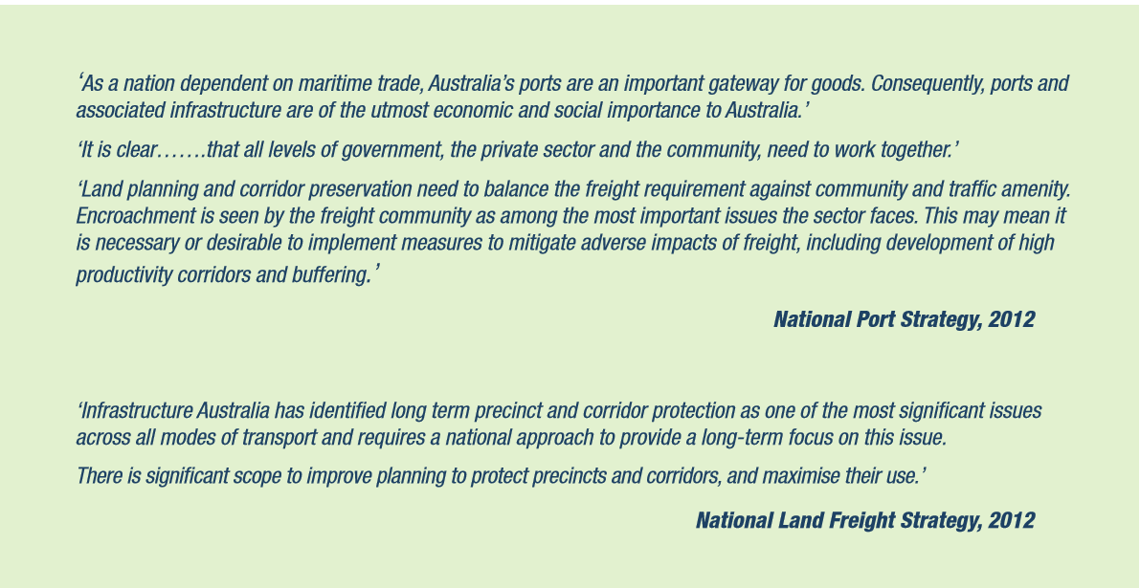

I-PG MULTI-BILLION DOLLAR SDA PROJECT AND

EASTERN AUSTRALIAN RAIL STRATEGY

POSITIONS GLADSTONE AS THE PREMIER HUB

FOR GLOBAL TRADE EXCHANGE AND ECONOMIC INTEGRATION

As indicated in the initial meeting held between the CEO of Inter-Port Global, Mr. Des Euen and the Gladstone Regional Council on December 12-2016, the primary aim of the envisioned Inter-Port Global development is to position Gladstone as eastern Australia’s premier hub for global trade exchange and economic integration.

The enterprise provides a compelling case to develop the Gladstone State Development Area (“SDA”) as a premier destination for high-end investment in all related sectors of the economy. It is envisioned that substantial flow-on investment can be expected not only throughout the industrial sector, but also technology and a diverse range of support-based business activities.

With some 27,000 hectares of potential development land, the SDA provides adequate capacity for such a major project. Additionally, the site’s accessibility to all major transport links – or its ready adaptation to the expansion of those links – adds a critical facet to the site’s suitability.

The I-PG Gladstone-based SDA economic development program, is by far, one of the most ambitious and deliverable economic development programs released in Australia over the past two decades. Ideally positioned on Australia’s primary trade shipping lane that carries upwards of 75% of nation’s import/export trade, the development will create Australia’s largest one-stop fully-integrated port and industrial precinct.

The strategic plan, we believe, will add significant value to Gladstone’s position as a world-class industrial city through a range of innovative globally focused developments that are flexible and adaptable to changing economic conditions.

The proposed I-PG all-embracing SDA development plan is, we believe, consistent with the objectives of the Queensland Ports Strategy and the Gladstone Regional 10 Year Development Plan.

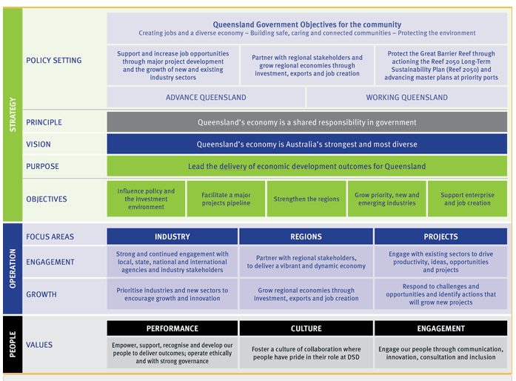

Gladstone -Toowoomba Railway Project Development

This section of the I-PG plan entails the construction of a 497km dual gauge railway linking the Port of Gladstone with the planned *Australian Rail Track* *Corporation (‘ARTC’)* Melbourne - Brisbane inland rail route at Oakey in south western Queensland. The advent of a dedicated high-speed, dual gauge, double height container rail corridor linking eastern Australian economic growth regions to the Port of Gladstone will open a new chapter in the history of Australian freight logistics operations. *Providing a time advantage of 60.5%* over the traditional method *‘multiple ports of call’* for cargo exchange will realise unprecedented growth in both market share and profit.

In today’s fast-moving world where time is of the essence, it is vital that export commodities reach their market destination in the shortest time possible. The I-PG logistics system has been systematically structured to achieve this result.

**Global benefits for Australian import/export organizations**

The consolidation of these three-major nation building projects *‘Mid-western Inland Rail – Toowoomba-Gladstone Rail Link and Port of Gladstone Expansion Program’* collectively provide the required infrastructure demanded in a world geared to the requirements for time efficiency. The expansion of the Gladstone Port and environs to form a globally significant freight logistics hub will have far-reaching economic benefits.

The result of this highly-coordinated operation, will ensure unparalleled cost savings based upon increases in reliability, efficiency and capacity throughout the entire system. The increases in profitability will be directly underpinned by the resulting increases in productivity.

Overall, the I-PG system will ensure a quantum leap in national and global supply chain logistics efficiency.

**Economic strengths and enduring benefits**

* 60.48%-time reduction for import/export cargo exchange

* Increased market access through an average of a 45% reduction in shipping cargo time and cost between Australasia - Greater Asia - China -India and UAE trade destinations;

* Increased trading opportunities as a result of derived benefits;
* New trade opportunities derived from broader access to commodities through increased trade participation and its resulting economies of scale cost savings.

Equally important is the Toowoomba - Gladstone line’s capacity to drive unprecedented business, employment and socio- economic growth along the length and breadth of the corridor. Traversing through one of Queensland’s largest mining and agricultural regions, the integrated railway system, made possible through the construction of the Toowoomba-Gladstone line, will drive unprecedented industry, employment and socio-economic growth along the entire length and breadth of the corridor. One of the stand-out areas for economic growth is the Surat Basin.

Home to large quantities of untapped thermal coal reserves, CSG and other resources, the integrated rail network will prove an invaluable asset in the securitisation of these resources and facilitate directly related economic expansion across multiple sectors. The integration of regional economic expansion in resource extraction with direct access to the Port of Gladstone not only enhances the viability of the Surat Basin, but will drive growth in presently disparate sectors of the economy – for example agricultural, industrial, services and tourism sectors.

With an estimated Gross Regional Product (GRP) of “AU$7.813 billion, Toowoomba represents 63.71 per cent of Surat Basin's GRP of $12.263 billion and 2.75 per cent of Queensland's GRP of AU$283.604 billion”. It is not unreasonable to forecast a major increase in regional GRP made possible through the development of the Toowoomba-Gladstone railway and its integration with the south-western Queensland railway system.

**Summary of salient features**

* Skilled labour, business and investor migration;
* Education and training;
* Support for regional economic growth;
* Strengthen decentralisation policy and planning;
* The provision of regional employment initiatives as per Federal and State Government policy

and objectives;

* Ecologically sustainable development including management for climate change imperatives;
* Indigenous economic engagement and opportunities;
* The use of advanced technology, and

**The I-PG plan is structured to address the following operational objectives:**

* Reduce infrastructure gaps and operational constraints via increases in productivity, capacity

and efficiency throughout the logistics chain;

* Provide unconstrained interconnection of port, rail, road networks;
* Strengthen and expand where necessary critical freight hubs;
* Increase rail’s share of inter-modal freight by upwards of 70%, and
* Provide a much-needed seamless connection between shipping, port, rail, road and end users.

**The economic significance of the I-PG project can be summarised as follows:**

Gladstone Port significantly reduces the shipping days from overseas hub ports. This has a twofold effect:

* 1. Reduced cost for overseas carriers servicing Australia, and
  2. Increased revenue for overseas carriers through the redeployment of vessels on additional

trade routes.

1. Reduces the operational cost associated with multiple ports of call.
2. Manufacture & Agricultural Exports
   1. Reduced lead-in time to international markets,
   2. Combination of a), b), and c) would enable a reduced cost base and delivery of a fresher product to the end market and consumer.
3. Support of the following government policies and initiatives:
   1. Existing and future Free Trade Agreements (FTA’s);
   2. Decentralisation;
   3. Increased regional employment opportunities, and
   4. Increased skilled migration.

It is, we believe, a clear pathway towards improving the reliability, capacity and efficiency of Australia’s national transportation system, in this generation and beyond.

**Project Funding:**

The I-PG portfolio of sequential projects will be delivered through private equity funding that has been sourced by the company executives and to which a contract of funding has been supplied. This initial funding will enable several stages of the project to be completed. Simultaneously, the Directors have been engaged in further negotiations with other sources of private equity funding to complete the outstanding stages of the project.

Copies of any correspondence in this regard can be made available upon request.