

7 August 2017

Freight and Supply Chain Inquiry

Department of Infrastructure and Regional Development

GPO Box 594

Parliament House

CANBERRA CITY ACT 2601

Email[: freightstrategy@infrastructure.gov.au](mailto:freightstrategy@infrastructure.gov.au)

Dear Sir

**Re: National Freight Supply Chain Priorities Inquiry**

Illawarra Business Chamber

Street address

Level 1 87-89 Market Street

Wollongong NSW 2500

Postal address

Level 1 87-89 Market Street

Wollongong NSW 2500

DX 15232

t (02) 4229 4722 f (02) 4229 6392

e [info@illawarrabusiness.com.au](mailto:info@illawarrabusiness.com.au)



I am delighted to provide you with a copy of a report the SMART Infrastructure Facility at the University of Wollongong has completed in collaboration with the Illawarra Business Chamber/Illawarra First.

The report examines measures to improve the speed and reliability of rail connectivity between the Illawarra and Sydney, which aligns with the objectives as set out in the Terms of Reference for the National Freight and Supply Chain Strategy, in particular rail access to ports and intermodals for Port Kembla Harbour.

The report also addresses the options for scenario planning and predictions relating to urban distribution and impacts of the movement of freight in urban areas and decentralization and redistribution of the population into regional centres.

A primary recommendation of the report is the construction of the South West Illawarra Rail Link (SWIRL) by completing and electrifying the Maldon-Dombarton Line (35kms), together with the electrification of a small section of the Moss Vale-Unanderra Line (7kms). The SWIRL would provide a critical passenger and freight service, creating a vital transport connection between the Illawarra and Sydney. The line would be dual-track except for the two major bridges and the 4-kilometre tunnel near Dombarton. The estimated cost to construct the SWIRL is $1.7 billion.

The report calculates a Benefit-Cost Ratio (BCR) for the SWIRL of 1.13 (central case NPV 7%, 50 years) or

1.56 (central case NPV 4%, 50 years). The total economic impact of completing the SWIRL is estimated to be an additional $2.6 billion in Gross Regional Product for the Illawarra. In addition to these assessments, the decision to proceed with Badgerys Creek airport provides further economic and social benefits that have not been estimated in this report and which did not exist when Maldon-Dombarton was originally conceived.



A key recommendation in the report is that the NSW Government submits an application to the Australian Government under the recently announced National Rail Program to develop a business case for the construction of the SWIRL and upgrades to the existing South Coast Line. Some $20 million is available for the development of up to three business cases under this program.

The report also identifies measures that could be pursued to speed up services on the South Coast Line. Reducing passenger travel times (3 hour daily commute from Wollongong to Sydney) are limited by the geographical features of the Illawarra escarpment and the consequent engineering challenges, such as in relation to tunnelling and line straightening.

In recent years, the efficiency of the existing South Coast Line has also been impacted by increased congestion with passenger and freight trains competing for scarce slots. Given the current projections and previous estimates of demand for freight services, these are anticipated to double over the next 20 years. At the same time, the increasing passenger demand is expected to limit the scope for expanding freight services. The construction of the SWIRL as an alternative entry point into the Sydney rail network will overcome this situation and would provide an essential and more efficient connection to Western Sydney, the third largest economy in Australia.

In addition, we contend the construction of the SWIRL is an appropriate risk mitigation investment given the potential for disruption or damage to the South Coast Line which would severely disrupt existing freight and passenger movements. The availability of a second dual purpose line between Sydney and the Illawarra would clearly reduce such risk. The construction of the SWIRL would also enable substantial upgrades to the existing South Coast Line without relying on alternative transport options or causing substantial inconvenience to both passengers and freight users.

In summary, the potential benefits of the SWIRL are numerous as residents and businesses in the Illawarra and Western Sydney will have greater and more convenient access to jobs, education, business and leisure opportunities. The commitment by the Australian Government to the National Rail Program provides an excellent opportunity to assist in delivering this major infrastructure project.

Yours sincerely

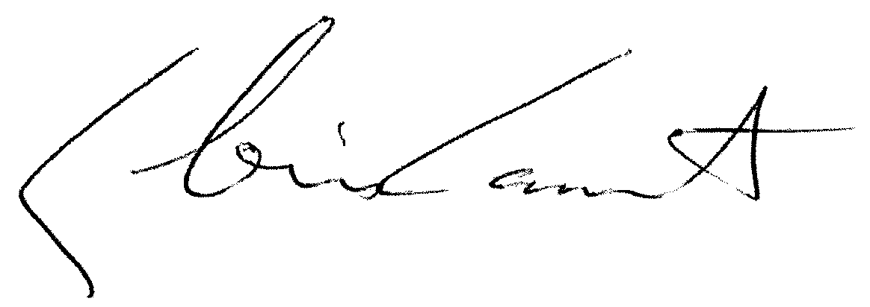

Chris Lamont

**Executive Director**