Page 1



**Submission to the Inquiry into National**

**Freight and Supply Chain Priorities**

**4 August 2017**

**Contents**

About GrainGrowers ..............................................................................................................2

About the Australian grains industry ......................................................................................2

Executive Summary...............................................................................................................3

GrainGrowers’ principles for the National Supply Chain Strategy...........................................4

Introduction............................................................................................................................5

Grains Supply Chain overview ...............................................................................................5

Competitiveness in the Australian grain freight sector..........................................................11

Urban growth pressures ......................................................................................................12

Conclusion...........................................................................................................................13



**About GrainGrowers**

GrainGrowers is an independent and technically resourced, grain farmer representative organisation with

17,500 members across Australia. GrainGrowers’ goal is a more efficient, sustainable and profitable grain production sector that benefits all Australia grain farmers and the wider grains industry. GrainGrowers has three divisions which work cooperatively to achieve improved grain industry outcomes: 1) Capability Building, 2) Industry Engagement and 3) Policy and Innovation.

GrainGrowers has a National Policy Group comprised of 15 elected representatives from across Australia. Five growers represent each of the three major grain-growing regions: Northern Region encompasses Queensland and Northern NSW, the Southern Region encompasses southern NSW and Victoria and the Western Region encompasses South Australia and Western Australia.

**About the Australian grains industry**

Australian grain farmers annually grow some 45 million tonnes of wheat, barley, oats, sorghum, canola and pulses such as chickpeas and faba bean, which at the farm gate alone is worth $13.5 billion. This production generates more than 170,000 jobs in rural, regional and metropolitan areas across Australia. Over 70% of Australia’s grain production is exported, earning some $11.4bn in export earnings annually, and accounting for more than a quarter of all agricultural export earnings. Furthermore, domestic sales of grain underpin the fortunes of the domestic food manufacturing sector and other important export industries such as the red meat and dairy industries.

Trade is vital for the Australian grains industry, and grains deliver significant export earnings for Australia and employment across rural, regional and metropolitan Australia. However this is contingent on producing a quality product which suits the market, and reliably and efficiently delivering grain to these markets. Ensuring an efficient, low cost supply chain is therefore imperative as it underpins the competitiveness of Australian grains in international markets.

**Executive Summary**

Australia needs a comprehensive and long term National Freight and Supply Chain Strategy to guide investment, policy and regulatory decisions to ensure our international competitiveness.

The National Freight and Supply Chain Strategy must explicitly address the needs of agriculture, and the grains industry in particular, to facilitate freight pathways which allow us to efficiently get our produce to market. With Australia's total grain production worth $17.3 billion at the farm gate, and total agricultural production forecast to be worth $63.8 billion in 2016-17, our ability to compete in global markets is contingent on low cost, reliable and efficient supply chains.

On average 45 million tonnes of grain is transported from Australian farms to domestic customers and ports each year at an estimated cost of more than $2.6 billion per year1; which is directly or indirectly paid by farmers. The cost of transporting grain to market in Australia is significant and growing, especially for moving grain to port. Transport remains the single largest component of the port value of grain, and costs per tonne per kilometre to transport grain in Australia are well above those of other grain exporting nations. This has a significant impact on farmers’ returns, consumer prices and Australia’s export competitiveness. Australia’s ability to lower production cost is limited given relatively high cost labour and other inputs compared to some competitors, and while on-farm productivity continues to improve, post-farm gate productivity is a critical area for improvement, hence the importance of efficient freight pathways.

Within Australia the grains freight task relies on road and rail. All grain leaves farms by road and much of it will then be delivered into country storage facilities. From these facilities, grain will be moved on road and/or rail to market or port as required by customers. The grain supply chain still relies on legacy infrastructure, ageing rail assets and roads of variable classification and quality, all of which are major impediments to efficiency and directly impact on Australia’s competitiveness in the international marketplace. While infrastructure improvements are essential, there is currently no overarching policy which coordinates and guides infrastructure investment decisions for either government and/or industry. Furthermore the regulatory settings, particularly relating to roads, impair investment and impact on the economies of scale which should be achieved along the grain supply chains. In general rail is the preferred and most efficient mode for bulk commodities like grain but there has been a significant shift of grain from rail to road because of poor infrastructure, a lack of maintenance and an uncertain investment environment. Too often rail and road investment decisions are considered in isolation, rather than adopting a holistic supply chain approach.

The real challenge for Government is to move from a piecemeal approach to infrastructure investment to ensure priorities are fully integrated through a long term strategy and deliver comprehensive freight solutions. This will also require a cooperative partnership with all three levels of government if real efficiencies are to be achieved. A project like Inland Rail for example, has the potential to offer significant benefits for the grains industry. However to realise this will require an ‘end to end’ port solution and investment in integrated road and rail linkages in order to attract grain freight onto the mainline through lower transport costs.

To remain globally competitive, Australia needs to ensure a low cost efficient supply chain. This can only be achieved with governments developing a national freight strategy which encourages long term investment in an integrated and coordinated network from regional areas through to port which aims to maximise rail utilisation, efficient intermodal hubs and a road network which underpins, rather than undermines, rail freight.

1 Preliminary TraNSIT modelling results from a GrainGrowers’ 2017 project

**GrainGrowers’ principles for the National Supply Chain Strategy**

GrainGrowers has identified the following principles which it believes should guide the strategy development.

The national freight and supply chain strategy should:

1. Encourage an increase in rail’s share of the national freight task for grain. A better road-rail mix in the delivery of the national freight task will help to reduce costs, deliver improved safety outcomes on our roads and produce clear environmental benefits.

2. Continue to progress the construction of inland rail and ensure the integration of existing rail and road infrastructure to underpin the inland rail line as a key part of the grains supply chain. The inland rail must be a complete port to port solution with appropriate infrastructure, capacity and access arrangements to ensure this is achieved. There must be a dedicated freight rail connection to the Ports of Brisbane and Melbourne, and encouragement of inland rail hubs to encourage the delivery of efficient rail connections from these inland hubs to the NSW ports of Newcastle, Port Botany and Port Kembla.

3. Invest in the road network to ensure roads are fit for purpose and allow efficient vehicle movements to accommodate the current and future growing freight task.

4. Align road regulations and ensure appropriate road classifications which facilitate an efficient supply chain from farm to market / port, to overcome first and last mile issues which restrict access of large trucks.

5. Adopt the CSIRO TraNSIT modelling as the basis for modelling the agricultural freight movements and scenario testing to identify national priorities.

6. Mitigate urban encroachment pressures through protected transport corridors and the introduction of regulations and laws which allow for the efficient delivery of grain freight to ports without severe restrictions and curfews.

7. Ensure the introduction of a single national heavy agricultural vehicles notice which covers the bulk (>80percent) of the current vehicles and equipment in use, and move to uniform national zones so as to facilitate safe and efficient supply chains.

8. Address as a matter of urgency the fact that the growth of agriculture and its contribution to the national economy will be constrained by supply chain inefficiencies without an overarching freight strategy.

9. Reconsider Australia’s approach to road and rail funding. Local government aren’t incentivised to maintain and enhance roads nor to increase load carrying capacity and standards. This is currently creating pinchpoints in the system.

10. Consideration of a full and direct road user charging system which replaces registrations and fuel excise. All revenue raised must be hypothecated to road construction, maintenance and operation, and an appropriate universal / community service obligations established to reflect the needs of rural communities and to ensure the baseline of road quality improves over time.

11. Consider innovative investment models to ensure the timely development of critical supply chain infrastructure.

**Introduction**

GrainGrowers welcomes the Australian Government's commitment to develop a National Freight and Supply Chain Strategy to guide infrastructure investments and shape policy which allow Australia’s freight system to be internationally competitive.

GrainGrowers is pleased to participate in this current inquiry into National Freight and Supply Chain Priorities and has appeared twice before the Inquiry on 2 June in Canberra, with the National Farmers Federation, and on 14 June in Sydney. This submission consolidates the issues raised in these meetings and reflects the supply chain principles which GrainGrowers’ National Policy Group believes are critical to the grains industry. GrainGrowers also supports the submission made by the National Farmers Federation to this Inquiry which encompasses the needs of the agricultural sector as a whole.

Given the importance of freight to all agricultural commodities including grains, GrainGrowers has recently commissioned CSIRO to use its TraNSIT model to develop a better understanding of the baseline grains freight task and then to test various scenarios and their impact on supply chain efficiencies. GrainGrowers expects this work to be completed in September and undertakes to provide the results to the Inquiry, however we have included some preliminary results in this submission. GrainGrowers also encourages the Inquiry to consider the final report, when available, of the TraNSIT Project undertaken as part of Priority 2 in the Agricultural Competitiveness as we understand it provides insights into the scope of the agricultural freight task by industry, and has modelled a number of scenarios to establish their impact on supply chain efficiency.

Supply chain partners to the Australian grain production sector play a critical role in the competitiveness of the industry and in determining profitably at the farm gate. Properly-planned, well-maintained and cost-efficient transport, grain handling and storage facilities are required to deliver the lowest-cost pathways to our market.

**Grains Supply Chain overview**

There are 20,7002 farms in Australia producing grain as the primary, or as a significant, agricultural output. Together they grow on average 45 million tonnes (mt) of crop each year worth $13 billion, with around

30 percent of this grain consumed domestically and 70 percent exported. However there can be considerable volatility in production between years due to climatic variations. The total cost of transporting grain from paddock to domestic customer or to port is in the vicinity of $2.5 billion, with freight estimated to account for 30 percent of the port price (AEGIC 2014). This prompts questions about the structure of, and investment in, the current supply chain and what changes must be made to achieve a more efficient and lower cost system.

As the industry continues to grow and use more sophisticated technology and equipment, the speed of harvest is increasing and pressures on the supply chain intensify. Compounding this, the traceability, biosecurity and provenance requirements are also increasing and demanding more from the supply chain

2 p21, GrainGrowers ‘State of the Australian Grains Industry Report 2016’

than ever before. Given the distance that grain travels, the reliability, efficiency and robustness of the supply chain is critical to underpin quality assurance programs and deliver grain as required by customers.

**What is moving where, why and how?**

The supply chain that services the Australian grains industry plays a critical role in the international competitiveness of the industry and for ensuring profitability through to the farm gate. Properly planned and well maintained freight routes are required to deliver a cost efficient pathway to market.

Unfortunately Australia’s international agricultural competitiveness is challenged by a chronic lack of investment, ageing infrastructure, poor planning and cumbersome regulation. Decades of government inaction has resulted in a freight and supply chain system that leaves our grain exports unfairly burdened against trade competitors and delivers grain to domestic consumers at a higher cost than necessary.

Australia’s rail networks are historically based upon state lines, operating below capacity in terms of speed limits and loading capacity and in some cases in danger of being shut down by their private operators. Regional and rural road investment is piecemeal, parochial and poorly coordinated between the three tiers of government. Ports, while expanding in number, are operating inefficiently due to a lack of throughput. There are also concerns about the accessibility and urban encroachment challenges.

Moving up to 45 mt of grain to market each year is a substantial task, engaging a network of rail and road freight, on-farm and regional up-country storages and metropolitan and port storages. More than 70 percent of Australian grain is exported (this percentage is significantly higher on the west coast while on the east coast a greater proportion of grain goes to domestic markets including feedlots, pig and chicken feed, malting and milling) and many domestic milling and processing facilities are concentrated in coastal metropolitan areas so the movement of grain from farm, to country storages and to the coast is a dominant feature of the entire Australian grain supply chain. Figure 1 shows the geographic spread of grain production, upcountry storage and freight pathways. The grain supply chain, particularly for wheat and barley, is characterised by peak load movement during harvest and the following two to three months. This puts significant pressure on parts of the supply chain at certain times of the year, including the road networks from farm to country storage. This pressure is eased a little with the growth of on-farm storage, which allows farmers flexibility in their marketing decisions and alters the timing of grain movements.

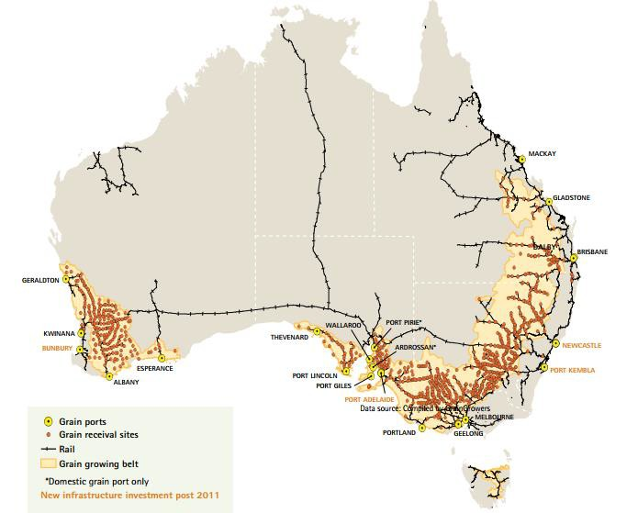

*Figure 1. The Australian grain bulk handling network, State of the Australian Grains Industry Report 2016, GrainGrowers*

This Australian system is based on delivery of grain into a bulk handling system operated by regional monopolies and characterised by a small number of segregations for each grain type at each delivery point and co-mingling of farmer deliveries, to a stack average based on receival standards. This facilitates the movement of grain in bulk, although container trade for specific customers and/or specialised markets is growing.

Reliance on road transport of grains is increasing as branch lines which service smaller up country storage facilities close. Consolidation and seasonal closures have increased in recent years with the greatest consolidation of site numbers occurring in Victoria and New South Wales.

Broader rail access issues also continue due in part to competition for slots from other commodities such as coal and ongoing tensions between above and below rail operators. These directly impact on rail freight costs and strongly influence logistics decisions made by the grain handlers, with associated costs mainly passed onto growers.

Road transport is now estimated to account for 50 percent of all grain movements on a total kilometre- tonne basis (AEGIC, 2014). From preliminary TraNSIT modelling work commissioned by GrainGrowers, annual transport costs for grains total $2,635 million comprising $2,149.7 million for road (81 percent of total

costs) and $487.4 million for rail. Grain freight accounts for 41 percent of all agricultural road freight and 90 percent of rail freight costs.

With consolidation, investment has also occurred in some parts of the network. The industry has witnessed the restructuring of the country storage system and changes in the road and rail mix over time. This investment is planned to result in greater efficiencies in the network, with the aim of sharing efficiencies with grain farmers who in many cases now have longer delivery distances. Given the monopoly nature of these regional networks, these efficiencies have not necessarily been shared with farmers, even though it is in the long-term interests of both the operators and the farmers to do so.

In many respects the sustainability and competitiveness of Australian grain farmers is in the hands of their supply chain partners. The multinational perspective of many of these partners, both in grain movement and in marketing, distracts from the task of selling Australian grains well. This in contrast to the interests of Australian grain farmers who are with one aim: a prosperous Australian grains industry, over the long term.

What changes would you like to see to make the supply chain work better?

The following freight density maps show the grain freight pathways by road (figure 2) and by rail (figure 3) and classifies routes based on the volume of grain (number of trailers or wagons) transported. The two maps overlaid reveal the significant volumes of grain moving to port by road despite freight price differentials for road and rail which are shown in figure 4.

From a grains industry perspective, the national strategy must provide a framework which delivers integrated planning of road, rail and port infrastructure so that least-cost pathways dominate the supply chain. The challenge for the industry, and indeed government, is how to integrate and coordinate the grains supply chain to

• increase amount of grain transported through an efficient rail network

• maximise the efficiency of ports to improve ship loading, and

• ensure appropriate investment in road and regional line rail.

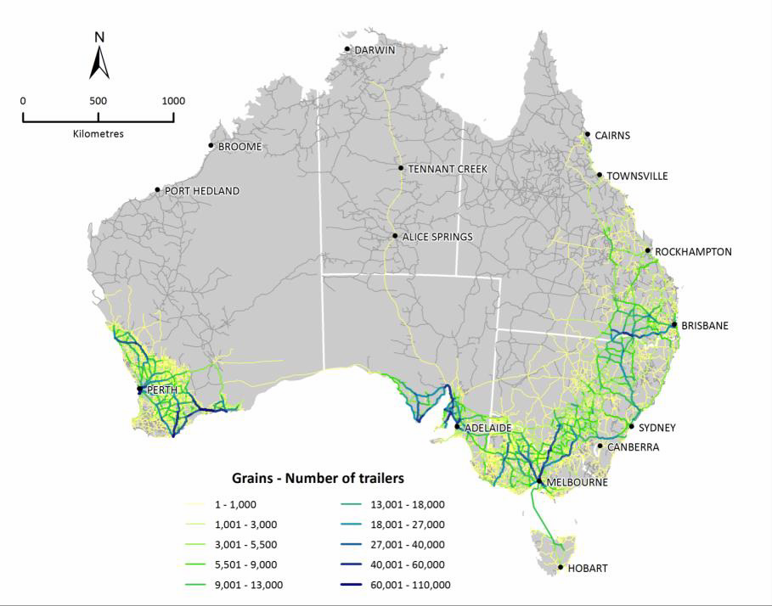

*Figure 2. TraNSIT Density maps: Australian grain from silos (Trailer is a semi-trailer equivalent (18 and 29 tonnes) and a B-double is 1.5 trailers.*

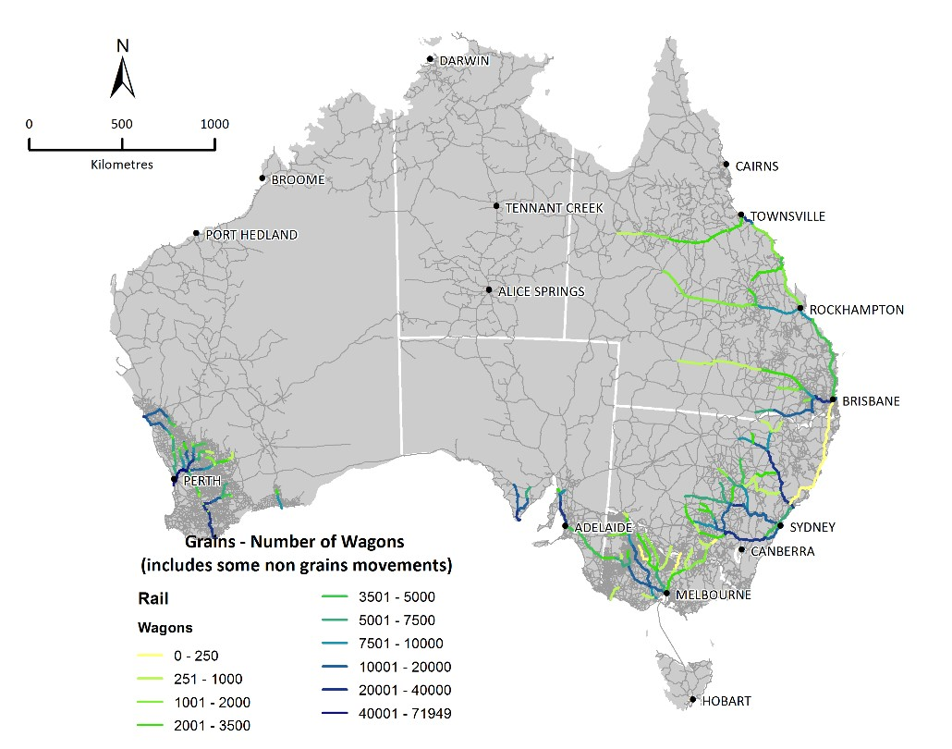

*Figure 3. TraNSIT Density maps: Australian grain rail (based on rail wagon of about 45 to 55 tonnes).*

*Figure 4. Overview of grains freight costs and rates (red denotes rail), TraNSIT modelling for a GrainGrowers’ current project.*

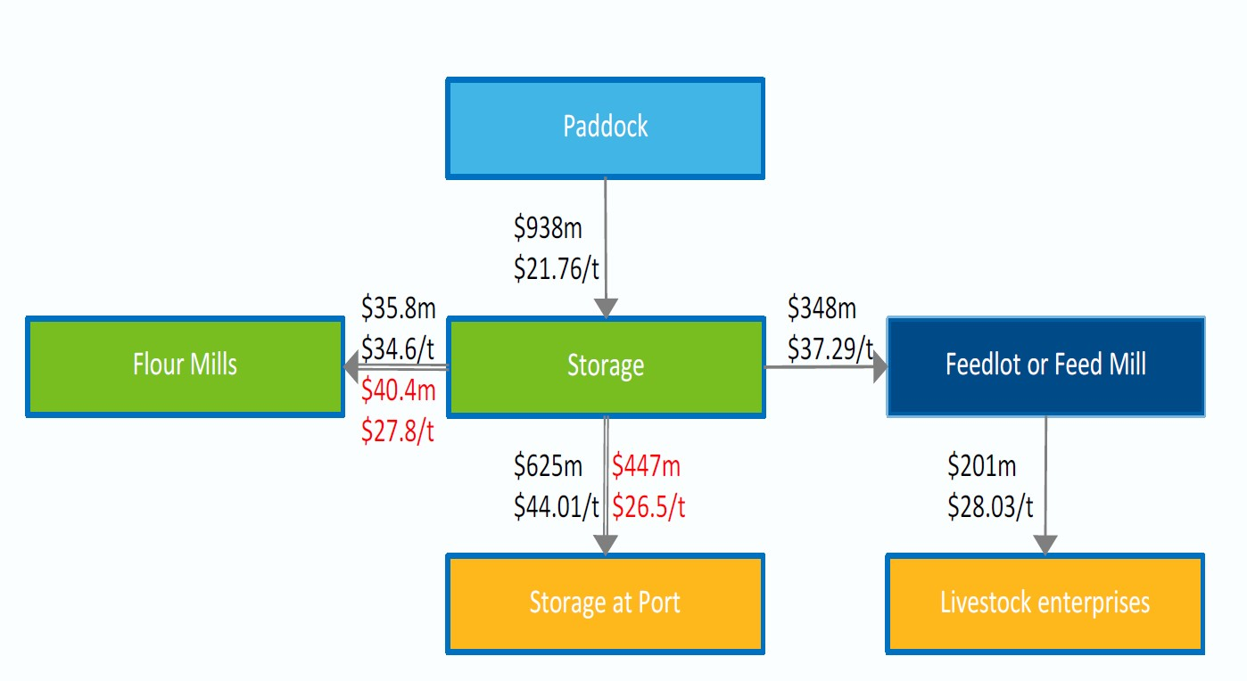

The freight density maps also highlight the significant opportunity presented by inland rail on the east coast. However for this to be realised, Melbourne and Brisbane ports must be fully integrated into the Inland rail to provide an end to end solution, strategic regional intermodal facilities must be developed along with the associated investment in feeder rail and road routes.

What data gaps are you aware of in relation to Australia’s freight and supply chains?

There is a paucity of reliable data on grain freight costs by mode and region, and also in relation to the current quality and capabilities of the rail and roads (especially local council ) infrastructure. This must be addressed so as to inform the national strategy and to test business cases for investment priorities.

As noted by Infrastructure Australia, the development of the proposed National Freight and Supply Chain strategy should be informed by CSIRO’s TraNSIT model. This tool should be used to identify the most efficient routes along major supply chains and to inform funding decisions on which strategic regional projects will have the most substantial economic impact.

From preliminary discussions with the National Heavy Vehicle Registrar (NHVR), it may eventually be possible to use national data (on permits, registrations and road classifications) gathered through their new portal to understand better the types of vehicles in use, the main local and regional freight paths which support the grains industry, and to identify where investment in roads infrastructure will lead to major improvements in freight pathways.

**Competitiveness in the Australian grain freight sector**

In your view, is Australia’s freight system internationally competitive? What are the key indicators which tell us this? How important is freight movement to your business competitiveness?

As a predominately export product, Australia competes with other countries to supply international markets. The premium quality of Australian grain and proximity to market remain key selling points. However, as other countries improve their agronomic and management practices and produce grain of higher quality, key customers are becoming much more price sensitive. This presents a very real challenge for the Australian grain industry to maintain and enhance its competitive position given the relative large supply chain costs compared to those of some competitors as shown in Table 1.

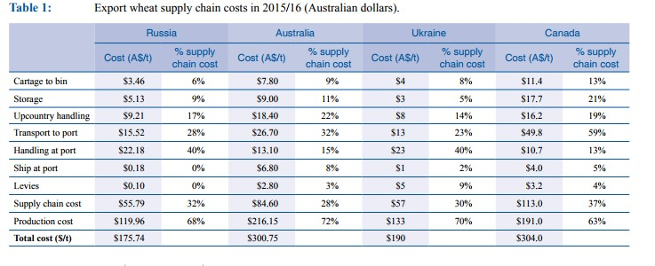

*"Is the Black Sea a dark cloud over Australia's grains industry? Prof Ross Kingwell, AEGIC, Farm Institute Insights Vol*

*13. No.4. Nov 2016*

Furthermore many grain operators in Australia are global companies with global sourcing capabilities, geared to source grain from the country which best fits the contract specifications at the lowest cost. This may not be Australia. Freight costs to port for Australian grains therefore has a directly impact on our market share.

Are regulatory factors affecting productivity for your business? How could this be improved?

Government has a role to play in establishing a framework which facilitates growth of agriculture as a major sector of the economy.

Regulatory inconsistencies have a direct impact on the supply chain, particularly with respect to road. The lack of consistent heavy vehicle regulations across the country are a major source of frustration for growers. The myriad state-based regulations, overlaid with further local council restrictions on roads, creates confusion. These regulations have also failed to keep pace with current agricultural equipment and vehicles. Currently,

mass and dimension limits vary across jurisdictions and are well below the actual specifications of the current fleet of agricultural vehicles. A recent survey conducted by GrainGrowers shows that state-based regulations/notices have failed to keep up with the equipment being used on farm. State agencies and local councils (as road owners) appear reluctant to make the necessary changes to zones, vehicle dimensions and mass limits, and road classifications required to achieve real reform and meet the stated intention of the NHVR to cover 80 percent of vehicles under a single class 1 notice. This must be addressed if we are to have a single national system which underpins, rather than impairs, the efficiency of industry.

The Port Terminal Access (Bulk Wheat) Code of Conduct (the Code) is to be reviewed this year and provides an opportunity to assess how well the current port infrastructure and operators are serving the industry.

*“First and last mile issues are associated with 50 percent of costs because of a lack of competition in ports.” Western region member of the National Policy Group*

Our members often cite problems with port infrastructure and bottlenecks in accessing ports as major issues. They raise concerns about the lack of competition and inability of smaller operators to access shipping facilities. GrainGrowers will participate in the review by the Australian Competition and Consumer Commission (ACCC) of grain port performance, a particularly important inquiry for the Australian grains industry in light of the record crop harvesting in 2016/17 and the associated high shipping schedule. The Code is due to be reviewed from September 2017. The aim is to assess its role in ensuring access to infrastructure and maintaining healthy competition at port.

**Urban growth pressures**

As an export commodity, grain moves from country storage to coastal ports. Many grain ports were first built in exclusively industrial zones but over time major urban areas have encroached, including those in Botany, Newcastle, Port Kembla, Brisbane, Melbourne, Perth and Adelaide.

This urban encroachment has resulted in limitations to road and rail accessibility and hours of operation, and have imposed other restrictions and/or changes to port operations and activities. These factors have increased freight costs and resulted in inefficiencies in the supply chain.

*“Freight costs to get to Brisbane port have increased over the last ten years from $39 to $75 per tonne,” National Policy Group member (Northern Region).*

The urban encroachment reflects the failure of governments to undertake strategic land use planning and protect freight access corridors, which ultimately could undermine the long term viability of these ports.

It is not just urban pressures in coastal areas which are adversely affecting the grains supply chain. As the size of many regional communities have grown, residential areas now are encroaching on industrial areas in towns and are forcing a rethink by councils about land use and the redesignation of industrial areas to residential. One example is GrainCorp’s Emerald storage facility which was closed down because of urban encroachment

– operations at the site were no longer practicable or compatible with surrounding residential uses.

While GrainCorp is investing in a new grain facility at a different location, it highlights the need for better planning to ensure that investments have a long life and can generate the return necessary.

**Conclusion**

The Australian grains industry needs governments of all levels to refocus efforts on regional areas to ensure our grain industry remains globally competitive. Initiatives to create better freight planning, increase infrastructure funding and reduce transport regulation would create a cheaper pathway to market for farmers and all supply chain participants.

Australia’s grain freight challenge can be addressed by tackling three key areas - improved freight routes, increased infrastructure investment options and better regulation.

This is a critical juncture for the Australian grains industry. With 30 percent of the cost of getting grain to port consumed by freight costs the industry needs to manage costs to remain globally competitive and grain needs to move faster, more efficiently and safer than ever before.

GrainGrowers fully supports the Inquiry's stated position that “it will be in the national interest to have a long term strategy that positions Australia’s freight infrastructure to extract the best value from investment and meets future challenges related to domestic and international growth.”3

GrainGrowers believes the strategy must explicitly address the unique needs of the agricultural supply chain to ensure that an efficient, low cost and integrated system ensures grains’ international competitive position and contribution to the Australian economy.

GrainGrowers looks forward to reviewing the Inquiry’s draft strategy and will provide the results of our grains supply chain scenario modelling to the Inquiry by the end of September 2017.

**Contact:**

Fiona McCredie | National Policy Manager | Grain Growers Ltd

E: | P: +61 0 9286 2000 |

3 P 3 Discussion Paper – May 2017 - Inquiry into National Freight and Supply Chain Priorities.