28 July 2017

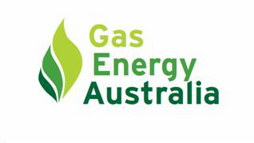

Freight and Supply Chain Inquiry

Department of Infrastructure and Regional Development (DI&RD) GPO Box 594

CANBERRA CITY ACT 2601

Email: [freightstrategy@infrastructure.gov.au](mailto:freightstrategy@infrastructure.gov.au)

Dear Sir/Madam

Gas Energy Australia (GEA) is pleased to make a submission responding to your Department’s Inquiry into the

National Freight and Supply Chain Priorities – Discussion Paper May 2017.

GEA is the national peak body which represents the bulk of the downstream gaseous fuels industry which covers Liquefied Petroleum Gas (LPG), Liquefied Natural Gas (LNG) and Compressed Natural Gas (CNG). The industry comprises major companies and small to medium businesses in the gaseous fuels supply chain; refiners, fuel marketers, equipment manufacturers, LPG vehicle converters, consultants and other providers of services to the industry.

GEA offers the following short, medium and long-term priorities for consideration.

• A short-term priority should be to review and eliminate unnecessarily restrictive freight transport regulations applied by all levels of government, including exclusions from tunnels and the imposition of curfews.

• A medium-term priority should be integration of dangerous goods transport into a national freight and logistics strategy inclusive of all levels of government that incorporates the necessary mechanisms to protect designated dangerous goods transport corridors from the impact of urban intensification.

• A long-term goal should be the alignment and removal of duplication of freight transport regulation across

Australia.

GEA welcomes the opportunity to further discuss this submission in relation to the transport of gaseous fuels and looks forward to working with DI&RD to address these priority issues and improve road safety and productivity.

For your consideration. Yours sincerely



John Griffiths

Chief Executive Officer

**Gas Energy Australia Suite 7 - 16 National Circuit Barton ACT 2600**

**Telephone: +61 2 6176 3100 Fax: +61 2 6176 0207**

[**www.gasenergyaustralia.com.au**](http://www.gasenergyaustralia.com.au/)

**Gas transport is moving energy across Australia to supply businesses and people via road, rail and sea**

In response to the DI&RD Discussion Paper, GEA offers the following relevant information

Gaseous fuels are a significant source of energy in Australia, providing energy for homes and businesses and fuel to power vehicles. This energy transits national freight infrastructure and can do so multiple times in the case of the LPG sector before it reaches consumers. It is worth noting firstly the volume and worth of this trade and following this, the extent of the current supply infrastructure and how reliant it is on freight corridors to deliver product to consumers.

There are multiple uses for LPG in Australia, which can be categorised into two key markets – traditional and autogas use. The traditional market for LPG comprises residential (eg, water heating, space heating and cooking), recreational, commercial (eg, forklifts) and industrial uses (eg, steam-raising, kiln firing and food processing). LPG for the traditional market is mainly propane to meet specifications for domestic and industrial heating appliances.

Autogas can be a mixture of propane and butane or propane alone. Generally, metropolitan populations use autogas made up of both propane and butane. In rural and regional Australia, most Autogas is propane.

This approach reduces the costs of supplying autogas and traditional LPG to these areas.

All States and Territories benefit from gaseous fuels.

|  |  |  |  |
| --- | --- | --- | --- |
| **State/ Territory**  NSW | **Autogas demand**  114 | **Traditional demand**  Volume in kilotonnes  180 | **Total domestic demand**  (kT)  294 |
| Victoria | 287 | 219 | 506 |
| Queensland | 46 | 173 | 219 |
| South Australia | 44 | 68 | 112 |
| Tasmania | 3 | 17 | 20 |
| Western Australia | 38 | 76 | 115 |
| Northern Territory | 1 | 10 | 11 |
| National total | 532 | 744 | 1,276 |

Table 1 – LPG used in Australia by State in 2016

Australia consumed 1,276 kT of LPG in 2016 and this was delivered through Australia’s freight network. In monetary terms in wholesale prices, at least $½ billion dollars of raw energy is transported internally on Australian freight networks annually. This figure does not include CNG and LNG fuel volumes which are point to point delivery systems (ie from a compressor station/liquefaction plant to the end user).

Australia is a major exporter of gaseous fuels. Most media attention focuses on the export of LNG, which is methane chilled into a much denser liquid form for ease of transport. But Australia is also a net exporter of LPG which is propane, butane or a combination of these gases. LPG is sourced mostly through separation plants from Australia’s gas fields and to lesser extent from Australia’s four remaining refineries where it is a product of refining crude oil.

There are a series of marine and regional terminals located across Australia which support the LPG distribution network and maintain supply to industry, domestic and automotive outlets supply industry and provide access to Australia’s internal freight network, which is predominately based on the road network which also links several

LNG plants supplying the domestic market.

LPG Domestic Supply Terminal LNG Domestic Supply point Petroleum Refinery

Gas Separation plant

Figure 1 – LPG and LNG Supply Infrastructure

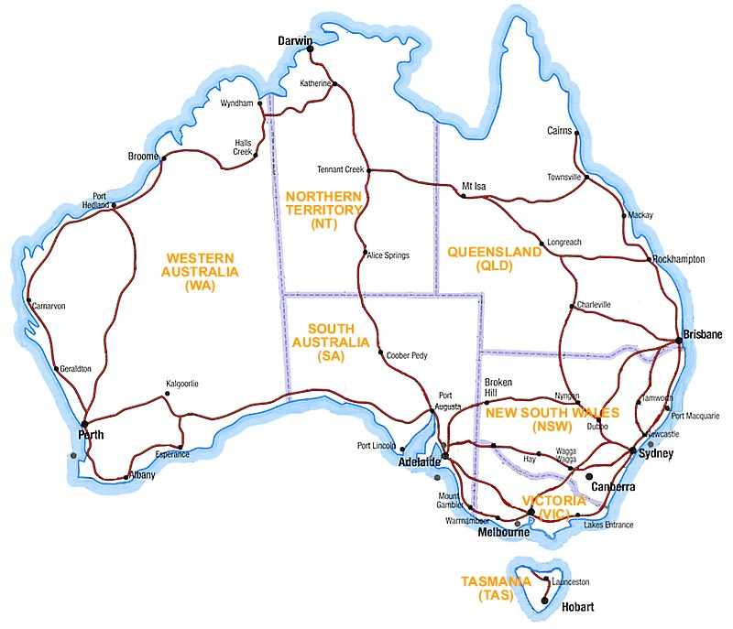

It is not only the major freight hubs such as Port Botany, Kwinana and Otway that are important, but the full distribution network including “the last mile” delivery.

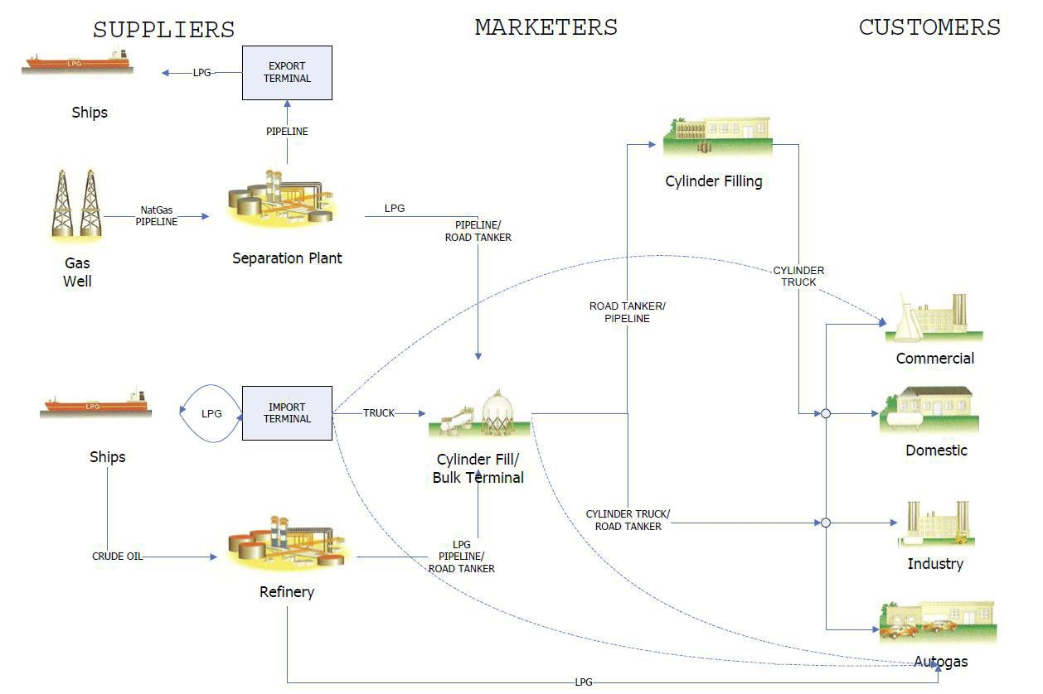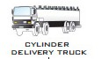

Diagram 2 – LPG Supply chain

What is not included in diagram 1 is the thousands of distribution depots and stores where LPG is held for delivery to consumers. The number of bulk distribution depots and stores combined with a significant reliance on road transport for the last mile is clearly apparent in diagram 2 as the last mile in the majority of cases is via road transport of some kind. Transport options include sea, rail and various forms of road transport from road trains and semi-trailers to rigid heavy vehicles and light vehicles.

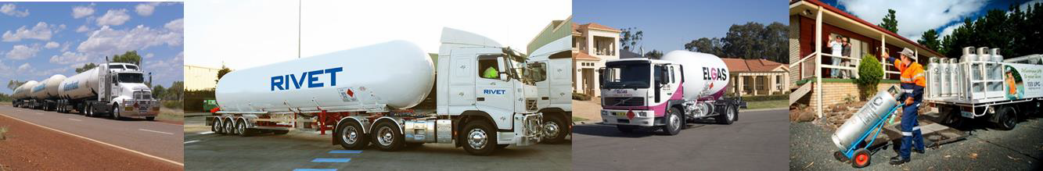

*What changes would you like to see to make your supply chain work better?*

**A National Freight and Supply Chain Strategy that is inclusive of Dangerous Goods and is applied by all levels of government**

The Discussion Paper identities a series of areas being considered by DI&RD including Urban Growth and Port Corridors Pressures and End-to-end supply chain integration and regulation. GEA offers the following observations on these areas as they affect Dangerous Goods

**Urban Growth**

**Freight transport is being pushed underground**

Freight transport is being driven underground by urban growth pressures. One only has to look at the example of the pressures in Sydney and in particular around Port Botany which significantly impact on freight movements to city and regional areas. This has the potential to increase costs for consumers across NSW and Australia.

The Sydney Westconnex project will be largely comprised of underground tunnels which will exclude trucks carrying dangerous goods such as gaseous fuels. At the same time, claims about heavy vehicle traffic being reduced by corridor projects such as Westconnex, are encouraging Sydney Councils such as those in the Inner West to create more public spaces and reduce heavy vehicles on Parramatta Road and its side roads.

This dilemma highlights the importance of road infrastructure solutions incorporating planning solutions for the movement of dangerous goods as the current exclusion of Dangerous Goods from tunnels in NSW forces tankers to continue using existing suburban corridors while local councils seek to reduce heavy vehicle impacts and move to limit loads and transit times. This makes it very difficult for industry to meet the energy demands of industry and consumers throughout city and regional areas. It results in longer transit times and increased freight costs which are passed onto consumers.

To understand in quantitative terms the effect tunnel exclusions can have on dangerous goods transport, GEA has summarised the impact of the Tugun Tunnel in South East Queensland. The Tugun Tunnel is

334m long and forms part of the Tugun Bypass project. The Tugun Bypass takes traffic to the west of the

Gold Coast Airport, connecting to Stewart Road interchange at Currumbin and the Tweed Heads Bypass north of Kennedy Drive at Tweed Heads West. The Bypass when designed was expected to take 55% of traffic off the existing Gold Coast Highway by 2017 and reduce the travel time between Currumbin and Tweed Heads West to 5 minutes. The project opened to traffic on 3 June 2008.

The Tugun Tunnel precludes the carriage of:

• Dangerous goods class 1

• Dangerous goods class 2.1, and

• Dangerous goods: mixed class

This requires tankers transporting LPG to take an alternate route using the Gold Coast Highway. The alternate route passes through commercial areas, with entrances to the John Flynn hospital, Southern Cross University and the Gold Coast Airport. LPG tankers must navigate 5 traffic lights and 5 intersections.

While the alternate route is only 1km longer, the transit time increases to between 15 and 30 minutes depending on the time of day, compared to the transit time on the bypass of 5 minutes. The Tugun Bypass requires one carrier’s LPG tankers to transit the Gold Coast highway 14 times per day and more during the winter period. Over 5,000 movements per year could have been avoided by one carrier alone with careful assessment of the public risk and appropriate design of the tunnel infrastructure. In productivity terms, using an average travel time of 15 minutes more than of normal traffic, the Bypass requires drivers and tankers carrying dangerous goods to be on the road **1274** hours more than they would without the tunnel exclusion.

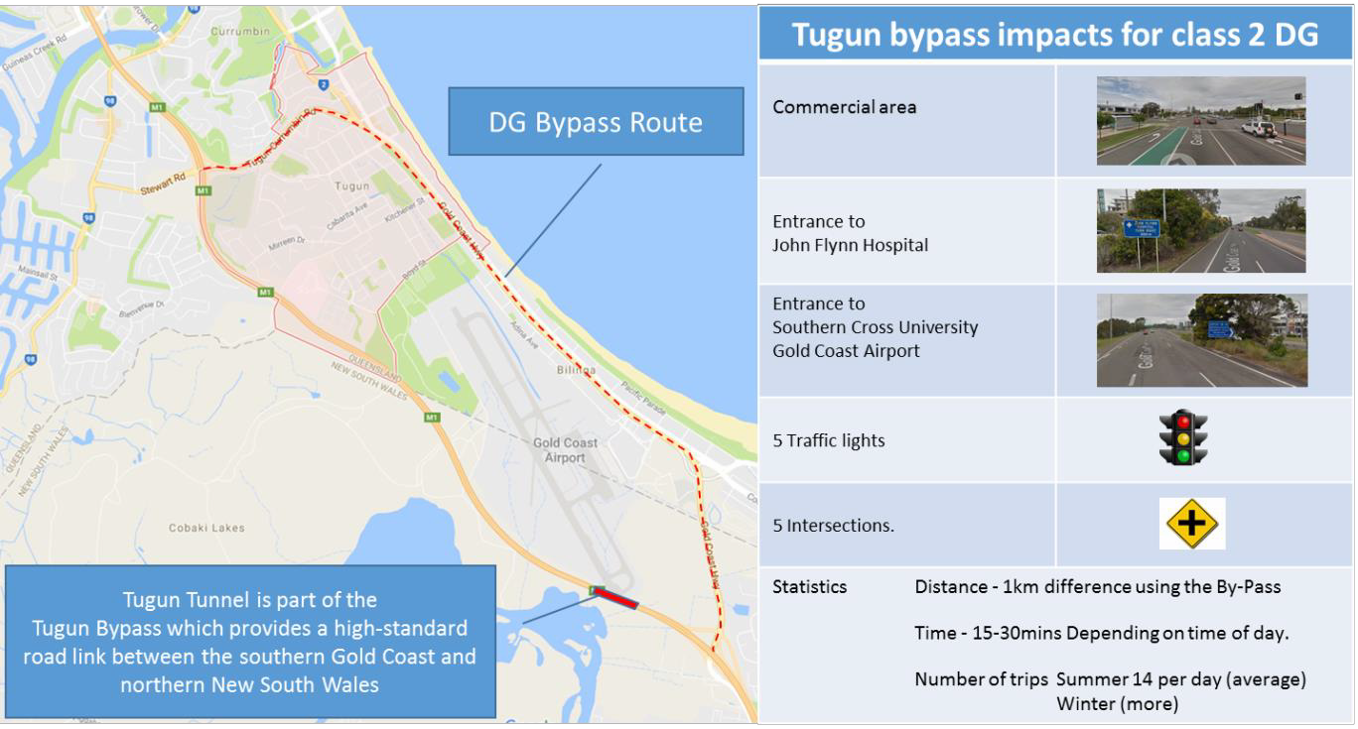

Diagram of Tugun Dangerous Goods Bypass

A study undertaken by Connell Wagner published in February 2004 “Coffs Harbour Highway Planning, Coffs Harbour Section, Dangerous Goods Transport Comparative Risk Assessment Working Paper No 8 provides a comparative assessment of risks associated with transporting dangerous goods in relation to route options in the Coffs Harbour area. The report notes the consequence of tunnel incidents including the statement that, “A serious incident in a tunnel can be very costly in terms of human lives, the environment, tunnel damage and transport disruption. On the other hand, needlessly banning dangerous goods from tunnels may create unjustified economic cost. Moreover, it may force operators to use more dangerous routes, such as through densely populated areas and thus increase the overall risks.”

This statement highlights that while banishing dangerous goods to an alternate route has an economic cost, it can also potentially increase the overall risk to the public.

To put the costs into in perspective, over 1.8 million households in Australia use LPG in their homes, and with the majority (over 1 million) of these energy customers in non-urban Australia, they bear the brunt of

increased freight costs. While a rural consumer experiences the direct cost of freight increases, ultimately higher energy prices in rural Australia flow through the supply chain back to city living costs through higher goods and produce prices. Maintaining freight corridors inclusive of Dangerous Goods would help to contain living costs for all Australians.

In relation to increased public risk, the Connell Wagner report, while focused on the design options and traffic at the time, noted that the tunnels in the project were relatively short (less than 600 metres) and while dependent on tunnel design, operational features and management practices, the likelihood of a serious incident ranged from 1 in 2000 years to 1 in 7,200 years depending on the tunnel length. The report also noted that while the impact on road users of a dangerous goods incident in a tunnel would be more severe than on a surface road, such an incident in a tunnel might reduce the impact on the surrounding environment, and concluded that all of the upgrade options (which included tunnels) would significantly reduce the risks of incidents involving dangerous goods when compared to the current base situation (i.e. the unimproved Pacific Highway).

**Urban restrictions are not just in the cities**

It is not just major Australian cities where urban pressures restrict or hamper freight delivery as exemplified by the following situation where a LPG supplier has a distribution depot located in a general industrial zone in the NSW town of Kempsey. The site has had restrictions placed on it by the local council which limit operations at the site from 7:30am to 5:30pm Monday to Friday. The distribution site supplies LPG, industrial, medical and hospitality gas products for the Kempsey area and the surrounding region.

This limit on operations in a general industrial zone means the LPG supplier has limited ability to support out of gas calls over weekends and supplies have to be supplied from Lismore more than 3 hours away.

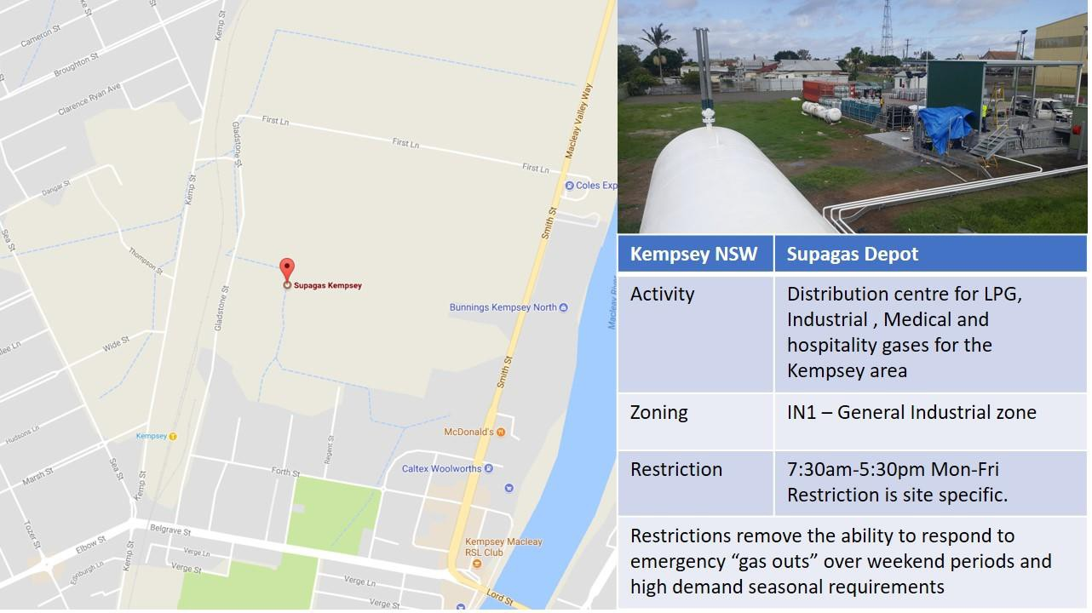

**The last mile – maintaining access**

Deliveries of LPG in the urban environment, be they for delivery of cylinders or for decanting into in-situ cylinders use heavy vehicles for economies of scale. As vehicle access to premises becomes congested by street parking and narrowing of access ways, deliveries to the last mile becomes increasing difficult. This forces smaller uneconomic vehicles to be used.

GEA recommends that the National Freight and Logistics Strategy adopts a holistic approach that recognises the distribution of a product does not finish with transport corridors but ultimately ends at a consumer site, and that all level of government impact on this, from the planning of tunnels and corridor infrastructure through to the zoning of land and management of street parking.

**Port Corridor**

Port facilities are a key component of gaseous fuels transport in Australia and clear unrestricted access to them is vital for the energy needs of Australians. There is increasing encroachment on port corridors which is directly impacting the current movement of gaseous fuels.

An example is access to Port Botany in Sydney. Denison Street is one of only two truck access routes to Port Botany. Denison Street is identified as an important freight access road by the NSW Government but it does not appear to be recognised as such by planning authorities. Denison Street provides an alternative access route to Foreshore Road, particularly for trucks travelling to and from the north of Port Botany and during peak commuter periods. It is important to the efficient operation of Port Botany, now and in years to come.

Botany Council (Bayside Council) has raised concerns over the increased movement of dangerous goods along Dennison Street due to its recent approval of a major retail development along this corridor. The Council has considered placing restrictions on truck movements along this corridor which if acted on would severely threaten the ability of the Port to service the growing chemical and energy fuels needs of NSW. Such restrictions mean trucks are on the road longer and with all transport requiring a driver, this results in additional hours at the wheel and increases exposure to fatigue.

GEA supports maintaining clear unrestricted access for all freight to Australian ports.

**End-to-end supply chain integration and regulation**

The integration and transfer of product in the supply chain is well understood and managed by industry with Australian Standards in place covering the storage and handling of gases. Because the freight is categorised as a dangerous good, the vehicle is subject to the National Heavy Vehicle Law (NHVL), and the freight is subject to not only the requirements of the NHVL (load restraint) but also to the Australian Dangerous Goods (ADG) Code of Practice for the transport of dangerous goods by road or rail which is called up in regulation by the States and Territories.

While the NHVL includes national licensing, permits and registration, the addition of the ADG code of practice means a second layer of licensing, registration and permits. While States and Territories have mutual recognition of Dangerous Goods licenses and registrations, permits are valid on a state by state basis. There are two issues at play here. First, the additional permit requirements which have been addressed under the NHVL for general freight but not for Dangerous Goods. Second, the double jeopardy situation where a gas transporter could be penalised for the release of gas by a State Transport Regulator under NHVL load restraint laws and be penalised by the Dangerous goods regulator for the same incident. GEA recommends that the National Freight and Logistics Strategy include regulatory alignment and removal of duplication of regulation.

The expanding urban environment also impacts on driver safety. The safe passage of freight requires supporting drivers by making available suitable rest areas and parking. With urban growth, this is becoming an issue, especially for dangerous goods transport. For example, in the Port Botany area, there are no suitable rest areas for tankers in the Port, or on Foreshore Road (which has plenty of space each side). Drivers need to wait to access the M1 or M5 before they find suitable rest areas. GEA recommends that the National Freight and Logistics Strategy provide driver support infrastructure as well as designing roads, bridges and tunnels.

**Changing Technology**

The gaseous fuels industry uses a variety of different technologies to support its drivers and their operations from GPS tracking and electronic log books to geocache transport routes and communications. The most significant changes will be integrating driver support into technology systems.

**Conclusion**

GEA’s seeks priority action for national freight transport planning and regulations to support the safe and efficient movement of dangerous goods freight rather than treat them as a pariah. Currently, people fear and attempt to exclude dangerous goods even though they are a key component in the supply of many consumer goods, be that as an energy source or as an input. Urban growth, port access, regulation and changing technology are all issues which are now impacting the transport of gaseous fuels, increasing cost burdens on consumers and exposing industry and road users to greater risks.

In response, GEA offers the following short, medium and long-term priorities for consideration.

• A short-term priority should be to review and eliminate unnecessarily restrictive freight transport regulations applied by all levels of government, including exclusions from tunnels and the imposition of curfews.

• A medium-term priority should be integration of dangerous goods transport into a national freight and logistics strategy inclusive of all levels of government that incorporates the necessary mechanisms to protect designated dangerous goods transport corridors from the impact of urban intensification.

• A long-term goal should be the alignment and removal of duplication of freight transport regulation across

Australia.