Page 1 of 5

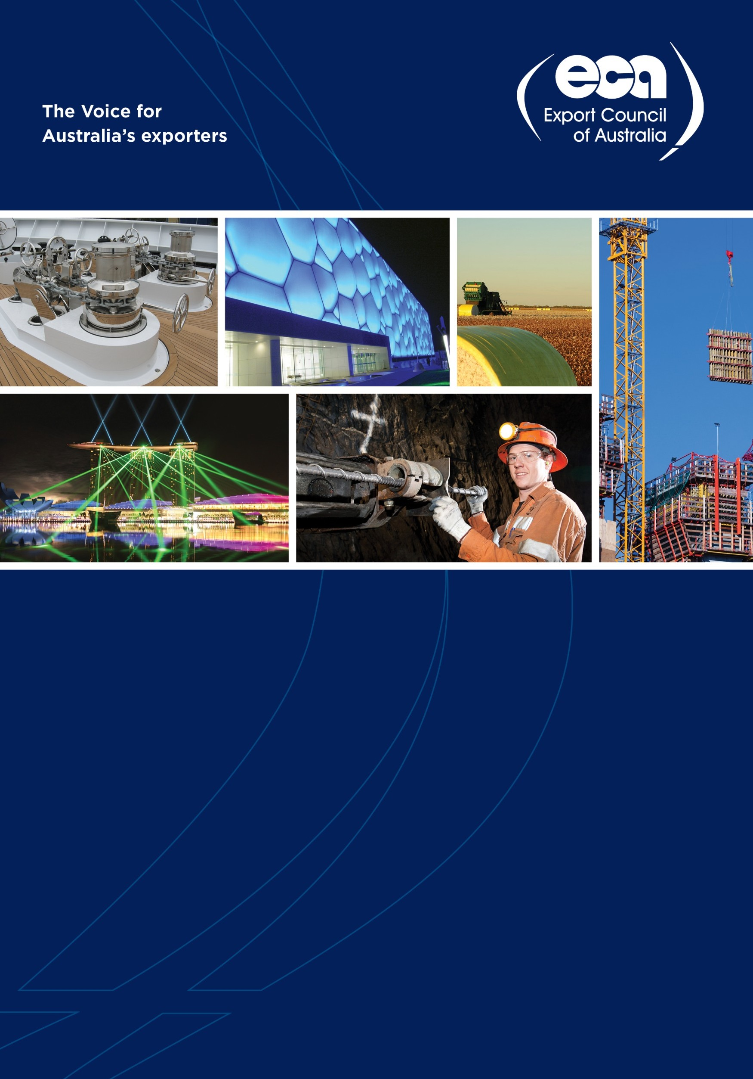

**Submission to the Inquiry into**

**National Freight and Supply Chain**

**Priorities**

**August 2017**

**Submission by the Export Council of Australia**

**About the Export Council of Australia**

The Export Council of Australia (ECA) welcomes the opportunity to make a submission to the Inquiry into National Freight and Supply Chain Priorities. The recommendations in this submission build on the ECA’s annual trade policy recommendations, found at <http://www.export.org.au/trade-policy/trade-policy->recommendations.

The ECA is the peak industry body for Australia’s exporters and importers, particularly SMEs. With a membership base of around 1,000 and a reach of over 15,000, the ECA represents companies of all sizes and across a wide range of industries.

The ECA’s core activities include research, advocacy, skills development and events. The ECA collaborates with a number of government agencies, at Commonwealth, state and territory levels, to advance the interests of its members and support SMEs. Within the Commonwealth, these agencies include the Department of Foreign Affairs and Trade, Austrade, Efic, the Department of Immigration and Border Protection, the Department of Industry, Innovation and Science, and the Department of Agriculture and Water Resources.

**Executive Summary**

The ECA supports the Council of Australian Governments (COAG) developing a National Freight and Supply

Chain strategy, and welcomes the opportunity to make a submission to the Inquiry.

Australia is a high-cost country, with a small domestic market, and is a significant distance from its major export markets. Australian businesses face significant challenges when competing internationally and it is imperative that domestic policy settings enhance, rather than limit, their competitivess. Getting infrastructure and supply chains right is a key part of this.

In summary, the ECA recommends the National Freight and Supply Chain strategy prioritise:

• minimising the cost of getting goods to and through ports/airports, including by ensuring the ACCC

closely oversees infrastructure access, pricing and services;

• reducing regulatory costs and barriers to trade by developing a single window for trade that incorporates the domestic supply chain and can also in the future link to similar systems in other countries

• developing a meaningful international benchmarking and national performance framework, and ensure cross-industry monitoring, across multiple locations

• embracing technological advances that will help drive future efficiencies, and enable new business models.

Given the importance of infrastructure on Australia’s international competitiveness, the ECA recommends the Australian Government seek greater input from exporters and importers on infrastructure planning and prioritisation.

**Submission**

The ECA supports COAG developing a National Freight and Supply Chain Strategy, and welcomes the opportunity to make a submission to the Inquiry.

Infrastructure is one of a range of factors that contribute to Australia’s international competitiveness. Along with infrastructure, these include regulation, education, R&D and innovation, tax settings and labour costs.

Page 2 of 5

With a small population, high labour costs and, culturally and linguistically diverse trading partners,

Australian exporters start with a handicap. In this context, it is imperative that governments strive to maximise competitiveness in areas which they can control. This includes infrastructure.

Minimising the cost of getting goods to and through ports/airports

**The strategy must prioritise minimising the cost of getting goods to and through ports/airports, including by ensuring the ACCC closely oversees infrastructure access, pricing and services.**

Despite the ‘tyranny of distance’ Australia faces, it is domestic freight costs that can be the biggest burden for Australian exporters. Domestic freight costs are a major part of exporters’ cost bases, and have a significant impact on Australia’s international competitiveness. Simply put, domestic freight costs in Australia are too high, and make it harder for Australian businesses to compete internationally.

Exporters from a range of industries have highlighted to the ECA the impact of domestic freight costs on their businesses. A Brisbane-based advanced manufacturing company paid as much to move their products the

35km between Southern Brisbane and the Port of Brisbane as it does to move them between the Port of

Brisbane and the United Kingdom. For a beetroot exporter, domestic costs accounted for two-thirds of its overall freight costs. For a grain exporter, domestic freight costs accounted for 30% of total costs.

It’s not just costs getting goods to port. Recent significant port charges increases have also reduced competitiveness. In April, DP World (one of the oligopoly container service operators) increased its infrastructure surcharge in Melbourne from $3 to $32.60 per container. In Sydney, the surcharge increased from $0 to $21.14 for all containers delivered into the terminal. Patricks, another of the three main stevedores, followed DP World’s lead in July 2017.

The costs of getting goods to and through ports and airports matter. While the ECA strongly supports the Australian Government’s free trade agenda, and notes the importance for business of the associated tariff reductions, these tariff reductions are only one part of the picture. For some sectors, domestic freight costs will affect their international competitiveness far more than an FTA could.

It is vital that the government strive to ensure these costs are as low as possible. This should include the Australian Competition and Consumer Commission closely monitoring the cost and provision of services for critical infrastructure, as well as third-party access to infrastructure.

Reduce regulatory costs and barriers to exports

**The strategy must prioritise reducing regulatory costs and barriers to trade by developing a single window for trade that incorporates the domestic supply chain and can also in the future link to similar systems in other countries.**

Domestic regulatory costs for exports, and the complexity of export supply chains, weigh down Australia’s international competitiveness. These costs and complexities should not just be seen as burdening businesses already exporting. Governments should also understand there are significant opportunity costs from the number of businesses that are put off exporting because they see it as too complex an undertaking.

As the World Bank’s *Logistics Performance Index* notes, Australian exporters must complete seven export documents—the average for East Asia and Pacific is four documents, and the average for high income OECD countries is two. According to the Bank’s *Trading Across Borders* index, documentary compliance for exporting takes seven hours and costs USD 749. By contrast the OECD average is two hours and USD 150.

The ECA has long called for the introduction of a Single Window for Trade in Australia that would make boarder processes quicker and lower their cost. In the 2017 election, the Coalition committed to introducing one, and delivering this is a shared responsibility of the Minister for Trade, Tourism and Investment, and the Minister for Immigration and Border Protection.

There are various models for a Single Window. At a minimum, a single window should provide a gateway to streamline the way exporters and importers engage with government. However, a broader, and far more transformative approach—which the ECA advocates—would be to create a single window that would provide a platform for digital engagement by all elements of the export and import supply chain: businesses, regulators, logistics providers, customs brokers, freight forwarders, and even finance and insurance.

This would bring major efficiencies into the process of trade, reduce risks for all parties, and as a result lead to significant cost savings. These benefits would be an order of magnitude greater if such a system were linked

to similar systems in other markets.

Taken from this broader perspective, a single window should not be seen as a portal for interacting with government. It should be seen as a piece of critical national infrastructure that will provide major benefits to the entire export and import supply chains. The ECA urges COAG, though the strategy, to support and enable development of such a system.

Measuring performance and international comparisons

**The strategy must prioritise developing a meaningful international benchmarking and national performance framework, and ensure cross-industry monitoring, across multiple locations.**

The ECA strongly supports developing better measures of the relative and absolute performance of Australia’s freight and supply chain system. That is, measuring relative performance through international benchmarking and absolute performance through a comprehensive national freight performance framework.

To give a true idea of performance, international benchmarking must be relevant. Comparisons must benchmark different Australian industries against different international locations.

To complement international benchmarking, Australian governments should develop a comprehensive national freight performance framework. This framework cannot be narrowly constrained to a handful of locations and industries. There should be broad coverage of locations and industries—key agricultural commodities and regions should be covered, as well as major manufacturing sectors in major cities.

This more comprehensive benchmarking within Australia, with results made publically available should ensure ‘competitive federalism’ helps stimulate efficiency improvements between Australian jurisdictions.

The ECA notes that in coming years, measuring performance will become increasingly cheap and accessible with advances in internet of things (IoT) technologies. IoT technologies are now a proven technology, with pilots done by the NSW Government and Data 61 demonstrating their value from a supply chain perspective. The strategy should explore use of IoT by government agencies to assess freight performance, as well as how agencies can access private sector IoT data.

Disruptive technology and changing business patterns

**The strategy must prioritise embracing technological advances that will help drive future efficiencies, and enable new business models.**

Thanks to technological development, the world is changing more quickly than ever before. The infrastructure and supply chain strategy must recognise this and position Australia’s current and future infrastructure to embrace technology and enable new business models.

The growth of ecommerce has been an example of how new technology and changing business models has had major implications for trade and infrastructure. By integrating the physical and digital worlds, the Industrial Revolution 4.0 and other emerging technologies will cause more dramatic changes.

Distributed ledger technology (most commonly seen through blockchain) will enable the type of innovations outlined above in the single window system. Linking infrastructure and supply chain participants to this type of system (for example, through IoT) would allow for greater efficiencies, better monitoring, and the provision of smart contracts. Bringing together artificial intelligence, big data and IoT will enable further innovations, including autonomous vehicles, improved route mapping and greater safety.

It will be essential that Australian infrastructure and supply chains quickly recognise and adopt these emerging technologies and business models, and ensure regulation keeps pace. Doing this will significantly enhance the productivity of Australian infrastructure and supply chains. Not doing this will see the relative performance of Australia’s infrastructure and supply chains—and therefore Australia’s international competitiveness—decline.