27th July 2017

Freight and Supply Chain Inquiry

Department of Infrastructure and Regional Development

GPO Box 594

Canberra City ACT 2601 [freightstrategy@infrastructure.gov.au](mailto:freightstrategy@infrastructure.gov.au)

David Coleman

Clean Transport Action

7 Norm Court Wodonga VIC 3690

Dear Inquirers,

**Submission to Inquiry into National Freight and Supply Chain Priorities**

The Transport sector is both Australia’s largest and fastest growing user of energy, and with the freight task forecast to grow 25% in the next decade, freight could overtake passenger transport in energy use during the time horizon of the National Freight and Supply Chain Strategy. Along with the sector’s rising emissions intensity, we face serious risks from declining fuel security and economic competitiveness in a low carbon world.

**1. Global Shift to Net Zero Carbon**

The Paris Agreement introduces a global target of net zero carbon emissions by 2050, and for Australia to reach an emissions reduction trajectory to meet its commitments, one estimate is that one billion tonnes CO2-e needs to be reduced from the Australian economy by 2030. With the Transport sector contributing about 18% of Australia’s current annual emissions (93 of 527 Mtco2e), its share would be 180 million TCO2e reduced by 2030, roughly 12 million tonnes pa.

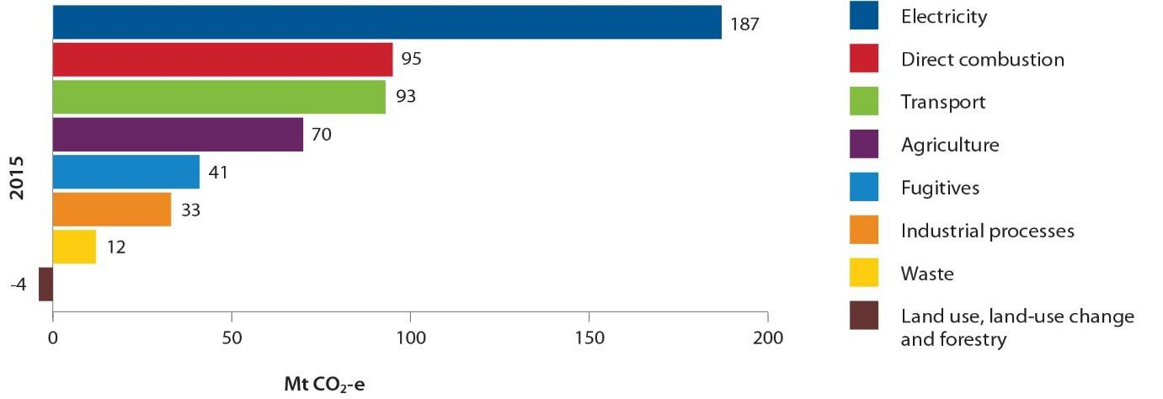

Source: Australia’s emissions projections 2016, Commonwealth of Australia 2016

Yet Australia is stuck with growing transport emissions, relying on voluntary action with no strategic goals or policy to keep up with the rest of the world. Under the Emissions Reduction Fund transport methods, only three projects have been contracted to deliver a total of 1.2 million tonnes CO2-e contracted over 7 years, averaging 170,000 TCO2-e p.a., about 1.5 per cent of the average annual mitigation required.

Clearly if government is to encourage greater mitigative action from the sector, new and enhanced policies will be needed. And quickly, because the long lives of transport vehicles such as trucks, buses, trains and ships, and their enabling infrastructure, means that decisions made over the next few short years may lock-in emissions-intensive freight transport for decades.

**2. Winners & Losers**

The winners in this global shift will be countries and organisations who make green investments in low carbon and renewable fuels along with productive equipment, infrastructure and information technologies. Leading transport and logistics players and their client sectors that embrace this change will attract the skills, capital and competitive advantage of profitable new business models while laggards will literally miss the boat with increasingly costly, inefficient and uncompetitive old technologies and practices, exacerbating Australia’s “technology-taker” status in the new clean energy world.

Global automotive giants are already switching to electric vehicles and transport & logistics corporates such as DHL, UPS, Fedex, Maersk and CMA CGM are already investing enormous sums into a variety of clean transport technologies and practices that create a head start on the multitudes of large, medium and (mostly) small transport firms across all modes in Australia. It’s a complex sector structurally, and difficult to effect change, which is why well-considered strategic and tactical support from government will be crucial to the future survival of many transport businesses and the clients they serve to compete on a global stage.

If through this National Freight and Supply Chain Inquiry process, based on terms of reference that make no mention of energy or emissions, Australia’s transport sector consciously chooses to support a national policy vacuum in this area, then all freight clients in the manufacturing, industrial, agricultural, resources and retail sectors and their transport providers will be increasingly exposed to the vagaries of state and federal emission reduction agendas that will result in a mish-mash of policies, targets and compliance frameworks that will replicate the unstructured conflicting state driven transport policies and regulations of the past, for example prior to the creation of the

National Heavy Vehicle Regulator in road freight.

Unaligned biofuels mandates in Queensland and New South Wales are just one example of what the future otherwise holds. And despite their existence, use of low carbon transport fuels such as biodiesel and ethanol along with natural gas has declined significantly in recent years, due to a variety of factors including low oil price, technology performance and a lack of refuelling infrastructure and supply chain development. The continued closure of local refining capacity means imported fossil-based fuels are relied upon for freight transport more than ever.

Current federal policies on energy and emissions have little to no influence on reducing transport companies’ emission profiles. Freight transport efficiency remains one of the largest opportunities for additional initiatives under the 15-year National Energy Productivity Plan, particularly for improving energy efficiency of trucks and buses, yet as the NEPP 2016 annual report notes, raising energy productivity in freight and commercial transport relies largely on voluntary action, and little progress is being made. The Clean Energy Finance Corporation’s energy efficiency finance discount program has had no interest from the heavy vehicle industry, and the Emissions Reduction Fund is financially and administratively unattractive for freight transport (see the Truck Industry Council submission to the Climate Change Policies Review for detailed examples of the ERF funding inadequacy). Although the Land and Sea Transport Method is currently being revised specifically to make mode shift opportunities eligible for funding, coastal shipping and grain-to-rail are explicitly

excluded from consideration, which represent two of the biggest mode-shift opportunities to reduce transport emissions. Unsurprisingly, the three projects to win ERF contracts represent just 0.6 per cent of total ERF funds committed in the five ERF auctions held to date.

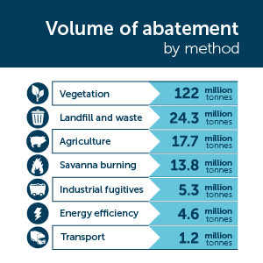

Source: Clean Energy Regulator June 2017

Environmental sustainability executives in many large transport companies bemoan how difficult it is to get environmental improvement projects approved these days. The ongoing low diesel price and removal of explicit carbon pricing means management attention has shifted, especially without freight customers demanding focus as they once did. Greater government support is needed to enhance financial benefits so that environmental improvements can be made at the rates required

to decarbonise Australian transport in line with global trends and commitments.

Without clearly defined action, we’ll end up with political gamesmanship of the type that resulted in the previous national carbon pricing policy being applied only to the lower-emitting rail and marine sectors while the politically stronger road freight sector avoided its carbon price obligation, giving freight clients the perverse incentive to shift freight to the highest-emitting mode of road transport.

**3. Strategic Vision to Compete in a Zero Carbon Transport World**

Freight transport needs policy leadership and strategic vision with clear objectives for energy use and emissions reduction with a single source of overall responsibility to integrate programs at all levels, including related activities in infrastructure and land-use planning for freight hubs and corridors, and productivity-raising initiatives in road and rail.

Significant freight infrastructure capacity building projects that dramatically improve the business case for shifting freight to less emissions-intensive modes should be of the highest priority to change business-as-usual growth in road freight and its consequences for greenhouse gas emissions, congestion, air pollution, road safety and fuel security. Initiatives could include increasing rail

payload capacities and more dedicated rail lines between ports and hinterland intermodal terminals, while re-building capacity for domestic shipping will need strategic investment in dedicated coastal

shipping terminals for intermodal and roll-on/roll-off cargoes and regulatory change that currently limits is use.

A strategic assessment of transport energy productivity growth, like those undertaken for other critical networks in the electricity, water and gas sectors, would better inform climate change policy development for transport generally, showing productivity growth or deterioration trends in network efficiency and its impact on national productivity and emissions.

Advancing use of natural gas as a transport fuel in the marine, road and rail sectors would allow Australia to maximise the value and benefits of its competitive advantages in natural resources while making substantial improvements in greenhouse and toxic gas emissions, fuel security, public health, trading balance of payments and the economic and social benefits of innovative new industry development that positions Australia at the forefront of clean transport technology.

Significant and growing amounts of green debt and equity finance capital is available globally to underpin clean transport investments, and Australia’s mature carbon market structures and strong professional skills can lead the transport sector’s exploitation of green funding opportunities.

**4. Research to Develop Best Transport Energy and Emissions Strategy**

Devising an integrated suite of mutually reinforcing policies at all levels of government to drive the significant reductions in transport emissions required while enhancing the competitiveness of the Australian economy is no small task. To develop a roadmap for the best way forward requires understanding of what others are doing globally at regional, national and subnational levels to see what works and what doesn’t, and how to tailor approaches to Australia’s unique circumstances.

It will require understanding the exponential technology trajectories enabled by infinitely powerful computing, networks, sensors, artificial intelligence, robotics, 3D printing and virtual reality. The emergence of intelligent transport systems promises better use of transport networks, yet the emissions reduction benefits of the progressive take-up of electric autonomous vehicles is uncertain: it could either dramatically reduce the number of vehicles on the road (and therefore transport emissions) through greater vehicle capacity sharing, or through its convenience and being 5X cheaper, instead increase trip volumes and the number of vehicles needed while reducing public transport demand. The resultant easing or compounding effects on urban road congestion will greatly impact freight productivity and costs either way.

Enhanced data gathering and analysis for better decision-making through these technologies will in many cases require industry and government collaboration. One such collaboration produced the

[2XEP Freight Roadmap,](http://www.2xep.org.au/files/2xEP_Freight_transport_roadmap_v3_0_170212.pdf) outlining a list of 70 initiatives that could be included in the National Energy

Productivity Plan or other existing policies for government and industry to action together, providing a focus for more detailed assessment.

**5. We can Help**

Taking a Finkel-like approach by establishing science-based clean transport targets and a single point of responsibility for their achievement are critical first principles for freight transport to help Australia reach its emission reduction goals for 2030 and beyond.

My colleagues and I have contributed to leading edge research on clean vehicle technology, market barriers and policy options produced for the 2XEP initiative and various state and federal government departments and stakeholder organisations over many years, and have the freight industry experience and connections to guide the conversation needed to shape and implement a

well-designed, effective and lowest-cost strategy to achieve the emissions reductions required by the national freight and supply chain sector

We can leverage the current goodwill of leading road, rail and marine players involved in the 2XEP

initiative and other linkages to further industry and bipartisan support for the best way forward.

Thank you for the opportunity to make this submission, and I look forward to the next stages of the process.

Yours sincerely

**David Coleman**

Principal

Clean Transport Action [davidcoleman@westnet.com.au](mailto:davidcoleman@westnet.com.au) [www.linkedin.com/in/davecoleman1](http://www.linkedin.com/in/davecoleman1)

+61 455 777 551 [blog](https://davecolemanblog.wordpress.com/2017/06/11/freight-transport-needs-a-finkel-clean-energy-target/)