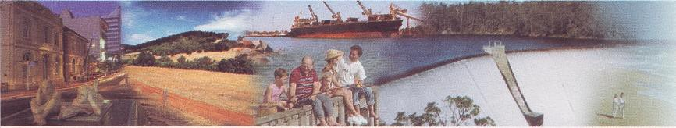

27th July, 2017

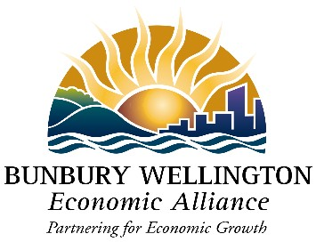

Freight and Supply Chain Inquiry

Department of Infrastructure and Regional Development

GPO Box 594

CANBERRA CITY ACT 2601 [freightstrategy@infrastructure.gov.au](mailto:freightstrategy@infrastructure.gov.au)

Dear Sir,

**BUNBURY OUTER RING ROAD – NATIONAL FREIGHT & SUPPLY CHAIN PRIORITY**

The Bunbury Wellington Economic Alliance (BWEA) is a partnership between local governments and business in the South West of Western Australia, dedicated to growing investment and employment in our regional economy.

The region’s traded economy is dominated by diverse businesses which operate in global supply chains including alumina, lithium, mineral sands, wood fibre, horticulture, beef, lamb and dairy production. The Bunbury Port is a key conduit for much of this regional production destined for global markets. Productive, safe and efficient freight networks are therefore fundamental for our $15 billion per annum regional economy.

The Bunbury Geographe Region has a vibrant population of 93,000 which has grown by 32% in the past ten years, exceeding growth rates of all other regional centres in Western Australia.

The Bunbury Outer Ring Road (BORR) is an essential element in delivering efficiency, productivity and safety in freight movements for our region.

The first stage of BORR, and Bunbury Port Access Road, were completed in 2013, providing an efficiency gain for some regional freight movements. It is to a degree, however, a stranded asset, given the majority of road freight moving through the Bunbury Geographe Region is restricted by increasing traffic lights and mixing with local commuter and tourist traffic. The

stop-start nature of heavy truck movements on the existing Main Roads network through

Bunbury Geographe, delays freight deliveries and affects the amenity of local residents. When completed, BORR will:

➢ provide more efficient access to the Bunbury Port and regional industrial centres,

including for 36.5 metre vehicles,

➢ provide an alternative route around Bunbury for freight traffic between Perth and the

South West,

➢ reduce congestion and divert a significant number of heavy vehicles away from residential areas of Bunbury Geographe to improve safety and social amenity, and

➢ stimulate residential and industrial land development such as the new City of Wanju and

Waterloo Industrial Park.

There is a well-established consensus that BORR is a priority for our region

➢ BORR is a priority initiative in the *Bunbury Geographe Growth Plan* (February, 2017)

➢ BORR features prominently in regional priority projects listed by the Bunbury Wellington Group of Councils, and is a key transformational opportunity (*South West Regional Blueprint*, 2015)

➢ Completing BORR is a “key infrastructure need” (*South West Regional Planning and*

*Infrastructure Framework*, Department of Planning & WA Planning Commission, 2015)

➢ BORR Stages 2 & 3 are National infrastructure priorities (Infrastructure Australia, National Infrastructure Priority List, December 2013)

➢ Completed BORR will be needed to support the expansion of the Busselton-Margaret

River Regional Airport, and

➢ Completing BORR will provide a major boost for local employment (200 direct jobs and employment multiplier of 11 - *Bunbury Geographe Growth Plan*)

We have welcomed the announcement by the Commonwealth and Western Australian governments this year of $12.5 million for further planning and design work relating to BORR.

We value the opportunity to provide this submission to the National Freight and Supply Chain Inquiry, and would be happy to provide further details upon your request relating to BORR as a national freight and supply chain priority.

We trust this submission assists the Federal Government in its deliberations over national freight and supply chain priorities.

Yours sincerely

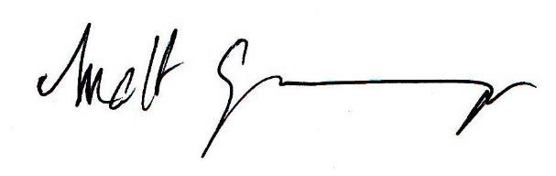

Matt Granger

Chief Executive Officer

Bunbury Wellington Economic Alliance