

National Transport and Supply Chain Strategy

**Introduction**

The supply chain and logistics industry is often a career path that you land in by chance. But once exposed to the size and nature of this exciting and vast industry, it’s impossible to ignore its impact into everyday life. Modern economies not only rely on it, but today’s consumer has certain expectations, despite no mental connection between a container that drives past them and the online purchases they are wearing.

Approximately 85 per cent of everything we interact with had some involvement with the supply chain, specifically road freight. Reading any public or private report it is evident there are three critical factors looming that will have catastrophic impacts on our country;

1. Growing freight task - 3 per cent per annum and tripled by 2050
2. Population growth - 23 million to 42 million by 2050; predominantly in major cities
3. The second oldest workforce of any industry – 56 is the average age of drivers

Our contribution to the national transport and freight strategy is focused on first and last mile metro road freight movement. The Bustle partners have an extensive history in road freight from a range of different market segments, all with a common goal of better-utilising the existing assets in our road network to reduce costs, emissions and traffic all whilst maintaining the safest operating systems.

During our research around road freight we have both industry experience and case studies that identify the need for a more transparent operating platform. Whilst the big customers in the mining and oil and gas sectors lead the way for safety standards, other SME businesses are still unaware that measuring and weighing freight is a legal requirement. They also struggle to negotiate with the same power as the majors for service agreements. Digitally transforming the transport procurement model is a way to level the playing field for all business.

Out of the 500,000 registered commercial vehicles on our roads in Australia, 70 per cent are owned by SME transport businesses, with a head count of 1-4 personnel. This means that large carriers are using a mix of company-owned assets, with sub-contractors making up the remainder of fleet. They are subject to the big companies’ standards, used as a commodity and removed when that no longer meets the company’s needs.

The same facts and figures seem to be used by anyone completing a report which indicates that a 1 per cent increase in efficiencies can lead to a $2b gain for the economy. Having a national strategy in place with a key focus on bringing together a fragmented market is not only a great step, it is a crucial one.

**2.1 What is moving where, why and how?**

**2.1a**

Partial and full trailer loads of general freight from retailers, manufacturers, wholesalers, FMCG consumables, mining, agriculture and oil and gas make up the majority of the market. This freight is imported or locally-sourced and transport movements are controlled by either a transport company, a freight broker or the business themselves using in house fleet. From an envelope or container load of general packaged freight to project-based heavy machinery for special movements, road freight manifests are broad and variable in size, quantity and movement frequency.

**2.1b What changes would you like to see to make your supply chain work better?**

As it stands, the changes required for a better use of Australia’s road freight networks is a greater utilisation of existing resources in our road network. Competition has been great for consumers, however it has lead to big companies investing in assets that focus on winning customers, going head to head and diminishing a distribution model to a de-centralised network of resources, all concerned about meeting internal targets or utilisation of their internal resources.

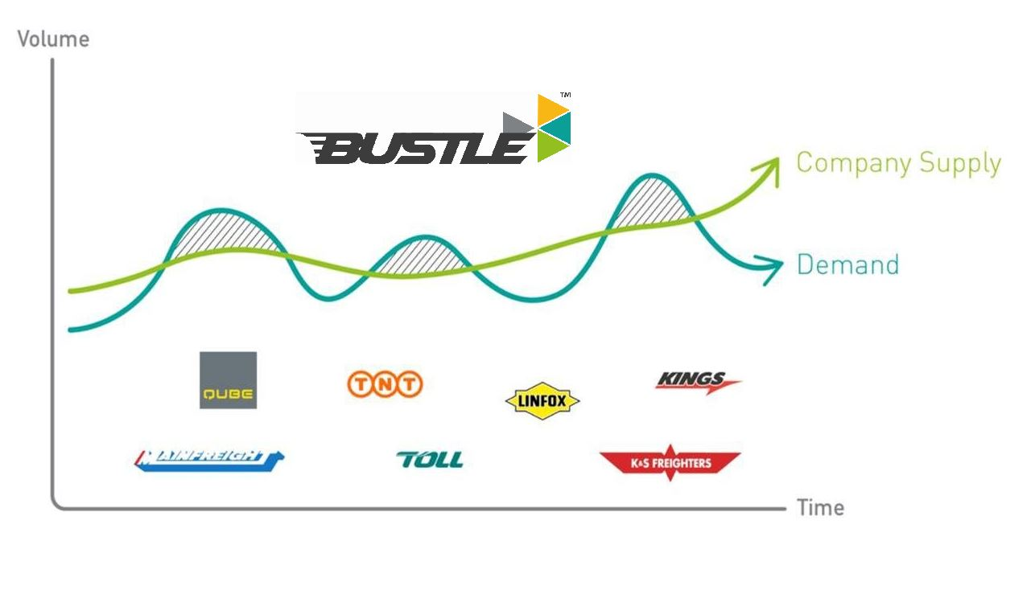

**2.1c What data gaps are you aware of in relation to Australia’s freight and supply chains?**

Data gaps are stemmed from competitors focusing on their client base with plans in place to service their needs specifically. From metro to intrastate to interstate there are service models set up around large carrier and large company requirements that the remainder of the market fall in to. Trucks travelling empty because they either don’t have access to work or it is competitors work is not only creating congestion it is costing our economy and our environment in emissions. All the major carriers would have internal data collated from their operations however none of it is generally made public i.e. routes used, distances travelled, kilograms moved or utilisation of assets.

**2.2 Competitiveness in the Australian freight sector**

**2.2a In your view, is Australia’s freight system internationally competitive.**

Bustle has limited knowledge of international transport businesses, however we have attended global supply chain conferences in Denver, CO. It was evident that our systems, solutions and technology is lagging behind countries like the USA and Europe. Their supply chain strategies and models looked more established and efficient.

**2.2b What are the key indicators that tell us this?**

NA

**2.2c How important is freight movements to your business competitiveness.**

Road freight movements are important as freight spend is a commodity that businesses need to understand and find ways to control more effectively.

Last mile road freight movement is the core of Bustle’s business. The platform facilitates first and last mile road freight movements for businesses, with a focus on B2B connections, to reduce empty running and increase vehicle utilisation. Our platform is a facilitator that will help businesses reduce 3PL time and costs so we would see our platform as an important addition to the industry.

**2.2d Are regulatory factors affecting productivity of your businesses? How could this be improved?**

Regulation in a country like Australia vs Indonesia is what makes our industry safer, but to remain compliant is costly to implement and maintain as part of a company’s delivery of services. Finding ways to make regulations more transparent or smarter ways to facilitate regulations in real-time is going to be critical in keeping our industry protected but also current in real-time. Traditional compliance models are reactive and not automated with a lot of human involvement.

**3.1 Urban Growth Pressures**

**3.1a What are the key issues for freight in Australia’s major cities?**

Issues approaching Australia’s freight in major cities are growing volumes, an ageing workforce and corporate competition. All reports and commentary from both private sectors and government are highlighting the same issues. Road freight volumes is expected to triple by 2050, The transport industry has the second oldest workforce; with truck drivers averaging 56 years of age. If we combine this with an increasing population from 23 million to 42 million, predominantly in capital cities, significant strain on our infrastructure and road network is imminent.

**3.2b How can Australia’s urban networks better prioritise passenger and freight services in the most effective manner possible?**

Having major carriers who tender on large, contracted parcels of work helps customers with a consolidated carrier but the focus is on executing the suite of work utilising in-house resources. The bi-product is a de-centralised market where vehicles are passing each other part loaded to make sure deadlines are met and company resources are sweated. The IoT will allow connectivity between systems and businesses to identify road activity, finding optimisation that is currently not visible or not favourable based on competition.

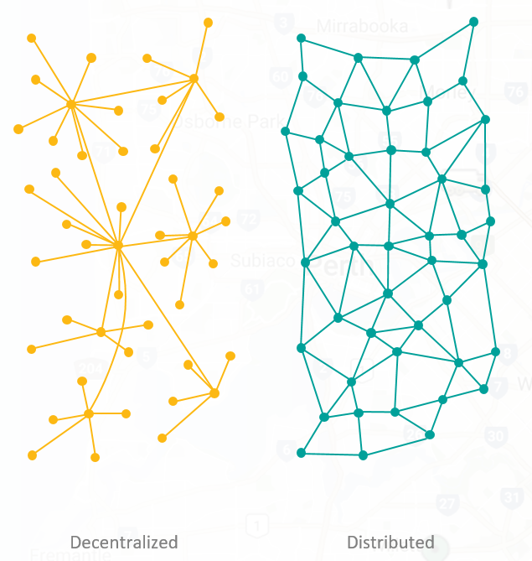

**3.1c How are our cities and supply chains being impacted by changing consumer behaviours such as online shopping?**

As consumers behaviour changes, new technology emerges and ongoing cost reduction strategies are enforced to meet market variables, the physical movement of freight landscape will continue to change. Last mile delivery will need to be a dynamic network of connected assets, technology and systems to get true synergies and efficiencies for Australia’s road freight. There won’t be one single answer, it will be a suite of system integration that will power a smarter road network.

**3.1d What are the critical last mile issues you face in urban areas?**

Last mile issues we face is that to implement a new way of facilitating distribution requires both a change in mindset from how it has always been done as well as businesses being prepared to break procedures in order to get the right result. Last mile hasn’t changed over the last 70 years in Australia and I don’t think disruption can fix this, it needs to be a suite of augmented platforms to connect the dots.

**3.2 Port Corridor Pressures – Protecting Land, Sea & Air Connections**

**3.2a Do you face, or expect in the future to face, problems moving your freight through Australian air, land or sea ports?**

Our business hasn’t been directly affected through these corridors, however in past business we have experienced the bottle necks involved in port activity. Managing deliveries and collections from the port was painful and rarely had efficiently utilised fleet running in and out of the wharf which has a flow on affect of more vehicles wanting to access the port and lengthy delays.

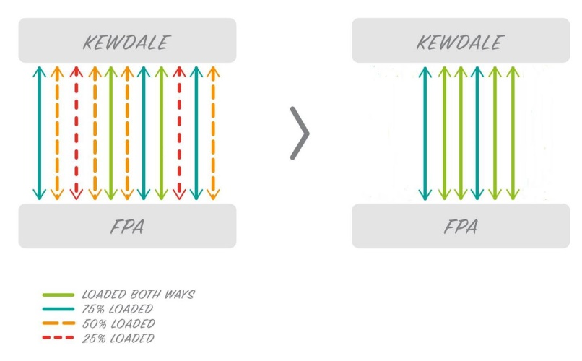

**3.2b How can Australia’s maritime channels be appropriately maintained and able to accommodate bigger ships?**

Not an area of our expertise.

**3.2c How are other countries dealing with the landside implications related to distributing cargo from bigger ships?**

Not an area of our expertise

**3.3 End-to-end supply chain integration and regulation**

**3.3a How effective is your supply chain at transition your freight between modes and across boundaries**

Not applicable to our model

**3.3b What regulations do you have to deal with in your supply chains?**

Regulations in our supply chain are around insurances, licences, accreditations and training/certifications. There are some stock standard industry expectations that relate to having a commercial vehicle on the road but there are also some company/market segment specific requirements. What we do know is that self-regulation by both customers of road freight and suppliers around risk mitigation has seen compulsory regulations become muddied with best practice/company set regulations with contractors losing sight of what they need to hold to operate in their specific market segment of road freight.

Based on the changing landscape of transported goods, customer market and technological advances it becomes challenging to simplify regulations, however some form of market standard or minimum could be an opportunity to help encourage transparency to the market i.e. retail, ,anufacturing, wholesale, mining etc.

Empty containers are an opportunity for Bustle to provide customers with a solution. Our platform allows customers and drivers to connect to better utilise a vehicle they may already be completing a delivery/collection of containers.

**3.4 The Air Freight Market**

Not our area of expertise

**3.5 Changing Technology**

**3.5a What emerging technological trends do you think will impact on your supply chain?**

Our platform is an emerging technology that will impact the supply chain in a positive way through consolidating the independently-owned fleet into a network that is non-competitive to transport companies. The sole focus of this technology is to facilitate transactions to utilise the empty running vehicles experience every day so instead of disruptors to the industry this is innovation that augments existing practice.

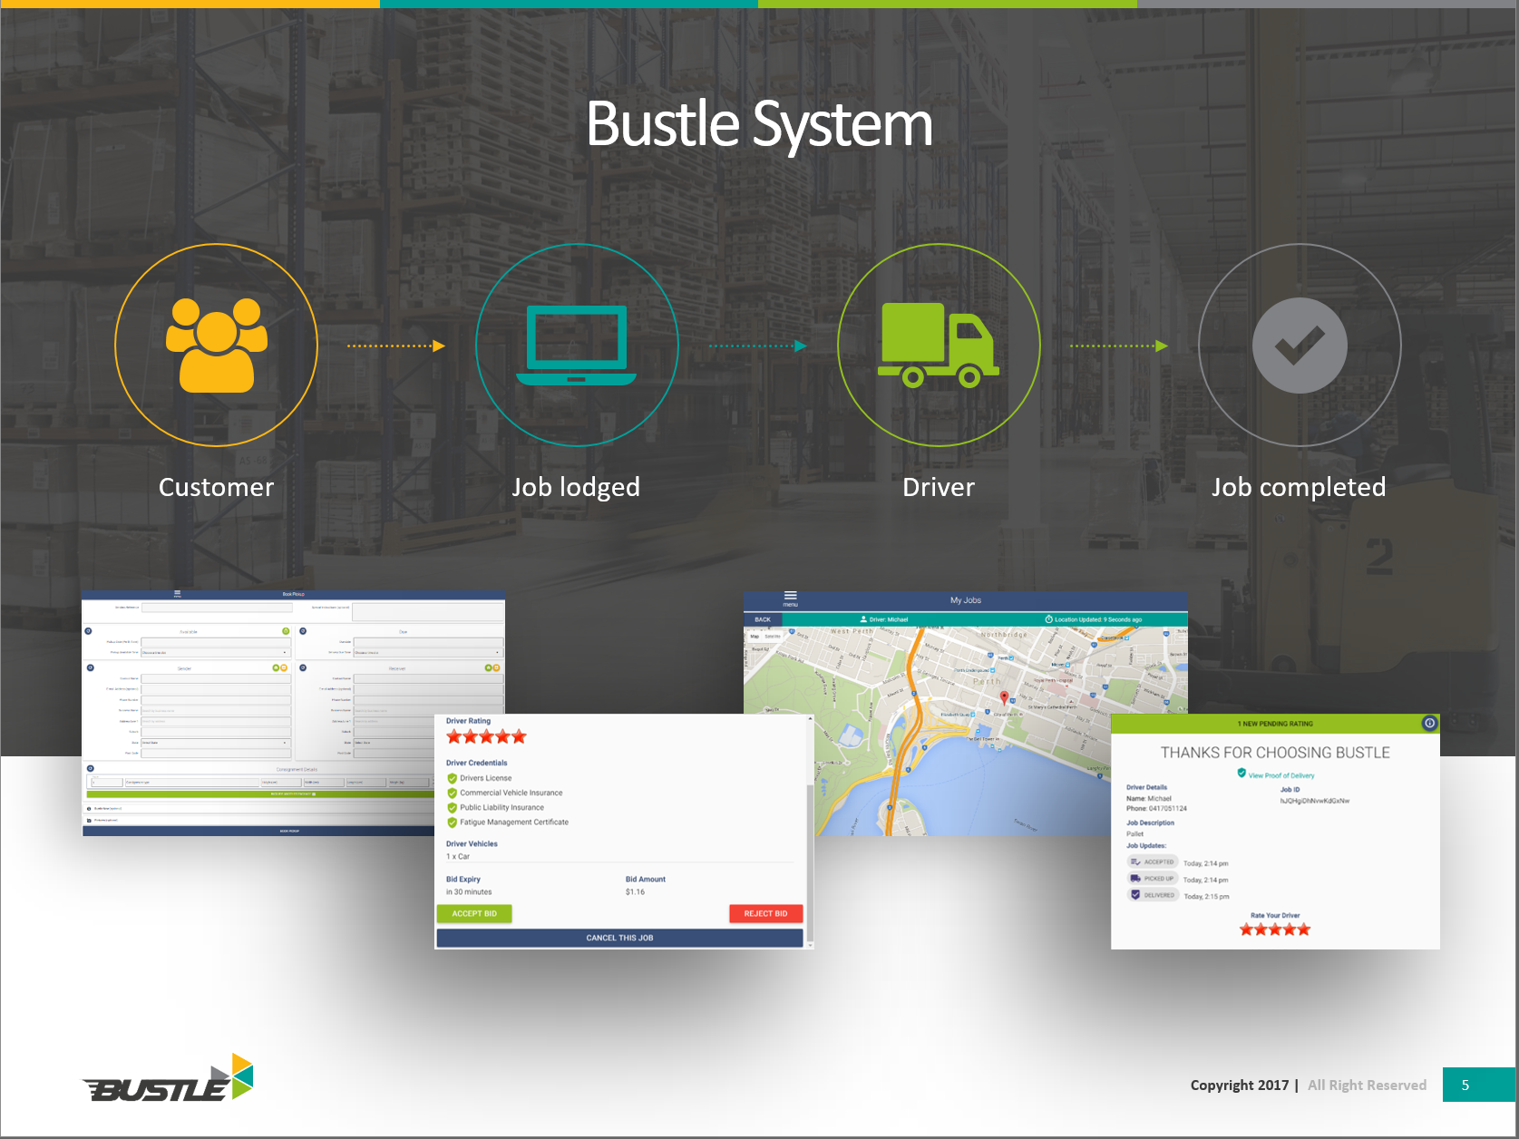

**3.5b When are these impacts likely to be felt and how does Australia’s freight infrastructure need to be adapted to make best use of likely changes?**

Now – The market is already changing and it would seem that physical movement of freight cannot be changed too much in terms of vehicles/fleet that execute the work, so the focus needs to be on the distribution centres’ location, technology and layouts that help facilitate faster cross docking to unimodal last mile delivery options i.e. hub depots. Technology such as 3D printing will also impact on physical transport of freight as items required can potentially be created on-site at a customer location potentially changing the volume or transport requirements.

Connectivity and the IoT is going to have a positive impact on road use as we become smarter about identifying, connecting and facilitating last mile road freight movements. Having a live market facilitator that can update remotely to all users will enable emerging technologies to be implemented faster than ever before.

**4.1 Capacity Forecasting**

**4.1a Any data or insights you are willing to contribute to assist in capacity forecasting assessment would be appreciated.**

As Bustle is relatively new to market we don’t have historic data that would prove to be beneficial to the national strategy. Bustle is collecting data from each transactions such as physical movement of freight, vehicle types, insurances, fuel, tyres, compliance, cycle times, routes, time of day etc. This data would be transaction focussed with private company or independent information removed as it is not about who is doing what but more what is happening, when and where.

Bustle is open to sharing information with the relevant governing bodies to help better utilise our resources and road network with a focus on both real time and retrospective data.

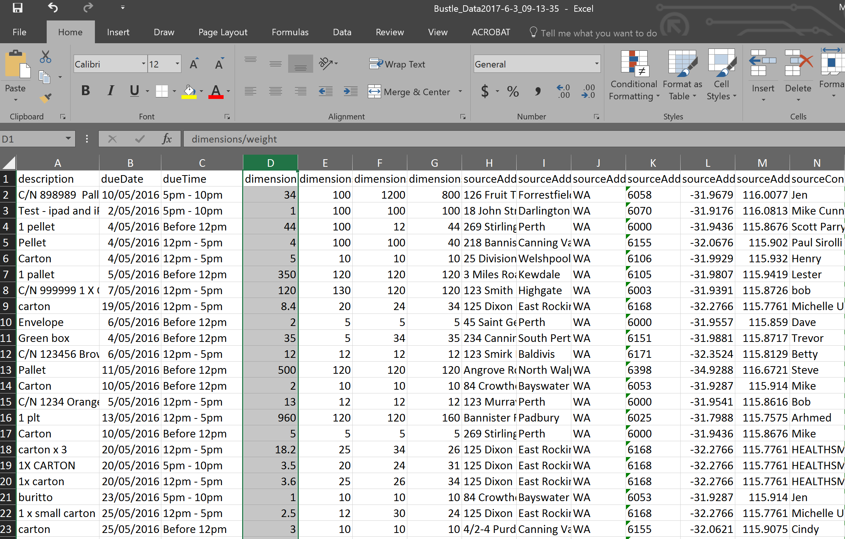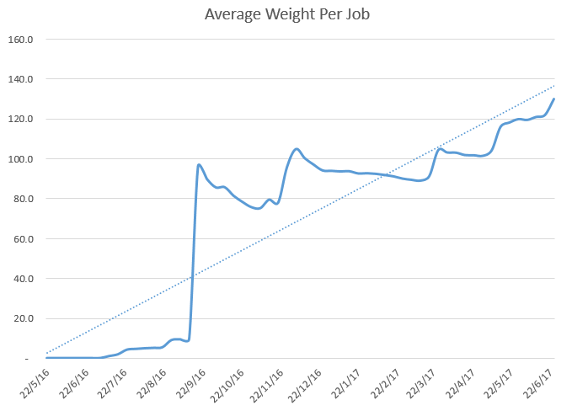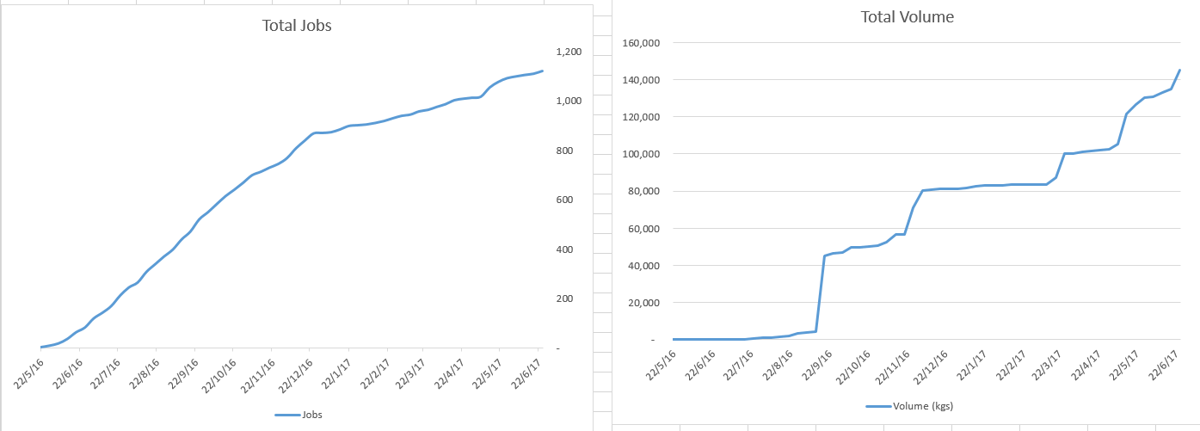

**4.2 Key Drivers of Change for Use in Scenario Planning**

**4.2a The inquiry welcomes views on what factors and key drivers of change should be considered in the scenario planning analysis.**

From all reports, the infrastructure in which physical freight is held, staged or moved through is what will require the most planning. Thinking about independently facilitated hub depots where freight can be staged or cross docked

4.2b The inquiry is also keen to identify key functional elements of supply chains through case studies demonstrating how Australia’s freight system is working on the ground, including case studies about things working well, as well as examples of the problems and where improvements can me made. Identification of potential future trends in supply chains would be valuable.

