Media content consumption survey

November 2020





Report prepared for:

Department of Infrastructure, Transport, Regional Development and Communications

Report prepared by:

Anna Truong and Charles Dove

The Social Research Centre

Level 9, 277 William Street

MELBOURNE VIC. 3000

Tel: (613) 9236 8500

Fax: (613) 9602 5422

Email: anna.truong@srcentre.com.au

www.srcentre.com.au

Version: 4, January 1, 2020

Logos:

ISO Experts: ISO 20252 certified.
ISO Experts ISP 27001 certified.
The Research Society, 2020-21 company partner, ethics - QPR - ISO.
AMSRO, privacy quality ethics.
Australian Evaluation Society.

**Contents**

Media content consumption survey i

**Contents** iii

**List of figures** 1

**List of tables** 3

Executive summary 4

Background 4

Australian content key findings 4

Screen content consumption key findings 5

Children’s screen content consumption key findings 6

News content consumption key findings 7

Sports content consumption key findings 8

1. Introduction 10

1.1. Background 10

1.1.1. Research objectives 10

1.2. Methodology 10

1.2.1. Sample structure 10

1.3. Analysis 12

1.3.1. Weighting 12

1.3.2. Significance testing 12

1.3.3. Quality assurance 12

2. Australian content 13

2.1. Aspects that make media content ‘Australian’ 13

2.2. Attitudes towards Australian screen content 16

3. Screen content 19

3.1. Adults’ screen content consumption 19

3.1.1. Channels used to watch screen content 19

3.1.2. Time spent watching screen content 23

3.1.3. Change in time spent watching screen content since COVID-19 27

3.1.4. Devices used to watch screen content 31

3.1.5. Device preferences for screen content 35

3.1.6. Genres watched across screen content channels 36

3.1.7. Video streaming subscription services 37

3.1.8. Pay-per-view services 46

3.2. Children’s screen content consumption 47

3.2.1. Channels used to watch children’s screen content 47

3.2.2. Time spent watching children’s screen content 50

3.2.3. Change in time spent watching children’s screen content 53

3.2.4. Australian children’s screen content 56

3.3. Types of news consumed 56

3.4. Sources of news 59

3.4.1. General news sources 59

3.4.2. Main source of news 68

3.5. Paid news subscriptions 69

3.6. Attitudes towards Australian and local news 74

4. Sport content 77

4.1. Sport content consumption 77

4.1.1. Channels used to watch or listen to sport content 79

Appendix 1 Questionnaire 83

2559 MEDIA CONTENT CONSUMPTION Questionnaire – September 2020 83

PROJECT NOTES 83

GENERAL PROGRAMMING NOTES 83

ORDER DUMMY VARIABLE, RANDOM ASSIGNMENT: 83

**\*CALL OUTCOMES AND RR1** 83

Life in Australia™ INTRODUCTION 84

NON-PROBABILITY PILOT INTRODUCTION 84

SECTION S: NON-PROBABILITY SAMPLE PROFILING 84

SECTION A: SCREENING FOR PARENTS 86

SECTION B: AUSTRALIAN MEDIA 88

SECTION C: SCREEN CONTENT BEHAVIOURS AND SPEND 89

SECTION D: NEWS 96

SECTION E: SPORT 102

SECTION F: CHILDREN’S SCREEN CONTENT 102

SECTION Z: DEMOGRAPHICS 106

SECTION Y: SURVEY FEEDBACK – PILOT ONLY 109

NON-PROBABILITY CLOSING 109

QUOTA FULL 110

TERMS – NONPROB ONLY 110

PICTURE POP-UPS 110

**List of figures**

Figure 1 Aspects that make media content ‘Australian’ – Total 13

Figure 2 Aspects that make screen content ‘Australian’ – by gender 14

Figure 3 Aspects that make screen content ‘Australian’ – by age 14

Figure 4 Aspects that make screen content ‘Australian’ – by region 15

Figure 5 Attitudes towards Australian content – Total 16

Figure 6 Attitudes towards Australian content – ‘Agree’ or ‘Strongly agree’ by age 17

Figure 7 Aspects that make screen content ‘Australian’ – by region 18

Figure 8 Channels used to watch screen content in the past seven days – Total 19

Figure 9 Channels used to watch screen content in the past seven days – by gender 20

Figure 10 Channels used to watch screen content in the past seven days – by age 21

Figure 11 Channels used to watch screen content in the past seven days – by region 22

Figure 12 Hours spent watching screen content per week – Total 23

Figure 13 Spent six hours or more per week watching screen content – by gender 24

Figure 14 Spent six hours or more per week watching screen content – by age 25

Figure 15 Spent six hours or more per week watching screen content – by region 26

Figure 16 Change in time spent watching screen content since COVID-19 – Total 27

Figure 17 Increased time spent watching screen content since COVID-19 – by gender 28

Figure 18 Increased time spent watching screen content since COVID-19 – by age 29

Figure 19 Increased time spent watching screen content since COVID-19 – by region 30

Figure 20 Device usage frequency to watch screen content on average per week – Total 31

Figure 21 Devices used at least once a day to watch screen content – by gender 32

Figure 22 Devices used at least once a day to watch screen content – by age 33

Figure 23 Devices used at least once a day to watch screen content – by region 34

Figure 24 Overall preference on devices used to watch screen content (amongst those who watch on more than one device) – Total 35

Figure 25 Most preferred devices to watch screen content 36

Figure 26 Video streaming subscription services in household – Total 38

Figure 27 Video streaming subscription services in household – by gender 39

Figure 28 Video streaming subscription services in household – by age 41

Figure 29 Video streaming subscription services in household – by region 42

Figure 30 Number of video streaming subscription services 43

Figure 31 Video streaming subscription services have enough Australian content 44

Figure 32 Willingness to pay extra for more Australian content on video streaming subscription services 45

Figure 33 Pay-per-view services used in past seven days – Total 46

Figure 34 Channels used to watch children’s screen content in the past seven days – Total 47

Figure 35 Channels used to watch children’s screen content in the past seven days – by age of child 48

Figure 36 Channels used to watch children’s screen content in the past seven days – by region 49

Figure 37 Hours spent watching children’s screen content per week – Total 50

Figure 38 Spent six hours or more per week watching screen content – by age of child 51

Figure 39 Spent six hours or more per week watching screen content – by region 52

Figure 40 Change in time spent watching screen content since COVID-19 – Total 53

Figure 41 Increased time spent watching screen content since COVID-19 – by age of child 54

Figure 42 Increased time spent watching screen content since COVID-19 – by region 55

Figure 43 Level of importance for child to have access to Australian children’s screen content – Total 56

Figure 44 Average weekly news consumption frequency – Total 57

Figure 45 Consume at least one type of news at least once a week – Total 57

Figure 46 Types of news consumed – by gender 58

Figure 47 Types of news consumed – by age 58

Figure 48 Types of news consumed – by region 59

Figure 49 General news sources – Total 60

Figure 50 General news sources – by gender 61

Figure 51 General news sources – by age 62

Figure 52 General news sources – by region 63

Figure 53 Online news sources (amongst search engine/social media users) – Total 64

Figure 54 Online news sources (amongst search engine/social media users) – by gender 65

Figure 55 Online news sources (amongst search engine/social media users) – by age 66

Figure 56 Online news sources (amongst search engine/social media users) – by region 67

Figure 57 Main source of news – Total 68

Figure 58 Number of paid news subscriptions 69

Figure 59 Receive a print version with paid news subscription 70

Figure 60 Reasons for not having a paid news subscription – Total 71

Figure 61 Reasons for not having a paid news subscription – by gender 72

Figure 62 Reasons for not having a paid news subscription – by age 73

Figure 63 Level of importance of aspects of Australian news – Total 74

Figure 64 Level of importance of aspects of Australian news (NET Very / Somewhat important) – by age 75

Figure 65 Sufficient choice of local news – Total 76

Figure 66 Type of sport content consumed – Total 77

Figure 67 Type of sport content consumed – by gender 78

Figure 68 Type of sport content consumed – by age 78

Figure 69 Channels used to consume sport content in the past seven days – Total 79

Figure 70 Channels used to watch sport content in the past seven days – by gender 80

Figure 71 Channels used to watch sport content in the past seven days – by age 81

Figure 72 Channels used to watch screen content in the past seven days – by region 82

**List of tables**

Table 1 Australian content key findings 4

Table 2 Screen content consumption key findings 5

Table 3 Children’s screen content consumption key findings 6

Table 4 News content consumption key findings 7

Table 5 Sports content consumption key findings 9

Table 6 Sample structure 11

Table 7 Genres watched by channel – Total 37

Executive summary

Background

This report presents the findings from the Media Content Consumption Survey (the Survey) conducted for the Department of Infrastructure, Transport, Regional Development and Communications (the Department). The Survey aims to explore Australian’s media content consumption behaviours, specifically:

* the screen and news content they consume,
* the distribution channels/technology that the content is delivered by, and
* the devices used to watch screen content.

The research methodology adopted was a mixed-mode approach, comprising quantitative online and telephone surveys conducted via the Social Research Centre’s national probability-based online panel, known as Life in Australia™ and a boost of parents of children aged 15 and younger using an online non-probability sample. The in-scope population was Australians aged 18 years and older, residing in Australia, and a total of n=4,096 online surveys were completed from 14 September to 28 September 2020. The data was weighted to minimise the average bias (i.e. the difference between the general population and the survey population) and to maximise the representativeness of the sample.

Australian content key findings

Table 1 shows the key findings related to Australian content. ‘Made in Australia’ was considered by most respondents as one of the aspects that makes media content ‘Australian’. This opinion was more likely to be held by females, respondents aged 35-54 years, and regional respondents.

Australian film and TV stories were considered by most respondents to be important for contributing to our sense of Australian identity and in showing Australian views and perspectives to the rest of the world. This view was more likely to be held by those aged 55 years or older and those living in regional areas.

When those with access to video streaming subscription services were asked whether video streaming subscription services have enough Australian content, the majority (58%) answered ‘No’.

Table 1 Australian content key findings

| Question | Highest survey results | Sub-groups with higher results  (Compared to other sub-groups) |
| --- | --- | --- |
| Aspects that make media content ‘Australian’ | Made in Australia (74%) | * Female (75%) * 35-54 years (77%) * Regional (76%) |
| Attitudes towards Australian screen content | Australian film and TV stories are important for contributing to our sense of Australian identity (85% ‘agree’ or ‘strongly agree’) | * 55 years or older (90%) |
|  | Australian film and TV stories are important in showing Australian views and perspectives to the rest of the world (85% ‘agree’ or ‘strongly agree’) | * 55 years or older (89%) * Regional (88%) |
| Australian content on video streaming subscription services | Video streaming subscription services **do not** have enough Australian content (58% amongst those with access) | * None |

Screen content consumption key findings

The key findings related to screen content consumption are shown in Table 2. Overall, the majority of respondents consumed screen content in the past seven days. Commercial free-to-air TV and online subscription services were the most common channels used to watch screen content. The former was more likely to be used by those aged 55 years or older and those living in regional areas; whereas the latter was more likely to be used by females and those aged 18-34 years. Free video streaming services and publicly owned free-to-air TV were also commonly used to watch screen content, particularly amongst males.

Televisions and mobile phones were the most common devices used to watch screen content. Those aged 55 years or older were more likely to use televisions; whereas respondents aged 18-34 and those living in metropolitan areas were more likely to use mobile phones.

The majority of respondents have a preference on which device is used to watch screen content, with television most commonly selected as the preferred device. Those aged 55 years or older were more likely to report this preference.

Most respondents have access to at least one streaming subscription service in household, with females and those aged 18-34 more likely to have access. Netflix is the most common video streaming subscription service. Females, those aged 18-34, and those living in metropolitan areas were more likely to have access to Netflix.

Table 2 Screen content consumption key findings

| Topic | Highest survey results | Sub-groups with higher results  (Compared to other sub-groups) |
| --- | --- | --- |
| Consumed screen content in past seven days | Consumed screen content in past seven days (98%) | * None |
| Channels used to watch screen content in the past seven days | Commercial free-to-air TV (61%) | * 55 years or older (78%) * Regional (65%) |
|  | Online subscription services (60%) | * Females (64%) * 18-34 years (75%) |
|  | Free video streaming services (54%) | * 18-34 years (73%) * Males (57%) * Metro (57%) |
|  | Publicly owned free-to-air TV (53%) | * 55 years or older (72%) * Males (55%) |
| Devices used to watch screen content on average per week | Television (54% at least once a day) | * 55 years or older (62%) |
|  | Mobile phone or smartphone (48% at least once a day) | * 18-34 years (71%) * Metro (50%) |
| Device preference | Have preference on which device is used to watch screen content (77%) | * 55 years or older (82%) |
|  | Television most preferred (63%) | * 55 years or older (81%) |
| Most common video streaming subscription service | Netflix (65%) | * Females (68%) * 18-34 years (79%) |
| Number of household streaming subscription services | One (25%) | * None |
|  | Two (20%) | * 18-34 years (22%) * 35-54 years (22%) |
|  | Three or more (26%) | * 18-34 years (39%) * 35-54 years (28%) |
|  | Do not have streaming subscription (27%) | * 55 years or older (42%) * Regional (31%) |

Children’s screen content consumption key findings

Parents or guardians of a child 15 years old or under were asked about their child’s screen content consumption. If a respondent had more than one child 15 years old or under, they were asked to answer questions about the child randomly selected by the program. The following section outlines the results about children’s screen content consumption. Table 3 presents the key findings related to children’s screen content consumption.

Overall, the majority of parents reported their children consumed screen content in the past seven days. Free video streaming services and online subscription services are the most common channels used to watch screen content. Both were more likely to be used by children aged 13-15. Overall, 74% of parents reported their child had used an online channel to watch screen content compared to only 53% who had watched free-to-air content.

The majority of parents considered it ‘very important’ or ‘somewhat important’ for their children to have access to Australian children’s screen content.

Table 3 Children’s screen content consumption key findings

| Topic | Highest survey results | Sub-groups with higher results  (Compared to other sub-groups) |
| --- | --- | --- |
| Child consumed screen content in past seven days | Consumed screen content in past seven days (90%) | * None |
| Channels child used to watch screen content in the past seven days | NET: Online (74%) | * Children aged 13-15 (82%) |
|  | NET: Free-to-air (53%) | * None |
|  | Free video streaming services (50%) | * Children aged 13-15 (60%) |
|  | Online subscription services (49%) | * Children aged 13-15 (57%) |
| Australian children’s screen content | ‘Very important’ or ‘Somewhat important’ for child to have access to Australian children’s screen content (81%) | * None |

News content consumption key findings

Table 4 presents the key findings related to news consumption. The majority of respondents reported they consume local, state, or territory news, Australian national news (politics, current affairs, economy), or international news at least once a week. Reported consumption levels were higher amongst males and those aged 55 years or older. Consumption of local, state, or territory news was the highest of the three types of news, particularly amongst those aged 55 years or older.

Commercial free-to-air TV, radio, and news websites or apps were reported as the most common sources of news. Those aged 55 years or older were more likely to consume news via commercial free-to-air TV and radio. Whereas the two younger age groups (those aged 18-34 and 35-54 years) and males were more likely to use news websites or apps.

Amongst search engine or social media users, the majority reported using Facebook (64%). Facebook use was more likely for females (70%), those aged 18-34 years (70%) and 35-54 years (67%), and those in regional areas (68%). The next most popular responses were Google Search (46%) and Google News (32%).

The majority of respondents reported they do not have a paid news subscription. Females, those aged 18-34 or 35-54, and those living in regional areas were more likely to report this. The main reasons reported for not paying for news were ‘free news meets my needs’ (63%), ‘I do not believe I should have to pay for news’ (40%), and ‘I do not want to commit to paying an ongoing subscription’ (33%).

When asked about how important different aspects of news were, most respondents reported that the following were very important or somewhat important; up-to-date news (96%), unbiased news (94%), and credible journalists (94%).

A significant proportion of respondents (66%) reported they have sufficient choice of local news. This response was more likely for those living in regional areas (69%).

Table 4 News content consumption key findings

| Topic | Highest survey results | Sub-groups with higher results  (Compared to other sub-groups) |
| --- | --- | --- |
| Overall news consumption | Consume at least one type of news at least once a week (96%) | * Males (97%) * 55 years or older (99%) |
| Type of news consumed | Local, state, or territory news (93% at least once a week) | * 55 years or older (97%) |
| General sources of news | Commercial free-to-air TV (63%) | * 55 years or older (75%) |
|  | Radio (52%) | * 55 years or older (64%) |
|  | News website or app (50%) | * Males (54%) * 18-34 years (56%) * 35-54 years (56%) |
| Online news sources (amongst search engine/social media users) | Facebook (64%) | * Females (70%) * 18-34 years (70%) * 35-54 years (67%) * Regional (68%) |
|  | Google search (46%) | * None |
|  | Google News (32%) | * Males (36%) |
| Paid news subscriptions | Do not have a paid news subscription (86%) | * Females (87%) * 18-34 years (91%) * 35-54 years (88%) * Regional (88%) |
| Main reasons for not paying for news (amongst those who do not have a paid news subscription) | ‘Free news meets my needs’ (63%) | * 55 years or older (72%) |
|  | ‘I do not believe I should have to pay for news’ (40%) | * None |
|  | ‘I do not want to commit to paying an ongoing subscription’ (33%) | * 55 years or older (37%) |
| Level of importance of aspects of Australian news (NET: Very important and somewhat important) | Up-to-date news (96%) | * 55 years or older (98%) |
|  | Unbiased news (94%) | * None |
|  | Credible journalists (94%) | * 55 years or older (96%) |
|  | Credible publications / brands (92%) | * None |
|  | Credible publications / brands (92%) | * None |
| Sufficient choice of local news | Yes (66%) | * Females (69%) * Regional (69%) |
|  | No (34%) | * Males (37%) * Metro (35%) |

Sports content consumption key findings

The key findings related to sports content consumption are shown in Table 5. Overall, fewer than half the respondents (45%) consumed sports content in the past seven days. Males and those aged 55 years or older were more likely to have consumed sport.

Amongst those who consumed sport content in the past seven days, the most common channels they used were commercial free-to-air TV (excluding catch-up TV), pay TV (including recorded content but excluding streaming), and publicly owned free-to-air TV (excluding catch-up TV). Those aged 55 years or older were more likely to use commercial and publicly owned free-to-air TV. Regional respondents were more likely to use commercial free-to-air TV.

Table 5 Sports content consumption key findings

| Topic | Highest survey results | Sub-groups with higher results  (Compared to other sub-groups) |
| --- | --- | --- |
| Overall sports content consumption | Consumed sports content in past seven days (45%) | * Males (57%) * 55 years or older (56%) |
| Channels used to consume sports content  (amongst those who consumed sport in the past seven days) | Commercial free-to-air TV, excluding catch-up TV (63%) | * 55 years or older (73%) * Regional (69%) |
|  | Pay TV, including recorded content but excluding streaming (29%) | * None |
|  | Publicly owned free-to-air TV, excluding catch-up TV (22%) | * 55 years or older (32%) |

# Introduction

## Background

The Department of Infrastructure, Transport, Regional Development and Communications (the Department) aims to provide an environment in which all Australians can access and benefit from communications services, creative experiences, and culture. In 2020, the Department engaged with the Social Research Centre to conduct the Media Content Consumption Survey to examine media content consumption behaviours.

The findings from the Survey will inform Government about how Australians consume media content, inform future work on media and content policy, and establish a robust evidence base for the development of media and content policy.

### Research objectives

The Survey aims to explore Australian’s media content consumption behaviours, specifically:

* the screen and news content they consume,
* the distribution channels/technology that the content was delivered by, and
* the devices used to watch screen content.

## Methodology

The research methodology adopted was a mixed-mode approach, comprising quantitative online and telephone surveys conducted via the Social Research Centre’s national probability-based online panel, known as Life in Australia™ and a boost of parents of children aged 15 and younger using an online non-probability sample. The in-scope population was Australians aged 18 years and older, residing in Australia.

The draft questionnaire was co-designed by the Social Research Centre and the Department. Twelve cognitive testing interviews were conducted to refine the draft questionnaire for pilot testing. The results from the cognitive testing were detailed in the report delivered to the Department (named ‘2561 Media Content Consumption Cognitive Testing Results 200812’). To finalise the questionnaire for full launch on Life in Australia™, n=100 online pilot test surveys were conducted using non-probability sample. This pilot data was delivered to the Department and was excluded from analysis and reporting.

The main survey was conducted from 14 September to 28 September 2020.

More details on the survey methodology can be found in the Technical Report delivered to the Department (named ‘2559 Media Content Consumption Survey Technical Report 201109’).

### Sample structure

A total of n=4,096 online surveys were completed. This comprised of n=3,055 surveys conducted on Life in Australia™, including n=176 computer-assisted telephone interviews (CATI) and n=2,879 online surveys). An additional n=1,041 surveys were conducted with parents of children aged 15 or younger using online non-probability sample. The average survey length of the Life in Australia™ survey was 15.9 minutes. The survey was longer for respondents completing over the phone (22.4 minutes) compared to those who self-completed online (15.7 minutes). The average survey length of the non-probability parent boost was 11.2 minutes.

The final achieved sample structure in shown in Table 6.

Table 6 Sample structure

| Sub-group | Proportion | Count |
| --- | --- | --- |
| **Total** | **100%** | **4,096** |
| **Gender** |  |  |
| Male | 43% | 1,763 |
| Female | 57% | 2,322 |
| Other / Prefer not to say | 0% | 11 |
| **Age (7 categories)** |  |  |
| 18-24 years | 3% | 128 |
| 25-34 years | 16% | 665 |
| 35-44 years | 23% | 935 |
| 45-54 years | 18% | 726 |
| 55-64 years | 16% | 675 |
| 65-74 years | 16% | 648 |
| 75 or more years | 8% | 317 |
| **Region** |  |  |
| Capital City | 66% | 2,716 |
| Rest of State | 34% | 1,379 |
| **State** |  |  |
| New South Wales | 29% | 1,200 |
| Victoria | 26% | 1,075 |
| Queensland | 20% | 804 |
| South Australia | 9% | 354 |
| Western Australia | 10% | 423 |
| Tasmania | 3% | 117 |
| Northern Territory | 1% | 24 |
| **Parental status** |  |  |
| Parent of child 15 or younger | 22% | 2,525 |
| Not a parent of child 15 or younger | 78% | 1,571 |
| **Country of birth** |  |  |
| Born in Australia | 71% | 2,899 |
| Born in mainly non-English speaking country | 17% | 690 |
| Born in mainly English speaking country | 12% | 496 |

## Analysis

### Weighting

The aim of the weighting process was to minimise the average bias (i.e. the difference between the general population and the survey population) and to maximise the representativeness of the sample.

Population distributions for demographic characteristics were obtained from the Australian Bureau of Statistics, and those for survey variables were obtained from Life in Australia™.

Several weighting approaches were examined and considered. The final adopted solution reduced the average bias by more than 65% compared to the unweighted solution, while still achieving an acceptable level of variability in the weights. More details on the weighting approach can be found in the Technical Report delivered to the Department (named ‘2559 Media Content Consumption Survey Technical Report 201109’).

### Significance testing

Data were analysed using Q Research Software (Q), including significance testing. Statistical testing was undertaken to establish whether the responses from one sub-group were statistically significantly different to other sub-groups. The significant differences within the following sub-groups were reported:

* Gender (male vs. female)
* Age (18-34 years vs. 35-54 years vs. 55 years or older)
* Region (metro vs. regional)

A z-test statistical test was used to test the difference in proportions for the same survey question for two mutually exclusive sub-groups.

Significantly higher results compared to all other sub-groups at the 95% confidence interval were indicated with a solid green up arrow (▲), results that show a significantly lower result were indicated by a solid red down arrow (▼).

Within age group significance testing, significantly higher results compared to one other age group at the 95% confidence interval were indicated with an outlined up arrow (△) and the corresponding significantly lower result was indicated by an outlined down arrow (▽).

Sub-group results were only charted if there were significant differences to report.

### Quality assurance

All data collection activities were undertaken in accordance with ISO 20252 quality standards, the Australian Market and Social Research Society code of ethics, and the Market and Social Research Privacy Principles.

# Australian content

## Aspects that make media content ‘Australian’

Respondents were asked to select from a list aspects that they considered to make media content, such as television shows, movies, documentaries, print newspapers and magazines, radio, music, and podcasts, ‘Australian’. Three in four (74%) considered that ‘Made in Australia’ makes media content Australian; this aspect being most commonly selected of all options presented.

The next most common aspect was ‘contains Australian subject matter (68%), followed closely by ‘contains Australian stories or story lines’ (64%) and ‘employs Australians in its production (59%). ‘Made for Australian audiences’ (49%) was selected by the least number of respondents.

Figure 1 Aspects that make media content ‘Australian’ – Total

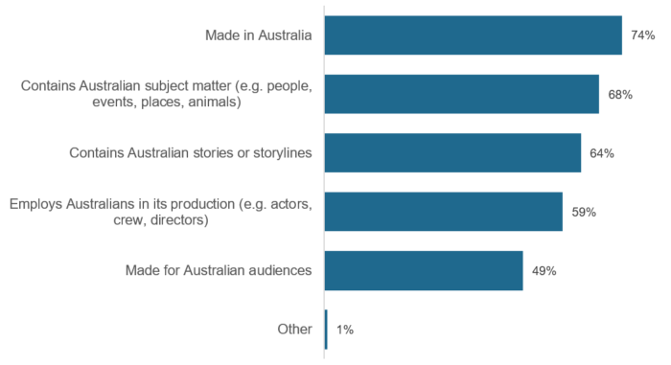B1. The next questions were about Australia’s media industry and the production of media content, such as television shows, movies, documentaries, print newspapers and magazines, radio, music, and podcasts. In your opinion, what makes media content ‘Australian’? (Multiple responses).

Base: All respondents – Total (n=4,096).

Note: The following were not shown: ‘Don’t know’ (<1%), ‘Refused’ (<1%).

Figure 2 shows that females were more likely than males to consider Australian content to be ‘Made in Australia’ (75% compared to 72% respectively), 'contains Australian subject matter’ (71% compared to 66% respectively), and ‘contains Australian stories or story lines’ (66% compared to 61% respectively).

Respondents aged 55 years or older and those living in regional areas were more likely to consider content that ‘employs Australians in its production’ to be ‘Australian’, as shown in Figure 3 and Figure 4. Those living in regional areas were also more likely to consider ‘Made in Australia’ to make content ‘Australian’ (76% compared to 72% amongst metro respondents).

Figure 2 Aspects that make screen content ‘Australian’ – by gender

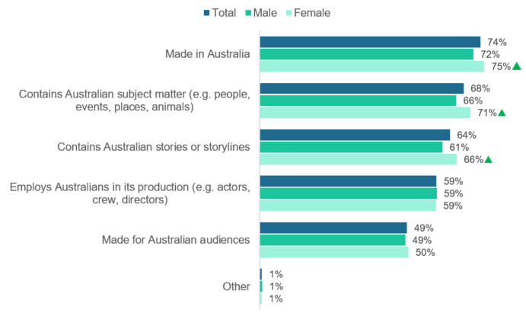

B1. The next questions were about Australia’s media industry and the production of media content, such as television shows, movies, documentaries, print newspapers and magazines, radio, music, and podcasts. In your opinion, what makes media content ‘Australian’? (Multiple responses).

Base: All respondents – Total (n=4,096), Male (n=1,763), Female (n=2,322).

Note: The following were not shown: ‘Don’t know’ (<1%), ‘Refused’ (<1%).

 Significantly different to the other sub-group at the 95% confidence level.

Figure 3 Aspects that make screen content ‘Australian’ – by age

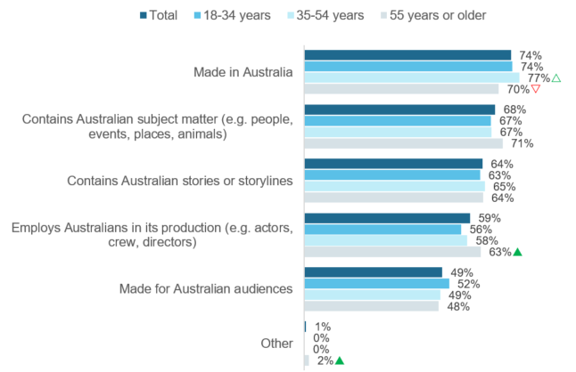B1. The next questions were about Australia’s media industry and the production of media content, such as television shows, movies, documentaries, print newspapers and magazines, radio, music, and podcasts. In your opinion, what makes media content ‘Australian’? (Multiple responses).

Base: All respondents – Total (n=4,096), 18-34 (n=793), 35-54 (n=1,661), 55 or older (n=1,640).

Note: The following were not shown: ‘Don’t know’ (<1%), ‘Refused’ (<1%).

 Significantly different to other sub-groups at the 95% confidence level.

△▽ Significantly different to sub-group with corresponding arrow at the 95% confidence level.

Figure 4 Aspects that make screen content ‘Australian’ – by region

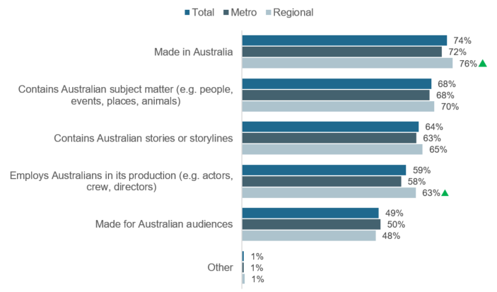B1. The next questions were about Australia’s media industry and the production of media content, such as television shows, movies, documentaries, print newspapers and magazines, radio, music, and podcasts. In your opinion, what makes media content ‘Australian’? (Multiple responses).

Base: All respondents – Total (n=4,096), Metro (n=2,716), Regional (n=1,379).

Note: The following were not shown: ‘Don’t know’ (0%), ‘Refused’ (0%).

 Significantly different to the other sub-group at the 95% confidence level.

## Attitudes towards Australian screen content

Respondents were asked how strongly they agree or disagree with four attitudinal statements about Australian screen content (i.e. film and TV stories). Figure 5 shows the results from this question.

Australian screen content was considered by the majority of respondents to be important for Australian identity. Four in five respondents (85%) ‘agree’ or ‘strongly agree’ that Australian screen content is ‘important for contributing to our sense of Australian identity’ (85%).

Australian screen content was also considered by the majority of respondents to be important in showing Australian views and perspectives internationally, with four in five (85%) who agreed that Australian content is ‘important in showing Australian views and perspectives to the rest of the world’.

Three in four (76%) respondents ‘agree’ or ‘strongly agree’ that they would miss Australian content if they ceased to exist. This outweighs those who ‘disagree’ or ‘strongly disagree’ (8%) by nearly tenfold.

There were polarising views on the amount of Australian content available. 38% ‘disagree’ or ‘strongly disagree’ that ‘there was more than enough Australian film and TV content available to meet my needs’, whereas 27% ‘agree’ or ‘strongly agree’ with this statement. A further 34% were ambivalent, stating they ‘neither agree nor disagree’ or with this statement.

Figure 5 Attitudes towards Australian content – Total

| NET strongly agree/agree: |  |  |  |
| --- | --- | --- | --- |
| 85% | 85% | 76% | 27% |

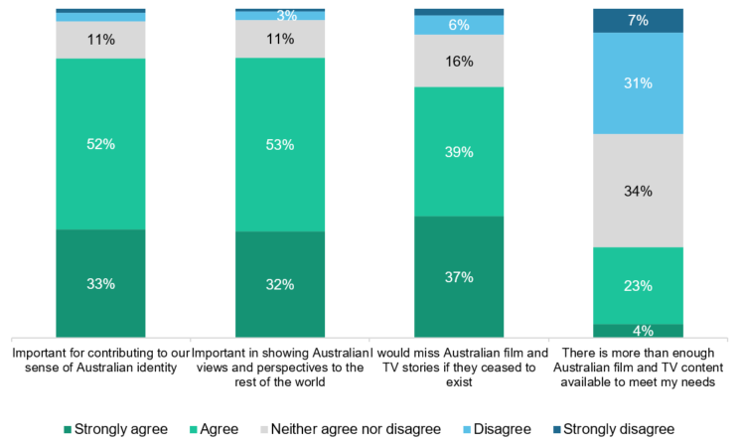

B2. How strongly do you agree or disagree with the following statements about Australian media (i.e. content that was made in Australia)?

Base: All respondents – Total (n=4,096).

Note: The following were not shown: ‘Don’t know’ (0%), ‘Refused’ (0%). Labels under 3% are not shown. Figures may not add to 100% due to rounding.

Figure 6 shows that compared to other age groups, respondents aged 55 years or older were more likely to agree that Australian content was ‘important for contributing to our sense of Australian identity’ (90%), that they ‘would miss Australian film and TV stories if they ceased to exist’ (89%), and that Australian content was ‘important in showing Australian views and perspectives to the rest of the world’ (85%). On the contrary, respondents aged 18-34 years were less likely to agree that Australian content was ‘important for contributing to our sense of Australian identity’ (78%) and that they ‘would miss Australian film and TV stories if they ceased to exist’ (65%).

Figure 6 Attitudes towards Australian content – ‘Agree’ or ‘Strongly agree’ by age

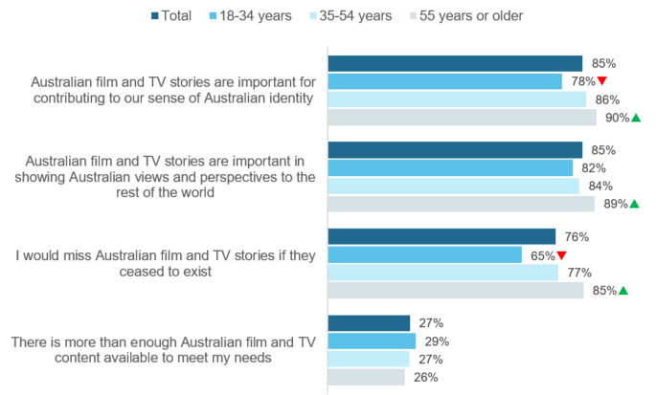

B2. How strongly do you agree or disagree with the following statements about Australian media (i.e. content that was made in Australia)? (‘Agree’ or ‘Strongly agree’).

Base: All respondents – Total (n=4,096), 18-34 (n=793), 35-54 (n=1,661), 55 or older (n=1,640).

 Significantly different to other sub-groups at the 95% confidence level.

Respondents living in regional areas (85%) were also more likely to agree with this statement compared to respondents living in metropolitan areas, as shown in Figure 7. Compared to those living in metropolitan areas regional respondents were also more likely to agree that they ‘would miss Australian film and TV stories if they ceased to exist’ (81%).

Figure 7 Aspects that make screen content ‘Australian’ – by region

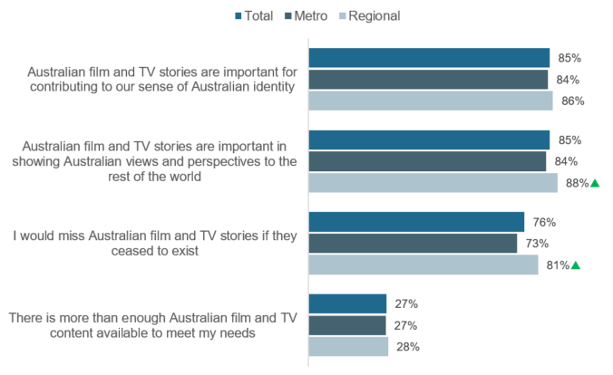

B2. How strongly do you agree or disagree with the following statements about Australian media (i.e. content that was made in Australia)? (‘Agree’ or ‘Strongly agree’).

Base: All respondents – Total (n=4,096), Metro (n=2,716), Regional (n=1,379).

 Significantly different to the other sub-group at the 95% confidence level.

# Screen content

The survey included two sections that asked about screen content consumption. One section asked about the respondent’s own screen content consumption. The other section asked parents or guardians of a child 15 years old or under about their child’s screen content consumption. If a respondent had more than one child under children 15 years old or under, they were asked to think about the child who was going to have the next birthday. The following sections outline the results about screen content consumption.

## Adults’ screen content consumption

### Channels used to watch screen content

When asked which channels they used to watch screen content in the past seven days, the most commonly selected by respondents were commercial free-to-air television, excluding catch-up TV (61%) and online subscription services (60%), as shown in Figure 8.

One in two respondents used free video streaming services such as YouTube or Twitch (54%), or a national broadcaster free-to-air TV (53%).

The least common platform to view screen content was pay-per-view services such as Google Play, iTunes and OzFlix (5%).

Four in five (81%) respondents used at least one online channel, excluding free-to-air catch-up TV. A similar proportion (80%) watched via a free-to-air channel.

Overall, only a minority (2%) reported they did not use any of the channels to watch screen content in the past seven days. An overwhelming majority (98%) consumed screen content via at least one channel.

Figure 8 Channels used to watch screen content in the past seven days – Total

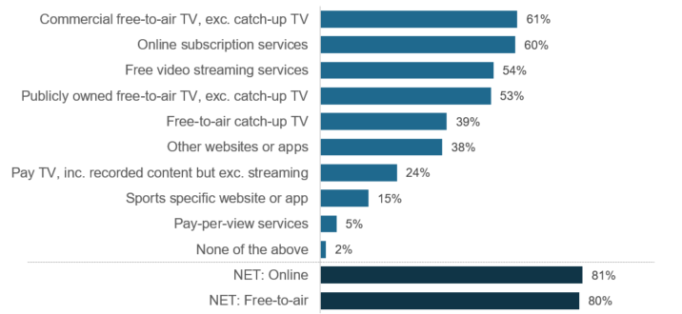

C1. The next questions were about content you personally watch, including things like television shows, movies and documentaries. Which of the following did you use to watch screen content in the past 7 days at home or elsewhere on any device? (Multiple responses).

Base: All respondents – Total (n=4,096).

Note: The following were not shown: ‘Don’t know’ (<1%), ‘Refused’ (0%). ‘NET: Online’ includes: ‘Online subscription services’, ‘Free video streaming services’, ‘Other websites or apps’, and ‘Sports specific website or app’. ‘NET: Free-to-air’ includes: ‘Commercial free-to-air TV’, ‘Publicly owned free-to-air TV’, and ‘Free-to-air catch-up TV’.

Figure 9 shows the gender differences in channels used to watch screen content in the past seven days. Females were more likely than males to use online subscription services (64%) or other websites or apps (40%) to watch screen content. Whereas compared to females, males were more likely to use free video streaming services (57%), publicly owned free-to-air TV, excluding catch-up TV (55%), or sports specific websites or apps (20%).

Figure 9 Channels used to watch screen content in the past seven days – by gender

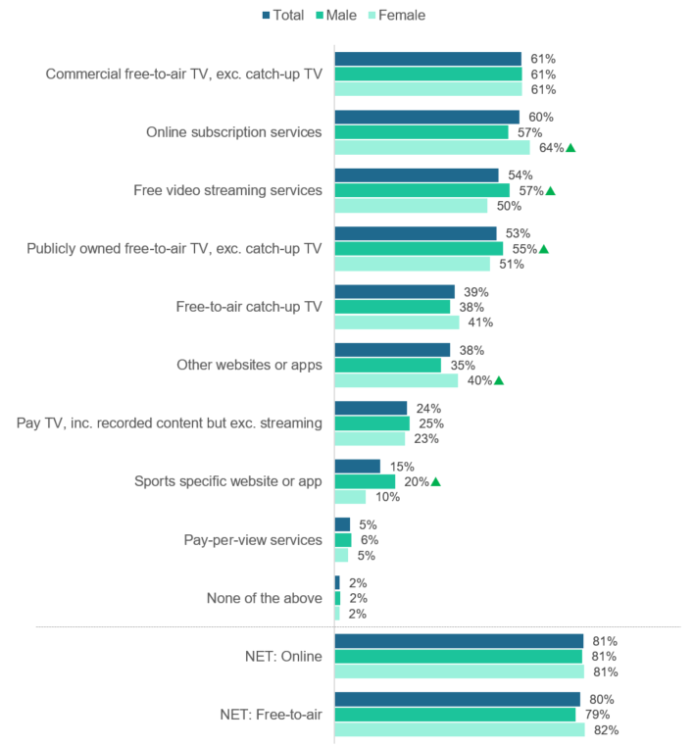

C1. The next questions were about content you personally watch, including things like television shows, movies and documentaries. Which of the following did you use to watch screen content in the past 7 days at home or elsewhere on any device? (Multiple responses).

Base: All respondents – Total (n=4,096), Male (n=1,763), Female (n=2,322).

Note: The following were not shown: ‘Don’t know’ (<1%), ‘Refused’ (0%).

 Significantly different to the other sub-group at the 95% confidence level.

The channels used to watch screen content in the past seven days varied by age, as shown Figure 10. Compared to other age groups, those aged 18-34 years were less likely to use free-to-air channels (62%) to watch screen content, but were more likely to use online channels (93%). They were also less likely to use Pay TV to watch screen content (16%).

On the contrary, respondents aged 55 years or older were more likely to consume screen content via free-to-air channels (94%), and less likely to consume via online channels (66%).

Respondents aged 35-54 years were more likely than other age groups to use pay-per-view services (7%) to watch screen content.

Figure 10 Channels used to watch screen content in the past seven days – by age

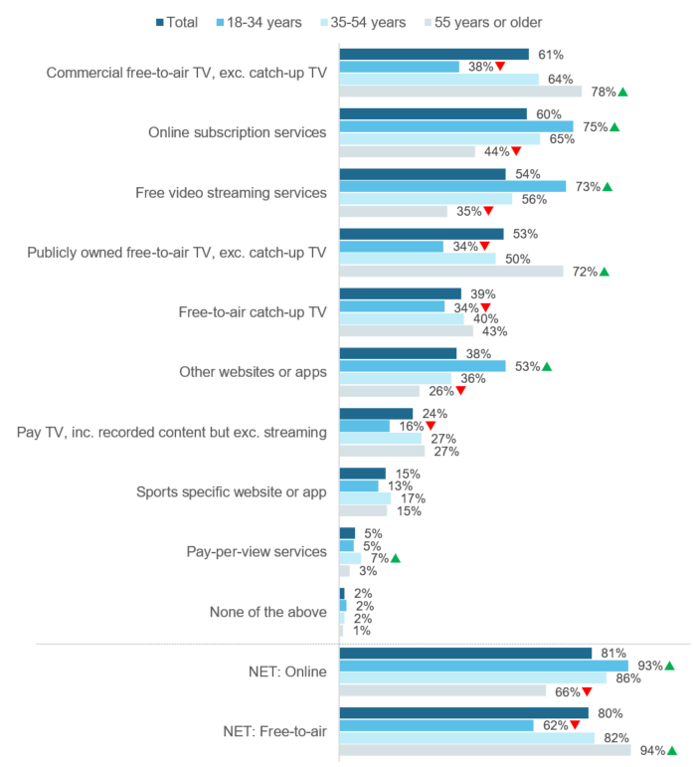

C1. The next questions were about content you personally watch, including things like television shows, movies and documentaries. Which of the following did you use to watch screen content in the past 7 days at home or elsewhere on any device? (Multiple responses).

Base: All respondents – Total (n=4,096), 18-34 (n=793), 35-54 (n=1,661), 55 or older (n=1,640).

Note: The following were not shown: ‘Don’t know’ (<1%), ‘Refused’ (0%).

 Significantly different to other sub-groups at the 95% confidence level.

Figure 11 shows that the channels used to watch screen content in the past seven days also varied by region. Those living in metro areas were more likely to use online channels (82%) to watch screen content, whereas those living in regional areas were more likely to use free-to-air (83%).

Figure 11 Channels used to watch screen content in the past seven days – by region

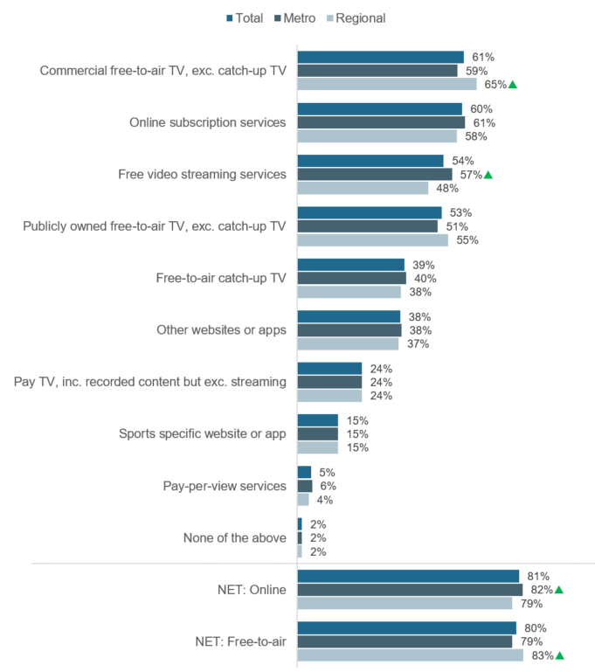

C1. The next questions were about content you personally watch, including things like television shows, movies and documentaries. Which of the following did you use to watch screen content in the past 7 days at home or elsewhere on any device? (Multiple responses).

Base: All respondents – Total (n=4,096), Metro (n=2,716), Regional (n=1,379).

Note: The following were not shown: ‘Don’t know’ (<1%), ‘Refused’ (0%).

 Significantly different to the other sub-group at the 95% confidence level.

### Time spent watching screen content

Figure 12 shows the average amount of time spent watching screen content across different channels per week. To allow for direct comparisons between channels, the proportion of those who did not watch via each of the channels in the past seven days are also shown.

The greatest amount of time spent watching screen content was reported for the most commonly used channels, with one in three respondents reporting they watch online subscription services (34%) and commercial free-to-air TV (32%) more than six hours per week on average. This was followed by one in four (24%) respondents who watch publicly owned free-to-air TV more than six hours per week on average.

Across all the channels, free video streaming services had the highest proportion of respondents who reported they watch screen content via this channel for five hours or less (33%).

The least amount of time was spent watching pay-per-view services, sports specific websites or apps, and pay TV.

Figure 12 Hours spent watching screen content per week – Total

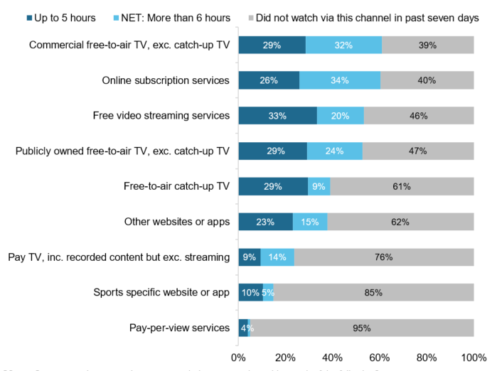

C2. On average, how many hours per week do you spend watching each of the following?

Base: All respondents – Total (n=4,096).

Note: The following were not shown: ‘Don’t know’ (<1%), ‘Refused’ (<1%). Labels under 3% are not shown. ‘NET: More than 6 hours’ includes (‘6-10 hours’, ‘11-15 hours’, ‘16-20 hours’, ‘21-25 hours’, ‘26-35 hours’, and ‘More than 35 hours’).

As shown in Figure 13, compared to females, males were more likely to spend six hours or more per week on average watching free video streaming services (25%), publicly owned free-to-air TV (26%), pay TV (16%), and sports specific websites or apps (7%).

Females were more likely than males to watch other websites or apps (16%).

Figure 13 Spent six hours or more per week watching screen content – by gender

C2. On average, how many hours per week do you spend watching each of the following? (‘6-10 hours’, ‘11-15 hours’, ‘16-20 hours’, ‘21-25 hours’, ‘26-35 hours’, and ‘More than 35 hours’).

Base: All respondents – Total (n=4,096), Male (n=1,763), Female (n=2,322).

 Significantly different to the other sub-group at the 95% confidence level.

Figure 14 shows the age differences in the proportion of respondents who watch screen content for six hours or more per week across different channels.

Those aged 55 years or older were more likely to watch screen content via commercial and publicly owned free-to-air TV for six hours or more per week (50% and 43% respectively), compared to the two younger age groups. They were also more likely to watch free-to-air catch TV for six hours or more per week (11%) compared to those aged 18-34 years (7%). Whereas they were less likely to report this level of consumption for online channels such as online subscription services (23%), free video streaming services (7%), and other websites or apps (7%) compared to younger respondents.

On the contrary, younger respondents aged 18-34 years were more likely to watch screen content via online subscription services (46%), free video streaming services (37%) and other websites or apps (25%) for six hours or more per week. They were less likely to watch commercial and publicly owned free-to-air TV (13% and 8% respectively) and pay TV (7%) for six hours or more per week.

Figure 14 Spent six hours or more per week watching screen content – by age

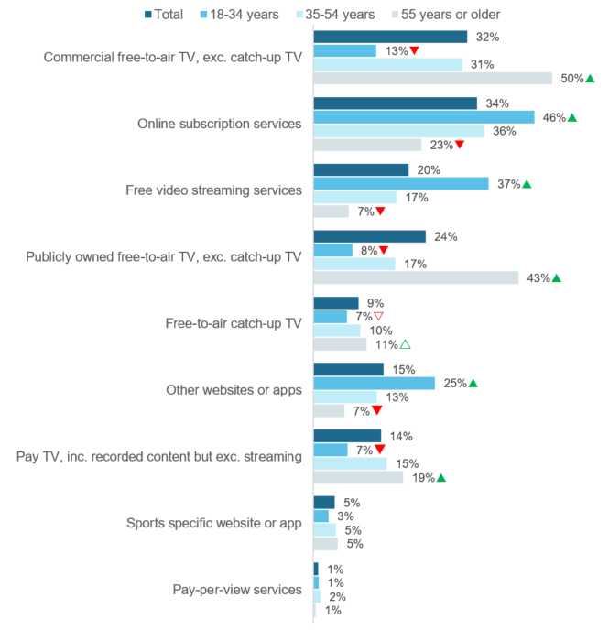

C2. On average, how many hours per week do you spend watching each of the following? (‘6-10 hours’, ‘11-15 hours’, ‘16-20 hours’, ‘21-25 hours’, ‘26-35 hours’, and ‘More than 35 hours’).

Base: All respondents – Total (n=4,096), 18-34 (n=793), 35-54 (n=1,661), 55 or older (n=1,640).

 Significantly different to the other sub-group at the 95% confidence level.

△▽ Significantly different to sub-group with corresponding arrow at the 95% confidence level.

Figure 15 shows that screen consumption of six hours or more per week also varies by region. Those living in metropolitan areas were more likely to report this higher level of consumption via free video streaming services (22%); whereas those living in regional areas were more likely to consume screen content via publicly owned free-to-air TV (28%) and sports specific websites or apps (6%).

Figure 15 Spent six hours or more per week watching screen content – by region

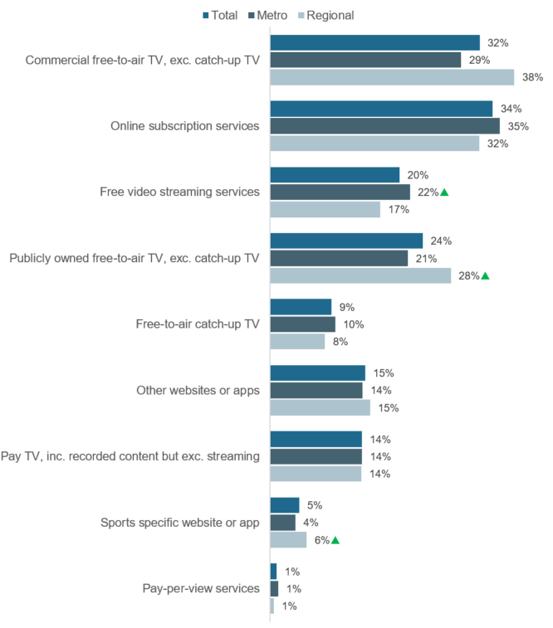

C2. On average, how many hours per week do you spend watching each of the following? (‘6-10 hours’, ‘11-15 hours’, ‘16-20 hours’, ‘21-25 hours’, ‘26-35 hours’, and ‘More than 35 hours’).

Base: All respondents – Total (n=4,096), Metro (n=2,716), Regional (n=1,379).

 Significantly different to the other sub-group at the 95% confidence level.

### Change in time spent watching screen content since COVID-19

Respondents who consumed screen content in the past seven days were asked how the amount of time they spent watching screen content via different channels changed since social and physical distancing restrictions were introduced in response to COVID-19 and Figure 16 shows the results.

To allow for direct comparisons between channels, the proportion of those who did not watch via each of the channels in the past seven days are also shown. A proportion of the respondents who reported they did not watch screen content in the past seven days may have decreased their screen content consumption since COVID-19 restrictions came in place. However, this can only be a speculation and the exact proportion cannot be determined as they were not asked this question directly.

Across all channels, the highest increased screen consumption since COVID-19 restrictions was reported for online channels, specifically: online subscription services (29%), free video streaming services (23%), and other websites and apps (16%).

Free-to-air screen consumption mostly stayed the same since COVID-19 restrictions. Two in five respondents reported their consumption of commercial free-to-air TV (42%) and publicly owned free-to-air TV, excluding catch-up TV (37%), stayed the same. One in four (24%) reported their consumption of catch-up TV did not change.

Figure 16 Change in time spent watching screen content since COVID-19 – Total

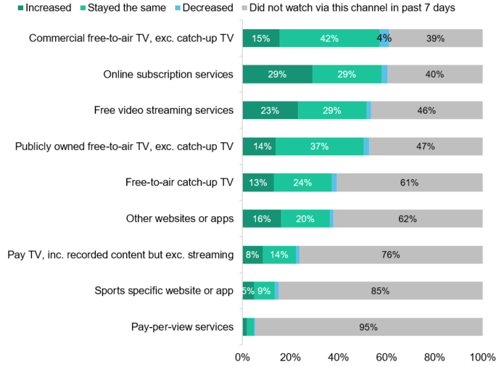

C3. Since social and physical distancing restrictions were introduced in response to COVID-19, how had the amount of time you have spent watching each of the following changed?

Base: All respondents – Total (n=4,096).

Note: The following were not shown: ‘Don’t know’ (<1%), ‘Refused’ (<1%). Labels under 3% are not shown.

Figure 17 shows that females were more likely than males to increase their screen consumption on commercial free-to-air TV, excluding catch-up TV (17%), online subscription services (33%), free-to-air catch-up TV (15%) and other websites and apps (20%) since COVID-19 restrictions. Whereas males were more likely to increase their consumption on sports specific websites and apps (6%).

Figure 17 Increased time spent watching screen content since COVID-19 – by gender

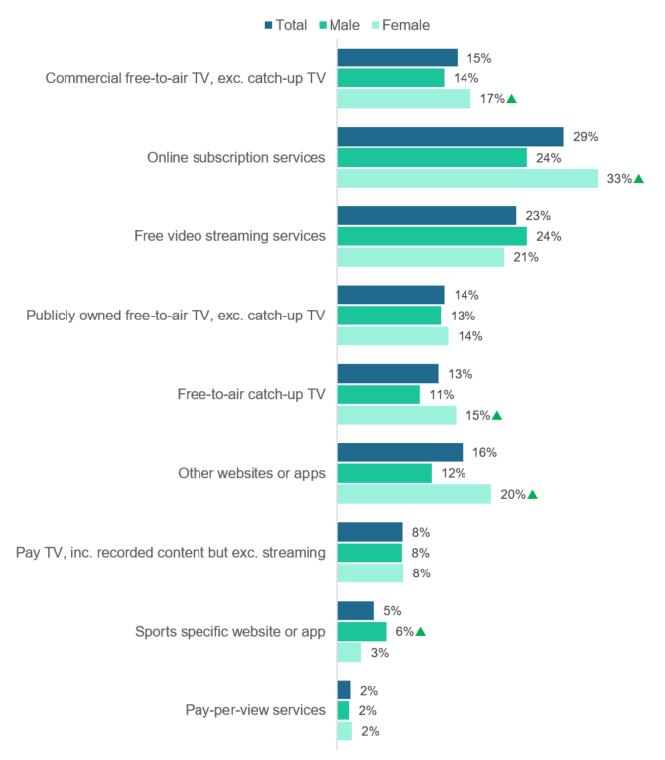

C3. Since social and physical distancing restrictions were introduced in response to COVID-19, how had the amount of time you have spent watching each of the following changed? (‘Increased’).

Base: All respondents – Total (n=4,096), Male (n=1,763), Female (n=2,322).

 Significantly different to the other sub-group at the 95% confidence level.

The differences by age in increased screen consumption since COVID-19 restrictions are shown in Figure 18. Younger respondents aged 18-34 years were more likely than older age groups to increase screen consumption via online subscription services (40%), free video streaming services (38%) and other websites or apps (31%). Whereas those aged 55 years were less likely to increase consumption via these channels (18%, 10%, and 5% respectively).

Respondents aged 25-54 years were more likely than those aged 18-34 years to increase their screen content consumption on pay TV (10%) since COVID-19 restrictions.

Figure 18 Increased time spent watching screen content since COVID-19 – by age

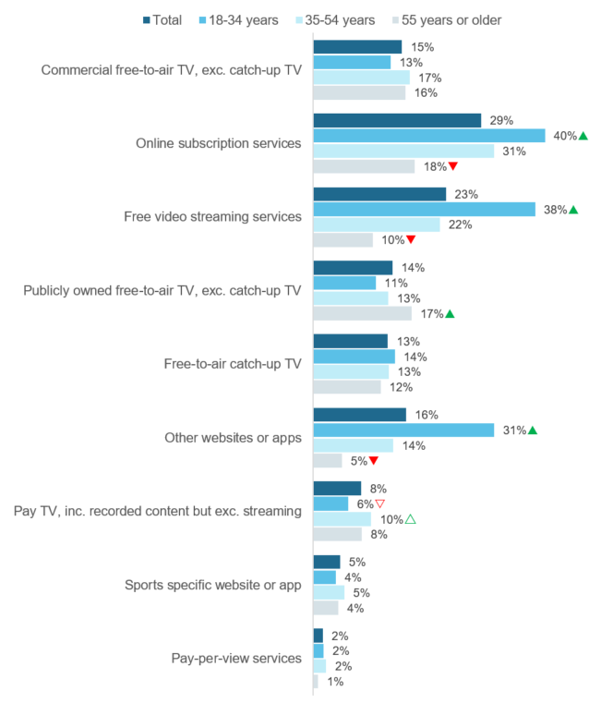

C3. Since social and physical distancing restrictions were introduced in response to COVID-19, how had the amount of time you have spent watching each of the following changed? (‘Increased’).

Base: All respondents – Total (n=4,096), 18-34 (n=793), 35-54 (n=1,661), 55 or older (n=1,640).

 Significantly different to the other sub-group at the 95% confidence level.

△▽ Significantly different to sub-group with corresponding arrow at the 95% confidence level.

Figure 19 shows that compared to regional respondents, those living in metropolitan areas were more likely to increase their screen consumption online, specifically: online subscription services (32%), free video streaming services (26%), and other websites or apps (17%).

Figure 19 Increased time spent watching screen content since COVID-19 – by region

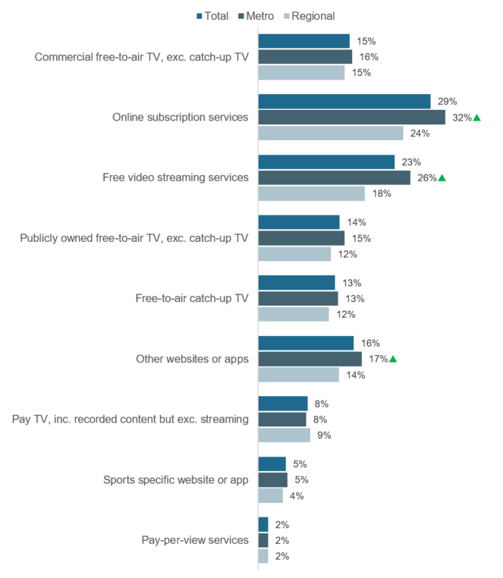

C2. On average, how many hours per week do you spend watching each of the following? (‘Increased’).

Base: All respondents – Total (n=4,096), Metro (n=2,716), Regional (n=1,379).

 Significantly different to the other sub-group at the 95% confidence level.

### Devices used to watch screen content

The survey included questions about devices used to watch screen content and device preferences for watching screen content. As shown in Figure 20, televisions and mobile phones were the most commonly used devices to watch screen content.

One in two respondents watch screen content on a television (54%) or a mobile phone (48%) at least once a day. However, mobile phone consumption was more frequent, with one in four (24%) respondents watching ‘more often than five times a day’, whereas only one in ten (10%) report this frequency on television.

Computers and tablets were the next most used devices to watch screen content. 31% of respondents watch screen content on a computer at least once a day, and 17% watch on a tablet at this frequency.

There was lower use of personal video recorders (PVR), digital media players, and game consoles to watch screen content.

Figure 20 Device usage frequency to watch screen content on average per week – Total

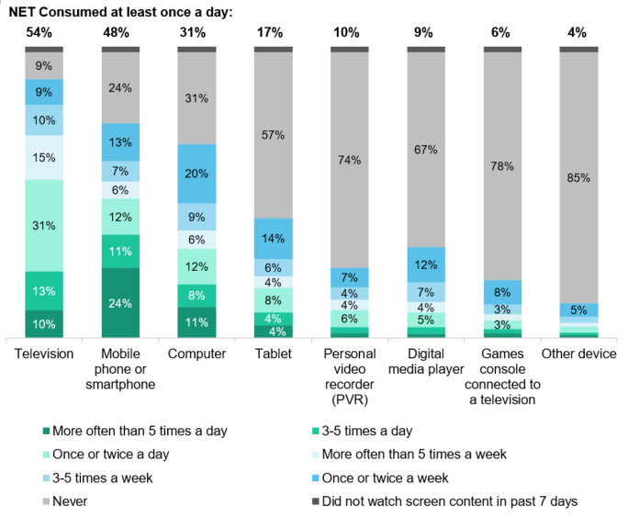

C4. On average per week, how often do you use the following devices to watch screen content?

Base: All respondents – Total (n=4,096).

Note: The following were not shown: ‘Don’t know’ (<1%), ‘Refused’ (<1%). Labels under 3% are not shown. ‘NET: Consumed at least once a day’ includes ‘Once or twice a day’, ‘3-5 times a day’, or ‘More often than 5 times a day’ and may not add up based on data in chart due to rounding.

Figure 21 shows that compared to females, males were more likely to watch screen content on a computer at least once a day (37%). Whereas females were more likely to watch screen content via a digital media player (10%) at this frequency.

Figure 21 Devices used at least once a day to watch screen content – by gender

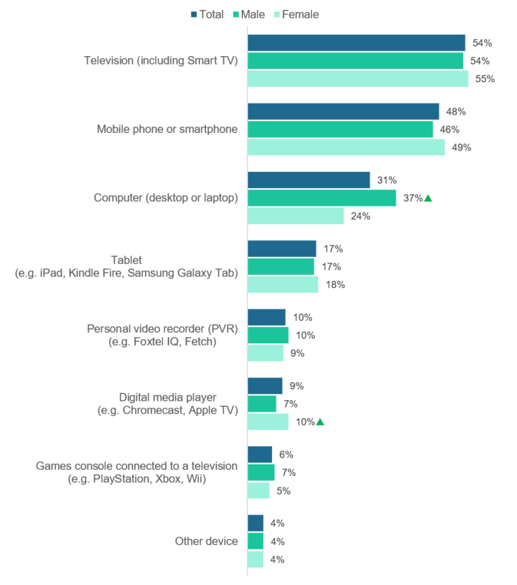

C4. On average per week, how often do you use the following devices to watch screen content? (‘Once or twice a day’, ‘3-5 times a day’, or ‘More often than 5 times a day’).

Base: All respondents – Total (n=4,096), Male (n=1,763), Female (n=2,322).

 Significantly different to the other sub-group at the 95% confidence level.

Figure 22 shows the age differences in devices used to watch screen content at least once a day. As shown, respondents aged 55 years or older were more likely to watch screen content on a television (62%) at least once a day, whereas 18-34 year olds were less likely to (41%). Compared to both younger age groups, those aged 55 years or older were less likely to use a mobile phone (28%), digital media player (3%), games console connected to a television (1%) or other device (2%) to watch screen content once a day.

Respondents aged 18-34 years were more likely than the two older age groups to watch screen content at least once a day on a mobile phone (71%), computer (40%), games console connected to a television (12%), or other device (6%); and less likely to watch on a PVR (7%).

Figure 22 Devices used at least once a day to watch screen content – by age

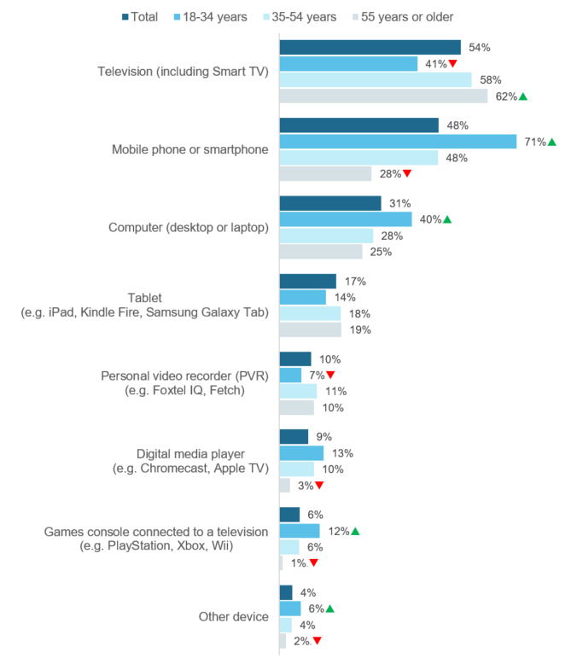

C4. On average per week, how often do you use the following devices to watch screen content? (‘Once or twice a day’, ‘3-5 times a day’, or ‘More often than 5 times a day’).

Base: All respondents – Total (n=4,096), 18-34 (n=793), 35-54 (n=1,661), 55 or older (n=1,640).

 Significantly different to the other sub-group at the 95% confidence level.

As shown in Figure 23, metropolitan respondents were more likely than regional respondents to watch screen content on a mobile phone (50% compared to 44%), computer (33% compared to 26%), digital media player (10% compared to 7%), or another device (5% compared to 3%) at least once a day.

Figure 23 Devices used at least once a day to watch screen content – by region

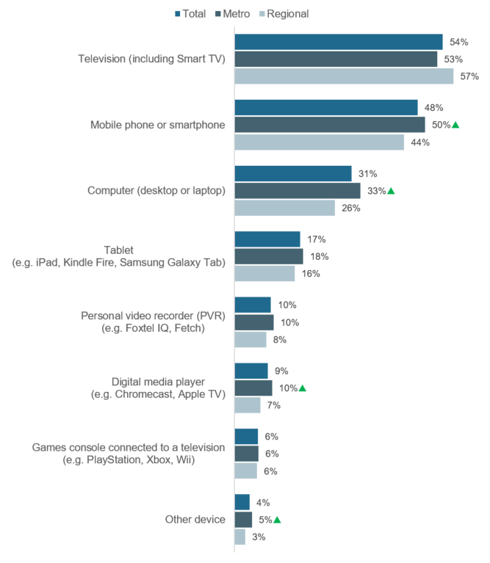

C2. On average, how many hours per week do you spend watching each of the following? (‘Once or twice a day’, ‘3-5 times a day’, or ‘More often than 5 times a day’).

Base: All respondents – Total (n=4,096), Metro (n=2,716), Regional (n=1,379).

 Significantly different to the other sub-group at the 95% confidence level.

### Device preferences for screen content

Respondents who used more than one device to watch screen content were asked if they had a preference on which device they used. As shown in Figure 24, three in four (77%) respondents reported that they do have a device preference. Those aged 55 years or older (82%) are more likely to have a device preference compared to younger age groups.

Figure 24 Overall preference on devices used to watch screen content (amongst those who watch on more than one device) – Total

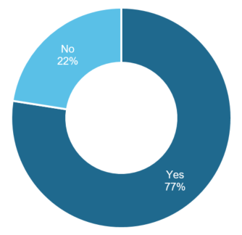

C5. Overall, do you have a preference on which device you use to watch screen content?

Base: Used multiple devices to watch screen content in C4 – Total (n=3,650).

Note: The following were not shown: ‘Don’t know’ (<1%), ‘Refused’ (0%). Figures may not add to 100% due to rounding.

Respondents who stated they had a device preference were then asked which one device they preferred to use to watch screen content. As shown in Figure 25, the majority (63%) prefer to watch on a television. Far fewer selected the next most preferred devices, with 13% preferring to watch on a computer, 9% on a mobile phone, and 5% on a tablet.

Figure 25 Most preferred devices to watch screen content

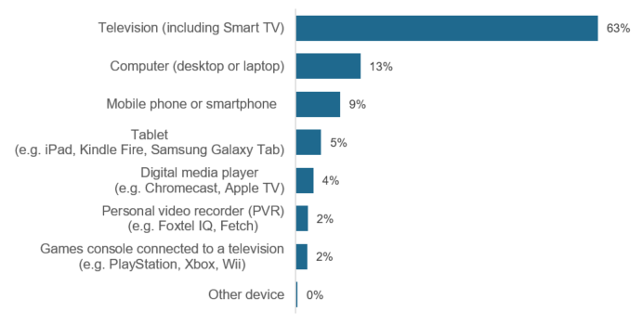

C6. Of all the devices you use, which do you prefer to use to watch screen content most?

Base: Have a preference on device used to watch screen content in C5 – Total (n=2,845).

Note: The following were not shown: ‘Don’t know’ (<1%), ‘Refused’ (0%). Figures may not add to 100% due to rounding.

### Genres watched across screen content channels

Respondents were asked to indicate which genres of content they generally watch on each channel. The results were detailed in Table 7, with the top and bottom three genres for each channel highlighted.

Free-to-air TV, including catch-up TV, were most commonly used to watch news and current affairs and documentaries. Pay TV, free video streaming services, and sports specific websites were most commonly used to watch documentaries. Online subscription and pay-per-view services were generally used to watch comedy, drama, and action / adventure screen content, which were watched on online subscription services more than any other channel. Out of all genres, documentary content was in the top three genres for the most channels.

User-generated videos were among least watched on most channels, with the exception of online subscription services and other websites of apps, where it was the most commonly watched genre on these channels.

Table 7 Genres watched by channel – Total

|  | **Commercial free-to-air TV** | **Publicly owned free-to-air TV** | **Pay TV** | **Free-to-air catch-up TV** | **Free video streaming services** | **Online subscription services** | **Pay-per-view services** | **Sports specific website or app** | **Other websites or apps** |
| --- | --- | --- | --- | --- | --- | --- | --- | --- | --- |
| **News and current affairs** | 47% | 41% | 9% | 18% | 17% | 9% | 1% | 2% | 15% |
| **Documentary** | 29% | 35% | 14% | 20% | 21% | 33% | 2% | 2% | 6% |
| **Comedy** | 26% | 22% | 11% | 17% | 22% | 40% | 2% | 1% | 13% |
| **Drama** | 25% | 22% | 12% | 19% | 8% | 39% | 2% | 1% | 3% |
| **Sport** | 24% | 14% | 12% | 6% | 8% | 8% | 1% | 13% | 4% |
| **Crime / Thriller** | 23% | 19% | 12% | 14% | 7% | 35% | 2% | 1% | 3% |
| **Action / Adventure** | 21% | 13% | 10% | 10% | 10% | 38% | 2% | 1% | 3% |
| **Reality** | 19% | 9% | 6% | 10% | 10% | 12% | 1% | 1% | 7% |
| **Talk shows / Game shows** | 17% | 10% | 3% | 5% | 7% | 4% | <1% | 1% | 2% |
| **Fantasy /Science fiction** | 9% | 7% | 6% | 6% | 6% | 25% | 2% | 1% | 2% |
| **User-generated videos** | 1% | 1% | <1% | 1% | 22% | 4% | <1% | <1% | 18% |
| **Other** | 2% | 2% | 1% | 1% | 10% | 2% | <1% | <1% | 5% |

C7a-i. In general, which types of content do you watch on…?

Base: All respondents – Total (n=4,096).

Note: The following were not shown: ‘Don’t know’ (<1%), ‘Refused’ (<1%).

■ The top three genres for each channel were highlighted in green.

■ The bottom three genres for each channel were highlighted in red.

### Video streaming subscription services

All respondents were asked which video streaming subscription services their household had access to, excluding catch-up TV and pay-per-view. A list of services were presented and respondents were allowed to select multiple responses.

As shown in Figure 26, the majority (77%) reported they have access to video streaming subscription services at home, with only one in four (23%) having no access to any of the listed video streaming subscription services in their household.

The most common service was Netflix, with two in three (65%) respondents having access to this service at home. The next most common service was Stan (21%), but with far fewer households subscribing to this service compared to Netflix. Disney+ (18%), a relatively new entrant to the market having only launched in Australia in November 2019[1], was the third most common video streaming subscription service.

Figure 26 Video streaming subscription services in household – Total

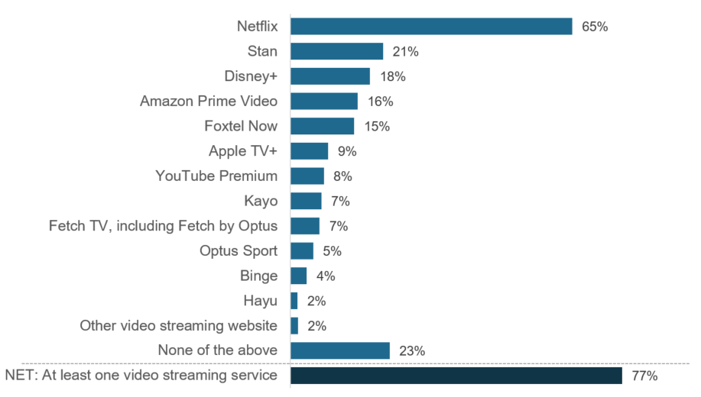

C8. Which of the following video streaming subscription services does your household currently have access to? This excludes catch-up TV and pay-per-view. (Multiple responses).

Base: All respondents – Total (n=4,096).

Note: The following were not shown: ‘Don’t know’ (<1%), ‘Refused’ (<1%).

Figure 27 shows that females (78%) were more likely to have access to at least one video streaming subscription service in their household compared to males (75%). In particular, they were more likely to have access to Netflix (68%), Stan (24%), or Disney+ (20%). Males, on the other hand, were more likely to have access to Amazon Prime Video (18%).

Figure 27 Video streaming subscription services in household – by gender

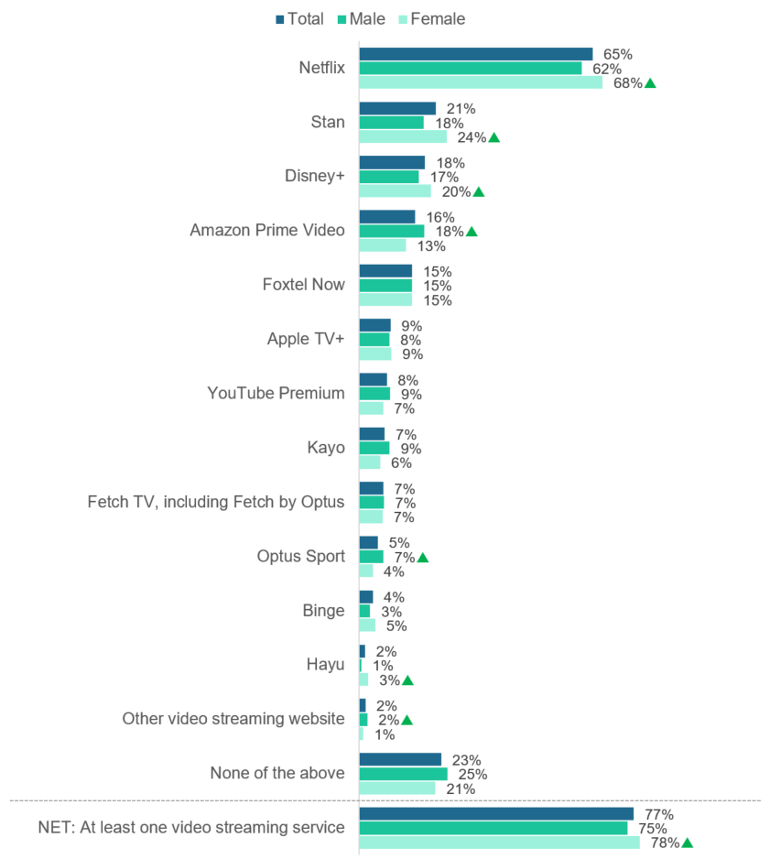

C8. Which of the following video streaming subscription services does your household currently have access to? This excludes catch-up TV and pay-per-view. (Multiple responses).

Base: All respondents – Total (n=4,096), Male (n=1,763), Female (n=2,322).

Note: The following were not shown: ‘Don’t know’ (0%), ‘Refused’ (0%).

 Significantly different to the other sub-group at the 95% confidence level.

As shown in Figure 28 (overleaf), respondents aged 18-34 years (88%) were more likely to have access to at least one video streaming subscription service in their household compared to the two older age groups, particularly those aged 55 years or older (63%) who were significantly less likely to have access.

The top three most popular video streaming subscription services, Netflix, Stan, Disney+ were more likely to be accessed by 18-34 year olds; as were YouTube Premium and Hayu.

With the exception of Foxtel Now, Fetch TV, and other lesser known video streaming subscription services, the oldest age group were less likely to subscribe to all of the services listed compared to the two other younger age groups. They were more likely to subscribe to none of the services listed (37%).

Figure 28 Video streaming subscription services in household – by age

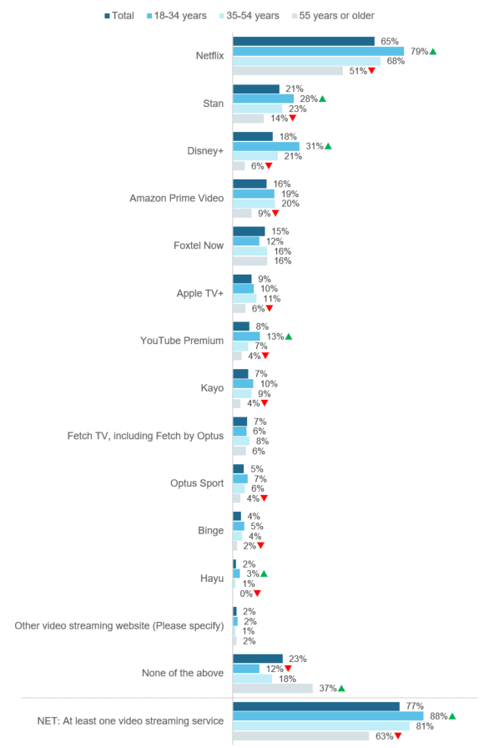

C8. Which of the following video streaming subscription services does your household currently have access to? This excludes catch-up TV and pay-per-view. (Multiple responses).

Base: All respondents – Total (n=4,096), 18-34 (n=793), 35-54 (n=1,661), 55 or older (n=1,661).

Note: The following were not shown: ‘Don’t know’ (<1%), ‘Refused’ (<1%).

 Significantly different to the other sub-group at the 95% confidence level.

Those living in metro areas (78%) were more likely to have access to at least one video streaming subscription service in their household compared to those living in regional areas (74%), as shown in Figure 29. In particular, they were more likely to have access to Amazon Prime Video, Apple TV+, Fetch TV, and Optus Sport.

Figure 29 Video streaming subscription services in household – by region

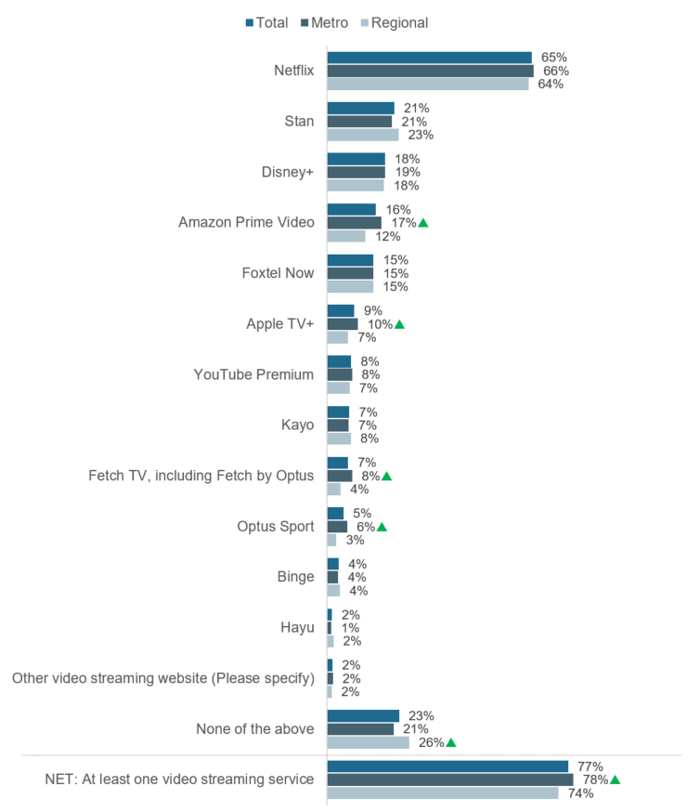

C8. Which of the following video streaming subscription services does your household currently have access to? This excludes catch-up TV and pay-per-view. (Multiple responses).

Base: All respondents – Total (n=4,096), Metro (n=2,716), Regional (n=1,379).

Note: The following were not shown: ‘Don’t know’ (0%), ‘Refused’ (0%).

 Significantly different to the other sub-group at the 95% confidence level.

Respondents were asked to enter the number of video streaming subscription services they have access to in their household. Figure 30 shows the results, including the proportion of respondents who do not have access to video streaming subscription services combined with those who entered a response of ‘0’. The results for sub-groups with significant differences were also shown.

The most common number of video streaming subscription services was one (25%) or two (20%) subscriptions.

Respondents aged 18-34 were more likely to have access to three (19%) or five (11%) video streaming subscription services compared to older age groups and were less likely to have no access (14%). On the contrary, those aged 55 years or older were more likely to have no access to a video streaming subscription service (42%). Respondents living in regional areas were also more likely to have no access to a video streaming subscription service (31%).

Figure 30 Number of video streaming subscription services

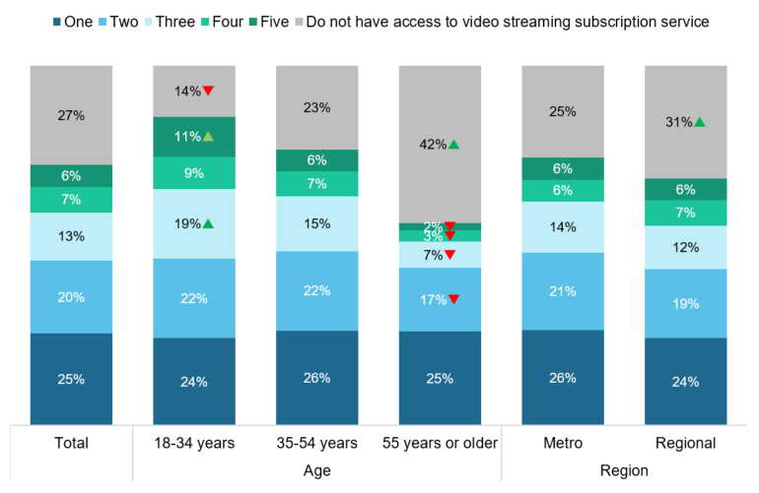

C10. How many video streaming subscription services does your household currently have access to? This excludes catch-up TV and pay-per-view.

Base: All respondents – Total (n=4,096), 18-34 (n=793), 35-54 (n=1,661), 55 or older (n=1,661), Metro (n=2,716), Regional (n=1,379).

Note: The following were not shown: ‘Don’t know’ (<2%), ‘Refused’ (<1%). Figures may not add to 100% due to rounding.

 Significantly different to the other sub-group at the 95% confidence level.

Respondents who have access to a video streaming subscription service were asked whether video streaming subscription services have enough Australian content and the results are shown in Figure 31. Overall, the proportion of respondents who reported video streaming subscription services do not have enough Australian content (58%) outweighs the proportion who say they have enough (39%). Respondents aged 18-34 years (41%) or aged 25-54 years (41%) were more likely to say that video streaming subscription services have enough Australia content when compared to those aged 55 years or older (34%).

Figure 31 Video streaming subscription services have enough Australian content

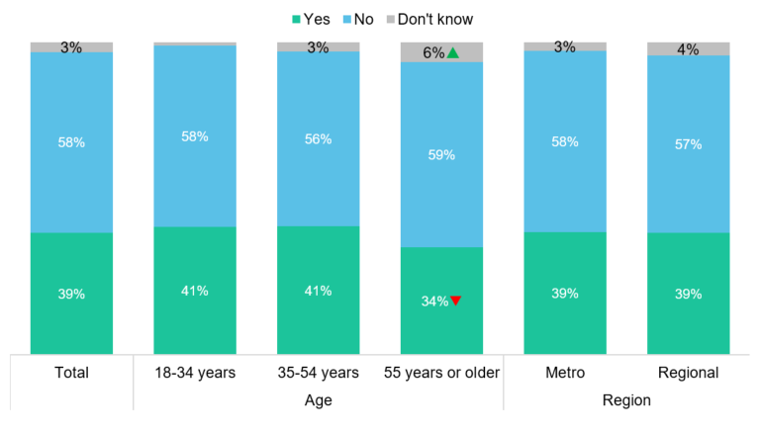

C11. In your opinion, do video streaming subscription services have enough Australian content?

Base: Have video streaming subscription in C8 – Total (n=3,144), 18-34 (n=719), 35-54 (n=1,368), 55 or older (n=1,055), Metro (n=2,130), Regional (n=1,014).

Note: The following were not shown: ‘Refused’ (<1%). Figures may not add to 100% due to rounding.

 Significantly different to the other sub-group at the 95% confidence level.

Respondents who reported they believe there is not enough Australian content on video streaming services were then asked how much they would be willing to pay per month for a video streaming subscription, if it included more Australian content. The results are shown in Figure 32.

One in two (47%) respondents who answered the question would be willing to pay more for new Australian documentaries; and two in five (44%) would be willing to pay more for new Australian drama. While only one in four (26%) respondents who answered the question would be willing to pay more for new Australian kids content, the willingness to pay amongst those who are parents of children aged 15 years or younger is higher (46%).

Figure 32 Willingness to pay extra for more Australian content on video streaming subscription services

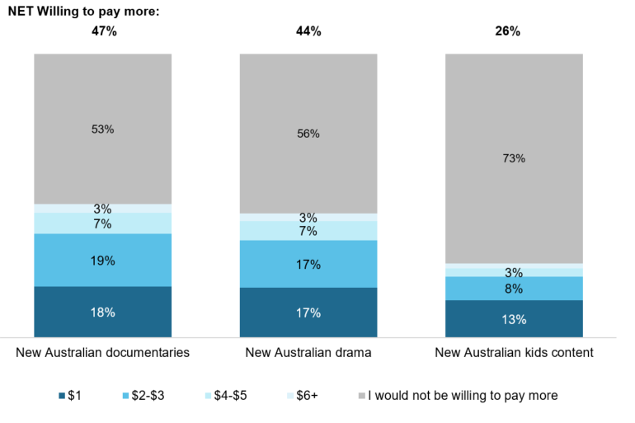

C12. How much extra would you be willing to pay per month for a video streaming subscription, if it included more…?

Base: Believe there was not enough Australian content on video streaming services in C11 – Total (n=983)

Note: The following were not shown: ‘Don’t know’ (<1%), ‘Refused’ (<1%). Labels under 3% are not shown.

 Significantly different to the other sub-group at the 95% confidence level.

### Pay-per-view services

Respondents who used a pay-per-view service to consume screen content in past seven days were asked which service they used to purchase an individual movie or TV series. As shown Figure 33, in the most common services were used by one in four pay-per-view consumers – Apple TV (23%), Google Play (23%), and iTunes (22%).

Figure 33 Pay-per-view services used in past seven days – Total

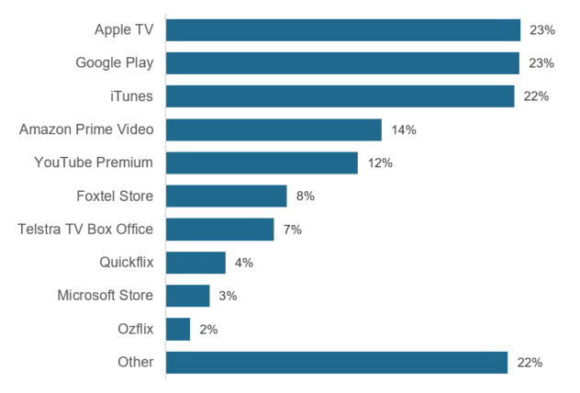

C9. In the past 7 days, which of the following pay-per-view services [ONLINE HOVER OVER: Pay-per-view services were used to purchase individual movies or TV series] did you use to purchase an individual movie/TV series? (Multiple responses).

Base: Used pay-per-view service to consume screen content in past seven days in C1 – Total (n=225).

Note: The following were not shown: ‘Don’t know’ (4%), ‘Refused’ (2%).

## Children’s screen content consumption

Parents or guardians of a child 15 years old or under were asked about their child’s screen content consumption. If a respondent had more than one child 15 years old or under, they were asked to answer questions about the child randomly selected by the program. The following section outlines the results about children’s screen content consumption.

### Channels used to watch children’s screen content

When asked which channels their child used to watch screen content in the past seven days, the most commonly selected by parents were free video streaming services (50%) and online subscription services (49%), as shown in Figure 34.

Three in four (74%) parents reported their child used at least one online channel, excluding free-to-air catch-up TV. This was higher than the proportion who reported that their child used any of the three forms of free-to-air TV (53%).

Overall, one in ten (10%) parents reported their children did not use any of the channels to watch screen content, resulting in the remaining nine in ten (90%) parents reporting their child consumed screen content via at least one channel.

Figure 34 Channels used to watch children’s screen content in the past seven days – Total

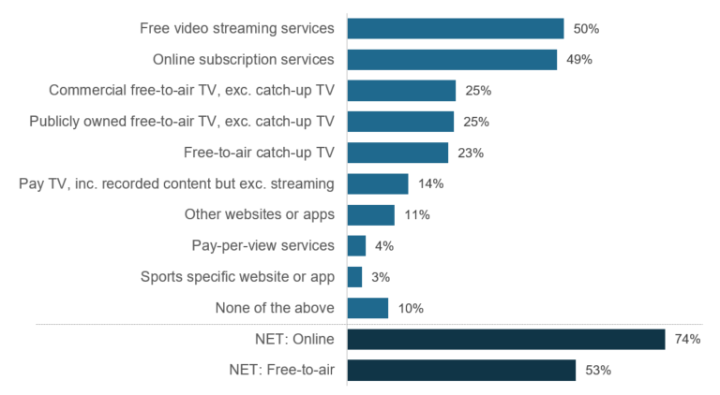

F1. In the past 7 days, which of the following did your child watch at home or elsewhere on any device? (Multiple responses).

Base: All parents – Total (n=1,571).

Note: The following were not shown: ‘Don’t know’ (0%), ‘Refused’ (<1%). ‘NET: Online’ includes: ‘Online subscription services’, ‘Free video streaming services’, ‘Other websites or apps’, and ‘Sports specific website or app’. ‘NET: Free-to-air’ includes: ‘Commercial free-to-air TV’, ‘Publicly owned free-to-air TV’, and ‘Free-to-air catch-up TV’.

When asked which channels their child used to watch screen content in the past seven days, there were some age differences. As shown in Figure 35, parents reported that younger children, aged 0-5 years, were more likely to watch publicly owned free-to-air TV (26%) but less likely to watch most other channels.

Figure 35 Channels used to watch children’s screen content in the past seven days – by age of child

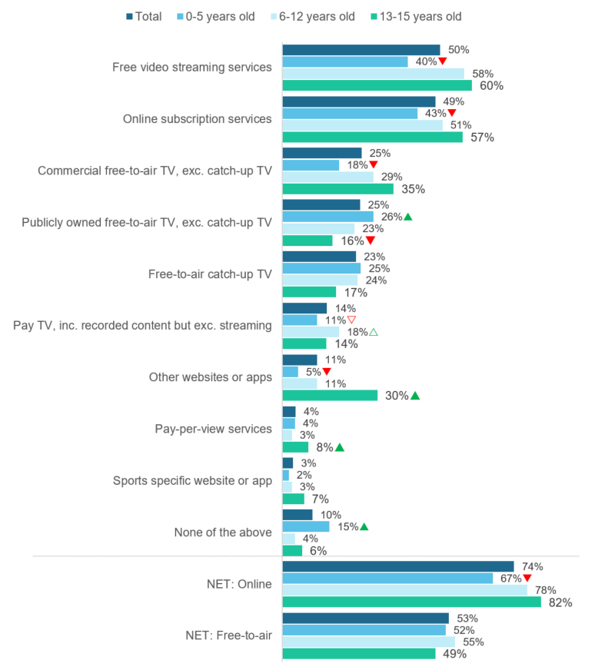

F1. In the past 7 days, which of the following did your child watch at home or elsewhere on any device? (Multiple responses).

Base: All parents – Total (n=1,571), Child aged: 0-5 (n=597), 6-12 (n=734), 13-15 (n=240).

Note: The following were not shown: ‘Don’t know’ (0%), ‘Refused’ (<1%). ‘NET: Online’ includes: ‘Online subscription services’, ‘Free video streaming services’, ‘Other websites or apps’, and ‘Sports specific website or app’. ‘NET: Free-to-air’ includes: ‘Commercial free-to-air TV’, ‘Publicly owned free-to-air TV’, and ‘Free-to-air catch-up TV’.

 Significantly different to the other sub-group at the 95% confidence level.

△▽ Significantly different to sub-group with corresponding arrow at the 95% confidence level.

Figure 36 shows regional differences in channels used to watch children’s screen content. Results from parents in metropolitan and regional areas were consistent across most channels, with those in regional areas more likely to watch screen content using online subscription services (59%).

Figure 36 Channels used to watch children’s screen content in the past seven days – by region

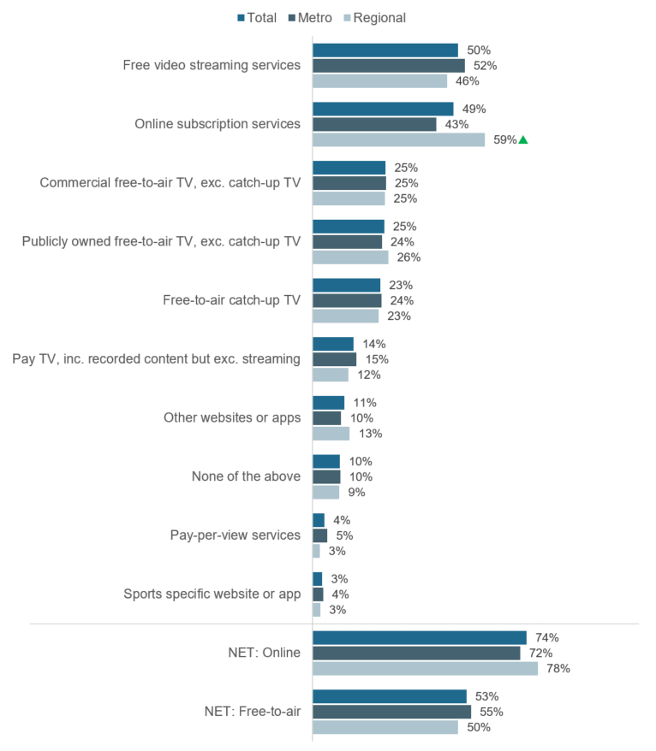

F1. In the past 7 days, which of the following did your child watch at home or elsewhere on any device? (Multiple responses).

Base: All parents – Total (n=1,571), Metro (n=1,085), Regional (n=486).

Note: The following were not shown: ‘Don’t know’ (0%), ‘Refused’ (<1%). ‘NET: Online’ includes: ‘Online subscription services’, ‘Free video streaming services’, ‘Other websites or apps’, and ‘Sports specific website or app’. ‘NET: Free-to-air’ includes: ‘Commercial free-to-air TV’, ‘Publicly owned free-to-air TV’, and ‘Free-to-air catch-up TV’.

 Significantly different to the other sub-group at the 95% confidence level.

### Time spent watching children’s screen content

Parents were then asked about the amount of time the selected child spends watching each platform in an average week. Figure 37 shows the amount of time spent watching screen content across different channels. To allow for direct comparisons between channels, the proportion of children who did not watch via each of the channels were also shown.

The greatest amount of time spent watching screen content were via the most commonly used channels, with one in four parents reporting their children watch free video streaming services like YouTube and Twitch (25%) and online subscription services (23%) more than six hours per week on average. This was followed by around one in ten parents who reported their children watch publicly owned free-to-air TV (10%), commercial free-to-air TV (9%), and free-to-air catch-up TV (8%) more than six hours per week on average.

The least amount of time was spent watching pay-per-view services and sports specific websites.

Figure 37 Hours spent watching children’s screen content per week – Total

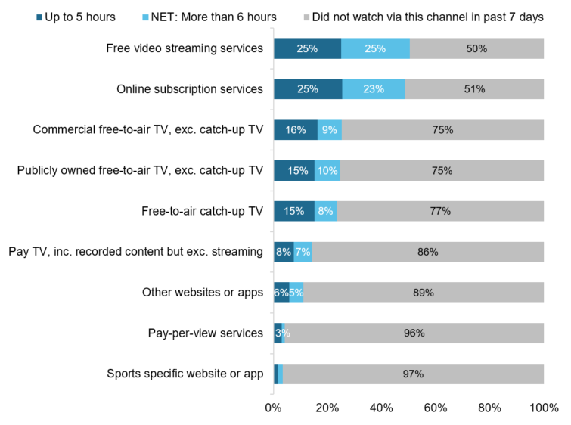

F2. On average, how many hours per week does your child spend watching each of the following?

Base: All parents – Total (n=1,571)

Note: The following were not shown: ‘Don’t know’ (0%), ‘Refused’ (0%). Labels under 3% are not shown.

As shown in Figure 38, compared to parents of children aged 0-5 years and 6-12 years, those with children aged 13-15 years were more likely to say their child spent six hours or more per week on average watching free video streaming services (42%), online subscription services (36%), and other websites or apps (18%). Parents of children aged 0-5 years were more likely to report use of publicly owned free-to-air TV (10%) than parents of children aged 13-15 years.

Figure 38 Spent six hours or more per week watching screen content – by age of child

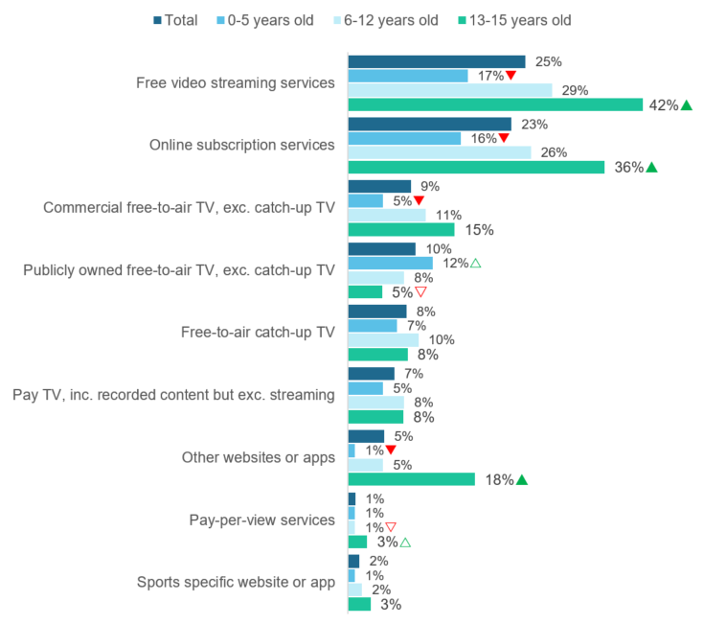

F2. On average, how many hours per week does your child spend watching each of the following? (‘6-10 hours’, ‘11-15 hours’, ‘16-20 hours’, ‘21-25 hours’, ‘26-35 hours’, and ‘More than 35 hours’).

Base: All parents – Total (n=1,571), Child aged: 0-5 (n=597), 6-12 (n=734), 13-15 (n=240).

Note: The following were not shown: ‘Don’t know’ (0%), ‘Refused’ (0%).

 Significantly different to the other sub-group at the 95% confidence level.

△▽ Significantly different to sub-group with corresponding arrow at the 95% confidence level.

When looking at region, as shown in Figure 39, compared to parents in metropolitan areas, those in regional areas were more likely to say their child spent six hours or more per week on average watching online subscription services (30%).

Figure 39 Spent six hours or more per week watching screen content – by region

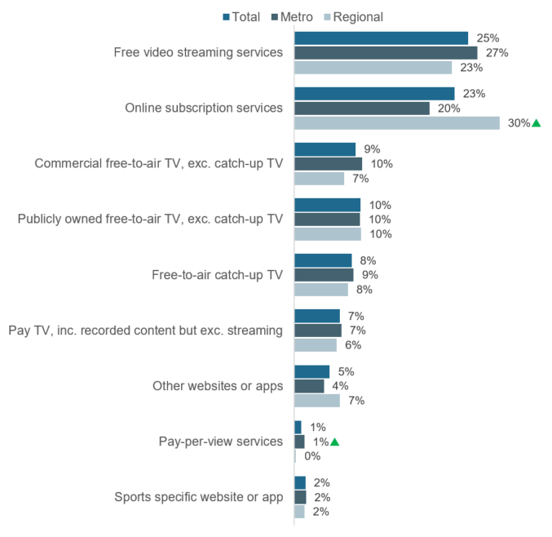

F1. In the past 7 days, which of the following did your child watch at home or elsewhere on any device? (Multiple responses).

Base: All parents – Total (n=1,571), Metro (n=1,085), Regional (n=486).

Note: The following were not shown: ‘Don’t know’ (0%), ‘Refused’ (0%).

 Significantly different to the other sub-group at the 95% confidence level.

### Change in time spent watching children’s screen content

Parents who reported their selected child watched screen content in the past seven days were asked how the amount of time their child spent watching screen content via different channels had changed since restrictions were introduced in response to COVID-19. Figure 40 shows the results.

To allow for direct comparisons between channels, the proportion of parents who reported their selected child did not watch via each of the channels in the past seven days are also shown. A proportion of these children who were reported to have not watched screen content in the past seven days may have decreased their screen content consumption since COVID-19 restrictions came in place. However, this can only be a speculation and the exact proportion cannot be determined as they were not asked this question directly.

Across all channels, the highest increased screen consumption amongst children aged 15 or younger since COVID-19 restrictions was reported for online channels, specifically free video streaming services (25%) and online subscription services (23%).

Figure 40 Change in time spent watching screen content since COVID-19 – Total

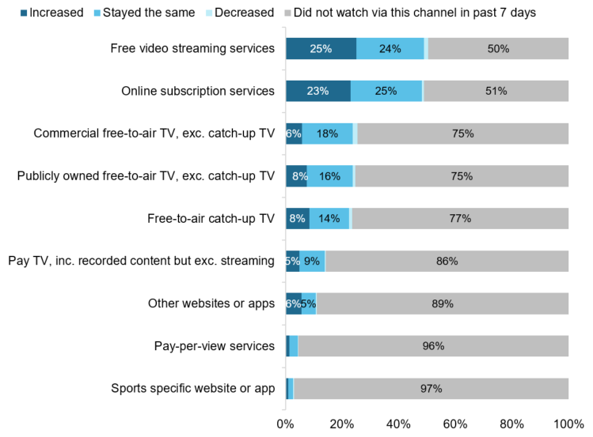

F3. Since social and physical distancing restrictions were introduced in response to COVID-19, how had the amount of time your child spent watching each of the following changed?

Base: All parents – Total (n=1,571)

Note: The following were not shown: ‘Don’t know’ (<1%), ‘Refused’ (0%). Labels under 3% are not shown.

Figure 41 shows parents of children aged 6- 12 years or 13-15 years were more likely than those with children aged 0-12 years to report an increase in their child’s screen consumption on free video streaming services (34% and 29%) and online subscription services (32% and 25%) since COVID-19 restrictions. Whereas parents of children aged 0-5 years or 6-12 years were more likely than parents of children aged 13-15 years to report an increase in their child’s consumption on publicly owned free-to-air TV, excluding catch-up TV (8% for both).

Figure 41 Increased time spent watching screen content since COVID-19 – by age of child

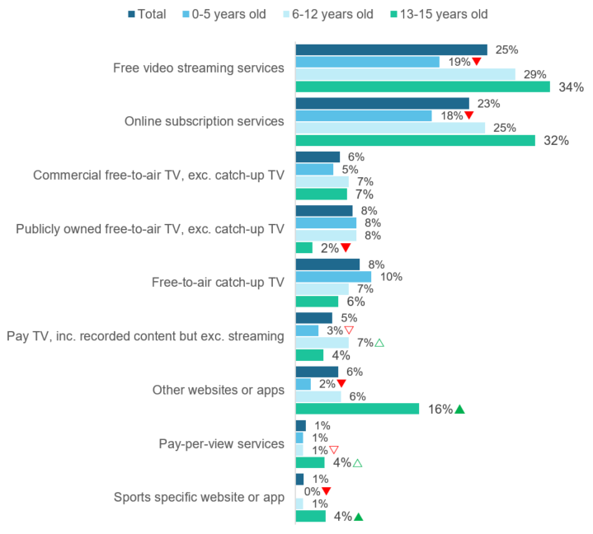

F3. Since social and physical distancing restrictions were introduced in response to COVID-19, how had the amount of time your child spent watching each of the following changed? (Increased).

Base: All parents – Total (n=1,571), Child aged: 0-5 (n=597), 6-12 (n=734), 13-15 (n=240).

Note: The following were not shown: ‘Don’t know’ (0%), ‘Refused’ (0%).

 Significantly different to the other sub-group at the 95% confidence level.

△▽ Significantly different to sub-group with corresponding arrow at the 95% confidence level.

When looking at region, as shown in Figure 42, the only difference was that parents who reported for children in metro areas were more likely to say their child increased their time spent watching content on other website or apps (8%) since COVID-19 compared to those who reported for children in regional areas (4%).

Figure 42 Increased time spent watching screen content since COVID-19 – by region

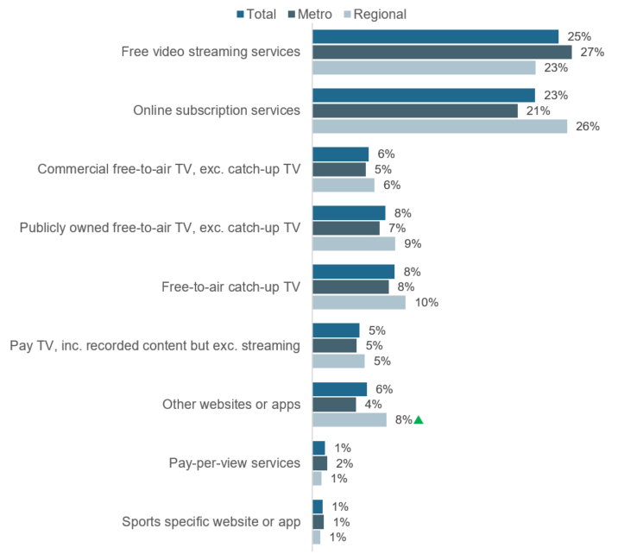

F3. Since social and physical distancing restrictions were introduced in response to COVID-19, how had the amount of time your child spent watching each of the following changed? (Increased).

Base: All parents – Total (n=1,571), Metro (n=1,085), Regional (n=486).

Note: The following were not shown: ‘Don’t know’ (0%), ‘Refused’ (0%).

 Significantly different to the other sub-group at the 95% confidence level.

### Australian children’s screen content

As shown in Figure 43, the majority (81%) of parents considered it ‘somewhat’ or ‘very important’ that their child aged 15 or younger have access to Australian children’s television programs, movies, or other videos.

Figure 43 Level of importance for child to have access to Australian children’s screen content – Total

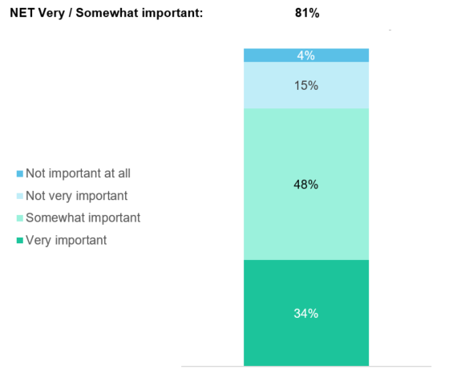

F4. How important was it to you that your child had access to Australian children’s television programs, movies, or other videos?

Base: Parents – Total (n=1,571).

Note: The following were not shown: ‘Don’t know’ (0%), ‘Refused’ (<1%).News content

The survey included a section that covered news and current affairs content consumption specifically (referred to throughout as ‘news’), focussing on types of news consumed and sources of news. The following sections outline the results about news content consumption.

## Types of news consumed

Respondents were asked how often in an average week they read, watch, or listen to three different types of news and current affairs:

* Local, state, or territory news
* Australian national news (politics, current affairs, economy)
* International news

Figure 44 shows that consumption levels of local and national news were relatively on par. Nine in ten (93%) respondents consume local news, and a similar proportion (92%) consume national news. Four in five (85%) consume international news.

Figure 44 Average weekly news consumption frequency – Total

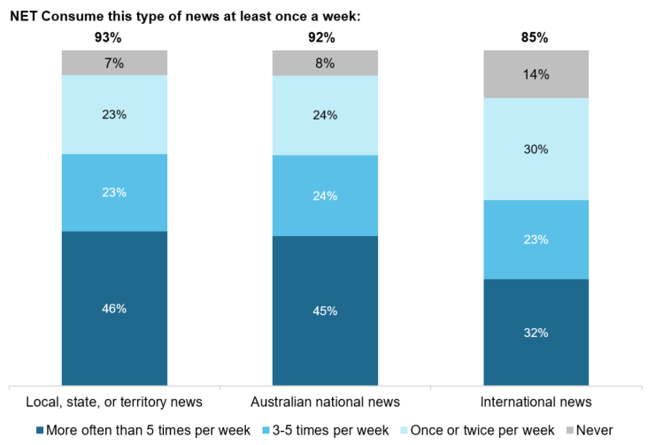

D1. On average per week, how often do you read, watch, or listen to any of the following types of news and current affairs? This includes TV, radio, newspapers, and online.

Base: All respondents – Total (n=4,096).

Note: The following were not shown: ‘Don’t know’ (<1%), ‘Refused’ (<1%). Figures may not add to 100% due to rounding.

Figure 45 shows that the majority of respondents (96%) consumed at least one of local, state, or territory, Australian national news (politics, current affairs, economy), or international news at least once a week. Males were more likely than females to consume at least one type of news (97%), as were those aged 55 years or older (99%) compared to younger age groups.

Figure 45 Consume at least one type of news at least once a week – Total

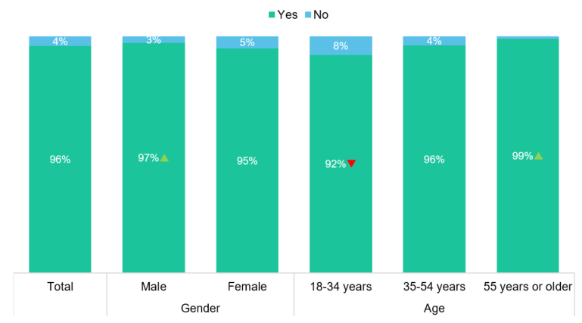

D1. On average per week, how often do you read, watch, or listen to any of the following types of news and current affairs? This includes TV, radio, newspapers, and online.

Base: All respondents – Total (n=4,096).

Note: Consume at least one type of news at least once a week was defined as: Consume local, national, or international news ‘Once or twice per week’, ‘3-5 times per week’, or ‘More often than 5 times per week’). Figures may not add to 100% due to rounding.

Figure 46 shows the gender differences in news consumption by type of news. As shown, males were more likely than females to consume national news (95%) and international news (91%).

Figure 46 Types of news consumed – by gender

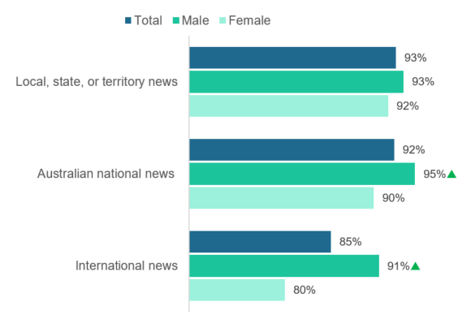

D1. On average per week, how often do you read, watch, or listen to any of the following types of news and current affairs? This includes TV, radio, newspapers, and online. (‘More often than 5 times per week’, ‘3-5 times per week’, or ‘Once or twice per week’).

Base: All respondents – Total (n=4,096), Male (n=1,763), Female (n=2,322).

Note: The following were not shown: ‘Don’t know’ (<1%), ‘Refused’ (<1%). ‘Consume at least one type of news’ defined as: Consume local, national, or international news ‘Once or twice per week’, ‘3-5 times per week’, or ‘More often than 5 times per week’).

 Significantly different to the other sub-group at the 95% confidence level.

Figure 47 shows that older respondents aged 55 years or older were more likely to consume all types of news – local (97%), national (97%), and international (89%) compared to the two younger age groups. Whereas younger respondents aged 18-34 were less likely to consume all types of news.

Figure 47 Types of news consumed – by age

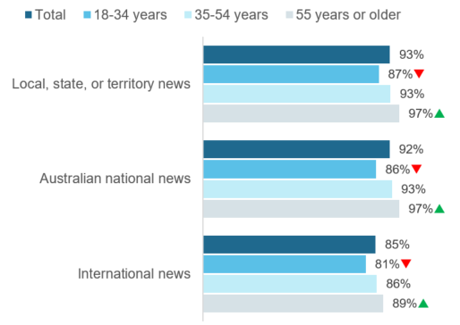

D1. On average per week, how often do you read, watch, or listen to any of the following types of news and current affairs? This includes TV, radio, newspapers, and online. (‘More often than 5 times per week’, ‘3-5 times per week’, or ‘Once or twice per week’).

Base: All respondents – Total (n=4,096), 18-34 (n=793), 35-54 (n=1,661), 55 or older (n=1,640).

Note: The following were not shown: ‘Don’t know’ (<1%), ‘Refused’ (<1%). ‘Consume at least one type of news’ defined as: Consume local, national, or international news ‘Once or twice per week’, ‘3-5 times per week’, or ‘More often than 5 times per week’).

 Significantly different to all other sub-groups at the 95% confidence level.

As shown in Figure 48, compared to those living in regional areas, metropolitan respondents were more likely to consume international news (87%).

Figure 48 Types of news consumed – by region

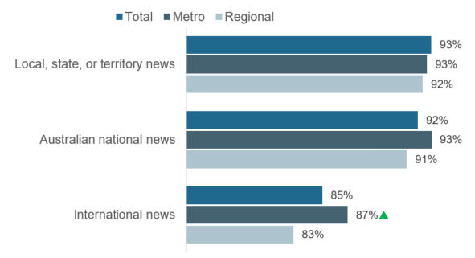

D1. On average per week, how often do you read, watch, or listen to any of the following types of news and current affairs? This includes TV, radio, newspapers, and online. (‘More often than 5 times per week’, ‘3-5 times per week’, or ‘Once or twice per week’).

Base: All respondents – Total (n=4,096), Metro (n=2,716), Regional (n=1,379).

Note: The following were not shown: ‘Don’t know’ (<1%), ‘Refused’ (<1%). ‘Consume at least one type of news’ defined as: Consume local, national, or international news ‘Once or twice per week’, ‘3-5 times per week’, or ‘More often than 5 times per week’).

 Significantly different to the other sub-group at the 95% confidence level.

## Sources of news

To understand the sources of news and current affairs content, respondents who accessed news in the past seven days were asked how they access news and current affairs in general and their main source for accessing different types of news (local, national, and international). The next sections outline the results from these questions.

### General news sources

When asked about general sources of news, respondents were able to select multiple options from a list that included different television, print newspaper, audio, and online sources. The results were presented in Figure 49.

Commercial free-to-air TV was the most common source of news, used to access news by two in three (63%) respondents. The next most common were radio (52%), news websites or apps (50%), and publicly owned free-to-air TV (49%), with one in two respondents accessing news via these sources.

At a broader level, television was the most common source of news (81%), followed by online (76%) and audio (56%), whereas newspapers were least common source of news (36%).

Figure 49 General news sources – Total

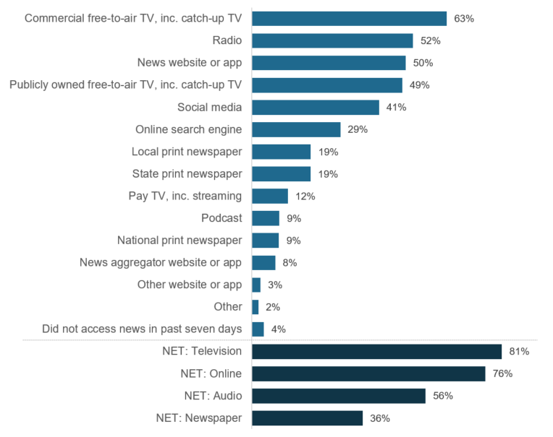

D2. In general, how do you access news and current affairs? (Multiple responses).

Base: All respondents – Total (n=4,096).

Note: The following were not shown: ‘Don’t know’ (<1%), ‘Refused’ (<1%). ‘NET: Television’ includes: ‘Commercial free-to-air TV, inc. catch-up TV’, ‘Publicly owned free-to-air TV, inc. catch-up TV’, and ‘Pay TV, inc. streaming’. ‘NET: Online’ includes: ‘News website or app’, ‘Social media’, ‘Online search engine’, ‘News aggregator website or app’, and ‘Other website or app’. ‘NET: Audio’ includes: ‘Radio’ and ‘Podcast’. ‘NET: Newspaper’ includes: ‘National print newspaper’, ‘State print newspaper’, and ‘Local print newspaper’.

Figure 50 shows the gender differences in news sources. Compared to females, males were more likely to access news via news websites or apps (54%), publicly owned free-to-air TV (52%), online search engines (31%), state (21%) and national (11%) print newspapers, pay TV (14%), other websites (4%) or apps, and other sources (3%). Whereas females were more likely than males to use social media (46%) and local print newspapers (21%) to access news content.

Figure 50 General news sources – by gender

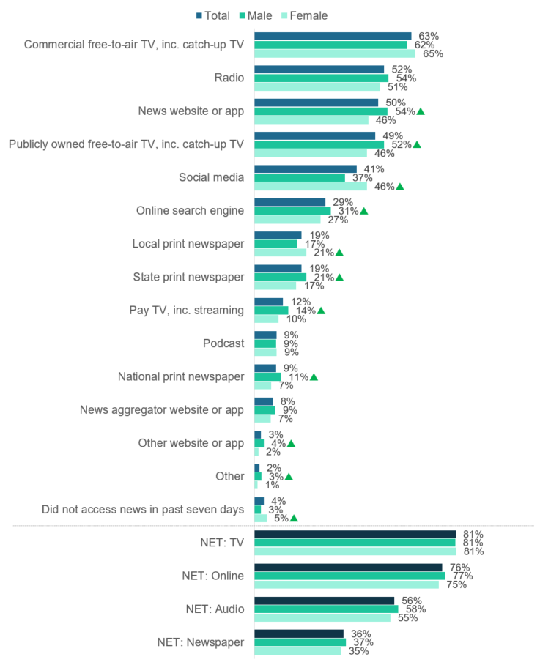

D2. In general, how do you access news and current affairs? (Multiple responses).

Base: All respondents – Total (n=4,096), Male (n=1,763), Female (n=2,322).

Note: The following were not shown: ‘Don’t know’ (<1%), ‘Refused’ (<1%). ‘NET: Television’ includes: ‘Commercial free-to-air TV, inc. catch-up TV’, ‘Publicly owned free-to-air TV, inc. catch-up TV’, and ‘Pay TV, inc. streaming’. ‘NET: Online’ includes: ‘News website or app’, ‘Social media’, ‘Online search engine’, ‘News aggregator website or app’, and ‘Other website or app’. ‘NET: Audio’ includes: ‘Radio’ and ‘Podcast’. ‘NET: Newspaper’ includes: ‘National print newspaper’, ‘State print newspaper’, and ‘Local print newspaper’.

 Significantly different to the other sub-group at the 95% confidence level.

As shown in Figure 51 (overleaf), respondents aged 55 years or older were more likely to access news via the television (95%) compared to younger respondents; specifically, commercial free-to-air TV (75%) and publicly owned free-to-air TV (66%). They were also more likely to access news via the radio (64%); as well as newspapers (50%), specifically, local (28%) and state (29%) newspapers. On the contrary, they were less likely to use online sources (64%) compared to the two younger age groups; especially online search engines (25%) and other websites and apps (2%) when compared to those aged 18-34 years. Younger respondents aged 18-34 years were less likely to use traditional sources like television (65%), radio (39%), and newspapers (26%); and more likely to use digital sources, such as social media (56%) and podcasts (13%).

Figure 51 General news sources – by age

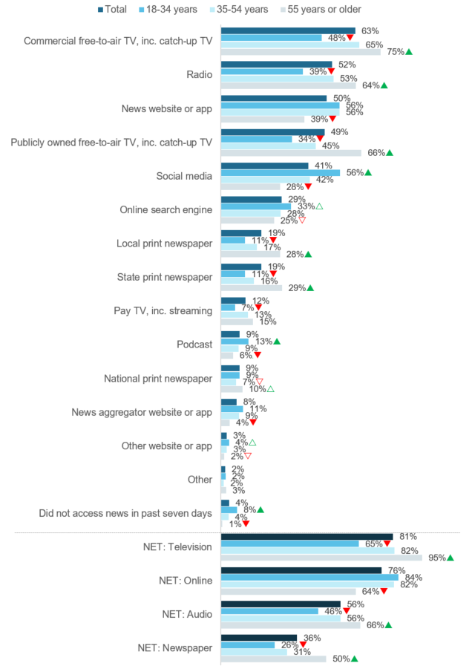

D2. In general, how do you access news and current affairs? (Multiple responses).

Base: All respondents – Total (n=4,096), 18-34 (n=793), 35-54 (n=1,661), 55 or older (n=1,640).

Note: The following were not shown: ‘Don’t know’ (<1%), ‘Refused’ (<1%). ‘NET: Television’ includes: ‘Commercial free-to-air TV, inc. catch-up TV’, ‘Publicly owned free-to-air TV, inc. catch-up TV’, and ‘Pay TV, inc. streaming’. ‘NET: Online’ includes: ‘News website or app’, ‘Social media’, ‘Online search engine’, ‘News aggregator website or app’, and ‘Other website or app’. ‘NET: Audio’ includes: ‘Radio’ and ‘Podcast’. ‘NET: Newspaper’ includes: ‘National print newspaper’, ‘State print newspaper’, and ‘Local print newspaper’.

 Significantly different to all other sub-groups at the 95% confidence level.

△▽ Significantly different to sub-group with corresponding arrow at the 95% confidence level.

Figure 52 shows there were also differences in news sources by region. Those living in metropolitan areas were more likely to access news via news websites or apps (56%), state (20%) and national (10%) print newspapers, and news aggregator websites and apps (9%). Those from regional areas, on the other hand, were more likely to listen to the radio (56%) and read local print newspapers (28%).

Figure 52 General news sources – by region

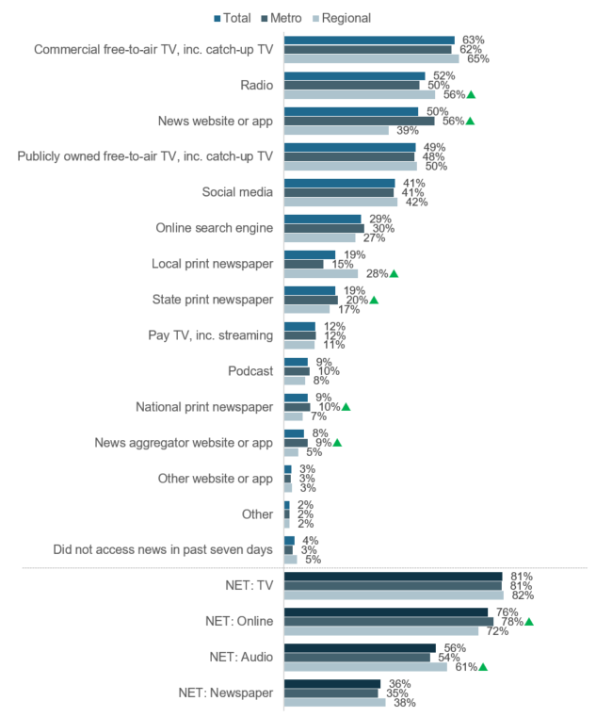

D2. In general, how do you access news and current affairs? (Multiple responses).

Base: All respondents – Total (n=4,096), Metro (n=2,716), Regional (n=1,379).

Note: The following were not shown: ‘Don’t know’ (<1%), ‘Refused’ (<1%). ‘NET: Television’ includes: ‘Commercial free-to-air TV, inc. catch-up TV’, ‘Publicly owned free-to-air TV, inc. catch-up TV’, and ‘Pay TV, inc. streaming’. ‘NET: Online’ includes: ‘News website or app’, ‘Social media’, ‘Online search engine’, ‘News aggregator website or app’, and ‘Other website or app’. ‘NET: Audio’ includes: ‘Radio’ and ‘Podcast’. ‘NET: Newspaper’ includes: ‘National print newspaper’, ‘State print newspaper’, and ‘Local print newspaper’.

 Significantly different to the other sub-group at the 95% confidence level.

#### Online news sources

Respondents who reported they used a search engine or social media to access news were asked which specific online websites or apps they used. The results were shown in Figure 53.

Amongst these respondents, Facebook (64%) was the most commonly used online source to access news. Google (62%) was the next most common source, including Google search (46%) and Google News (32%). Instagram (16%) and Twitter (11%) were used by more than one in ten of those who used search engine/social media to access news.

Figure 53 Online news sources (amongst search engine/social media users) – Total

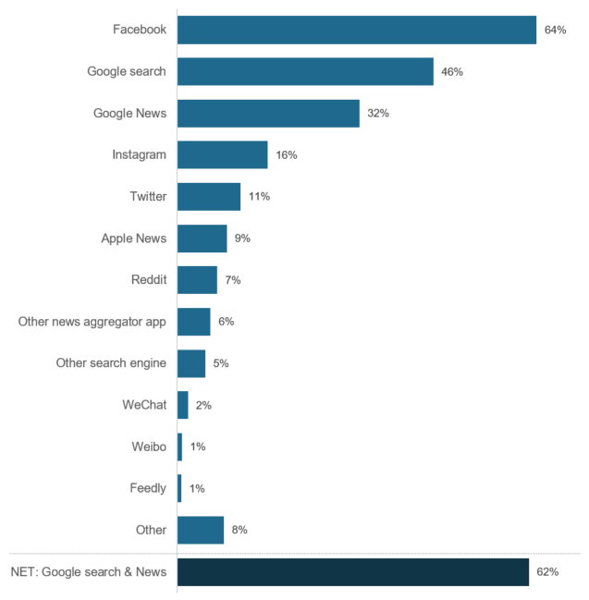

D4. Which online websites or apps do you use to access news and current affairs? (Multiple responses).

Base: Consumed news via ‘Search engine’ or ‘Social media’ in D2 – Total (n=1,971).

Note: The following were not shown: ‘Don’t know’ (1%), ‘Refused’ (<1%). ‘NET: Google search & News’ includes: ‘Google search’ and ‘Google News’.

Figure 54 shows that amongst those who use a search engine or social media to access news, females were more likely to use Facebook (70%) and Instagram (20%); whereas males were more likely to use Google News (36%), Twitter (14%), Reddit (10%), and other news aggregator apps (8%) or other search engines (7%).

Figure 54 Online news sources (amongst search engine/social media users) – by gender

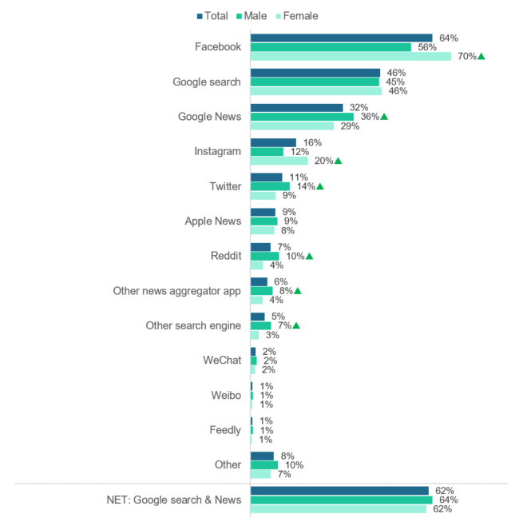

D4. Which online websites or apps do you use to access news and current affairs? (Multiple responses).

Base: Consumed news via ‘Search engine’ or ‘Social media’ in D2 – Total (n=1,971), Male (n=795), Female (n=1,167).

Note: The following were not shown: ‘Don’t know’ (1%), ‘Refused’ (<1%).

 Significantly different to the other sub-group at the 95% confidence level.

As shown in Figure 55, amongst those who use a search engine or social media to access news, respondents aged 18-34 years were more likely than older age groups to use Instagram (27%) or Reddit (15%). Compared to 18-34 year olds, those aged 55 years or older were more likely to use other news aggregator app (9%). However, they were less likely to use Facebook (52%), Instagram (5%), Twitter (5%), or Reddit (1%) compared to younger age groups.

Figure 55 Online news sources (amongst search engine/social media users) – by age

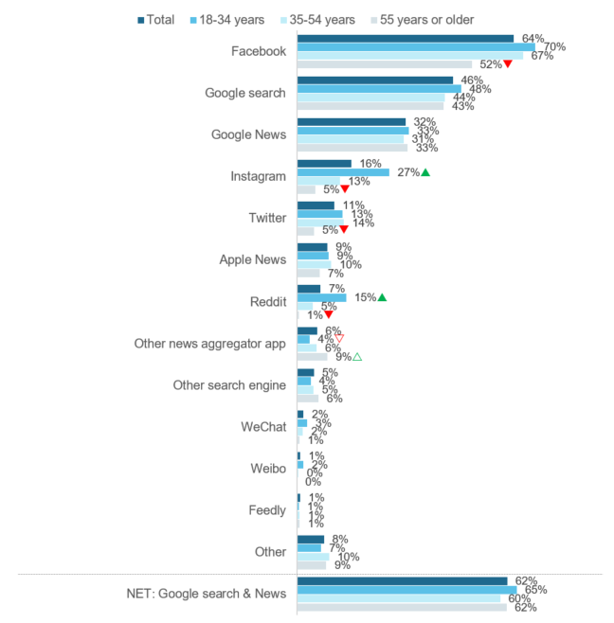

D4. Which online websites or apps do you use to access news and current affairs? (Multiple responses).

Base: Consumed news via ‘Search engine’ or ‘Social media’ in D2 – Total (n=1,971), 18-34 (n=471), 35-54 (n=829), 55 or older (n=669).

Note: The following were not shown: ‘Don’t know’ (1%), ‘Refused’ (<1%).

 Significantly different to other sub-groups at the 95% confidence level.

△▽ Significantly different to sub-group with corresponding arrow at the 95% confidence level.

Figure 56 shows that amongst those who use a search engine or social media to access news, respondents living in regional areas were more likely to use Facebook (68%) to access news compared to those living in metropolitan areas. Whereas those living in metropolitan areas were more likely to use one of the Google services (65%), Apple News (11%), or WeChat (3%) compared to regional respondents.

Figure 56 Online news sources (amongst search engine/social media users) – by region

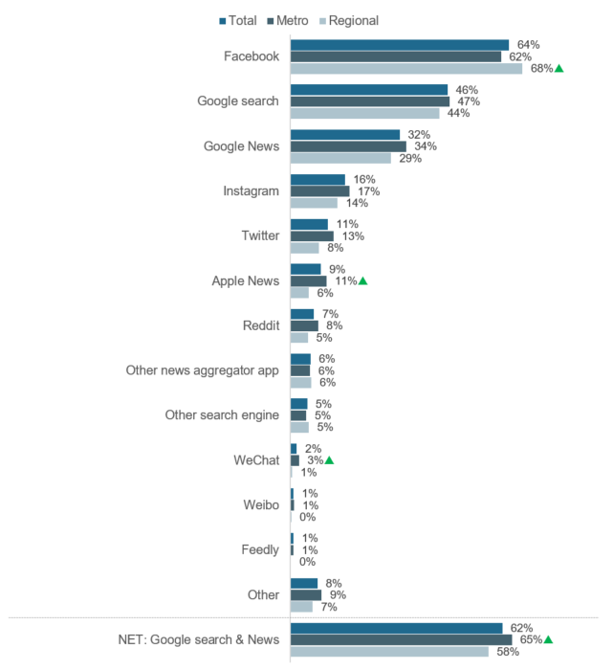

D4. Which online websites or apps do you use to access news and current affairs? (Multiple responses).

Base: Consumed news via ‘Search engine’ or ‘Social media’ in D2 – Total (n=1,971), Metro (n=1,285), Regional (n=1,686).

 Significantly different to the other sub-group at the 95% confidence level.

### Main source of news

Respondents were asked to select their one main source for each local, national, and international news. The results were presented in Figure 57.

Overall, the most common source for all types of news was television, specifically commercial free-to-air TV, including catch-up. 29% of respondents use commercial free-to-air TV to access local or national news, and 24% use it to access international news.

The next most common way respondents access news was online, specifically news websites or apps, with 16% accessing local or national news this way, and 20% accessing international news via this source.

Figure 57 Main source of news – Total

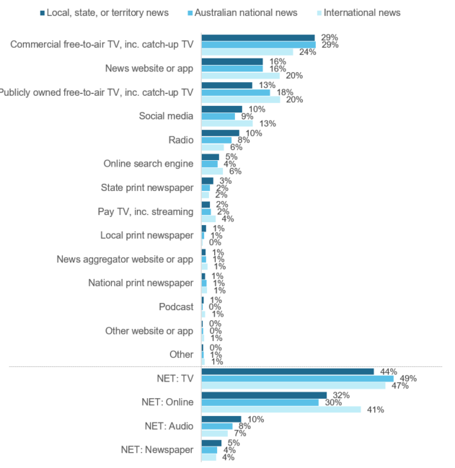

D3. In general, what was your main source for accessing news about each of the following?

Base: All respondents – Total (n=4,096).

Note: The following were not shown: ‘Don’t know’ (<1%), ‘Refused’ (<1%). ‘NET: Television’ includes: ‘Commercial free-to-air TV, inc. catch-up TV’, ‘Publicly owned free-to-air TV, inc. catch-up TV’, and ‘Pay TV, inc. streaming’. ‘NET: Online’ includes: ‘News website or app’, ‘Social media’, ‘Online search engine’, ‘News aggregator website or app’, and ‘Other website or app’. ‘NET: Audio’ includes: ‘Radio’ and ‘Podcast’. ‘NET: Newspaper’ includes: ‘National print newspaper’, ‘State print newspaper’, and ‘Local print newspaper’.

## Paid news subscriptions

Respondents were asked whether they currently have a paid news subscription and how many news subscriptions they have. The results were presented in Figure 58.

Overall, the majority (86%) of respondents did not have a paid news subscription. Only one in seven (14%) respondents reported they pay for a news subscription.

Regarding sub-group comparison, males (16%) were more likely than females (13%) to have a paid news subscription, in particular, two paid news subscriptions (4%). Those aged 55 years or older (21%) were more to pay for news than the younger age groups, and those in metropolitan areas (15%) were more likely to pay for news than those in regional areas (12%).

Overall, one in ten (10%) respondents reported only paying for one news subscription, with 3% paying for two subscriptions, and only 1% paying for three or more subscriptions.

Figure 58 Number of paid news subscriptions

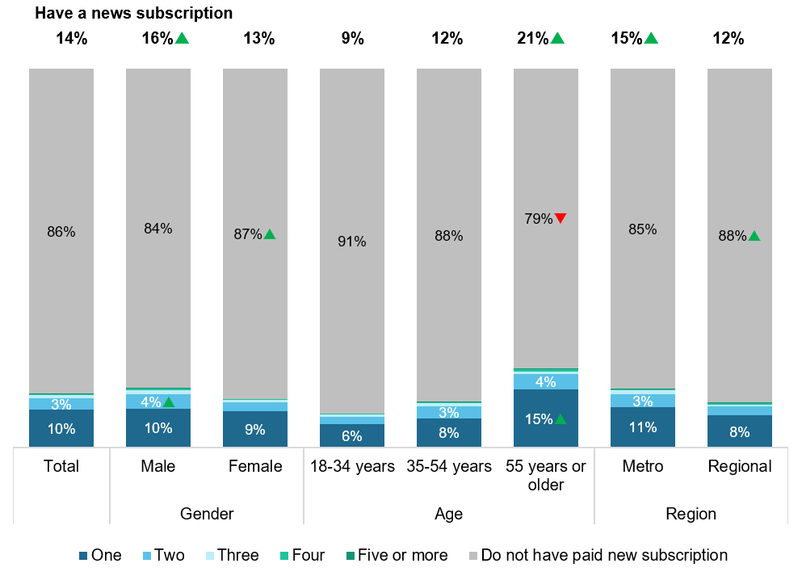

D5. Do you currently have a paid news and current affairs subscription? This includes print or digital subscriptions to news and magazine publications. (‘Yes’)

D6. How many paid news subscriptions do you currently have?

Base: All respondents – Total (n=4,096), Male (n=1,763), Female (n=2,322), 18-34 (n=793), 35-54 (n=1,661), 55 or older (n=1,640), Metro (n=2,716), Regional (n=1,379).

Note: The following were not shown: ‘Don’t know’ (0%), ‘Refused’ (0%). Figures may not add to 100% due to rounding. Labels under 3% are not shown.

Respondents were asked whether they receive a print version with their paid news subscription and the results were shown in Figure 59. Overall, the same proportion receive a news subscription (7%) as those who do not (7%). Respondents aged 55 years or older were more likely (12%) to receive a print version of the news compared to younger respondents. Respondents from metro areas were more likely (8%) to receive a print version of the news compared to respondents from regional areas (5%).

Figure 59 Receive a print version with paid news subscription

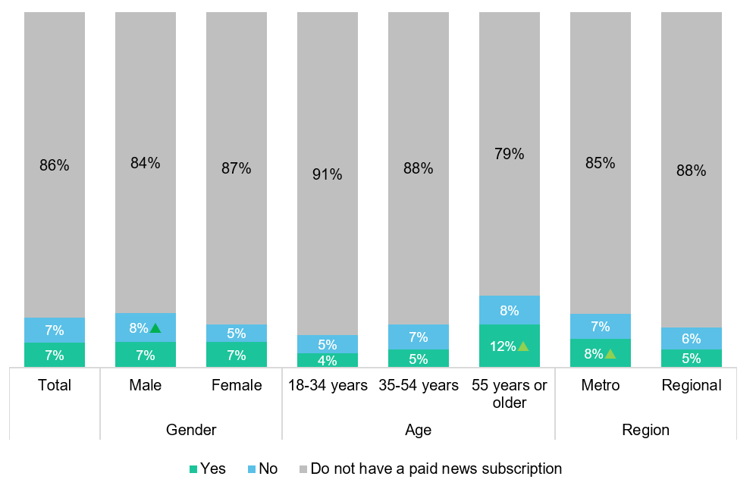

D5. Do you currently have a paid news and current affairs subscription? This includes print or digital subscriptions to news and magazine publications.

Base: All respondents – Total (n=4,096), 18-34 (n=793), 35-54 (n=1,661), 55 or older (n=1,661), Metro (n=2,716), Regional (n=1,379).

Note: The following were not shown: ‘Don’t know’ (<1%), ‘Refused’ (0%). Figures may not add to 100% due to rounding.

 Significantly different to the other sub-group at the 95% confidence level.

Respondents who do not have a paid news subscription were then asked what the main reasons for that were. As shown in Figure 60, the main reasons were ‘free news meets my needs’ (63%), ‘I do not believe I should have to pay for news’ (40%), and ‘I do not want to commit to paying an ongoing subscription’ (33%).

Figure 60 Reasons for not having a paid news subscription – Total

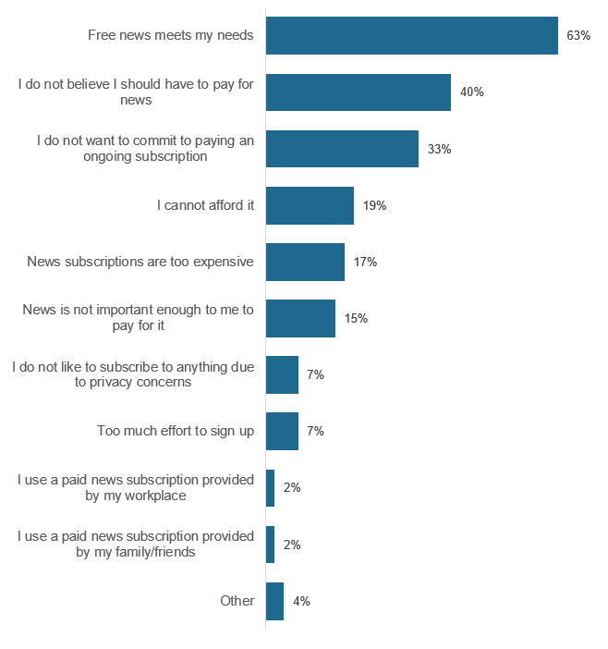

D8. What were the main reasons you do not currently have a paid news subscription? (Multiple responses).

Base: Do not have a paid news subscription in D5 – Total (n=3,340).

Note: The following were not shown: ‘Don’t know’ (<1%), ‘Refused’ (<1%).

As shown in Figure 61, females were more likely to indicate they cannot afford a paid news subscription (22%) while males were more likely to indicate privacy concerns with a subscription (9%) and the effort to sign up (8%) were reasons they did not have a paid news subscription.

Figure 61 Reasons for not having a paid news subscription – by gender

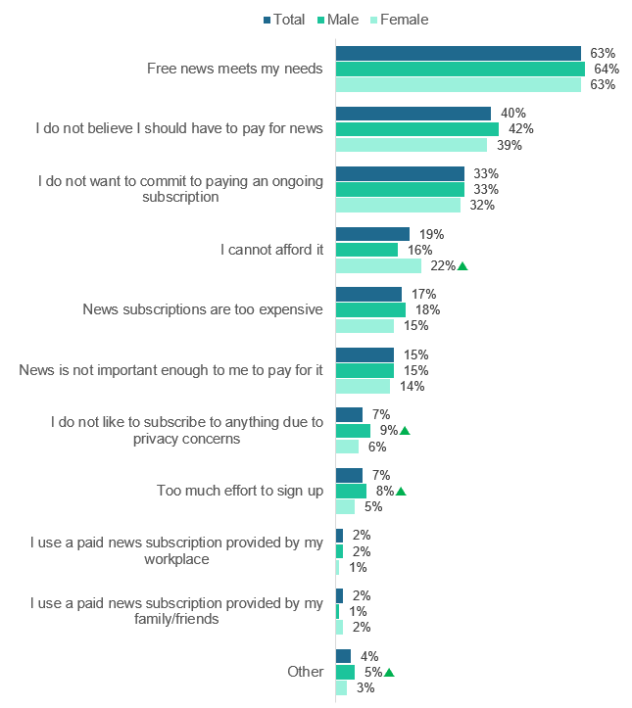

D8. What were the main reasons you do not currently have a paid news subscription? (Multiple responses).

Base: Do not have a paid news subscription in D5 – Total (n=3,340), Male (n=1,394), Female (n=1,937).

Note: The following were not shown: ‘Don’t know’ (<1%), ‘Refused’ (<1%).

 Significantly different to the other sub-group at the 95% confidence level.

Figure 62 shows that compared to younger age groups, respondents aged 55 years or older were more likely to report they do not have a news subscription because free news meets their needs (72%), they do not want to commit to an ongoing subscription (37%), and they have concerns about privacy (12%). Those aged 18-34 were more likely to indicate that news was not important enough to pay for (20%) and it was too much effort to sign up (11%) compared to the older age groups.

Those aged 55 years or older were more likely to believe they should not have to pay for news compared to those aged 35-54 years (44% and 38% respectively). They were also more likely to indicate they cannot afford it when compared to those aged 35-54 years (22% and 16% respectively).

Figure 62 Reasons for not having a paid news subscription – by age

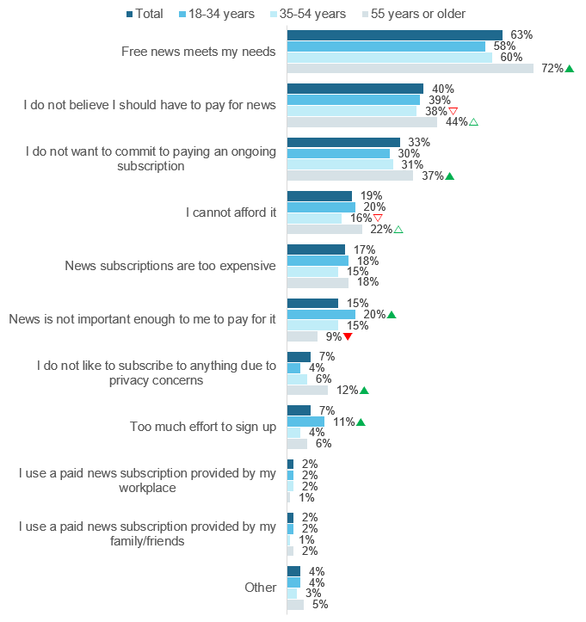

D8. What were the main reasons you do not currently have a paid news subscription? (Multiple responses).

Base: Do not have a paid news subscription in D5 – Total (n=3,340), 18-34 years (n=), 35-54 years (n=), 55 years or older (n=).

Note: The following were not shown: ‘Don’t know’ (<1%), ‘Refused’ (<1%).

 Significantly different to the other sub-group at the 95% confidence level.

## Attitudes towards Australian and local news

Respondents were asked how important certain aspects of Australian news were to them. The results were presented in Figure 63Figure 57.

At least nine in ten respondents rated all the as important (very important or somewhat important), with up-to-date news (96%), unbiased news (94%), and credible journalists (94%), showing the highest levels. Unbiased news received the most ‘very important’ ratings (77%).

Figure 63 Level of importance of aspects of Australian news – Total

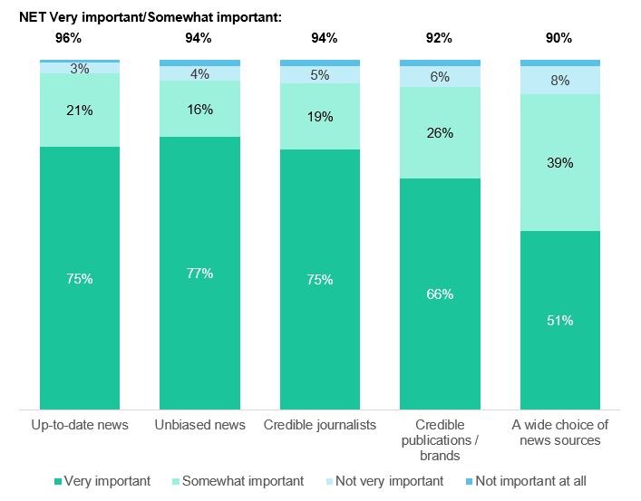

D9. When thinking about Australian news, how important was it for you to have access to…?

Base: All respondents – Total (n=4,096).

Note: The following were not shown: ‘Don’t know’ (<1%), ‘Refused’ (<1%). Labels under 3% are not shown. Figures may not add to 100% due to rounding.

 Significantly different to the other sub-group at the 95% confidence level.

Regarding sub-group comparisons, Figure 64 shows respondents aged 55 years and older were more likely to consider up-to-date news (98%) and credible journalists (96%) as important when compared to younger age groups. They were also more likely than respondents aged 18-34 years to indicate unbiased news as important to them (96% compared to 92%).

Figure 64 Level of importance of aspects of Australian news (NET Very / Somewhat important) – by age

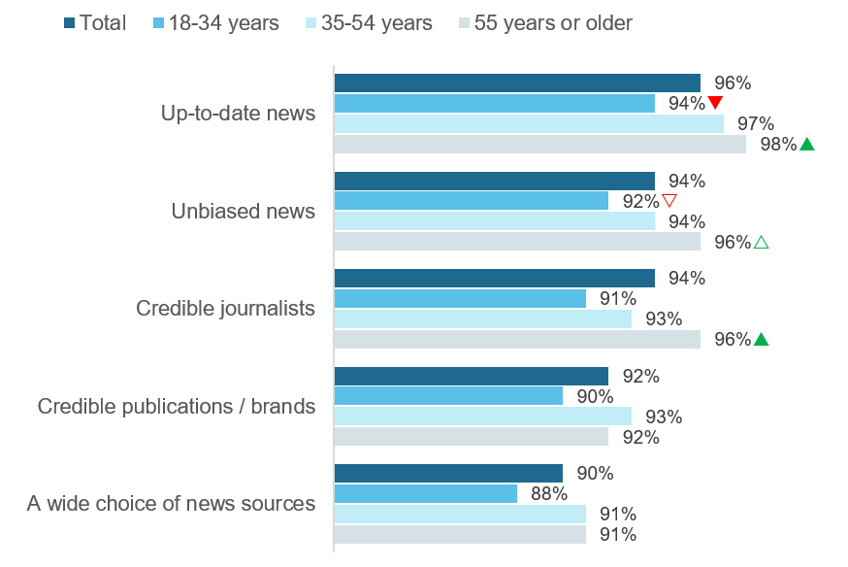

D9 When thinking about Australian news, how important was it for you to have access to…?

Base: All respondents – Total (n=4,096), 18-34 (n=793), 35-54 (n=1,661), 55 or older (n=1,640).

Note: The following were not shown: ‘Don’t know’ (<1%), ‘Refused’ (<1%). Figures may not add to 100% due to rounding.

 Significantly different to the other sub-group at the 95% confidence level.

△▽ Significantly different to sub-group with corresponding arrow at the 95% confidence level.

Respondents were asked if they feel they have sufficient choice of news sources to inform them about their local community. As shown in Figure 65, overall two in three (66%) respondents feel they have sufficient choice of local community news sources.

Females were more likely than males to believe they have sufficient choice of local news (69% compared to 63%). While those in regional areas were more likely than those in metros areas to believe they have sufficient choice of local news (69% compared to 64%).

Figure 65 Sufficient choice of local news – Total

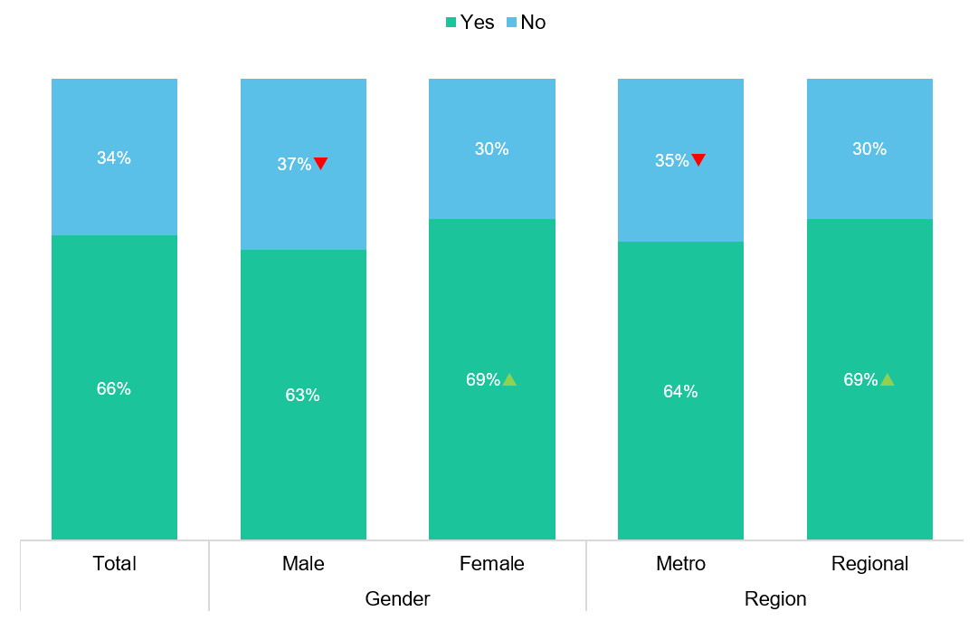

D10. Do you feel you have sufficient choice of news sources to inform you about your local community?

Base: All respondents – Total (n=4,096), Male (n=1,763), Female (n=2,322), Metro (n=2,716), Regional (n=1,379).

Note: The following were not shown: ‘Don’t know’ (<1%), ‘Refused’ (<1%).

 Significantly different to the other sub-group at the 95% confidence level.

# Sport content

The survey included a section that asked about sport content consumption specifically, focussing on types of content consumed and channels of consumption. The following sections outline the results about sport content consumption.

## Sport content consumption

When asked which type of sport content they had consumed in the past seven days, just under half the respondents (45%) had consumed live sport, replayed sport, or other sports related programs. Figure 66 shows the breakdown of the different types of sport consumed, with 38% consuming live sport, 18% consuming replayed sport, and 9% consuming other sports related programs in the last seven days.

Figure 66 Type of sport content consumed – Total

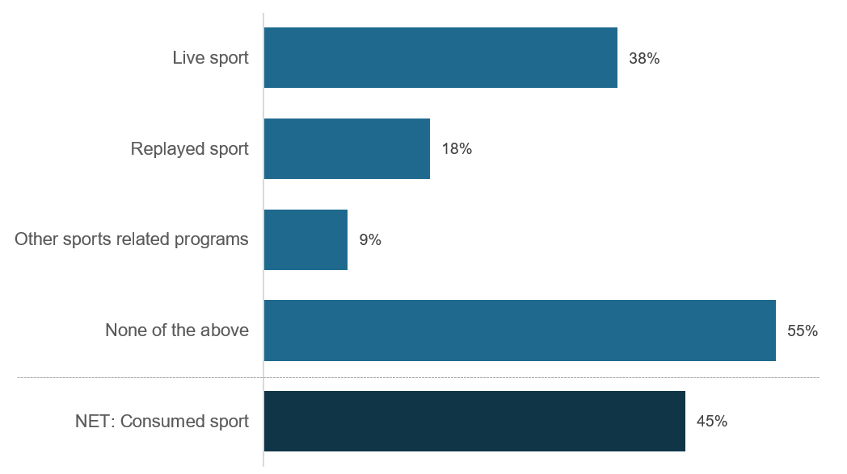

E1. The next questions were about sports related programs. In the past 7 days, did you watch or listen to…? (Multiple responses).

Base: All respondents – Total sample (n=4,096).

Note: The following were not shown: ‘Don’t know’ (0%), ‘Refused’ (0%).

Figure 67 shows the gender differences in channels used to consume sport content in the past seven days. Males were more likely than females to consume sport in general (57% compared to 34%) as well each individual type of sports content.

Figure 67 Type of sport content consumed – by gender

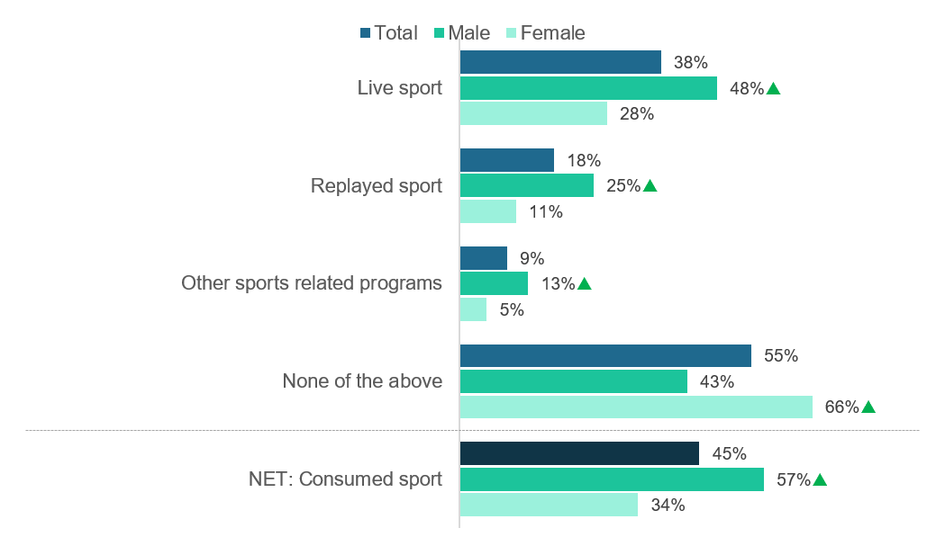

E1. The next questions were about sports related programs. In the past 7 days, did you watch or listen to…? (Multiple responses).

Base: All respondents – Total sample (n=4,096), Male (n=1,763), Female (n=2,322).

Note: The following were not shown: ‘Don’t know’ (0%), ‘Refused’ (0%).

 Significantly different to other sub-groups at the 95% confidence level.

Figure 68 shows the age differences in channels used to consume sport content in the past seven days. Those aged 55 years or older were more likely (56%) to have consumed sport in the last seven days than those in younger age groups. Whereas those aged 18-34 were less likely to have consumed any sport in the last seven days (34%) compared to older age groups.

Figure 68 Type of sport content consumed – by age

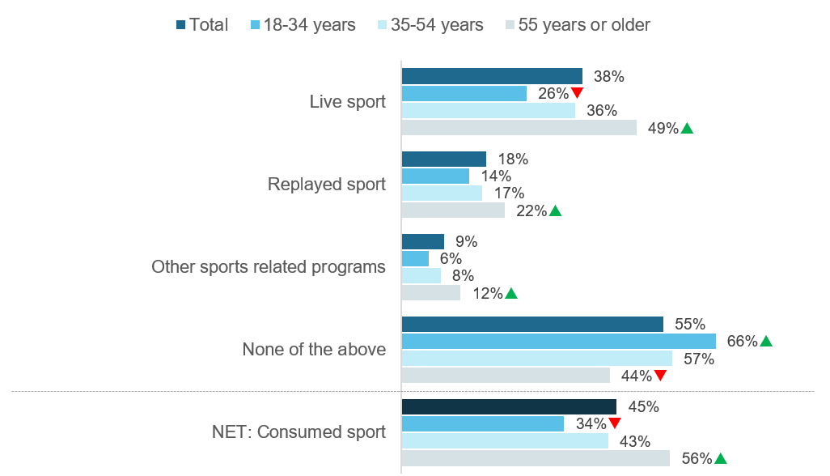

E1. The next questions were about sports related programs. In the past 7 days, did you watch or listen to…? (Multiple responses).

Base: All respondents – Total sample (n=4,096), 18-34 (n=793), 35-54 (n=1,661), 55 or older (n=1,640).

Note: The following were not shown: ‘Don’t know’ (0%), ‘Refused’ (0%).

 Significantly different to other sub-groups at the 95% confidence level.

### Channels used to watch or listen to sport content

Those that consumed at least one type of sport content in the last seven days were then asked which channels they used to watch or listen to sport content. The most commonly selected by respondents were commercial free-to-air television, excluding catch-up TV (63%) and pay TV, including recorded content but excluding streaming (29%), as shown in Figure 69.

One in five respondents used publicly owned free-to-air TV, excluding catch-up TV (22%) or a sports specific website or app (21%). The least common platform to consume sport content was pay-per-view services such as Google Play, iTunes, and OzFlix (1%).

Overall, three in four (73%) of those who consumed sport did so via a free-to-air channel, while two in five (40%) consumed via an online channel.

Figure 69 Channels used to consume sport content in the past seven days – Total

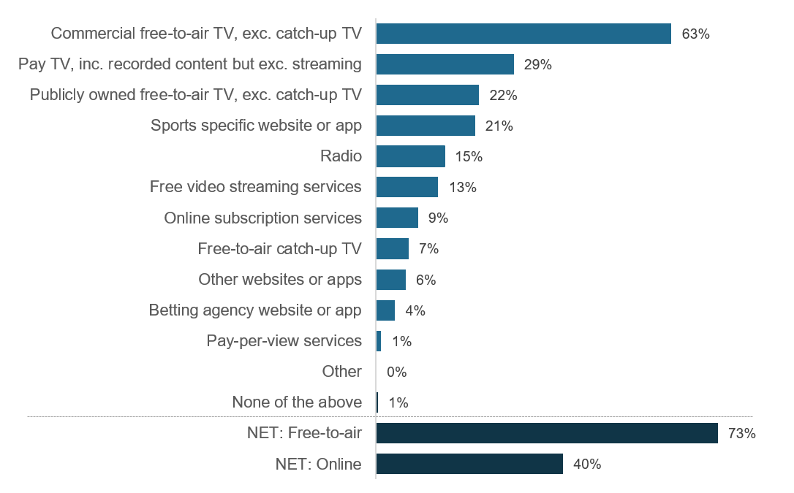

E2. How did you watch or listen to sports related programs in the past 7 days? (Multiple responses)

Base: Consumed sport in last seven days at E1 – Total sample (n=1,903).

Note: The following were not shown: ‘Don’t know’ (0%), ‘Refused’ (0%). ‘NET: Online’ includes: ‘Online subscription services’, ‘Free video streaming services’, ‘Other websites or apps’, ‘Sports specific website or app’ and ‘Betting agency website or app’. ‘NET: Free-to-air’ includes: ‘Commercial free-to-air TV’, ‘Publicly owned free-to-air TV’, and ‘Free-to-air catch-up TV’.

Figure 70 shows the gender differences in channels used to watch or listen to sport content in the past seven days. Males were more likely than females to access sport content via radio (17%), free video streaming services like YouTube or Twitch (16%), or other websites or apps (3%). Males were more likely to consume sport online than females (44% compared to 33%).

Figure 70 Channels used to watch sport content in the past seven days – by gender

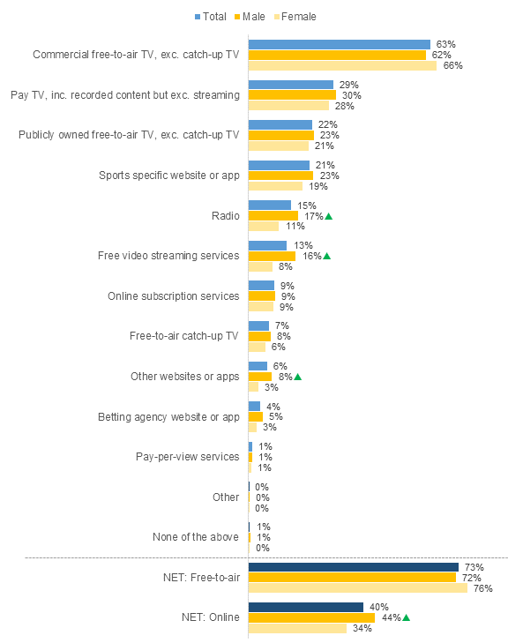

E2. How did you watch or listen to sports related programs in the past 7 days? (Multiple responses)

Base: Consumed sport in last seven days at E1 – Total sample (n=1,903), Male (n=1,057), Female (n=853).

Note: The following were not shown: ‘Don’t know’ (0%), ‘Refused’ (0%). ‘NET: Online’ includes: ‘Online subscription services’, ‘Free video streaming services’, ‘Other websites or apps’, ‘Sports specific website or app’ and ‘Betting agency website or app’. ‘NET: Free-to-air’ includes: ‘Commercial free-to-air TV’, ‘Publicly owned free-to-air TV’, and ‘Free-to-air catch-up TV’.

 Significantly different to the other sub-group at the 95% confidence level.

Figure 71 shows the age differences in channels used to consume sport content in the past seven days. Respondents aged 55 years or older were more likely than other age groups to use traditional channels to consume sport, including commercial free-to-air TV (73%), publicly owned free-to-air TV (32%), and radio (22%). Those aged 18-34 years were more likely to use free video streaming services like YouTube and Twitch (27%), online subscription services like Netflix and Foxtel Now (17%), and other websites or apps (13%) than those in older age groups.

Overall, those aged 18-34 years were most likely to consume sport content in the last seven days via online media (66%) while those aged 55 years and older were most likely to consume free-to-air sports programming (84%).

Figure 71 Channels used to watch sport content in the past seven days – by age

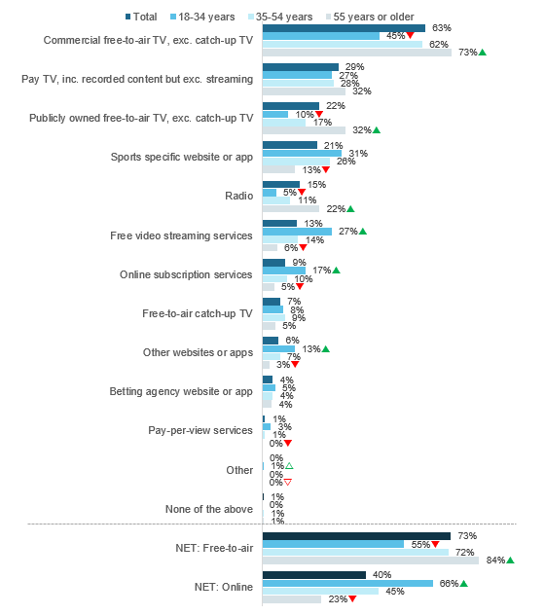

E2. How did you watch or listen to sports related programs in the past 7 days? (Multiple responses)

Base: Consumed sport in last seven days at E1 – Total sample (n=1,903), 18-34 (n=307), 35-54 (n=703), 55 or older (n=892).

Note: The following were not shown: ‘Don’t know’ (0%), ‘Refused’ (0%). ‘NET: Online’ includes: ‘Online subscription services’, ‘Free video streaming services’, ‘Other websites or apps’, ‘Sports specific website or app’ and ‘Betting agency website or app’. ‘NET: Free-to-air’ includes: ‘Commercial free-to-air TV’, ‘Publicly owned free-to-air TV’, and ‘Free-to-air catch-up TV’.

 Significantly different to all other sub-group at the 95% confidence level.

△▽ Significantly different to the other category flagged at the 95% confidence level.

Figure 72 shows that the channels used to consume sport content in the past seven days by region. Those living in regional areas were more likely to consume sport via commercial free-to-air TV (69%) than those living in metro areas (60%). Those living in metro areas were more likely to consume sport via free video streaming services like YouTube and Twitch TV (16%) than those living in regional areas (9%). Those in metro areas (43%) were more likely to consume sport online generally than those in regional areas (36%).

Figure 72 Channels used to watch screen content in the past seven days – by region

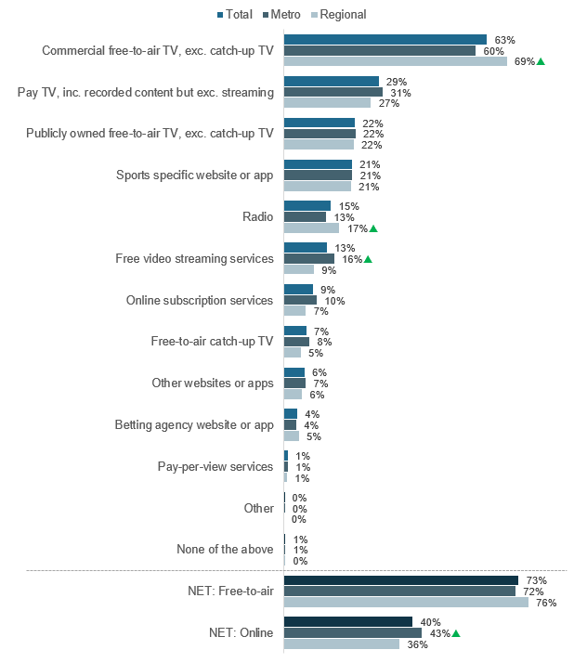

E2. How did you watch or listen to sports related programs in the past 7 days? (Multiple responses)

Base: Consumed sport in last seven days at E1 – Total sample (n=1,903), Metro (n=1,275), Regional (n=628).

Note: The following were not shown: ‘Don’t know’ (0%), ‘Refused’ (0%). ‘NET: Online’ includes: ‘Online subscription services’, ‘Free video streaming services’, ‘Other websites or apps’, ‘Sports specific website or app’ and ‘Betting agency website or app’. ‘NET: Free-to-air’ includes: ‘Commercial free-to-air TV’, ‘Publicly owned free-to-air TV’, and ‘Free-to-air catch-up TV’.

 Significantly different to the other sub-group at the 95% confidence level.

Appendix 1 Questionnaire

2559 MEDIA CONTENT CONSUMPTION Questionnaire – September 2020

PROJECT NOTES

* Online pilot with n=100 non-probability sample (Project number = 2559P)
* Data collection in Life in Australia™ (Project number = 2559)
* n=1,000 boost of parents of children aged 0-15 using online non-probability sample (Project number = 2559B)

GENERAL PROGRAMMING NOTES

* All question text in BLUE was CATI only and in ORANGE was web only. Text in BLACK was for both.
* Unless otherwise specified, all grid questions were to be displayed as a grid (i.e. table)
* For INTERVIEWMODE=WEB, always hide options 98, and 99. If respondent doesn’t answer, please then add them to the frame
  + MESSAGE ON POP-UP: You have not provided a response. Is that because you’re not sure, or you would prefer not to answer?

ORDER DUMMY VARIABLE, RANDOM ASSIGNMENT:

1. NORMAL CODE FRAME ORDER [50%]

2. REVERSE CODE FRAME ORDER [50%]

**\*CALL OUTCOMES AND RR1**

**USE STANDARD CALL OUTCOMES

**USE STANDARD RR1

Life in Australia™ INTRODUCTION

*(2559 ONLY, Life in Australia™ ONLY)

DITRDC This section was on behalf of the Department of Infrastructure, Transport, Regional Development and Communications and asks questions about the media you read, watch, or listen to.

NON-PROBABILITY PILOT INTRODUCTION

*(2559P AND 2559B ONLY, ONLINE PANEL ONLY – NOT Life in Australia™)

NPINTRO Welcome to our survey!

The survey will take about 15 minutes to complete and was being conducted by the Social Research Centre. Participation in this survey was voluntary and you can withdraw at any point. If you don’t wish to answer any question, you can just click ‘Next’ to move to the next question.

Your answers will be held in the strictest confidence and under the Privacy Act all information provided will only be used for research purposes. The responses of everyone who participates in this survey will be combined for analysis. This survey also complies with Australian (AMSRS) and International (ESOMAR) codes of practice for Market & Social Research.

SECTION S: NON-PROBABILITY SAMPLE PROFILING

*(2559P AND 2559B ONLY, ONLINE PANEL ONLY – NOT Life in Australia™)

STATE Which state do you live in?

1. NSW

2. VIC

3. QLD

4. SA

5. WA

6. TAS

7. NT

8. ACT

99. Prefer not to say [GO TO TERM1]

*(2559P AND 2559B ONLY, ONLINE PANEL ONLY – NOT Life in Australia™)

POSTCODE What was your current residential postcode?

1. <RANGE ALL VALID POSTCODES BASED ON STATE]

98. Not sure [GO TO TERM1]

99. Prefer not to say [GO TO TERM1]

COMPUTE REGION FROM POSTCODE

1. Capital City

2. Rest of State

COMPUTE GEOGRAPHY FROM POSTCODE

1. Greater Sydney

2. Rest of NSW

3. Greater Melbourne

4. Rest of Vic.

5. Greater Brisbane

6. Rest of Qld

7. Greater Adelaide

8. Rest of SA

9. Greater Perth

10. Rest of WA

11. Greater Hobart

12. Rest of Tas.

13. Greater Darwin

14. Rest of NT

15. Australian Capital Territory

COMPUTE SEIFA FROM POSTCODE

1. Quintile 1 - Most disadvantage

2. Quintile 2

3. Quintile 3

4. Quintile 4

5. Quintile 5 - Least disadvantage

*(2559P AND 2559B ONLY, ONLINE PANEL ONLY – NOT Life in Australia™)

AGE How old were you last birthday?

1. <RANGE 15-110> [IF UNDER 18 – GO TO TERM4]

99. Prefer not to say

*(AGE=98 OR 99, DK / REF AGE) [AUTO-FILL FROM AGE]

AGE_GROUP Ok, would you mind selecting your age group?

97. Under 18 [GO TO TERM4]

1. 18-24 years

2. 25-34 years

3. 35-44 years

4. 45-54 years

5. 55-64 years

6. 65-74 years

7. 75 or more years

99. Prefer not to say [GO TO TERM1]

*(2559P AND 2559B ONLY, ONLINE PANEL ONLY – NOT Life in Australia™)

GENDER Which of the following best describes your current gender identity?

1 Male

2 Female

3 Non-binary / Gender fluid

4. Different identity (please describe)

99. Prefer not to say [GO TO TERM1]

*(2559P ONLY, PILOT ONLY)

S1 In the **past 7 days** did you read, watch, or listen to any of the following?

*Please select all that apply.*

(MULTIPLE) (RANDOMISE)

1. News and current affairs

2. Television shows

3. Movies

4. Documentaries

4. Radio

6. Music

7. Podcasts

97. None of the above [GO TO TERM2]

99. Prefer not to say [GO TO TERM1]

SECTION A: SCREENING FOR PARENTS

*(ALL)

A1 So we can ask you the right questions today, the first set of questions were about your household.

How would you describe the household you live in?

*Please select one response only.*

(READ OUT)

(SINGLE)

1. One person household

2. Couple without children

3. Couple with child/children, includes children aged 18 years and older

4. One parent family, includes children aged 18 years and older

5. Other family household (e.g. siblings living together, multi-generational families)

6. Group household (i.e. all people in household were non-related)

96. Other (please specify)

99. (Refused) / Prefer not to say

*(A1=3-4, HAVE CHILDREN)

A2 Which age group/s were the children in your household in?

*Please select all that apply.*

(READ OUT ONE BY ONE)

(MULTIPLE)

1. 0-2 years old

2. 3-5 years old

3. 6-8 years old

4. 9-10 years old

5. 11-12 years old

6. 13-15 years old

7. 16-17 years old

8. 18 years old and over

98. (Don’t know) / Not sure

99. (Refused) / Prefer not to say

*(A2=1-6, HAVE CHILDREN UNDER 15)

A3 Are you a parent or guardian of any of the children under the age of 15 in your household?

*Please select one response only.*

(SINGLE)

1. Yes

2. No

99. (Refused) / Prefer not to say

*(ADD VARIABLE ‘PARENT’. CODE AS ‘1’ IF A3=1)

*(ADD VARIABLE ‘CHILD’ TO CAPTURE AGE OF CHILD FROM A2. IF MORE THAN ONE CODE SELECTED AT A2, RANDOMLY SELECT ONE)

*(NEVER SELECT CODE 7 OR 8 FROM A2)

*(IF (A3>1) AND PROJECT 2559B, GO TO TERM3)

SECTION B: AUSTRALIAN MEDIA

*(ALL)

B1 The next questions were about Australia’s media industry and the production of media content, such as television shows, movies, documentaries, print newspapers and magazines, radio, music, and podcasts.

In your opinion, what makes media content **‘Australian’**?

*Please select all that apply.*

(READ OUT ONE BY ONE)

(MULTIPLE) (RANDOMISE 1-5)

1. Made in Australia

2. Made for Australian audiences

3. Contains Australian subject matter (e.g. people, events, places, animals)

4. Employs Australians in its production (e.g. actors, crew, directors)

5. Contains Australian stories or storylines

96. Other (Please specify)

98. (Don’t know) / Not sure

99. (Refused) / Prefer not to say

*Taken from Screen Australia Survey*

*(ALL)

B2 How strongly do you agree or disagree with the following statements about Australian media (i.e. content that was made in Australia)?

(READ OUT)

(STATEMENTS) (RANDOMISE)

a) I would miss Australian film and TV stories if they ceased to exist

b) Australian film and TV stories were important for contributing to our sense of Australian identity

c) Australian film and TV stories were important in showing Australian views and perspectives to the rest of the world

d) There was more than enough Australian film and TV content available to meet my needs

(RESPONSE FRAME) (SINGLE) (DISPLAY ORDER BASED ON S_ORDER VARIABLE)

1. Strongly disagree

2. Disagree

3. Neither agree nor disagree

4. Agree

5. Strongly agree

98. (Don’t know) / Not sure

99. (Refused) / Prefer not to say

SECTION C: SCREEN CONTENT BEHAVIOURS AND SPEND

*Adapted from QF4 from ACMA Consumer Survey*

*(ALL)

C1 The next questions were aboutcontent you **personally watch**, including things liketelevision shows, movies and documentaries.

Which of the following did you use to watch screen content in the **past 7 days** at home or elsewhere on any device?

*Please select all that apply.*

(READ OUT ONE BY ONE)

(MULTIPLE) (RANDOMISE 1-8)

1. **Commercial free-to-air TV** (e.g. Seven, Nine, Ten), excluding catch-up TV

2. **Publicly owned free-to-air TV** (i.e. ABC, SBS), excluding catch-up TV

3. **Pay TV** (e.g. Foxtel, Fetch TV), including recorded content but excluding streaming

4. **Free-to-air catch-up TV** (e.g. ABC iview, 10 play, 7Plus)

5. **Free video streaming services** (e.g. YouTube, Twitch)

6. **Online subscription services** (e.g. Netflix, Foxtel Now, YouTube Premium)

7. **Pay-per-view services** (e.g. Google Play, iTunes, Ozflix)

8. **Sports specific website or app** (e.g. AFL Live, NRL Live, Cricket Australia Live, Kayo)

96. **Other websites or apps** (e.g. Facebook, TikTok, Instagram)

97. None of the above *(EXCLUSIVE)

98. (Don’t know) / Not sure *(EXCLUSIVE)

99. (Refused) / Prefer not to say *(EXCLUSIVE)

*Adapted from QF5 from ACMA Consumer Survey*

*(C1=1-96, WATCHED SCREEN CONTENT IN P7D)

C2 On **average**, how many **hours per week** do you spend watching each of the following?

(PROBE TO CODE FRAME)

(STATEMENTS) (ONLY DISPLAY CODES SELECTED AT C1) (DISPLAY all codes on one screen as grid) (KEEP ORDER AS C1)

a. **Commercial free-to-air TV** (e.g. Seven, Nine, Ten), including recorded content but excluding catch-up TV

b. **Publicly owned free-to-air TV** (i.e. ABC, SBS), excluding catch-up TV

c. **Pay TV** (e.g. Foxtel, Fetch TV), including recorded content but excluding streaming

d. **Free-to-air catch-up TV** (e.g. ABC iview, 10 play, 7Plus)

e. **Free video streaming services** (e.g. YouTube, Twitch)

f. **Online subscription services** (e.g. Netflix, Foxtel Now, YouTube Premium)

g. **Pay-per-view services** (e.g. Google Play, iTunes, Ozflix)

h. **Sports specific website or app** (e.g. AFL Live, NRL Live, Cricket Australia Live, Kayo)

i. **Other websites or apps** (e.g. Facebook, TikTok, Instagram)

(RESPONSE FRAME) (SINGLE)

1. Up to 5 hours

2. 6-10 hours

3. 11-15 hours

4. 16-20 hours

5. 21-25 hours

6. 26-35 hours

7. More than 35 hours

98. (Don’t know) / Not sure

99. (Refused) / Prefer not to say

*(C1=1-96, WATCHED SCREEN CONTENT IN P7D)

C3 Since social and physical distancing restrictions were introduced in response to COVID-19, how had the amount of time you have spent watching each of the following changed?

(READ OUT)

(STATEMENTS) (ONLY DISPLAY CODES SELECTED AT C1) (DISPLAY all codes on one screen as grid) (KEEP ORDER AS C1)

a. **Commercial free-to-air TV** (e.g. Seven, Nine, Ten), including recorded content but excluding catch-up TV

b. **Publicly owned free-to-air TV** (i.e. ABC, SBS), excluding catch-up TV

c. **Pay TV** (e.g. Foxtel, Fetch TV), including recorded content but excluding streaming

d. **Free-to-air catch-up TV** (e.g. ABC iview, 10 play, 7Plus)

e. **Free video streaming services** (e.g. YouTube, Twitch)

f. **Online subscription services** (e.g. Netflix, Foxtel Now, YouTube Premium)

g. **Pay-per-view services** (e.g. Google Play, iTunes, Ozflix)

h. **Sports specific website or app** (e.g. AFL Live, NRL Live, Cricket Australia Live, Kayo)

i. **Other websites or apps** (e.g. Facebook, TikTok, Instagram)

(response frame) (SINGLE) (DISPLAY ORDER BASED ON S_ORDER VARIABLE)

1. Increased

2. Stayed the same

3. Decreased

98. (Don’t know) / Not sure

99. (Refused) / Prefer not to say

*(C1=1-96, WATCHED SCREEN CONTENT IN P7D)

C4 On **average per week**, how often do you use the following **devices** to watch screen content?

(READ OUT)

(SINGLE) (RANDOMISE A-g)

a. Television (including Smart TV)

b. Tablet (e.g. iPad, Kindle Fire, Samsung Galaxy Tab)

c. Computer (desktop or laptop)

d. Mobile phone or smartphone

e. Games console connected to a television (e.g. PlayStation, Xbox, Wii)

f. Personal video recorder (PVR) (e.g. Foxtel IQ, Fetch)

g. Digital media player (e.g. Chromecast, Apple TV)

h. Other device

(RESPONSE FRAME) (SINGLE) (DISPLAY ORDER BASED ON S_ORDER VARIABLE)

1. Never

2. Once or twice a week

3. 3-5 times a week

4. More often than 5 times a week

5. Once or twice a day

6. 3-5 times a day

7. More often than 5 times a day

98. (Don’t know) / Not sure

99. (Refused) / Prefer not to say

*(ANY TWO OF C4(a-h)=2-7, USED MULTIPLE DEVICES TO WATCH SCREEN CONTENT)

C5 Overall, do you have a **preference** on which device you use to watch screen content?

*Please select one response only.*

(SINGLE)

1. Yes

2. No

98. (Don’t know) / Not sure

99. (Refused) / Prefer not to say

*(C5=1, HAVE A DEVICE PREFERENCE)

C6 Of all the devices you use, which do you **prefer** to use to watch screen content **most**?

*Please select one response only.*

(READ OUT)

(SINGLE) (ONLY SHOW DEVICE IF C4=2-7)

1. Television (including Smart TV)

2. Tablet (e.g. iPad, Kindle Fire, Samsung Galaxy Tab)

3. Computer (desktop or laptop)

4. Mobile phone or smartphone

5. Games console connected to a television (e.g. PlayStation, Xbox, Wii)

6. Personal video recorder (PVR) (e.g. Foxtel IQ, Fetch)

7. Digital media player (e.g. Chromecast, Apple TV)

8. Other device

98. (Don’t know) / Not sure

99. (Refused) / Prefer not to say

*(C1=1-96, WATCHED SCREEN CONTENT IN P7D)

C7 In **general**, which **types of content** do you watch on [INSERT STATEMENT]?

*Please select all that apply.*

(READ OUT OPTIONS ONE BY ONE)

(STATEMENTS) (DISPLAY ONE STATEMENT AT A TIME) (ONLY DISPLAY CODES SELECTED AT C1) (KEEP ORDER AS C1)

a. **Commercial free-to-air TV** (e.g. Seven, Nine, Ten), including recorded content but excluding catch-up TV

b. **Publicly owned free-to-air TV** (i.e. ABC, SBS), excluding catch-up TV

c. **Pay TV** (e.g. Foxtel, Fetch TV), including recorded content but excluding streaming

d. **Free-to-air catch-up TV** (e.g. ABC iview, 10 play, 7Plus)

e. **Free video streaming services** (e.g. YouTube, Twitch)

f. **Online subscription services** (e.g. Netflix, Foxtel Now, YouTube Premium)

g. **Pay-per-view services** (e.g. Google Play, iTunes, Ozflix)

h. **Sports specific website or app** (e.g. AFL Live, NRL Live, Cricket Australia Live, Kayo)

i. **Other websites or apps** (e.g. Facebook, TikTok, Instagram)

(RESPONSE FRAME) (MULTIPLE)

*(IF NECESSARY, CLARIFY CODE 11 AS: User generated videos were posted by users on online platforms such as social media.)

1. Action/Adventure

2. Comedy

3. Crime/Thriller

4. Documentary

5. Drama

6. Fantasy/Science fiction

7. News and current affairs

8. Reality

9. Sport

10. Talk shows/Game shows

11. User-generated videos [ONLINE HOVER OVER: Online hover over:

User generated videos were posted by users on online platforms such as social media.]

96. Other

98. (Don’t know) / Not sure *(EXCLUSIVE)

99. (Refused) / Prefer not to say *(EXCLUSIVE)

*(ALL)

C8 Which of the following **video streaming subscription services** does your household currently **have access to**? This excludes catch-up TV and pay-per-view.

*Please select all that apply.*

(READ OUT ONE BY ONE)

(MULTIPLE) (RANDOMISE 1-12)

1. Amazon Prime Video

2. Apple TV+

3. Binge

4. Disney+

5. Fetch TV, including Fetch by Optus

6. Foxtel Now

7. Hayu

8. Kayo

9. Netflix

10. Optus Sport

11. Stan

12. YouTube Premium

96. Other video streaming website (Please specify)

97. None of the above *(EXCLUSIVE)

98. (Don’t know) / Not sure *(EXCLUSIVE)

99. (Refused) / Prefer not to say *(EXCLUSIVE)

*(C1=7, WATCHED PAY-PER-VIEW IN P7D)

C9 In the **past 7 days**, which of the following **pay-per-view** **services** [ONLINE HOVER OVER: Pay-per-view services were used to purchase individual movies or TV series] did you use to purchase an individual movie/TV series?

*(IF NECESSARY: Pay-per-view services were used to purchase individual movies or TV series.)

*Please select all that apply.*

(READ OUT ONE BY ONE)

(MULTIPLE) (RANDOMISE 1-10)

1. Amazon Prime Video

2. Apple TV

3. Google Play

4. iTunes

5. Foxtel Store

6. Microsoft Store

7. Ozflix

8. Quickflix

9. Telstra TV Box Office

10. YouTube Premium

96. Other (Please specify)

98. (Don’t know) / Not sure *(EXCLUSIVE)

99. (Refused) / Prefer not to say *(EXCLUSIVE)

*(C8=1-96, HAVE VIDEO STREAMING SUBSCRIPTION)

C10 How **many** **video streaming subscription services** does your household currently have access to? This excludes catch-up TV and pay-per-view.

*Please type in your response.*

1. (NUMERIC OPEN-END BOX) (WHOLE NUMBER ONLY) (LIMIT TO TWO DIGITS) (SHOW ERROR MESSAGE IF >20: ‘Can you please confirm you have [INSERT NUMBER] subscription services?)

98. (Don’t know) / Not sure *(EXCLUSIVE)

99. (Refused) / Prefer not to say *(EXCLUSIVE)

*(C8=1-96, HAVE VIDEO STREAMING SUBSCRIPTION)

C11 In your opinion, do video streaming subscription services have enough Australian content?

*Please select one response only.*

(SINGLE)

1. Yes

2. No

98. (Don’t know) / Not sure

99. (Refused) / Prefer not to say

*(C11=2, BELIEVE THERE IS NOT ENOUGH AUSTRALIAN CONTENT ON VIDEO STREAMING SERVICES)

C12 How much **extra** would you be willing to **pay per month** for a video streaming subscription, if it included more…?

(STATEMENTS)

a) New Australian drama

b) New Australian documentaries

c) New Australian kids content

(READ OUT)

(RESPONSE FRAME) (SINGLE)

1. I would not be willing to pay more

2. $1

3. $2-$3

4. $4-$5

5. $6+

98. (Don’t know) / Not sure

99. (Refused) / Prefer not to say

SECTION D: NEWS

*(ALL)

D1 The next questions were about **news and current affairs**.

On **average per week**, how often do you read, watch, or listen to any of the following types of news and current affairs? This includes TV, radio, newspapers, and online.

(READ OUT)

(statements)

a. Local, state, or territory news

b. Australian national news (politics, current affairs, economy)

c. International news

(RESPONSE FRAME) (SINGLE)

1. Never

2. Once or twice per week

3. 3-5 times per week

4. More often than 5 times per week

98. (Don’t know) / Not sure

99. (Refused) / Prefer not to say

*(ANY OF D1a-c=2-4, CONSUMED NEWS)

D2 In **general**, how do you access news and current affairs?

*Please select all that apply.*

(READ OUT ONE BY ONE) (DO NOT READ HEADERS)

(MULTIPLE)

*(IF NECESSARY, CLARIFY CODE 10 AS: A news aggregator website or app combines online news content in one location for easy viewing.)

**Television** *(HEADER TEXT ONLY)

1. Commercial free-to-air TV (e.g. Seven, Nine, Ten), including catch-up TV

2. Publicly owned free-to-air TV (i.e. ABC, SBS), including catch-up TV

3. Pay TV (e.g. Foxtel, Fetch TV), including streaming

**Print newspaper \***(HEADER TEXT ONLY)

4. National print newspaper (e.g. The Australian, The Financial Review)

5. State print newspaper (e.g. Sydney Morning Herald, The Age, The Courier Mail)

6. Local print newspaper

**Radio or podcast, including online streaming** *(HEADER TEXT ONLY)

7. Radio

8. Podcast

**Online** *(HEADER TEXT ONLY)

9. News website or app

10. News aggregator website or app (e.g. Apple News, Feedly) [ONLINE HOVER OVER: A news aggregator website or app combines online news content in one location for easy viewing.]

11. Online search engine (e.g. Google News/Reader)

12. Social media (e.g. Facebook, Instagram, Twitter)

95. Other website or app

96. Other (Please specify)

98. (Don’t know) / Not sure *(EXCLUSIVE)

99. (Refused) / Prefer not to say *(EXCLUSIVE)

*(D2=1-96, RECALL SOURCE OF NEWS)

D3 In **general**, what was your **main** source for accessing news about each of the following?

*Please select one response only.*

(READ OUT)

(STATEMENTS) (ONLY SHOW IF CODE 2-4 SELECTED AT D1) (show one statement at a time)

a. Local, state, or territory news

b. Australian national news (politics, current affairs, economy)

c. International news

(response frame) (ONLY SHOW IF SELECTED AT D2) (ONLY SHOW HEADERS IF OPTIONS UNDER THAT HEADER)

*(IF NECESSARY, CLARIFY CODE 10 AS: A news aggregator website or app combines online news content in one location for easy viewing.)

**Television** *(HEADER TEXT ONLY)

1. Commercial free-to-air TV (e.g. Seven, Nine, Ten), including catch-up TV

2. Publicly owned free-to-air TV (i.e. ABC, SBS), including catch-up TV

3. Pay TV (e.g. Foxtel, Fetch TV), including streaming

**Print newspaper \***(HEADER TEXT ONLY)

4. National print newspaper (e.g. The Australian, The Financial Review)

5. State print newspaper (e.g. Sydney Morning Herald, The Age, The Courier Mail)

6. Local print newspaper

**Radio or podcast, including online streaming** *(HEADER TEXT ONLY)

7. Radio

8. Podcast

**Online** *(HEADER TEXT ONLY)

9. News website or app

10. News aggregator website or app (e.g. Apple News, Feedly) [ONLINE HOVER OVER: A news aggregator website or app combines online news content in one location for easy viewing.]

11. Online search engine (e.g. Google News/Reader)

12. Social media (e.g. Facebook, Instagram, Twitter)

95. Other website or app

96. <D2_96 response>

98. (Don’t know) / Not sure *(EXCLUSIVE)

99. (Refused) / Prefer not to say *(EXCLUSIVE)

*(D2=11 OR 12, CONSUMED NEWS ON SEARCH ENGINE OR SOCIAL MEDIA)

D4 Which **online websites or apps** do you use to access news and current affairs?

*Please select all that apply.*

(READ OUT ONE BY ONE)

(MULTIPLE)

1. Apple News

2. Facebook

3. Feedly

4. Google News

5. Google search

6. Instagram

7. Reddit

8. Twitter

9. WeChat

10. Weibo

94. Other news aggregator app [ONLINE HOVER OVER: A news aggregator website or app combines online news content in one location for easy viewing.]

95. Other search engine

96. Other (please specify)

98. (Don’t know) / Not sure *(EXCLUSIVE)

99. (Refused) / Prefer not to say *(EXCLUSIVE)

*(ALL)

D5 Do you currently have a paid **news and current affairs subscription**? This includes print or digital subscriptions to news and magazine publications.

*Please select one response only.*

(SINGLE)

1. Yes

2. No

98. (Don’t know) / Not sure

99. (Refused) / Prefer not to say

*(D5=1, HAVE A PAID SUBSCRIPTION)

D6 How many **paid news subscriptions** do you currently have?

*Please select one response only.*

(SINGLE)

1. One

2. Two

3. Three

4. Four

5. Five or more

98. (Don’t know) / Not sure

99. (Refused) / Prefer not to say

*(D5=1, HAVE A PAID SUBSCRIPTION)

D7 Do you receive a **print version** with any of your news subscriptions?

*Please select one response only.*

(SINGLE)

1. Yes

2. No

98. (Don’t know) / Not sure

99. (Refused) / Prefer not to say

*(D5=2, NO PAID NEWS SUBSCRIPTIONS)

D8 What were the main reasons you do not currently have a paid news subscription?

*Please select all that apply.*

(READ OUT ONE BY ONE)

(MULTIPLE) (RANDOMISE 1-10)

1. I use a paid news subscription provided by my workplace

2. Free news meets my needs

3. News subscriptions were too expensive

4. I cannot afford it

5. I do not believe I should have to pay for news

6. Too much effort to sign up

7. I use a paid news subscription provided by my family/friends

8. News was not important enough to me to pay for it

9. I do not like to subscribe to anything due to privacy concerns

10. I do not want to commit to paying an ongoing subscription

96. Other (Please specify)

98. (Don’t know) / Not sure *(EXCLUSIVE)

99. (Refused) / Prefer not to say *(EXCLUSIVE)

*(ALL)

D9 When thinking about **Australian news**, how important was it for you to have access to…?

(READ OUT)

(STATEMENTS) (RANDOMISE)

a) Unbiased news

b) Up-to-date news

c) A wide choice of news sources

d) Credible journalists

e) Credible publications/brands

(RESPONSE FRAME) (SINGLE) (DISPLAY ORDER BASED ON S_ORDER VARIABLE)

1. Not important at all

2. Not very important

3. Somewhat important

4. Very important

98. (Don’t know) / Not sure

99. (Refused) / Prefer not to say

*(ALL)

D10 Do you feel you have sufficient choice of news sources to inform you about **your** **local community**?

*Please select one response only.*

(SINGLE)

1. Yes

2. No

98. (Don’t know) / Not sure

99. (Refused) / Prefer not to say

SECTION E: SPORT

*(ALL)

E1 The next questions were about **sports** related programs.

In the **past 7 days**, did you watch or listen to…?

*Please select all that apply.*

(READ OUT ONE BY ONE)

(MULTIPLE)

1. Live sport

2. Replayed sport

96. Other sports related programs

97. None of the above ^

98. (Don’t know) / Not sure *(EXCLUSIVE)

99. (Refused) / Prefer not to say *(EXCLUSIVE)

*(E1=1,2 OR 96, CONSUMED SPORT)

E2 How did you watch or listen to sports related programs in the past 7 days?

*Please select all that apply.*

(READ OUT)

(MULTIPLE)

1. **Commercial free-to-air TV** (e.g. Seven, Nine, Ten), including recorded content but excluding catch-up TV

2. **Publicly owned free-to-air TV** (i.e. ABC, SBS), excluding catch-up TV

3. **Pay TV** (e.g. Foxtel, Fetch TV), including recorded content but excluding streaming

4. **Free-to-air catch-up TV** (e.g. ABC iview, 10 play, 7Plus)

5. **Free video streaming services** (e.g. YouTube, Twitch)

6. **Online subscription services** (e.g. Netflix, Foxtel Now, YouTube Premium)

7. **Pay-per-view services** (e.g. Google Play, iTunes, Ozflix)

8. **Sports specific website or app** (e.g. AFL Live, NRL Live, Cricket Australia Live, Kayo)

9. **Betting agency website or app** (e.g. Sportsbet, Ladbrokes, Tabcorp)

10. **Other websites or apps** (e.g. Facebook, TikTok, Instagram)

11. **Radio**

96. Other (Please specify)

98. (Don’t know) / Not sure *(EXCLUSIVE)

99. (Refused) / Prefer not to say *(EXCLUSIVE)

SECTION F: CHILDREN’S SCREEN CONTENT

*(PARENT=1, HAVE CHILDREN)

INTROD The next questions were about television programs, movies, or other videos your **child** **aged (INSERT AGE FROM CHILD)** watches.

When answering these questions, please think about your **child aged (INSERT AGE FROM CHILD)**.

If you have more than one child aged [INSERT AGE FROM CHILD], please think about the child who was going to have the next birthday for the next questions.

*(PARENT=1, HAVE CHILDREN)

F1 In the **past 7 days**, which of the following did **your child** watchat home or elsewhere on any device?

*Please select all that apply.*

(READ OUT ONE BY ONE)

(MULTIPLE) (KEEP ORDER AS C1)

1. **Commercial free-to-air TV** (e.g. Seven, Nine, Ten), including recorded content but excluding catch-up TV

2. **Publicly owned free-to-air TV** (i.e. ABC, SBS), excluding catch-up TV

3. **Pay TV** (e.g. Foxtel, Fetch TV), including recorded content but excluding streaming

4. **Free-to-air catch-up TV** (e.g. ABC iview, 10 play, 7Plus)

5. **Free video streaming services** (e.g. YouTube, Twitch)

6. **Online subscription services** (e.g. Netflix, Foxtel Now, YouTube Premium)

7. **Pay-per-view services** (e.g. Google Play, iTunes, Ozflix)

8. **Sports specific website or app** (e.g. AFL Live, NRL Live, Cricket Australia Live, Kayo)

96. **Other websites or apps** (e.g. Facebook, TikTok, Instagram)

97. None of the above *(EXCLUSIVE)

98. (Don’t know) / Not sure *(EXCLUSIVE)

99. (Refused) / Prefer not to say *(EXCLUSIVE)

*(F1=1-96, CHILD WATCHED CONTENT IN P7D)

F2 On average, how many **hours** **per week** does your child spend watching each of the following?

(PROBE TO CODE FRAME)

(STATEMENTS) (ONLY DISPLAY CODES SELECTED AT F1) (DISPLAY all codes on one screen as grid) (KEEP ORDER AS F1)

a. **Commercial free-to-air TV** (e.g. Seven, Nine, Ten), including recorded content but excluding catch-up TV

b. **Publicly owned free-to-air TV** (i.e. ABC, SBS), excluding catch-up TV

c. **Pay TV** (e.g. Foxtel, Fetch TV), including recorded content but excluding streaming

d. **Free-to-air catch-up TV** (e.g. ABC iview, 10 play, 7Plus)

e. **Free video streaming services** (e.g. YouTube, Twitch)

f. **Online subscription services** (e.g. Netflix, Foxtel Now, YouTube Premium)

g. **Pay-per-view services** (e.g. Google Play, iTunes, Ozflix)

h. **Sports specific website or app** (e.g. AFL Live, NRL Live, Cricket Australia Live, Kayo)

i. **Other websites or apps** (e.g. Facebook, TikTok, Instagram)

(RESPONSE FRAME) (SINGLE)

1. Up to 5 hours

2. 6-10 hours

3. 11-15 hours

4. 16-20 hours

5. 21-25 hours

6. 26-35 hours

7. More than 35 hours

98. (Don’t know) / Not sure

99. (Refused) / Prefer not to say

*(F1=1-96, CHILD WATCHED SCREEN CONTENT IN P7D)

F3 Since social and physical distancing restrictions were introduced in response to COVID-19, how had the amount of time your child spent watching each of the following changed?

(READ OUT)

(STATEMENTS) (ONLY DISPLAY CODES SELECTED AT F1) (DISPLAY all codes on one screen as grid) (KEEP ORDER AS F1)

a. **Commercial free-to-air TV** (e.g. Seven, Nine, Ten), including recorded content but excluding catch-up TV

b. **Publicly owned free-to-air TV** (i.e. ABC, SBS), excluding catch-up TV

c. **Pay TV** (e.g. Foxtel, Fetch TV), including recorded content but excluding streaming

d. **Free-to-air catch-up TV** (e.g. ABC iview, 10 play, 7Plus)

e. **Free video streaming services** (e.g. YouTube, Twitch)

f. **Online subscription services** (e.g. Netflix, Foxtel Now, YouTube Premium)

g. **Pay-per-view services** (e.g. Google Play, iTunes, Ozflix)

h. **Sports specific website or app** (e.g. AFL Live, NRL Live, Cricket Australia Live, Kayo)

i. **Other websites or apps** (e.g. Facebook, TikTok, Instagram)

(response frame) (SINGLE) (DISPLAY ORDER BASED ON S_ORDER VARIABLE)

1. Increased

2. Stayed the same

3. Decreased

98. (Don’t know) / Not sure

99. (Refused) / Prefer not to say

*(PARENT=1, HAVE CHILDREN)

F4 How important was it to you that your child had access to Australian children’s television **programs, movies, or other videos**?

*Please select one response only.*

(READ OUT)

(SINGLE) (DISPLAY ORDER BASED ON S_ORDER VARIABLE)

1. Not important at all

2. Not very important

3. Somewhat important

4. Very important

98. (Don’t know) / Not sure

99. (Refused) / Prefer not to say

SECTION Z: DEMOGRAPHICS

*(2559P AND 2559B ONLY, ONLINE PANEL ONLY – NOT Life in Australia™)

Z1 Now, just some questions about your use of the internet.

How often do you…?

(STATEMENTS)

a) Look for information over the Internet

b) Comment or post images to social media sites (Facebook, Twitter, etc.)

c) Post to blogs / forums / interest groups

[ORDER BASED ON ‘S_**ORDER’** VARIABLE]

1. Several times a day

2. About once a day

3. Three to five days a week

4. One to two days a week

5. Every few weeks

6. Once a month

7. Less than once a month

8. Never

98. (Don’t know) / Not sure

99. (Refused) / Prefer not to say

*(2559P AND 2559B ONLY, ONLINE PANEL ONLY – NOT Life in Australia™)

Z2 Thinking about an average weekday, how much time would you spend viewing content on each of the following…?

(STATEMENTS)

a) Commercial free-to-air television, such as Seven, Nine, Ten, Go!, 7Mate and Eleven

b) Pay or subscription TV channels such as Foxtel

c) Online ‘Catch-up TV’ services from Australian commercial networks such as Plus7, SBS on Demand, Ten Play, 9Now, and including Freeview Plus

d) YouTube

e) Online streaming services such as Netflix, Stan, Disney+, and Amazon Prime

f) Social media, such as Facebook or Instagram

g) Other internet content

(READ OUT)

[ORDER BASED ON ‘S_**ORDER’** VARIABLE]

[NOTE: CANNOT ANSWER CODE 1 FOR ALL STATEMENTS. ERROR MESSAGE = ‘That was more hours than were in a day. Please review your answer.’]

1. Over 4 hours

2. 2 to 4 hours

3. 1 to less than 2 hours

4. 30 to 59 minutes

5. Less than 30 minutes

6. None

98. (Don’t know) / Not sure

99. (Refused) / Prefer not to say

*(2559P AND 2559B ONLY, ONLINE PANEL ONLY – NOT Life in Australia™)

Z3 Just some questions about yourself to finish off.

In which country were you born?

1. Australia

2. England

3. New Zealand

4. China

5. India

6. Philippines

7. Other (please specify)

98. (Don’t know) / Not sure

99. (Refused) / Prefer not to say

*(2559P AND 2559B ONLY, ONLINE PANEL ONLY – NOT Life in Australia™)

Z4 What was the level of the highest qualification you have completed?

1. Postgraduate Degree Level (incl. master degree, doctoral degree, other postgraduate degree)

2. Graduate Diploma and/or Graduate Certificate Level

3. Bachelor Degree Level

4. Advanced Diploma and/or Diploma Level

5. Certificate III and/or IV Level

6. Certificate I and/or II Level

7. Year 12 level

8. Year 11 or below

96. Other (please specify)

98. (Don’t know) / Not sure

99. (Refused) / Prefer not to say

*(2559P AND 2559B ONLY, ONLINE PANEL ONLY – NOT Life in Australia™) [MULTI-RESPONSE]

P_CONCESSIONCARD. Are you covered by any of these concession cards?

*Please select all that apply.*

(READ OUT ONE BY ONE)

1. Health Care Card (Centrelink) [HOVER OVER POP UP PICTURE 1]

2. Pensioner Concession Card [HOVER OVER POP UP PICTURE 2]

3. Commonwealth Seniors Health Card (Centrelink) – this was different from a State Seniors Card. It was red and yellow in colour and was issued by Centrelink to eligible applicants. [HOVER OVER POP UP PICTURE 3]

97. None of the above ^

98. (Don’t know) / Not sure ^

99. (Refused) / Prefer not to say ^

*(2559P AND 2559B ONLY, ONLINE PANEL ONLY – NOT Life in Australia™)

EMP1 Of the following categories, which best describes your **current** job situation?

*Please exclude jobs that were voluntary.*

(READ OUT)

1. Have a job, currently working paid hours

2. Have a job, but not currently working any paid hours

3. Do not have a paid job

98. (Don’t know) / Not sure

99. (Refused) / Prefer not to say

*(EMP1=1 OR 2, HAS JOB)

EMP2 Did you work more, less, or the same number of hours last week as you would usually work?

1. More

2. Less

3. Same

98. (Don’t know) / Not sure

99. (Refused) / Prefer not to say

*(ALL)

P_HH_INCOME. Before tax or other deductions, what was the **total** annual **household income** from all sources for you and your family or others living with you? Please include any pensions and allowances, and income from interest or dividends.

(INTERVIEWER NOTE: Seeking estimate only – especially if unsure of income of other household members. Probe with categories.)

IF NEEDED: If on an age pension or disability support pension, for a single person select $20,800 to $25,999 per year. For a couple, select $26,000 - $33,799 per year.

1. $156,000 or more per year ($3,000 or more per week)

2. $104,000 to $155,999 per year ($2,000 - $2,999 per week)

3. $91,000 to $103,999 per year ($1,750 - $1,999 per week)

4. $78,000 to $90,999 per year ($1,500 - $1,749 per week)

5. $65,000 to $77,999 per year ($1,250 - $1,499 per week)

6. $52,000 to $64,999 per year ($1,000 - $1,249 per week)

7. $41,600 to $51,999 per year ($800 - $999 per week)

8. $33,800 to $41,599 per year ($650 - $799 per week)

9. $26,000 to $33,799 per year ($500 - $649 per week)

10. $20,800 to $25,999 per year ($400 - $499 per week)

11. $15,600 to $20,799 per year ($300 - $399 per week)

12. $7,800 to $15,599 per year ($150 - $299 per week)

13. Less than $7,800 per year ($1 - $149 per week)

14. Nil

15. Negative income

98. (Don’t know) / Not sure

99. (Refused) / Prefer not to say

SECTION Y: SURVEY FEEDBACK – PILOT ONLY

*(2559P ONLY, PILOT ONLY) *(DISPLAY Y1 AND Y2 ON ONE SCREEN)

Y1 Just before you finish today, we’d like to understand how you found the survey. In particular, please tell us about…

**Questions** that were difficult or confusing to understand or respond to?

*Please be as detailed as possible.*

(OPEN-END TEXT BOX)

*(2559P ONLY, PILOT ONLY)

Y2 **Response options** that were difficult or confusing to understand or use?

*Please be as detailed as possible.*

(OPEN-END TEXT BOX)

NON-PROBABILITY CLOSING

*(2559P AND 2559B ONLY, ONLINE PANEL ONLY – NOT Life in Australia™)

CLOSE That was the final question. Thanks for helping with this important research. This research was conducted by the Social Research Centre on behalf of the Department of Infrastructure, Transport, Regional Development and Communications.

This research study had been carried out in compliance with the Privacy Act and the Australian Privacy Principles, and the information you have provided will only be used for research purposes.

Please click ‘Next’ to be re-directed to the rewards page.

QUOTA FULL

Thank you for your participation, unfortunately we have spoken to enough people in your group. Please click 'Next' to be re-directed to the rewards page.

TERMS – NONPROB ONLY

TERM1 Unfortunately, we need this information to continue. Thanks for your time. Please click ‘Next’ to be re-directed to the rewards page. (DETAILEDCALLOUTCOME=Refused screeners)

TERM3 Unfortunately, for this study, we need to speak to parents or guardians of children under the age of 15. Thanks for your time. Please click ‘Next’ to be re-directed to the rewards page. (DETAILEDCALLOUTCOME=Not a parent of child 15 or under)

TERM4 Unfortunately, for this study, we need to speak to people over the age of 18. Thanks for your time. Please click ‘Next’ to be re-directed to the rewards page. (DETAILEDCALLOUTCOME=Under 18)

PICTURE POP-UPS



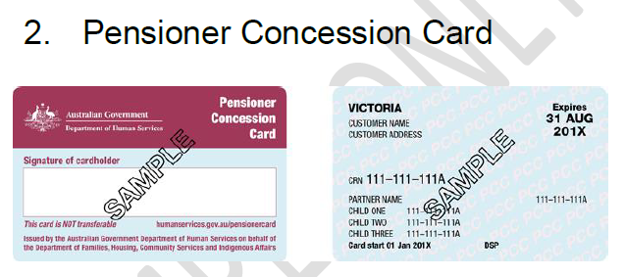

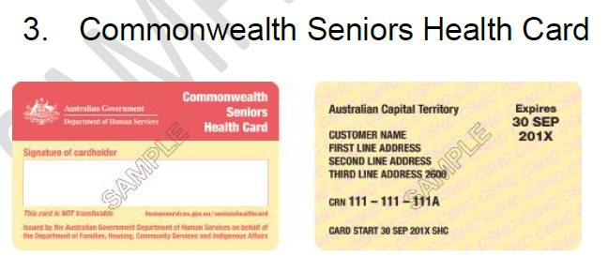

1. <https://www.disney.com.au/news/disney-plus-sneak-peek-australia#:~:text=Disney%2B%20launched%20in%20Australia%20and,Geographic%2C%20all%20in%20one%20place>.