 

# International comparison of fixed broadband performance

Data consumption

December 2020

# 

## Role of fixed broadband

Fixed broadband plays a vital role in connecting Australians, and it is important that the performance of Australia’s fixed broadband infrastructure is known and comparable to our international peers.

Fixed broadband, including both fixed-line and wireless connections to fixed locations, plays a vital role in connecting Australians. There has been significant public investment to develop fixed broadband infrastructure with the rollout of the NBN. Therefore it is important that the performance of Australia’s fixed broadband infrastructure is known and can be compared to our international peers, especially in the COVID-19 environment.

This fact sheet outlines Australia’s fixed broadband performance on access to higher speeds and migration to higher speed services.[1] Further information on this and other broadband performance indicators, including how the comparison countries identified in the analysis were selected is provided in the paper *Measuring Australia’s fixed broadband performance*.[2]

### Insights from data usage metrics

Data usage shows the extent to which broadband and broadband networks are being used, providing policy insights. Greater usage is one indicator that a broadband network is realising the benefits of connectivity to Australians.

### Australians are hungry for data

Australia is a leading country for fixed data usage with per capita data consumption of around 61GB in 2018.

This ranks Australia equal third out of nine comparable countries, with only the United Kingdom and United States ranking higher in terms of the amount of data consumed (chart 1)

This is chart 1 and is titled - fixed broadband data volumes per capita per month.

It shows in gigabytes the volume of fixed broadband data per capita per month, both upload and download data, across a select sub-set of countries, including the United Kingdom, the United States, Australia, New Zealand, Sweden, Germany, Japan, France and Italy. The United Kingdom is in first place with 95 gigabytes of data downloaded per capita per month. Australia is in equal third place with New Zealand, with the per capita data volume being 61 gigabytes per month in each country. Source: Ofcom International Broadband Scorecard. Including upload and download data.

Australians’ average monthly data usage per user over the year from June 2019 to June 2020 was 295GB over the NBN (or around 88GB when measured on a per capita basis for the Australian population that has NBN coverage). This takes into account the COVID-19 pandemic on data consumption (see below).

Australia is also a high performer for growth in data consumption compared to our international peers. From 2017 to 2018 Australia’s data consumption per capita grew 42 per cent over the 12 month period. This is the 3rd highest growth amongst the nine countries for which data is available (chart 2).

Chart 2 is titled annual percentage change in fixed broadband data volume per captita per month.

The chart shows that Australia's data consumption was third highest in terms of growth over the period 2017 to 2018 at 42 per cent. The United States had the highest growth of the selected countries over this period, at over 90 per cent per capita. In order from highest ranking to lowest ranking, the countries depicted in chart 2 are the United States. New Zealand, Australia, Germany, the United Kingdom, France, Sweden, Japan and Italy.

Source: Ofcom International Broadband Scorecard. Including upload and download data.

Data use has also grown over the period of the NBN rollout. Average monthly data downloaded per fixed-line subscription was over 310GB in June 2020, compared to almost 100GB in 2016 and around 35GB in June 2013 (chart 3).

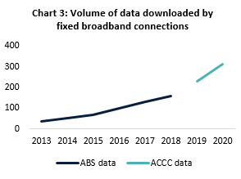

Source: BCARR analysis; ABS, Internet Activity Survey; ACCC Internet Activity Report[3]

The COVID-19 pandemic has seen a greater demand for data on the back of working and schooling from home, as well as increased usage of video gaming and streaming services.

Data collected by the ACCC shows that for the June 2020 quarter, the volume of data downloaded over NBN services had almost doubled compared to the same period in 2019, increasing from 3.48 million terabytes (TB) to around 6.28 million TB of data downloaded on these services.

The total volume of data downloaded over all fixed services also increased from 5.29 million TB over the June 2019 quarter to 7.42 million TB over the June 2020 quarter (chart 4).

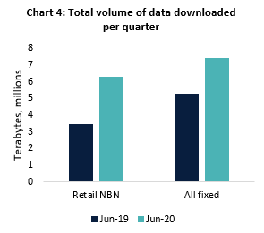

Source: ACCC, Internet Activity Report June 2020.

Similar to the drivers of increased demand for higher speed internet services, described in *International comparison of fixed broadband performance: migration to higher speed plans*, factors contributing to increased data consumption are likely to include the increasing popularity of video streaming services, a greater number of internet-connected household devices and the increased importance of home internet due to the impact of the COVID-19 pandemic

1. Information in this fact sheet draws on data available as at September 2020 for countries analysed, and may not always relate to the same period. ‘Speeds’ refer to wholesale speeds.
2. Limitations on the availability of appropriate data means that for some measures, analysis of different subsets of countries from the list of identified peer countries was required.
3. Prior to June 2018 this data was collected by the ABS. From December 2018 and onwards this data is being collected by the ACCC and uses a different methodology.