

Instruction sheet 5.3—NRS Captions—call to emergency services

Step-by-step instructions
Step number | Image | Instruction
1 |  | Go to www.communications.gov.au/accesshub/nrs.  Click on the make a NRS Captions call link (the call page can be bookmarked for future use).
2 | 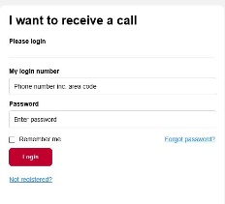 | Go to I want to make a call.  Type the area code and phone number you are calling from in the My phone number box.
3 |   OR  000  +   | Click the red Emergency Services button.  OR  Type Triple Zero (000) in The telephone number I want to call box and click Connect Now  Whichever option you choose, the call will be given priority in the relay service call answer queue.
4 |  | Watch the screen.  Pick up your phone when it rings.  The call is now connected to the National Relay Service, with a relay officer (RO) converting the words of the other person to the captions seen on your screen.
5 |  | Wait to be connected to the Emergency Services Officer (ESO).  Watch the screen for captions and let the ESO know the address including street address and state and which emergency service is needed.
6 | 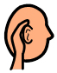 | Listen to the ESO.  Watch the screen for captions.  There will be a short delay between hearing the ESO and captions appearing.
7 |  | Speak directly to the ESO.  Answer all questions and do not hang up until the ESO tells you the call is finished.
8 |  | To end the call, say ‘goodbye’ and hang up the phone.  Click end call on the screen.

NRS Helpdesk
The Helpdesk is open from 8am to 6pm, Monday to Friday (Eastern Standard Time). There are a number of ways to make contact with Helpdesk staff:
- Email helpdesk@relayservice.com.au
- Phone 1800 555 660
- SMS 0416 001 350
- Online contact form.

