

Instruction sheet 4.4—Video Relay—Call to Emergency Services
If you have a life-threatening or time-critical situation, you can use the NRS to contact emergency services. Note that there is NO queue priority for Video Relay calls to emergency services. And Video Relay only operates in limited hours. In an emergency, NRS users are encouraged to contact emergency services using an alternative NRS call option.

Step-by-step instructions
Step number | Image | Instruction
1 |  | Login to Skype on a desktop computer, laptop or mobile device.
2 |    | Open your Contacts.  Find and open the NRS VIDEO RELAY SERVICE contact.  You will be taken to a chat screen.  Type hello.
3 | 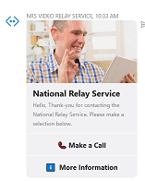 | This window will come up.  Click on Make a Call near the bottom of the picture.
4 |  | You will be sent a message asking you to wait to be connected with the next available relay officer.
5 | 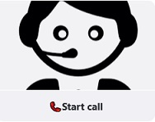 | When a relay officer is available this picture will be sent to you.  Click on Start a call at the bottom of the picture
7 |  | A full video screen will appear.  Click on the green Start call button.  You will then see the RO on screen.
8 |  | The RO will ask what number you want to call.  Sign Triple Zero (000) for emergency.  Then sign Fire or Police or Ambulance.
9 |  | Wait for the RO to connect to an Emergency Services Officer (ESO).  Wait for the RO to sign what the ESO says.
10 |  | Answer all questions from the ESO.
11 |  | Do not end call until the RO signs the call is finished.

NRS Helpdesk
The Helpdesk is open from 8am to 6pm, Monday to Friday (Eastern Standard Time). There are a number of ways to make contact with Helpdesk staff:
- Email helpdesk@relayservice.com.au
- Phone 1800 555 660
- SMS 0416 001 350.

Hints
- Video Relay is available 7am to 6pm (Eastern Standard Time) Monday to Friday except for national public holidays.
- Please note that Relay Officers can only relay Auslan. They cannot relay mojis (emojis), photos or files.

