

Instruction sheet 4.1—Video Relay—preparing to make calls
These are instructions for downloading Skype, setting up a Skype account and accessing the new NRS VIDEO RELAY SERVICE released in November 2019. You only need to complete these steps once. If you have already completed these steps, please see Instruction sheet 4.2—Video Relay—making a call.

Step-by-step instructions
Step number | Image | Instruction
1 |      | If you already have Skype downloaded on your device, skip to Step number 2.  If you don’t already have Skype on your device.  Find and download Skype  - For desktops and laptops go to www.skype.com and click on the blue button that says Download Skype.  - For android smartphones and tablets go to Google Play:  - Tap the search bar and type: Skype  - Tap to select Skype  - Tap install to download the app  - For iPhone and iPad users go to the Apple app store:  - Tap the search field and type Skype.  - Tap to select the app.  - Tap Get to download Skype  - Tap install to add the app to your device or use Touch ID (if you have it) to install.
2 | 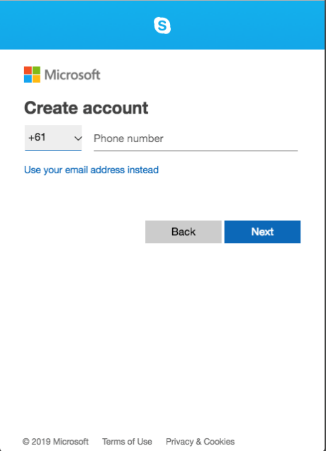 | Creating a Skype Account  If you already have a Skype account skip to Step number 3.  Complete the details and create a Skype name for yourself.  If you are using the NRS app, you can now skip to Step number 7.
3 | bit.ly/2SQSHw4 | To access the NRS VIDEO RELAY SERVICE Skype contact, type the link provided on the left into the browser of your device.
4 | 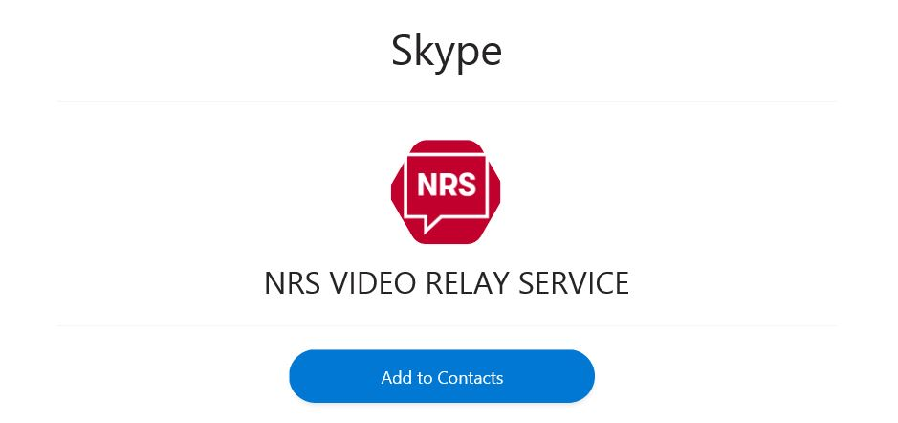 | You will be taken to this window in Skype.  Click on the blue Add to Contacts button.
5 | 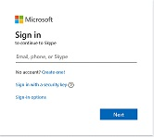 | You will be asked to sign into Skype.
6 |  | NRS VIDEO RELAY SERVICE will now be added to your Skype contacts and you will be ready to make Video Relay calls.
7 | 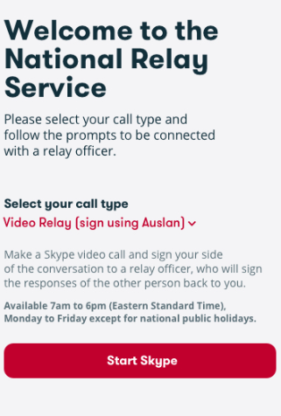 | If you are using the NRS app, open the app and select the Video Relay (Sign using Auslan) option from the Select your call type menu, and then tap Start Skype.  The NRS VIDEO RELAY SERVICE contact will be automatically added to your Skype contacts list.

Deleting the old Skype contact
If you were a Video Relay user before 20 November 2019, you need to delete the old NRS VIDEO RELAY contact as it won’t deliver a service any more. The new contact is called NRS VIDEO RELAY SERVICE.
To do this, follow the instructions provided by Skype at https://support.skype.com/en/faq/FA34868/how-do-i-remove-a-contact-in-skype.

NRS Helpdesk
Contact the NRS Helpdesk to find out more about preparing to make Video Relay calls and setting up Skype.
The Helpdesk is open from 8am to 6pm, Monday to Friday (Eastern Standard Time). There are a number of ways to make contact with Helpdesk staff:
- Email helpdesk@relayservice.com.au
- Phone 1800 555 660
- SMS 0416 001 350.

