Commonwealth Crest and National Relay Service logo with the words 'An Australian Government Initiative'.

communications.gov.au/accesshub

# Instruction sheet 3.1—NRS app (Internet Relay)—making a call

## Step-by-step instructions

| Step number | Instructions |
| --- | --- |
| 1 | Open the NRS app. |
| 2 | Tap **make a call.** |
| 3 | From the **call options** screen, tap **make an Internet Relay call**. |
| 4 | Type the **area code** and **phone number** to call, into the phone number box OR tap **contacts** at the top right of the screen to select the stored phone number. |
| 5 | Tap **connect now**. |
| 6 | Wait to be transferred to a relay officer (RO). |
| 7 | Wait for the other person’s greeting and read ‘GA’ (Go ahead). |
| 8 | Send a typed message. The RO will read your typed messages to the other person.  There are four ways you can send typed messages during a call:  1. Type your message in the text box at the bottom of the screen. Type ‘GA’. Tap **send**.  2. Tap the **profile** button Image of the profile button in NRS app. to send pre-stored information from your profile. Select the type of message, for example, first name from your profile. Type ‘GA’. Tap **send**.  3. Tap the **quick phrases** button Image of the quick phrases button in NRS app. to select pre-stored phrases from your list. Type ‘GA’. Tap **send**.  4. Tap the **location** button Image of the location button in NRS app. to find your current address. Tap **done** and your GPS address will be added to your conversation. |
| 9 | Read the other person’s messages. Wait to read ‘GA’ before replying each time. |
| 10 | To end the call, type ‘goodbye SKSK’ (Stop Keying. Stop Keying) or use a pre-stored message. |
| 11 | Read your caller’s ‘goodbye SKSK’.(stop keying, stop keying) |
| 12 | The RO will ask if you want to make another call.  If yes, type the **phone number** to call.  If no, type ‘no thank you’ or use your pre-stored **quick phrases**. |
| 13 | Tap **hang up** in top right corner of the screen and again in the pop-up box. |

## NRS Helpdesk

The Helpdesk is open from 8am to 6pm, Monday to Friday (Eastern Standard Time). There are a number of ways to make contact with Helpdesk staff:

* Email [helpdesk@relayservice.com.au](mailto:helpdesk@relayservice.com.au)
* Phone 1800 555 660
* SMS 0416 001 350.

## Hints

### Downloading the NRS app

#### iPhone/iPad users



1. Tap the Apple App Store icon.
2. Tap **Search** on the bottom right corner of the screen.
3. Tap the search field and type: NRS app.
4. Tap to select the **NRS app**.
5. Tap **Get** to download the app.
6. Tap **install** to add the app to your device or use Touch ID (if you have it) to install.

#### Android smartphone/ tablet users



1. Tap Google Play Store icon.
2. Tap the search bar and type: **NRS app**.
3. Tap to select the NRS app.
4. Tap **install** to download the app.

### Making a call

* You will need to tap **send** every time you would like your message to be sent to your conversation partner.
* If you need to send a message directly to the RO, put the words in brackets so that The RO knows not to relay them, For example:

(‘RO, I am a very slow typist, please ask my caller to be patient while I type a message’).

* If you need more time to read and respond, you can paste a message from your Quick Phrases menu:

(‘RO, I need time to respond, please ask my caller to be patient while I read their words and type a reply).

* If you have phone numbers saved to your device you do not need to retype them into the phone number box. Tap ‘Contacts’ in the top right of the phone number screen, find the contact in your device, and tap the number. The number will then be inserted into the number field.

### NRS app passcode

* You can protect some of the information you store in the NRS app by a passcode. You will be asked to create a passcode the first time you save information to your Services or Profile. You will need to remember this passcode each time you wish to access your stored information.

### Registering

1. Open the app.
2. Click **Not registered?**
3. Fill in your details: name, phone number, email address. You can use any ten digit mobile phone number or landline number as your ‘login number’. Incoming calls will come to the device you are logged in to.
4. Choose a password with at least 6 letters.
5. You will receive a confirmation email. Click on the activation link supplied and registration is complete.
6. Note: If you have already registered to receive Internet Relay or web browser Captioned Relay calls on your computer, you can use the same login details.

### Logging in

1. Open the app.
2. Click **Login**.
3. Enter your login number and password.
4. Click **login**. You only need to do this once, the app will remember your login details if you do not log out or use a different device.

Your login number is the ten digit number you registered with, it might be your area code and phone number or your mobile number.

### Special NRS app features

#### Quick phrases

Icon: quick phrases.

* Quick phrases allows you to pre-store sentences which can be inserted as text into an Internet Relay call.

You might like to pre-store sentences you will use regularly so that you do not need to type them every time.

E.g. Okay, thank you for calling SKSK.

* To create Quick phrases open the app, tap ‘Quick Phrases’, and then tap the plus icon at the top of the screen. Type your stored message and tap **save**.
* To insert Quick Phrases into your call tap the ‘Quick Phrases’ icon at the top of the screen. Then tap the pre-store sentence you would like to insert and tap **Use Quick Phrase**.
* Information stored in Quick Phrases is not protected by your NRS app passcode so don’t save private or sensitive information here. Anyone with access to your phone can access this information.

#### Services

Icon: services.

* Use Services to pre-store start-up messages, which can make it quicker to start an Internet Relay call.

You might like to save a start-up message in the business category for a company you call regularly.

E.g. Hi, I need to make an appointment with Dr Green. It’s Carol Smith here GA.

* Information stored in Services is protected by your NRS app passcode.
* To setup Services open the app, tap **Services**, enter **your passcode**, and then tap the category you would like to save the start-up message to. Tap the **plus icon** at the top of the screen. Type your message and tap **save**.
* When you setup a Services start-up message you can choose to automatically share information from your Profile caller notes with the RO. To do this, slide the **OFF** button next to ‘Send caller notes’ to the **ON** position.
* Tap the **Services** icon to begin a call using your stored start-up messages. You will need to type in your passcode and then select which category you have saved the pre-stored message in.

#### Profile

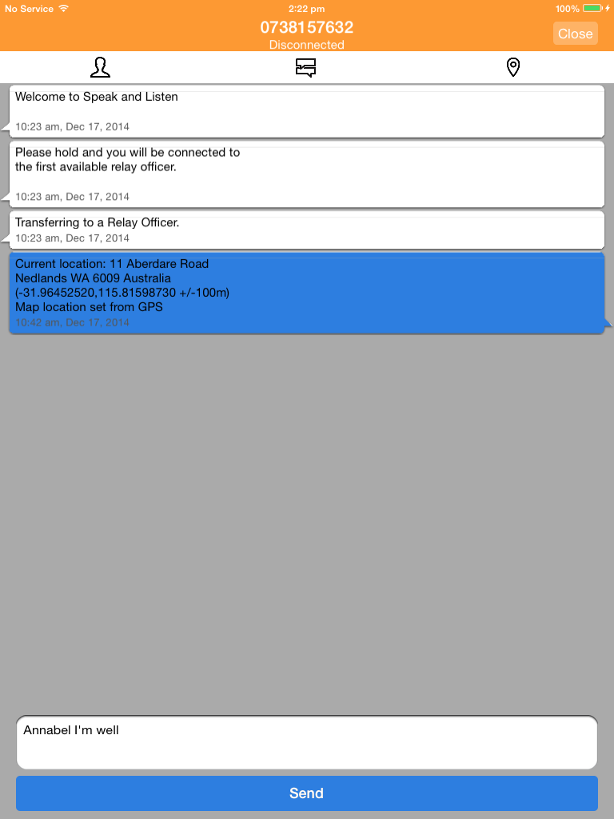

* Your Profile allows you to pre-store personal information that can be inserted as text into an Internet Relay call.
* Information that is stored in your Profile is protected by your NRS app passcode.
* To create your Profile open the app, tap the **More** icon, then tap **Profile**. Type in the information you would like to store and tap **save**.
* To insert information from your profile during a call tap the **Profile** icon at the top of the screen.

#### Caller notes

* Use the Caller notes section in your app Profile to pre-store information to help the relay officer understand any issues you may having managing your NRS calls.
* E.g. ‘I’m a slow typist, please ask my caller to be patient’.
* Caller notes will not be relayed to the other person on your call unless you specifically ask the relay officer to do so.
* To add Caller notes to your Profile tap the **More** icon, then tap **Profile**. Scroll down to the field titled Caller notes. Type in the information you would like the RO to know and tap **save**.
* You can choose to send this information to the RO automatically at the start of every call by turning on Caller notes during the setup of a Services message.
* To send the RO Caller notes during a call tap on the **Profile** icon at the top of the screen. Tap on the **Caller notes** field, tap **select** and **send**.

#### Location

Icon: location.

* Use Location to enter your current address into an Internet Relay call using the GPS function on your device.
* To use this function you will need to have ‘Location services’ turned on for your device. Note that the NRS app Location button is only visible during a call.
* To insert your location during a call tap the **drop pin icon** and tap **done**.
* You should always check that the pin is in the correct location before you click **done**—you may need to move the pin before sending.
* You can adjust your location manually by:

Holding and dragging the drop pin to the right location (for Android devices) or tapping **Drag pin** and dragging the pin (for Apple devices).

Tapping **Search** and typing your address into the pop-up box that appears.