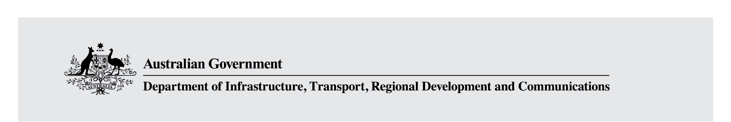

Fact Sheet: Screen production funding and incentives reforms
The Australian Government is making a number of improvements to its current policy settings to support the creation of film and television content in response to the Supporting Australian stories on our screens Options Paper.

Australian Screen Production Incentive
The Australian Screen Production Incentive (ASPI), as the Australian Government’s primary mechanism for providing support to the screen industry, provides tax incentives for film, television and other screen production in Australia and is available in three streams: the Producer Offset, the Post Digital and Visual Effects (PDV) Offset and the Location Offset.
Following consultation on the options paper, the Australian government is making a range of changes to the ASPI to provide long-term, stable settings for the production sector, encouraging it to target expenditure towards onscreen quality and encourage the creation of original Australian stories.
Current ASPI settings and new ASPI settings
Current setting | New setting
Producer Offset rate for television content is 20 per cent | Increase the Producer Offset rate to 30 per cent
Producer Offset minimum qualifying Australian production expenditure (QAPE) threshold for feature length content is $500,000 | Increase the minimum QAPE threshold for feature length content to $1 million
Producer Offset ‘Gallipoli Clause’ permits some costs incurred outside of Australia to be claimed as QAPE | Remove the Gallipoli Clause from the Producer Offset
Producer Offset only enables a series to claim QAPE incurred up to 65 commercial hours | Remove the 65 commercial hour cap for drama productions
Producer Offset caps Above the line (ATL) QAPE at 20 per cent of total film expenditure for all content except non-feature documentary | Extend the ATL cap non-feature documentary
PDV Offset minimum PDV-QAPE threshold is $500,000 | Increase the minimum PDV-QAPE threshold to $1 million
Under all three tax offsets productions are permitted to claim a certain percentage of their production spend as overheads not directly related to the making of the film to cover company expenses | Remove overheads as eligible expenditure for all three tax offsets
Under all three tax offsets productions are able to claim uncapped expenditure incurred on Australian held copyright | Cap the level of copyright expenditure that can be claimed at 30 per cent of total production expenditure under all three offsets
As the Australian Screen Production Incentive is underpinned by the Income Tax Assessment Act 1997 and changes will be implemented through legislative amendments. These amendments will come into effect for productions that commence principal photography or post, digital and visual effects activity on, or after 1 July 2021.
As per the announcement on 11 April 2021, the Government has decided to retain the Producer Offset rate for feature film at 40 per. For further information, see the media release.

Funding to support quality Australian screen content
The Australian Government is providing an additional $30 million to Screen Australia over two years from 2021–22 for funding for Australian drama, documentary and children’s screen content across film and television.
Screen Australia is the Australian Government’s principal funding agency for providing support to Australian screen practitioners. It supports Australian stories on screen through direct and indirect funding, facilitates industry growth through enterprise funding, market support, targeted initiatives and partnerships, and resources the industry through research, advice and expertise. The Government will provide funding of $81.85 million in 2020–21 to Screen Australia.
This boost in funding to Screen Australia will enable it to target quality and culturally important Australian film and television content and support producers to find a pathway to audiences thereby resulting in a positive commercial return.
Funding will be delivered through Screen Australia’s competitive funding programs. Information on how to apply for funding is available on Screen Australia’s website www.screenaustralia.gov.au.

Funding to support script writing and script development
The Australian Government is also providing an additional $3 million to Screen Australia over three years from 2020-21 to support a Screen Writing and Script Development Fund.
In the contemporary screen production environment, commissioners of content worldwide are looking for well-developed and well-written creative concepts. To support our sector to secure work in this global production industry, Australia’s script writers will be supported to spend time, hone skills and develop expertise to put forward polished, production-ready scripts. This Fund will strengthen our industry’s ability to be competitive in a global environment.
Funding will be delivered through Screen Australia. Information on how to apply for funding is available on Screen Australia’s website www.screenaustralia.gov.au.

Funding for quality Australian children’s content
The Australian Government is providing $20 million over two years from 2021-22 to the Australia Children’s Television Foundation (ACTF) to invest in the development, production and distribution of Australian children’s content.
This funding will make sure young audiences continue to enjoy access to high quality Australian stories that are critical for education, entertainment and the development of a shared sense of culture and identity.
The ACTF provides funding to support the development, production and distribution of high quality Australian children’s content and educational resources. Information on eligibility and how to apply for funding from the ACTF can be found on its website www.actf.com.au.

