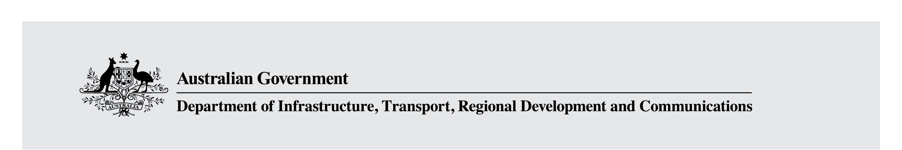

Fact sheet—Modernising Australian content regulation
The Australian Government is modernising the regulatory framework that underpins Australian content. These new measures will support Australian content on all screens, not just on television, and reflect the new ways that Australians are accessing and consuming content in a digital media environment.

What does this mean for free-to-air television?
Commercial free-to-air television broadcasters will continue to be subject to obligations to broadcast Australian drama, children’s and documentary content, but will have more flexibility around how they meet these obligations.
- From 1 January 2021, commercial television broadcasters will be subject to a new, streamlined set of sub-quota rules for Australian drama, documentaries and children’s content.
- This will allow broadcasters to better target their content to suit their audiences, while still protecting and promoting Australian stories and perspectives.
Children’s content will be regulated through the new modified quota. Any ‘P’ (pre-school) or ‘C’ (children’s) content broadcast by commercial television broadcasters will continue to be required to meet the existing safeguards which apply to such content (for example, restrictions on advertising). Broadcasters will be able to meet their modified quota obligations on their primary or multichannels.
Commercial broadcasters will continue to be required to provide 55 per cent overall Australian content on their primary channels between 6:00 am and midnight, and to provide 1,460 hours of Australian content per year on their multichannels.

How will the modified content quota be implemented?
The changes will be implemented through a Ministerial direction to the Australian Communications and Media Authority (ACMA) to revoke and remake the Australian Content Standard and Children’s Television Standards.

How will the modified content quota work in practice?
The modified content quota will require each broadcaster to reach 250 points of Australian genre content in a calendar year which can be met by broadcasting commissioned Australian drama and documentaries, including children’s drama and documentaries, and acquired Australian films. Each hour of content will receive different points depending on its hourly production budget (see Table 1).
Table 1
Genre | Points per hour
Commissioned documentary | 1
Commissioned children’s content (non-drama) | 1.5
Commissioned drama (<$450,000 production budget per hour) | 1.5
Commissioned drama ($450,000—$700,000 production budget per hour) | 4
Commissioned drama ($700,000—$1 million production budget per hour) | 5
Commissioned drama ($1 million to $1.4 million production budget per hour) | 6
Commissioned drama (>$1.4 million production budget per hour) | 7
Acquired Australian film (licence fee less than $50,000) | 1
Acquired Australian film (licence fee more than $50,000) | 2
This will mean that a broadcaster can meet their annual quota of 250 points with any combination of genres (with one qualification: a maximum of 50 points will be able to be acquitted on commissioned documentaries). To qualify as commissioned content, the broadcaster will need to have made a financial contribution to the production budget before the production has been completed.
In-house productions will be treated equivalently to commissioned programming for the purposes of the new quota. To qualify for the new quota, Australian films will need to have been produced in the last two years and to have not been televised before in the relevant commercial television licence area.

What about subscription television?
Subscription television broadcasters (such as Foxtel) will continue to be required to spend a proportion of their drama program expenditure on Australian drama programming. The Government will move to reduce this obligation from 10 per cent of program expenditure for each drama channel to 5 per cent from 1 July 2021. The changes will be implemented through amendment to the Broadcasting Services Act 1992.

What new obligations will streaming services face?
The Government will request large video streaming services operating in Australia to report on their level of investment in Australian content to the Australian Communications and Media Authority, commencing from 1 January 2021. The Government will engage with affected services about the details and scope of the request.

