Commonwealth Crest and National Relay Service logo with the words 'An Australian Government Initiative'.

communications.gov.au/accesshub

# Fact sheet 7B—TTY—Type and Read

In TTY Type and Read calls you type your side of the conversation on a TTY and read the responses from the other person on the TTY which have been typed by the relay officer.

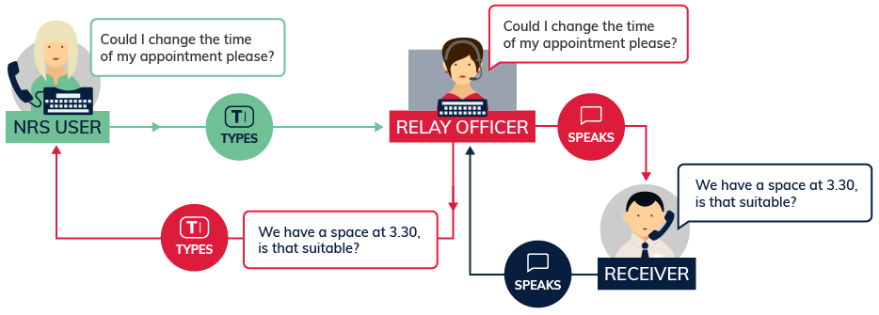

## What equipment is needed?

You will need a TTY (also known as a teletypewriter or a textphone) and a landline connection.

## How much will it cost?

A TTY call will cost the same as any other call to a 13/1300 phone number depending on your phone plan. At the end of each call, the relay officer will offer the option of making another call. On application, users can usually rent a TTY for about the same cost as an ordinary phone through the [disability equipment programs](https://www.communications.gov.au/what-we-do/phone/services-people-disability/access-specialist-phone-equipment) offered by Telstra or Optus.

## Things to remember

For a detailed step-by-step explanation about how to use this TTY option, read the TTY Type and Read instruction sheets on the [Service features webpage](https://www.communications.gov.au/what-we-do/phone/services-people-disability/accesshub/national-relay-service/service-features) on Accesshub.

## Helpdesk

The Helpdesk is open from 8am to 6pm, Monday to Friday (Eastern Standard Time). There are a number of ways to make contact with Helpdesk staff:

* email [helpdesk@relayservice.com.au](mailto:helpdesk@relayservice.com.au)
* phone 1800 555 660
* SMS 0416 001 350
* TTY 1800 555 630
* Fax 1800 555 690.